1. We will be designing a solver for a genus two minesweeper. The tiling for this minesweeper will be 45 – 67.5– 67.5 triangles
   1. This project should be able to solve a game of minesweeper, and we should be able to test this out by creating randomized minesweeper boards and by inputting them. We would like to show a completed board on a genus two structure and show the progression of the game through images of the board in the form of an octagon
      1. A completed Board of 10 rows
         1. 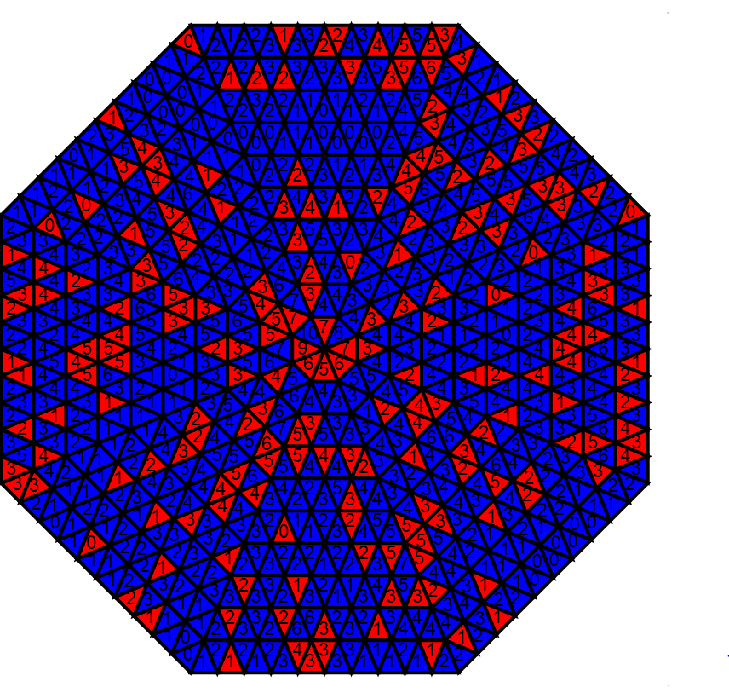
      2. A board in terms of being revealed
         1. 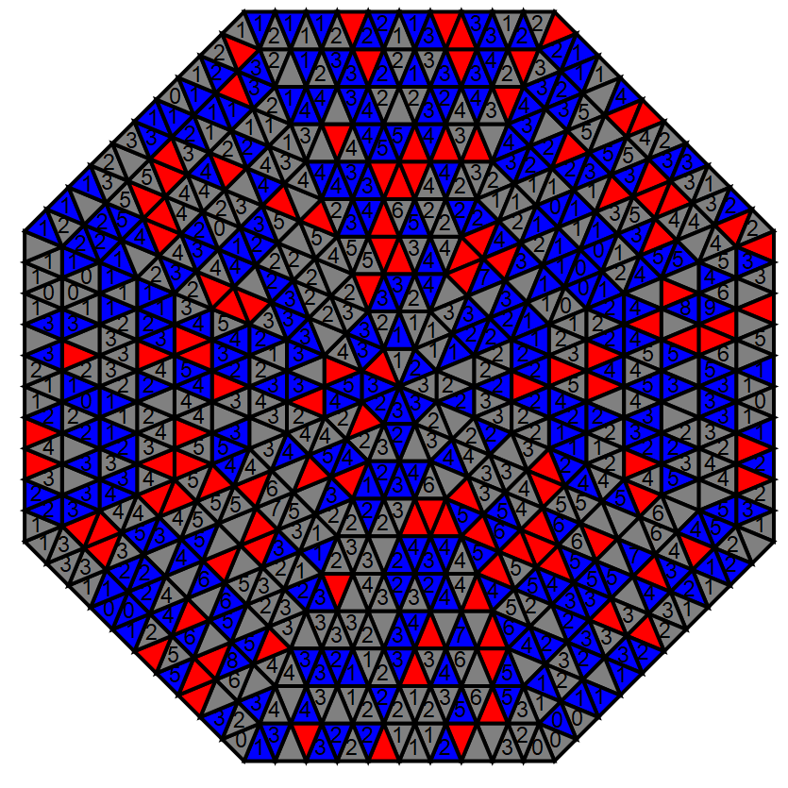
   2. The user will be able to input their board including what tiles have been revealed and the numbers on them. Our solver will then give a logical move.
      1. Start Screen
         1. 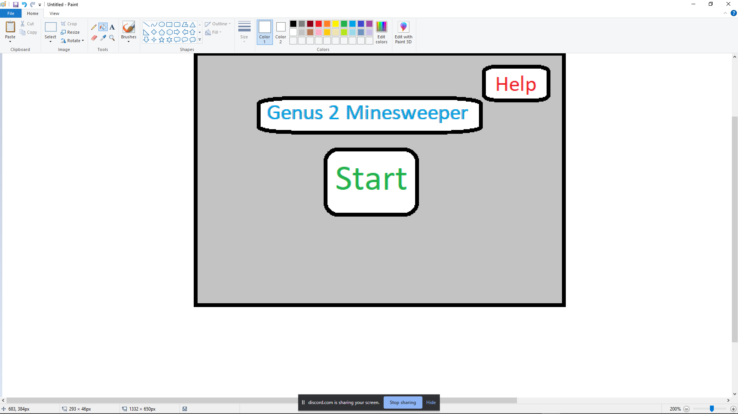
      2. Screen where you can choose if you want to play a game or you want to use the solver
         1. 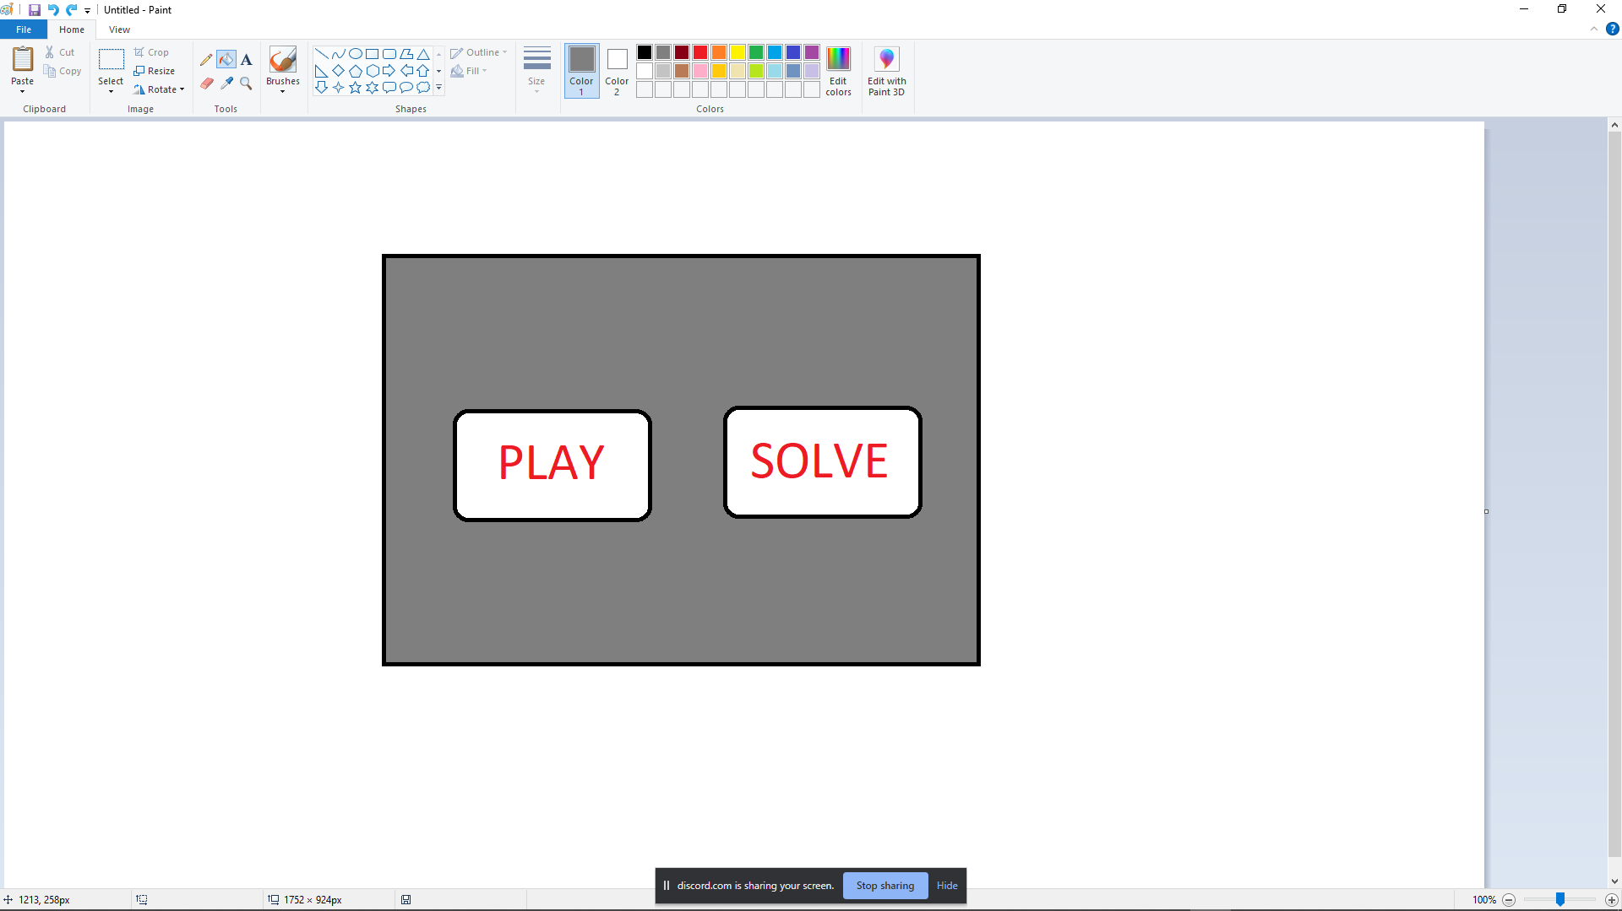
      3. Screen where you can play
         1. 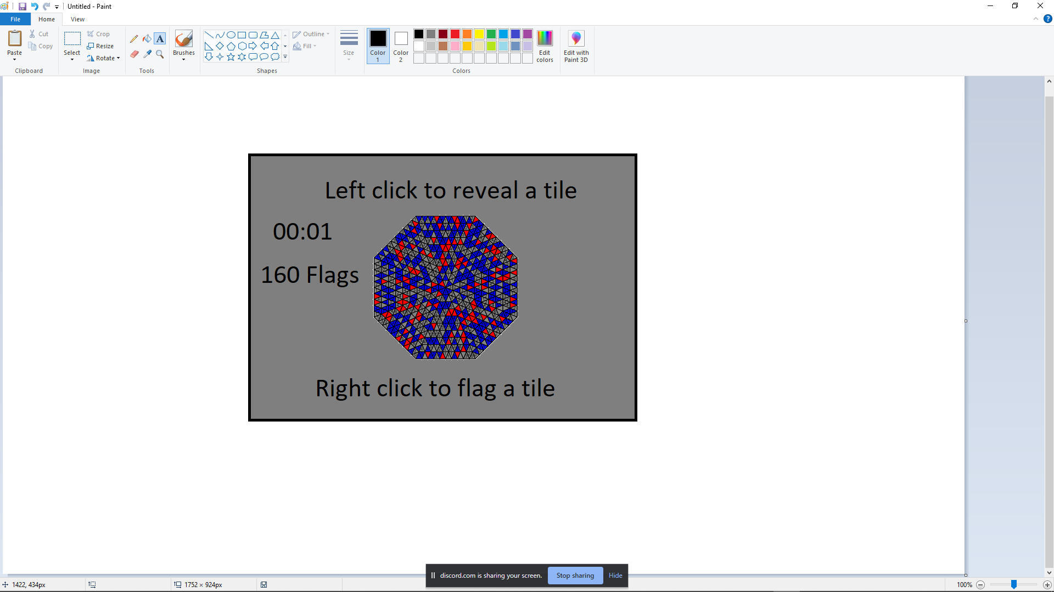
      4. Screen that will let you choose whether you want to randomly generate a board and solve or input
         1. 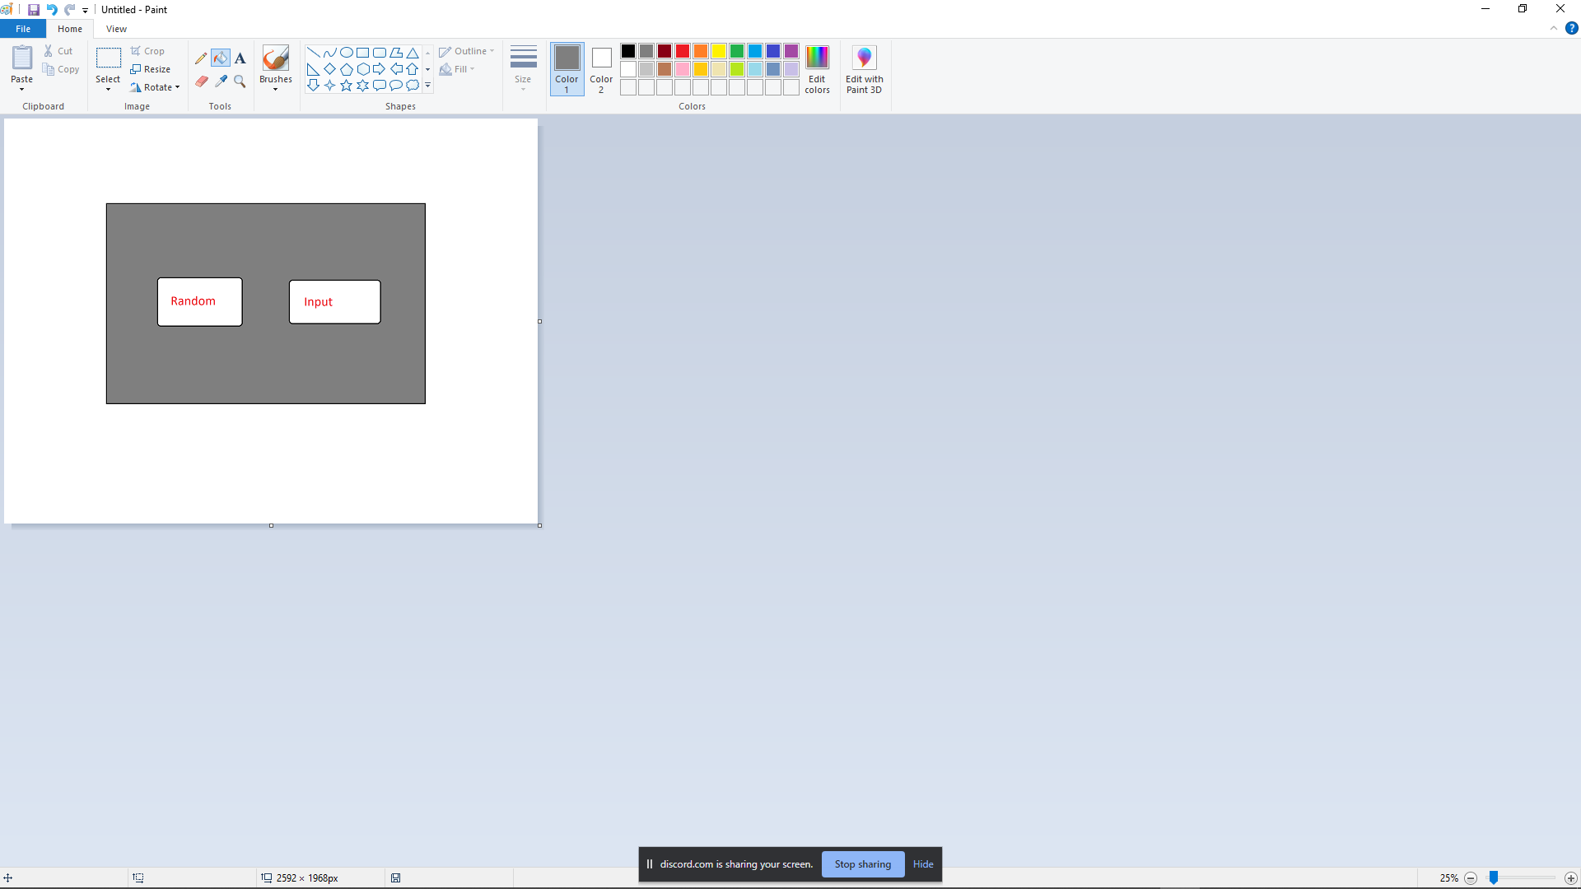
      5. Screen with randomized board being solved
         1. 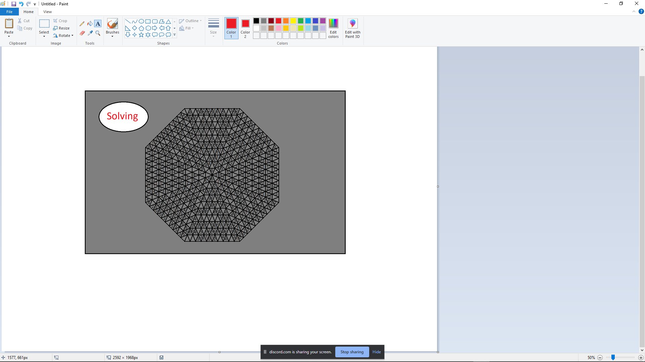
      6. Screen where they input a board
         1. 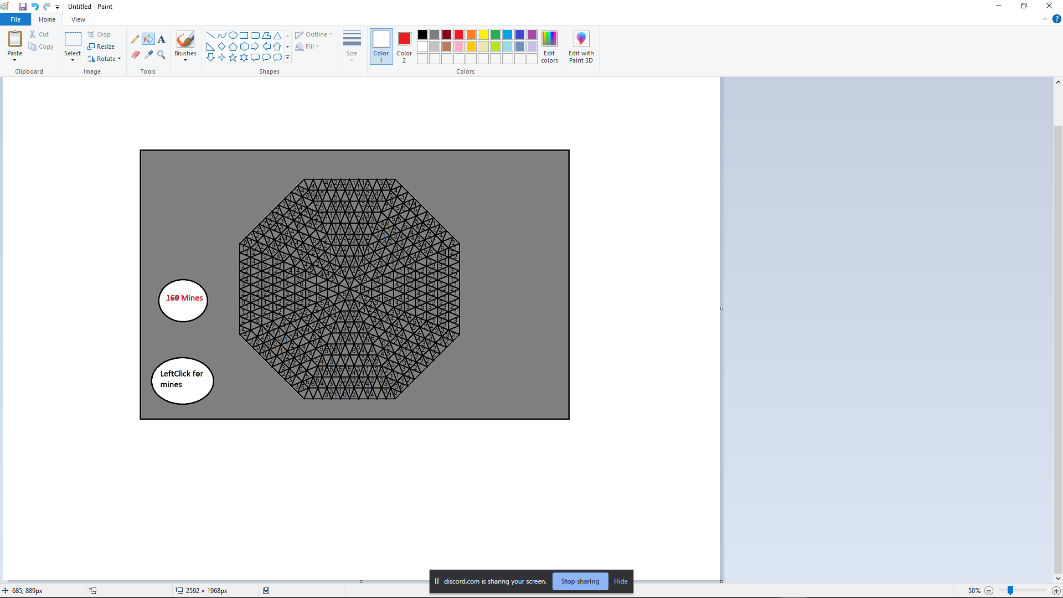
   3. We need to create the game and create the graphics and other necessary things needed for the solver.
   4. We need to come up with an algorithm and implement it.
   5. Work out octagon to genus two graphics