AutoDoc AI — Declarations
Student name: Kaavika Sri S
Department: B.Tech CSE (AI & DS)
Project: AutoDoc AI — Automotive Document Assistant
Institution / register number: SASTRA Deemed University 127156065
Date: 14/10/2026

Declaration 1 — Academic Integrity
I declare that I have reviewed the AutoDoc AI project submission and that the description of the implementation, results, external resources, and my individual contribution is accurate to the best of my knowledge. I have not knowingly fabricated results or represented unimplemented features as completed work. I will identify external code, datasets, models, and documents used in the project, and I understand that I am responsible for the correctness and explanation of the submitted work.
Before signing, I confirm that I have checked the final code and report, added any required citations, and corrected any statement that does not match the actual project.
Student signature: 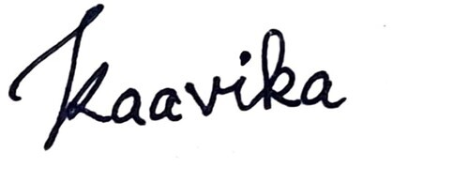 Date: 14/10/2026

Declaration 2 — AI-Tool Usage
I disclose the use of AI assistance during project planning, code drafting/refinement, presentation preparation, and documentation drafting. I have reviewed the outputs I submit and remain responsible for their correctness. I will not claim that AI-generated suggestions or code were independently authored by me without appropriate disclosure.
Student signature: Date: 14/10/2026

AI Tool / Model Usage Table
AI Model / Tool | Purpose | Artifact affected | Verified by student
ChatGPT (OpenAI) | Project planning, code generation/refinement, troubleshooting guidance | AutoDoc AI source code / project plan | Pending student review: run and inspect the final code
ChatGPT (OpenAI) | Presentation and technical-report drafting | PPT, report and project documentation | Pending student review: verify all claims against the app and source document

