LinkLab in Cisco Packet Tracer
Oct 26, 2026 · @Kaavin

Overview
This lab shows the data link layer working on real Cisco devices inside Packet Tracer. In Simulation mode you watch frames move hop by hop and open each one to see its fields. It is the live companion to the LinkLab website: the website simulates the algorithms, and Packet Tracer shows the same ideas inside real Ethernet, HDLC, PPP and TCP traffic.
What you show live | Where it appears in Packet Tracer | LinkLab topic | List items
Ethernet frame format and the CRC-32 FCS | PDU details of any ping | CRC | #14
Unicast, broadcast and multicast MAC addresses | ARP request, ARP reply, OSPF hello | MAC validation | #24, #33
Switch learning MAC addresses | show mac address-table before and after a ping | Data link switching | #11, #30, #32
HDLC vs PPP framing on a serial link | Change the encapsulation and watch the link go down, then up | Framing | #35
Sliding window and flow control | SEQ, ACK and WINDOW fields of TCP segments | Sliding window, flow control | #34, #36
Routing between the two LANs | OSPF on both routers | OSPF | #16
Packet Tracer cannot corrupt bits on a link, so error detection shows only as the FCS field in each frame. The bit-flipping demo stays on the LinkLab website. Everything here works in Packet Tracer 8.x.

Topology and addressing
Two LANs, each behind its own router, are joined by one serial WAN link. Nine devices in total: 2 routers, 2 switches, 4 PCs and 1 server.
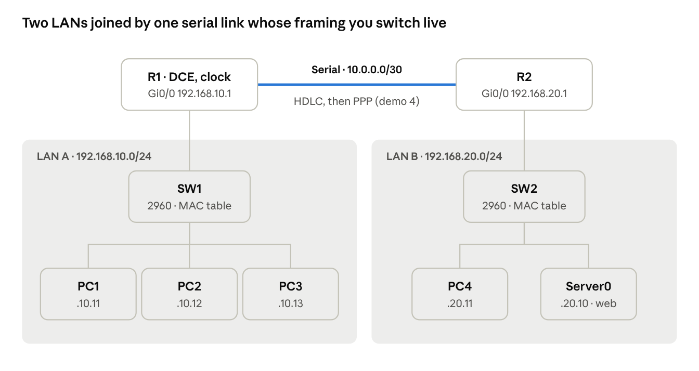
LinkLab topology · 2 LANs, 1 serial WAN link
The highlighted serial link is where the framing demo happens. Everything else is plain Ethernet.
Device | Model in Packet Tracer | Interface | IP address | Gateway
R1 | 1941 router + HWIC-2T module | Gi0/0 (to SW1) | 192.168.10.1 /24 | -
R1 |  | Se0/1/0 (to R2, DCE) | 10.0.0.1 /30 | -
R2 | 1941 router + HWIC-2T module | Gi0/0 (to SW2) | 192.168.20.1 /24 | -
R2 |  | Se0/1/0 (to R1) | 10.0.0.2 /30 | -
SW1 | 2960-24TT switch | Fa0/1 to Fa0/3 PCs, Gi0/1 to R1 | - | -
SW2 | 2960-24TT switch | Fa0/1 to Fa0/2 hosts, Gi0/1 to R2 | - | -
PC1 | PC | Fa0 to SW1 Fa0/1 | 192.168.10.11 /24 | 192.168.10.1
PC2 | PC | Fa0 to SW1 Fa0/2 | 192.168.10.12 /24 | 192.168.10.1
PC3 | PC | Fa0 to SW1 Fa0/3 | 192.168.10.13 /24 | 192.168.10.1
PC4 | PC | Fa0 to SW2 Fa0/1 | 192.168.20.11 /24 | 192.168.20.1
Server0 | Server | Fa0 to SW2 Fa0/2 | 192.168.20.10 /24 | 192.168.20.1
All Ethernet links use Copper Straight-Through cables. The WAN link uses a Serial DCE cable, plugged into R1 first so that R1 is the DCE side and supplies the clock.

Build steps
The build takes about 30 minutes. Save as LinkLab.pkt after every step.
- Add the serial modules. Place two 1941 routers and rename them R1 and R2 (click the device, Config tab, Display Name). On each one, open the Physical tab, switch the router off, drag HWIC-2T into an empty slot and switch it back on.
- Place the switches and hosts. Add two 2960-24TT switches (SW1, SW2), four PCs (PC1 to PC4) and one Server (Server0). Lay them out as in the topology table: PC1 to PC3 under SW1, PC4 and Server0 under SW2.
- Cable the LANs. Use Copper Straight-Through for each link: PC1 Fa0 to SW1 Fa0/1, PC2 to Fa0/2, PC3 to Fa0/3, SW1 Gi0/1 to R1 Gi0/0. Then PC4 to SW2 Fa0/1, Server0 to SW2 Fa0/2, SW2 Gi0/1 to R2 Gi0/0.
- Cable the WAN. Choose Serial DCE, click R1 first and pick Se0/1/0, then click R2 and pick Se0/1/0. A clock icon on R1's end confirms it is the DCE.
- Set the host addresses. On each PC and the server, open Desktop, IP Configuration, choose Static and type the IP, mask 255.255.255.0 and gateway from the table.
- Label the zones. Use the Note tool to add "LAN A - 192.168.10.0/24", "WAN - HDLC / PPP" and "LAN B - 192.168.20.0/24", and a title note "LinkLab: the data link layer, live". Draw a rectangle around each LAN for a clean screenshot.
- Configure the routers and switches with the commands in the next section.
- Customise the web page. On Server0, open Services, HTTP, edit index.html and replace the body with <h1>LinkLab</h1><p>This page crossed Ethernet, HDLC/PPP and TCP to reach you.</p>.

Configuration
Open each device's CLI tab and paste its block. The serial link starts on HDLC, the Cisco default; demo 4 switches it to PPP live.
R1
enable
configure terminal
hostname R1
no ip domain-lookup
interface gigabitEthernet0/0
description LAN A
ip address 192.168.10.1 255.255.255.0
no shutdown
interface serial0/1/0
description WAN to R2
ip address 10.0.0.1 255.255.255.252
clock rate 64000
no shutdown
router ospf 1
network 192.168.10.0 0.0.0.255 area 0
network 10.0.0.0 0.0.0.3 area 0
end
write memory
R2
enable
configure terminal
hostname R2
no ip domain-lookup
interface gigabitEthernet0/0
description LAN B
ip address 192.168.20.1 255.255.255.0
no shutdown
interface serial0/1/0
description WAN to R1
ip address 10.0.0.2 255.255.255.252
no shutdown
router ospf 1
network 192.168.20.0 0.0.0.255 area 0
network 10.0.0.0 0.0.0.3 area 0
end
write memory
SW1 (SW2 is the same with its own name)
enable
configure terminal
hostname SW1
banner motd # LinkLab - LAN A switch #
end
write memory
Check it works. Wait about 40 seconds for OSPF, then on R1 run show ip route. You should see O 192.168.20.0/24 through 10.0.0.2. From PC1, open Command Prompt and run ping 192.168.20.10. The first reply can time out while ARP resolves, and the rest should succeed.

Live demos in Simulation mode
Each demo takes 2 to 4 minutes. Switch to Simulation mode with the tab at the bottom right, or Shift+S. In the Simulation panel, use Edit Filters to show only the protocols named in each demo. Capture / Forward moves one hop at a time. Clicking an envelope opens its PDU details, with OSI Model and Outbound PDU Details tabs.

Demo 1 - Ethernet frame and its CRC
- Filter: ICMP only. Use Add Simple PDU (the closed envelope) and click PC1, then PC2.
- Press Capture / Forward once, then click the envelope sitting at PC1.
- Open Outbound PDU Details. Point at each field of the Ethernet II frame: PREAMBLE, DEST ADDR, SRC ADDR, TYPE 0x0800 (IPv4), DATA and FCS.
- Say: "The FCS is a CRC-32. The sender computes it over the frame, and the receiver recomputes it and drops the frame if they differ. LinkLab does the same with CRC-8."

Demo 2 - Unicast, broadcast and multicast MAC addresses
- On PC1's Command Prompt, run arp -d to clear its ARP cache.
- Filter: ARP and ICMP. Add a Simple PDU from PC1 to PC3 and step through it.
- The ARP request is sent to FFFF.FFFF.FFFF, so SW1 floods it to PC2, PC3 and R1. This is a broadcast.
- The ARP reply from PC3 goes only to PC1's own MAC address. This is a unicast.
- Filter: OSPF only and press Play. An OSPF hello leaving R1 Gi0/0 is sent to 224.0.0.5, and its frame's DEST ADDR is 0100.5E00.0005. This is a multicast.
- Explain the rule: the lowest bit of the first byte is 0 for unicast and 1 for multicast, and all 48 bits set to 1 means broadcast.

Demo 3 - A switch learning MAC addresses
- In Realtime mode, open SW1's CLI and run clear mac address-table dynamic, then show mac address-table. The table is empty.
- Ping from PC1 to PC2, then run show mac address-table again. Two entries appear, each with a MAC address and its port (Fa0/1, Fa0/2).
- Back in Simulation mode, send the same PDU again. This time SW1 forwards the frame only out Fa0/2 instead of flooding it, because it has learned where PC2 is.

Demo 4 - HDLC vs PPP framing
- On R1, run show interfaces serial0/1/0. Point at Encapsulation HDLC and line protocol is up.
- Change only R1's end:
configure terminal
interface serial0/1/0
encapsulation ppp
end
- Within a few seconds the line protocol goes down, the OSPF neighbour drops, and a ping from PC1 to Server0 fails. Say: "The physical link is fine, but the two ends no longer agree on the frame format, so neither can read the other's frames."
- Run the same three commands on R2. The link comes back up, OSPF re-forms, and the ping works again.
- Optional, to show PPP's extra feature, add CHAP authentication on both routers:
! on R1
configure terminal
username R2 password linklab
interface serial0/1/0
ppp authentication chap
end
! on R2 the same, with username R1
- In Simulation mode, open a frame on the serial link and compare its layer 2 header with the Ethernet frame from demo 1.

Demo 5 - Sliding window in TCP
- Filter: TCP and HTTP. On PC1 open Desktop, Web Browser and go to http://192.168.20.10.
- Step through the three-way handshake: SYN, SYN+ACK, ACK.
- Open any TCP segment's details and point at SEQUENCE NUM, ACK NUM and WINDOW.
- Say: "WINDOW is how many bytes the receiver will accept before it must acknowledge. That is flow control with a sliding window, the same mechanism LinkLab simulates for Go-Back-N and Selective Repeat at the frame level."
- Let it finish. The LinkLab page from step 8 of the build appears in PC1's browser.

Demo script and troubleshooting
A 10-minute presentation: open with the LinkLab website for 4 minutes, then run demos 2, 4 and 5 in Packet Tracer for 6 minutes. Keep demos 1 and 3 ready in case the examiner asks.
- Website, Pipeline tab: send a message with noise at 40% and show a corrupted frame being caught by CRC and resent.
- Website, Sliding window tab: play Go-Back-N, then Selective Repeat with the same seed, and compare their efficiency.
- Packet Tracer, demo 2: "Here are the three kinds of MAC address on real frames."
- Packet Tracer, demo 4: "If framing doesn't match, the link dies even though the cable is fine."
- Packet Tracer, demo 5: "The same window idea appears again in TCP."
Questions to expect
- Why does the link go down when only one side uses PPP? HDLC and PPP use different header fields, so each router discards the other's frames as invalid.
- Why is R1 the DCE? On a serial link one side must supply the clock, set with clock rate 64000. In a lab the DCE end of the cable decides which one.
- Why does the first ping time out? The PC sends an ARP request first and drops the ping until it learns the gateway's MAC address.
- Why can't Packet Tracer show a CRC error? It does not corrupt bits on its links. That is why LinkLab's own simulator injects errors itself.
If something doesn't work
Symptom | Likely cause | Fix
No serial port on the router | HWIC-2T not added | Power off, add the module, power on
Serial link stays red | No clock rate, or DCE cable on the wrong end | clock rate 64000 on R1, or re-cable starting from R1
show ip route has no O routes | OSPF networks or wildcard masks mistyped | Recheck the network lines, wait 40 seconds
PC can ping its gateway but not the other LAN | Wrong default gateway on the PC | Set it to .1 of its own LAN
Link down after demo 4 | Encapsulation differs on R1 and R2 | Run encapsulation ppp on both, or encapsulation hdlc on both
CHAP link stays down | Username isn't the other router's hostname, or passwords differ | R1 uses username R2, R2 uses username R1, same password

