MediNet: Smart Hospital Network
Oct 26, 2026
Computer Networks project · Kaavin Nitin Khatri · Computer Engineering · L.J. Institute of Engineering and Technology

Abstract
MediNet is a segmented hospital network built in Cisco Packet Tracer and modelled in a browser simulator. Seven departments sit on seven VLANs across three Cisco 2960 switches, joined by one Cisco 2911 router using router-on-a-stick. The router hands out addresses to six DHCP pools, the HMS server provides DNS and the hospital web portal, and two extended access lists keep guests away from clinical systems and keep patient records closed to all but doctors and servers. All nine tests run in Packet Tracer gave the expected result. The simulator's failure analysis shows the R1 to SW-Core trunk is the single point of failure: losing it cuts all seven client devices off from the portal.

1. Introduction
A hospital needs one network that behaves like several: clinical, administrative, guest and life-support traffic must share cables without sharing risk. In a flat network every device is in one broadcast domain, so a visitor's phone can reach the records PC, a broadcast storm in the lab slows the ICU, and nothing can be filtered between departments.
Aim. Design, build and test a hospital network that separates departments, centralises addressing and name services, secures records and guest access, and carries ICU monitoring alarms.
Objectives
- Split the hospital into seven VLANs and carry them over 802.1Q trunks between three switches.
- Route between VLANs with one router port (router-on-a-stick) and give every client its address by DHCP.
- Run DNS and an HTTP portal (hms.medinet.local) on a central server.
- Give visitors WPA2 Wi-Fi that reaches only the public portal.
- Close the records VLAN to every department except doctors and servers.
- Show ICU alarms flowing to the nurse station and find the network's single points of failure.
Scope. One building with three zones (ground floor OPD, server room and admin, ICU wing), built in Cisco Packet Tracer 9.0.1 and reproduced in a browser simulator that explains every hop. Internet access, redundancy and a real IoT protocol stack are outside the scope and listed as future work.

2. Theory
VLAN. A virtual LAN is a separate broadcast domain on shared switches. Frames from one VLAN never reach ports of another; traffic between VLANs must be routed, which is where security rules can be applied.
IEEE 802.1Q trunking. A trunk port carries many VLANs over one link by inserting a 4-byte tag that holds a 12-bit VLAN ID (1 to 4094) into each Ethernet frame. Access ports belong to one VLAN and send frames untagged, so end devices never see tags.
Inter-VLAN routing (router-on-a-stick). One physical router port is split into logical subinterfaces, one per VLAN, each with encapsulation dot1Q <vlan> and the gateway address of that VLAN. Frames go up the trunk to the router and come back down tagged for the destination VLAN.
ARP and MAC learning. A host resolves the MAC address of its next hop with an ARP broadcast: the destination itself if it is on the same subnet, otherwise its default gateway. Switches learn source MAC addresses on each port and forward only to the learned port.
DHCP. A client gets its address in four messages, DORA: Discover (broadcast), Offer, Request (broadcast) and Acknowledge. The server listens on UDP port 67 and the client on UDP port 68. Because a discover is a broadcast that routers do not forward, a server in another VLAN would need a relay (ip helper-address); MediNet avoids that by making R1, which has an interface in every VLAN, the DHCP server.
DNS and HTTP. DNS (UDP 53) turns hms.medinet.local into 192.168.50.10. HTTP runs over TCP port 80 and serves the HMS portal page.
Extended access control lists. An extended ACL matches protocol, source, destination and port, and is checked top-down with an implicit deny any at the end. The keyword established matches TCP segments with ACK or RST set, which are replies to connections opened from the protected side.
Wireless LAN. IEEE 802.11 Wi-Fi with WPA2-PSK and AES encryption. An access point bridges wireless clients into the wired VLAN of the port it connects to.
IoT monitoring. Bedside monitors and room sensors report through a gateway. Alarms are small UDP messages (CoAP uses UDP port 5683) that should reach the nurse station with as few hops as possible.

3. Network design
The design is an extended star: R1 at the top, SW-Core in the server room, and one switch per zone below it. Each VLAN number matches the third octet of its subnet, so 192.168.20.x is always the doctors and the gateway is always .1.
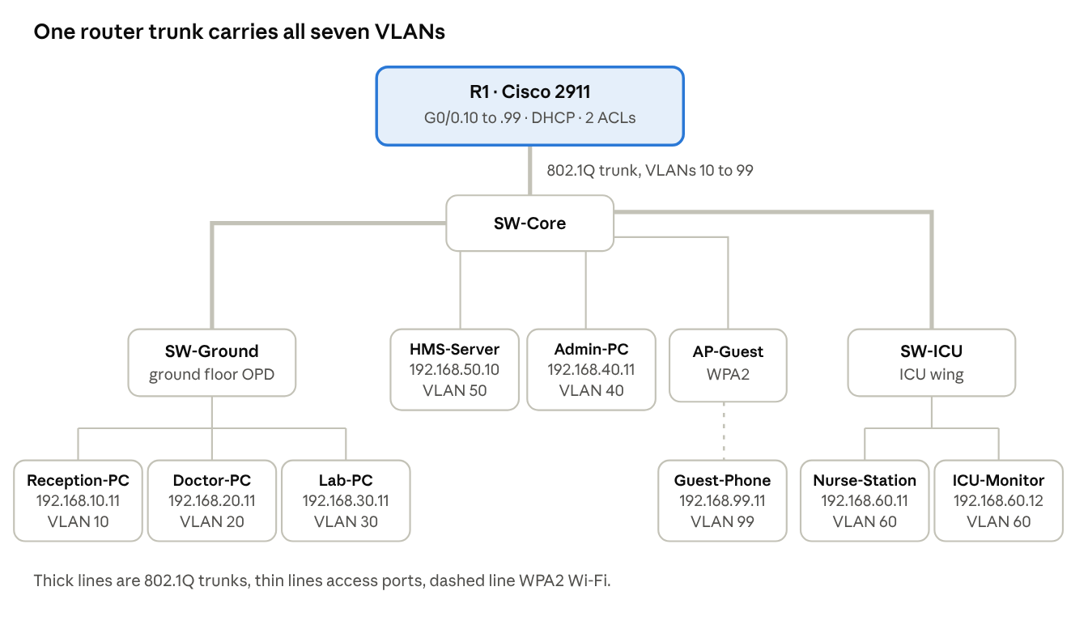
MediNet topology · 1 router, 3 switches, 1 access point, 8 end devices
Every inter-department packet climbs a trunk to R1 and comes back down in the destination VLAN; traffic inside one VLAN, such as the ICU, stays on its own switch.

Addressing and VLAN plan
VLAN | Department | Subnet | Gateway on R1 | DHCP pool | Devices
10 | Reception | 192.168.10.0/24 | 192.168.10.1 | RECEPTION, .11 to .254 | Reception-PC 192.168.10.11
20 | Doctors / OPD | 192.168.20.0/24 | 192.168.20.1 | DOCTORS, .11 to .254 | Doctor-PC 192.168.20.11
30 | Laboratory | 192.168.30.0/24 | 192.168.30.1 | LAB, .11 to .254 | Lab-PC 192.168.30.11
40 | Admin and Records | 192.168.40.0/24 | 192.168.40.1 | ADMIN, .11 to .254 | Admin-PC 192.168.40.11
50 | Servers | 192.168.50.0/24 | 192.168.50.1 | none (static) | HMS-Server 192.168.50.10
60 | ICU and IoT | 192.168.60.0/24 | 192.168.60.1 | ICU, .11 to .254 | Nurse-Station .11, ICU-Monitor .12
99 | Guest Wi-Fi | 192.168.99.0/24 | 192.168.99.1 | GUEST, .11 to .254 | Guest-Phone 192.168.99.11
Addresses .1 to .10 of every pool are excluded for gateways and static devices.

Device and port map
Device | Model | Port | Mode | Connected to
R1 | Cisco 2911 | G0/0 | Trunk, 7 subinterfaces | SW-Core G0/1
SW-Core | Cisco 2960-24TT | Fa0/1 | Access VLAN 50 | HMS-Server
SW-Core | Cisco 2960-24TT | Fa0/3 | Access VLAN 40 | Admin-PC
SW-Core | Cisco 2960-24TT | Fa0/5 | Access VLAN 99 | AP-Guest (AccessPoint-PT)
SW-Core | Cisco 2960-24TT | Fa0/24 | Trunk | SW-Ground Fa0/24
SW-Core | Cisco 2960-24TT | Fa0/23 | Trunk | SW-ICU Fa0/24
SW-Ground | Cisco 2960-24TT | Fa0/1, 0/2, 0/3 | Access VLAN 10, 20, 30 | Reception-PC, Doctor-PC, Lab-PC
SW-ICU | Cisco 2960-24TT | Fa0/1, 0/2 | Access VLAN 60 | Nurse-Station, ICU-Monitor
AP-Guest | AccessPoint-PT | Wi-Fi | SSID MediNet-Guest, WPA2-PSK | Guest-Phone (Smartphone-PT)

Security policy
Access list | Applied | Rule (in order)
GUEST_IN | R1 G0/0.99, inbound | 10 permit DHCP (UDP 67) · 20 permit DNS to 192.168.50.10 · 30 permit HTTP to 192.168.50.10 · 40 deny guest to 192.168.0.0/16 · 50 permit the rest
RECORDS_OUT | R1 G0/0.40, outbound | 10 permit TCP established · 20 permit ICMP echo-reply · 30 permit doctors 192.168.20.0/24 · 40 permit servers 192.168.50.0/24 · 50 deny everything else

4. Implementation
MediNet was built twice from the same plan: as a working network in Cisco Packet Tracer 9.0.1 (MediNet.pkt) and as a single-file web simulator that anyone can open in a browser and that explains each packet's path.

4.1 Web simulator
The simulator models every device, port, VLAN, MAC address and both access lists, and computes each result by walking the real path. It has five tabs:
Tab | What it shows
Packet trace | Pick a source, destination and traffic type (ping, web, DNS). An animated packet crosses the map; tagged frames carry a ring. The log lists every ARP, switch hop, 802.1Q tag, routing decision and ACL line. Clicking a device shows its configuration and live ARP or MAC table.
DHCP | Release and renew any client and watch Discover, Offer, Request and Acknowledge with their real fields. A cut cable makes the client fall back to an APIPA address.
Security | A matrix of six departments against six services, each cell a real trace. Clicking a cell names the deciding ACL line; a switch turns both ACLs off for comparison.
ICU monitoring | Six beds and three room sensors update every second. An alarm is sent to the nurse station (switched inside VLAN 60) and logged on the HMS server (routed to VLAN 50).
Link failures | Click any cable to cut it. A reachability table updates, and a single-point-of-failure chart cuts each cable in turn.

4.2 Packet Tracer build
The topology was placed and cabled with copper straight-through cables, then each device was configured from its CLI. The router configuration:
hostname R1
interface GigabitEthernet0/0
no shutdown
interface GigabitEthernet0/0.10
encapsulation dot1Q 10
ip address 192.168.10.1 255.255.255.0
! same for .20 .30 .40 .50 .60 .99
ip dhcp excluded-address 192.168.10.1 192.168.10.10
ip dhcp pool RECEPTION
network 192.168.10.0 255.255.255.0
default-router 192.168.10.1
dns-server 192.168.50.10
! same for DOCTORS LAB ADMIN ICU GUEST
ip access-list extended GUEST_IN
permit udp any any eq 67
permit udp 192.168.99.0 0.0.0.255 host 192.168.50.10 eq 53
permit tcp 192.168.99.0 0.0.0.255 host 192.168.50.10 eq 80
deny ip 192.168.99.0 0.0.0.255 192.168.0.0 0.0.255.255
permit ip any any
ip access-list extended RECORDS_OUT
permit tcp any any established
permit icmp any any echo-reply
permit ip 192.168.20.0 0.0.0.255 any
permit ip 192.168.50.0 0.0.0.255 any
deny ip any any
interface GigabitEthernet0/0.99
ip access-group GUEST_IN in
interface GigabitEthernet0/0.40
ip access-group RECORDS_OUT out
Each switch creates all seven VLANs, sets its uplinks to trunk mode and puts each end-device port in its access VLAN:
vlan 20
name DOCTORS_OPD
interface FastEthernet0/24
switchport mode trunk
interface FastEthernet0/2
switchport mode access
switchport access vlan 20
The HMS server has the static address 192.168.50.10, runs DNS with the A record hms.medinet.local, and serves an HMS portal page over HTTP. AP-Guest broadcasts the SSID MediNet-Guest with WPA2-PSK. Every PC and the guest phone take their address by DHCP.

5. Testing and results
All nine Packet Tracer tests gave the expected result, and the web simulator's security matrix agrees with every one of them.
# | Test in Packet Tracer | Expected | Result
1 | All PCs and the guest phone set to DHCP | Each gets .11 (ICU-Monitor .12), gateway .1, DNS 192.168.50.10 | Pass
2 | Doctor-PC: ping 192.168.50.10 | Replies, TTL 127 (routed once) | Pass
3 | Doctor-PC: ping 192.168.40.11 | Replies: RECORDS_OUT line 30 allows doctors | Pass
4 | Reception-PC: ping 192.168.40.11 | Destination host unreachable: RECORDS_OUT line 50 | Pass
5 | Reception-PC: ping 192.168.50.10 | Replies | Pass
6 | Guest-Phone: ping 192.168.40.11 | Destination host unreachable: GUEST_IN line 40 | Pass
7 | Guest-Phone: ping 192.168.50.10 | Destination host unreachable: guests get web and DNS only | Pass
8 | Guest-Phone browser: hms.medinet.local | HMS portal loads: GUEST_IN lines 20 and 30 | Pass
9 | Nurse-Station: ping 192.168.60.12 | Replies, TTL 128 (same VLAN, not routed) | Pass
The first ping in a new path loses one packet while ARP resolves the next hop; that is normal and not a failure.

Packet Tracer evidence
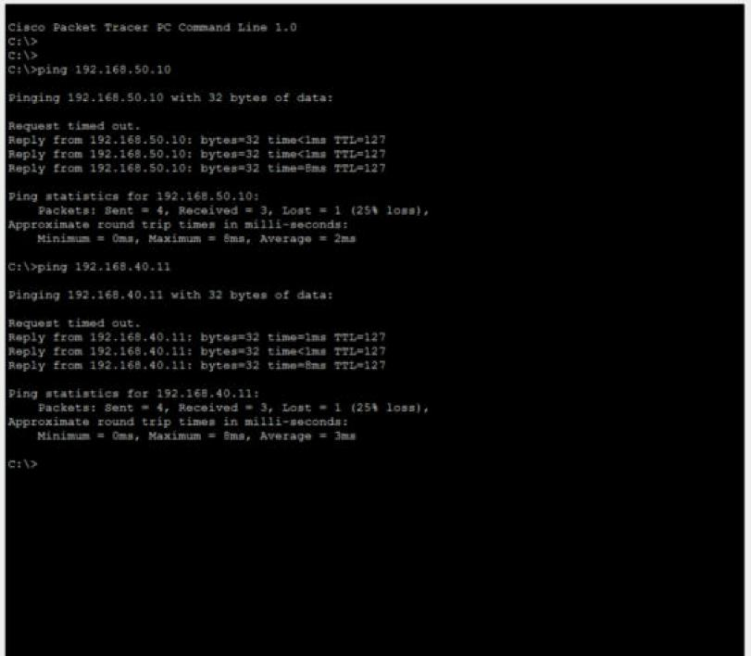
Doctor-PC reaches the server (VLAN 50) and the records PC (VLAN 40); the TTL of 127 shows one routed hop.
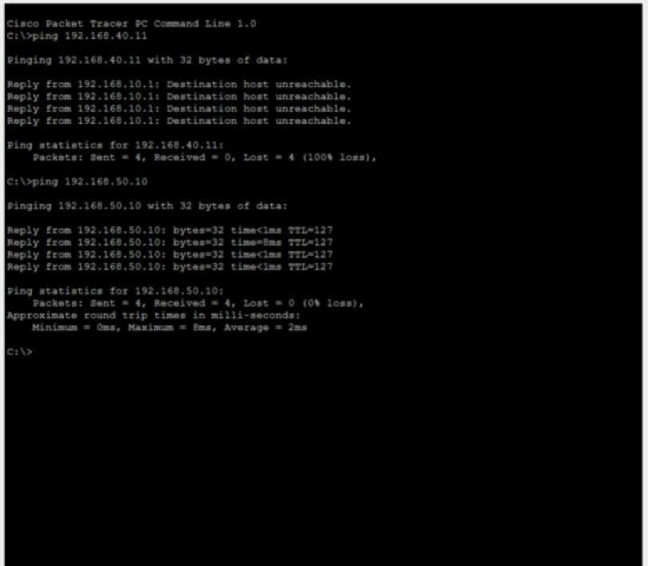
R1 answers Reception-PC with Destination host unreachable for 192.168.40.11, the RECORDS_OUT deny, while the server still replies.
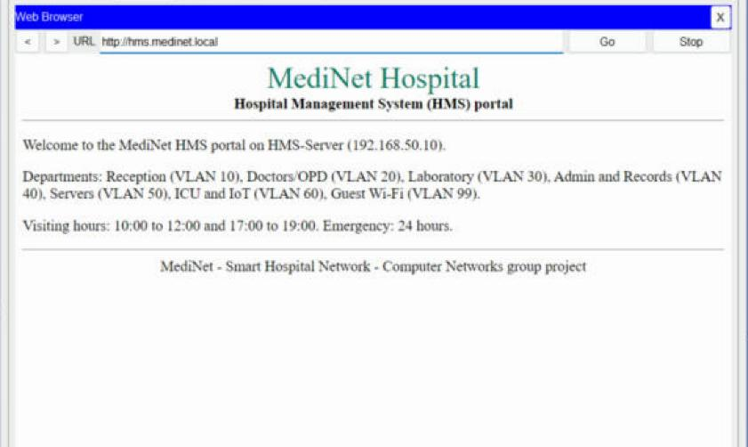
Over WPA2 Wi-Fi, Guest-Phone resolves hms.medinet.local and loads the portal; its pings to internal hosts are refused.

Single points of failure
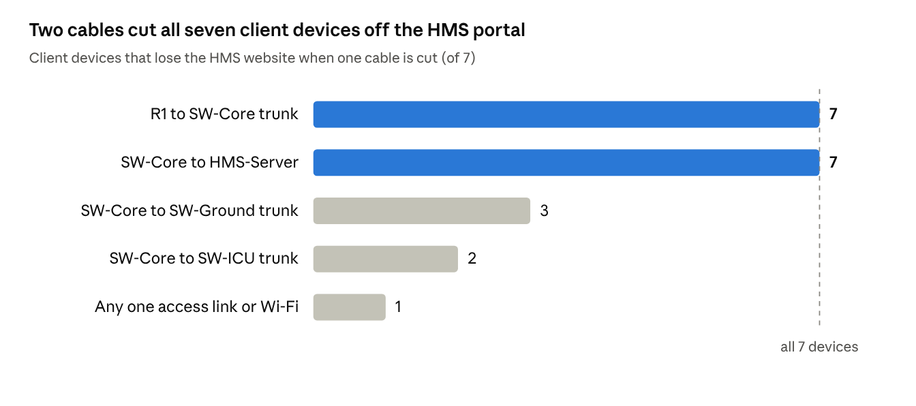
MediNet simulator, single-link failure analysis · 12 cables, 7 client devices
The R1 to SW-Core trunk and the server's own cable each cut every client off the portal; losing the trunk also stops DHCP and all inter-VLAN traffic. ICU alarms still reach the nurse station when SW-ICU is cut off, because that traffic never leaves VLAN 60.

6. Conclusion
MediNet meets every objective: seven departments are isolated on their own VLANs, one router connects them and serves all addresses, the records VLAN answers only doctors and servers, and visitors reach the portal over WPA2 Wi-Fi without seeing anything else. ICU alarms stay inside VLAN 60, so they keep flowing even if the rest of the network fails. The web simulator lets an examiner see why each packet is allowed or dropped, down to the ACL line.
Future scope
- Remove the single point of failure with a second router running HSRP and redundant uplinks protected by Rapid PVST+.
- Replace router-on-a-stick with a Layer 3 switch for faster inter-VLAN routing.
- Use VLSM, for example a /27 for the ICU, to save address space.
- Add an internet edge with NAT and a firewall, and real IoT devices registered to a Packet Tracer IoT server.
- Add port security and DHCP snooping on access ports.

References
- B. A. Forouzan, Data Communications and Networking, 5th ed., McGraw-Hill.
- A. S. Tanenbaum and D. J. Wetherall, Computer Networks, 5th ed., Pearson.
- IEEE Std 802.1Q, Bridges and Bridged Networks (VLAN tagging).
- RFC 2131, Dynamic Host Configuration Protocol.
- RFC 1035, Domain Names: Implementation and Specification.
- Cisco Networking Academy, CCNA: Switching, Routing and Wireless Essentials (VLANs, inter-VLAN routing, DHCPv4, WLAN) and Enterprise Networking (ACLs).
- Cisco Packet Tracer 9.0.1 documentation.

