|  |  |  |
| --- | --- | --- |
| **Ex.No.: 14** | | **MONGODB** |
| **Date:** | **16.10.2024** |

Structure of 'restaurants' collection:

{

"address": { "building": "1007",

"coord": [ -73.856077, 40.848447 ],

"street": "Morris Park Ave", "zipcode": "10462"

},

"borough": "Bronx",

"cuisine": "Bakery", "grades": [

{ "date": { "$date": 1393804800000 }, "grade": "A", "score": 2 },

{ "date": { "$date": 1378857600000 }, "grade": "A", "score": 6 },

{ "date": { "$date": 1358985600000 }, "grade": "A", "score": 10 },

{ "date": { "$date": 1322006400000 }, "grade": "A", "score": 9 },

{ "date": { "$date": 1299715200000 }, "grade": "B", "score": 14 }

],

"name": "Morris Park Bake Shop", "restaurant_id": "30075445"

}

1. Write a MongoDB query to find the restaurant Id, name, borough and cuisine for those restaurants which prepare dishes except 'American' and 'Chinese' or restaurant's name begin with the letter 'Wil'.

db.restaurants.find({ $or: [{ cuisine: { $nin: ["American", "Chinees"] } },{ name: { $regex:

/^Wil/i } }]},{restaurant_id: 1,name: 1,borough: 1,cuisine: 1,_id: 0 });

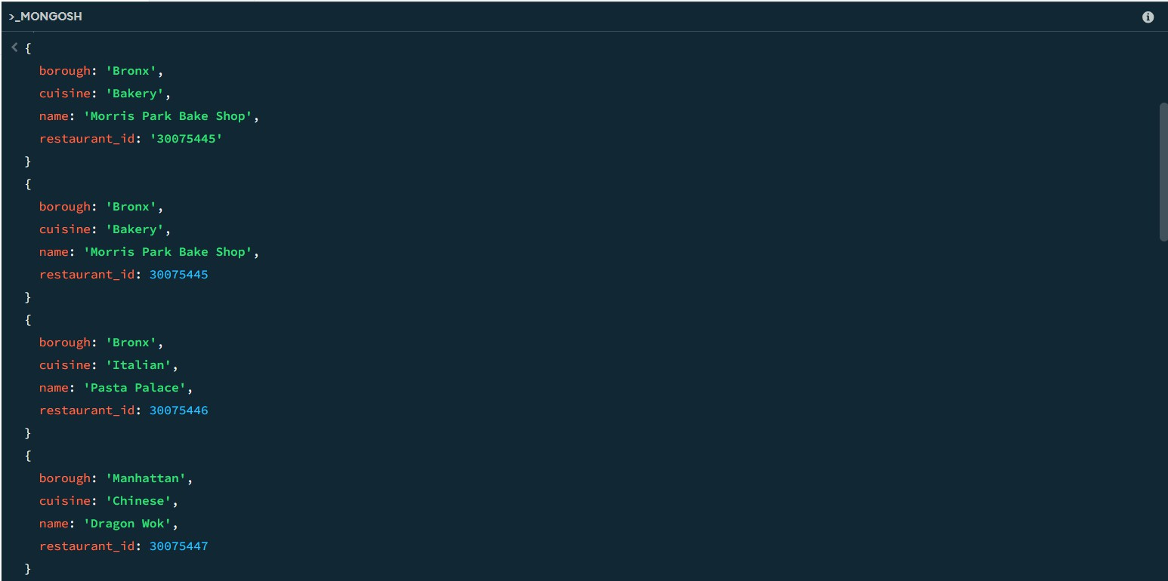

1. Write a MongoDB query to find the restaurant Id, name, and grades for those restaurants which achieved a grade of "A" and scored 11 on an ISODate "2014-08-11T00:00:00Z" among many survey dates..

db.restaurants.find({ grades: {$elemMatch: {grade: "A", score: 11}}},{restaurant_id: 1,name: 1, grades: 1, _id: 0 });

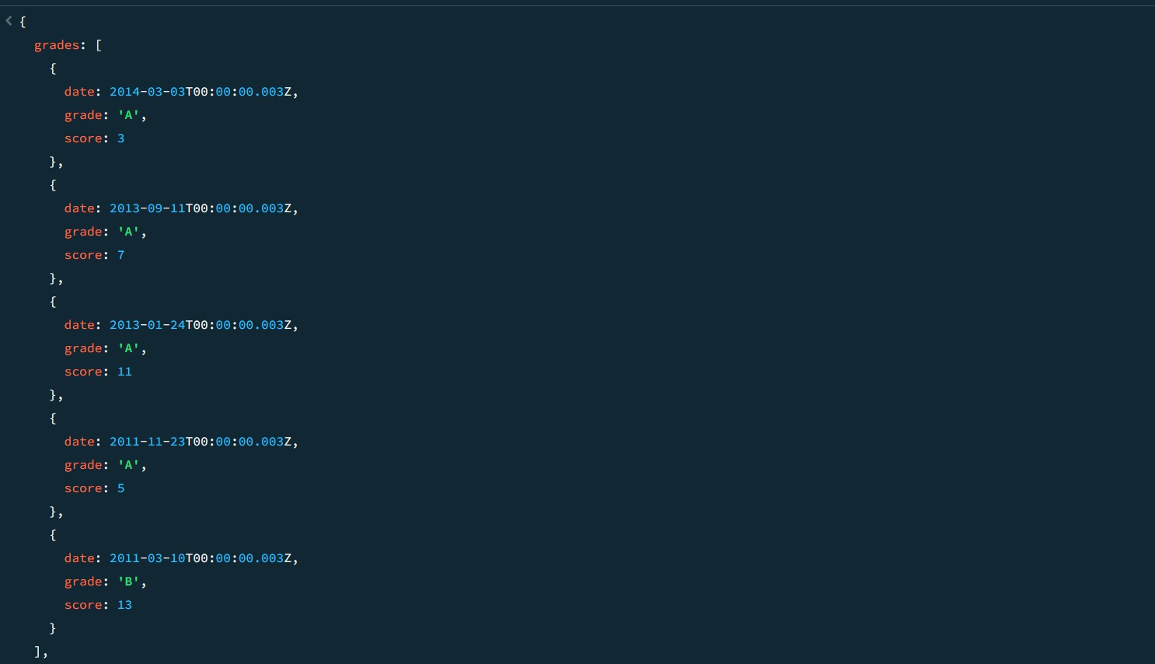

1. Write a MongoDB query to find the restaurant Id, name and grades for those restaurants where the 2nd element of grades array contains a grade of "A" and score 9 on an ISODate "2014-08-11T00:00:00Z".

db.restaurants.find({ "grades.1": {$elemMatch: {grade: "A",score: 9}}},{restaurant_id: 1, name: 1, grades: 1, _id: 0 });

1. Write a MongoDB query to find the restaurant Id, name, address and geographical location for those restaurants where 2nd element of coord array contains a value which is more than 42 and upto 52..

db.restaurants.find({ "address.coord.1": { $gt: 42, $lte: 52 }},{restaurant_id: 1,name: 1, address: 1, _id: 0 });

1. Write a MongoDB query to arrange the name of the restaurants in ascending order along with all the columns.

db.restaurants.find().sort({ name: 1 }); SAMPLE OUTPUT:-

{ _id: ObjectId('671b5e6d56ec9972ca8f5dc4'), address: { building: 5566, coord: [-73.867377,40.854047 ] , street: '28th Avenue', zipcode: 10490 } ,

borough: 'Bronx', cuisine: 'BBQ', grades: [{ date: 2014-03-03T00:00:00.028Z, grade: 'A', score: 10 },

{ date: 2013-09-11T00:00:00.028Z, grade: 'A', score: 7},

{ date: 2013-01-24T00:00:00.028Z, grade: 'A', score: 11},

{ date: 2011-11-23T00:00:00.028Z, grade: 'A', score: 9},

{ date: 2011-03-10T00:00:00.028Z, grade: 'B', score: 15}],

name: 'BBQ Haven', restaurant_id: 30075473 }

{ _id: ObjectId('671b5dab56ec9972ca8f5db0'), address: { building: 5566, coord: [ -73.859377, 40.850047

],

street: '8th Avenue', zipcode: 10470

},

borough: 'Manhattan', cuisine: 'French', grades: [

{

date: 2014-03-03T00:00:00.008Z,

grade: 'A', score: 7

},

{

date: 2013-09-11T00:00:00.008Z,

grade: 'A', score: 9

},

{

date: 2013-01-24T00:00:00.008Z,

grade: 'A', score: 10

},{

date: 2011-03-10T00:00:00.008Z,

grade: 'A', score: 6

}], name: 'Bistro Belle', restaurant_id: 30075453

}

1. Write a MongoDB query to arrange the name of the restaurants in descending along with all the columns.

db.restaurants.find().sort({ name: -1 }); SAMPLE OUTPUT:-

{

_id: ObjectId('671b5e9456ec9972ca8f5dc8'), address: {

building: 9900, coord: [

-73.868977,

40.854847

],

street: '32nd Avenue', zipcode: 10494

},

borough: 'Manhattan', cuisine: 'Russian', grades: [

{

date: 2014-03-03T00:00:00.032Z,

grade: 'A', score: 10

},

{

date: 2013-09-11T00:00:00.032Z,

grade: 'B', score: 5

},

{

date: 2013-01-24T00:00:00.032Z,

grade: 'A', score: 9

},

{

date: 2011-11-23T00:00:00.032Z,

grade: 'A', score: 8

},

{

date: 2011-03-10T00:00:00.032Z,

grade: 'A', score: 11

}

], name: "Tsar's Table",

restaurant_id: 30075477

}

{

_id: ObjectId('671b5e6d56ec9972ca8f5dbe'), address: {

building: 9900, coord: [

-73.864977,

40.852847

],

street: '22nd Avenue', zipcode: 10484

},

borough: 'Bronx', cuisine: 'Italian', grades: [

{

date: 2014-03-03T00:00:00.022Z,

grade: 'A', score: 8

},

{

date: 2013-09-11T00:00:00.022Z,

grade: 'B', score: 5

},

{

date: 2013-01-24T00:00:00.022Z,

grade: 'A', score: 12

},

{

date: 2011-11-23T00:00:00.022Z,

grade: 'A', score: 9

},

{

date: 2011-03-10T00:00:00.022Z,

grade: 'A', score: 14

}

], name: 'Trattoria Bella', restaurant_id: 30075467

}

1. Write a MongoDB query to arrange the name of the cuisine in ascending order and for that the same cuisine borough should be in descending order.

db.restaurants.find().sort({ cuisine: 1, borough: -1 }); SAMPLE OUTPUT:-

{

_id: ObjectId('671b5d549d3d63480e0a64e9'), address: {

building: 2233, coord: [

-73.858177,

40.849447

],

street: '5th Avenue', zipcode: 10467

},

borough: 'Bronx', cuisine: 'American', grades: [

{

date: 2014-03-03T00:00:00.005Z,

grade: 'A', score: 10

},

{

date: 2013-09-11T00:00:00.005Z,

grade: 'A', score: 6

},

{

date: 2013-01-24T00:00:00.005Z,

grade: 'B', score: 12

},

{

date: 2011-11-23T00:00:00.005Z,

grade: 'A', score: 9

},

{

date: 2011-03-10T00:00:00.005Z,

grade: 'A', score: 14

}

], name: 'Burger Bistro', restaurant_id: 30075450

}

{

_id: ObjectId('671b5e6d56ec9972ca8f5dc4'), address: {

building: 5566, coord: [

-73.867377,

40.854047

],

street: '28th Avenue', zipcode: 10490

},

borough: 'Bronx', cuisine: 'BBQ', grades: [

{

date: 2014-03-03T00:00:00.028Z,

grade: 'A', score: 10

},

{

date: 2013-09-11T00:00:00.028Z,

grade: 'A', score: 7

},

{

date: 2013-01-24T00:00:00.028Z,

grade: 'A', score: 11

},

{

date: 2011-11-23T00:00:00.028Z,

grade: 'A', score: 9

},

{

date: 2011-03-10T00:00:00.028Z,

grade: 'B', score: 15

}

], name: 'BBQ Haven', restaurant_id: 30075473

}

1. 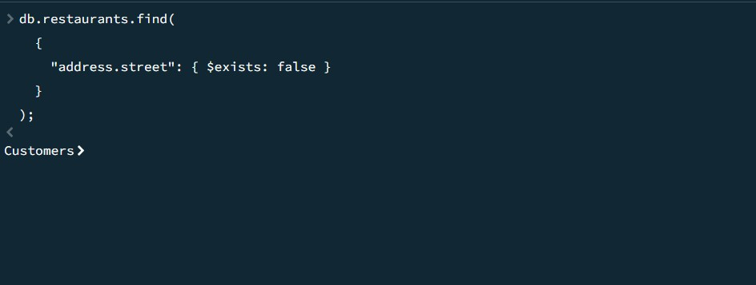Write a MongoDB query to know whether all the addresses contain the street or not. db.restaurants.find({"address.street": { $exists: false }});
2. Write a MongoDB query which will select all documents in the restaurants collection where the coord field value is Double.

db.restaurants.find({ "address.coord": { $type: "double" }});

SAMPLE OUTPUT:-

{

_id: ObjectId('671b92d339ec8a9bc8b6588b'), address: {

building: '1007', coord: [

-73.856077,

40.848447

],

street: 'Morris Park Ave', zipcode: '10462'

},

borough: 'Bronx', cuisine: 'Bakery', grades: [

{

date: 2014-03-03T00:00:00.000Z,

grade: 'A', score: 2

},

{

date: 2013-09-11T00:00:00.000Z,

grade: 'A', score: 6

},

{

date: 2013-01-24T00:00:00.000Z,

grade: 'A', score: 10

},

{

date: 2011-11-23T00:00:00.000Z,

grade: 'A', score: 9

},

{

date: 2011-03-10T00:00:00.000Z,

grade: 'B', score: 14

}

], name: 'Morris Park Bake Shop', restaurant_id: '30075445'

}

{

_id: ObjectId('671b5d549d3d63480e0a64e5'), address: {

building: 1234, coord: [

-73.856577,

40.848647

],

street: '1st Avenue', zipcode: 10463

},

borough: 'Bronx', cuisine: 'Italian', grades: [

{

date: 2014-03-03T00:00:00.001Z,

grade: 'A', score: 5

},

{

date: 2013-09-11T00:00:00.001Z,

grade: 'A', score: 8

},

{

date: 2013-01-24T00:00:00.001Z,

grade: 'B', score: 12

},

{

date: 2011-11-23T00:00:00.001Z,

grade: 'A', score: 7

},

{

date: 2011-03-10T00:00:00.001Z,

grade: 'A', score: 15

}

], name: 'Pasta Palace', restaurant_id: 30075446

}

1. Write a MongoDB query which will select the restaurant Id, name and grades for those restaurants which return 0 as a remainder after dividing the score by 7.

db.restaurants.find({"grades.score": { $mod: [7, 0] }},{restaurant_id: 1,name: 1,grades: 1,

_id: 0});

SAMPLE OUTPUT:-

{

grades: [

{

date: 2014-03-03T00:00:00.000Z,

grade: 'A', score: 2

},

{

date: 2013-09-11T00:00:00.000Z,

grade: 'A', score: 6

},

{

date: 2013-01-24T00:00:00.000Z,

grade: 'A', score: 10

},

{

date: 2011-11-23T00:00:00.000Z,

grade: 'A', score: 9

},

{

date: 2011-03-10T00:00:00.000Z,

grade: 'B', score: 14

}

], name: 'Morris Park Bake Shop', restaurant_id: '30075445'

}

{

grades: [

{

date: 2014-03-03T00:00:00.001Z,

grade: 'A', score: 5

},

{

date: 2013-09-11T00:00:00.001Z,

grade: 'A', score: 8

},

{

date: 2013-01-24T00:00:00.001Z,

grade: 'B', score: 12

},

{

date: 2011-11-23T00:00:00.001Z,

grade: 'A', score: 7

},

{

date: 2011-03-10T00:00:00.001Z,

grade: 'A', score: 15

}

], name: 'Pasta Palace', restaurant_id: 30075446

}

1. Write a MongoDB query to find the restaurant name, borough, longitude and attitude and cuisine for those restaurants which contain 'mon' as three letters somewhere in its name.

db.restaurants.find({name: { $regex: /mon/i }},{name: 1, borough: 1,"address.coord.0": 1, "address.coord.1": 1, cuisine: 1, _id: 0});

1. Write a MongoDB query to find the restaurant name, borough, longitude and latitude and cuisine for those restaurants which contain 'Mad' as the first three letters of its name.

db.restaurants.find({name: { $regex: /^Mad/i }},{name: 1,borough: 1,"address.coord.0": 1, "address.coord.1": 1, cuisine: 1,_id: 0});

1. Write a MongoDB query to find the restaurants that have at least one grade with a score of less than 5.

db.restaurants.find({"grades.score": { $lt: 5 }}); SAMPLE OUTPUT:-

{

_id: ObjectId('671b92d339ec8a9bc8b6588b'), address: {

building: '1007', coord: [

-73.856077,

40.848447

],

street: 'Morris Park Ave', zipcode: '10462'

},

borough: 'Bronx', cuisine: 'Bakery', grades: [

{

date: 2014-03-03T00:00:00.000Z,

grade: 'A', score: 2

},

{

date: 2013-09-11T00:00:00.000Z,

grade: 'A', score: 6

},

{

date: 2013-01-24T00:00:00.000Z,

grade: 'A', score: 10

},

{

date: 2011-11-23T00:00:00.000Z,

grade: 'A', score: 9

},

{

date: 2011-03-10T00:00:00.000Z,

grade: 'B', score: 14

}

], name: 'Morris Park Bake Shop', restaurant_id: '30075445'

}

{

_id: ObjectId('671b5d549d3d63480e0a64e6'), address: {

building: 5678, coord: [

-73.856977,

40.848847

],

street: '2nd Avenue', zipcode: 10464

},

borough: 'Manhattan', cuisine: 'Chinese', grades: [

{

date: 2014-03-03T00:00:00.002Z,

grade: 'B', score: 4

},

{

date: 2013-09-11T00:00:00.002Z,

grade: 'A', score: 9

},

{

date: 2013-01-24T00:00:00.002Z,

grade: 'A', score: 10

},

{

date: 2011-11-23T00:00:00.002Z,

grade: 'A', score: 8

},

{

date: 2011-03-10T00:00:00.002Z,

grade: 'B', score: 16

}

], name: 'Dragon Wok', restaurant_id: 30075447

}

1. Write a MongoDB query to find the restaurants that have at least one grade with a score of less than 5 and that are located in the borough of Manhattan.

db.restaurants.find({"grades.score": { $lt: 5 },borough: "Manhattan"});

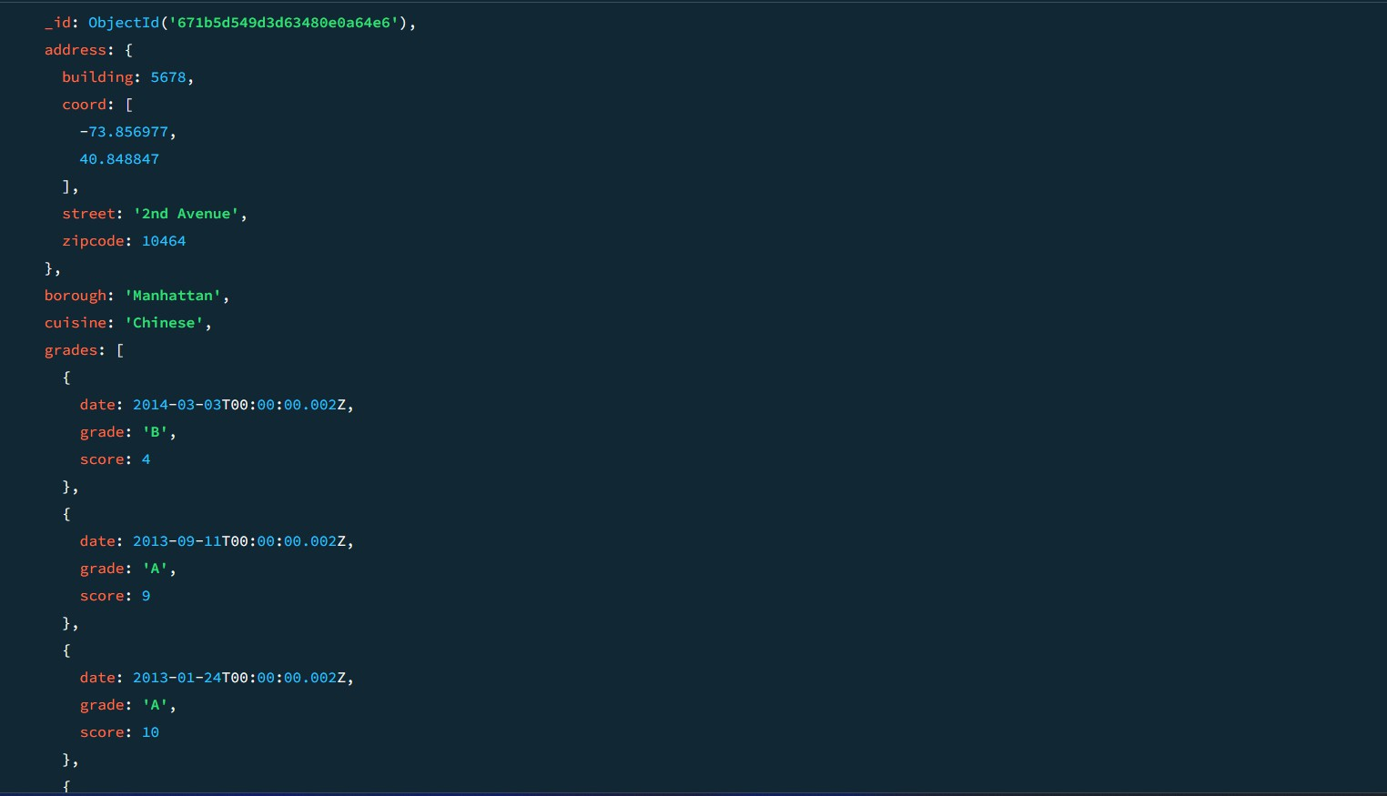

1. Write a MongoDB query to find the restaurants that have at least one grade with a score of less than 5 and that are located in the borough of Manhattan or Brooklyn.

db.restaurants.find({"grades.score": { $lt: 5 },borough: { $in: ["Manhattan", "Brooklyn"] }});

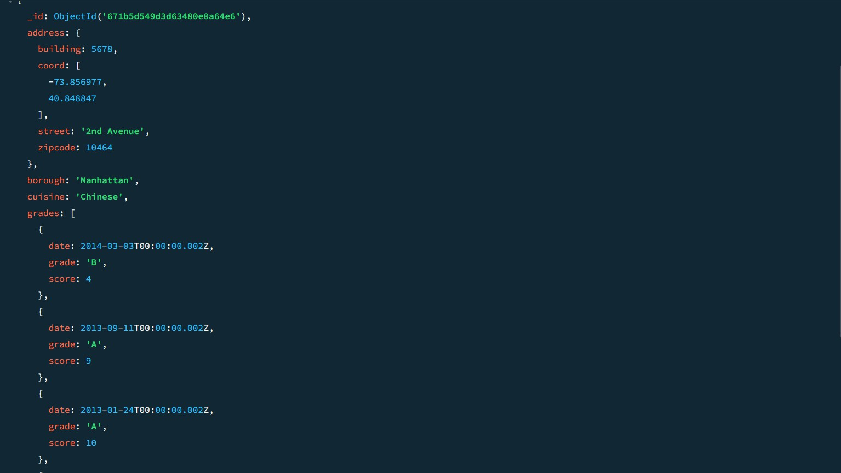

1. Write a MongoDB query to find the restaurants that have at least one grade with a score of less than 5 and that are located in the borough of Manhattan or Brooklyn, and their cuisine is not American.

db.restaurants.find({"grades.score": { $lt: 5 },borough: { $in: ["Manhattan", "Brooklyn"]}, cuisine: { $ne: "American" }});

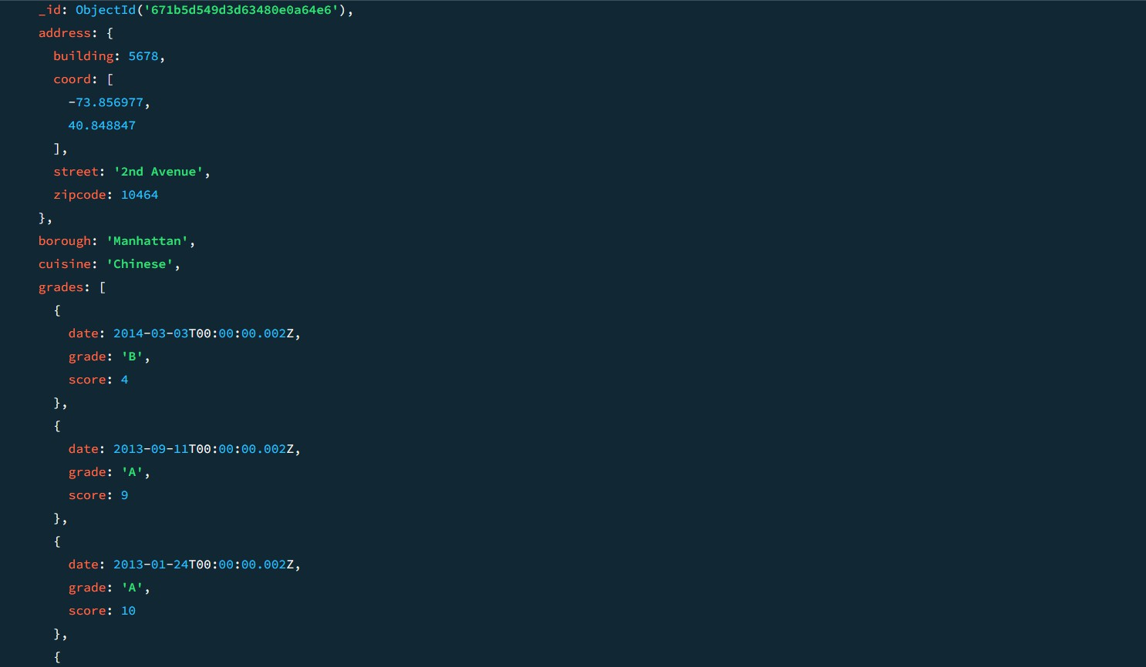

1. Write a MongoDB query to find the restaurants that have at least one grade with a score of less than 5 and that are located in the borough of Manhattan or Brooklyn, and their cuisine is not American or Chinese.

db.restaurants.find({"grades.score": { $lt: 5 },borough: { $in: ["Manhattan", "Brooklyn"]

},cuisine: { $nin: ["American", "Chinese"] }});

1. Write a MongoDB query to find the restaurants that have a grade with a score of 2 and a grade with a score of 6.

db.restaurants.find({grades: {$all: [{ $elemMatch: { score: 2 } },{ $elemMatch: { score: 6 }

}]}});

SAMPLE OUTPUT:-

{

_id: ObjectId('671b92d339ec8a9bc8b6588b'), address: {

building: '1007', coord: [

-73.856077,

40.848447

],

street: 'Morris Park Ave', zipcode: '10462'

},

borough: 'Bronx', cuisine: 'Bakery', grades: [

{

date: 2014-03-03T00:00:00.000Z,

grade: 'A', score: 2

},

{

date: 2013-09-11T00:00:00.000Z,

grade: 'A', score: 6

},

{

date: 2013-01-24T00:00:00.000Z,

grade: 'A', score: 10

},

{

date: 2011-11-23T00:00:00.000Z,

grade: 'A', score: 9

},

{

date: 2011-03-10T00:00:00.000Z,

grade: 'B', score: 14

}

], name: 'Morris Park Bake Shop', restaurant_id: '30075445'

}

{

_id: ObjectId('671b5c5f9d3d63480e0a64e4'), address: {

building: 1007, coord: [

-73.856077,

40.848447

],

street: 'Morris Park Ave', zipcode: 10462

},

borough: 'Bronx', cuisine: 'Bakery', grades: [

{

date: 2014-03-03T00:00:00.000Z,

grade: 'A', score: 2

},

{

date: 2013-09-11T00:00:00.000Z,

grade: 'A', score: 6

},

{

date: 2013-01-24T00:00:00.000Z,

grade: 'A', score: 10

},

{

date: 2011-11-23T00:00:00.000Z,

grade: 'A', score: 9

},

{

date: 2011-03-10T00:00:00.000Z,

grade: 'B', score: 14

}

], name: 'Morris Park Bake Shop', restaurant_id: 30075445

}

1. Write a MongoDB query to find the restaurants that have a grade with a score of 2 and a grade with a score of 6 and are located in the borough of Manhattan.

db.restaurants.find({borough: "Manhattan",grades: {$all: [{ $elemMatch: { score: 2 } },{

$elemMatch: { score: 6 }}]}});

1. Write a MongoDB query to find the restaurants that have a grade with a score of 2 and a grade with a score of 6 and are located in the borough of Manhattan or Brooklyn.

db.restaurants.find({borough: { $in: ["Manhattan", "Brooklyn"] },grades: {$all: [

{ $elemMatch: { score: 2 } },{ $elemMatch: { score: 6 }}]}});

1. Write a MongoDB query to find the restaurants that have a grade with a score of 2 and a grade with a score of 6 and are located in the borough of Manhattan or Brooklyn, and their cuisine is not American.

db.restaurants.find({borough: { $in: ["Manhattan", "Brooklyn"] },grades: {$all: [{

$elemMatch: { score: 2 }},{ $elemMatch: { score: 6 }}]},cuisine: { $ne: "American" }});

1. Write a MongoDB query to find the restaurants that have a grade with a score of 2 and a grade with a score of 6 and are located in the borough of Manhattan or Brooklyn, and their cuisine is not American or Chinese.

db.restaurants.find({borough: { $in: ["Manhattan", "Brooklyn"] },grades: {$all: [

{ $elemMatch: { score: 2 } },{ $elemMatch: { score: 6 }}]},cuisine: { $nin: ["American", "Chinese"] }});

1. Write a MongoDB query to find the restaurants that have a grade with a score of 2 or a grade with a score of 6.

db.restaurants.find({$or: [{ "grades.score": 2 },{ "grades.score": 6 }]}); SAMPLE OUTPUT:-

{

_id: ObjectId('671b5d549d3d63480e0a64e9'), address: {

building: 2233, coord: [

-73.858177,

40.849447

],

street: '5th Avenue', zipcode: 10467

},

borough: 'Bronx', cuisine: 'American', grades: [

{

date: 2014-03-03T00:00:00.005Z,

grade: 'A', score: 10

},

{

date: 2013-09-11T00:00:00.005Z,

grade: 'A', score: 6

},

{

date: 2013-01-24T00:00:00.005Z,

grade: 'B', score: 12

},

{

date: 2011-11-23T00:00:00.005Z,

grade: 'A', score: 9

},

{

date: 2011-03-10T00:00:00.005Z,

grade: 'A', score: 14

}

], name: 'Burger Bistro', restaurant_id: 30075450

}

{

_id: ObjectId('671b5dab56ec9972ca8f5daf'), address: {

building: 4455, coord: [

-73.858977,

40.849847

],

street: '7th Avenue', zipcode: 10469

},

borough: 'Bronx', cuisine: 'Thai', grades: [

{

date: 2014-03-03T00:00:00.007Z,

grade: 'A', score: 9

},

{

date: 2013-09-11T00:00:00.007Z,

grade: 'B', score: 6

},

{

date: 2013-01-24T00:00:00.007Z,

grade: 'A', score: 12

},

{

date: 2011-11-23T00:00:00.007Z,

grade: 'A', score: 8

},

{

date: 2011-03-10T00:00:00.007Z,

grade: 'B', score: 14

}

], name: 'Thai Delight', restaurant_id: 30075452

}

Sample document of 'movies' collection

{

_id: ObjectId("573a1390f29313caabcd42e8"),

plot: 'A group of bandits stage a brazen train hold-up, only to find a determined posse hot on their heels.',

genres: [ 'Short', 'Western' ], runtime: 11,

cast: [

'A.C. Abadie',

"Gilbert M. 'Broncho Billy' Anderson", 'George Barnes',

'Justus D. Barnes'

],

poster: 'https://m.media- amazon.com/images/M/MV5BMTU3NjE5NzYtYTYyNS00MDVmLWIwYjgtMmYwYWIxZ DYyNzU2XkEyXkFqcGdeQXVyNzQzNzQxNzI@._V1_SY1000_SX677_AL_.jpg',

title: 'The Great Train Robbery',

full plot: "Among the earliest existing films in American cinema - notable as the first film that presented a narrative story to tell - it depicts a group of cowboy outlaws who hold up a train and

rob the passengers. They are then pursued by a Sheriff's posse. Several scenes have color included - all hand tinted.",

languages: [ 'English' ],

released: ISODate("1903-12-01T00:00:00.000Z"),

directors: [ 'Edwin S. Porter' ], rated: 'TV-G',

awards: { wins: 1, nominations: 0, text: '1 win.' }, lastupdated: '2015-08-13 00:27:59.177000000',

year: 1903,

imdb: { rating: 7.4, votes: 9847, id: 439 }, countries: [ 'USA' ],

type: 'movie', tomatoes: {

viewer: { rating: 3.7, numReviews: 2559, meter: 75 },

fresh: 6,

critic: { rating: 7.6, numReviews: 6, meter: 100 },

rotten: 0,

lastUpdated: ISODate("2015-08-08T19:16:10.000Z")

}

1. Find all movies with full information from the 'movies' collection that released in the year 1893.

db.movies.find({ year: 1893 });

1. Find all movies with full information from the 'movies' collection that have a runtime greater than 120 minutes.

db.movies.find({ runtime: { $gt: 120 } });

SAMPLE OUTPUT:-

{

_id: ObjectId('573a1390f29313caabcd42ec'),

plot: 'An astronaut stranded on Mars must survive alone.', genres: [

'Sci-Fi', 'Drama'

],

runtime: 135, cast: [

'Matt Damon', 'Jessica Chastain'

], poster: 'https://m.media-amazon.com/images/poster4.jpg', title: 'Mars Alone',

fullplot: 'An astronaut, left alone on Mars, struggles to survive with limited resources while awaiting rescue.',

languages: [ 'English'

],

released: 2015-10-02T00:00:00.000Z,

directors: [ 'Ridley Scott'

],

rated: 'PG-13', awards: { wins: 8,

nominations: 6,

text: '8 wins & 6 nominations.'

},

lastupdated: '2021-08-09 17:22:30.000000000',

year: 2015, imdb: { rating: 8,

votes: 25650,

id: 443

},

countries: [ 'USA'

],

type: 'movie', tomatoes: { viewer: { rating: 4.5,

numReviews: 2201,

meter: 93

},

fresh: 18, critic: { rating: 8.5,

numReviews: 25,

meter: 96

},

rotten: 1,

lastUpdated: 2021-07-19T21:20:55.000Z

}

}

1. Find all movies with full information from the 'movies' collection that have the "Short" genre.

db.movies.find({ genres: "Short" });

SAMPLE OUTPUT:-

{

_id: ObjectId('573a1390f29313caabcd42e8'),

plot: 'A group of bandits stage a brazen train hold-up, only to find a determined posse hot on their heels.',

genres: [ 'Short', 'Western'

],

runtime: 11, cast: [

'A.C. Abadie',

"Gilbert M. 'Broncho Billy' Anderson", 'George Barnes',

'Justus D. Barnes'

], poster:

'https://m.media-amazon.com/images/M/MV5BMTU3NjE5NzYtYTYyNS 00MDVmLWIwYjgtMmYwYWIxZDYyNzU2XkEyXkFqcGdeQXVyNzQzNz QxNzI@._V1_SY1000_SX677_AL_.jpg',

title: 'The Great Train Robbery',

fullplot: "Among the earliest existing films in American cinema - notable as the first film that presented a narrative story to tell - it depicts a group of cowboy outlaws who hold up a train and rob the passengers. They are then pursued by a Sheriff's posse. Several scenes have color included - all hand tinted.",

languages: [ 'English'

],

released: 1903-12-01T00:00:00.000Z,

directors: [ 'Edwin S. Porter'

],

rated: 'TV-G', awards: { wins: 1,

nominations: 0,

text: '1 win.'

},

lastupdated: '2015-08-13 00:27:59.177000000',

year: 1903,

imdb: { rating: 7.4,

votes: 9847,

id: 439

},

countries: [ 'USA'

],

type: 'movie', tomatoes: { viewer: { rating: 3.7,

numReviews: 2559,

meter: 75

},

fresh: 6, critic: { rating: 7.6,

numReviews: 6,

meter: 100

},

rotten: 0,

lastUpdated: 2015-08-08T19:16:10.000Z

}

}

1. Retrieve all movies from the 'movies' collection that were directed by “William K.L. Dickson” and include complete information for each movie.

db.movies.find({ directors: "William K.L. Dickson" });

1. Retrieve all movies from the 'movies' collection that were released in the USA and include complete information for each movie.

db.movies.find({ countries: "USA" });

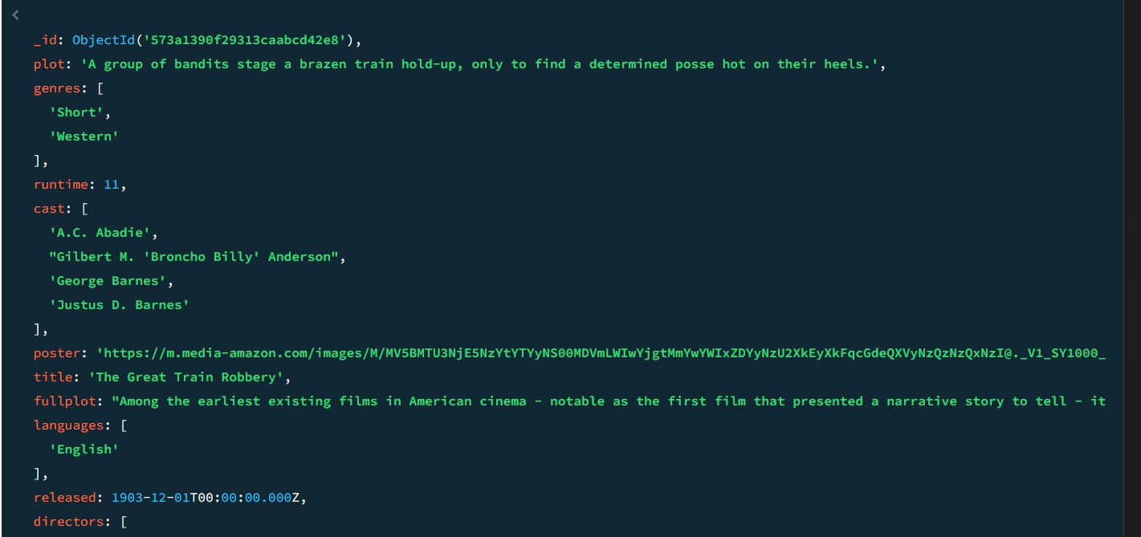

1. Retrieve all movies from the 'movies' collection that have complete information and are rated as "UNRATED".

db.movies.find({ rated: "UNRATED" });

1. Retrieve all movies from the 'movies' collection that have complete information and have received more than 1000 votes on IMDb.

db.movies.find({ "imdb.votes": { $gt: 1000 } });

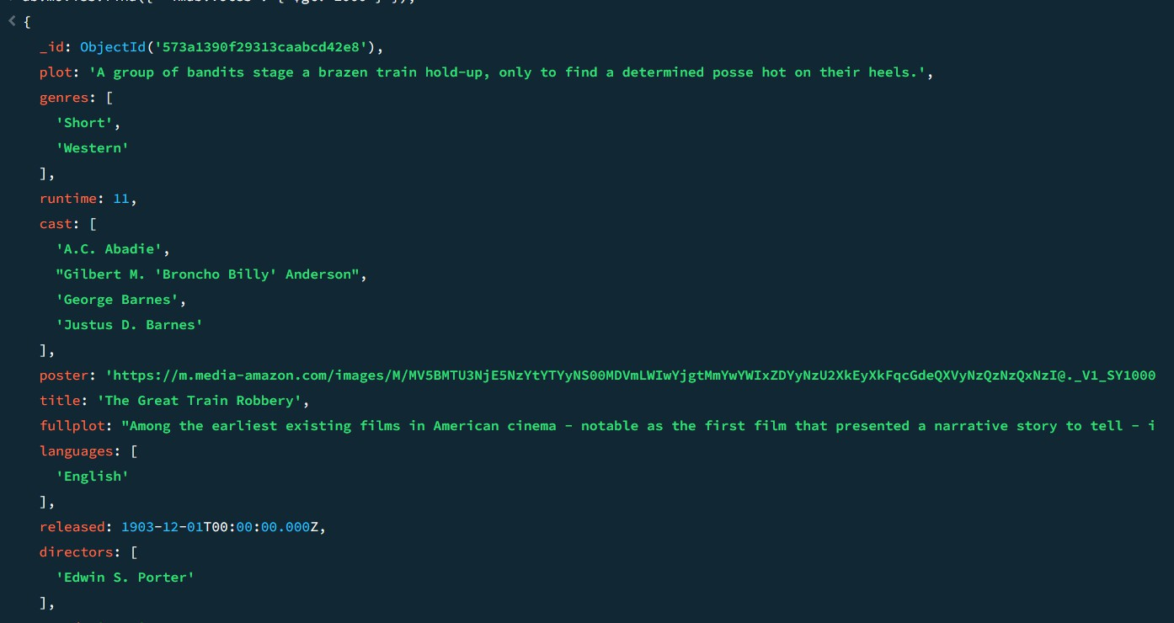

1. Retrieve all movies from the 'movies' collection that have complete information and have an IMDb rating higher than 7.

db.movies.find({ "imdb.rating": { $gt: 7 } });

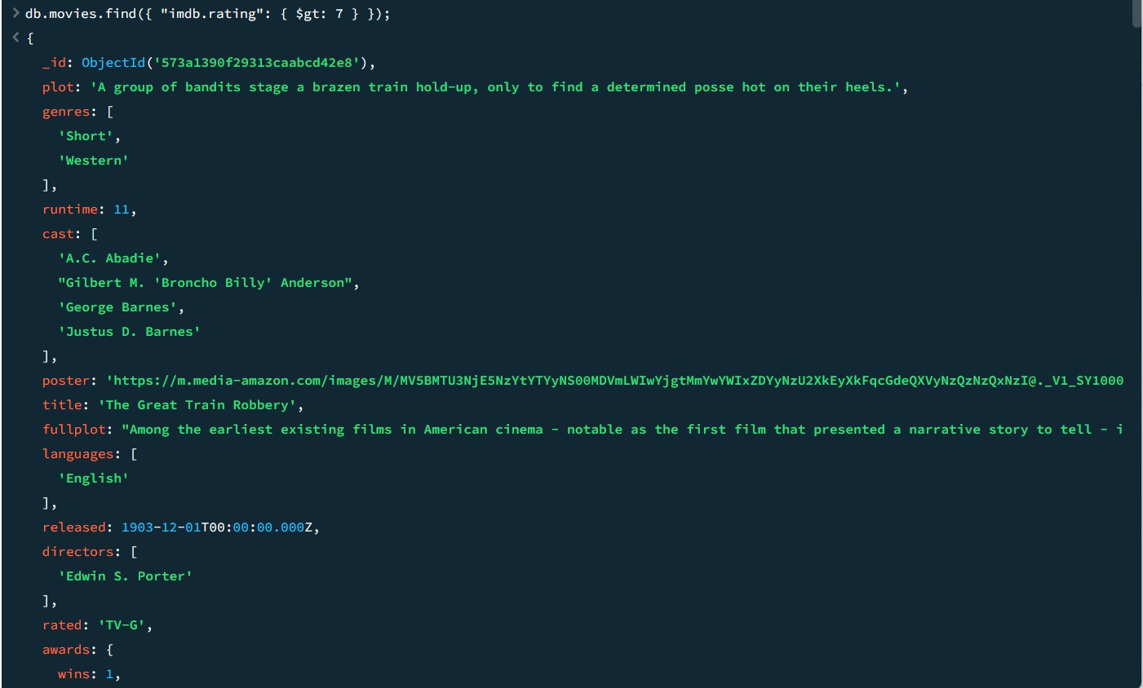

1. Retrieve all movies from the 'movies' collection that have complete information and have a viewer rating higher than 4 on Tomatoes.

db.movies.find({ "tomatoes.viewer.rating": { $gt: 4 } });

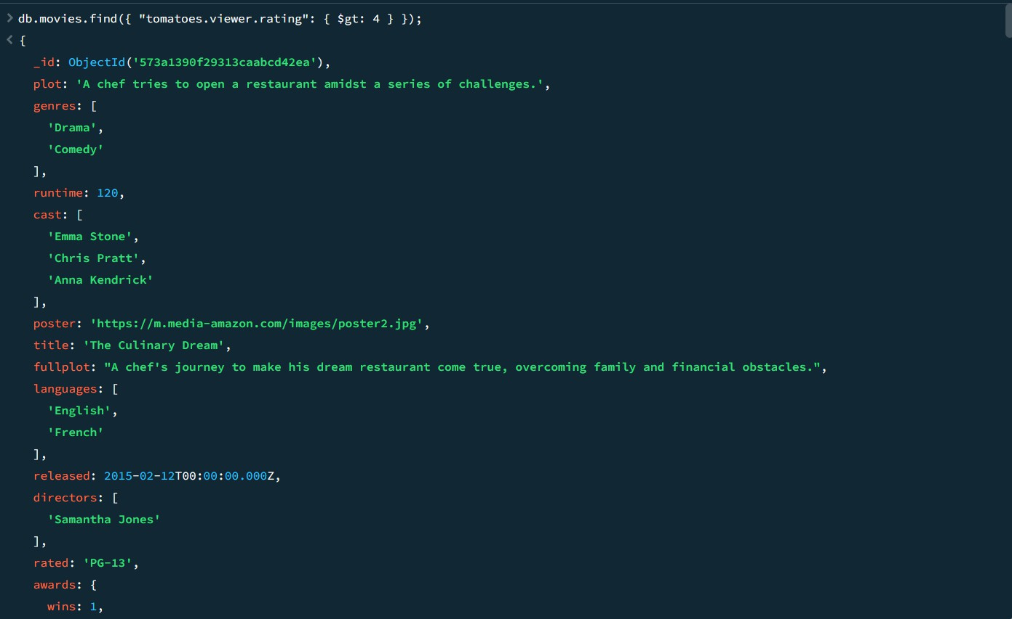

1. 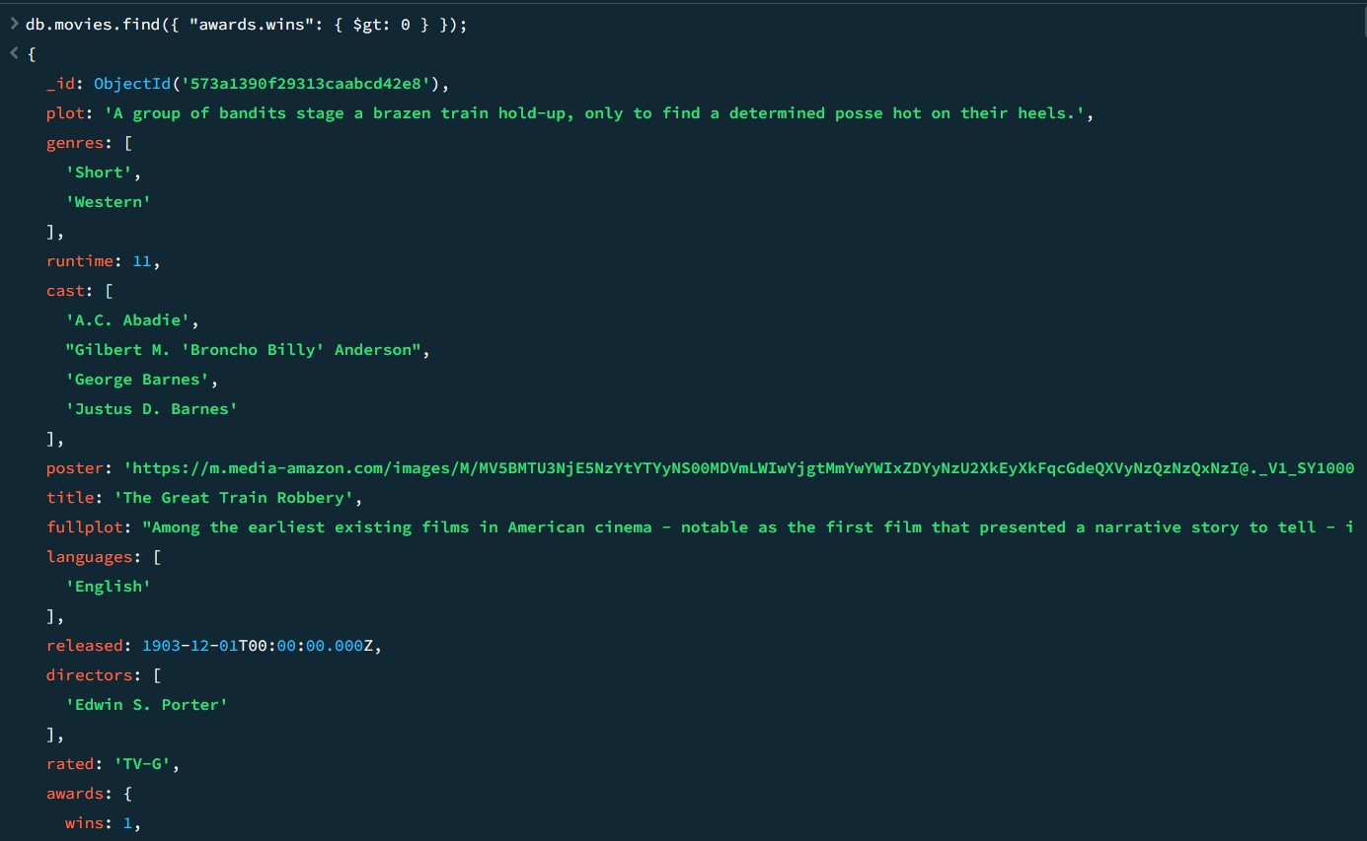Retrieve all movies from the 'movies' collection that have received an award. db.movies.find({ "awards.wins": { $gt: 0 } });
2. Find all movies with title, languages, released, directors, writers, awards, year, genres, runtime, cast, countries from the 'movies' collection in MongoDB that have at least one nomination.

db.movies.find({ "awards.nominations": { $gt: 0 }},{title: 1,languages: 1,released: 1, directors: 1, writers: 1,awards: 1,year: 1,genres: 1,runtime: 1,cast: 1,countries: 1});

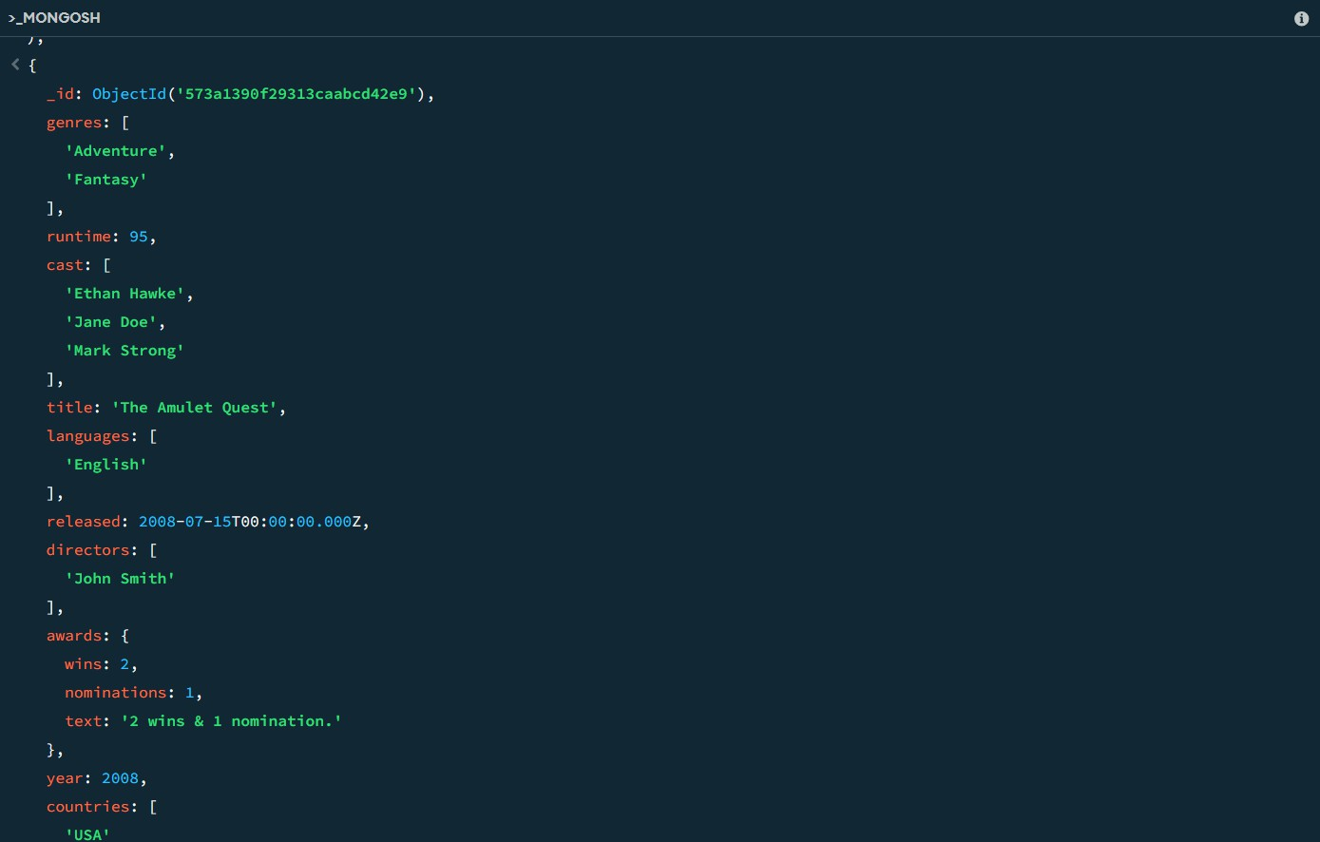

1. Find all movies with title, languages, released, directors, writers, awards, year, genres, runtime, cast, countries from the 'movies' collection in MongoDB with cast including "Charles Kayser".

db.movies.find({ cast: "Charles Kayser" },{title: 1,languages: 1,released: 1,directors: 1,writers: 1,awards: 1,year: 1,genres: 1,runtime: 1,cast: 1,countries: 1});

1. Retrieve all movies with title, languages, released, directors, writers, countries from the 'movies' collection in MongoDB that was released on May 9, 1893.

db.movies.find({ released: ISODate("1893-05-09T00:00:00Z") },{title: 1,languages: 1,released: 1,directors: 1,writers: 1,countries: 1});

1. Retrieve all movies with title, languages, released, directors, writers, countries from the 'movies' collection in MongoDB that have the word "scene" in the title.

db.movies.find(

{ title: { $regex: /scene/i } },{title: 1,languages: 1,released: 1,directors: 1,writers: 1, countries: 1});