RAJALAKSHMI ENGINEERING COLLEGE
THANDALAM-602105
Department of CSE

Lab Questions

Class : IV Year CSE, VII Sem
Subject code and Subject :CS23B39 –MLOPS Lab
Marks Distribution

Aim  (5) | Algorithm  Procedure (10) | Program1  (25) | Program2  (15) | Output1  (20) | Output2  (10) | Viva  (10) | TOTAL  (100)

1.
a. Explain the exact operational difference between staging changes via 'git add' and committing them via 'git commit'. Provide the terminal commands required to:
a) Check the status of the workspace.
b) Stage a specific file named 'index.html'.
c) Commit the staged changes with a professional commit message.
d) View the detailed line-by-line file modifications before staging them.

b. Install Git, Docker & Jenkins on Ubuntu VM/Windows. Connect all three by triggering a Jenkins job that pulls from Git and runs inside a Docker container.

2. Scenario: Your team has created a static portfolio site in a local Git repository. Your task is to establish a local, automated continuous integration process.
Instructions:
1. Initialize a local Git repository and create an 'index.html' file representing a portfolio website.
2. Install and launch Jenkins locally. Create a new Freestyle Build Job named 'Local-Portfolio-Deploy'.
3. Configure the job to pull source code from your local Git repository folder.
4. Add a Build Step (Execute Shell) that programmatically copies the repository's 'index.html' into your local HTTP web server root folder (e.g., '/var/www/html/' on Linux/macOS or 'C:\inetpub\wwwroot\' on Windows).
5. Make a small visual update to 'index.html', commit it to Git, and execute the Jenkins build manually.
b. Create a Jira Scrum project with Epic, User Stories and Sprint. Map Scrum ceremonies to DevOps practices. Calculate and visualise all 4 DORA metrics from sample data.

3. Scenario: Deploying a web page is only half the battle; validating its status programmatically is essential. You must construct an automated deployment verification step inside a pipeline job.

Instructions:
1. Set up a Git repository containing your web development files.
2. Create a Jenkins Declarative Pipeline job named 'Automated-HTTP-Validation'.
3. Write a Pipeline script (Jenkinsfile) with two primary stages:
a) Stage 1: Deploy -- Copies the static site files to the local HTTP server web directory.
b) Stage 2: Validate -- Executes a shell script utilizing 'curl' to query 'http://localhost'. It must extract and verify that the HTTP response header returns a status of '200 OK'.
4. Force a failure by stopping the local HTTP server or changing the verification target to an invalid port. Show that the pipeline fails. Then restart the server and show a successful pipeline run.

b. Write a Python script that reads 10+ sample data points for each DORA metric (Deployment Frequency, Lead Time, CFR, MTTR) and generates a visual dashboard with charts.

4. Git Collaborative Development of a College Management System: You are part of a 4-member software development team building a College Management System using Python. The project is hosted on GitHub, and the team follows this workflow:
main
│
└── develop
│
├── feature/student
├── feature/faculty
└── feature/attendance
Get the latest version of the project from GitHub. • Create your own branch called: feature/student , Add a new Python file: student.py , Implement functions to:
- Add a student
- Display student details
- Search for a student
Check the changes you have made. Stage the changes. Commit them with a meaningful commit message. Push your branch to GitHub. Create a Pull Request to merge your ,branch into develop

b. Implement GitFlow branching (main, develop, feature/user-auth, release/1.0, hotfix/login-bug). Resolve a deliberate merge conflict, tag the release, and push all branches to GitHub.
5. Scenario: Large Docker image sizes slow down container deployments in production. You must optimize a Node.js or Go application's container footprint using a Docker Multi-Stage build.

Instructions:
1. Create a basic Node.js application (using express) or Go web app.
2. Write a baseline single-stage Dockerfile that runs NPM install and copies all files. Build it as 'app-large:latest'.
3. Write a multi-stage Dockerfile which utilizes a heavy build environment (e.g., 'node:20-alpine' or 'golang:1.22') to compile/prepare dependencies, and then copies only the production assets or binaries into a bare-minimum run environment (e.g., 'alpine:latest' or 'gcr.io/distroless/static'). Build this as 'app-optimized:latest'.
4. Compare the file sizes of the two generated images using the CLI.

b. Write a declarative Jenkinsfile with 5 stages: Checkout → Install Deps → Run Unit Tests (pytest) → Static Analysis (flake8) → Deploy to Staging. Trigger via GitHub webhook on push to main.

6. Scenario: Developers frequently commit code, and they expect the continuous integration server to automatically build a verified Docker container on every update. You must build this pipeline in Jenkins.

Instructions:
1. Set up a simple static web application inside a local Git repository with a standard 'Dockerfile'.
2. Write a declarative 'Jenkinsfile' pipeline containing three specific stages:
a) Stage 1: Checkout -- Pulls the codebase from Git.
b) Stage 2: Build Image -- Builds the Docker image and tags it as 'jenkins-app:build-${BUILD_NUMBER}'.
c) Stage 3: Deploy & Verify -- Safely stops and removes any previously running container of that name, runs the new container mapping port 8081:80, and checks its health.
3. Run the pipeline in Jenkins and verify that all stages complete successfully.

b. Create a GitHub Actions workflow that builds a Python app on every Pull Request: runs pytest, enforces ≥80% coverage with pytest-cov, and posts the coverage report as a Pull Request comment. Fails if threshold is not met.

7. Scenario: CI pipelines are responsible for publishing verified Docker images to central registries. You must secure and automate this flow within a Jenkins Pipeline.

Instructions:
1. Sign up for a free Docker Hub account (or run a local Docker registry on port 5000).
2. In Jenkins, configure secure credentials (Global Credentials) of type 'Username with Password' for your registry credentials.
3. Write a 'Jenkinsfile' pipeline that retrieves these credentials securely using the 'withCredentials' helper.
4. Define a build pipeline that: compiles the Docker image, logs into the registry programmatically using the environment credentials, tags the image with your registry path (e.g., 'username/repo:latest'), and pushes the image.

Installing and Configuring MLflow for an ML Project;
You are working on a Student Performance Prediction project using Python and scikit-learn.
Your team wants to use MLflow to track:
- Experiments
- Parameters
- Metrics
- Machine-learning models
- Different runs of the model

b. Train Logistic Regression, Random Forest & XGBoost on Wine Quality dataset. Log hyperparams, metrics (Accuracy, F1, ROC-AUC) and confusion matrix plots to MLflow. Select the best model programmatically via MLflow client API.

8. Collaborative Development of an Online Bookstore
You are one of three developers working on an Online Bookstore Web Application using Python.
The project is maintained in a GitHub repository named: online-bookstore
Your team follows this branch structure:
main
│
└── develop
│
├── feature/books
├── feature/cart
└── feature/payment
Perform the complete workflow:
GitHub Repository CloneCreate Feature BranchModify CodeStageCommit PushUpdate from develop Resolve ConflictTestPush Again Pull Request Code Review Merge

b. Define a 3-stage dvc.yaml pipeline: prepare → train → evaluate. Version two dataset iterations using Git + DVC. Run dvc repro and use dvc metrics diff to show metric changes between versions.
9. Scenario: To eliminate deployment downtime, MLOps engineers employ Blue-Green deployments. You must configure an Nginx reverse proxy to perform a quick switch between two live versions.

Instructions:
1. Launch two separate web container instances (or local servers):
a) Blue Instance: Running on port 8081 serving an index.html labeled 'Version 1.0 (Blue)'.
b) Green Instance: Running on port 8082 serving an index.html labeled 'Version 2.0 (Green)'.
2. Configure a local Nginx reverse proxy instance. Add an 'upstream web_service' block in its configuration pointing to the Blue container port (8081).
3. Route primary web traffic from port 80 to the upstream service.
4. Simulate a production deployment: update the Nginx upstream config to point to Green (8082), and trigger an instantaneous config reload using 'nginx -s reload'.
OR
Install and configure Jenkins CI/CD pipeline with your own scenario

b. Register the best model from Exp 7 via MLflow Python API. Add description and tags, transition through None → Staging → Production with a validation gate (accuracy > threshold). Load the Production model and run batch inference.

10. Scenario: Two Developers Working on One Python Project
Perform the below in git with your own project idea and display the result
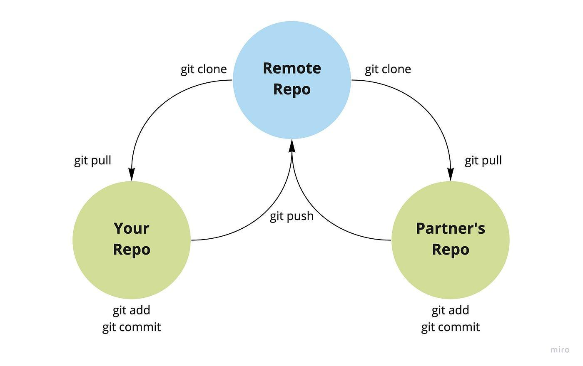
b. Write a multi-stage Dockerfile using python:3.11-slim. Install only production deps, copy model artifacts, add a HEALTHCHECK, expose port 8000. Build, run, verify health check, push to Docker Hub. Test predictions via curl.

11. Scenario 1 — Arun starts working, Arun has successfully cloned the project from GitHub.He now modifies student.py and adds a new function:

def calculate_average(marks):
return sum(marks) / len(marks)
Before committing his changes, Arun wants to check what has changed in his working directory.
Question: Which Git command should Arun use and show the result of all the command performed.

b. Build FastAPI app with Pydantic input schema, /predict (returns prediction + confidence), /health (model version + status), /model-info endpoints. Write pytest integration tests using httpx.AsyncClient. Run tests inside Docker.

12. You are working as part of a 4-member development team developing a Python-based Student Attendance Management System. The GitHub repository is: student-attendance-system. Your team follows this workflow:
- main → stable production code
- Each developer creates a separate branch for their work.
- Changes are pushed to GitHub.
- A Pull Request (PR) is created to merge changes into main.

Your Task: You are assigned to implement a new feature called "Student Search".
You need to perform the following GitHub operations: Clone the GitHub repository to your local computer.,Check the current branch. Create a new branch named: feature/student-search Switch to the newly created branch.,Create/modify the Python files required for the Student Search feature. Check which files have been modified. Stage the changes. Commit the changes with an appropriate commit message. Push the new branch to GitHub.
OR
b. Build a 4-job GitHub Actions pipeline: (1) data-validation with Great Expectations, (2) train-and-evaluate with F1 gate ≥0.85, (3) build-docker tagged with Git SHA, (4) deploy-staging with kubectl apply. Jobs run sequentially with dependency gates.

13. Automated Web Application Deployment Using Jenkins
You are working as a developer in a college software team. Your team has developed a simple Student Result Web Application using: HTML/CSS/JavaScript for the frontend ,Git for version control ,Jenkins for Continuous Integration and Continuous Deployment ,A local HTTP server for hosting the application. Perform development of CI/CD Workflow and show the result
OR
b.Write main.tf / variables.tf / outputs.tf to provision: EC2 t2.micro instance, S3 bucket for ML models, security group (ports 22 + 8000 only). Store state in S3 backend with DynamoDB locking. Run init → plan → apply. Document all outputs.
14. CI/CD Pipeline for a Web Application Using Git, Jenkins and Docker
OR

Perform any 7 git command with along with github for any scenarioof your own.
OR
b.Write an Ansible Playbook with 3 roles: common (Python 3.11, pip, git, Docker), mlflow (deploy MLflow as a systemd service on port 5000), dvc (install DVC, configure S3 remote). Run against the EC2 from Exp 13. Verify services with systemctl status.

15. Jenkins Pipeline : Create a simple Jenkins pipeline containing the following stages: Checkout ↓ Test ↓ Build Docker Image ↓ Deploy Container ↓ Verify

OR
Create the GitHub Account to demonstrate CI/CD pipeline using Cloud Platform
OR

b. Terraform provisions a Kubernetes cluster (EKS or Minikube). Ansible deploys the ML stack: ConfigMap for model config, Deployment with 2 replicas of the FastAPI container (Exp 10), Service on port 8000. End-to-end: terraform apply → ansible-playbook → kubectl get pods → curl /predict.

