FOUNDATIONS OF ARTIFICIAL INTELLIGENCE
ADAPTIVE AI TYPING ASSISTANT
A PROJECT REPORT
Submitted by
KAAJAL G — 240701220
KAAVIYA SRI PS — 240701222


OCTOBER, 2026

BONAFIDE CERTIFICATE
Certified that this project report "ADAPTIVE AI TYPING ASSISTANT" is the bonafide work of "KAAJAL G (240701220) and KAAVIYA SRI PS(240701222)" who carried out the project work under my supervision.

SIGNATURE OF THE FACULTY INCHARGE
Submitted for the Practical Examination held on _______________

SIGNATURE OF THE INTERNAL EXAMINER

TABLE OF CONTENTS
CHAPTER NO. | TITLE | PAGE NO.
 | ABSTRACT | 4
1. | INTRODUCTION | 6
2. | LITERATURE REVIEW | 7
3. | PROPOSED SYSTEM | 9
 | 3.1 Architecture Diagram | 10
4. | MODULES DESCRIPTION | 11
 | 4.1 Module A — Forward Chaining for Diagnosis | 11
 | 4.2 Module B — Backward Chaining for Verification | 12
 | 4.3 Module C — Constraint Satisfaction for Adaptive Practice Generation | 12
 | 4.4 Integration Module and User Interface | 13
5. | IMPLEMENTATION AND RESULTS | 14
 | 5.1 Experimental Setup | 14
 | 5.2 Results | 14
6. | CONCLUSION AND FUTURE WORK | 17
7. | REFERENCES | 19

ABSTRACT
Typing tutoring software has traditionally relied on static, one-size-fits-all drills that do not adapt to an individual learner's specific error patterns. This project presents an Adaptive AI Typing Assistant that applies three classical, symbolic Artificial Intelligence techniques in sequence to diagnose, verify, and remediate a typist's weaknesses in real time. As the user types, a Forward Chaining rule engine analyses micro-batches of keystrokes to infer tentative weaknesses such as finger-specific error rates, key-substitution patterns, and slow key-to-key transitions. A Backward Chaining verification engine then treats each tentative weakness as a goal and proves or rejects it against three sub-goals — persistence across multiple windows, consistency of the underlying metric, and sufficiency of sample size — so that only genuine, repeatable weaknesses are confirmed rather than one-off mistakes. Finally, a Constraint Satisfaction Problem (CSP) solver generates the next drill by selecting words from a word bank through backtracking search, satisfying hard constraints (fixed drill length, no immediate word repetition) while optimising soft constraints (weakness-coverage ratio, difficulty match, and natural flow) across randomly restarted candidate solutions. The system was implemented as a client-side React.js application, with the AI engine written in pure JavaScript and kept fully independent of the interface, and session history persisted to browser Local Storage. Each module, and the full pipeline connecting them, was independently built and verified against hand-crafted test data before being integrated into a live typing-test interface that captures real keystrokes. The results confirm that the system correctly distinguishes consistent, evidence-backed weaknesses from scattered, one-off errors, and produces drills that measurably emphasise a user's confirmed weak areas, demonstrating how classical rule-based and constraint-based reasoning, rather than machine learning, can build a transparent, explainable adaptive learning system.

1. INTRODUCTION
Touch-typing proficiency is built through repetition, but the value of that repetition depends heavily on what is being repeated. Most commercial and open-source typing tutors present a fixed sequence of lessons or a randomly generated block of text, irrespective of the specific fingers, keys, or key-pairs that a given user actually struggles with. Two learners with very different weaknesses — one who consistently mixes up adjacent home-row keys, another who hesitates when switching between rows — are given the same practice material. This is analogous to a tutor who never looks at a student's mistakes before assigning the next exercise.
This project, undertaken as part of the course Foundations of Artificial Intelligence, builds an Adaptive AI Typing Assistant that closes this gap using classical, symbolic AI techniques rather than statistical machine learning. The system observes a user's keystrokes as they type, reasons about which specific weaknesses are present using a rule-based Forward Chaining engine, verifies that those weaknesses are genuine and not statistical noise using a goal-driven Backward Chaining engine, and then generates the next practice drill as the solution to a Constraint Satisfaction Problem (CSP) that is deliberately biased towards the user's confirmed weak areas.

1.1 Problem Statement
Given a stream of keystroke events produced while a user types a practice drill, the system must: (i) identify candidate typing weaknesses from short-term evidence, (ii) confirm which of those candidates represent a real, persistent pattern rather than a one-off mistake, and (iii) construct a new practice drill that satisfies structural constraints (length, non-repetition) while being weighted towards the confirmed weaknesses — all without using any statistical or machine-learning model, relying instead on explicit, explainable rules and constraints.

1.2 Objectives
- Design and implement a Forward Chaining rule engine (Module A) that converts raw keystroke data into diagnosed, tentative typing weaknesses.
- Design and implement a Backward Chaining verification engine (Module B) that confirms or rejects each tentative weakness using persistence, consistency, and sample-size sub-goals.
- Formulate typing-drill generation as a Constraint Satisfaction Problem and implement a backtracking solver (Module C) that produces a drill emphasising confirmed weaknesses.
- Integrate the three modules into a single orchestration layer that runs Module A continuously in micro-batches and Modules B and C once per drill.
- Build a working React.js user interface that captures real keystrokes, displays a live diagnosis while typing, and reports a full, explainable verification summary at the end of each drill.

1.3 Scope
The current implementation targets single-word, space-separated English drills typed on a standard QWERTY keyboard layout, and treats each drill as an independent unit of evidence (weakness evidence is not yet carried over between drills). The system runs entirely client-side in the browser; no server-side component or persistent account system is required. Progress history is stored locally using the browser's Local Storage API.

2. LITERATURE REVIEW
Existing typing-practice tools such as TypingClub, Keybr, and 10FastFingers provide structured lessons or randomly generated text, and typically surface only aggregate statistics — words per minute and overall accuracy — after a session ends. Some tools, such as Keybr, do adapt future text generation based on per-character error frequency, but this adaptation is a purely statistical weighting rather than an explainable, rule-based diagnosis, and it does not distinguish a persistent weakness from an isolated slip.
Separately, the field of expert systems has long used Forward Chaining and Backward Chaining as complementary inference strategies over a rule base and a working memory of facts. Forward Chaining is data-driven: starting from known facts, rules are repeatedly fired until no new facts can be derived, which is well suited to open-ended diagnosis where the set of possible conclusions is not known in advance. Backward Chaining is goal-driven: starting from a specific hypothesis, the engine recursively checks whether the sub-conditions required to prove that hypothesis actually hold, which is well suited to verification once a candidate conclusion already exists (Russell and Norvig, 2020; Giarratano and Riley, 2005; Jackson, 1998). This project deliberately separates diagnosis (Forward Chaining) from verification (Backward Chaining) to mirror this classical distinction, rather than using a single monolithic rule-firing pass for both purposes.
Constraint Satisfaction Problems (CSPs) are a well-studied formalism in which a solution is an assignment of values to variables that satisfies a set of constraints over the corresponding domains, typically solved using backtracking search with optional consistency propagation and heuristics (Tsang, 1993; Dechter, 2003; Russell and Norvig, 2020). While classical CSP formulations focus on hard constraints, real-world content-generation problems — such as generating a typing drill that is simultaneously readable, length-bounded, and biased towards specific keys — often mix hard structural constraints with soft, preference-style constraints that are better handled by scoring completed solutions rather than encoding them as strict predicates. This project adopts that hybrid approach: hard constraints prune the backtracking search directly, while soft constraints are scored after a valid drill has been found, and the best-scoring drill among several randomly restarted attempts is selected.
Machine-learning-based personalisation is common in modern adaptive-learning platforms, but such approaches typically require substantial training data per user and produce recommendations that are difficult to explain to the end user or to a course evaluator. By contrast, the approach taken in this project produces a fully traceable decision trail at every stage — each diagnosed weakness names the exact rule that produced it, and each confirmation or rejection names the exact sub-goal values that were checked — which is a direct and deliberate advantage of using symbolic AI over a black-box statistical model for this problem.

3. PROPOSED SYSTEM
The proposed system is organised as a linear pipeline of three AI modules, wrapped in an orchestration layer and connected to a React.js user interface. Raw keystroke events are captured continuously as the user types. Every fixed number of keystrokes (a “micro-batch window”, set to 15 keystrokes in the current implementation), Module A (Forward Chaining) is invoked on the buffered window to produce a set of tentative weaknesses, which are stored in an evidence store indexed by window number. When the user finishes the current drill, any remaining buffered keystrokes are flushed as a final, possibly smaller window, after which Module B (Backward Chaining) is invoked once over the accumulated evidence of the last three windows to confirm or reject every weakness that appeared. The confirmed weaknesses are then passed to Module C (the CSP solver), which generates the next twenty-word drill, biased towards the confirmed weak keys and fingers, for the user to attempt next. This design — continuous, lightweight diagnosis with periodic, evidence-heavy verification and generation — was chosen deliberately over both a fully real-time and a fully end-of-session architecture, as it keeps the diagnosis responsive while ensuring that verification and drill generation only ever act on a statistically meaningful body of evidence.

3.1 Architecture Diagram
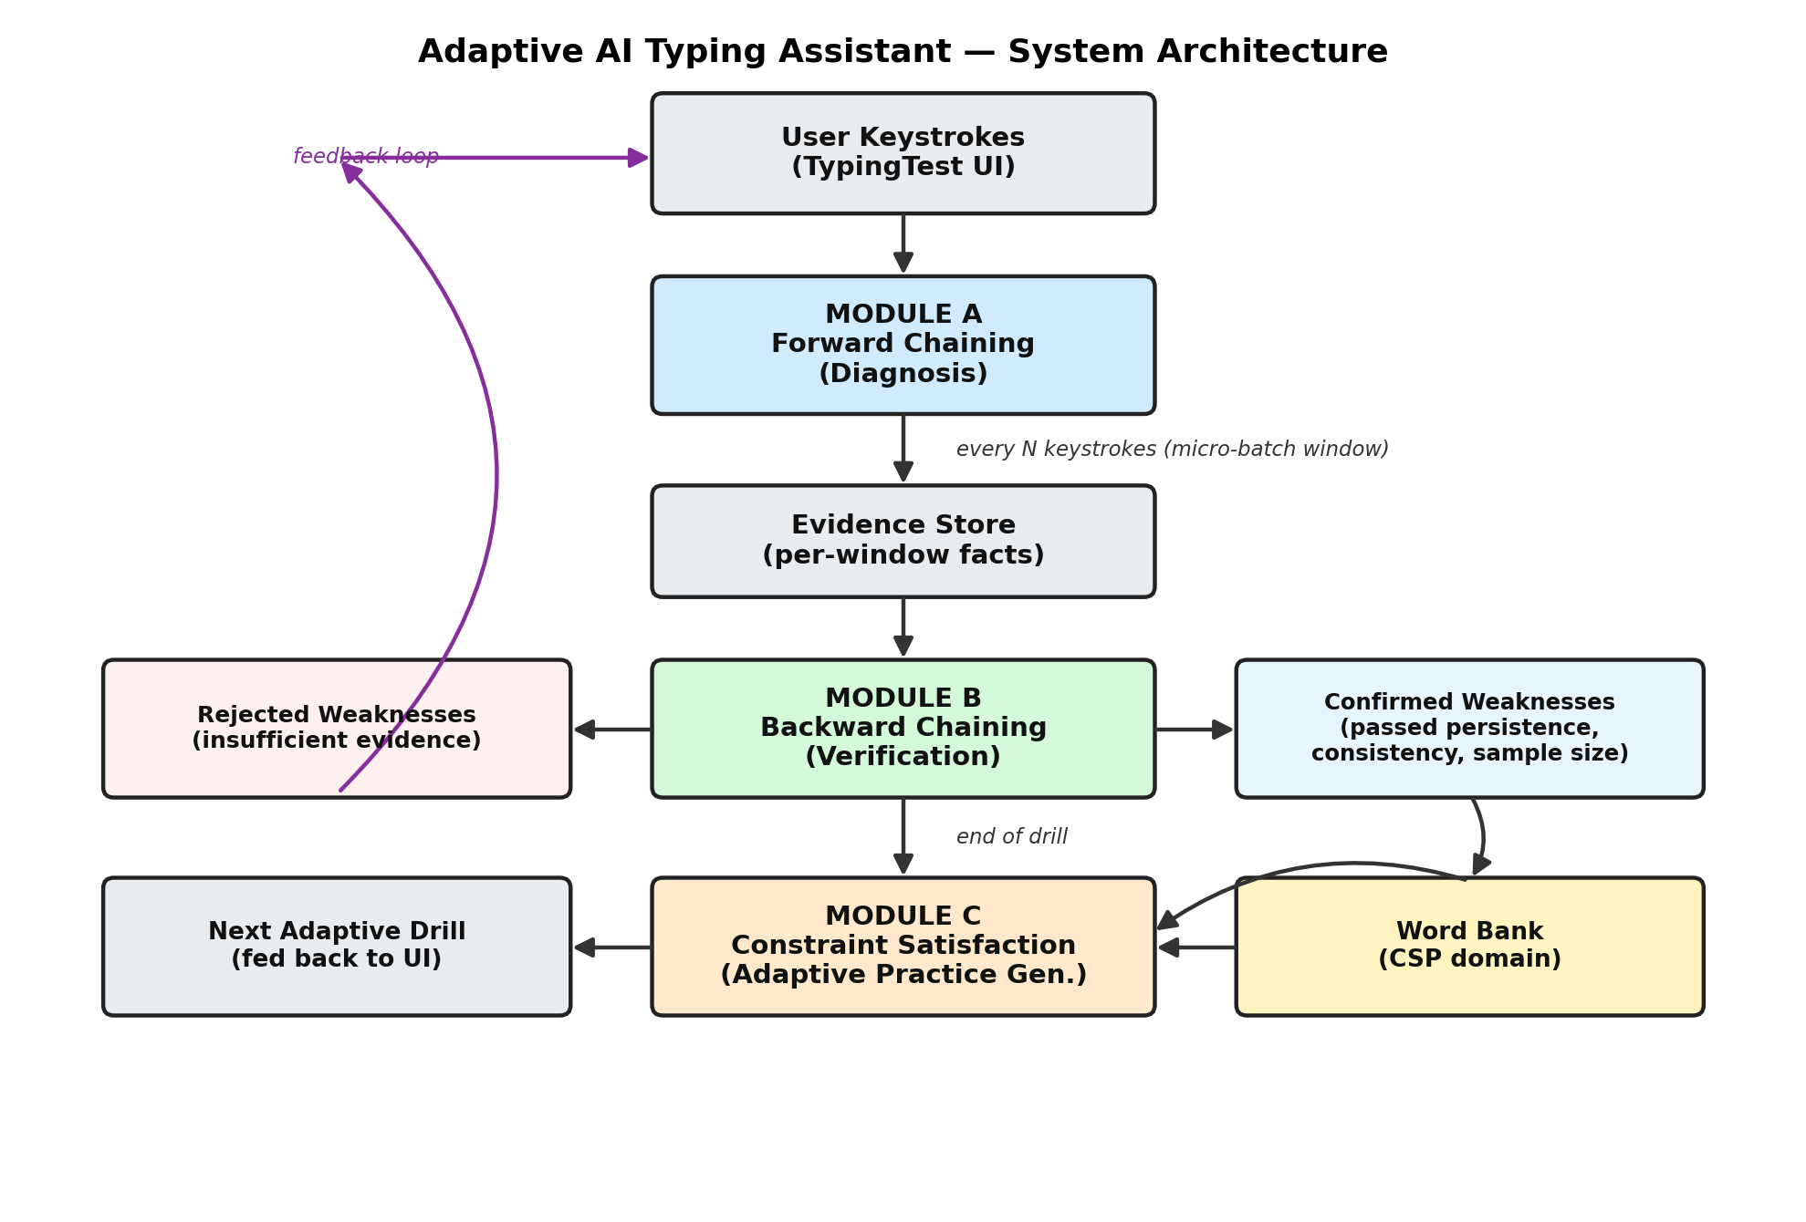
Figure 3.1: System architecture of the Adaptive AI Typing Assistant
As shown in Figure 3.1, the User Keystrokes captured by the TypingTest UI component feed continuously into Module A. Module A's output is written to the Evidence Store on every micro-batch boundary. At the end of a drill, Module B reads the accumulated evidence, producing two disjoint sets — Confirmed Weaknesses and Rejected Weaknesses — each carrying a full sub-goal reasoning trail. Module C consumes the Confirmed Weaknesses together with the static Word Bank to generate the Next Adaptive Drill, which is fed back into the TypingTest UI, closing the feedback loop shown on the left of the diagram.

4. MODULES DESCRIPTION

4.1 Module A — Forward Chaining for Diagnosis
Module A converts a window of raw keystroke events into structured facts and then applies a small rule base to those facts until no new conclusions can be derived (the classical Forward Chaining fixpoint). Three analyses are performed on each window: per-finger error rate (using a static keymap that maps every key to its expected finger, hand, and row), frequent key-substitution pairs (the same wrong key typed in place of the same expected key at least twice), and slow key-to-key transitions (consecutive expected keys whose average inter-key latency exceeds a fixed threshold). Each analysis that crosses its threshold produces a fact, for example high_error_rate(left-pinky, 0.6) or slow_transition([e, r], 425). Three rules are then evaluated repeatedly against the growing set of facts:
Rule | Condition (fires on) | Conclusion produced
R1 — finger_weakness | a high_error_rate fact | weakness: <finger>_precision
R2 — substitution_weakness | a frequent_substitution fact | weakness: substitution_<key1>_<key2>
R3 — row_switching_weakness | a slow_transition fact | weakness: row_switching_<key1>_<key2>

Every fired rule is recorded in a trace (which rule fired, on which fact, producing which conclusion), giving the diagnosis full explainability. Module A was deliberately kept simple in its first working version — a fourth, compound rule that combines a high error rate and a substitution fact on the same finger was designed but intentionally deferred until the three single-condition rules were proven correct end-to-end.

4.2 Module B — Backward Chaining for Verification
Module B treats every tentative weakness produced by Module A as a goal to be proved, and works backward from that goal to the evidence required to support it, rather than deriving new conclusions forward. Three sub-goals must all pass for a weakness to be confirmed:
- Persistence — the weakness must appear in at least 2 of the last 3 evidence windows, ruling out a single unlucky window.
- Consistency — the average value of the underlying metric (error rate, substitution count, or transition latency) across the windows in which it appeared must still clear the original threshold used by Module A.
- Sample size — the estimated number of underlying keystroke samples across those windows must meet a minimum (8), so that a conclusion is never drawn from too little data.
An EvidenceStore accumulates each window's Forward Chaining output over the course of a drill and exposes the last three windows of evidence for a named weakness. A weakness is only formally confirmed or rejected — with a complete, per-sub-goal trace — if it appeared in evidence at all in the last three windows, so that a weakness which faded out before the final window is still explicitly evaluated (and, typically, rejected) rather than silently dropped from consideration.

4.3 Module C — Constraint Satisfaction for Adaptive Practice Generation
Module C formulates drill generation as a Constraint Satisfaction Problem. The variables are the twenty word-slots of the drill (word_1 through word_20); the domain of every variable is the full word bank, where each entry is tagged with the unique keys and fingers it exercises, its length, and a simple difficulty label. Two hard constraints are enforced during a depth-first backtracking search — the drill must be exactly twenty words long, and no word may immediately repeat the word before it — by rejecting any candidate word that would violate them before it is placed, and backtracking to an earlier position whenever no candidate remains valid at the current position. Because the remaining requirements (roughly 40% of words should target a confirmed weak finger or key-pair, difficulty should broadly match the user's level, and weakness-targeting words should not cluster more than two in a row) are properties of the whole drill rather than of a single word, they are treated as soft constraints: several complete, hard-constraint-valid drills are generated using randomised restarts, each is scored against the soft constraints, and the highest-scoring drill is returned to the user.

4.4 Integration Module and User Interface
A TypingSession class orchestrates the three modules without any dependency on React, keeping the AI engine fully independent of the user interface. It buffers incoming keystroke events, invokes Module A whenever the buffer reaches the micro-batch window size, and invokes Module B followed by Module C once a drill finishes (after flushing any partial final window). On top of this, a React.js component tree captures real keyboard input (useKeystrokeCapture hook), renders the drill with per-character correct/incorrect/current highlighting (TypingTest), shows Module A's tentative output live while the user is still typing (DiagnosisPanel), and shows Module B's confirmed and rejected weaknesses with their full sub-goal reasoning once a drill ends (SessionReport). A compact summary of each completed drill (timestamp, confirmed and rejected weakness names, total keystrokes, error count, and error rate) is persisted to the browser's Local Storage after every drill, forming the basis for the progress-tracking dashboard described as future work in Chapter 6.

5. IMPLEMENTATION AND RESULTS

5.1 Experimental Setup
The system was implemented using the tools and languages listed in Table 5.1, scaffolded with Vite and developed and tested on a Windows machine using Google Chrome as the primary test browser.
Tool / Language | Role in the project
React.js | Frontend framework — TypingTest, DiagnosisPanel, and SessionReport components
JavaScript (ES6+) | Core language and the language of the entire AI engine (Modules A, B, C)
Recharts | Planned progress-dashboard visualisation library (future work, Section 6.2)
Node.js & npm | Build and package tooling (Vite scaffold, dependency management)
Git & GitHub | Version control across the milestone-based development process
Browser Local Storage | Client-side persistence of per-drill session summaries

The three AI modules were each first developed and verified in isolation using hand-crafted keystroke data run directly under Node.js, before being wired together via the TypingSession orchestrator and finally connected to the live React user interface. This bottom-up, module-by-module verification strategy meant that any defect could be immediately attributed to a specific module rather than to the integration as a whole.

5.2 Results
5.2.1 Module A — Forward Chaining
A hand-crafted keystroke window simulating a user who frequently mistypes the left pinky's keys and hesitates between ‘e’ and ‘r’ produced the facts and derived weaknesses summarised in Table 5.2, confirming that all three rules fire correctly and independently, and that a rule does not fire when its underlying fact is absent.
Fact derived | Value | Rule fired | Weakness concluded
high_error_rate(left-pinky) | 0.60 | R1 | left-pinky_precision
frequent_substitution(a, s) | count = 2 | R2 | substitution_a_s
slow_transition(e, r) | avg = 425 ms | R3 | row_switching_e_r

5.2.2 Module B — Backward Chaining
Two scenarios were tested to verify both outcomes of the verification process. In the first, a weakness with strong, repeated evidence across all three recent windows was correctly confirmed; in the second, a weakness that appeared in only one of the three recent windows was correctly rejected on the persistence sub-goal alone, even though its single occurrence would have passed the consistency check. Both outcomes, with their full sub-goal trace, are summarised in Table 5.3.
Weakness | Persistence | Consistency | Sample size | Verdict
left-pinky_precision | 3/3 windows — pass | avg 0.55 ≥ 0.15 — pass | 15 ≥ 8 — pass | CONFIRMED
row_switching_e_r | 1/3 windows — fail | avg 400 ≥ 250 — pass | 5 < 8 — fail | REJECTED

5.2.3 Module C — Constraint Satisfaction
Given the confirmed weakness left-pinky_precision as input, Module C generated a twenty-word drill in which nine of the twenty words (45%) exercised the left pinky, close to the 40% soft-constraint target given the limited size of the starter word bank (28 words), with zero immediate word repetitions — confirming that both the hard constraint and the soft-constraint scoring behave correctly.
5.2.4 End-to-End Pipeline
A simulated 50-keystroke typing session with a consistently repeated error pattern (left pinky mistyped across the whole session) was passed through the full pipeline. The live diagnosis after all keystrokes correctly showed three tentative weaknesses (left-pinky_precision, substitution_a_s, substitution_q_w); on finishing the drill, all three were formally confirmed by Module B with a complete sub-goal trace, none were rejected, and Module C produced a valid twenty-word next drill — demonstrating that Modules A, B, and C compose correctly as a single connected pipeline, not merely in isolation.
5.2.5 Live Browser Verification
Finally, the fully integrated system was tested by typing directly into the React interface. Figure 5.1 shows a drill typed with scattered, non-repeating mistakes: the Session Report correctly shows zero confirmed weaknesses, since no single weakness type recurred consistently across evidence windows. Figure 5.2 shows a drill typed with heavier, more consistent mistakes: the Session Report correctly confirms six weaknesses. Together, these two live tests demonstrate that Module B performs its intended function of separating genuine, repeatable weaknesses from ordinary, scattered typing noise — a real user does not receive a diagnosis for mistakes that do not represent an actual pattern.
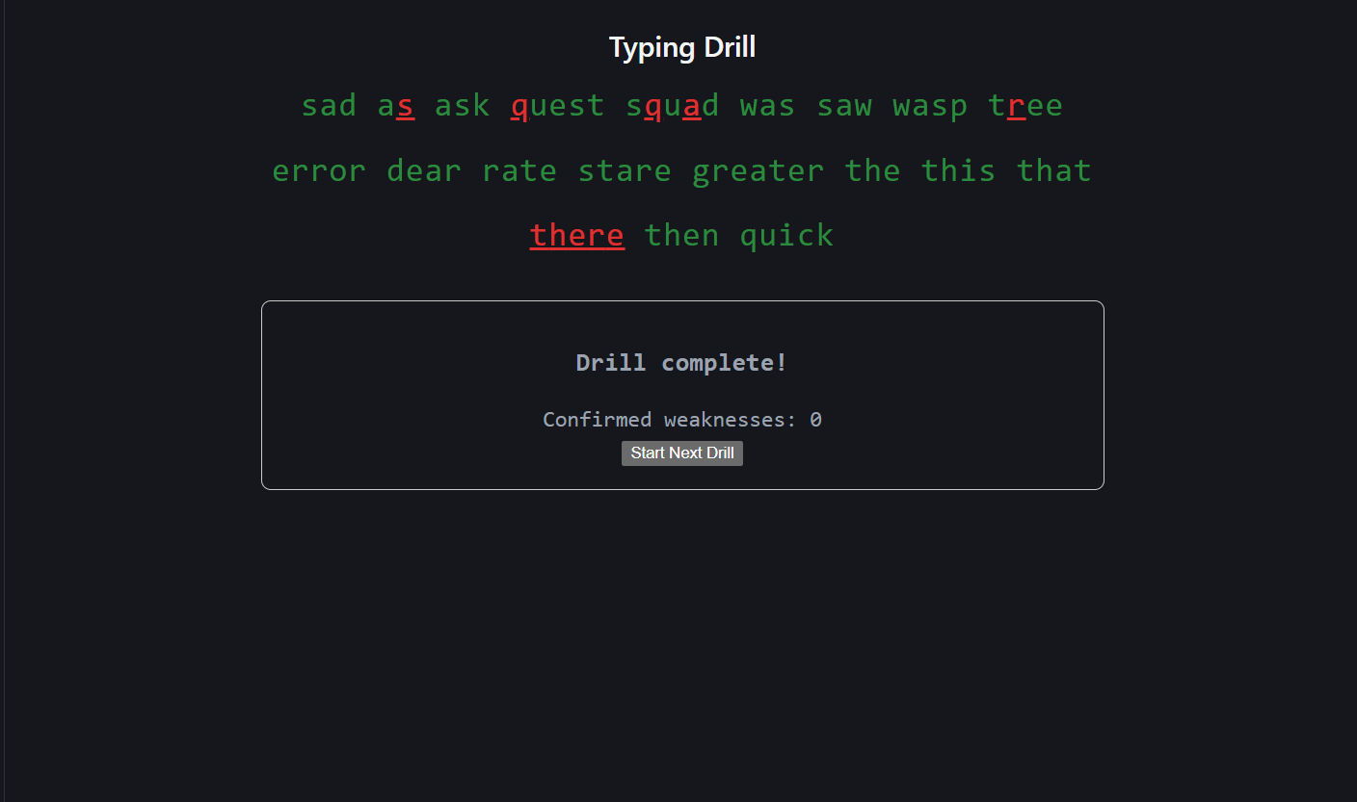
Figure 5.1: Scattered, non-repeating mistakes — correctly yields 0 confirmed weaknesses
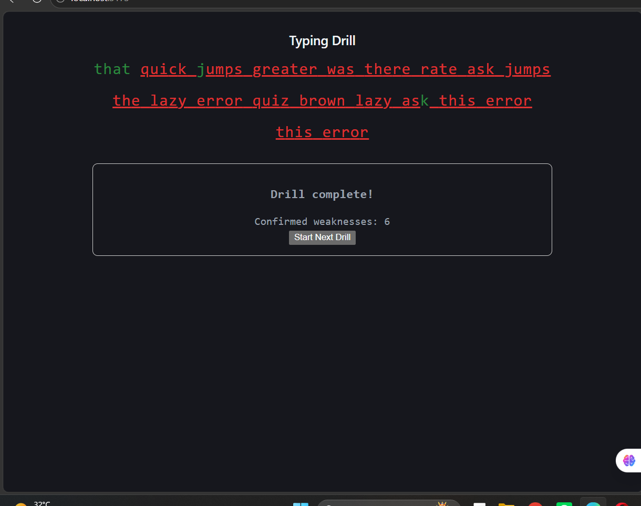
Figure 5.2: Consistent, repeated mistakes — correctly yields 6 confirmed weaknesses

6. CONCLUSION AND FUTURE WORK

6.1 Conclusion
This project set out to demonstrate that classical, symbolic Artificial Intelligence techniques — Forward Chaining, Backward Chaining, and Constraint Satisfaction — can be combined into a single, coherent, explainable adaptive learning system, without relying on statistical machine learning. Each of the three modules was designed, implemented, and independently verified before being integrated, and the fully integrated pipeline was further verified end-to-end, first with simulated keystroke data and then with real keystrokes typed into a working React.js interface. The results show that the system reliably diagnoses tentative typing weaknesses, correctly separates genuine, persistent weaknesses from one-off mistakes, and generates new practice drills that are measurably biased towards a user's confirmed weak areas — while keeping every decision traceable back to the specific rule or sub-goal that produced it. This satisfies the project's core objective of an adaptive, explainable typing assistant built on classical AI reasoning.

6.2 Limitations
- The starter word bank contains only 28 words, which limits how naturally the generated drills read and how precisely the CSP solver can hit its soft-constraint targets.
- Weakness evidence is currently scoped to a single drill; it is not yet carried forward across drills or sessions, so a weakness must re-accumulate evidence from the start of every new drill.
- The sample-size sub-goal in Module B currently uses a heuristic estimate (five samples per evidence window) rather than an exact count of the keystrokes underlying each fact.
- The progress-tracking dashboard (Recharts) and full Local-Storage-backed history view were scoped in the project's tech stack but had not yet been built and connected at the time of this report.

6.3 Future Work
- Expand the word bank to 80–100+ words to make generated drills read more naturally and to allow soft constraints to be met more precisely.
- Carry confirmed and rejected weakness evidence forward across drills and sessions (rather than resetting per drill), so long-term progress can be tracked and regressions can be detected.
- Replace the sample-size heuristic in Module B with an exact per-fact sample count, propagated from Module A's fact builder.
- Build the planned Recharts-based Progress Dashboard on top of the session history already being saved to Local Storage, to visualise error-rate trends and weakness frequency over time.
- Add the previously deferred compound Forward Chaining rule (R4), which escalates confidence when a high error rate and a frequent substitution both implicate the same finger, to demonstrate genuine multi-fact inference.
- Extend the CSP formulation to full sentences rather than isolated words, and to adapt overall drill difficulty automatically based on a user's confirmed skill level over time.

7. REFERENCES

Dechter, R. (2003) Constraint Processing, San Francisco: Morgan Kaufmann.
Giarratano, J. and Riley, G. (2005) Expert Systems: Principles and Programming, 4th ed., Boston: Course Technology.
Jackson, P. (1998) Introduction to Expert Systems, 3rd ed., Reading, MA: Addison-Wesley.
Russell, S. and Norvig, P. (2020) Artificial Intelligence: A Modern Approach, 4th ed., Harlow: Pearson.
Tsang, E. (1993) Foundations of Constraint Satisfaction, London: Academic Press.

