*DATA ANALYSIS- College-Majors*

*San Jose State University*

*Professor - Dr. Shilpa Gupta*

*Date - 05-11-2022*

*I care about the college-Majors data set, reason being - as a graduate student, hunting job is pivotal.*

*It is equally important for others to look at this data because everyone needs job and to know what majors will help them in securing the job.*

*The context of the data includes the major code, major, major category, total number of students, Employed full time year, unemployed, unemployed rate, median and the percentile salary.*

*“A college degree is no guarantee of economic success. But through their choice of major, they can take at least some steps toward boosting their odds.”*

[College-major data](https://github.com/fivethirtyeight/data/tree/master/college-majors)

[College-major all ages data](https://github.com/fivethirtyeight/data/blob/master/college-majors/all-ages.csv)

[Link to write up and analysis](https://fivethirtyeight.com/features/the-economic-guide-to-picking-a-college-major/)

*All data is from American Community Survey 2010-2012 Public Use Microdata Series.*

*cases incluede - variation in the number of employed and unemployed with respect to the major and major category*

*will be studying the categorical and numerical variables.*

*This is an observational study*

getwd()

## [1] "/Users/Kavya/Desktop"

setwd("~/Desktop")  
  
edu <- read.csv("all-ages-data.csv", header = TRUE, sep = ",")  
dim(edu)

## [1] 173 11

mis <- is.na(edu)  
dim(mis)

## [1] 173 11

dupli <- unique(edu)  
dim(dupli)

## [1] 173 11

sum(is.na(edu))

## [1] 0

head(edu)

## Major_code Major  
## 1 1100 GENERAL AGRICULTURE  
## 2 1101 AGRICULTURE PRODUCTION AND MANAGEMENT  
## 3 1102 AGRICULTURAL ECONOMICS  
## 4 1103 ANIMAL SCIENCES  
## 5 1104 FOOD SCIENCE  
## 6 1105 PLANT SCIENCE AND AGRONOMY  
## Major_category Total Employed Employed_full_time_year_round  
## 1 Agriculture & Natural Resources 128148 90245 74078  
## 2 Agriculture & Natural Resources 95326 76865 64240  
## 3 Agriculture & Natural Resources 33955 26321 22810  
## 4 Agriculture & Natural Resources 103549 81177 64937  
## 5 Agriculture & Natural Resources 24280 17281 12722  
## 6 Agriculture & Natural Resources 79409 63043 51077  
## Unemployed Unemployment_rate Median P25th P75th  
## 1 2423 0.02614711 50000 34000 80000  
## 2 2266 0.02863606 54000 36000 80000  
## 3 821 0.03024832 63000 40000 98000  
## 4 3619 0.04267890 46000 30000 72000  
## 5 894 0.04918845 62000 38500 90000  
## 6 2070 0.03179089 50000 35000 75000

* The dimention of data is 173 rows and 11 colums
* there is no missing data
* there is no duplicate data

summary(edu)

## Major_code Major Major_category Total   
## Min. :1100 Length:173 Length:173 Min. : 2396   
## 1st Qu.:2403 Class :character Class :character 1st Qu.: 24280   
## Median :3608 Mode :character Mode :character Median : 75791   
## Mean :3880 Mean : 230257   
## 3rd Qu.:5503 3rd Qu.: 205763   
## Max. :6403 Max. :3123510   
## Employed Employed_full_time_year_round Unemployed   
## Min. : 1492 Min. : 1093 Min. : 0   
## 1st Qu.: 17281 1st Qu.: 12722 1st Qu.: 1101   
## Median : 56564 Median : 39613 Median : 3619   
## Mean : 166162 Mean : 126308 Mean : 9725   
## 3rd Qu.: 142879 3rd Qu.: 111025 3rd Qu.: 8862   
## Max. :2354398 Max. :1939384 Max. :147261   
## Unemployment_rate Median P25th P75th   
## Min. :0.00000 Min. : 35000 Min. :24900 Min. : 45800   
## 1st Qu.:0.04626 1st Qu.: 46000 1st Qu.:32000 1st Qu.: 70000   
## Median :0.05472 Median : 53000 Median :36000 Median : 80000   
## Mean :0.05736 Mean : 56816 Mean :38697 Mean : 82506   
## 3rd Qu.:0.06904 3rd Qu.: 65000 3rd Qu.:42000 3rd Qu.: 95000   
## Max. :0.15615 Max. :125000 Max. :78000 Max. :210000

*My research question on the data that I have selected are*

*Q1. How is the median salary distributed*

*Q2. Which Major has the highest salary earning and lowest salary earning*

*Q3. What were the most common majors (will not be showing all 173, as it will be huge)*

*Q4. Which Major categor is making*

library(tidyverse)

## ── Attaching packages ─────────────────────────────────────── tidyverse 1.3.1 ──

## ✓ ggplot2 3.3.5 ✓ purrr 0.3.4  
## ✓ tibble 3.1.6 ✓ dplyr 1.0.8  
## ✓ tidyr 1.2.0 ✓ stringr 1.4.0  
## ✓ readr 2.1.2 ✓ forcats 0.5.1

## ── Conflicts ────────────────────────────────────────── tidyverse_conflicts() ──  
## x dplyr::filter() masks stats::filter()  
## x dplyr::lag() masks stats::lag()

library(ggplot2)  
library(scales)

##   
## Attaching package: 'scales'

## The following object is masked from 'package:purrr':  
##   
## discard

## The following object is masked from 'package:readr':  
##   
## col_factor

summary(edu)

## Major_code Major Major_category Total   
## Min. :1100 Length:173 Length:173 Min. : 2396   
## 1st Qu.:2403 Class :character Class :character 1st Qu.: 24280   
## Median :3608 Mode :character Mode :character Median : 75791   
## Mean :3880 Mean : 230257   
## 3rd Qu.:5503 3rd Qu.: 205763   
## Max. :6403 Max. :3123510   
## Employed Employed_full_time_year_round Unemployed   
## Min. : 1492 Min. : 1093 Min. : 0   
## 1st Qu.: 17281 1st Qu.: 12722 1st Qu.: 1101   
## Median : 56564 Median : 39613 Median : 3619   
## Mean : 166162 Mean : 126308 Mean : 9725   
## 3rd Qu.: 142879 3rd Qu.: 111025 3rd Qu.: 8862   
## Max. :2354398 Max. :1939384 Max. :147261   
## Unemployment_rate Median P25th P75th   
## Min. :0.00000 Min. : 35000 Min. :24900 Min. : 45800   
## 1st Qu.:0.04626 1st Qu.: 46000 1st Qu.:32000 1st Qu.: 70000   
## Median :0.05472 Median : 53000 Median :36000 Median : 80000   
## Mean :0.05736 Mean : 56816 Mean :38697 Mean : 82506   
## 3rd Qu.:0.06904 3rd Qu.: 65000 3rd Qu.:42000 3rd Qu.: 95000   
## Max. :0.15615 Max. :125000 Max. :78000 Max. :210000

str(edu)

## 'data.frame': 173 obs. of 11 variables:  
## $ Major_code : int 1100 1101 1102 1103 1104 1105 1106 1199 1301 1302 ...  
## $ Major : chr "GENERAL AGRICULTURE" "AGRICULTURE PRODUCTION AND MANAGEMENT" "AGRICULTURAL ECONOMICS" "ANIMAL SCIENCES" ...  
## $ Major_category : chr "Agriculture & Natural Resources" "Agriculture & Natural Resources" "Agriculture & Natural Resources" "Agriculture & Natural Resources" ...  
## $ Total : int 128148 95326 33955 103549 24280 79409 6586 8549 106106 69447 ...  
## $ Employed : int 90245 76865 26321 81177 17281 63043 4926 6392 87602 48228 ...  
## $ Employed_full_time_year_round: int 74078 64240 22810 64937 12722 51077 4042 5074 65238 39613 ...  
## $ Unemployed : int 2423 2266 821 3619 894 2070 264 261 4736 2144 ...  
## $ Unemployment_rate : num 0.0261 0.0286 0.0302 0.0427 0.0492 ...  
## $ Median : int 50000 54000 63000 46000 62000 50000 63000 52000 52000 58000 ...  
## $ P25th : int 34000 36000 40000 30000 38500 35000 39400 35000 38000 40500 ...  
## $ P75th : num 80000 80000 98000 72000 90000 75000 88000 75000 75000 80000 ...

edu %>% mutate(Major_category = fct_reorder(Major_category, Median)) %>% ggplot(aes(Major_category, Median)) + geom_boxplot() + scale_y_continuous(labels = label_dollar ()) + coord_flip()

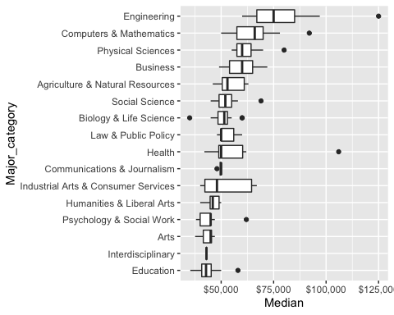 *Ans 1. From the distribution it is clear that the Engineering Major_category has highest median earning of $75000 and Education category has the lowest median salary of around $35000*

edu_data <- edu %>% arrange(desc(Median)) %>%   
 select(Major, Major_category, Median, P25th, P75th) %>%  
 head(10) %>%   
 mutate(Major= str_to_title(Major), Major = fct_reorder(Major, Median)) %>%  
 ggplot(aes(Major, Median, color = Major_category)) +   
 geom_point() +   
 coord_flip()   
 edu_data

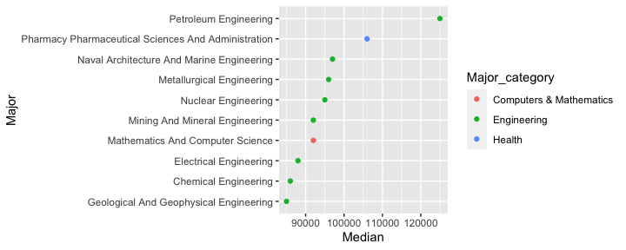

edu_data <-edu %>% arrange(desc(Median)) %>%   
 select(Major, Major_category, Median, P25th, P75th) %>%  
 tail(10) %>%   
 mutate(Major= str_to_title(Major), Major = fct_reorder(Major, Median)) %>%  
 ggplot(aes(Major, Median, color = Major_category)) +   
 geom_point() +   
 coord_flip()  
 edu_data

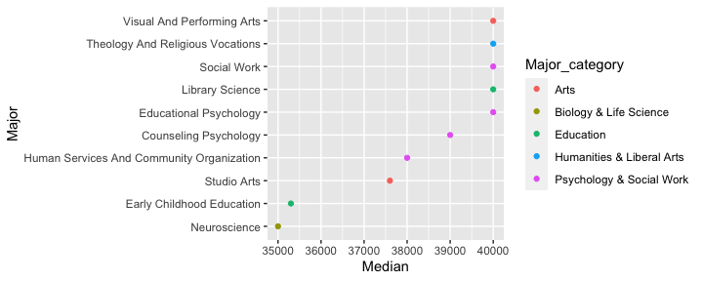 *Ans 2. Petroleum Engineering Major has the highest median paying of around 120000 and Neuroscience has the lowest salary earning of 35000*

edu_analysing <- edu %>% count(Major_category, wt = Employed, sort = TRUE) %>%  
 mutate(Major_category = fct_reorder(Major_category, n)) %>%  
 ggplot(aes(Major_category, n, fill = Major_category )) +  
 geom_col() +  
 coord_flip() +  
 labs( y = "No of Employment") +   
 scale_y_continuous(labels = label_number())  
  
edu_analysing

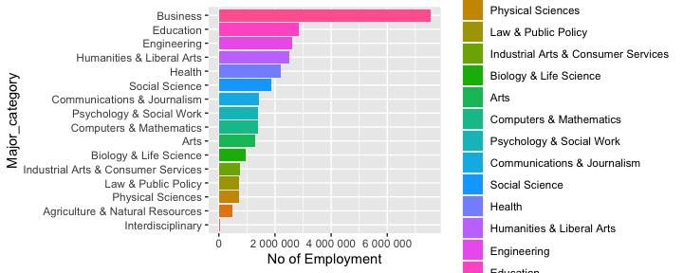

edu_analysing_1 <- edu %>%   
 mutate(Major = fct_reorder(Major, Total)) %>%  
 arrange(desc(Total)) %>%  
 head(20) %>%  
 ggplot(aes(Major, Total, fill = Major_category )) +  
 geom_col() +  
 coord_flip() +  
 labs( y = "Total no of graduates") +   
 scale_y_continuous(labels = comma_format())  
edu_analysing_1

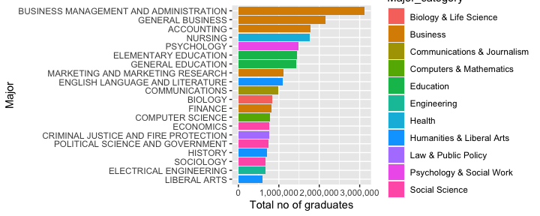 *Ans 3. From the graph it can be inferred that Majors has the common categories (with same color) e.g > Business Management and administration > general Business > accounting > Marketing research >Finance have the common Major_category of Business*

Hypothesis

mean_edu <- mean(edu$Median)  
max(sapply(edu$Median, max))

## [1] 125000

min(sapply(edu$Median, min))

## [1] 35000

sd(edu$Median)

## [1] 14706.23

*The typical recent college graduate with a full-time job earns about $36,000 a year, according to the American Community Survey.*

*But graduates with a degree in petroleum engineering is earning $125,000 and Neuroscience has the lowest earning of $35,000*

*The mean median salary is 56816.18 from the data.*

*For the graduates, is the mean median salary less than the typical salary of recent graduate obtained from the American Community Survey?*

1. H0: µ = 36,000 H1: µ > 36,000

*The Mean median salary is more than the salary obtained in the survey, in the alternate hypothesis seems to be true in case of 1st hypothesis formulation.*

*But even in more closely related fields, there are clear differences in earnings between majors. Actuarial science majors earn more than accounting majors; public policy majors out-earn history majors; and court reporting is better earnings bet than criminology.*

x <- edu$Median  
t.test(x, mu = 36000)

##   
## One Sample t-test  
##   
## data: x  
## t = 18.618, df = 172, p-value < 2.2e-16  
## alternative hypothesis: true mean is not equal to 36000  
## 95 percent confidence interval:  
## 54609.23 59023.14  
## sample estimates:  
## mean of x   
## 56816.18

*Here we reject the alternate hypothesis as the mean value is not equal to 36000 and the P-value is less*

attach(edu)  
plot(Total, Employed, main="employment graph",  
 xlab="Total", ylab="Employed", pch=19)

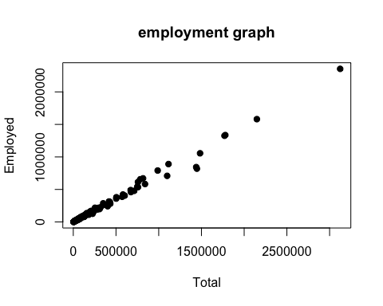

plot(Total, Employed, main="Scatterplot Example",  
 xlab=" Total", ylab="Employed", pch=19)  
abline(lm(Total~Employed), col="red") # regression line (y~x)  
lines(lowess(Total, Employed), col="blue") # lowness line (x,y)

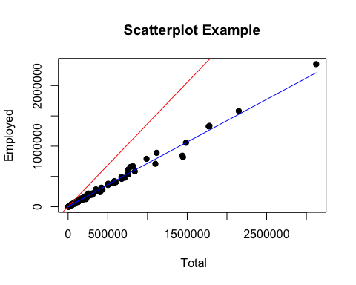 *There is a linear relationship between the total number of students and the number of Employment*

*If the number of students enrolled is more then the no of employees will also be more*

*The regression line is added in the second graph*

linear_reg <- lm(formula = Employed~Total, data = edu)  
summary(linear_reg)

##   
## Call:  
## lm(formula = Employed ~ Total, data = edu)  
##   
## Residuals:  
## Min 1Q Median 3Q Max   
## -228060 -2024 809 3926 92130   
##   
## Coefficients:  
## Estimate Std. Error t value Pr(>|t|)   
## (Intercept) -6.545e+02 2.674e+03 -0.245 0.807   
## Total 7.245e-01 5.574e-03 129.967 <2e-16 ***  
## ---  
## Signif. codes: 0 '***' 0.001 '**' 0.01 '*' 0.05 '.' 0.1 ' ' 1  
##   
## Residual standard error: 30860 on 171 degrees of freedom  
## Multiple R-squared: 0.99, Adjusted R-squared: 0.9899   
## F-statistic: 1.689e+04 on 1 and 171 DF, p-value: < 2.2e-16

*From the coefficient Estimate it is seen that there is a positive relationship between “Total” number of students and the “Employment”*

*R-squared value here is 0.99, i.e the ‘monthly energy’ usage explains 99% of the variability in ‘peak-hour’ demand*

*correlation coefficient = sqrt(R-square) For alpha = 0.05, data frame = 173-2 = 173-2 = 171*

ct_edu <- cor.test(edu$Total, edu$Employed)  
ct_edu

##   
## Pearson's product-moment correlation  
##   
## data: edu$Total and edu$Employed  
## t = 129.97, df = 171, p-value < 2.2e-16  
## alternative hypothesis: true correlation is not equal to 0  
## 95 percent confidence interval:  
## 0.9932204 0.9962783  
## sample estimates:  
## cor   
## 0.9949763

*The correlation coefficient with respect to 95% of confidence interval is found to be 0.9932 and 0.9962*

plot(linear_reg)

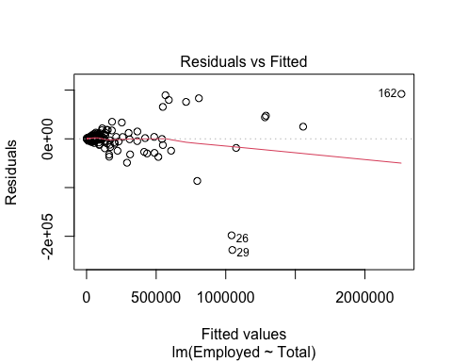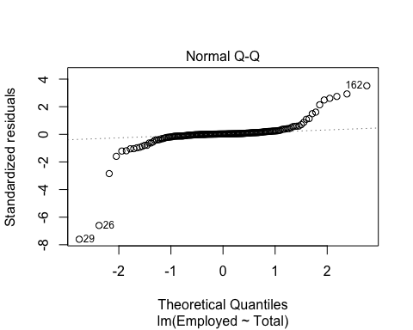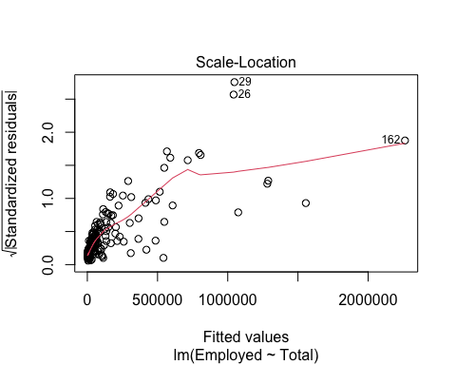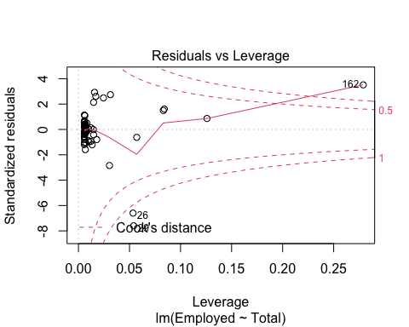

*Graph 1 - The linearity assumption is not met in the 1st plot, hence there is a pattern and also the variation is not constant*

*Graph 2 - From the second plot the error are not normally distributed as there is no linearity in the distribution(points are not falling roughly on a diagonal line)*

*Graph 3, 4 - from these graph it is seen that there is non linearity, the variance is not constant*