1.
b)
UCS IDS A* IDA*
Time complexity 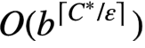 O(b^{d}) O(b^{d}) O(b^{d})
Memory usage 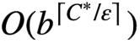 O(bd) O(b^{d}) O(mb)

In UCS, c is the cost of an optimal solution, m is the minimum edge cost.
In A*, the time complexity and memory usage are considered as worst case
In IDA*, m is the maximum depth of the search tree

2.

