ALLIANCE SCHOOL OF ADVANCED COMPUTING
Department of IT, ASAC
ASSIGNMENT 2
DFS Edge Classification and Graph Construction
Course Name: Data Structures and Algorithms
Course Code: IE1ITC302
Assignment No: 2
Name of the Student: Kaaysha Rao
Registration Number: 2411021060775
Platform: HackerRank
Language: C++11
Algorithm: DFS Edge Classification / Directed Graph Construction
A. Title of The Problem:
Construct a Directed Graph with Specified DFS Edge Classifications
B. Problem Statement in details:
Given four non-negative integers t, b, f, and c representing the required numbers of tree edges, back edges, forward edges, and cross edges, construct a directed graph G. Every vertex must be reachable from vertex 1, and between any two distinct vertices there can be at most one directed edge. When standard Depth-First Search (DFS) is started from vertex 1, the graph must contain exactly t tree edges, b back edges, f forward edges, and c cross edges. If such a graph cannot be constructed, the program prints -1. Otherwise, the program prints the number of vertices followed by each vertex's outdegree and its destination vertices in the exact order in which DFS considers the edges.
A tree edge discovers a vertex for the first time. A back edge points from a vertex to one of its DFS ancestors that is still on the DFS stack. A forward edge points to a descendant that has already been discovered through another path, while a cross edge connects vertices having no ancestor-descendant relationship.
C. HackerRank/Leetcode Link of the problem (If applicable):
HackerRank: https://www.hackerrank.com/challenges/torque-and-development/problem
D. Student’s Github link of report and code upload, along with the readme file:
https://github.com/KaayshaRao20/Graph-Analytics/tree/main/Assignment2
The Assignment2 folder contains the C++11 source code, README documentation, and the HackerRank test-case-passed screenshot.
E. Solution Steps/Algorithm:
1. Read the four input values t, b, f, and c, representing the required numbers of tree, back, forward, and cross edges.
2. Check whether any of t, b, f, or c is negative. If any value is negative, print -1 and terminate because edge counts cannot be negative.
3. Handle the special case t = 0. A connected graph reachable from vertex 1 can then contain only one vertex and therefore cannot contain any other edge type. Print one vertex with outdegree 0 only when b = f = c = 0; otherwise print -1.
4. Since a connected DFS tree with n vertices always has n - 1 tree edges, calculate the number of vertices as n = t + 1.
5. Observe that a single chain is not sufficient when cross edges are required, because every pair of vertices on one chain has an ancestor-descendant relationship.
6. When c > 0, divide the t non-root vertices into two DFS branches starting from vertex 1. Let Branch A contain a vertices and Branch B contain t - a vertices.
7. Place the tree edge from vertex 1 to Branch A before the tree edge from vertex 1 to Branch B. This guarantees that DFS completely finishes Branch A before it starts Branch B.
8. For a split into Branch A of size a and Branch B of size bl = t - a, calculate the maximum possible number of back edges as backCapacity = a(a + 1)/2 + bl(bl + 1)/2.
9. Calculate the maximum possible number of forward edges as forwardCapacity = backCapacity - t. The subtraction of t removes the tree edges from the possible ancestor-descendant pairs.
10. Calculate the maximum possible number of cross edges as crossCapacity = a × bl, because every Branch B vertex can connect to every Branch A vertex.
11. If c = 0, use one single chain of t non-root vertices because it provides the maximum capacity for back and forward edges without needing a second branch.
12. If c > 0, try possible splits a = 1, 2, ..., t - 1. Select the first split for which b ≤ backCapacity, f ≤ forwardCapacity, and c ≤ crossCapacity.
13. If no valid split is found, print -1 because the requested combination of DFS edge classifications cannot be represented by the constructed DFS tree.
14. Build the tree edges. Branch A is constructed as a chain and Branch B is constructed as another chain. The root's edge to Branch A is inserted before the root's edge to Branch B.
15. Add back edges. For every vertex, choose only an ancestor in the same branch or the root as the destination. Add edges until exactly b back edges have been generated.
16. Add forward edges. Choose non-adjacent descendants inside the same branch, because the direct child relationship is already represented by a tree edge. Additional forward edges from the root to non-immediate descendants are also added when required.
17. Keep tree edges before non-tree edges in each adjacency list. This ordering is important because DFS must discover the intended child through the tree edge before considering an additional edge to that already discovered descendant.
18. Add cross edges only from Branch B to Branch A. Branch A has already finished before Branch B is explored, and the two branches have no ancestor-descendant relationship, so these edges are classified as cross edges.
19. The construction loops stop as soon as the required number of back, forward, and cross edges has been added. Each generated ordered pair is unique, so no duplicate directed edge needs to be removed separately.
20. Print n as the first line. For every vertex i from 1 to n, print its outdegree followed by its destination vertices in the exact DFS consideration order.
21. For the sample input 3 1 1 1, n = 4. A valid split is Branch A = 1 vertex and Branch B = 2 vertices. The resulting edges can be 1→2, 1→3, 3→4, 2→1, 1→4, and 3→2.
22. During DFS, 1→2, 1→3, and 3→4 are tree edges; 2→1 is a back edge; 1→4 is a forward edge; and 3→2 is a cross edge. Thus the required counts 3, 1, 1, and 1 are obtained exactly.
23. Time Complexity: O(t + b + f + c) for graph construction after the split search; the split search itself is O(t).
24. Space Complexity: O(t + b + f + c), for storing the adjacency lists and the generated graph.
F. Code developed:
#include <bits/stdc++.h>
using namespace std;

int main() {
ios::sync_with_stdio(false);
cin.tie(nullptr);

long long t, b, f, c;
cin >> t >> b >> f >> c;

if (t < 0 || b < 0 || f < 0 || c < 0) {
cout << -1 << "\n";
return 0;
}

// Special case: no tree edges means only one vertex is possible.
if (t == 0) {
if (b == 0 && f == 0 && c == 0)
cout << 1 << "\n" << 0 << "\n";
else
cout << -1 << "\n";
return 0;
}

long long n = t + 1;

auto backCap = [](long long a, long long bl) -> long long {
return a * (a + 1) / 2 + bl * (bl + 1) / 2;
};

auto fwdCap = [&](long long a, long long bl) -> long long {
return backCap(a, bl) - (a + bl);
};

auto crossCap = [](long long a, long long bl) -> long long {
return a * bl;
};

// Find a valid (Branch A size, Branch B size) split.
long long A = -1, B = -1;

if (c == 0) {
// One chain maximises back/forward capacity.
if (b <= backCap(t, 0) && f <= fwdCap(t, 0)) {
A = t;
B = 0;
}
} else if (t >= 2) {
for (long long a = 1; a <= t - 1; a++) {
long long bl = t - a;

if (b <= backCap(a, bl) &&
f <= fwdCap(a, bl) &&
c <= crossCap(a, bl)) {
A = a;
B = bl;
break;
}
}
}

if (A == -1) {
cout << -1 << "\n";
return 0;
}

long long a = A, bl = B;
vector<vector<long long>> adj(n + 1);

// Tree edges
// Branch A is started before Branch B.
adj[1].push_back(2);

if (bl > 0)
adj[1].push_back(a + 2);

for (long long p = 1; p < a; p++)
adj[p + 1].push_back(p + 2);

for (long long q = 1; q < bl; q++)
adj[a + 1 + q].push_back(a + 2 + q);

// Back edges: vertex -> ancestor
long long need_b = b;

for (long long p = 1; p <= a && need_b > 0; p++) {
long long v = p + 1;

for (long long k = 1; k <= p && need_b > 0; k++) {
adj[v].push_back(k);
need_b--;
}
}

for (long long q = 1; q <= bl && need_b > 0; q++) {
long long v = a + 1 + q;
vector<long long> anc;

anc.push_back(1);

for (long long j = 1; j < q; j++)
anc.push_back(a + 1 + j);

for (size_t idx = 0; idx < anc.size() && need_b > 0; idx++) {
adj[v].push_back(anc[idx]);
need_b--;
}
}

// Forward edges: vertex -> non-adjacent descendant
long long need_f = f;

for (long long p = 1; p <= a && need_f > 0; p++) {
long long v = p + 1;

for (long long p2 = p + 2; p2 <= a && need_f > 0; p2++) {
adj[v].push_back(p2 + 1);
need_f--;
}
}

for (long long q = 1; q <= bl && need_f > 0; q++) {
long long v = a + 1 + q;

for (long long q2 = q + 2; q2 <= bl && need_f > 0; q2++) {
adj[v].push_back(a + 1 + q2);
need_f--;
}
}

for (long long p = 2; p <= a && need_f > 0; p++) {
adj[1].push_back(p + 1);
need_f--;
}

for (long long q = 2; q <= bl && need_f > 0; q++) {
adj[1].push_back(a + 1 + q);
need_f--;
}

// Cross edges: Branch B vertex -> Branch A vertex
long long need_c = c;

for (long long q = 1; q <= bl && need_c > 0; q++) {
long long v = a + 1 + q;

for (long long p = 1; p <= a && need_c > 0; p++) {
adj[v].push_back(p + 1);
need_c--;
}
}

// Output
cout << n << "\n";

for (long long i = 1; i <= n; i++) {
cout << adj[i].size();

for (long long x : adj[i])
cout << " " << x;

cout << "\n";
}

return 0;
}
G. HackerRank test case passed Screenshot or Output screenshot (Mandatory):
The HackerRank sample test cases were successfully passed. The screenshot below is the test-case-passed evidence from the Assignment2 GitHub folder.
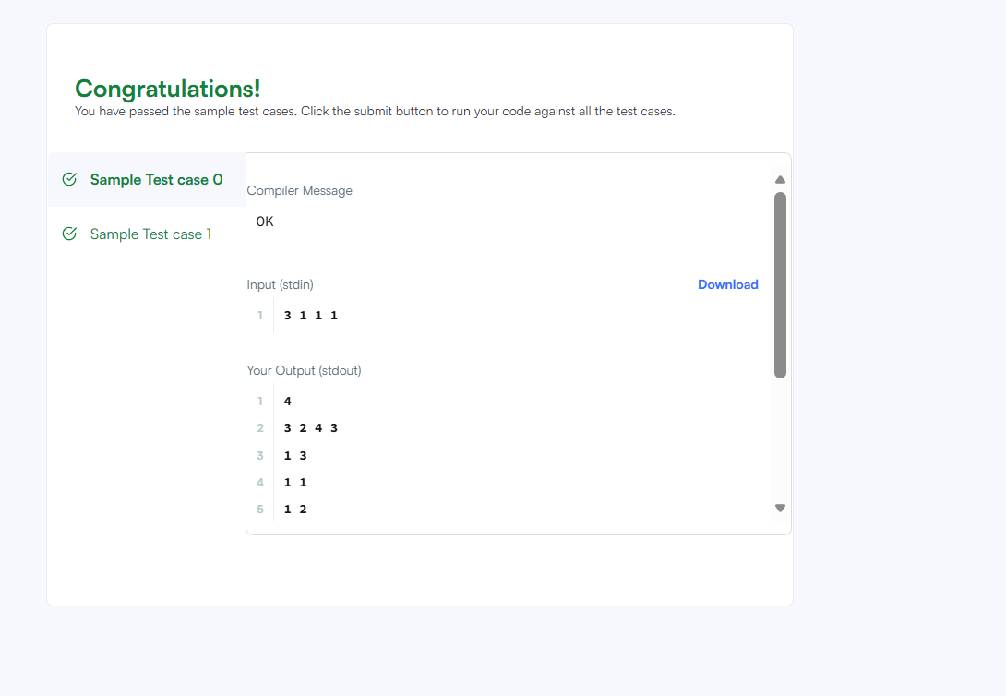
Figure: HackerRank sample test cases passed successfully.
H. Observation:
The assignment demonstrates that DFS edge classification is determined by the structure of the DFS tree and by the relationship between the source and destination vertices. The number of tree edges fixes the number of vertices as n = t + 1 because a connected DFS tree has n - 1 tree edges.
A single chain is sufficient when no cross edges are required, because it provides a large number of ancestor-descendant pairs for back and forward edges. When cross edges are required, the graph is divided into two DFS branches from vertex 1. The first branch finishes before the second branch starts, making an edge from the second branch to the first branch a valid cross edge.
The adjacency-list order is essential. Tree edges are inserted before additional non-tree edges so that DFS discovers each intended child through the tree edge first. Back edges target ancestors, forward edges target non-adjacent descendants, and cross edges are generated only between the two separate branches.
For the sample input 3 1 1 1, the program constructs a valid graph with four vertices and exactly three tree edges, one back edge, one forward edge, and one cross edge. The approach follows the implementation and README maintained in the Assignment2 GitHub folder.
Sample Graph Representation:
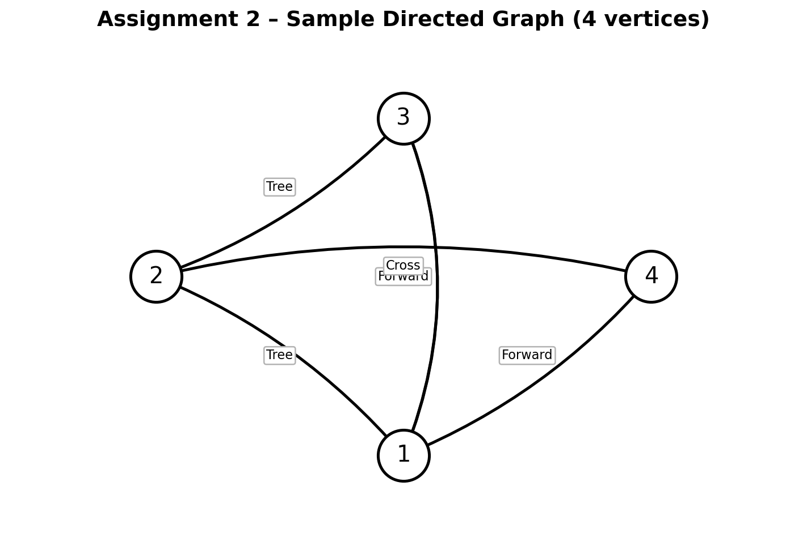
Figure: Sample directed graph showing DFS edge classifications.

