Algorithm Simulator
By Team B+ Trees

Purpose:
The purpose of this document is to teach new users how to use the simulator website.

Walkthrough:

When the user first navigates to where the software is being hosted they will be presented with a screen similar to the following image:

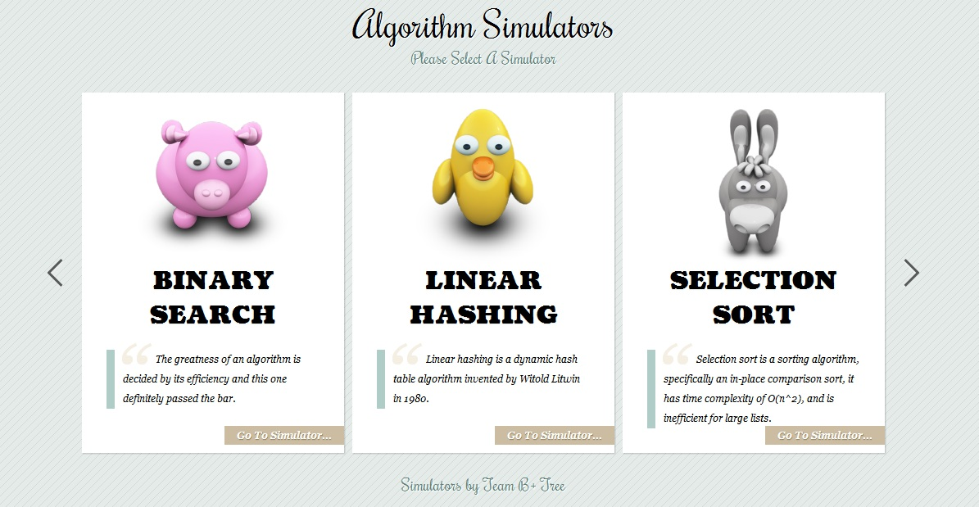
The user can select which algorithm simulator they wish to run. The arrows on the right and left sides or scrolling the mouse wheel can be used to scroll through the available simulators. Once an algorithm simulator has been selected, click the 'Go To Simulator...' button to bring up a screen similar to the following:

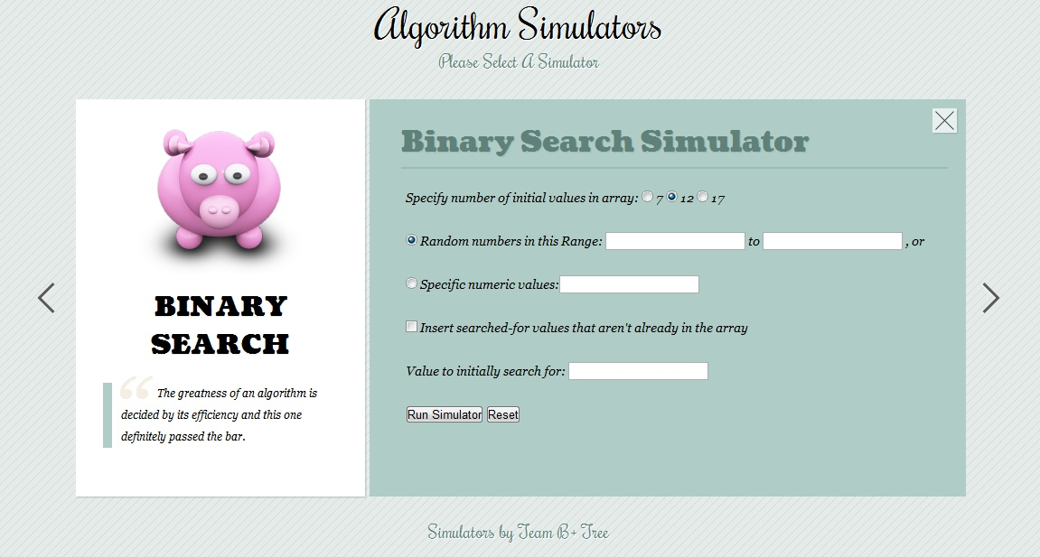
This is the input screen where the user will input the data that will be used in the simulator. This is an example of the Binary Search Simulator user input screen. All the algorithms will have varying user input screens. At this point it is still possible to return to the previous screen by clicking the large 'X' button in the top-right corner of the screen. Or, if the user has already input some data they can click the right and left arrows to change the simulator and the data will be transferred over to the next simulator's input screen. Once the user has input the data they wish to use, they can click the 'Run Simulator' button to progress to the next screen, or the 'Reset' button to reset the form to their original values. If the user has left a required field blank or did not put the proper input type in the field they will receive a error message after clicking the 'Run Simulator' button, similar to the following screen:
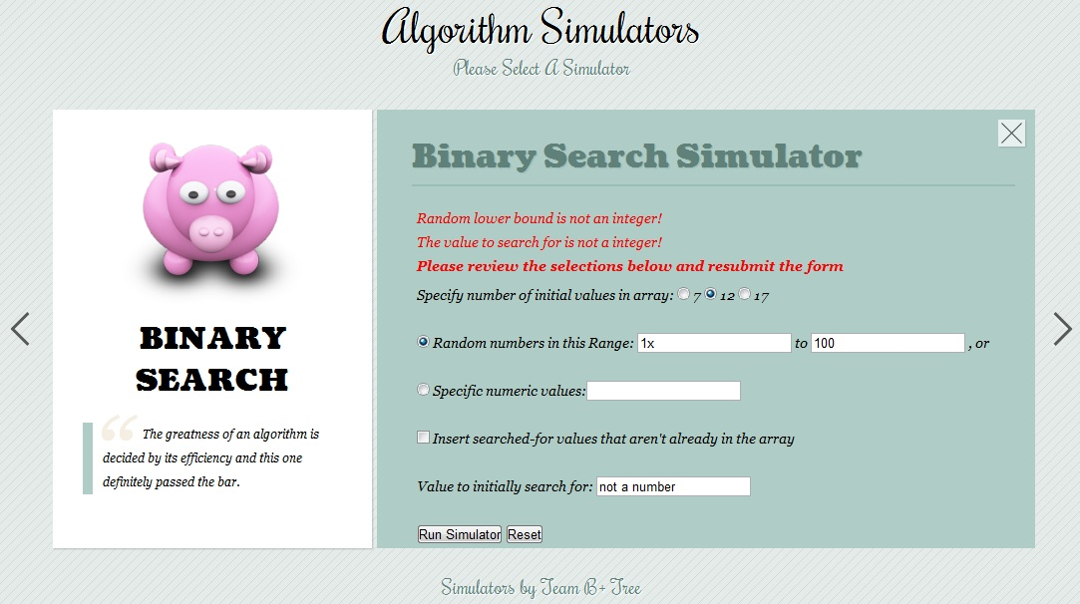
Once the errors have been corrected click the 'Run Simulator' button again to continue on to the input summary screen shown below:
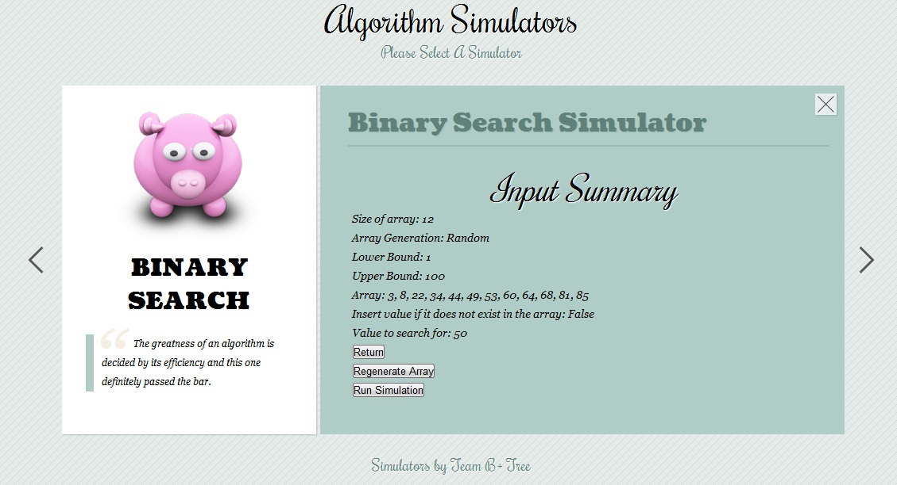
At this screen the user can press the 'Return' button to return to the data input screen, click the 'Regenerate Array' button to generate a new random array, only if they chose to create a random array, or click the 'Run Simulation' button to finalize the input and continue to the simulation. At this screen it is still possible to switch algorithms by clicking the left and right arrows or scrolling the mouse wheel. When the 'Run Simulation' button is clicked the screen will progress to the simulation shown below:
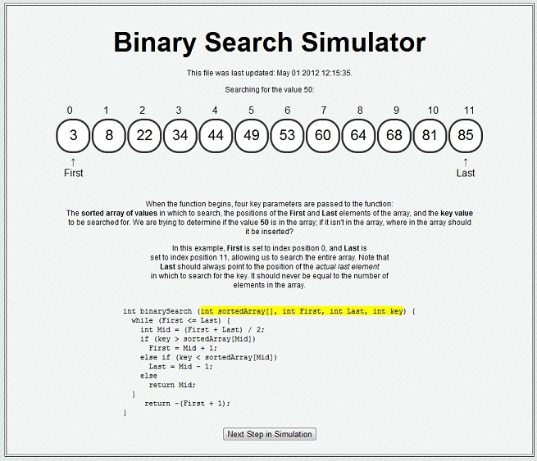
This screen will differ depending on which algorithm the user selected, but most will have the same general array display with arrows to indicate where algorithm variables are at the current step, a description of what is currently happening in the algorithm, a C-styled code of the algorithm with the current line being executed highlighted and then a 'Next Step in Simulation' button. The user will press the 'Next Step in Simulation' button to continue to the next step, or press <ENTER> on the keyboard if javascript is enabled in their browser. When the 'Next Step in Simulation' button is pressed the page will update and display a 'Previous Step in Simulation' button if javascript is enabled and there is a previous step, as seen below:
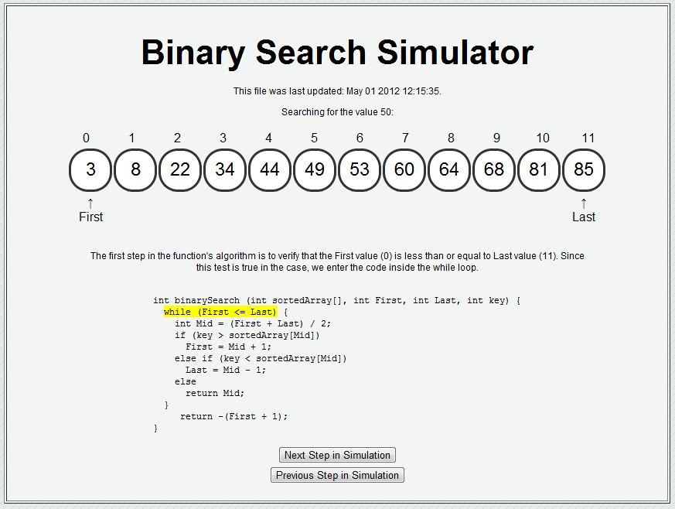
As the algorithm progresses indexes that have been already sorted or searched will be grayed out to show they are no longer in the scope of the algorithm. As shown below:
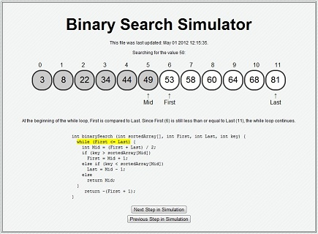
When the algorithm finished a final screen will be shown showing the final outcome of the algorithm as well as some other actions that can be taken.
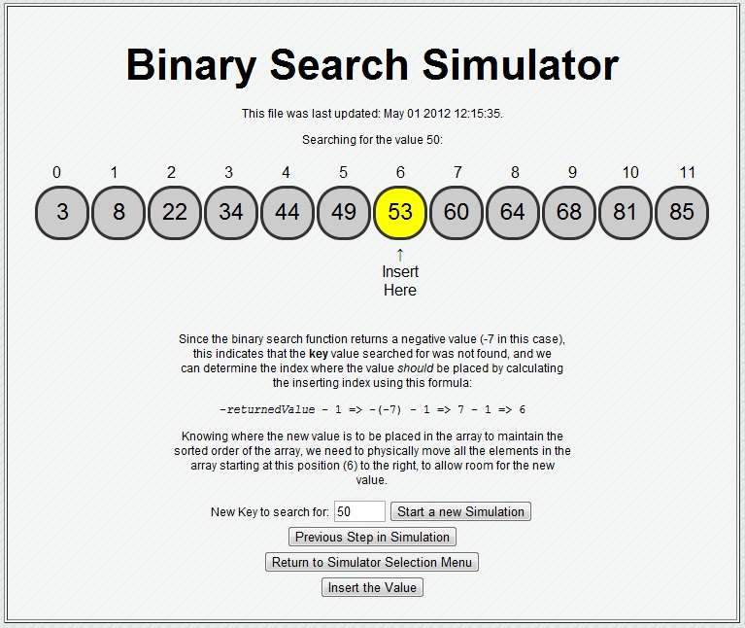
The user can, in this case, enter a new number to search the current array with by entering the new number in the field and clicking the 'Start a new Simulation' button, press the 'Previous Step in Simulation' button to return to the previous step, return to the main menu to select a new simulation by clicking the 'Return to Simulator Selection Menu', or run the simulation to insert the value into the array, only if the value is not in the array, by pressing the 'Insert the Value' button.

