B.Sc. Engg. Thesis

A Thesis on Online Shopping Management System

Md. Tunazzinur Rahman Kabbo (ID: 19202103268)  
Md. Zobayer Hasan Nayem (ID:19202103274)  
Hamim Reza (ID:19202103269)

Rubaiatul Jannat (ID: 19202103249)  
Md. Abu Essa (ID:19202103265)

Submitted to

Department of Computer Science & Engineering

(In partial fulfillment of the requirements for the degree of  
Bachelor of Science in Computer Science & Engineering)



Department of Computer Science & Engineering  
Bangladesh University of Business & Technology (BUBT)  
Dhaka 1000  
November 16, 2021

**Acknowledgment**

We would like to pay our gratitude to the Almighty Allah who created us with all the abilities to understand analysis and develop the process with patience. We are thankful to our thesis supervisor Badhan Chandra Das, Assistant Professor, Computer Science and Engineering Department, Bangladesh University of Business and Technology for his professional guidance and motivation during the work of this thesis which is a major part of it. Without his valuable support and guidance, this thesis could not reach this level of development from our point of view.

We would like to thank all the faculty members, Department of CSE, Bangladesh University of Business and Technology for their valuable time spend in requirements analysis and evaluation of the thesis work. We would like to express our sincere and warm gratitude to all those who have encouraged us directly, provided mental encouragement and criticized our work in several phases during the development of this thesis and for preparing this thesis indirectly.

**Declaration**

We hereby declare that the Thesis on Online Shopping Management System submitted in partial fulfillment of the requirements for the degree of Bachelor of Science in Computer Science and Engineering of Bangladesh University of Business and Technology (BUBT) is our own work and that it contains no material which has been accepted for the award to the candidate(s) of any other degree or diploma, except where due reference is made in the text of the project. To the best of our knowledge, it contains no materials previously published or written by any other person except where due reference is made in the project.

Tinazzinur Rahman Kabbo Md. Zobayer Hasan Nayem Hamim Reza  
 ID: 19202103268 ID: 19202103274 ID: 19202103269

Rubaiatul Jannat Md. Abu Essa   
 ID: 19202103249 ID: 19202103265

**Copyright**

©Copyright by Tunazzinur Rahman Kabbo (19202103268), Hamim Reza (19202103269), Zobayer Hasan Nayem (ID: 19202103274), Rubaiatul Jannat (19202103249) and Md. Abu Essa (19202103265).

All Right Reserved.

**Dedication**

*Dedicated to our parents, teachers, friends and who loved us for all their love and inspiration.*

**Certificate**

This is to certify that Tunazzinur Rahman Kabbo (ID-19202103268), Hamim Reza (ID-19202103269), Zobayer Hasan Nayem (ID-19202103274), Rubaiatul Jannat (19202103249) and Md. Abu Essa (ID-19202103265). were belong to the department of Computer Science and Engineering, have completed their Thesis on Online Shopping Management System using SQL satisfactorily in partial fulfillment for the requirement of Bachelor of Science in Computer Science and Engineering of Bangladesh University of Business and Technology in the year 2021.

Supervisor  
Badhan Chandra Das  
Lecturer  
Department of Computer Science and Engineering  
Bangladesh University of Business and Technology

**Approval**

A Thesis on Online Multi-Shop is submitted by Tunazzinur Rahman Kabbo (ID-19202103268), Hamim Reza (ID-19202103269), Zobayer Hasan Nayem (ID-19202103274), Rubaiatul Jannat (ID-19202103249) and Md. Abu Essa (ID-19202103265) under the department of Computer Science and Engineering of Bangladesh University of Business and Technology is accepted in partial fulfillment of the requirements for the degree of Bachelor of Science in Computer Science and Engineering.

Chairman  
Prof. Dr. M. Ameer Ali  
Professor and Chairman  
Department of Computer Science and Engineering  
Bangladesh University of Business and Technology

Supervisor  
Mr. Atanu Shome  
Assistant Professor  
Department of Computer Science and Engineering  
Bangladesh University of Business and Technology

**Contents**

1. **Introduction**

* Online Shopping Management System

1. **Description**

* How an online shopping management system works
* Our Projects Details
* Tables
* Queries & Results
* ER Diagram

1. **Extensions**

* Future scope and further enhancement of the project
* Bibliography
* Conclusion

**Introduction**

* 1. **Introduction**

This “Online-Shopping-Management-System” is a database system where a shop will have the facility to calculate and manage everything. It contains all the necessary details of all products, customers and employees on a daily, monthly and yearly basis. Through this system the manager of a shop can easily manages the functions of his shop.

**The Online Shopping System will have the following key features:**

* A search engine on the database to allow customers to find specific types of merchandise.
* A secure system that will allow shoppers to purchase goods safely using their credit cards.
* A data security system that will ensure that all data that is transmitted between the various system.
* A database of merchandise with photos, product descriptions and stock information. This database will also contain all relevant merchant and customer information.
* Customer reviews of the product. These ideas will add more of a personal touch to their overall shopping experience.
* A fast guest checks out option

**Description**

* 1. **How an online shopping management** **system works**

An Online Shopping System which will allow formal and informal merchants in developing countries to advertise and sell their goods on the internet. This would permit rural communities to make their wares available to the rest of the world via the World Wide Web. The objective of this project is to create an Online Shopping System web portal with a content management system which would allow product information to be updated securely using a mobile device. The web portal will have an online interface in the form of an Online Shopping System website that will allow users to buy goods from the merchants.

* 1. **Our Project Details**

So, keeping this facility in mind, we have created this type of project so that an owner can run all the accounts and activities of the shop in a smooth manner. This facility includes how many customers order products in the store, how many employees work in our store. Where the buyer's product will go, the buyer's address, all kinds of information. From which employee did the order come, how did the buyer pay, what product did he order. In addition to product reviews, how the buyer views a product. No product returned. And the product that the buyer buys belong to which tag, also the discount of the product can be known.

**Hardware and Software Requirement specifications:**

For setting this ecommerce portal, it requires certain technical requirements to be met for the store to operate properly. First, a web server must be created to make the ecommerce store publicly available on the web.

**Software Details for running Online Shopping System:**

* Web Server (Apache)
* MYSQL
* Google Chrome
  1. 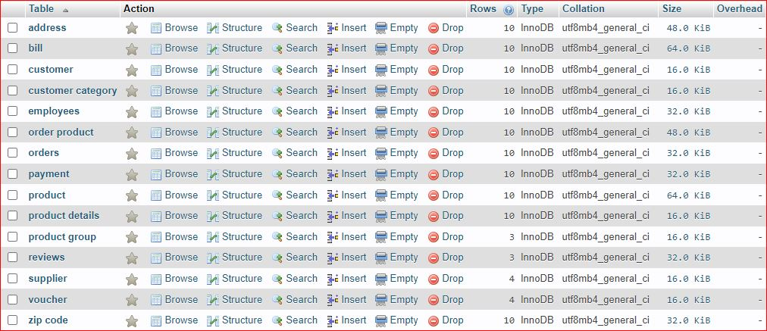**Tables**
* **Address —** (Address_ID, Apartment_Number, Street, Customer_ID)
* **Bill —** (Billing_ID, Billing_Date, Amount_Paid, Voucher_ID, Payment_ID, Order_ID)
* **Customer —** (Customer_ID, First_Name, Last_Name, Phone_Number, Email_Address, Customer_Type)
* **Customer Category —** (Customer_Catagory, Customer_ID)
* **Employees —** (Employee_ID, Employee_Name, SSN, Designation, Employee_Type, Salary, Payment_ID)
* **Order Product —** (Quantity, Product_ID, Order_ID)
* **Orders —** (Order_ID, Order_Date, Status, Shipment_Duration, Payment_ID)
* **Payment —** (Payment_ID, Payment_Mode, Card_Type, Card_Number, CVV, Name_On_Card, Customer_ID)
* **Product —** (Product_ID, Product_Name, Available_Number, Group_ID, Supplier_ID, Review_ID)
* **Product Details —** (Product_ID, Weight, Width, Height, Colour)
* **Product Group —** (Group_ID, Group_Name)
* **Reviews —** (Quality_Rating, Defect%, Review_ID, Review_Date, Product_ID)
* **Supplier —** (Supplier_ID, Supplier_Name, Supply_Quantity)
* **Voucher —** (Voucher_ID, Discount%)
* **Zip code —** (State, Zipcode_ID, City, Address_ID)
  1. **Queries & Results**
* **Find how many customers are there group by category**

SELECT Customer_Type, COUNT(Customer_Type) AS Total

FROM customer

GROUP BY Customer_Type;

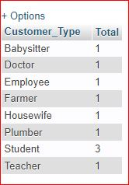

* **Find apartment whose name is 'Bilash Vobon' or zip code id is 1210**

SELECT Address_ID, Apartment_Name, Zipcode_ID

FROM address

WHERE (Apartment_Name= 'Bilash Vobon' OR Zipcode_ID = '1210')

ORDER BY Zipcode_ID DESC;



* **Find the supplied product count and their group for each product**

SELECT supplier.Supplier_ID, supplier.Supplier_Name, Count(product.Group_ID)

AS `Product Count`, `product group`.Group_Name

FROM supplier

INNER JOIN product

ON supplier.Supplier_ID = product.Supplier_ID

INNER JOIN `product group`

ON product.Group_ID = `product group`.Group_ID

GROUP BY Supplier_ID ASC;

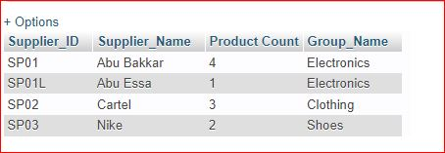

* **List of products by department which has high defect%**

SELECT reviews.Product_ID, product.Product_Name, MAX(reviews.`Defect%`)

AS `Defect%`, `product group`.Group_Name

FROM reviews

INNER JOIN product ON reviews.Product_ID = product.Product_ID

INNER JOIN `product group` ON product.Group_ID = `product group`.Group_ID

GROUP BY `product group`.Group_ID;

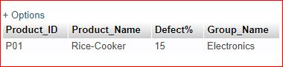

* **Total amount of revenue earned with respect to their purchasing modes**

SELECT COUNT(Payment_Mode) AS Total_Cutomers, payment.Payment_Mode, SUM(bill.Amount_Paid)

AS Total_Amount

FROM payment

INNER JOIN bill

ON payment.Payment_ID = bill.Payment_ID

GROUP BY Payment_Mode;

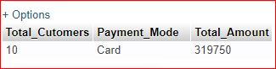

* **Find the quantity of products available whose status is in progress and shipment duration is immediate**

SELECT product.Product_Name, product.Available_Number, `order product`.Quantity, orders.Order_Date, orders.`Status`, orders.Shipment_Duration

FROM orders

INNER JOIN `order product`

ON orders.Order_ID = `order product`.Order_ID

INNER JOIN product

ON `order product`.Product_ID = product.Product_ID

WHERE orders.`Status` = 'In Progress' AND orders.Shipment_Duration = 'Immediate';

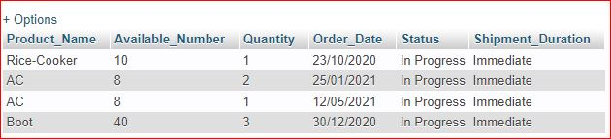

* **Find the names and defect% order by defect%**

SELECT Product_Name,`Defect%`

FROM product

INNER JOIN reviews

ON reviews.Product_ID = product.Product_ID

ORDER BY `Defect%` Desc;

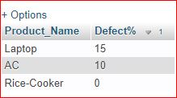

* **Find customers payment id, mode, voucher applied and their visit number**

SELECT bill.Voucher_id, payment.Payment_ID, payment.Payment_Mode, payment.Visit_Number

FROM bill, payment

WHERE payment.Payment_ID = bill.Payment_ID

AND bill.Amount_Paid > 1000;

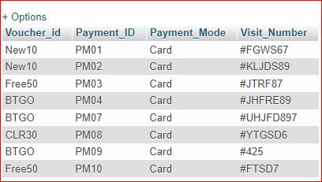

* **Find product and their respective color**

SELECT Product_Name, Colour

FROM `product details`

INNER JOIN product

ON `product details`.Product_ID = product.Product_ID

ORDER BY Colour;

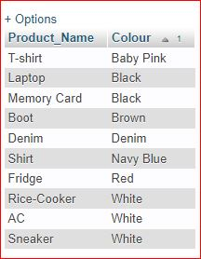

* **Find the product names and their respective groups**

SELECT Group_Name, Product_Name

FROM `product group`

INNER JOIN product

ON `product group`.Group_ID = product.Group_ID

ORDER BY Group_Name;

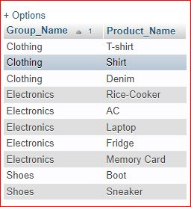

* **Find total salaries paid to each employee type**

SELECT SUM(Salary), Employee_Type

FROM employees

GROUP BY Employee_Type;

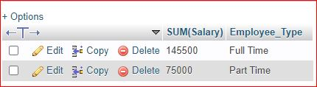

* **Find maximum salaries paid to each employee type**

SELECT MAX(Salary), Employee_Type

FROM employees

GROUP BY Employee_Type;

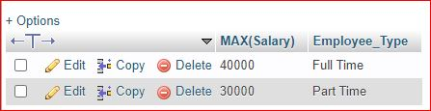

* 1. **ER Diagram**

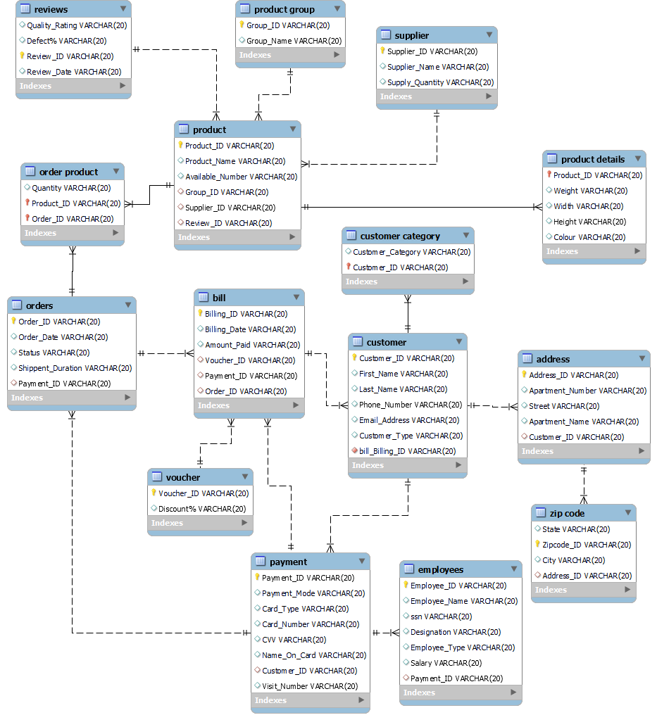

**Extensions**

* **Future scope and further enhancement of the project:**

Today, the market place is flooded with several Online Shopping System options for shoppers to choose from. A variety of innovative products and services are being offered spoiling customers for choice. Online shopping is no more a privilege enjoyed by your friends and family living in the Bangladesh. Today, it is a reality in India. In the last couple of years, the growth of Online Shopping System industry in Bangladesh has been phenomenal as more shoppers have started discovering the benefits of using this platform. There is enough scope for online businesses in the future if they understand the Indian shopper’s psyche and cater to their needs.

* **Bibliography:**
* Articles on Ecommerce - www.epaynews.com/statistics/
* Articles on Ecommerce - www.merchantpicks.com
* Articles on Ecommerce - www.google.com
* Articles on Ecommerce - www.emarketer.com
* Articles on Ecommerce - www.internet-story.com/
* Articles on Ecommerce -www.networld.com/hosting/online-shopping-system.com
* Articles on Ecommerce - www.exploitlib.org/issue3/online-shopping-system/
* Articles on Ecommerce - www.onlineshoppingsystemtimes.com/perl/story/18403.html
* Articles on Ecommerce - www.eglobal.es/cisco_view.pdf
* Articles on Ecommerce - www.cnn.co
* **Conclusions:**

Finally, successfully develop and implement the site 'Online Shopping Management System'. With the help of various kinds of links and tools, includes all the features which was basic requirement for an ecommerce web site. Provide an ecommerce site which is live and running on the web. Finally got success in our attempt to take care of the needs of both the customers as well as the administrator which was our main objectives.

**THANK YOU**