Zhanibek Kabdygalyk
SE-2520

Goal
This code needs to show a little information about me and write your subject, day when it is will be and time and in the end information, your name, Gmail and choose your favorite color.

Description of task
In task I need to use basic HTML elements, image, button, links, table, basic form. And in CSS need to use stylesheet and selectors, typography, colors and backgrounds, Box model (margin, padding), navigation states and image styling.
(If it’s needed you can see at the end of this document)

Screenshoots and summary of my work
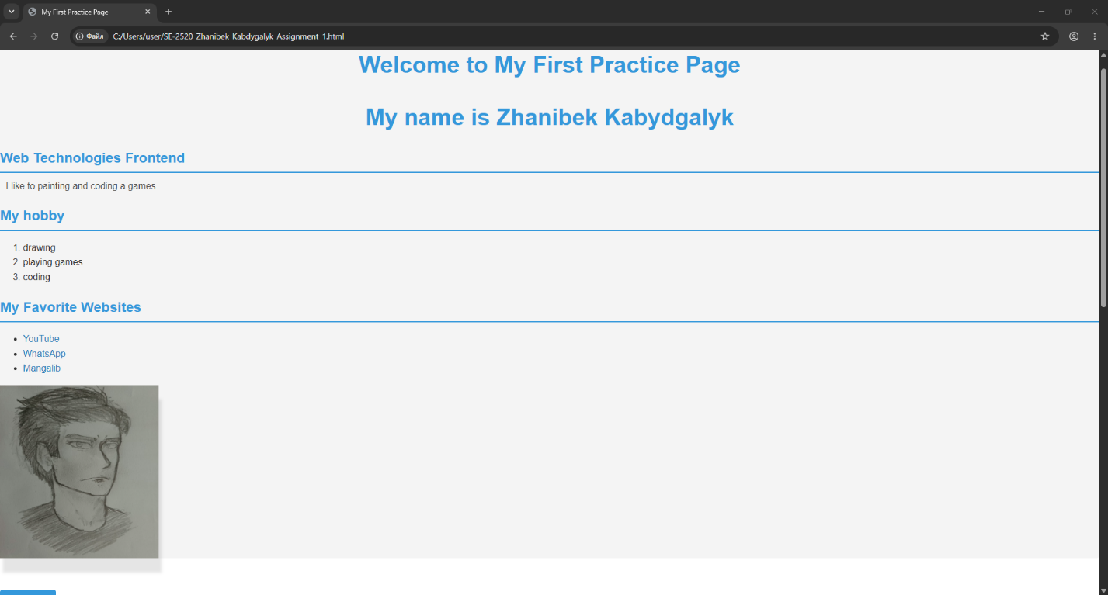

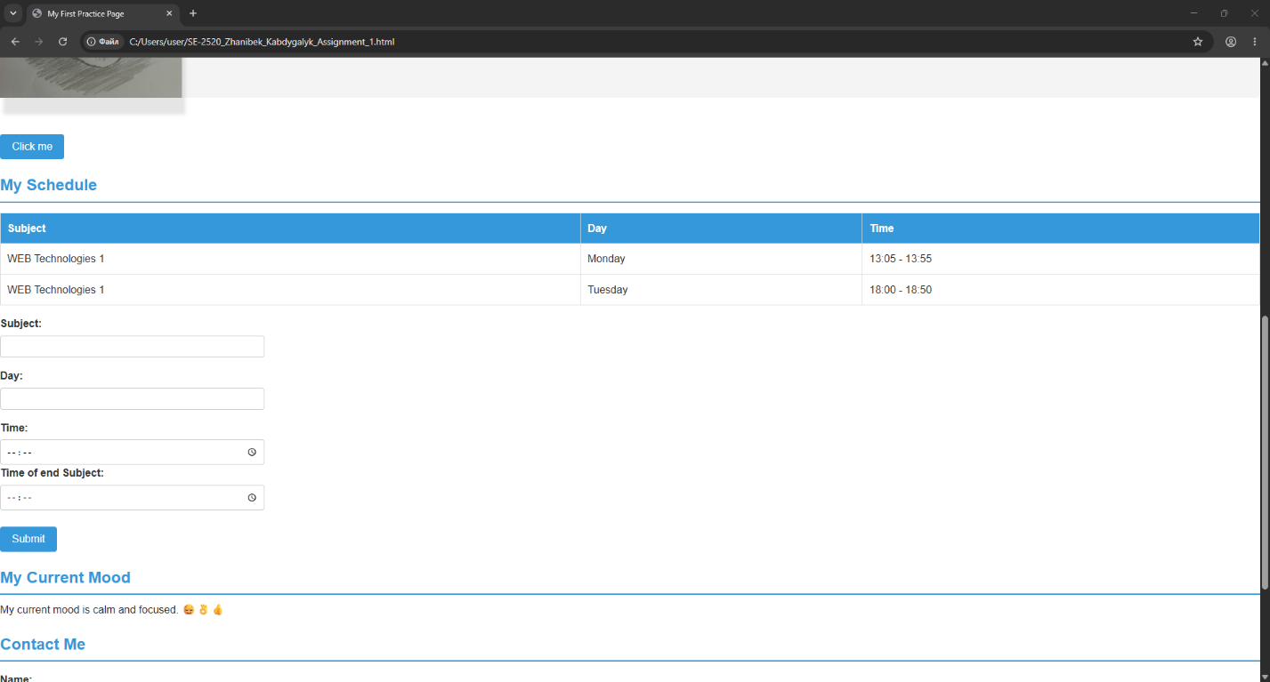

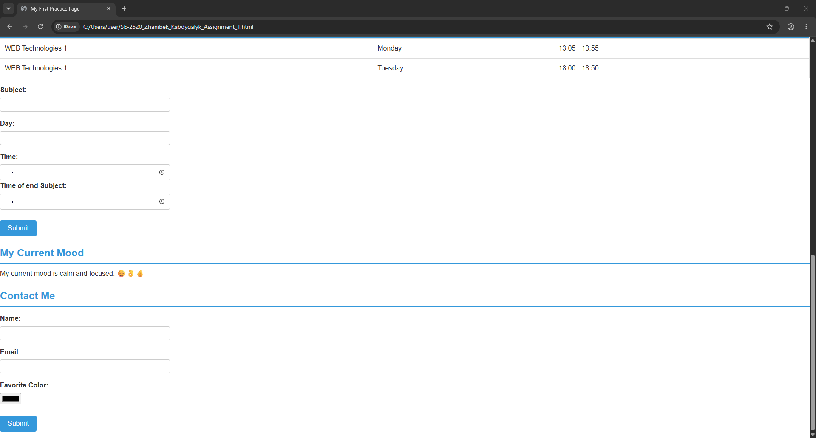

In HTML I write about me, divide sections be using <h2> (in CSS I do like after text in <h2> will be created line). After photo, button and after table and sections for write data about your subject. After my emotional state with 3 emoji. And another section for writing data about you (this part was created before in subject section).

In CSS I just write about how it should look like. Like size of text, color. In body, h2, p, a and in :hover, :focus. Background color in table cell, size of space of input, space between object and left wall, place of text (about h1) etc.

What I Learn
I learn about how to work in CSS, about classes, id, div, form, etc. So how to take one of the object or type, child (about second practice class)

Part 1. Build the HTML page
1. Project setup.
- Create a project folder containing index.html, style.css, and an images folder. Use VS Code or another editor. Include the HTML doctype, html, head, title, and body elements; set the document language and UTF-8 encoding. Set the page title to "My First Webpage".

2. Page structure and introduction.
- Organize the page into a header, navigation, main content, and footer. Use h1, h2, and h3 appropriately to present your name, course, and an "About Me" section. Write a short introductory paragraph.

3. Lists, image, and links.
- Add an ordered list of hobbies and an unordered list of favorite websites. Include at least two working external links. Add a personal photo or avatar with descriptive alternative text. Use relative paths for local images.

4. Navigation and button.
- Create navigation links to sections of the same page using matching section IDs. Include a button labelled "Click Me"; no JavaScript action is required.

5. Schedule table.
- Create a class schedule with three columns: Subject, Day, and Time. Use table header cells and include your schedule entries. Use the table for data; use CSS to arrange the page.

6. Mood paragraph.
- Add a short paragraph about your mood containing at least three emojis. Check that they display correctly in the browser.

7. Basic form.
- Include Name (text input), Email (email input), Favorite Color (color input), and a Submit button. Associate each input with a visible label. The controls must work in the browser; storing or sending data is not required.

Part 2. Style the same webpage
Apply CSS to the HTML page created in Part 1. Keep the design consistent and the source code easy to explain.
8. External stylesheet and selectors.
- Link style.css from the head of index.html and place your styles in that file. Demonstrate all four selector types:
- Element selector, such as p or h1, for general styling.
- Class selector for reusable styling, using a descriptive name such as .profile-card.
- ID selector for one unique element, such as #about-me. Do not repeat an ID.
- Descendant selector, such as .site-nav a, for elements inside a container.

Create your own meaningful class and ID names. Avoid names such as class1 or item2. Do not import Bootstrap or rely on its predefined classes.
9. Typography.
- Set font family, size, and weight. Make headings and body text visually distinct. Apply suitable text alignment, and customize link color and text decoration. Standard fonts are sufficient; external fonts are optional.

10. Colors and backgrounds.
- Choose a consistent palette for text, links, and backgrounds. Apply background colors or images to page sections. Maintain readable contrast between text and its background.

11. Box model and sizing.
- Use margin, padding, and border to separate and group content. Demonstrate width and height settings on suitable elements. Keep text readable and images proportional; avoid clipping or overlap.

12. Navigation states.
- Style the navigation with clear spacing between links. Add a visible :hover effect. Keep visible keyboard focus on links, buttons, and form controls, using the browser default or a custom focus style.

13. Image styling.
- Control image dimensions without

