# NED University of Engineering & Technology

# Department of Software Engineering

Course Coordinator: Ms. Simra Najm

Designation: Assistant Professor

Email: simranajm@neduet.edu.pk

Fundamentals of Information Techmology

CT-174

Assignment Number 1

Of

Number System & Data representation

Submission date :24th-12-2019 Tuesday:

Q1. Convert each of the following base 10 & base 2 numbers in signed magnitude, one’s complement and two’s complement. Each of the numbers should be represented in 8 bits. C2

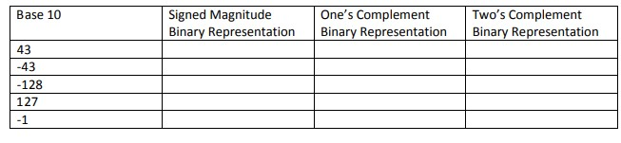

|  |  |  |  |
| --- | --- | --- | --- |
| -66 |  |  |  |
| 00111011 |  |  |  |
| 011110 |  |  |  |
| 11101001 |  |  |  |

Q2. Compute the following binary numbers, Negative numbers are represented using two’s complement, give the decimal representation of obtained result. C3



Q3.Compute the following additions on 8-bit numbers, generating an 8-bit result. Negative numbers are represented using 1’s complement, give the decimal representation of obtained result. C3

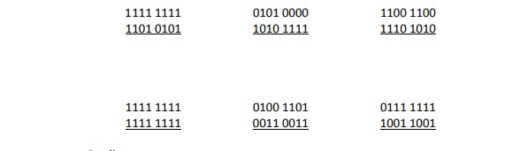

Q4. Consider a computer that represents number using a sequence of 12 bits

Represent a number in base 2 and base 10 C2

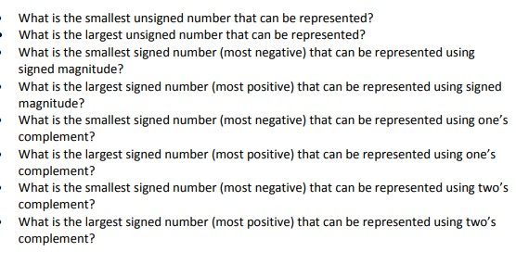

Q5. Convert the following C 2

1. A0F1H 🡪 Base 2 , base 8
2. 101010010B 🡪 base 16 , base 8
3. 2678 O 🡪 base 10 , base 2