Practice-3

C:\Users\Fareed Ahmed\Desktop\Consistentency prob. clips\Capture-1a.JPGQ#1.

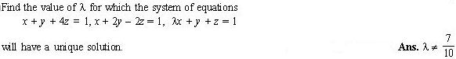Q#2.

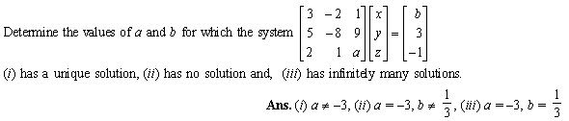

Q#3.

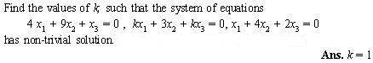Q#4.

C:\Users\Fareed Ahmed\Desktop\Consistentency prob. clips\Capture-5.jpgQ#5.