**DML OPERATIONS USING DATASETS**

**OBJECTIVE**

To implement dml operations using dataset auto generated methods

**THEORY**

**DATA MANIPUATION LANGUAGE**

The Data Manipulation Language (DML) is used to retrieve, insert and modify database information. These commands will be used by all database users during the routine operation of the database. Let's take a brief look at the basic DML commands:

**INSERT**The INSERT command in SQL is used to add records to an existing table.

**Example**

INSERT INTO personal_info  
values('bart','simpson',12345,$45000)

**SELECT**   
The SELECT command is the most commonly used command in SQL. It allows database users to retrieve the specific information they desire from an operational database.

**Example**

SELECT *  
FROM personal_info

**UPDATE**   
The UPDATE command can be used to modify information contained within a table, either in bulk or individually.

**Example**

UPDATE personal_info  
SET salary = salary * 1.03

**DELETE**

The DELETE command with a WHERE clause can be used to remove his record from the personal_info table.

**Example**

DELETE FROM personal_info  
WHERE employee_id = 12345

**DATASET**

The DataSet contains the copy of the data we requested through the SQL statement. We can use Dataset in combination with SqlDataAdapter class . The SqlDataAdapter object allows us to populate [Data Tables](http://vb.net-informations.com/dataset/dataset-create-without-database.htm) in a DataSet. We can use Fill method in the SqlDataAdapter for populating data in a Dataset.

**EXERCISE**

**Using dataset auto generated methods implement DML operations.**

**TABLES**

* Create a table
* Right Click **data connection** 🡪 Add Connection 🡪 **MS SQL Server compact edition 3.5 (select)**
* Enter **Database Name** 🡪 Create database🡪 Database created with **.sdf extension**

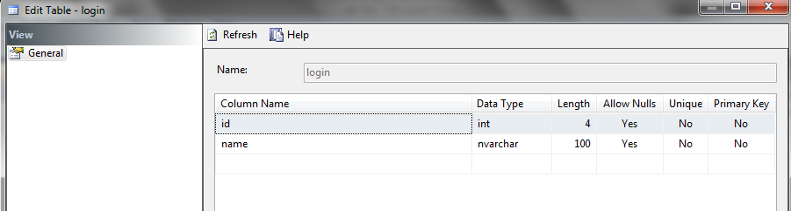

**DATASET**

* Solution Explorer 🡪 Windows Form🡪 Right Click **Add Datasets** 🡪 Drag and Drop table
* Right click **table Adapter** 🡪 Add query 🡪 Run the **Wizard of query generation**

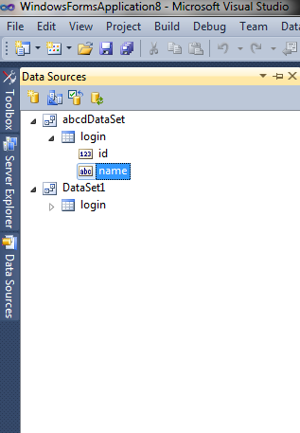

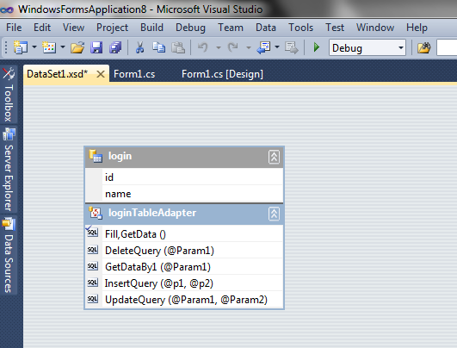

**FORM DESIGN:**

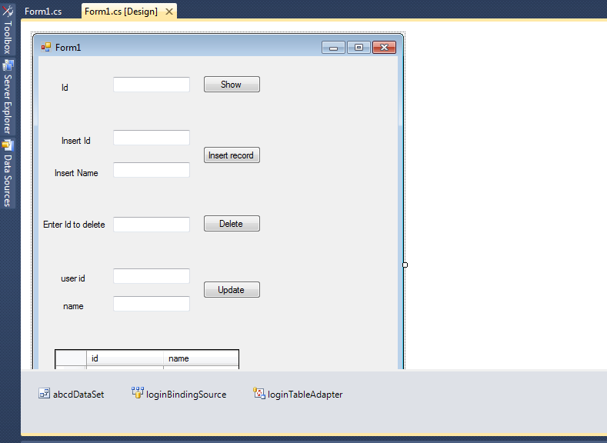

**CODING:**

using System;

using System.Collections.Generic;

using System.ComponentModel;

using System.Data;

using System.Drawing;

using System.Linq;

using System.Text;

using System.Windows.Forms;

using WindowsFormsApplication8.DataSet1TableAdapters;

namespace WindowsFormsApplication8

{

public partial class Form1 : Form

{

public Form1()

{

InitializeComponent();

}

private void button1_Click(object sender, EventArgs e)

{

int a = int.Parse(textBox1.Text);

loginTableAdapter d = new loginTableAdapter();

dataGridView1.DataSource = d.GetDataBy(a);

}

private void button2_Click(object sender, EventArgs e)

{

int b= int.Parse(textBox2.Text);

DataSet1TableAdapters.loginTableAdapter ob = new DataSet1TableAdapters.loginTableAdapter();

ob.InsertQuery(b, textBox3.Text);

}

private void button3_Click(object sender, EventArgs e)

{

int c = int.Parse(textBox4.Text);

DataSet1TableAdapters.loginTableAdapter ab = new DataSet1TableAdapters.loginTableAdapter();

ab.DeleteQuery(c);

}

private void button4_Click(object sender, EventArgs e)

{

int d = int.Parse(textBox5.Text);

DataSet1TableAdapters.loginTableAdapter n= new DataSet1TableAdapters.loginTableAdapter();

n.UpdateQuery(textBox6.Text, d);

}

private void Form1_Load(object sender, EventArgs e)

{

this.loginTableAdapter.Fill(this.abcdDataSet.login);

}

}}

**OUTPUT**

