**SQL STORED PROCEDURES**

**OBJECTIVE**

To explore functions of stored procedures in sql server.

**THEORY**

**STORED PROCEDURES**

**Introduction**

* Stored procedures are special objects available in sql server. It is a precompiled statements where all the preliminary parsing operations are performed and the statements are ready for execution.
* It is very fast when compared to ordinary sql statements where the sql statements will undergone a sequence of steps to fetch the data.
* Stored procedure involves various syntax based on the parameters passed.

**Syntax**

**Code:**

CREATE PROCEDURE procName

AS

BEGIN

-----Query goes here

END

To execute the stored procedure we have to use exec command,

**Code:**

EXEC procName

Applications do not need to transmit all of the SQL statements in the procedure: they have to transmit only an EXECUTE or CALL statement containing the name of the procedure and the values of the parameters.

**BACKUP**

Every [recovery model](http://msdn.microsoft.com/en-us/library/ms189275.aspx) lets you back up a whole or partial SQL Server database or individual files or filegroups of the database. Table-level backups cannot be created.

**DATABASE BACKUPS**

Database backups are easy to use and are recommended whenever database size allows. SQL Server supports the following types of database backups.

|  |  |
| --- | --- |
| **Backup type** | **Description** |
| [**Database backup**](http://msdn.microsoft.com/en-us/library/ms186289.aspx) | A full backup of the whole database. Database backups represent the whole database at the time the backup finished. |
| [**Differential database backups**](http://msdn.microsoft.com/en-us/library/ms181092.aspx) | A backup of all files in the database. This backup contains only the data extents that were modified since the most recent database backup of each file. |

**SCRIPTS**

The Database Scripts project is a series of command line scripts which will dump, erase, restore and merge databases. They are specifically set up to work the best when developing within a version control environment. The primary goals are to:

* keep the database **in sync with code**
* preserve ability to **use the web GUI**
* enable a **rapid** development workflow
* **Merge** development and production databases

**EXERCISE**

**Explore functions of stored procedures and take backups and generate scripts of database.**

**TABLE CREATION**

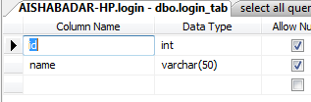

**CREATING STORED PROCEDURE**

Expand Programmability in object explorer.

Programmability 🡪 Right Click on Stored Procedure 🡪 New Stored procedure

**SELECT ALL QUERY STORED PROCEDURE**

CREATE PROCEDURE sp_login

AS

BEGIN

SELECT * FROM login_tab

END

GO

exec sp_login

**PARAMETERIZED QUERY**

CREATE PROCEDURE sp_log

@id int

AS

BEGIN

SELECT name from login_tab

where id=@id

END

GO

exec sp_log 1

**CREATING BACKUP**

Right Click on the data base🡪 Tasks 🡪 Backup

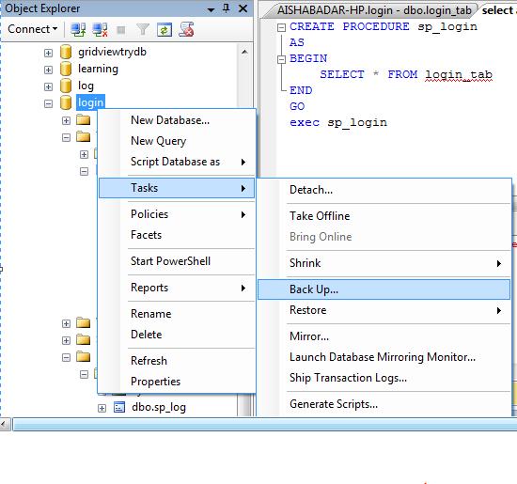

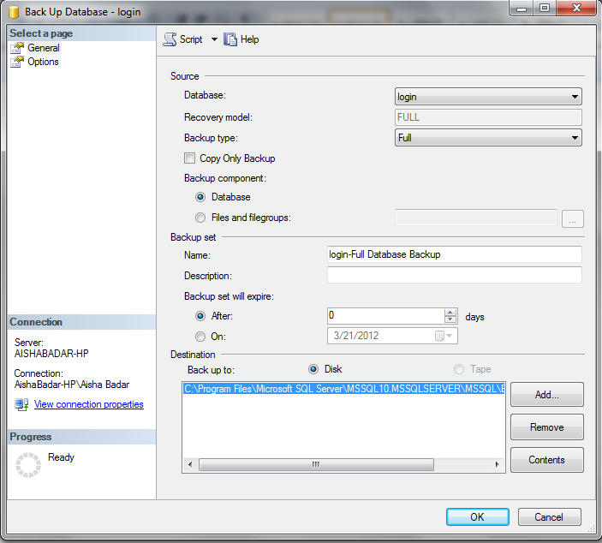

Press Ok

This message will appear on the screen

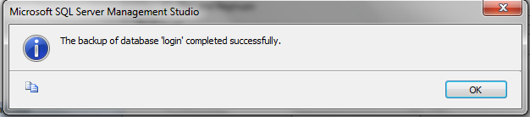

**CREATING SCRIPTS**

* Right Click on the **data base**🡪 **Tasks** 🡪 **Generate Scripts**

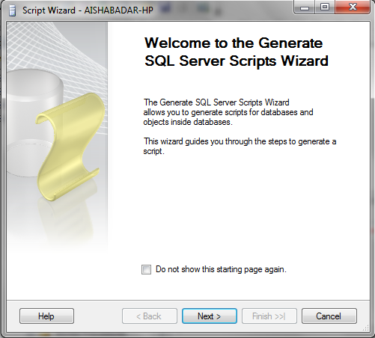

* Click Next🡪 Select your Database Name 🡪 Click **Next**
* Select Stored Procedures and Tables if wants to generate their scripts

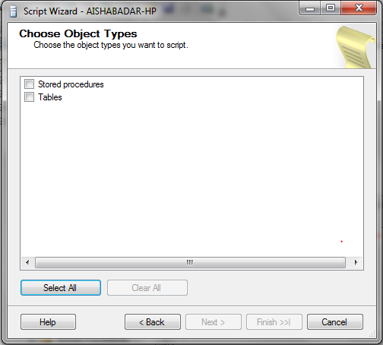

* Select those Stored Procedures whose scripts are required.

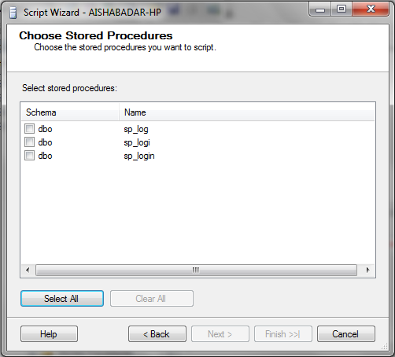

* Select those tables in the database whose scripts are required.

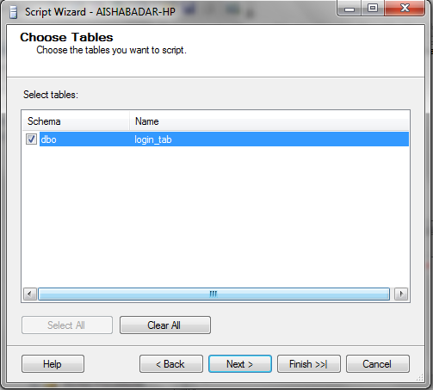

* Select the destination of the script

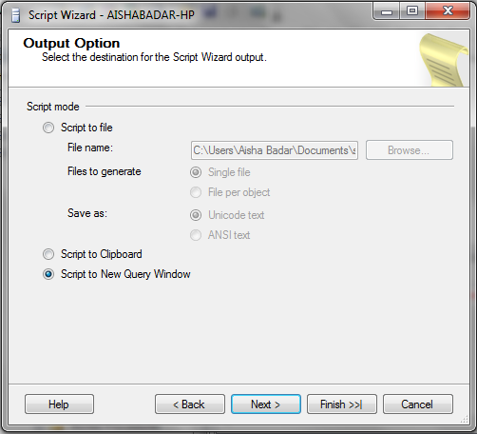

* Click Finish

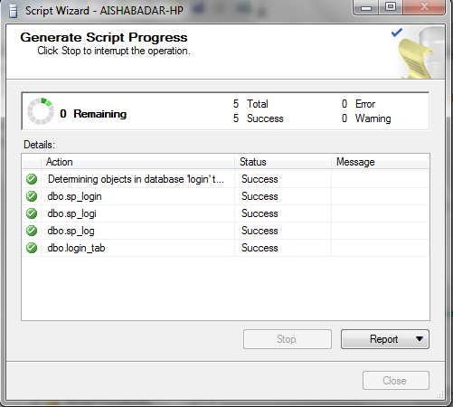

**SCRIPT**

USE [login]

GO

/****** Object: Table [dbo].[login_tab] Script Date: 03/21/2012 23:04:31 ******/

SET ANSI_NULLS ON

GO

SET QUOTED_IDENTIFIER ON

GO

SET ANSI_PADDING ON

GO

CREATE TABLE [dbo].[login_tab](

[id] [int] NULL,

[name] [varchar](50) NULL

) ON [PRIMARY]

GO

SET ANSI_PADDING OFF

GO

/****** Object: StoredProcedure [dbo].[sp_login] Script Date: 03/21/2012 23:04:30 ******/

SET ANSI_NULLS ON

GO

SET QUOTED_IDENTIFIER ON

GO

-- Batch submitted through debugger: SQLQuery2.sql|0|0|C:\Users\Aisha Badar\AppData\Local\Temp\~vsC8DD.sql

CREATE PROCEDURE [dbo].[sp_login]

AS

BEGIN

SELECT * FROM login_tab

END

GO

/****** Object: StoredProcedure [dbo].[sp_logi] Script Date: 03/21/2012 23:04:30 ******/

SET ANSI_NULLS ON

GO

SET QUOTED_IDENTIFIER ON

GO

CREATE PROCEDURE [dbo].[sp_logi]

@id int

AS

BEGIN

SELECT name from login_tab

where id=@id

END

GO

/****** Object: StoredProcedure [dbo].[sp_log] Script Date: 03/21/2012 23:04:30 ******/

SET ANSI_NULLS ON

GO

SET QUOTED_IDENTIFIER ON

GO

CREATE PROCEDURE [dbo].[sp_log]

@id int

AS

BEGIN

SELECT name from login_tab

where id=@id

END

GO