**LAB No 8**

**EXERCISE**

**Implement Linked server using SQL Server Management Studio and Stored Procedure**

**USING SQL SERVER MANAGEMENT STUDIO**

**For data source:**

Follow these steps.

* First Create a simple **Database in MS access**, add a table and save it in any drive.
* Go to **Control Pannel**, click **system security**, then click **admin tools**.
* Select **data source**, then **system DNS**,

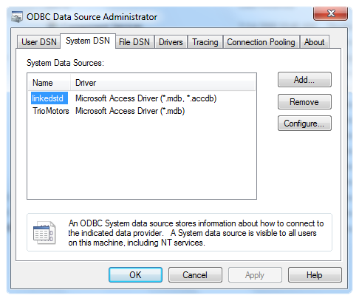

* Write data source name (eg LINKEDSTD), Then click **Select**.

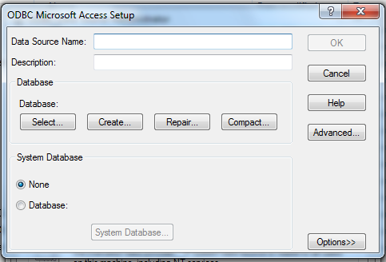

|  |
| --- |
|  |
|  |

* Browse the database you created in MS Access, and press OK.

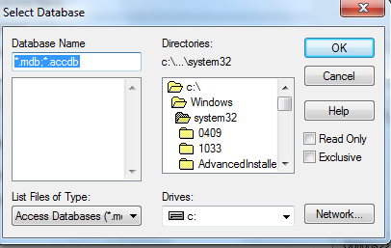

* Now click **Start**, click **All Programs**, click **Microsoft SQL Server**, and then click **SQL Server Management Studio**.
* In the **Connect to Server** dialog box, specify the name of the appropriate SQL Server, and then click **Connect**.
* In **SQL Server Management Studio**, double-click **Server Objects**, right-click **Linked Servers**, and then click **New Linked Server**.

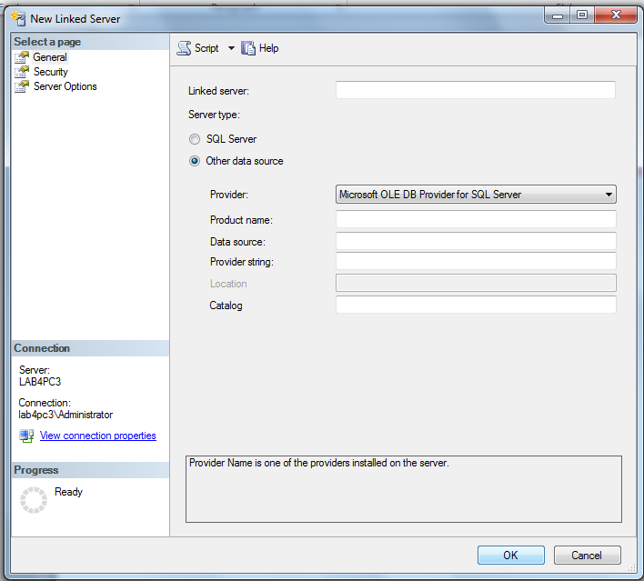

|  |
| --- |
|  |
|  |
|  |

* In the **New Linked Server** dialog box, on the **General** page, in the **Linked server** text box, enter the full network name of the Server you want to link to.
* Under **Server type**, click **other data source**.
* Then in provider select **Microsoft Office 12.0 Access Database Engine OLEDB provider.**
* In product name, write MSAccess**.**
* Now write the **data source** name LINKEDSTD that created earlier.

**USING STORED PROCEDURE**

* Now click **Start**, click **All Programs**, click **Microsoft SQL Server**, and then click **SQL Server Management Studio**.
* Then from menu, select View, then Template Explorer.
* A side window will open, look for linked server and expand it,
* Choose first template for a stored procedure and make changes as follows.

EXECsp_addlinkedserver

@server = linkedserver11,

@provider ='Microsoft Office 12.0 Access Database Engine OLEDB provider',

@srvproduct ='MSAccess',

@datasrc ='D:\studentDB';

GO

