File structure of the project:

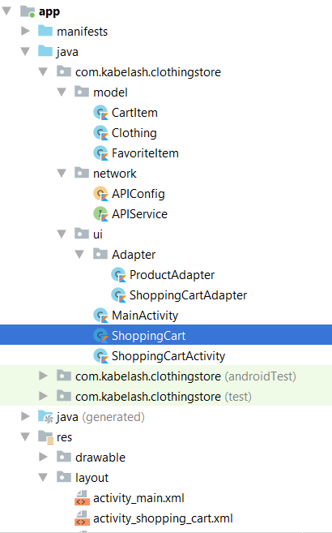

In this task I’ve used following dependencies:

1. Cardview

implementation 'androidx.cardview:cardview:1.0.0'

1. Recyclerview

implementation 'androidx.recyclerview:recyclerview:1.1.0'

1. RxJava

implementation 'io.reactivex.rxjava2:rxjava:2.2.4'

1. RxKotlin

implementation 'io.reactivex.rxjava2:rxkotlin:2.2.0'

1. Retrofit 2

implementation 'com.squareup.retrofit2:retrofit:2.6.1'

implementation 'com.squareup.retrofit2:converter-gson:2.6.1'

implementation 'com.squareup.retrofit2:converter-scalars:2.3.0'

1. Gson

implementation 'com.google.code.gson:gson:2.8.5'

1. Picasso

implementation 'com.squareup.picasso:picasso:2.71828'

I have created 4 layout files:

activity_mian.xml: Which contains RecyclerView & Floating Button for checkout option.

product_row_item.xml: Which contains the raw item for the RecyclerView such as product image, title, addToCart, removeItem, addFavourite

shopping_cart: Which view the shoppingcart items

cart_list_item.xml: raw item for the shopping cart which contains product name, image & quantity.

I have created 3 model classes under ‘model’ package:

Clothing: contains Serialized objects of the JSON

CarItem: contains product & quantity to be added to shopping cart

FavoriteItem: contains product & quantity to be added to favorites

Then under network I’ve created API interface called **APIService** as below

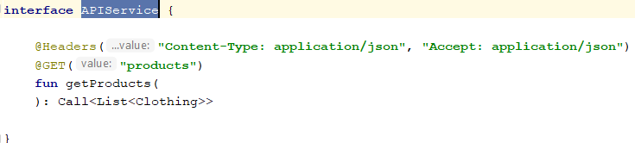

And used Retrofit 2 for network calls in the **APIConfig** object

Then I’ve created the MainActivity along with ProductAdapter to load to load the Json data in the RecyclerView. Also I’ve implemented the adding & removing cart item and add favourites in the ProductAdapter and also I’ve created another class called ShoppingCart to add companion object to save to shopping cart items & favourites. (sample code given below)

*//Adding item from cart***fun** addItem(cartItem: CartItem) {  
 **val** cart =  
 getCart()  
  
 **val** targetItem = cart.*singleOrNull* **{ it**.**product**.**productId** == cartItem.**product**.**productId }  
  
 if** (targetItem == **null**) {  
 cartItem.**quantity**++  
 cart.add(cartItem)  
 } **else** {  
  
 targetItem.**quantity**++  
 }  
 saveCart(cart)  
  
}

Finally, I’ve created the ShoppingCartActivity & ShoppingCartAdapter to view the shopping cart. I’ve implemented this as an optional.

Screenshots:

