#include <stdio.h>

#include <stdlib.h>

#include <string.h>

// Structure to represent a contact typedef

struct Contact

{

char name[50];

char phoneNumber[15];

struct Contact\* next;

struct Contact\* prev;

} Contact;

// Function to create a new contact Contact\* createContact(const char\* name, const char\* phoneNumber)

{

Contact\* newContact = (Contact\*)malloc(sizeof(Contact));

if (newContact != NULL)

{

strcpy(newContact->name, name);

strcpy(newContact->phoneNumber, phoneNumber);

newContact->next = NULL;

newContact->prev = NULL;

}

return newContact;

}

// Function to insert a contact into the phone directory void insertContact(Contact\*\* head, const char\* name, const char\* phoneNumber)

{

Contact\* newContact = createContact(name, phoneNumber);

if (newContact == NULL)

{

printf("Memory allocation failed.\n");

return;

}

if (\*head == NULL)

{ // List is empty

\*head = newContact;

}

else

{

// Insert at the end

Contact\* temp = \*head;

while (temp->next != NULL)

{

temp = temp->next;

}

temp->next = newContact;

newContact->prev = temp;

}

printf("Contact added successfully.\n");

}

// Function to display all contacts in the phone directory

void displayContacts(Contact\* head)

{ printf("\nPhone Directory:\n");

while (head != NULL)

{

printf("Name: %s, Phone Number: %s\n", head->name, head->phoneNumber); head = head->next;

} printf("\n");

}

// Function to search for a contact by name

Contact\* searchContact(Contact\* head, const char\* name)

{

while (head != NULL)

{

if (strcmp(head->name, name) == 0)

{

return head;

// Contact found

}

head = head->next;

}

return NULL;

// Contact not found

}

int main()

{

Contact\* phoneDirectory = NULL;

// Menu-driven phone directory application

int choice;

char name[50];

char phoneNumber[15];

do {

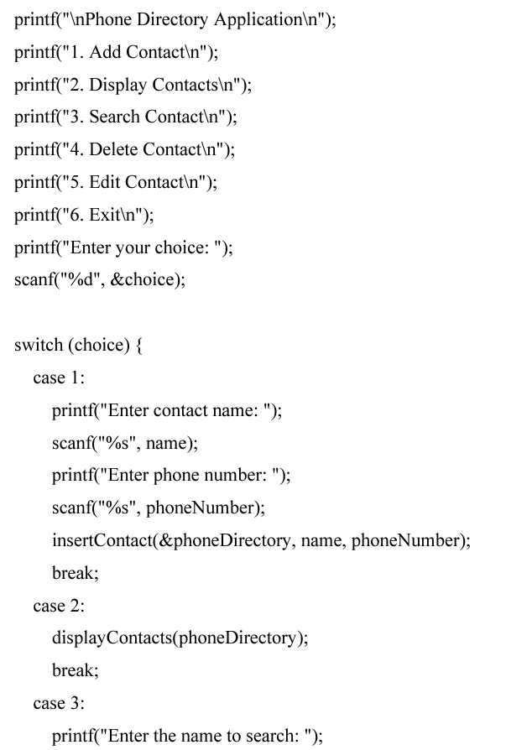

scanf("%s", name);

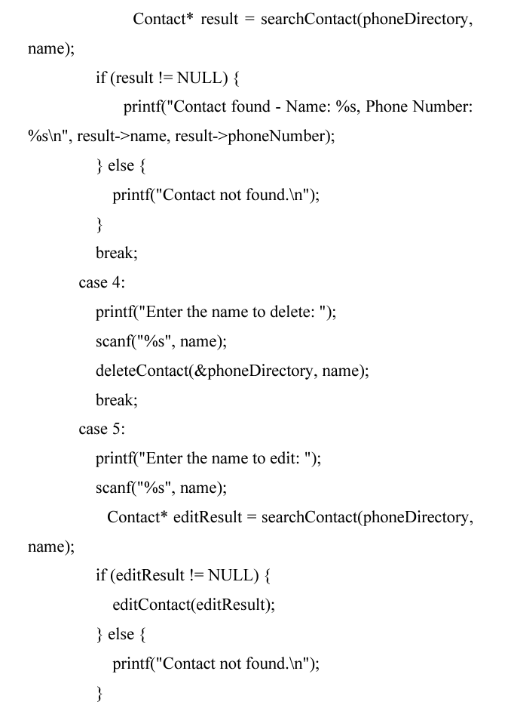

break;

