1. Design Choices, Data Structure and GUI Layout
Goals and Scope
- Provide a visual prototype for user journey:
  - Lecturer: Create a claim, attach supporting documents and track their claim.
  - Programme Coordinator (PC): Review and Verify submitted claims to check for insufficient documentation or if the lecturer truly worked the hours they will get paid for.
  - Programme Manager (PM): Check the Programme Coordinators review then approve correct claims or overturn rejected claims.
- Keep Consistency (Components, spacing and typography) to lessen cognitive stress and make the project easy to use.
- Make sure that the status of the claim (Pending, Approve, Paid) are clearly visible.

Key Design Choices
- Three roles: You can either login as a Lecturer, Programme Coordinator or Programme Manager.
- Two step signoffs: The claim is verified twice to ensure that mistakes aren’t made, first the Programme Coordinator will Review that way it can be quickly checked, if necessary, documentation and information is provided after the review is completed the Programme Manager will approve or reject the reviewed claim.
- Status transparency: The lecturer will see whether their status is still pending review, review completed and accepted or rejected.

Database structure overview
Lecturer ~> LecturerID PK, Name, Surname, Faculty.
Claim ~> ClaimID PK, LecturerID FK, Lecturer.Name, Lecturer.Surname, Sessions, HoursWorked, HourlyRate, Document/s.
ProgMngr ~> PM_ID PK, ClaimID FK, Lecturer.Name, Lecturer.Surname, Claim.Sessions, Claim.HoursWorked, Claim.HourlyRate, TotalAmount, Claim.Documents, ReviewStatus
ProCoordinator ~> PC_ID PK, PM_ID FK, ClaimID, Lecturer.Name, Lecturer.Surname, Claim.Sessions, Claim. HoursWorked, Claim.HourlyRate, ProgMngr.TotalAmount, Claim.Documents, ProgMngr.ReviewStatus, FinalAction

2. UML class Diagram

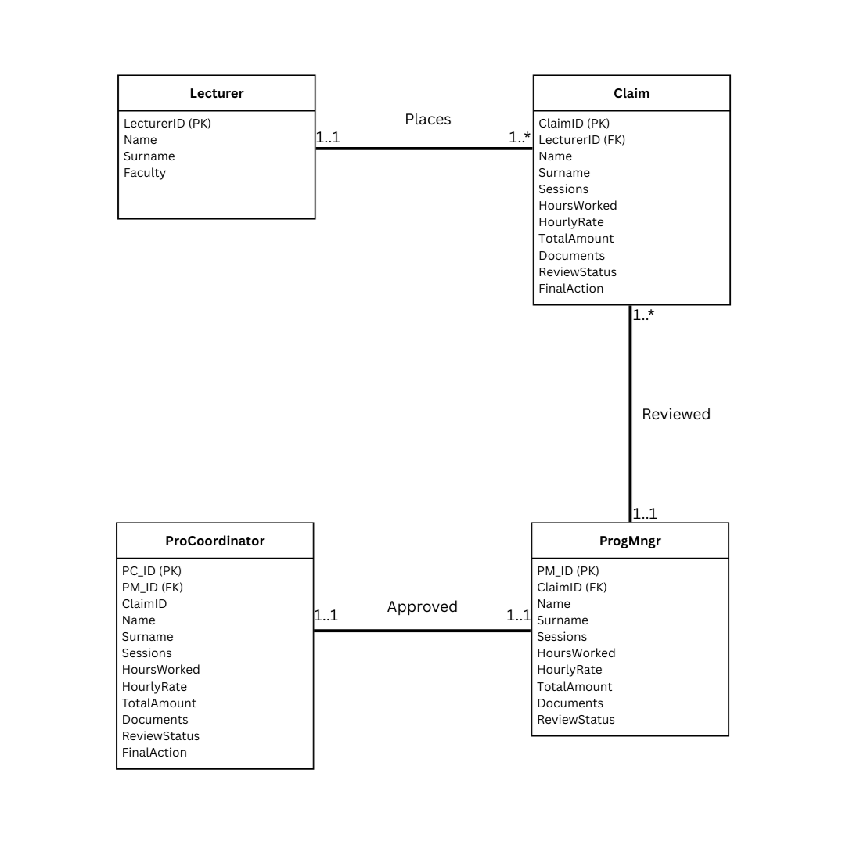

3. Project Plan
 | Task | Output | Duration
1 | Clarify scope & roles | Brief + role matrix | 1 week/s
2 | UX flows & wireframes | Low-fi screens | 0.5 week/s
3 | Information architecture | Nav map, naming | 0.75 week/s
4 | Data model & UML | Class diagram + notes | 2 week/s
5 | ASP. NET Core MVC | MVC folders routing, layout | 0.5 week/s
6 | Lecturer, PC, PM page | Claim form, upload, tables | 1.5 week/s
7 | Accessibility & responsive passes | Keyboard, semantic HTML | 0.75 week/s
8 | Packaging & documentation | README + screenshots | 0.25 week/s

