Campus Incident Reporting App
Technical Report – Formative Assignment 2
Samuel Kabera Nshuti | s.kabera@alustudent.com
GitHub: https://github.com/KaberaSamuel/campus-incident-reporting-app
Demo video: https://youtu.be/TlBVMA2kfQQ

1. Introduction
I built Campus Incident Reporting, an Android app made with Flutter. Students use it to report campus problems such as broken facilities, water shortages, electricity outages, damaged furniture, sanitation problems and safety concerns. I made it so that students and campus staff have one place to report an issue and follow it until it is resolved. Students can attach up to three photos, search and filter reports, and see the status of each report. Staff can review all reports and update their status.
The app uses Firebase Authentication, Cloud Firestore and Cloud Functions. Photos are stored in Cloudflare R2 (see Section 4.3). The app is meant for ALU users only, so it accepts only @alustudent.com and @alueducation.com emails.

2. Application architecture
I organised the code in feature folders (auth, incidents, locations, notifications, profile, staff, student) and split each feature into screens, models, providers and repositories. I did this so that the UI never talks to Firebase directly. A screen calls a provider or a repository, and only the repository knows about Firestore. This made it easy for me to change queries without touching the widgets.
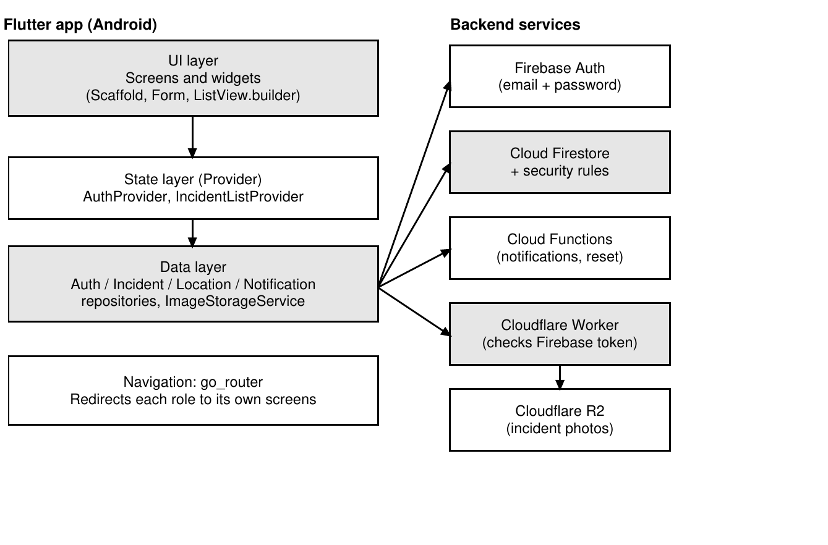
Figure 1. Architecture of the app and its backend services.
Navigation. I used go_router with two ShellRoutes, one for students and one for staff. Each shell shows a NavigationBar with that role's tabs (students: Home, Reports, Report, Inbox, Profile). The router has a redirect function and listens to the auth state, so a signed-out user is sent to login and a student can never open a staff screen.

3. Firebase data structure
I used four Firestore collections. I stored the location name and the reporter name inside each incident so that the list screen can show them without extra reads.
Collection | Main fields | Purpose
users/{uid} | email, fullName, role (student | staff), fcmTokens | Profile and role used for access control and push notifications
incidents/{id} | reporterId, reporterName, category, title, titleLowercase, description, locationId, locationName, imageUrls (max 3), status, staffNote, statusHistory[], createdAt, updatedAt | Every incident report
locations/{id} | name | Places a student can choose when reporting (managed by staff)
notifications/{id} | userId, type, title, body, incidentId, read, createdAt | In-app inbox, written by Cloud Functions

Categories and statuses. I used Dart enums for the category (facilities, water, electricity, furniture, sanitation, safety, other) and for the status (submitted, in_progress, resolved). Each enum has a firestoreValue so the stored text stays stable even if I change a label in the UI. Every status change adds an entry to statusHistory, which the detail screen shows as a timeline.
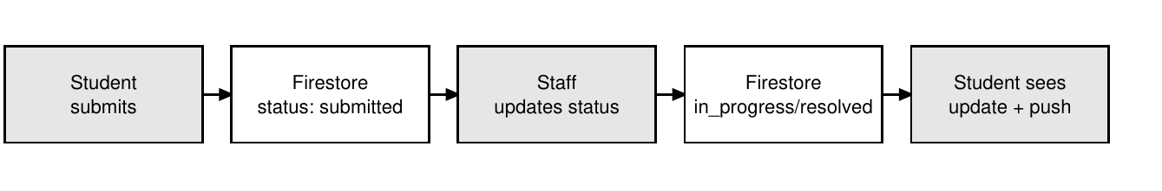
Figure 2. Life of an incident.

4. Engineering decisions

4.1 State management: Provider
I chose Provider because it is simple and it is the approach we learned. In main.dart a MultiProvider exposes the repositories and services once, and screens read them with context.read. I used two ChangeNotifier classes:
- AuthProvider holds the signed-in user, their profile and role. Screens use context.watch on it, and go_router listens to it so a login or logout changes the screen right away.
- IncidentListProvider holds the list, the loading and error states, and the filters (search, category, status, location, my reports only). I did this so the list screen only draws the data and does not contain query logic. It also handles pagination: it loads 20 incidents at a time and calls loadMore when the user scrolls down.
- For one report that can change while it is open, I used a StreamBuilder on a Firestore snapshots() stream so the status updates live. I used setState only for small things like a form field or a loading flag inside one widget.

4.2 Key Flutter widgets
Widget | Where I used it and why
Scaffold, NavigationBar | Each role's shell has a bottom bar so the main tabs are always one tap away.
Form, TextFormField | Login, register and the report form validate input (empty title, short password, wrong email domain) before anything is sent.
DropdownButtonFormField | Choosing a category and a location when reporting.
FilterChip, search field | Filtering the report list by category and status, and searching by title.
ListView.builder, RefreshIndicator | Builds long incident lists lazily; pull down to refresh and scroll down to load more.
StreamBuilder | Live view of one incident and the inbox.
Image.network | Shows the incident photos from their R2 link.
Card, ListTile, SnackBar, AlertDialog | Reusable list items, quick feedback messages and confirmation before deleting.

I also made small reusable widgets in core/widgets (StatusBadge, LoadingView, ErrorStateView, EmptyStateView) so every screen shows loading, errors and empty lists the same way.

4.3 Photo storage: Cloudflare R2 instead of Firebase Storage
On Photo uploads firebase storage needs the paid Blaze plan which requires a credit card and initial topup of $30, which I don’t have. So I had to use Cloudflare R2 Storage. So My application stores the uploaded photos to cloudflare bucket and keep the file url in the firestore document.
An Android app cannot safely contain the R2 secret keys, so I wrote a small Cloudflare Worker (worker/src/index.js). The app sends the photo to the Worker together with the user's Firebase ID token. The Worker checks the token, then allows the upload only for ALU student accounts, with at most 3 photos per incident and 5 MB per photo. Delete is allowed for the reporter (only while the report is still submitted) or for staff. Before uploading, the app compresses each image with flutter_image_compress to save data. The Worker returns a public link, and I store that link in the incident's imageUrls field, so Firestore stays the source of truth for each report.

4.4 Authentication and email verification
I used Firebase Authentication with email and password. A user can only register with an ALU address. I added email verification: after sign-up Firebase sends a verification email, and the app only lets the user in once the email is verified, so the app can only be used with a real ALU mailbox. The role is chosen from the email domain (@alustudent.com = student, @alueducation.com = staff) and saved in users/{uid}. For the school project I also wrote a Cloud Function, resetSchoolPassword, so a password can be reset, and I added a change-password screen that asks for the current password first.

4.5 Push notifications
I used two Cloud Functions that listen to Firestore. When a student creates an incident, staff get a push notification (Firebase Cloud Messaging) and an inbox entry. When staff change a status, the reporter gets the same. Tapping a notification opens that incident.

5. User roles and access control
The app has two roles. Students submit and view reports. Staff review reports, change the status, add a staff note and manage locations. I enforce this in three places so that hiding a button is not the only protection:
- Router: go_router redirects each role to its own screens.
- Firestore security rules: only a student can create an incident (it must start as submitted and belong to the student); only staff can update an incident, and only the fields status, staffNote, updatedAt, statusHistory; a student can delete their own report only while it is submitted; only staff can edit locations; a user can read only their own profile and notifications.
- Cloudflare Worker: repeats the same upload and delete rules for photos.
Staff account used for the demo. A real staff account must use a real alueducation.com email. I am a student, so I do not have one. To show the staff role in my demo, I created the account staff@alueducation.com. It only passes the domain check and receives the staff role, and it is used for demonstration only. In a real deployment, staff accounts would be created from real ALU staff mailboxes, ideally by an administrator.

6. UI/UX decisions
I kept the design simple on purpose so that a student can report an issue in a few taps.
- The report form is one screen: category, title, description, location, optional photos, then Submit. Required fields are validated and the Submit button shows a progress indicator while uploading.
- Status is shown with a StatusBadge (Submitted, In progress, Resolved) on every list item and on the detail screen, with a timeline so students see when each change happened.
- Every list has a loading state, an error state with a retry, and a friendly empty state.
- Students can see all campus reports, find their own with a You tag or the My reports filter, and search and filter to avoid sending duplicates.
- The staff dashboard shows counts per status, so staff see what needs attention first.
- A student can submit only when staff have added at least one location, so reports always have a place.
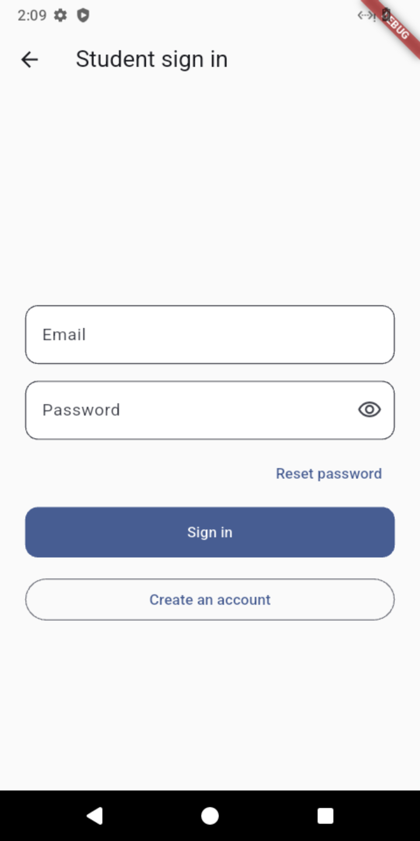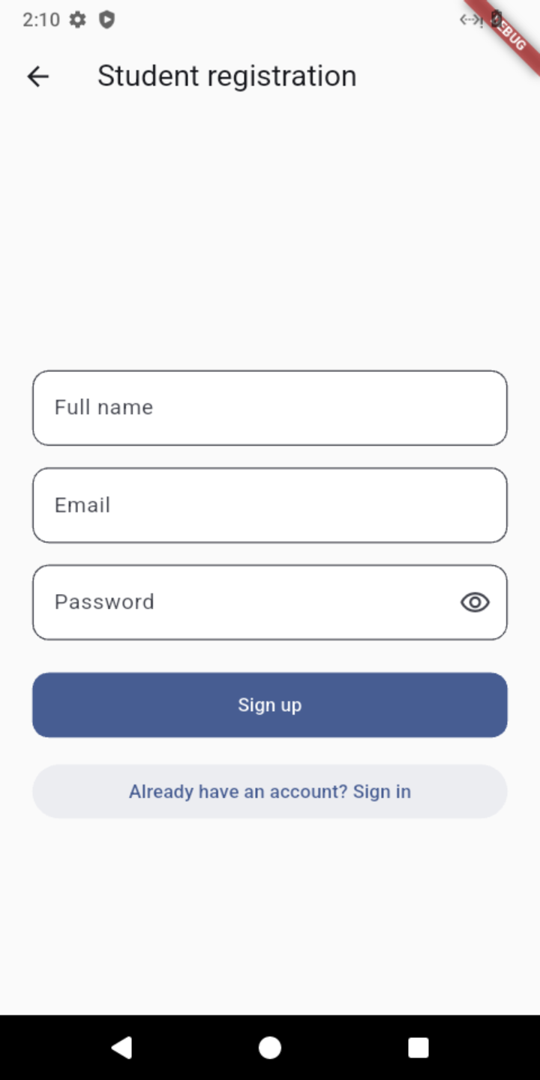
Login / register screens
Figure 3. Authentication screens.
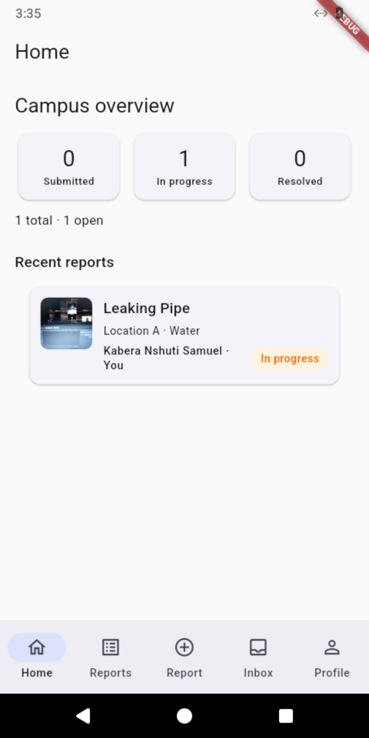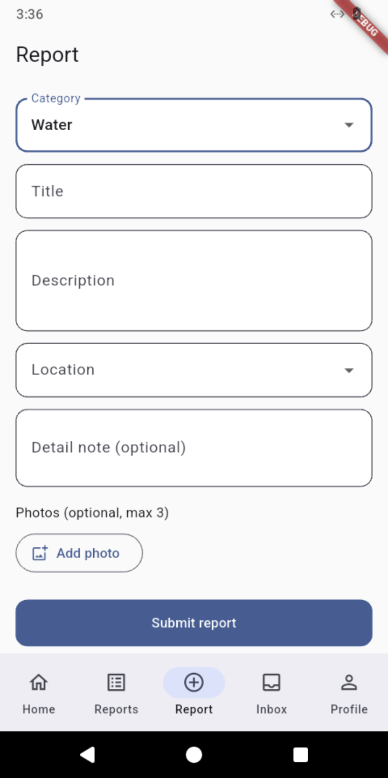
Figure 4. Student: home screen and submitting an incident with a photo.
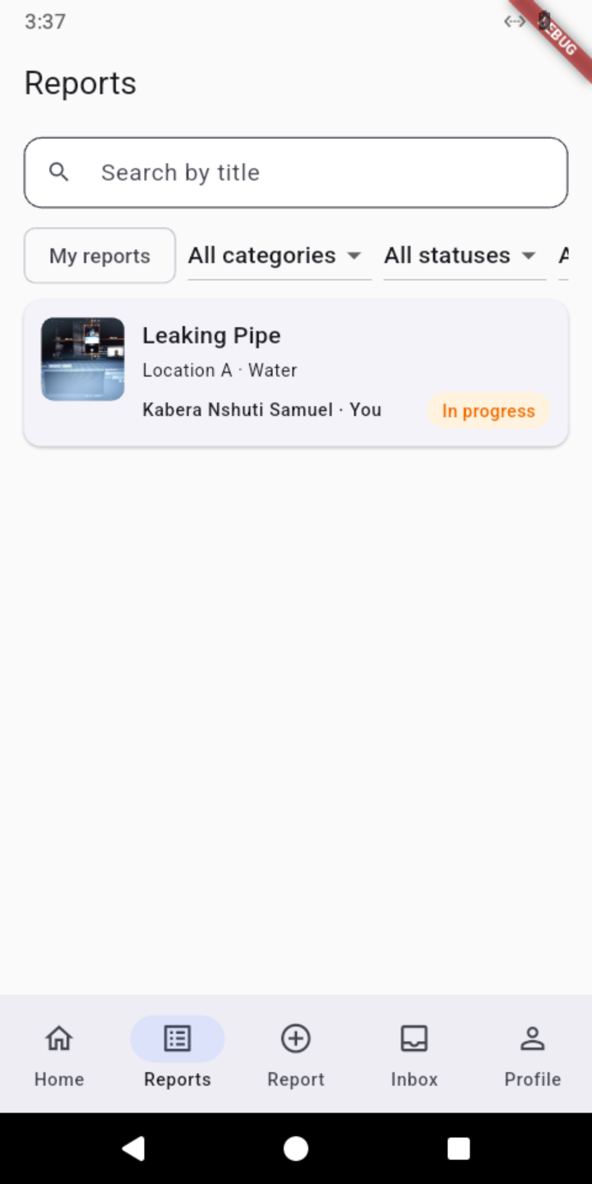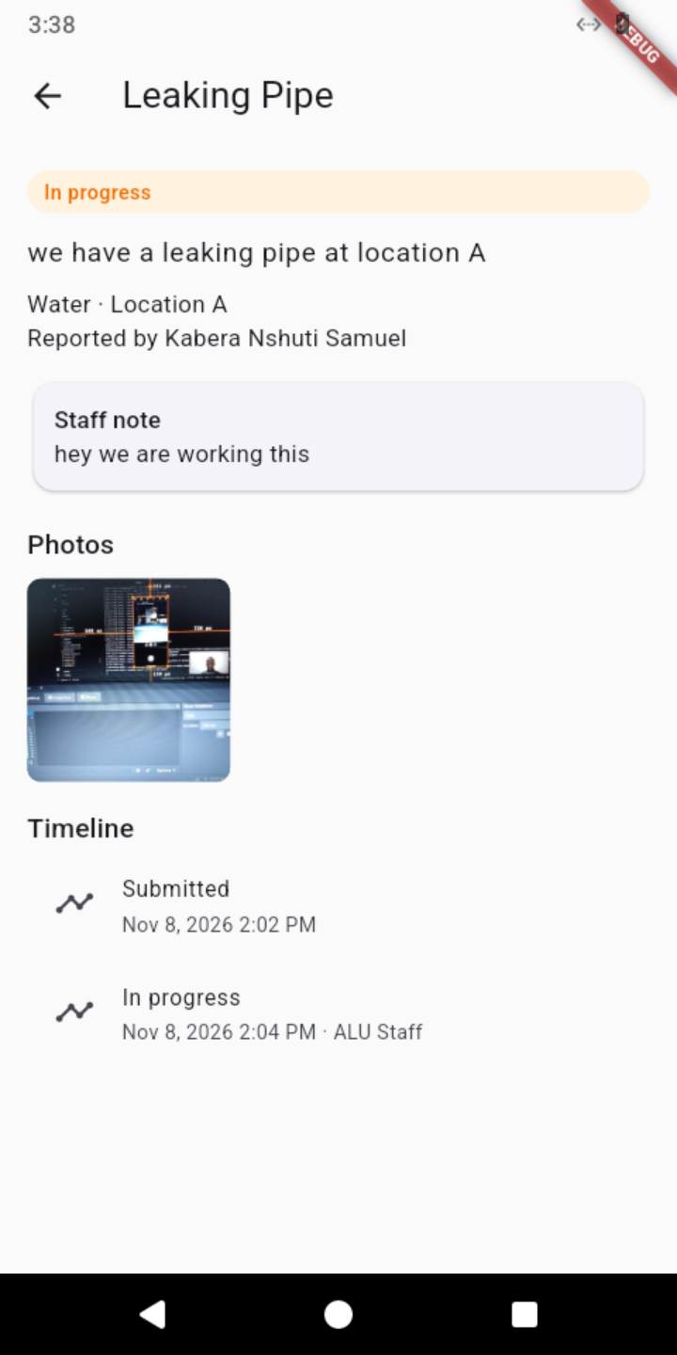
Figure 5. Browsing, filtering and viewing a report.
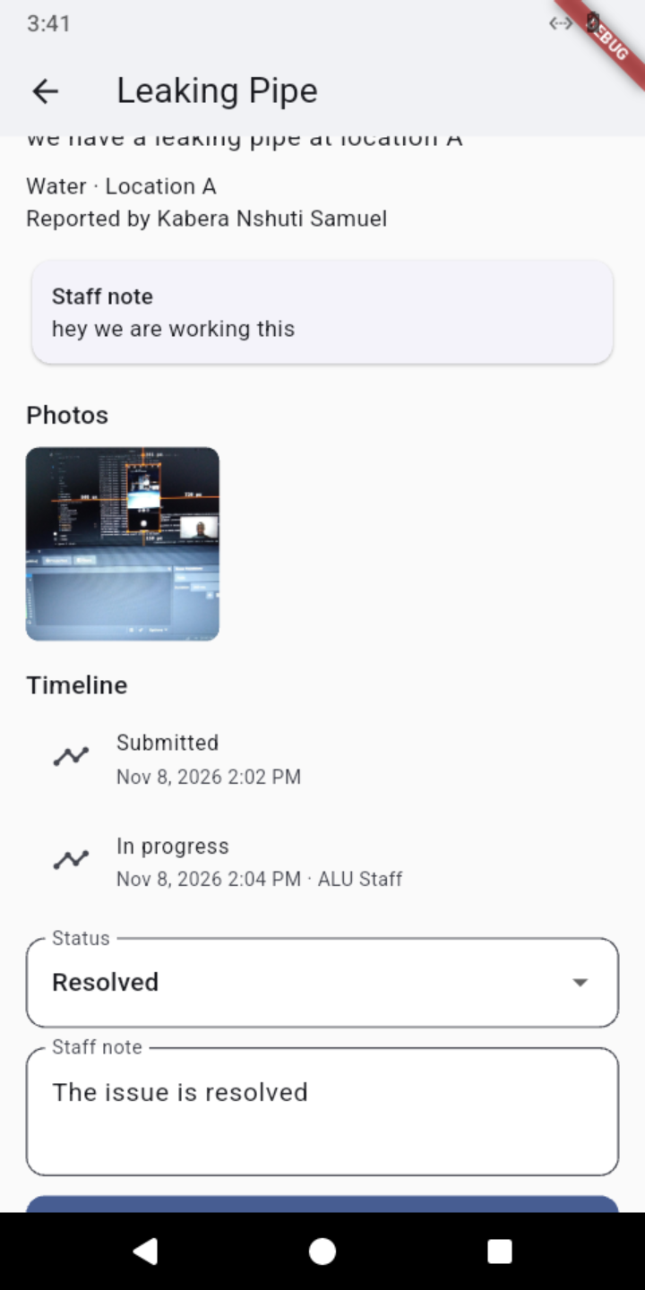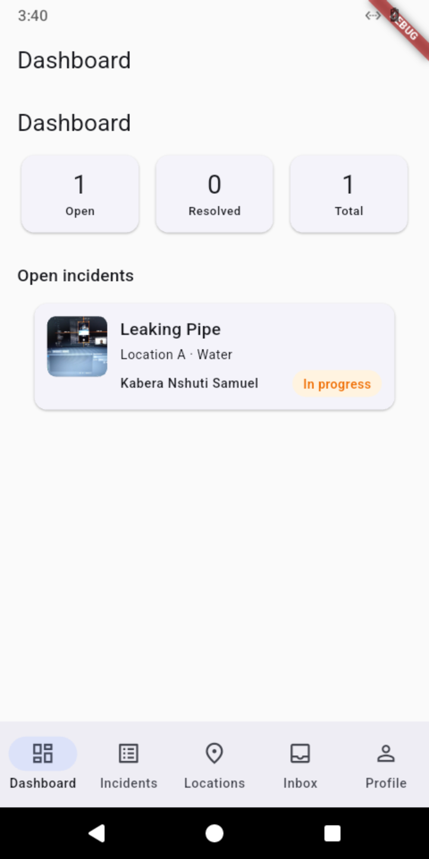
Figure 6. Staff: updating a status with a note, and dashboard.
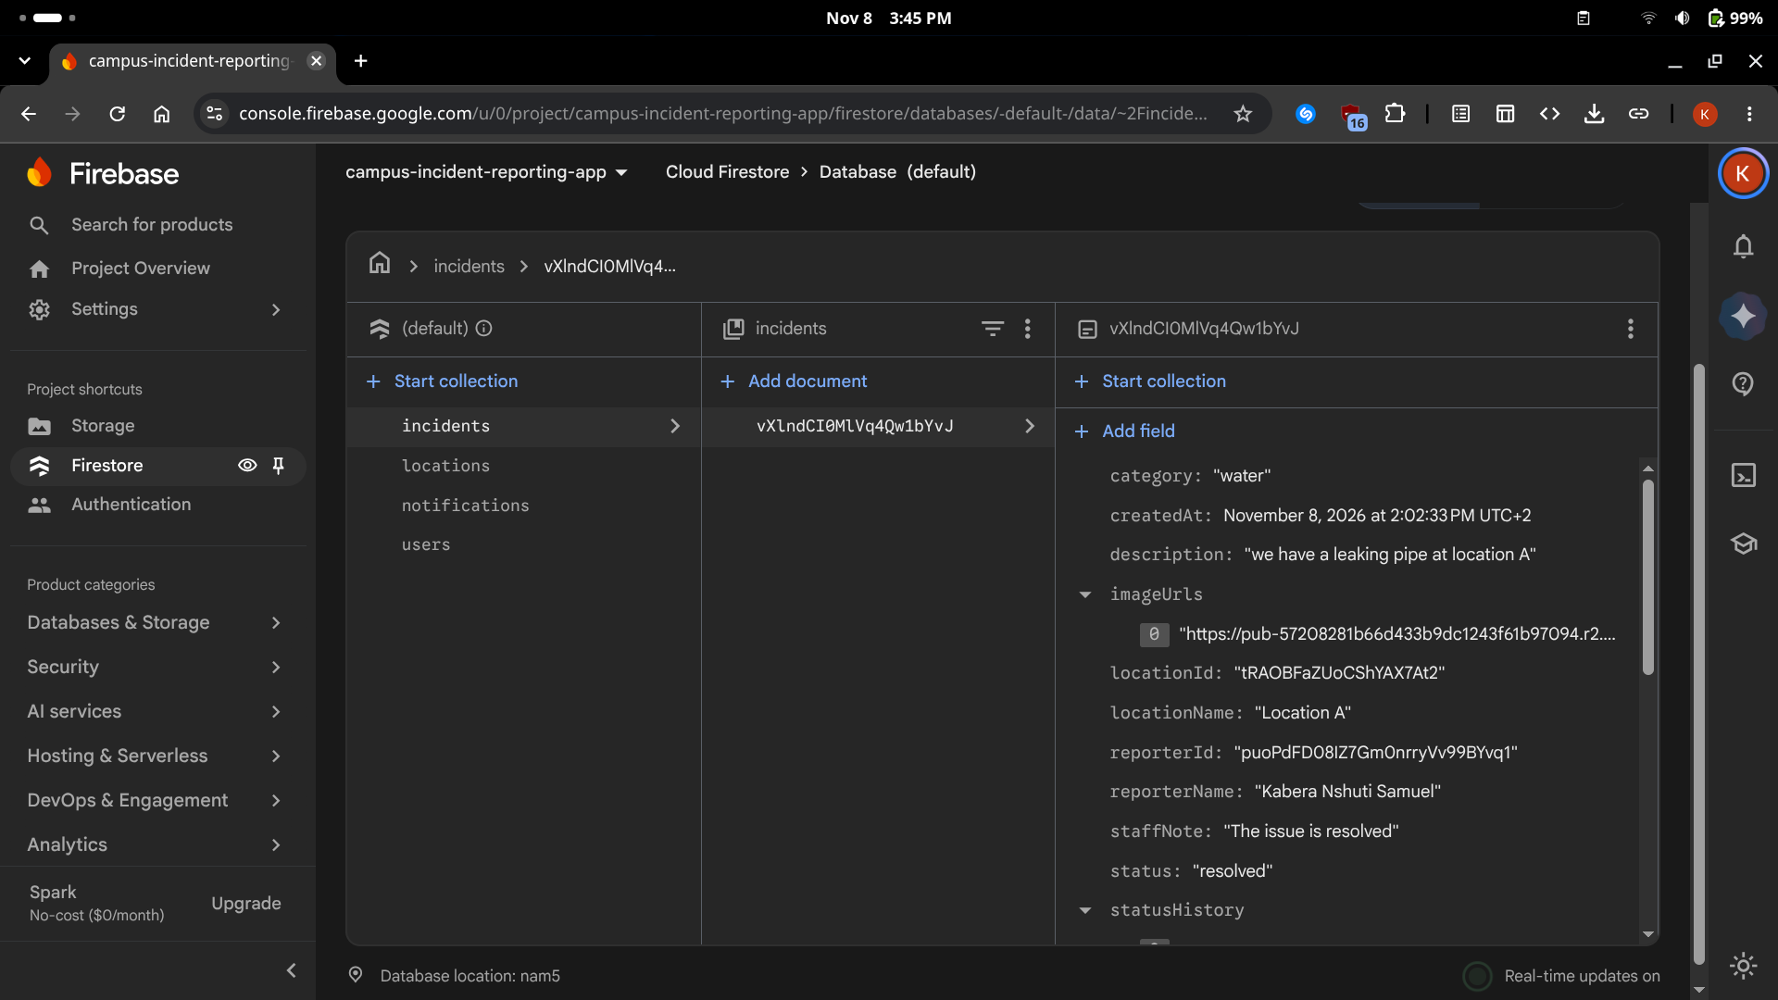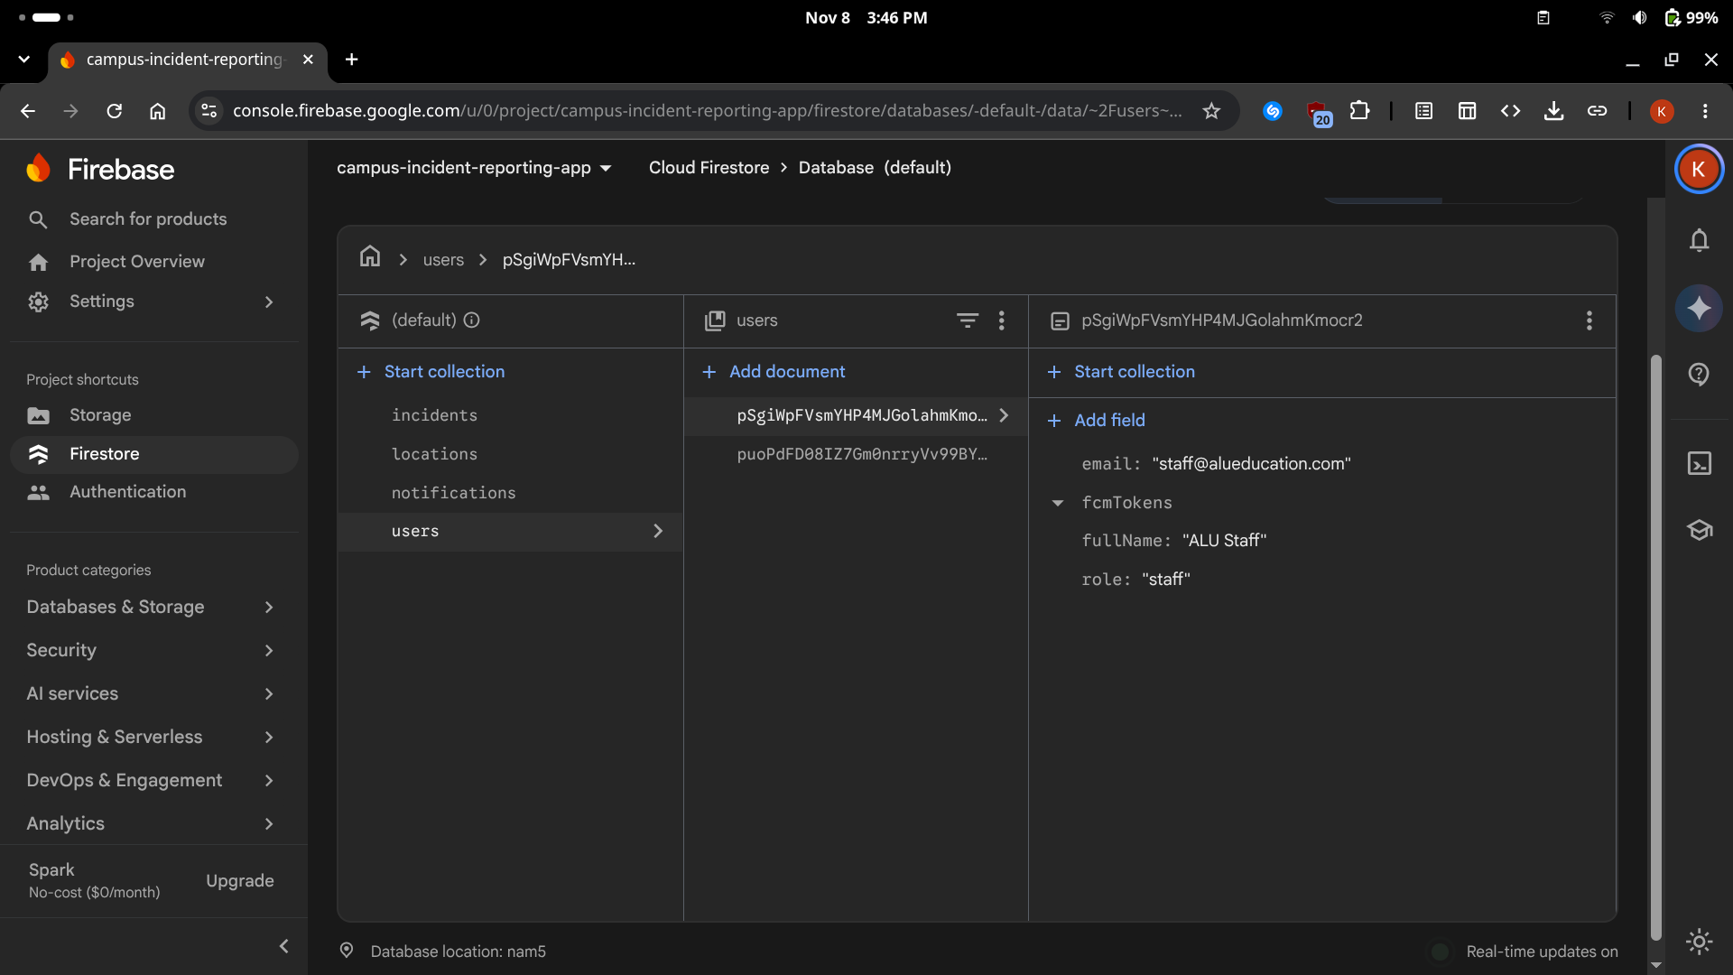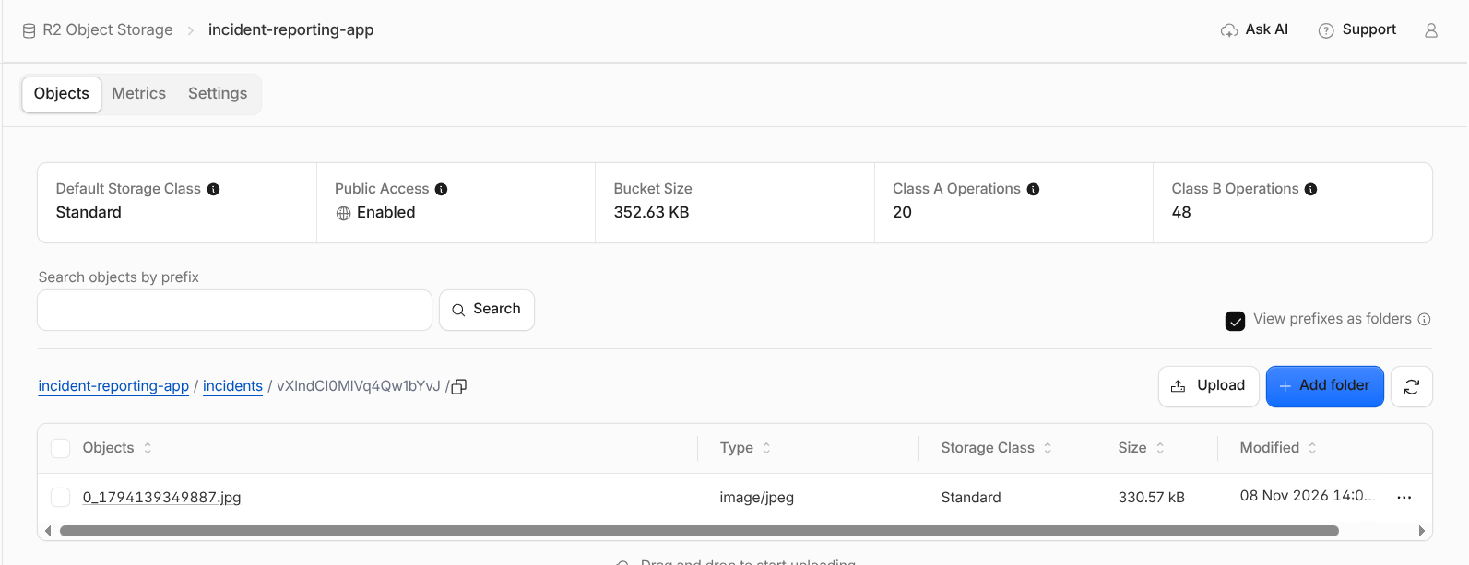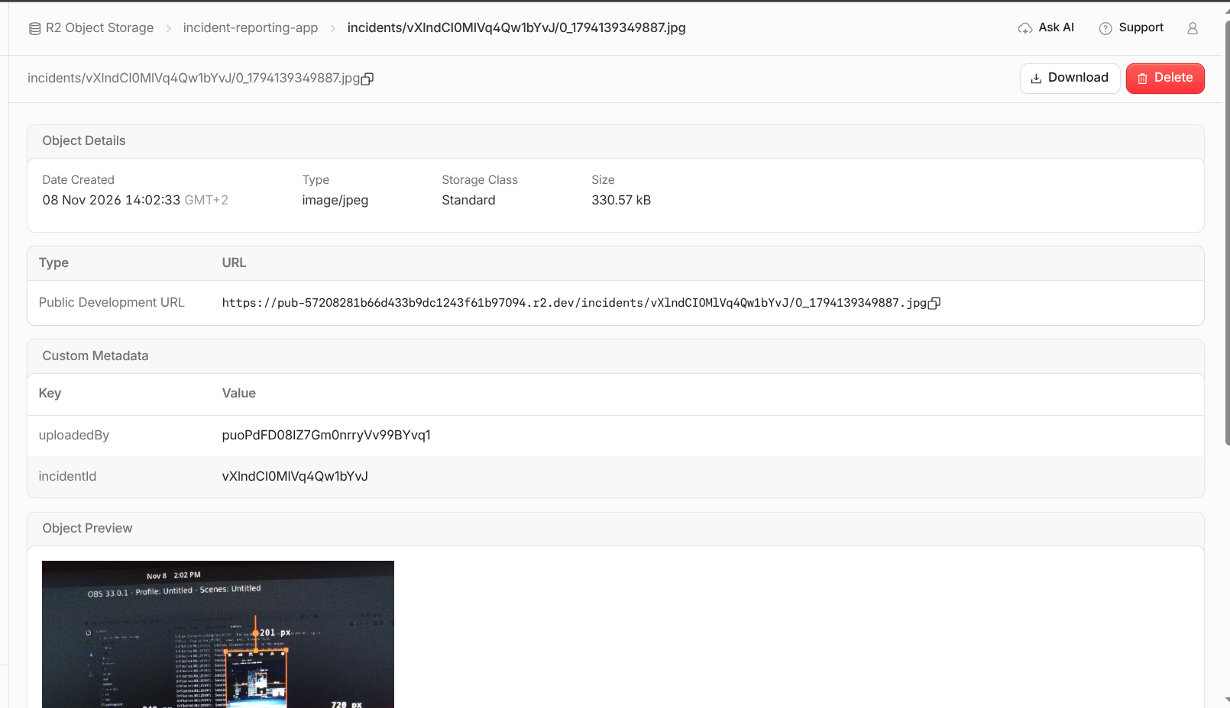
Figure 7. Firestore records created by the app.

7. Testing strategy
I used a mix of automated and manual testing:
- Automated: I have unit tests to test the small components of the application in isolation
- Manual checklist I do manual testing using an Android emulator: register and log in with both email domains; reset and change password; log out; submit a report with 0 to 3 photos; search and filter; delete my own report only while it is submitted; staff status update and note; manage locations (delete fails when a location is used); push notification and inbox; tapping a notification opens the incident.

References
[1] Google, "Flutter documentation," 2026. [Online]. Available: https://docs.flutter.dev
[2] Google, "Firebase Authentication," 2026. [Online]. Available: https://firebase.google.com/docs/auth
[3] Google, "Cloud Firestore and security rules," 2026. [Online]. Available: https://firebase.google.com/docs/firestore
[4] Google, "Cloud Functions for Firebase," 2026. [Online]. Available: https://firebase.google.com/docs/functions
[5] Google, "Firebase Cloud Messaging," 2026. [Online]. Available: https://firebase.google.com/docs/cloud-messaging
[6] Cloudflare, "R2 object storage and Workers," 2026. [Online]. Available: https://developers.cloudflare.com/r2
[7] R. Rousselet, "provider package," pub.dev, 2026. [Online]. Available: https://pub.dev/packages/provider
[8] Flutter team, "go_router package," pub.dev, 2026. [Online]. Available: https://pub.dev/packages/go_router

