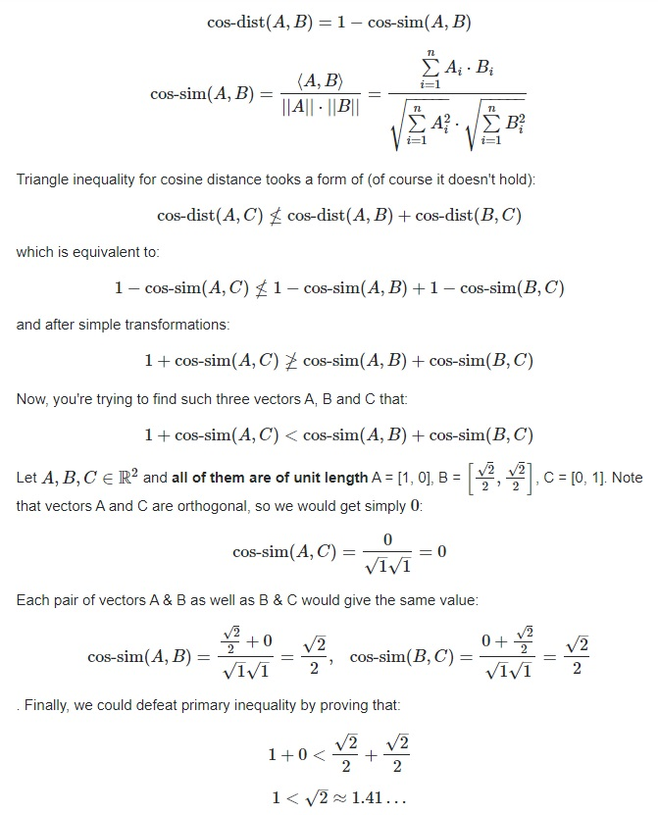

https://stats.stackexchange.com/questions/198080/proving-that-cosine-distance-function-defined-by-cosine-similarity-between-two-u