create database bisheshwor;

use bisheshwor;

create table Branch( branch_id varchar(5), staff_id varchar(5), branch_add varchar(30), assets varchar(30) , primary key(branch_id, staff_id));

create table Customer(
-> cust_id varchar(5),
-> cust_name varchar(50),
-> cust_phone varchar(10),
-> cust_dob date,
-> primary key(cust_id));

create table Loan(
-> loan_number varchar(6),
-> branch_id varchar(5),
-> amount numeric(8),
-> primary key(loan_number));

create table Borrower(
-> cust_id varchar(5),
-> loan_number varchar(6));

create table Account(
-> account_number varchar(6),
-> branch_id varchar(5),
-> balance numeric(8),
-> primary key(account_number));

create table Depositor( cust_id varchar(5), account_number varchar(6));

create table Staff( staff_id varchar(5), staff_name varchar(30), staff_add varchar(30), primary key(staff_id));

insert into Branch(branch_id, staff_id, branch_add, assets) values
-> ('B-01', 'S-01','banepa-kavre', 'loans'),
-> ('B-01', 'S-02','banepa-kavre', 'loans'),
-> ('B-01', 'S-03','banepa-kavre', 'loans'),
-> ('B-02', 'S-04','suryabinayak-Bhaktapur', 'liquid assets'),
-> ('B-02', 'S-05','suryabinayak-Bhaktapur', 'liquid assets'),
-> ('B-01', 'S-06','banepa-kavre', 'liquid assets'),
-> ('B-03', 'S-07','Narayanghat', 'loans'),
-> ('B-03', 'S-08','Narayanghat', 'liquid assets'),
-> ('B-04', 'S-09','lakeside-pokhara', 'liquid assets'),
-> ('B-04', 'S-010','lakeside-pokhara', 'loans')
-> ;

insert into Borrower(cust_id, loan_number) values
-> ('C-01', 'L-01'),
-> ('C-02', 'L-02'),
-> ('C-03', 'L-03'),
-> ('C-04', 'L-04'),
-> ('C-05', 'L-05'),
-> ('C-06', 'L-06'),
-> ('C-07', 'L-07'),
-> ('C-08', 'L-08'),
-> ('C-09', 'L-09'),
-> ('C-10', 'L-10');

insert into Customer(cust_id, cust_name, cust_phon, cust_dob) values ('C-02', 'Shyan Sherma', '9843813902', '1998-01-11'), ('C-03', 'Rohit Chand', '9843813912', '1955-01-14'),
('C-04', 'Mahesh Bhatt', '9843813412', '1965-04-12'), ('C-05', 'Ramesh Pant', '9843813400', '1965-05-13'), ('C-06', 'Sita KC', '9863813400', '1990-08-13'), ('C-07', 'Bishesh Neupane', '9863813550', '1991-04-14'), ('C-08', 'Biplov Giri', '9863813445', '1991-06-14') , ('C-09', 'Lata Jaiswal', '9860813440', '1980-03-11'), ('C-10', 'Rita Dhungel', '9860714550', '1988-06-22');

insert into Account(account_number, branch_id, balance) values ('400-40','B-01','10000'), ('400-41','B-02','100000'), ('400-42','B-03','20000'), ('400-43','B-03','13000'), ('400-44','B-02','14000'), ('400-45','B-01','140000'), ('400-46','B-04','30000'), ('400-47','B-04','50000'), ('400-48','B-05','50000'), ('400-49','B-06','1000000');

insert into Depositor(cust_id, account_number) values ('C-01','400-00'), ('C-02','400-01'), ('C-03','400-02'), ('C-04','400-03'), ('C-05','400-04'), ('C-06','400-05'), ('C-07','400-06'), ('C-08','400-07'), ('C-09','400-08'), ('C-10','400-09');

INSERT INTO Loan(loan_number, branch_id, amount) values ('L-00','B-01','1500000'), ('L-01','B-01','1500000'), ('L-02','B-02','2000000'), ('L-03','B-03','2000000'), ('L-04','B-04','4000000'), ('L-05','B-05','4000000'), ('L-06','B-05','4000000'), ('L-07','B-04','4000000'), ('L-08','B-02','4000000'), ('L-09','B-03','5000000');

insert into Staff(staff_id, staff_name, staff_add) values ('S-00','Ram Nepal','banepa-kavre'), ('S-01','Shyan Nepal','banepa-kavre'), ('S-02','Sujan Nepal','banepa-kavre'), ('S-03','Ram Oli','ghorahi-dang'), ('S-04','Gita Oli','ghorahi-dang'), ('S-05','Timal kc','ghorahi-dang'), ('S-06','Utsav Paudel','bhaktapur-Suryabinayak'), ('S-07','Manish Joshi','koteshwor-kathmandu'), ('S-08','Bishal Joshi','Chabahil-kathmandu'), ('S-09','Gopal Pandey','Chabahil-kathmandu');

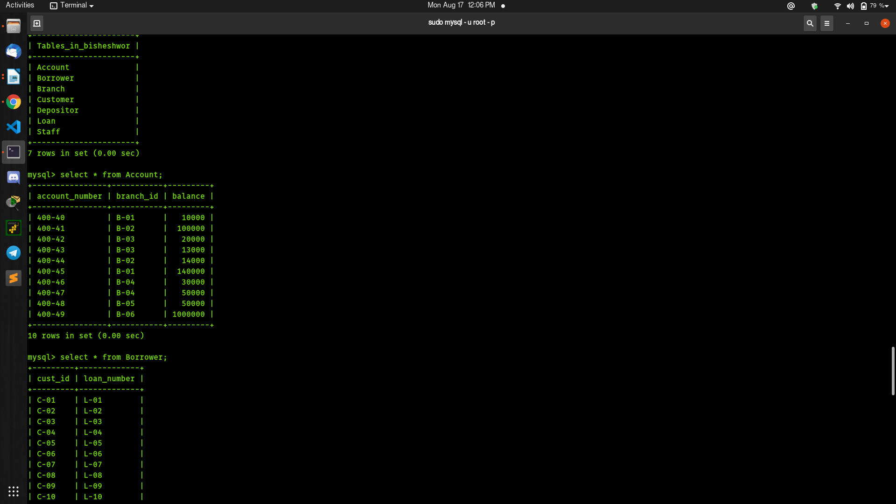

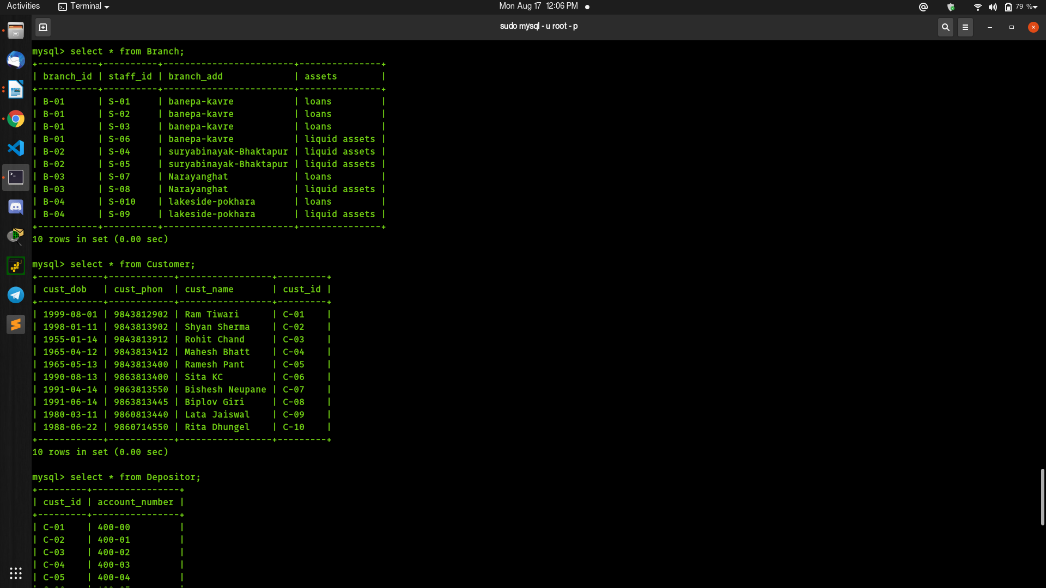

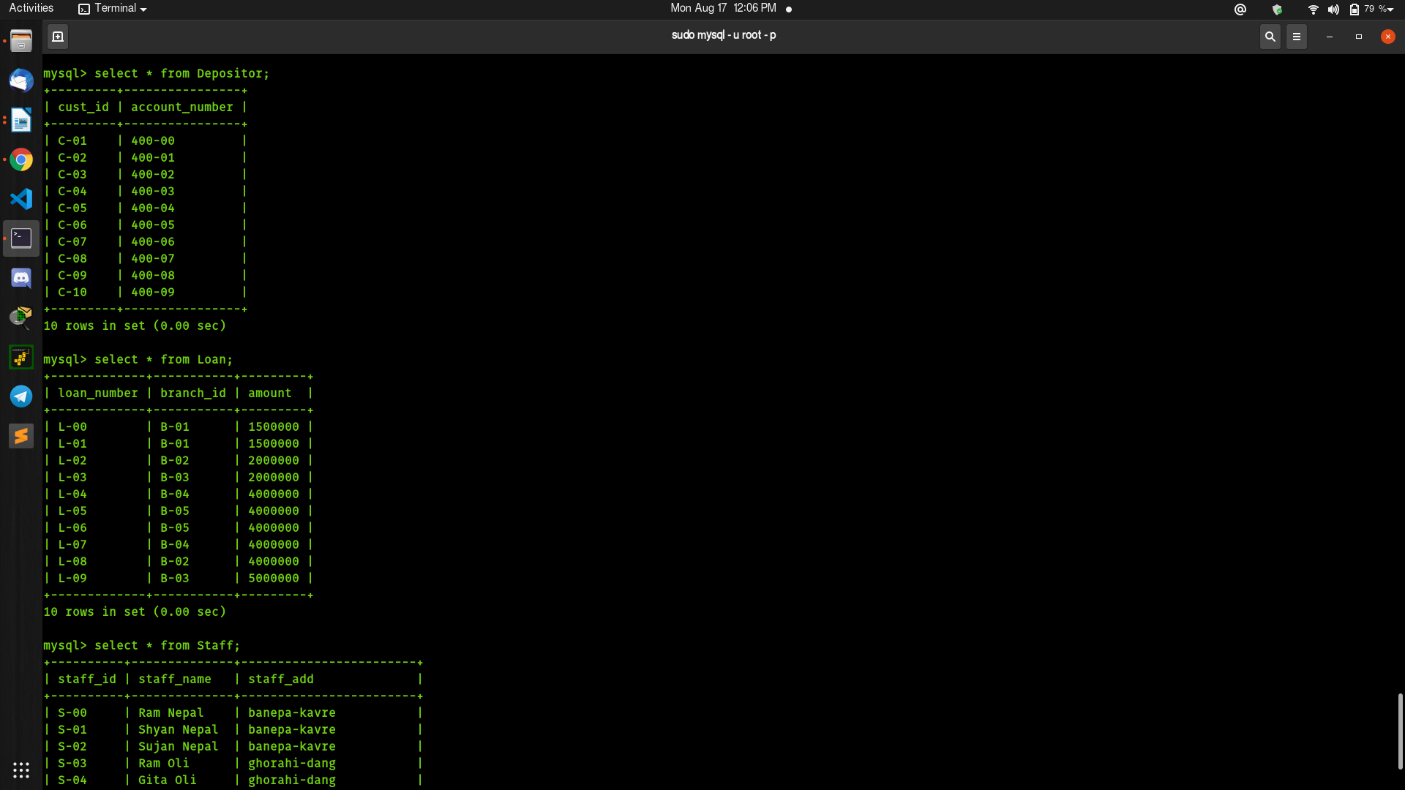

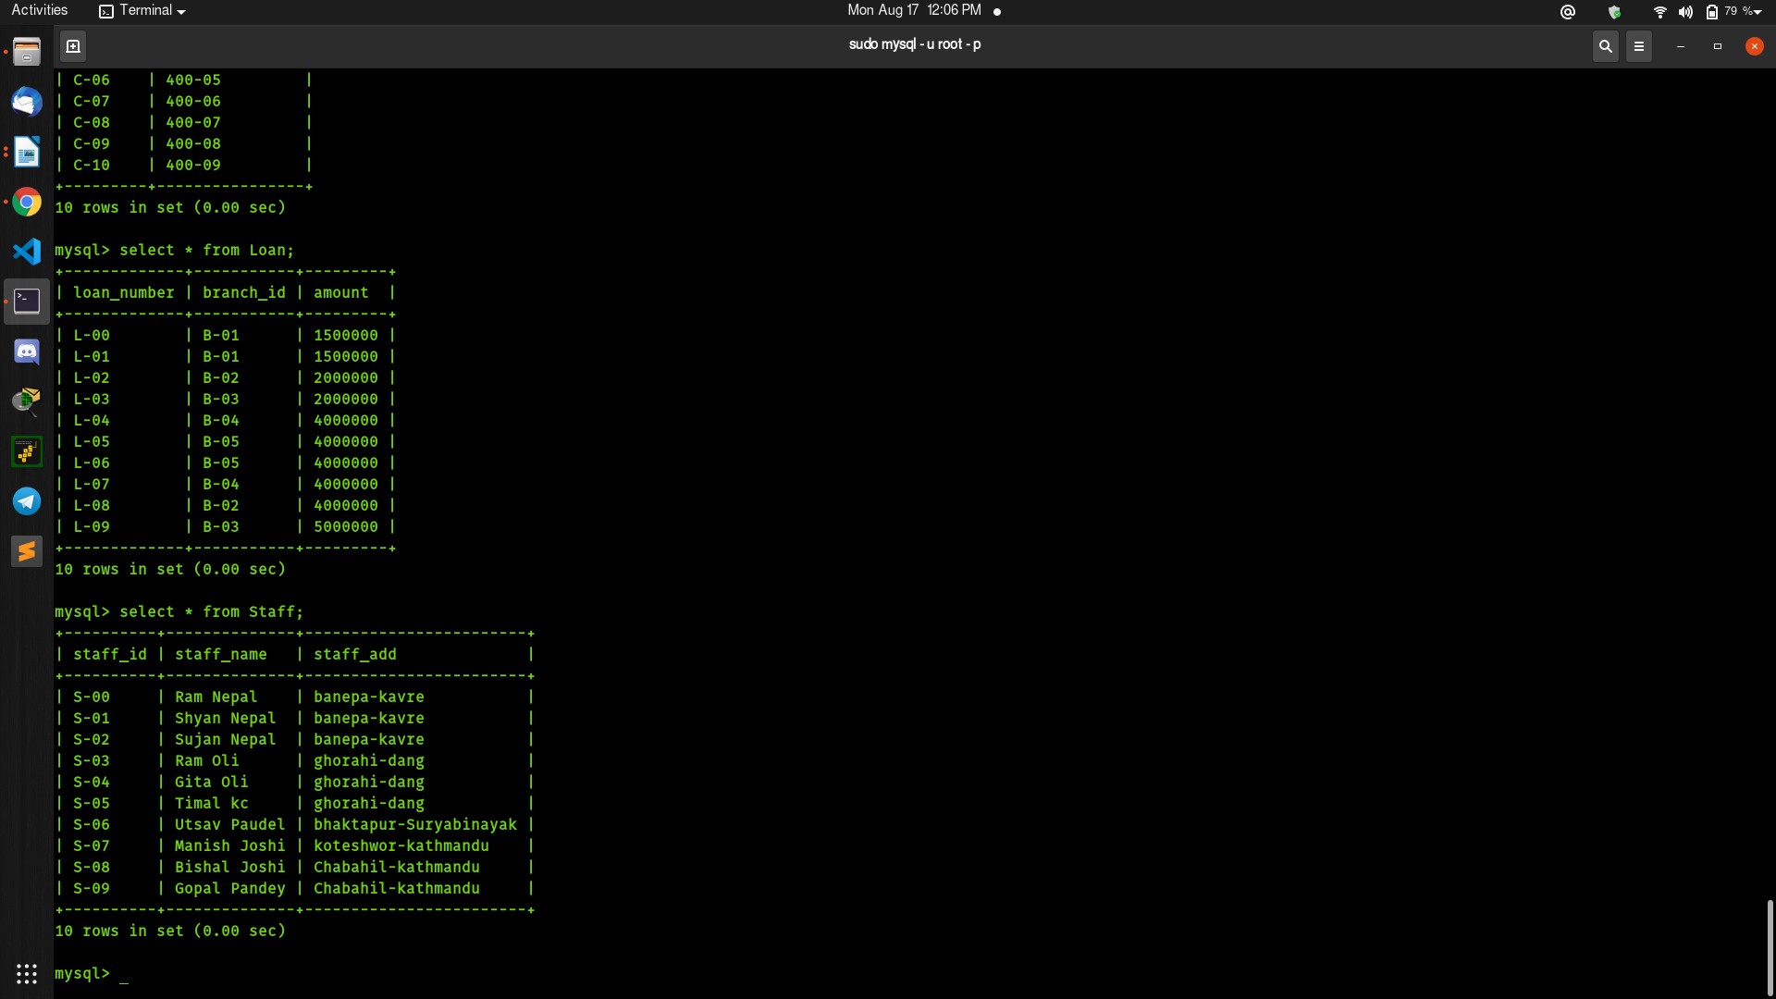

Update Staff set Designation = 'Assistant' where staff_id = 'S-00';
Query OK, 1 row affected (0.01 sec)
Rows matched: 1 Changed: 1 Warnings: 0

mysql> Update Staff set Designation = 'Assistant' where staff_id = 'S-01';
Query OK, 1 row affected (0.01 sec)
Rows matched: 1 Changed: 1 Warnings: 0

mysql> Update Staff set Designation = 'Assistant' where staff_id = 'S-02';
Query OK, 1 row affected (0.01 sec)
Rows matched: 1 Changed: 1 Warnings: 0

mysql> Update Staff set Designation = 'Assistant' where staff_id = 'S-03';
Query OK, 1 row affected (0.01 sec)
Rows matched: 1 Changed: 1 Warnings: 0

mysql> Update Staff set Designation = 'Assistant' where staff_id = 'S-04';
Query OK, 1 row affected (0.01 sec)
Rows matched: 1 Changed: 1 Warnings: 0

mysql> Update Staff set Designation = 'guard' where staff_id = 'S-05';
Query OK, 1 row affected (0.01 sec)
Rows matched: 1 Changed: 1 Warnings: 0

mysql> Update Staff set Designation = 'Manager' where staff_id = 'S-06';
Query OK, 1 row affected (0.00 sec)
Rows matched: 1 Changed: 1 Warnings: 0

mysql> Update Staff set Designation = 'Manager' where staff_id = 'S-07';
Query OK, 1 row affected (0.00 sec)
Rows matched: 1 Changed: 1 Warnings: 0

mysql> Update Staff set Designation = 'officer' where staff_id = 'S-08';
Query OK, 1 row affected (0.03 sec)
Rows matched: 1 Changed: 1 Warnings: 0

mysql> Update Staff set Designation = 'officer' where staff_id = 'S-09';
Query OK, 1 row affected (0.02 sec)
Rows matched: 1 Changed: 1 Warnings: 0

mysql> DELETE FROM Staff WHERE staff_name='Timal kc';
Query OK, 1 row affected (0.00 sec)

----------+--------------+------------------------+-------------+
| staff_id | staff_name | staff_add | Designation |
+----------+--------------+------------------------+-------------+
| S-00 | Ram Nepal | banepa-kavre | Assistant |
| S-01 | Shyan Nepal | banepa-kavre | Assistant |
| S-02 | Sujan Nepal | banepa-kavre | Assistant |
| S-03 | Ram Oli | ghorahi-dang | Assistant |
| S-04 | Gita Oli | ghorahi-dang | Assistant |
| S-06 | Utsav Paudel | bhaktapur-Suryabinayak | Manager |
| S-07 | Manish Joshi | koteshwor-kathmandu | Manager |
| S-08 | Bishal Joshi | Chabahil-kathmandu | officer |
| S-09 | Gopal Pandey | Chabahil-kathmandu | officer |

SELECT MAX(balance)
-> FROM Account;
+--------------+
| MAX(balance) |
+--------------+
| 1000000 |

mysql> select * from Account where balance = (select max(balance) from Account);
+----------------+-----------+---------+
| account_number | branch_id | balance |
+----------------+-----------+---------+
| 400-49 | B-06 | 1000000 |
+----------------+-----------+---------+
1 row in set (0.00 sec)

Update Account set balance = 1000000-5000 where account_number = '400-49';
Query OK, 1 row affected (0.02 sec)
Rows matched: 1 Changed: 1 Warnings: 0

select cust_name from Customer where cust_dob = (select max(cust_dob) from Customer)
;
+------------+
| cust_name |
+------------+
| Ram Tiwari |
+------------+
1 row in set (0.00 sec)
mysql> select loan_number from Loan where amount > 10000;
+-------------+
| loan_number |
+-------------+
| L-00 |
| L-01 |
| L-02 |
| L-03 |
| L-04 |
| L-05 |
| L-06 |
| L-07 |
| L-08 |
| L-09 |
+-------------+
10 rows in set (0.00 sec)

mysql> select * from Customer where cust_add = 'Nayasadak';

+------------+------------+--------------+---------+-----------+
| cust_dob | cust_phon | cust_name | cust_id | cust_add |
+------------+------------+--------------+---------+-----------+
| 1955-01-14 | 9843813912 | Rohit Chand | C-03 | Nayasadak |
| 1965-04-12 | 9843813412 | Mahesh Bhatt | C-04 | Nayasadak |
| 1965-05-13 | 9843813400 | Ramesh Pant | C-05 | Nayasadak |
| 1990-08-13 | 9863813400 | Sita KC | C-06 | Nayasadak |
+------------+------------

DROP bisheshwor;

