AIRLINES ER diagram
Solution:

The entities are :
Airport: It has the following attributes:
pk: Airport Code
Airport Name
City
State
Then we know that the flight trip can have departure or aparture to or from the airport. Many flight trips can happen at the same airport.

Flight Trip: It has following attributes:
pk:Leg number
Scheduled Departure Time
Scheduled Arrival Time

Then we know that a flight trip has trip instances which can be have following attributes:

Trip Instance: It has the following attributes:
Date
number of available seats
Customer Reservations
Since,customer Reservation the most important entity for trip instance,

Customer Reservation: It has following attributes:
Seat Numbers
Customer Name
Phone

The airline flight has the flight trips.The airline flight has following attributes:
pk:Flight Number
Airline Name
week days

The airplanes can have many trip instances.
Airplane:
pk: Airplane_id
seat numbers
Airplane type

The airplane might be of different types:
Airplane Types: It includes following attributes:
pk:name
manufacturing company
maximum no. of seats.

Many airline of different types can land on the airports.

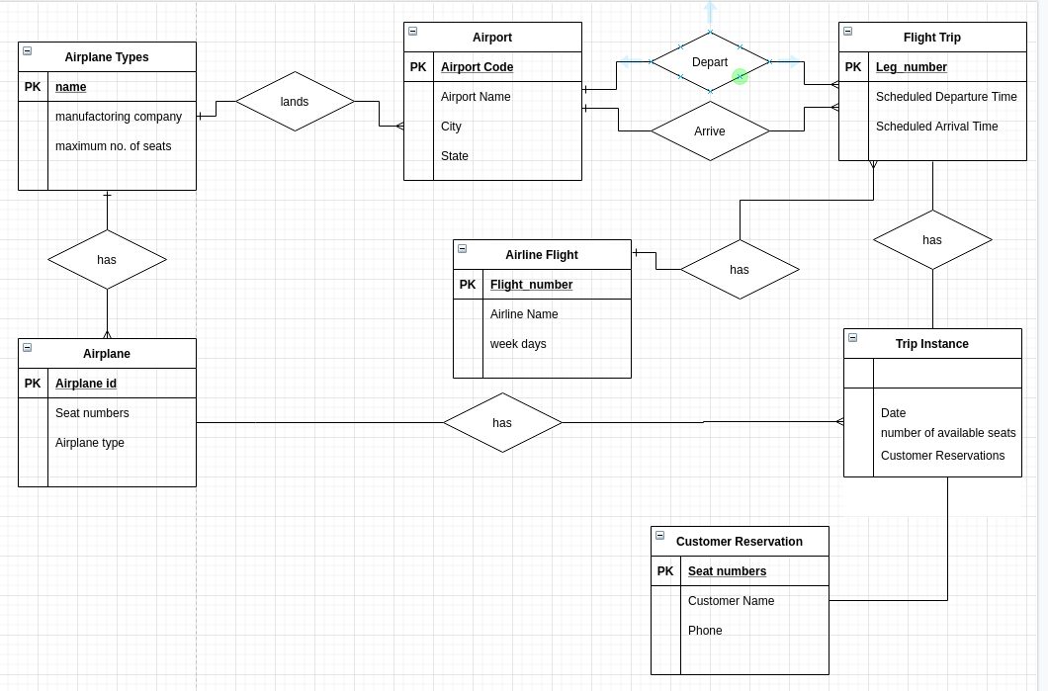
Fig: ER Diagram of the airlines

