CGAP An Adaptive Online Learning Framework for Personalized Physiological-State Recognition from Wearable Sensor Signals

Abstract

Real-time human–computer interaction requires physiological-state recognition models that can adapt to individual users and changing signal patterns. Existing wearable-sensing studies often rely on static batch classifiers, subject-specific models, or controlled offline evaluation. Consequently, they provide limited support for continuous user adaptation, participant-independent initialization, and prediction under changing physiological conditions. To address these limitations, this study proposes CGAP (Context-Guided Adaptive Personalization), an online adaptive framework that uses wearable acceleration (ACC), blood-volume pulse (BVP), electrodermal activity (EDA), and temperature signals. CGAP combines general cross-participant learning with sequential user-specific updating to classify baseline, stress, and amusement states.The processed WESAD dataset contains 3,281 windows from 15 participants and 24 statistical features. CGAP combines a global Extra-Trees classifier with an online stochastic-gradient classifier through probability-level fusion. A leakage-controlled participant-independent evaluation was conducted using leave-one-subject-out testing and three random seeds. The proposed model achieved a macro-F1 of 0.936 ± 0.016, outperforming Logistic Regression, RBF SVM, the global-only model, and the no-online-update configuration. Ablation results confirmed that online adaptation was the main contributor to the performance improvement, while class weighting supported balanced recognition across baseline, stress, and amusement states. The results demonstrate that combining general cross-participant learning with supervised online personalization can improve physiological-state recognition for unseen users. CGAP provides a foundation for future real-time HCI systems that adapt interface behaviour according to continuously changing user states.

Keywords: Wearable sensors; WESAD; stress detection; affect recognition; online learning; adaptive updating; human–computer interaction; physiological computing; participant-independent evaluation; Extra-Trees; stochastic-gradient learning; personalised machine learning.

1. Introduction

Recent advances in wearable sensing have created new opportunities for continuous stress and affect recognition in real-world environments. However, conventional supervised models require large amounts of labelled data and often perform poorly when physiological patterns vary between individuals. Yaseen et al. [1] use masked signal modelling with self-supervised transformers to learn representations from wearable biosignals before classification. However, their transformer-based approach is primarily representation-focused and does not address continuous user-specific online updating during deployment. Calza-Metre et al. [2] examine stress-detection performance and cross-dataset generalisation, demonstrating that performance can vary across datasets. Nevertheless, their study does not provide a sequential predict-then-update mechanism for adapting predictions to an individual user during an incoming sensor stream. These gaps motivate a framework that combines cross-participant learning with supervised online personalization.

Stress-detection systems must also balance predictive performance with computational cost and device practicality. Pataca et al. [3] compare several machine-learning algorithms for stress detection, demonstrating that model selection substantially influences classification performance and implementation complexity. Although high-capacity models may achieve strong results, they may require considerable computational resources and may not be suitable for continuous wearable operation. Bello-Orgaz et al. [4] further examine this trade-off by analysing stress-level detection using smart devices while considering model complexity and device intrusiveness. Their work emphasises the importance of lightweight, user-friendly systems that can operate with limited hardware resources. Nevertheless, these approaches generally depend on static training procedures and may not adapt sufficiently to individual physiological changes during long-term use.

Kocaçınar et al. [5] explore deep-learning-based stress detection using multimodal biosignals, demonstrating the value of combining complementary physiological measurements for improved recognition. Multiple wearable physiological signals, including acceleration, blood-volume pulse, electrodermal activity, and skin temperature, provide complementary information about movement, cardiovascular response, sympathetic arousal, and peripheral temperature. However, physiological signals are non-stationary: the same individual may produce different patterns across time, activities, and environmental conditions. Static models therefore require repeated retraining and may not adequately personalize predictions for a new user. This motivates the proposed CGAP framework, which combines a global Extra-Trees classifier with an online stochastic-gradient classifier and probability-level fusion. The main contributions are a participant-independent initialization strategy, training-only leakage-controlled preprocessing, sequential predict-then-update personalization, and evaluation across baseline, stress, and amusement states. The framework is intended to provide an adaptive foundation for future physiological-state-aware HCI systems.

2. Literature Survey

Han et al. [6] improve wearable stress recognition through subject-specific normalisation and stacking ensemble learning. Their approach addresses the problem that physiological measurements differ considerably between individuals, making a single global model unreliable. Subject-specific normalisation reduces inter-person variability, while ensemble learning combines several classifiers to improve robustness. Tazarv et al. [7] investigate personalised stress monitoring in everyday settings using wearable sensors and real-time physiological measurements. Their work demonstrates the importance of collecting data outside controlled laboratory environments, where movement, context, and daily routines influence sensor signals. Together, these studies show that reliable real-world stress recognition requires both personalisation and robust ensemble modelling. However, they also indicate the need for adaptive algorithms that can update continuously as the user’s physiological patterns change.

Mattern et al. [8] study emotion recognition using physiological signals collected from a wrist-worn device during emotional recall tasks. Their work demonstrates the usefulness of blood-volume pulse, electrodermal activity, skin temperature, and acceleration for affective-state classification. However, the results also show that subject-independent recognition remains difficult because emotional responses vary substantially across individuals. Muñoz-Saavedra et al. [9] address wearable affective-state classification by designing and evaluating a dedicated wearable system with machine-learning algorithms. Their study highlights the importance of integrating sensing hardware, feature extraction, and classification into one practical pipeline. These findings support the use of multimodal wearable signals in human–computer interaction, while also revealing the limitations of static models that cannot adapt to changing users and real-world conditions.

Bolpagni et al. [10] provide a scoping review of personalised stress-detection systems based on wearable biosignals. Their analysis identifies personal physiological variability, limited labelled data, battery constraints, and real-world deployment as major challenges. These issues are especially important for systems intended to operate continuously and unobtrusively. Yang et al. [11] propose a spiking feed-forward neural network for emotion recognition from multimodal physiological signals. Their model demonstrates how temporal and spatial information can be combined while potentially reducing computational cost. Together, these studies motivate the development of efficient and personalised learning systems for wearable human–computer interaction. Nevertheless, a practical solution must additionally support online updates, concept-drift handling, and reliable evaluation across previously unseen participants.

Lange et al. [12] investigate the generation of synthetic health-sensor data for privacy-preserving wearable stress detection. Their work addresses the difficulty of sharing sensitive physiological data while maintaining sufficient information for machine-learning development. Synthetic data can improve dataset availability, reduce privacy risks, and support model experimentation; however, synthetic samples must be validated carefully to avoid unrealistic distributions. Rahmani et al. [13] introduce EmoWear, a wearable physiological and motion dataset designed for emotion recognition and context awareness. The dataset demonstrates the value of combining physiological and movement information when interpreting affective states. These studies emphasise the importance of privacy, multimodal sensing, and contextual information for developing deployable HCI systems. They also reinforce the need for models that generalise across participants and operating environments.

Fan et al. [14] present an online incremental-learning framework for wearable human-activity recognition. Their work addresses non-stationary sensor streams by continuously updating the model as new observations become available. This principle is directly relevant to real-time stress and affect recognition, where physiological patterns may change because of fatigue, activity, environment, or individual adaptation. Kacimi et al. [15] examine affective-state classification from physiological signals using valence and arousal representations, highlighting the relationship between signal preprocessing, feature extraction, dimensionality reduction, and machine-learning classification. Building on these studies, the proposed project develops a real-time adaptive framework that combines multimodal feature processing, global classification, online learning, and user-specific updating. The objective is to provide reliable and personalised physiological-state recognition for human–computer interaction applications.

Yang et al. [16] propose a spiking feed-forward neural network for recognising emotions from multimodal physiological signals. Their method combines information from several biosignals while exploiting the computational efficiency of spiking neural architectures. This is relevant to wearable human–computer interaction because real-time systems require low latency and limited energy consumption. Lange et al. [17] address privacy concerns by generating synthetic health-sensor data for wearable stress detection. Their work reduces the need to share sensitive physiological recordings, although synthetic data must preserve realistic signal distributions. Together, these studies demonstrate the importance of efficient multimodal modelling and privacy-aware data processing. However, they do not fully address continuous personalisation or online adaptation when a user’s physiological patterns change over time.

Rahmani et al. [18] introduce EmoWear, a dataset containing wearable physiological and motion signals for emotion recognition and context awareness. The dataset supports research on multimodal affective computing by linking physiological responses with movement and environmental context. Such information is valuable for distinguishing emotional changes from responses caused by physical activity. Fan et al. [19] develop an online incremental-learning framework for wearable human-activity recognition. Their method continuously updates the model as new sensor observations arrive, addressing non-stationary data streams and changing user behaviour. These contributions directly support the proposed project, which requires real-time processing and adaptive updating. Nevertheless, activity recognition and emotion recognition involve different decision boundaries, so an adaptive stress-classification framework must be designed specifically for physiological-state recognition.

Kacimi and Adda [20] investigate affective-state classification using physiological signals represented through valence and arousal dimensions. Their work highlights the importance of preprocessing, feature extraction, dimensionality reduction, and classification in transforming raw biosignals into meaningful emotional states. This processing sequence is also applicable to the present project, where acceleration, blood-volume pulse, electrodermal activity, and temperature features are used to classify baseline, stress, and amusement states. Building on Yang et al. [16], Lange et al. [17], Rahmani et al. [18], and Fan et al. [19], the proposed framework combines multimodal classification with online learning and adaptive personalisation. Its objective is to maintain reliable performance when physiological distributions vary across users, activities, and time.

Table 1. Summary of Existing Wearable-Sensor, Stress-Recognition, and Adaptive-Learning Studies

Ref. | Author citation | Model / method | Dataset / data | Research gap
[21] | Sandulescu et al. | Wearable physiological stress detection | Wearable physiological recordings | No continuous personalisation or online updating
[22] | Gedam and Paul | Review of ML stress-detection methods | Multiple wearable-stress datasets | Need standardised evaluation and real-time deployment
[23] | Shen et al. | Regional–global multimodal fusion with spatial-temporal alignment | Multimodal physiological emotion data | High complexity; limited lightweight adaptation
[24] | Choi et al. | Wearable stress, fatigue, and drowsiness monitoring | Driver-monitoring wearable data | Driver-specific; limited general HCI applicability
[25] | Ding et al. | Intra- and inter-subject video stress learning | Stress-related video data | Does not use multimodal physiological signals
[26] | Fu et al. | Transfer learning for personalised activity recognition | Wearable activity-sensor data | Focuses on activity, not stress or affect
[27] | Krawczyk | Adaptive ensemble learning for data streams | Online activity streams | Not designed for physiological stress recognition
[28] | Zhang | Time-varying wearable posture recognition | Wearable posture streams | Limited validation and no affective application
[29] | Egger et al. | Review of physiological emotion-recognition methods | Multiple physiological datasets | Inconsistent features, labels, and protocols
[30] | Yang et al. | Deep behavioural–physiological multimodal model | Mobile emotion data | Computationally expensive; limited online adaptation
[31] | Moser et al. | Explainable deep learning for stress detection | Wearable sensor measurements | Limited continuous adaptation and cross-subject testing
[32] | Zhang et al. | Multifunctional wearable-sensor activity recognition | Wearable activity datasets | Focuses on activity, not stress or adaptive HCI

Table 1 compares existing studies according to their authors, modelling approaches, data sources, and limitations relevant to the proposed project. Previous research has investigated wearable stress detection, emotion recognition, activity recognition, multimodal physiological fusion, transfer learning, ensemble learning, and online learning. However, most studies focus on static classification, activity recognition, video-based signals, or subject-specific applications. The practical gap addressed here is the implementation of a lightweight participant-independent workflow that combines multimodal physiological features with supervised online updating for future HCI applications. The proposed CGAP framework addresses this gap through multimodal feature processing, online learning, adaptive updating, and subject-independent evaluation.

3. Proposed Methodology
3.1 Overview of the Proposed Framework

This study proposes CGAP (Context-Guided Adaptive Personalization), a real-time machine-learning framework for physiological-state recognition in human–computer interaction. The framework processes multimodal wearable signals, including acceleration (ACC), blood-volume pulse (BVP), electrodermal activity (EDA), and skin temperature. The signals are divided into fixed-length windows, and statistical features are extracted from each window to represent the user’s physiological condition.
CGAP contains two learning components. The global Extra-Trees classifier learns general relationships between physiological features and the three target states: baseline, stress, and amusement. The online stochastic-gradient classifier then adapts these predictions to the current user by learning from newly available labelled observations. The outputs of both models are combined through probability-level fusion to provide a stable yet personalised prediction.
The overall architecture of the proposed CGAP framework is presented in Figure 1 below. The figure illustrates the complete data flow from wearable-sensor input to real-time HCI decision generation. It also shows the interaction between the global learning branch, the online adaptation branch, and the final prediction-fusion module.
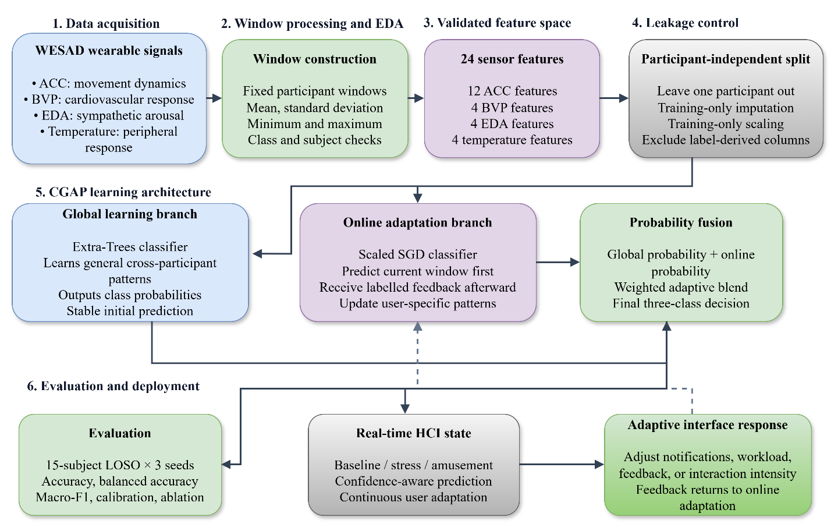
Figure 1. Overall architecture of the proposed CGAP framework, showing the complete workflow from multimodal WESAD
Figure 1 presents the complete workflow of the proposed CGAP system, beginning with WESAD wearable signals from acceleration, blood-volume pulse, electrodermal activity, and temperature sensors. The signals are divided into fixed windows and converted into 24 statistical features. Exploratory analysis and leakage-controlled preprocessing are then performed before the data enter two learning branches: a global Extra-Trees model that learns general patterns across participants and an online SGD model that adapts to the current user. Their class probabilities are fused to classify baseline, stress, or amusement. The prediction is evaluated using participant-independent LOSO testing and then supplied to the HCI layer, where it can support personalised interface responses. Labelled feedback is subsequently returned to the online branch for continuous adaptation.

3.2 Dataset Description and Exploratory Data Analysis

The experiments use the WESAD wearable stress and affect detection dataset. After selecting the corrected participant-level files, the working dataset contains recordings from 15 participants, 3,281 windows, and 24 numerical sensor features. The features are derived from four signal modalities: acceleration (ACC), blood-volume pulse (BVP), electrodermal activity (EDA), and temperature. For each available sensor channel, four statistical descriptors are calculated: mean, standard deviation, minimum, and maximum. For a window containing samples $s_{1},s_{2},…,s_{n},$the mean and standard deviation are calculated as:
$μ_{s}=\frac{1}{n}\sum_{j=1}^{n}{s_{j}}$ (1)
$σ_{s}=\sqrt{\frac{1}{n-1}\sum_{j=1}^{n}{{\left(s_{j}-μ_{s}\right)}^{2}}}$ (2)
The minimum and maximum values are defined as:

$s_{min}=\min\left(s_{1},…,s_{n}\right), s_{max}=\max\left(s_{1},…,s_{n}\right)$ (3)

The feature vector for window i is therefore represented as:

$x_{i}=\left[μ_{ACC1},σ_{ACC1},s_{ACC1,min},s_{ACC1,max},…,μ_{Temp},σ_{Temp},s_{Temp,min},s_{Temp,max}\right]∈R^{24}$ (4)

The classification target contains three physiological states:

$y_{i}∈\left\{1,2,3\right\}$ (5)
where 1 denotes baseline, 2 denotes stress, and 3 denotes amusement. ACC represents body movement, BVP reflects cardiovascular activity, EDA captures sympathetic arousal, and temperature provides peripheral thermal information. Their combination provides a multimodal representation of physiological changes associated with stress and affect.
Exploratory data analysis includes participant-wise window counts, class-frequency analysis, missing-value checking, duplicate detection, non-finite-value checking, feature-distribution analysis, and correlation inspection. The corrected participant files contained no missing feature values or duplicate rows. The resulting exploratory figures are presented: class distribution, participant-wise window counts, feature distributions, and the feature-correlation heatmap. These analyses are used to verify data quality and motivate participant-level evaluation before model training.
3.3 Preprocessing, Participant Partitioning, and Leakage Prevention

All preprocessing operations are performed separately within each training partition. The processed WESAD files were first checked for missing values, non-finite values, duplicate rows, and invalid labels. If a missing feature value is detected, it is replaced using the median calculated from the training participants only. For models that require standardisation, the training mean and standard deviation are also calculated only from the training data. The held-out participant is then transformed using these fixed training-derived parameters. Consequently, no information from the test participant is used during preprocessing.
Because physiological responses vary substantially between individuals, random row-wise splitting is avoided. All windows belonging to one participant remain in the same partition. For participant p, the training and testing data are defined as:
$$D=D_{train}^{\left(-p\right)}∪D_{test}^{\left(p\right)}$$For participant p, the held-out test set is $D_{test}^{\left(p\right)}$, containing all windows from participant p, and the training set is $D_{train}^{\left(-p\right)}$, containing windows from the remaining participants. The held-out participant is excluded from model fitting, preprocessing estimation, and hyperparameter tuning. No decision threshold is tuned; the final class is selected by the largest predicted probability.
The implementation applies leakage-prevention controls. Duplicate windows are checked before modelling, participant windows are never distributed across training and testing partitions, and label-derived columns such as label_id are excluded from the feature matrix. Hyperparameters are selected using grouped inner validation performed only on the training participants. The outer test label is revealed only after the current online prediction has been recorded.

${\hat{y}}_{t}=h_{t}\left(x_{t}\right), h_{t+1}=\operatorname{Update}\left(h_{t},x_{t},y_{t}\right)$ (7)
This protocol prevents the current test label from influencing its own prediction and accurately represents labelled-feedback adaptation in a real-time HCI system.

3.4 Global Learning Model
The global learning component is trained using all participants included in the training partition, while the held-out participant remains completely unseen. Its purpose is to learn general relationships between the 24 sensor-derived features and the three physiological states: baseline, stress, and amusement.
The global classifier is implemented using an Extra-Trees ensemble:

$h_{g}:R^{24}→\left\{\text{baseline},\text{stress},\text{amusement}\right\}$ (8)
Extra-Trees is selected because it can represent nonlinear relationships and interactions between ACC, BVP, EDA, and temperature features while maintaining relatively low computational cost. The implemented model uses an ensemble of T=80 decision trees. Each tree produces a class-probability vector, and the ensemble probability is calculated by averaging the tree-level probabilities:

$p_{g}\left(y=c∣x_{t}\right)=\frac{1}{T}\sum_{k=1}^{T}{p_{k}}\left(y=c∣x_{t}\right)$ (9)
Here, $p_{k}\left(y=c∣x_{t}\right)$denotes the probability assigned to class c by tree k. The global probability is the mean of the tree-level probabilities, and the global prediction is the class with the highest averaged probability.

${\hat{y}}_{t}^{\left(g\right)}=\arg{\max_{c}{p_{g}\left(y=c∣x_{t}\right)}}$ (10)
The global model provides a stable initial prediction and supplies one of the probability vectors used by the CGAP fusion module. Its parameters are fitted only on the training participants and are not updated using the held-out participant’s data.

3.5 Online Adaptive Learning Model

The online component is implemented using a scaled stochastic-gradient classifier. It is first initialised with the training participants and then updated sequentially using labelled observations from the held-out participant. For every incoming window, the model predicts the physiological state before receiving the corresponding label. After the label becomes available, the model is updated through the classifier’s incremental partial_fit operation.

This procedure enables the model to learn user-specific physiological patterns and respond to gradual changes in the data distribution. Class weights are calculated from the training data and are applied during online updates to reduce the effect of class imbalance. The online model does not use future test windows or future labels before producing the current prediction.

3.6 Adaptive Prediction Fusion

CGAP combines the probability outputs of the global Extra-Trees model and the online SGD model. The fusion weight is selected during inner participant-grouped validation and is then fixed for the held-out participant:

$p_{CGAP}\left(c|x_{t}\right)=\left(1-λ\right)p_{g}\left(c|x_{t}\right)+λp_{o}\left(c|x_{t}\right)$ (11)
$$p_{g}p_{o}λ$$Here, p_g is the global-model probability, p_o is the online-model probability, and λ is the selected online-branch weight. The final class is determined by the largest fused probability.

${\hat{y}}_{t}=\arg{\max_{c∈C}{p_{CGAP}\left(c|x_{t}\right)}}$ (12)where:

$C=\left\{\text{baseline},\text{stress},\text{amusement}\right\}$ (13)
The global branch supplies a cross-participant reference, while the online branch supplies user-specific adaptation. The current results do not establish a statistically significant performance advantage for fusion over the Online-only configuration.

3.7 Real-Time HCI Output Layer

The current implementation produces a real-time physiological-state prediction rather than directly controlling a specific interface. The predicted class can be passed to an application-level HCI controller:

${\hat{y}}_{t}→\text{state interpretation}→\text{interface response}$ (14)
For example, a stress prediction could be used by a future HCI application to reduce notification frequency, simplify displayed information, or recommend a short break. A baseline prediction could maintain normal interaction, while an amusement prediction could support more engaging feedback. These interface actions are application possibilities and are not claimed as experimentally implemented in the current classifier.

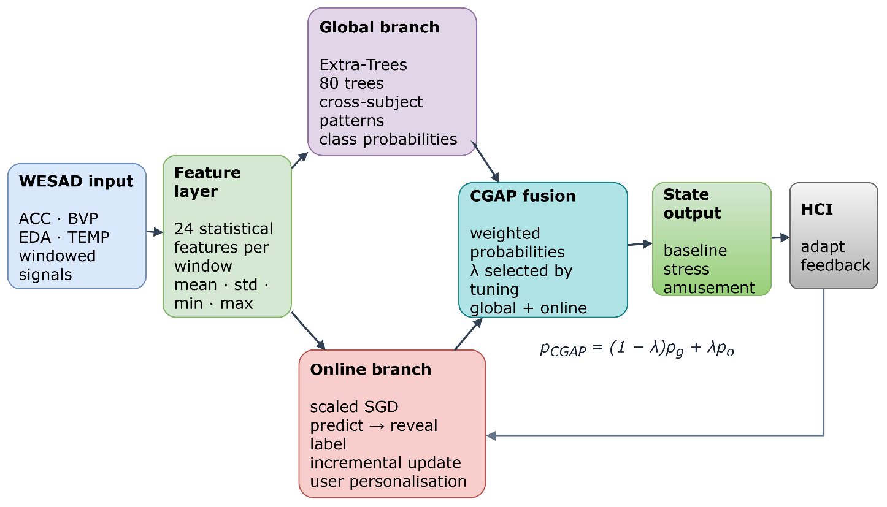

Figure 2. Proposed CGAP Architecture for Real-Time Adaptive Physiological-State Recognition
The figure illustrates the internal workflow of the proposed CGAP model. Windowed WESAD signals from ACC, BVP, EDA, and temperature are converted into 24 statistical features. These features are processed through two parallel learning branches: the global Extra-Trees branch learns cross-participant physiological patterns, while the online scaled-SGD branch performs predict-then-update learning for user-specific personalisation. The class probabilities from both branches are combined using the tuned fusion weight $λ.$The fused output classifies the user’s state as baseline, stress, or amusement and provides the corresponding HCI response. After prediction, labelled feedback is returned to the online branch for incremental updating.

4. Results

4.1 Experimental Setup

The complete experiment used a leakage-controlled, nested, participant-independent evaluation protocol. Each of the 15 WESAD participants was used once as the held-out test participant, while the remaining 14 participants were used for training and inner hyperparameter tuning. Three random seeds—17, 42, and 2026—were applied to every outer participant split, resulting in 45 participant–seed evaluations.

The models were trained using 24 sensor-derived features generated from ACC, BVP, EDA, and temperature signals. The columns subject, window, label, and label_id were excluded from the feature matrix because they identify the participant, describe the window, or directly represent the target label. For each outer split, preprocessing parameters and model hyperparameters were learned only from the training participants. The held-out participant was used only for final evaluation.

The online evaluation followed a strict predict-then-update protocol. For each test window, the online model first generated a prediction. After the prediction was stored, the corresponding label was revealed and used for the next incremental update. Thus, the current test label could not influence its own prediction. This procedure represents labelled-feedback adaptation and should be distinguished from completely unsupervised, label-free adaptation.

Table 2. Experimental Configuration and Evaluation Protocol

Item | Configuration
Dataset | WESAD wearable stress and affect detection dataset
Participants | 15
Evaluation protocol | Participant-independent Leave-One-Subject-Out
Held-out test subjects | Each participant used once for testing
Training subjects per split | 14
Random seeds | 17, 42, and 2026
Total participant–seed runs | 45
Input modalities | ACC, BVP, EDA, and temperature
Input features | 24 statistical features
Target classes | Baseline, stress, amusement
Global model | Extra-Trees classifier
Online model | Scaled SGD classifier with incremental updates
Baselines | Majority Dummy, Logistic Regression, RBF SVM
Hyperparameter tuning | Grouped inner validation using training participants only
Missing-value handling | Training-partition median imputation
Feature scaling | Training-partition standardisation where required
Leakage controls | Participant separation; exclusion of subject, window, label, and label_id
Online protocol | Predict first, then reveal label and update
Evaluation metrics | Accuracy, balanced accuracy, macro-precision, macro-recall, macro-F1
Statistical unit | Participant, with seeds averaged within participant

Table 2 summarises the dataset, model, preprocessing, evaluation, and reproducibility settings used in the study. The experiment uses 15 WESAD participants, 24 sensor-derived features, three physiological classes, and three random seeds, resulting in 45 participant–seed evaluations. Leave-One-Subject-Out evaluation is used to assess participant-independent initialization followed by supervised online personalization. Hyperparameters, imputation values, and scaling parameters are estimated only from the training participants. The table also specifies the global Extra-Trees model, online SGD model, baseline classifiers, leakage controls, predict-then-update protocol, and evaluation metrics. These details support reproducibility and document the implemented CGAP framework.

4.2 Comparison of Proposed CPAG with Baseline Models

Table 3 presents the participant-level performance averaged across the three random seeds. The comparison includes three conventional baselines—Majority Dummy, Logistic Regression, and RBF SVM—together with the proposed CGAP model.

Table 3. Overall participant-independent performance of CGAP and baseline models

Model | Accuracy | Balanced accuracy | Macro-F1 | Macro-precision | Macro-recall
Majority Dummy | 0.533 ± 0.007 | 0.333 ± 0.000 | 0.232 ± 0.002 | 0.178 ± 0.002 | 0.333 ± 0.000
Logistic Regression | 0.533 ± 0.156 | 0.525 ± 0.156 | 0.477 ± 0.158 | 0.570 ± 0.142 | 0.525 ± 0.156
RBF SVM | 0.587 ± 0.173 | 0.549 ± 0.146 | 0.508 ± 0.161 | 0.594 ± 0.184 | 0.549 ± 0.146
Proposed CGAP Full | 0.946 ± 0.016 | 0.930 ± 0.016 | 0.936 ± 0.016 | 0.950 ± 0.012 | 0.930 ± 0.016

The table compares the proposed CGAP model with Majority Dummy, Logistic Regression, and RBF SVM using participant-independent evaluation. Results are reported as mean ± standard deviation across the held-out participants and random seeds. The Majority Dummy provides a minimum reference level, while Logistic Regression and RBF SVM represent conventional linear and nonlinear batch-learning methods. The proposed CGAP achieves the strongest overall performance among the listed models, obtaining an accuracy of $0.946±0.016$, balanced accuracy of $0.930±0.016$, macro-F1 of $0.936±0.016$, macro-precision of $0.950±0.012$, and macro-recall of $0.930±0.016$ . This improvement demonstrates the benefit of combining global physiological-pattern learning with online user-specific adaptation.
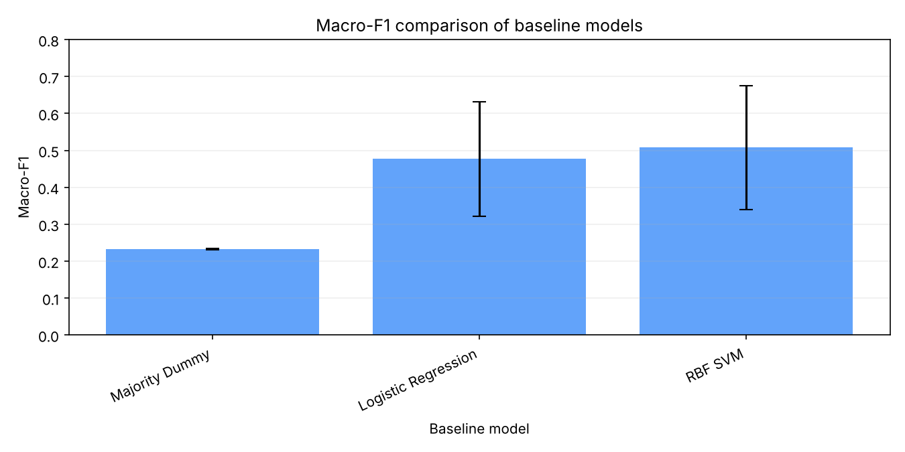
Figure 3. Mean macro-F1 comparison between CGAP and baseline models.

Figure 3 displays the mean macro-F1 values with standard-deviation error bars across participants. The proposed CGAP model is visually distinguished from the conventional baseline classifiers. The comparison shows the improvement obtained over the static classifiers evaluated in this study.

4.3 Per-Class Performance of the Proposed CGAP Model

Table 4 reports the precision, recall, and F1-score obtained by CGAP Full for each physiological state. The results show that the model performs consistently across all three classes.

Table 4. Per-class performance of the proposed CGAP model

Class | Precision | Recall | F1-score
Baseline | 0.928 | 0.989 | 0.957
Stress | 0.959 | 0.868 | 0.911
Amusement | 0.963 | 0.919 | 0.940

Table 4 reports the precision, recall, and F1-score achieved by the proposed CGAP model for each physiological state. The proposed CGAP model achieved the highest F1-score for baseline (0.957), followed by amusement (0.940) and stress (0.911). Stress produced the lowest recall (0.868), indicating that some stress windows were classified as baseline or amusement. However, its precision remained high (0.959), showing that most windows predicted as stress were correct. Overall, the proposed CGAP model maintained strong performance across all three classes, supporting the use of macro-averaged evaluation rather than accuracy alone.

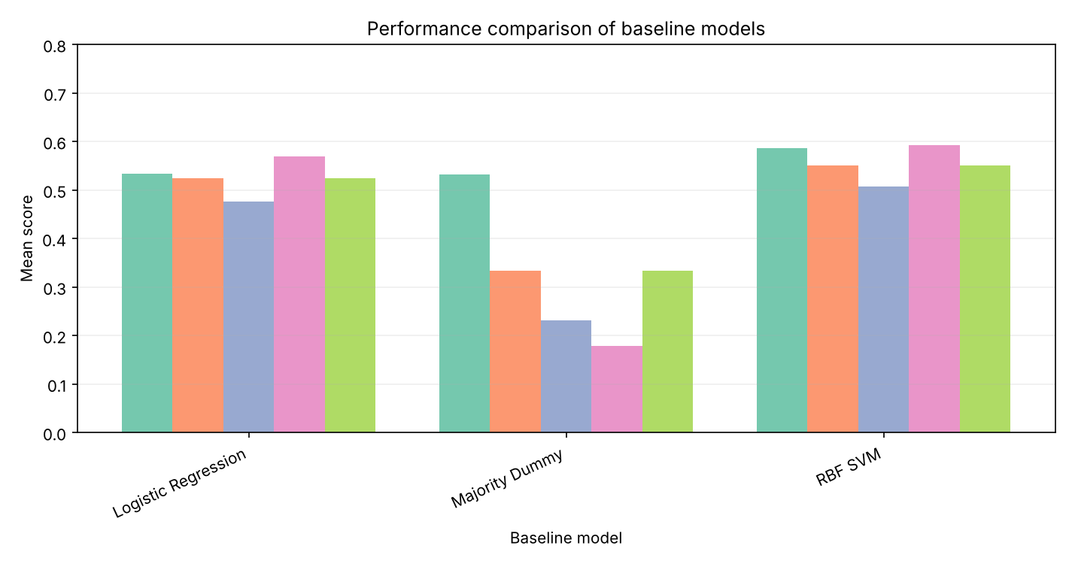
Figure 4. Class-wise precision, recall, and F1-score of the proposed CGAP model

Figure 4 compares the three evaluation measures across baseline, stress, and amusement. The figure shows strong performance for all classes, with baseline achieving the highest recall and stress showing the main area for improvement.

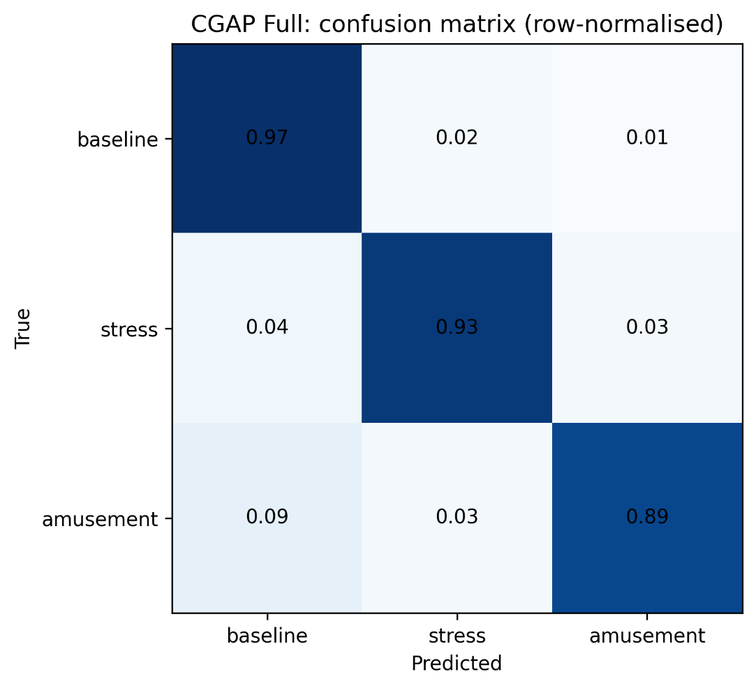
Figure 5. Normalised confusion matrix of the proposed CGAP model

Figure 5 presents the row-normalised confusion matrix using the class order baseline, stress, and amusement. The diagonal cells represent correctly classified windows, while the off-diagonal cells represent classification errors. The off-diagonal values are interpreted with particular attention to the stress class, which has the lowest recall among the three classes. This analysis provides more detailed information about the types of physiological states that are difficult for the model to distinguish.

4.4 Online Learning Behaviour of the Proposed CGAP Model

The online learning curves illustrate how the proposed CGAP model changes as labelled feedback becomes available from the held-out participant. At the beginning of the test stream, the online branch has limited information about the individual user’s physiological patterns. As each window is predicted and its label is subsequently revealed, the online SGD classifier updates its parameters through incremental learning. This allows the model to gradually adapt to participant-specific signal characteristics.

The horizontal axis represents the number of held-out windows processed, while the vertical axis represents cumulative macro-F1. The curves illustrate how labelled feedback changes performance during sequential adaptation.

4.5 Robustness of the Proposed CGAP Model to Sparse Feedback

The proposed CGAP model was evaluated under different feedback frequencies to determine how often the true label must become available for online adaptation. Four conditions were compared: feedback after every window, feedback every 5 windows, feedback every 20 windows, and no online updates.

Table 5. Macro-F1 of the proposed CGAP model under different feedback conditions
Feedback condition | Macro-F1
Every window | 0.936
Every 5 windows | 0.789
Every 20 windows | 0.630
No online updates | 0.488
The proposed CGAP model achieved its highest macro-F1 when feedback was available after every window. Performance decreased to 0.789 when feedback was provided every 5 windows and to 0.630 when feedback was provided every 20 windows. Without online updates, macro-F1 decreased to 0.488. These results show that the proposed model benefits from frequent labelled feedback because the online branch can update more regularly to reflect user-specific physiological patterns. Nevertheless, the model remains more effective under sparse feedback than when adaptation is completely disabled.

4.6 Ablation Analysis of the Proposed CGAP Model

The ablation analysis evaluates the contribution of the main components of the proposed CGAP model. The Global-only configuration uses only the Extra-Trees branch, while CGAP without online updates combines the global and online branches but prevents adaptation during testing. CGAP without class weights removes class weighting from the online updates. Online-only uses only the adaptive SGD branch, whereas CGAP Full includes all implemented components.

Table 6. Ablation results for the proposed CGAP model

Configuration | Accuracy | Macro-F1
Global only | 0.629 | 0.481
Proposed CGAP without online updates | 0.619 | 0.488
Proposed CGAP without class weights | 0.929 | 0.909
Online only | 0.946 | 0.936
Proposed CGAP Full | 0.946 | 0.936

Removing online updates reduced macro-F1 from 0.936 to 0.488. This large decrease demonstrates that sequential adaptation is the primary contributor to the performance of the proposed framework. Removing class weighting reduced macro-F1 to 0.909, indicating that class weighting improves balanced recognition across baseline, stress, and amusement.
The proposed CGAP Full and Online-only configurations achieved the same rounded macro-F1. This indicates that most of the predictive benefit comes from the adaptive online branch. The present results do not establish a statistically significant advantage for probability fusion over the Online-only configuration; the global branch should therefore be interpreted as a complementary cross-participant reference rather than as a proven early-stage stabilizer.

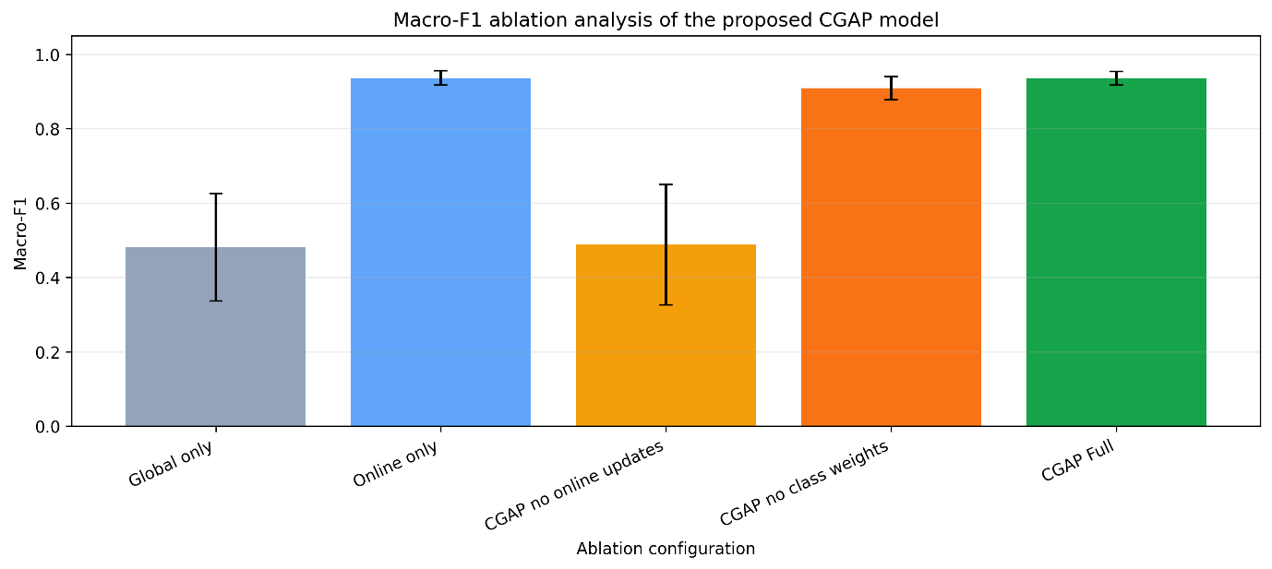

Figure 6. Participant-level macro-F1 heatmap for the proposed CGAP ablation configurations

Figure 6 presents participants on the vertical axis and ablation configurations on the horizontal axis. The heatmap highlights differences in participant-level performance and shows how online updating, class weighting, and global–online integration affect individual participants. Because the current evaluation is participant-independent, the figure also illustrates the variability of model performance across unseen users.

4.7 Calibration and Confidence Analysis

Calibration analysis was performed to determine whether the predicted class probabilities were consistent with the observed correctness of the models. The evaluated measures were the multiclass Brier score, log-loss, and expected calibration error (ECE). Lower values indicate better calibration.

Table 7. Calibration performance across participant-independent evaluation

Model | Brier score | Log-loss | ECE
Majority Dummy | 0.598 ± 0.003 | 0.995 ± 0.004 | 0.006 ± 0.005
Logistic Regression | 0.597 ± 0.171 | 1.057 ± 0.372 | 0.197 ± 0.098
RBF SVM | 0.614 ± 0.271 | 1.543 ± 1.066 | 0.250 ± 0.143
Global only | 0.482 ± 0.149 | 0.909 ± 0.423 | 0.174 ± 0.076
Online only | 0.100 ± 0.020 | 0.226 ± 0.049 | 0.072 ± 0.026
Proposed CGAP without online updates | 0.498 ± 0.109 | 0.843 ± 0.172 | 0.193 ± 0.065
Proposed CGAP without class weights | 0.142 ± 0.026 | 0.304 ± 0.041 | 0.126 ± 0.034
Proposed CGAP Full | 0.130 ± 0.026 | 0.294 ± 0.045 | 0.154 ± 0.034

The proposed CGAP Full model produced lower Brier and log-loss values than the conventional static baseline models. However, Online-only achieved lower Brier score, log-loss, and ECE than the proposed CGAP Full configuration, while the Majority Dummy achieved the lowest ECE among all listed models. These results show that online adaptation improves classification performance, but probability calibration depends on the selected branch and weighting configuration.

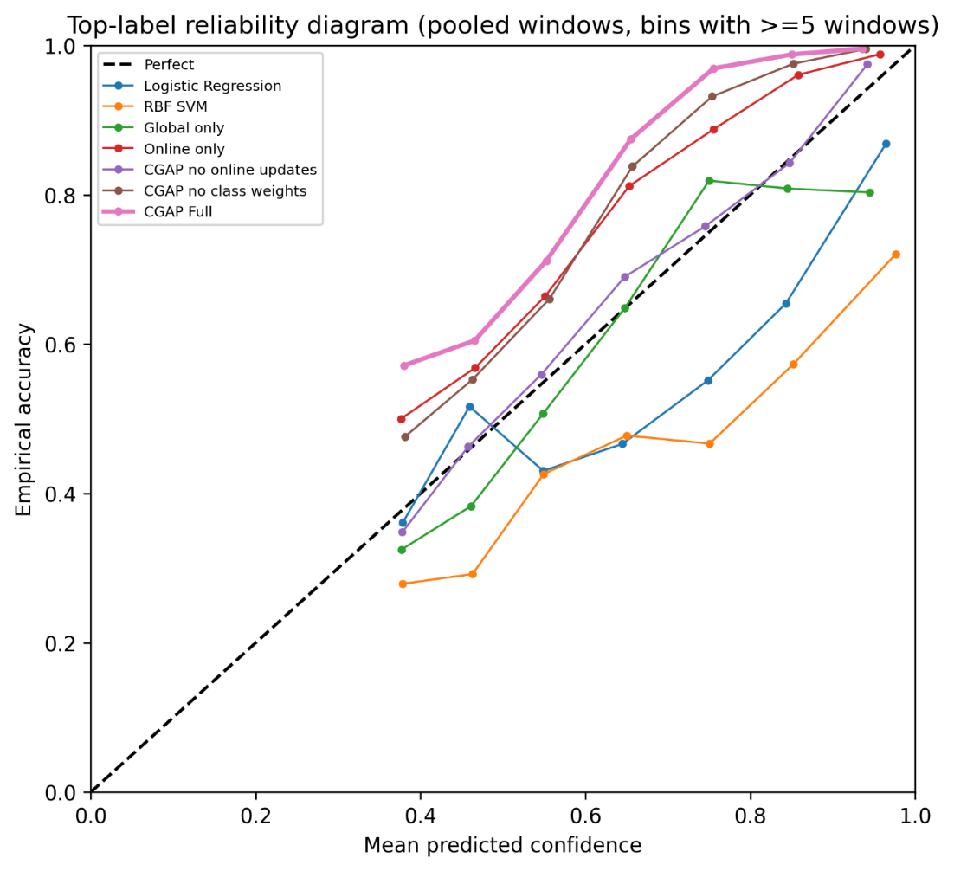

Figure 7. Reliability diagrams for the proposed CGAP model and baseline classifiers

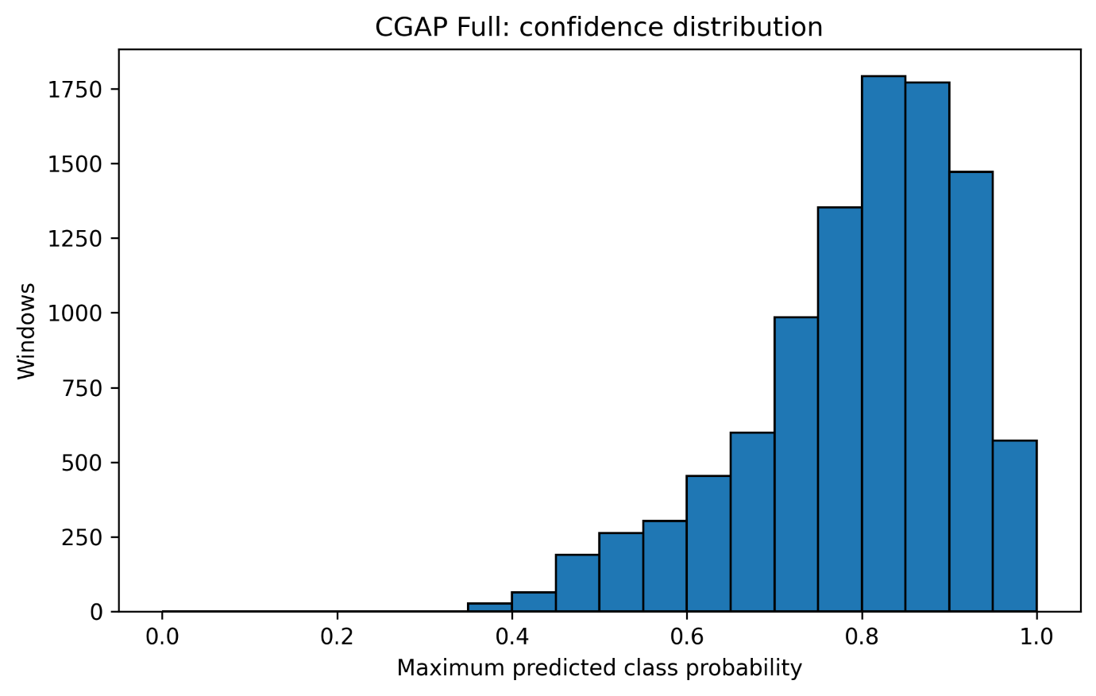

Figure 8. Confidence distributions of the proposed CGAP model and baseline classifiers

The confidence histograms show whether the models produce cautious or overconfident predictions. This is important for HCI deployment because an interface should avoid strong interventions when the predicted physiological state has low confidence.

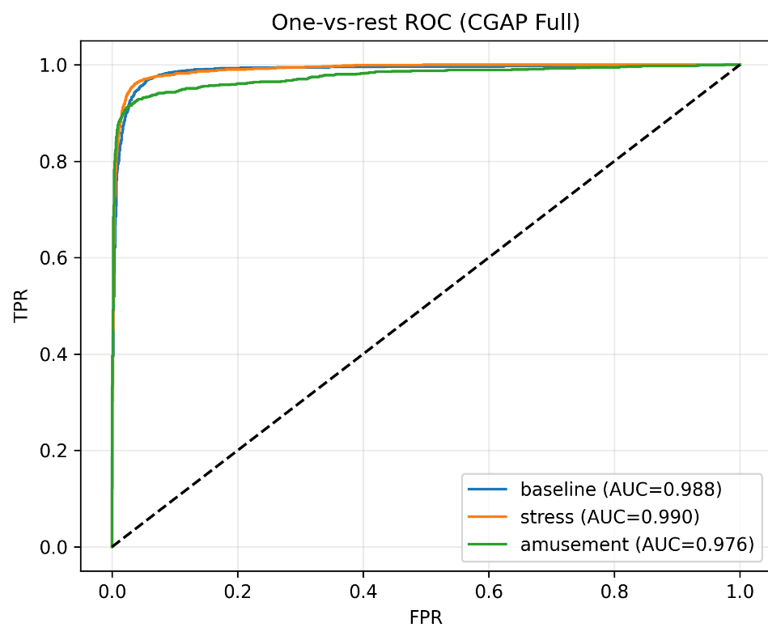

Figure 9. One-vs-Rest ROC Curves for the Proposed CGAP Model

This figure presents the one-vs-rest receiver operating characteristic (ROC) curves for the proposed CGAP model across the three physiological states. The horizontal axis represents the false-positive rate (FPR), while the vertical axis represents the true-positive rate (TPR). The proposed CGAP model achieved high observed discrimination, with AUC values of 0.988 for baseline, 0.990 for stress, and 0.976 for amusement. The curves remain close to the upper-left corner and substantially above the dashed random-classification line, indicating that the model effectively separates each physiological state from the remaining classes. Among the three classes, stress produced the highest AUC, while amusement showed slightly lower but still strong discrimination.

4.8 Statistical Significance Analysis

The participant was used as the independent statistical unit. The three seed results were first averaged within each participant, producing 15 participant-level observations per model. A Friedman test was then used as the omnibus test, followed by paired Wilcoxon signed-rank tests comparing the proposed CGAP Full model with each comparator. Holm correction was applied separately for each metric.

Table 8. Friedman Omnibus Test Results for the Proposed CGAP Model and Comparator Methods
Metric | Kendall’s $W$ | p-value
Accuracy | 0.837 | 3.46 × 10⁻¹⁸
Balanced accuracy | 0.899 | 1.06 × 10⁻¹⁹
Macro-F1 | 0.898 | 1.09 × 10⁻¹⁹
Macro-precision | 0.888 | 1.94 × 10⁻¹⁹
Macro-recall | 0.899 | 1.06 × 10⁻¹⁹

The Friedman test was significant for every principal metric, indicating that model performance differed across the evaluated configurations. Kendall’s W indicates the degree of agreement in model rankings across participants; it should not be interpreted as a conventional magnitude-of-performance effect size. Holm-adjusted pairwise tests showed that the proposed CGAP Full model significantly outperformed Majority Dummy, Logistic Regression, RBF SVM, Global-only, and CGAP without online updates. The difference between CGAP Full and Online-only was not statistically significant after correction.

4.9 Explainability Analysis of the Proposed CGAP Model

Population-level SHAP analysis was conducted for the leakage-controlled implementation of the proposed CGAP model. Only the 24 sensor-derived features were used for explanation; subject, window, label, and label_id were excluded from the feature matrix. The SHAP additivity errors were effectively zero, confirming that the calculated feature contributions were mathematically consistent with the model outputs.

The population-level SHAP analysis was aggregated across all 15 participants. ACC and EDA statistics were among the strongest contributors to the fused class probabilities. These values represent model attributions rather than physiological causation.

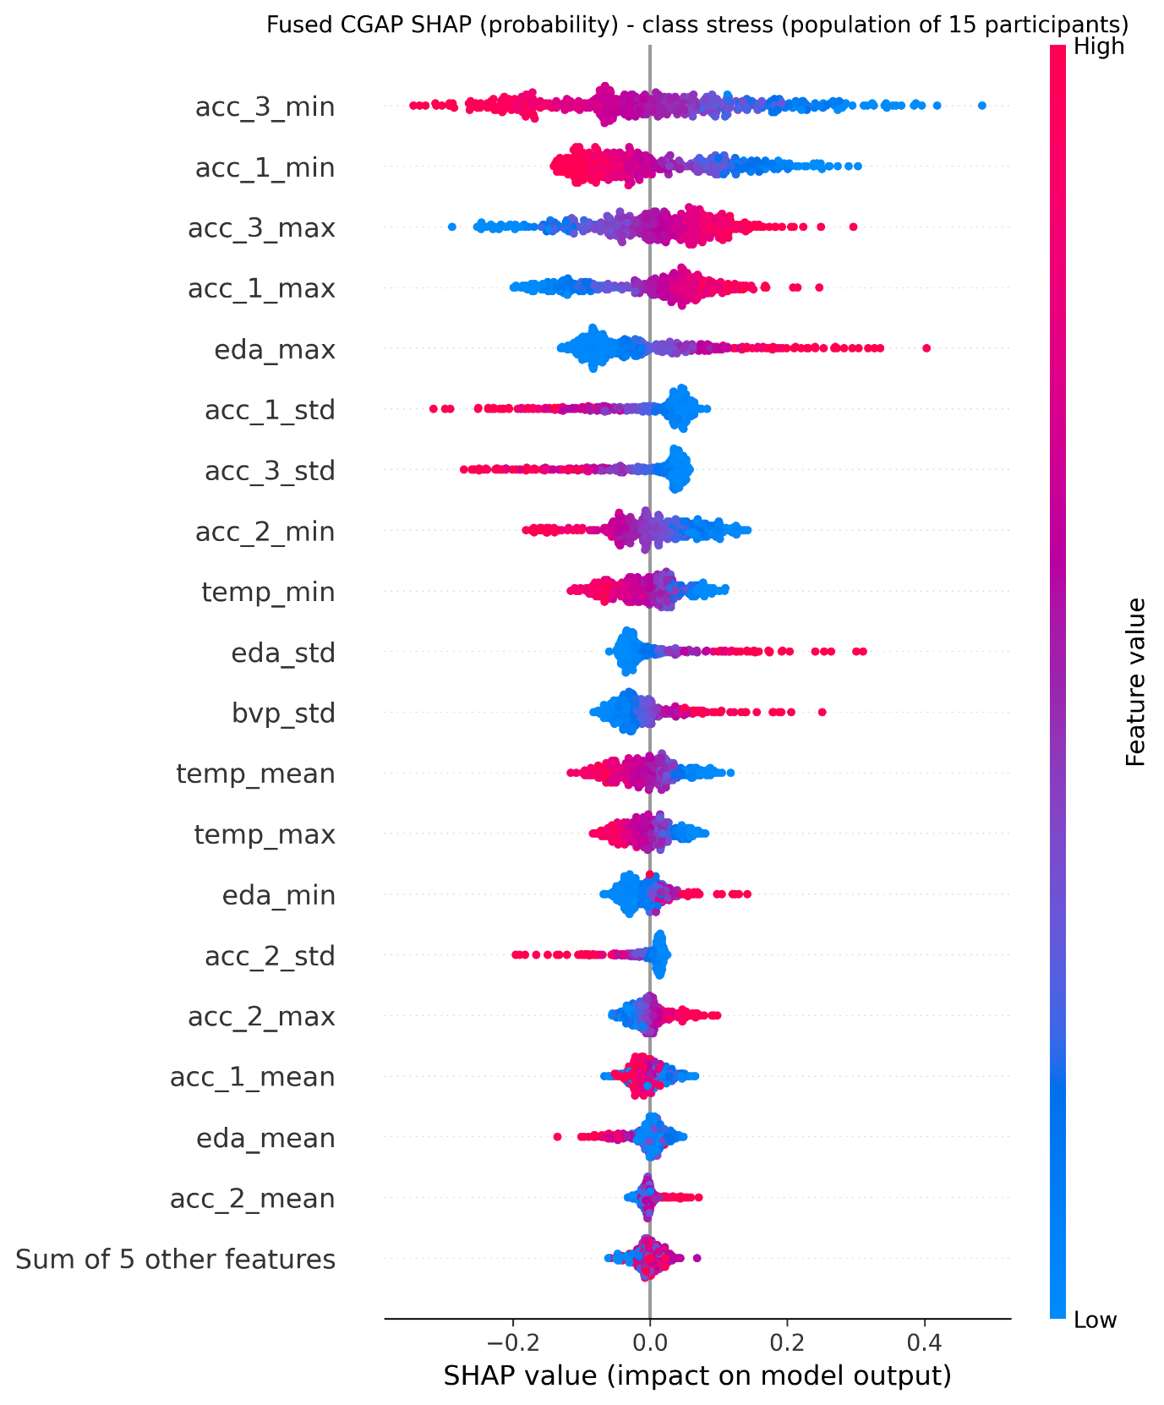
Figure 10. Population-level fused CGAP SHAP summary for the stress class
This beeswarm plot presents the SHAP contributions of the 24 sensor-derived features to the predicted stress probability across all 15 WESAD participants. Features are ordered according to their mean absolute SHAP value. The horizontal axis represents the effect on stress probability: positive SHAP values increase the predicted stress probability, whereas negative values decrease it. Red points represent high feature values and blue points represent low feature values. The most influential features include acc_3_min, acc_1_min, acc_3_max, acc_1_max, and eda_max. These results indicate that acceleration dynamics and electrodermal-activity variation contribute strongly to stress-state predictions.

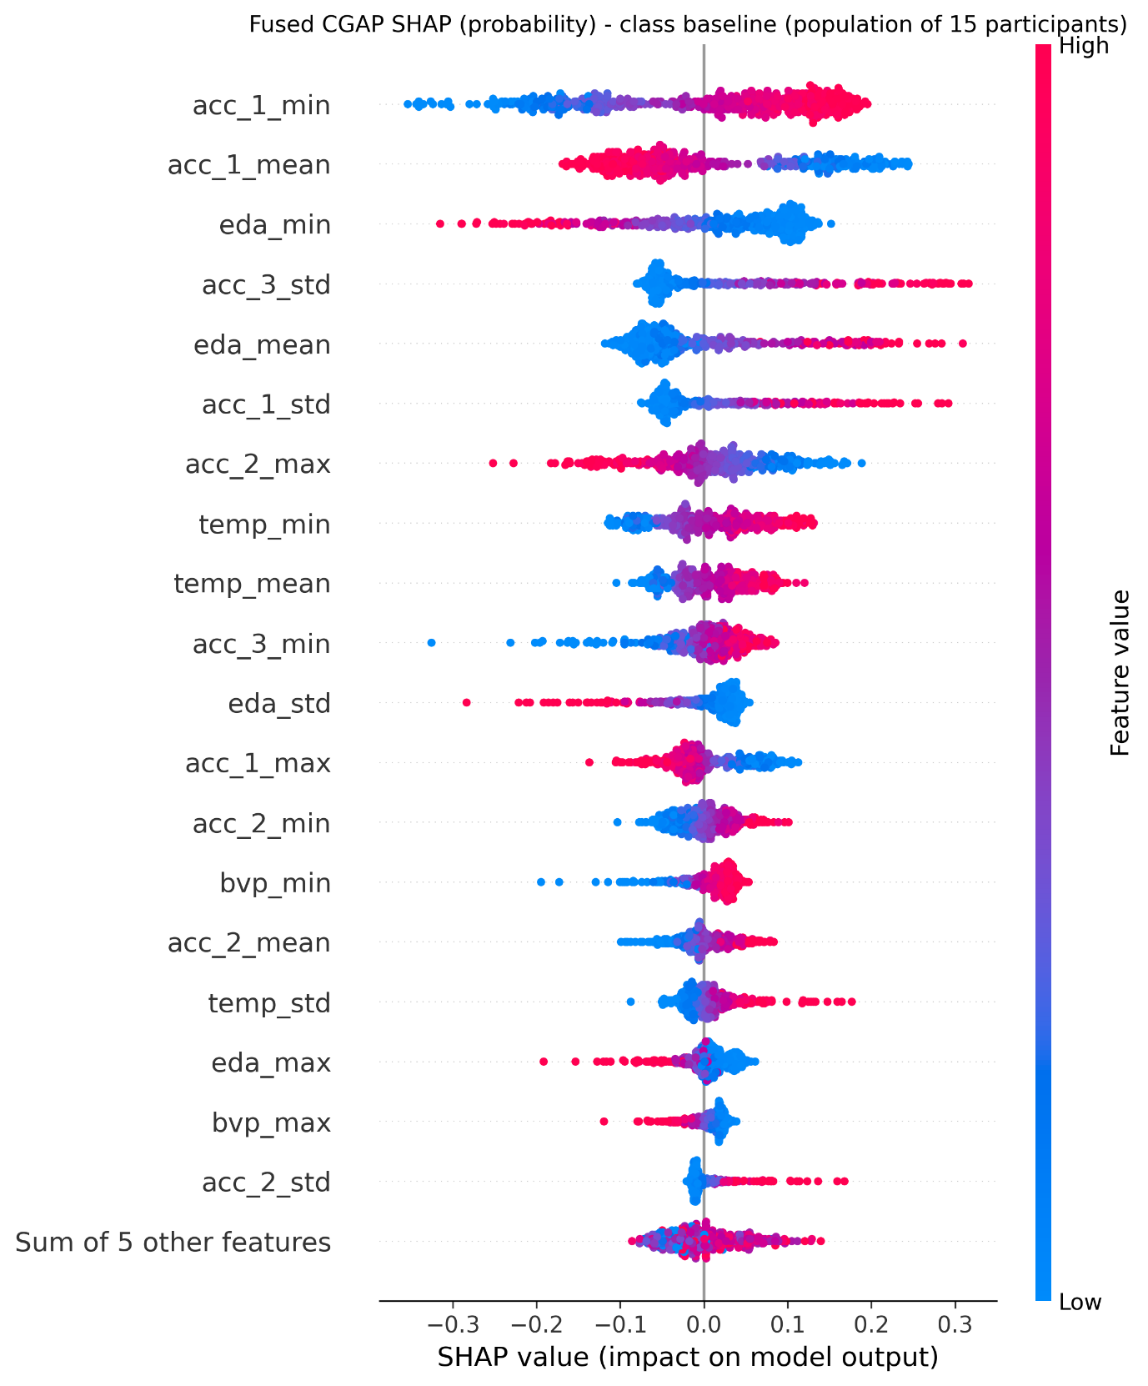
Figure 11. Population-level fused CGAP SHAP summary for the baseline class
This figure shows the population-level SHAP contributions of the 24 sensor-derived features to the predicted baseline probability across all 15 participants. The features are ranked by mean absolute SHAP contribution. Points to the right of the zero line increase the predicted probability of the baseline class, while points to the left decrease it. Red points indicate high feature values and blue points indicate low feature values. The leading features are acc_1_min, acc_1_mean, eda_min, acc_3_std, and eda_mean. The plot shows that movement statistics and electrodermal-activity characteristics substantially influence baseline-state recognition.

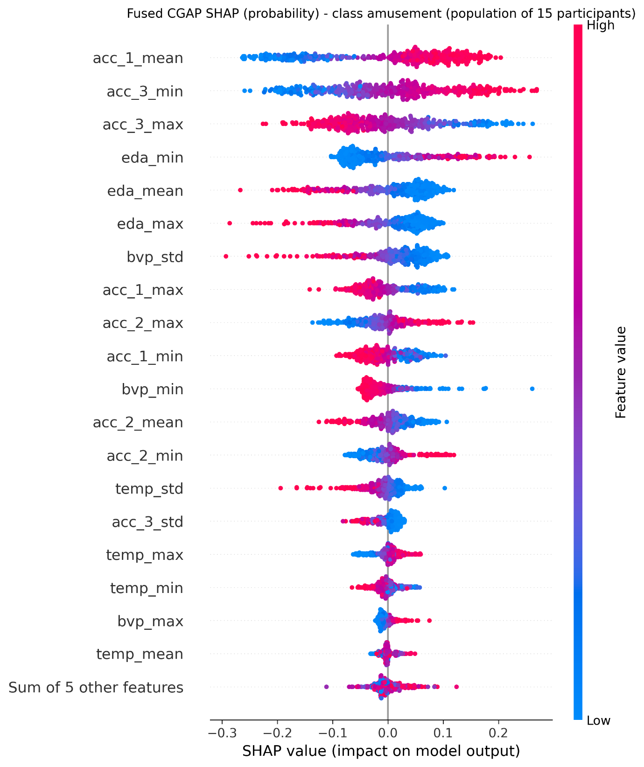Figure 12. Population-level fused CGAP SHAP summary for the amusement class
This beeswarm plot presents the SHAP contributions of the 24 sensor-derived features to the predicted amusement probability across all 15 WESAD participants. Positive SHAP values increase the predicted amusement probability, whereas negative values reduce it. Feature colour represents the original feature magnitude, with red denoting high values and blue denoting low values. The most influential features include acc_1_mean, acc_3_min, acc_3_max, eda_min, and eda_mean, followed by selected BVP and temperature statistics. The results indicate that acceleration and electrodermal-activity patterns are important contributors to amusement-state predictions. Because these plots aggregate explanations across all 15 participants, they provide population-level model-attribution evidence; however, SHAP values should be interpreted as predictive contributions rather than physiological causation.

5. Discussion

The proposed CGAP framework substantially outperformed the conventional static classifiers. Logistic Regression and RBF SVM achieved macro-F1 scores of 0.477 and 0.508, respectively, while the Global-only model achieved 0.481. In contrast, the proposed CGAP Full configuration achieved a macro-F1 of 0.936. The ablation results show that online adaptation was the main contributor: removing online updates reduced macro-F1 to 0.488, whereas the Online-only configuration achieved 0.936. This confirms the importance of sequential user-specific updating for recognizing physiological patterns that vary between participants.
The class-wise results showed strong recognition of baseline and amusement, while stress produced the lowest recall because stress-related physiological patterns may overlap with movement and general arousal. The population-level SHAP analysis identified ACC and EDA statistics as important contributors to the model predictions. These findings support CGAP as a participant-independent framework with supervised online personalization. However, the SHAP values represent model-attribution results rather than physiological causation, and the current results demonstrate state-recognition capability rather than direct improvement in HCI task performance.

5.1 Limitations

- Limited dataset size and diversity: WESAD contains controlled recordings from only 15 participants and may not represent different populations, devices, environments, or real-world HCI conditions.
- Dependence on labelled feedback: The online branch uses a predict-then-update protocol in which the true label is revealed after prediction. Therefore, the method represents supervised online personalization rather than completely label-free adaptation.
- Restricted feature representation: The model uses statistical features from ACC, BVP, EDA, and temperature but does not include advanced HRV, tonic–phasic EDA, frequency-domain, or learned temporal features. ACC may also capture movement and wrist-orientation effects.
- No direct HCI validation: The current study predicts baseline, stress, and amusement states but does not measure interface workload, user satisfaction, task performance, energy consumption, or long-term concept drift. Future work should evaluate CGAP in real interactive systems and on external datasets.

6. Conclusion and Future Work

This study presented CGAP, a real-time adaptive framework for multimodal physiological-state recognition in human–computer interaction. The framework combines a global Extra-Trees classifier with an online SGD classifier and fuses their probability outputs. A leakage-controlled participant-independent evaluation was conducted using 15 participants and three random seeds.

The proposed CGAP model achieved a macro-F1 of 0.936 ± 0.016, outperforming the conventional baseline classifiers and the no-online-update configuration. The ablation results confirmed that online updating is the main contributor to the predictive improvement, while class weighting supports more balanced recognition of baseline, stress, and amusement.

The main contribution of this study is the development of an adaptive participant-independent framework that learns general physiological patterns and progressively personalizes predictions using labelled feedback. The results demonstrate the potential of CGAP as a foundation for future HCI systems capable of adjusting interaction behaviour according to the user’s continuously changing physiological state.

6.1 Future Work

- Temporal evaluation: Evaluate non-overlapping physiological episodes and report stream-ordering and window-overlap details.
- Label-efficient adaptation: Investigate active learning, semi-supervised learning, and weakly supervised updating to reduce the amount of labelled feedback required.
- Cross-dataset and real-device validation: Evaluate CGAP on additional wearable datasets and deploy it on smartphones, smartwatches, or edge devices.
- Adaptive HCI experiments: Connect CGAP to a real interactive interface and measure its effect on user workload, satisfaction, responsiveness, and interaction quality.

Data availability

The WESAD dataset used in this study was obtained from https://ubi29.informatik.uni-siegen.de/usi/data_wesad.html. The processed participant-level feature files generated in this study are available from the corresponding author upon reasonable request, subject to the original dataset licence and privacy restrictions.

Code availability statement

The code used for preprocessing, feature extraction, leakage-controlled evaluation, baseline comparison, CGAP training, online updating, ablation analysis, calibration analysis, and SHAP interpretation is available from the corresponding author upon reasonable request. The corresponding author may provide the code, configuration files, and execution instructions required to reproduce the reported results.

References

- Yaseen, E.S. and Şahin, S., 2026. Masked signal modeling with self-supervised transformers for stress and affect detection using wearable biosignals. Biomedical Signal Processing and Control, 118, p.109607.
- Calza-Metre, M. and Borzì, L., 2026. Machine learning-based automatic stress detection: Performance and generalization across datasets. Smart Health, p.100693.
- Pataca, A.O. and Pires, I.M., 2026. Comparative analysis of machine learning algorithms for stress detection. Procedia Computer Science, 278, pp.1161-1169.
- Bello-Orgaz, G., Menéndez, H.D., Quintana-Quiroga, F. and Díaz-Álvarez, A., 2026. Smart devices and stress level detection: Balancing machine learning model complexity and device intrusiveness. Biomedical Signal Processing and Control, 117, p.109683.
- Kocaçınar, B., Çöpürkaya, Ç., Meriç, E., Erik, E.B., Akbulut, F.P. and Catal, C., 2026. Deep learning-based stress detection using multimodal biosignals. International Journal of Data Science and Analytics, 22(1), p.290.
- Pei, X., Ghandehari, A., Chakoma, S., Rajendran, J., Tavares-Negrete, J.A. and Esfandyarpour, R., 2026. A quantitative, multimodal wearable bioelectronic device for comprehensive stress assessment and sub-classification. Nature Communications, 17(1), p.1150.
- Aydoğan, Y. and Povina, F.V., 2026. Stress or arousal? Exercise confounding in wearable stress detection. Medical engineering & physics, 147(9), p.095021.
- Bhoi, S.R., Joshi, A., Bag, M., Bhoi, T., Dansana, D., Acharya, B., Prasad, V.K. and Deferisha, A.D., 2026. A unified multimodal learning framework for stress detection using IoT biomarkers and NLP with return-aligned decision transformers. Discover Internet of Things, 6(1), p.132.
- Baajour, M., Abdul Aal, S. and Zahed, K., Machine Learning for Mental Health Episode Prediction via Wearable Devices. In Proceedings of the Human Factors and Ergonomics Society Annual Meeting (p. 10711813261498738). Sage CA: Los Angeles, CA: SAGE Publications.
- Pareja Bernal, L.F., Ben Souissi, S. and Golz, C., 2026. Machine learning-based detection of workplace stress using wearable and multimodal data: a systematic literature review. Frontiers in Artificial Intelligence, 9, p.1837195.
- Han, T.T., Tran Tien, D. and Pham-Nguyen, T.L., 2026. Robust stress detection from wearable ECG using subject-specific normalization and stacking ensemble learning. Computer Methods in Biomechanics and Biomedical Engineering, pp.1-10.
- Tazarv, A., Labbaf, S., Reich, S.M., Dutt, N., Rahmani, A.M. and Levorato, M., 2021, November. Personalized stress monitoring using wearable sensors in everyday settings. In 2021 43rd Annual International Conference of the IEEE Engineering in Medicine & Biology Society (EMBC) (pp. 7332-7335). IEEE.
- Mattern, E., Jackson, R.R., Doshmanziari, R., Dewitte, M., Varagnolo, D. and Knorn, S., 2023. Emotion recognition from physiological signals collected with a wrist device and emotional recall. Bioengineering, 10(11), p.1308.
- Muñoz-Saavedra, L., Escobar-Linero, E., Miró-Amarante, L., Bohórquez, M.R. and Domínguez-Morales, M., 2023. Designing and evaluating a wearable device for affective state level classification using machine learning techniques. Expert Systems with Applications, 219, p.119577.
- Bolpagni, M., Pardini, S., Dianti, M. and Gabrielli, S., 2024. Personalized stress detection using biosignals from wearables: A scoping review. Sensors, 24(10), p.3221.
- Yang, X., Yan, H., Zhang, A., Xu, P., Pan, S.H., Vai, M.I. and Gao, Y., 2024. Emotion recognition based on multimodal physiological signals using spiking feed-forward neural networks. Biomedical Signal Processing and Control, 91, p.105921.
- Lange, L., Wenzlitschke, N. and Rahm, E., 2024. Generating synthetic health sensor data for privacy-preserving wearable stress detection. Sensors, 24(10), p.3052.
- Rahmani, M.H., Symons, M., Sobhani, O., Berkvens, R. and Weyn, M., 2024. EmoWear: wearable physiological and motion dataset for emotion recognition and context awareness. Scientific data, 11(1), p.648.
- Fan, L., Peng, H., Xiao, L., Shi, L., Zhou, S., Song, Y. and Fan, H., 2026. Agile human activity recognition for wearable devices based on online incremental learning. Frontiers in Public Health, 14, p.1727388.
- Kacimi, Y. and Adda, M., 2024. From signals to emotion: affective state classification through Valence and arousal. Procedia Computer Science, 251, pp.358-365.
- Sandulescu, V., Andrews, S., Ellis, D., Bellotto, N. and Mozos, O.M., 2015, June. Stress detection using wearable physiological sensors. In International work-conference on the interplay between natural and artificial computation (pp. 526-532). Cham: Springer International Publishing.
- Gedam, S. and Paul, S., 2021. A review on mental stress detection using wearable sensors and machine learning techniques. IEEe Access, 9, pp.84045-84066.
- Shen, J., Liang, H., Ma, R., Xu, Y., Zhu, K., Gao, H., Hou, K., Zhang, Y., Zhang, X. and Hu, B., 2026. Emotion recognition using multimodal physiological signals through regional to global fusion with a spatial-temporal semantic alignment mechanism. Information Fusion, p.104224.
- Choi, M., Koo, G., Seo, M. and Kim, S.W., 2017. Wearable device-based system to monitor a driver’s stress, fatigue, and drowsiness. IEEE Transactions on Instrumentation and Measurement, 67(3), pp.634-645.
- Ding, Y., Dai, Y., Cao, L., Tian, J., Lin, Z. and Feng, L., 2026. Detecting stress from videos via intra-subject and inter-subject learning. Health Information Science and Systems, 14(1), p.53.
- Fu, Z., He, X., Wang, E., Huo, J., Huang, J. and Wu, D., 2021. Personalized human activity recognition based on integrated wearable sensor and transfer learning. Sensors, 21(3), p.885.
- Krawczyk, B., 2017. Active and adaptive ensemble learning for online activity recognition from data streams. Knowledge-Based Systems, 138, pp.69-78.
- Zhang, W., 2017, May. Phd forum: Recognizing human posture from time-changing wearable sensor data streams. In 2017 IEEE International Conference on Smart Computing (SMARTCOMP) (pp. 1-2). IEEE.
- Egger, M., Ley, M. and Hanke, S., 2019. Emotion recognition from physiological signal analysis: A review. Electronic Notes in Theoretical Computer Science, 343, pp.35-55.
- Yang, K., Wang, C., Gu, Y., Sarsenbayeva, Z., Tag, B., Dingler, T., Wadley, G. and Goncalves, J., 2021. Behavioral and physiological signals-based deep multimodal approach for mobile emotion recognition. IEEE Transactions on Affective Computing, 14(2), pp.1082-1097.
- Moser, M.K., Ehrhart, M. and Resch, B., 2024. An explainable deep learning approach for stress detection in wearable sensor measurements. Sensors, 24(16), p.5085.
- Zhang, L., Du, Y., Li, H., Yan, S., Yao, Q., Liu, C., Zhang, Y. and Zhu, X., 2026. Wearable Multifunctional Sensors for Human Activity Recognition. Sensors, 26(11), p.3420.

