Concept Map-Driven Visualization for Personalized Educational Short-Video Recommendations: An Explainable AI Perspective
Abstract
Educational platforms offer thousands of learning resources, and it is challenging for learners to find relevant short videos that align with their interests, knowledge level, and prerequisite requirements. This work proposes a behaviour- and concept-enhanced sequential recommendation, namely BCE-SASRec, with an interpretable concept-map visualization. Our model exploits chronological watching history, watch behaviors, temporal interval, course context, video metadata, and concept associations to capture the educationally meaningful sequential patterns. A causal Transformer encoder is adopted to encode the sequential learning behavior. The auxiliary concept-alignment and completion-prediction tasks are introduced to maintain the educationally meaningful information during pretraining. This framework has been benchmarked on MOOCCubeX with leakage-controlled chronological training/validation/test splits. Experiments are conducted with three randomly seeded runs to evaluate the model's consistency. On the validation set, the model achieves around 0.74 NDCG@10, 0.86 Recall@10, and 0.91 Recall@20, with consistent results across different random seeds. For the test set, three-seed mean achieves 0.6935 NDCG@10, 0.8224 Recall@10, 0.6594 MRR, 0.5718 Accuracy@1, 0.8139 Concept Recall@10, and 0.8813 Recall@20. This result suggests that our proposed model can successfully retrieve relevant educational videos while providing sufficient concept coverage. The proposed concept map ties together the user's watching history, covered concepts, prerequisites, and finally the recommended videos, establishing a clear understanding of what the model has learned for the recommendation. Even though the accuracy at the top ranks could be improved, the framework provides a good starting point for personalized educational short-video recommendation.
Keywords: Educational recommendation, short video, concept map, explainable artificial intelligence, MOOCCubeX, sequential recommendation, Transformer, BCE-SASRec.

1. Introduction

Online learning platforms offer the learners a vast amount of teaching resources, e.g., courses, lectures, exercises, and short videos. While such a big variety helps to increase education opportunities, it also brings significant challenges, e.g., too much information can confuse and mislead the learner who has to choose what to study next based on their interests, current knowledge, desired learning outcomes, and individual prerequisites. Traditional recommendation systems usually solve this issue by learning the pattern of interactions and suggesting items similar to those previously watched or purchased. Still, education recommendation has specific aspects since a video has to fit the individual learner and their current level of knowledge and be beneficial for their learning progress. Evangelista et al., in [1], proposed a fair and explainable recommendation approach based on graph representation and sequential learning. While this method was proven to be successful in personalization and fairness, it did not focus on educational videos and, thus, cannot provide concept-map-based explanations.

Knowledge graphs proved to be a great source of information for constructing a recommendation system, as they can store relationships between learners, concepts, courses, videos, and prerequisites, which allows the recommender to model the current knowledge of the learner and suggest courses and videos to fill in the gaps. In particular, Cheng et al. [2] designed a knowledge graph-based model, which used learner-state prediction and reinforcement learning to recommend personalized learning paths. Boubaker et al. [3] suggested utilizing knowledge graph relationships to recommend courses and provide visual explanations based on semantic paths. While these studies focused on providing personalized recommendations based on knowledge graphs, their scope was primarily on the course and path levels. They do not consider the need for short videos, which are increasingly popular with learners.

Apart from the general challenges of providing educational recommendations, such as the importance of prerequisites, the need for individualization, and the ability to explain the logic behind the suggestions, there are additional issues specific to short videos. For instance, popularity does not necessarily translate into positive educational value. A short video can feature concepts already known to the learner, present information in too simple or too complex a manner, or have nothing to do with the learner’s intent. Moreover, a click or a partial watch of a video does not mean that the learner understood the concepts presented there. The recommendation model has to account for the sequential nature of interactions, video completion, the time since the interaction, the course or other educational resource, which the video is a part of or serves as an alternative to, and the concepts presented in the video itself. Only then can the recommender prioritize the videos, which fit the learner’s individual learning path the best.

This study introduces BCE-SASRec, a behaviour- and concept-enhanced sequential recommendation model for personalized educational short videos. It uses a causal Transformer to learn the pattern of interactions and represent the current state of the learner based on their history of video views. The model incorporates auxiliary task-specific objectives, such as concept alignment and completion prediction, to ensure that the recommendation fits the educational context. Additionally, BCE-SASRec recommends multiple short videos, which can be used to fill in the knowledge gaps based on the concepts covered in previously viewed videos and the concepts, which the learner is expected to cover next. The concepts are visualized in the graphical explanation, which displays the learner’s history, current and target knowledge states, and the recommended resources. In such a way, BCE-SASRec provides personalized video ranking while maintaining educational value and allowing for concept-level interpretation.
2. Literature Survey

Yun et al. [4] studied the use of large language models to generate evidence-supported explanations in an educational recommendation system. Their aim was to reduce unsubstantiated recommendations by linking generated explanations to existing learner and resource evidence. However, it was primarily simulated learners and not investigated whether a real-world learner could understand generated explanations from a visual concept map. Li et al. [5] surveyed personalization methods in learning-path recommendation. They stressed the need to incorporate knowledge graphs, learner profiling, adaptive pathway generation, and explainability. However, the survey did not implement a unified short-video recommendation system. These works motivate the development of a recommendation framework grounded in verified learner-video-concept relationships.

Delianidi et al. [6] created DK-PRACTICE, an intelligent platform with knowledge tracing plus educational-content recommendation. The platform estimates learner knowledge based on assessment responses and recommends relevant materials. The system's performance was demonstrated in a Computer Organization and Architecture course, but limited to one course and without concept-map visualization. Zhang et al. [7] applied collaborative filtering, TransR knowledge-graph embeddings, hierarchical attention, and reinforcement learning to generate personalized language-learning paths. Although representing relationships among language concepts, it does not process short educational videos or their behavioural information. BCE-SASRec extends prior research by using chronological viewing behaviour and video-concept relations to recommend individual educational videos.

Li et al. [8] presented a knowledge-graph based adaptive model for training-course recommendation. The framework combines dynamic knowledge representation, learner-state tracking, and reinforcement learning to update recommendations based on learning progress. However, it works at the complete-course level and provides limited learner-facing explanations. Qi et al. [9] developed personalized learning paths for underachieving students using a combination of cognitive, behavioural, emotional, motivational, metacognitive, and demographic characteristics. The system implements deep knowledge tracing, a curriculum knowledge graph, and Proximal Policy Optimization. However, its graph only has 26 knowledge points and evaluated for 300 students. The present study works at the video level using the larger MOOCCubeX graph connecting learners, videos, courses, and concepts.

Oubagine et al. [10] proposed SAEF, an adaptive and explainable feedback system that evaluates learner performance, progress, and time spent on learning activities by weighted indicators and predefined rules. The system's explanations are easy to follow, but dependent on manually defined rules and not evaluated for long-term classroom deployment. Khaled et al. [11] developed EduExplain by combining a Restricted Boltzmann Machine with collaborative filtering for course recommendation, where recommendations are explained based on similar learners' preferences and performance. However, it experiences cold-start and scalability issues when interaction data are sparse. In contrast, BCE-SASRec augments behavioural history with video concepts, courses, and metadata to allow recommendations to utilize content information when learner histories are limited.

Striebel et al. [12] built a heterogeneous knowledge graph connecting courses, skills, occupations, and skill dependencies. The system estimates course relevance through skill-dependency paths and uses these as explanations for career-oriented recommendations. However, it does not adequately model an individual learner's concept state or recommend specific learning videos. Syed et al. [13] applied an attention-enhanced heterogeneous graph neural network to represent students, courses, academic attributes, and their relationships. Attention highlights influential graph connections, but may not provide explanations easy for learners to interpret. The proposed concept map presents explicit paths connecting learner history, weak concepts, prerequisites, and recommended videos.

Deshmukh et al. [14] considered the integration of large language models with sequential recommendation for personalized learning-path generation. Large language models can interpret learning goals and generate flexible explanations, but may also recommend unsubstantiated learner evidence. Zhou et al. [15] proposed an LLM-driven attribute-augmented framework to enrich learner and course representations with additional semantic information. This approach may reduce the influence of sparse interactions, but concentrated on complete-course recommendation and lacking concept-level visualization. The proposed framework grounds its explanations in observed interactions and verified MOOCCubeX relations instead of relying solely on generated reasoning.

Gao et al. [16] introduced ALP-CRS, which combines Apriori association-rule mining, student graph clustering, and link prediction to identify course-selection patterns and recommend courses preferred by similar learner groups. Although improving precision, its recall is comparatively limited and the recommendations lack semantic explanations. Zhang et al. [17] proposed KG-RecCNN by integrating knowledge-graph semantics, convolutional embeddings, semantic paths, and multi-head attention. The model captures explicit knowledge relations and hidden interaction patterns, but its evaluation relies on metadata and not extensively examining educational video behaviour. BCE-SASRec combines learner interactions with direct video-concept associations to enhance retrieval and provide concept-level explanation.

Chang et al. [18] developed PAIRS-SRL using K-Nearest Neighbours to generate adaptive learning paths for an online database course. The evaluation reported improvements in learner motivation, engagement, achievement, self-regulation, and cognitive load, but constrained to one course at one university. Luo et al. [19] presented SRLAdvisor, a generative-AI recommender that detects self-regulation difficulties from student conversations and generates personalized advice. Although supporting self-regulated learning, repeated generated suggestions may become monotonous and encourage overreliance on AI. A visual concept map provides an alternate means by allowing learners to inspect concept connections and choose among recommended videos.

Obeng et al. [20] designed a modular adaptive-learning recommender for integration with a production Moodle environment. The architecture separates data ingestion, model training, and recommendation generation through standardized interfaces, increasing scalability and maintenance. However, the study concentrated more on the system architecture rather than an explainable recommendation algorithm. Li et al. [21] combined Deep Q-Networks, PPO, contextual bandits, emotion analysis, bias mitigation, and a knowledge graph to recommend ideological and political education resources. Although supporting real-time adaptation, part of the evaluation was simulated and the experimental data not easily reproducible. The present study uses MOOCCubeX and a reproducible chronological pipeline for preprocessing, training, validation, testing, and explanation.

Hesari et al. [22] proposed a complexity-informed framework that treats an educational recommender as a dynamic system evolving with its learners. The framework emphasizes context, feedback loops, emergence, self-organization, and continuous adaptation, but remains primarily theoretical and requires empirical implementation. Xu et al. [23] developed a dynamic knowledge-graph and GNN-based recommendation system for English-teaching content. The system updates learner knowledge from classroom and online behaviour while combining collaborative and content-based recommendation. However, it reported delayed learner-state updates and insufficient recommendation diversity for advanced learners. BCE-SASRec uses recent chronological interactions and can be extended with diversity-aware reranking to reduce repetitive recommendations.

Zhao et al. [24] proposed KRMKG-GNN by combining knowledge reasoning, a multimodal knowledge graph, graph neural networks, Bayesian Knowledge Tracing, reinforcement learning, and multi-objective path optimization. The system combines text, selected video frames, learner behaviour, and graph relations to estimate knowledge mastery. However, it used a private institutional dataset and did not process complete educational videos. Nizam et al. [25] combined Random Forest, content-based filtering, and SHAP to recommend higher-education courses from grade-12 subject marks. SHAP identifies the learner features that influence a recommendation, but not represent prerequisite relationships among concepts. The proposed approach connects behavioural and content evidence with graph paths to allow explanations to show both learner suitability and conceptual relevance.

Chen et al. [26] introduced FPPEV, a framework for predicting educational-video popularity and engagement. It combined contrastive feature decomposition, mutual-information constraints, self-attention-based dynamic fusion, and dual KL-divergence regularization to model visual, audio, and textual features. However, the framework predicts general popularity rather than the suitability of a video for a particular learner. Cao et al. [27] proposed VBF++, a multimodal video recommender that uses variational Bayesian fusion, context-aware priors, adversarial refinement, and meta-learning. Although modeling uncertainty and multimodal information, its evaluation used MovieLens, TikTok, and Kuaishou, which primarily contain entertainment content. The present work is focused on education and considers learner history, concept coverage, course context, and prerequisite needs.

Cai et al. [28] proposed RLUR, a reinforcement-learning method deployed on the Kuaishou short-video platform. It formulated recommendation as an infinite-horizon Markov Decision Process and optimized long-term user retention by considering delayed rewards, uncertainty, and differences among user groups. However, retention and application-opening frequency do not necessarily represent meaningful learning. Sunday et al. [29] examined the impact of learner choice and different concept-map formats on knowledge retention and transfer. Their study of 529 chemistry students found that learner choice improves retention and that concept-map translation can produce strong learning outcomes, but the work did not include a recommendation model. The proposed system combines short-video personalization with concept-map visualization to allow learners to understand and explore alternative educational resources.

Feng et al. [30] developed NSRL-DM-EDU by combining neural-symbolic reinforcement learning and a denoising diffusion probabilistic model. Symbolic educational rules constrain the generated learning paths, while the diffusion model reconstructs changes in learner knowledge. This alignment improves traceability and teacher trust, but the system concentrates on knowledge tracing rather than educational short-video recommendation. Hesari et al. [22] similarly emphasized that educational recommendation should continuously adapt to changing learner states and contextual feedback. However, their complexity-informed framework remained conceptual. These works support the need for an empirically evaluated system that models learner development and provides transparent recommendations. BCE-SASRec responds to this requirement through chronological behaviour modelling, concept-aware learning objectives, and concept-map explanations.
2.4 Comparative Analysis of Existing Studies
Table 1. Comparative analysis of existing educational recommendation studies
S.No. | Paper | Dataset |  | Model / Method | Research Gap
1 | Evangelista & Bukhari (2026) | Moodle LMS |  | Graph Transformer + GRU | No short-video concept map
2 | Cheng et al. (2026) | Junyi, MOOCCubeX, ASSISTments |  | GraphRAG + DIMKT + PPO | Simulation-based evaluation
3 | Boubaker et al. (2025) | Coursera/EduKA |  | KG embeddings + ML | Course-level only
4 | Yun et al. (2026) | MOOCCubeX + simulated learners |  | Ranking + LLM explanations | No real-user validation
5 | Li et al. (2026) | Multiple educational datasets |  | Systematic survey | No implemented model
6 | Delianidi et al. (2026) | KT benchmarks + COaA |  | PB-BoW + RNN | Single-course evaluation
7 | Zhang (2026) | Lang-8 |  | TransR + Attention + RL | No video recommendations
8 | Z. Li (2026) | China University MOOC |  | Dynamic KG + DKT + RL | Limited explanation evaluation
9 | Qi et al. (2026) | 300 middle-school students |  | DKT + KG + PPO | Small curriculum graph
10 | Oubagine et al. (2026) | ASSISTments |  | Rule-based SAEF | No long-term evaluation
11 | Khaled & Iwidat (2026) | OULAD, Goodreads |  | RBM + Collaborative Filtering | Cold-start limitations
12 | Striebel et al. (2026) | O*NET + course data |  | Heterogeneous KG | No video recommendation
13 | Syed et al. (2026) | 400 learners |  | Attention HGNN | Small private dataset
14 | Deshmukh et al. (2026) | Not reported |  | LLM + Sequential Model | Dataset not verified
15 | Zhou et al. (2026) | Not reported |  | LLM representation learning | Dataset not verified
16 | Gao et al. (2026) | University course records | Apriori + Link Prediction |  | Low recall
17 | Y. Zhang (2026) | RRD-2025 | KG-RecCNN |  | Limited multimodal support
18 | Chang & Dao (2026) | University course data | KNN |  | Single-course evaluation
19 | Luo et al. (2026) | Student chat records | SRLAdvisor LLM |  | Risk of AI dependence
20 | Obeng & Opoku (2026) | Moodle LMS | Collaborative Filtering |  | No concept-level explanation
21 | Z. Li (2026) | IPE interaction data | DQN + PPO + KG |  | Partly simulated
22 | Hesari et al. (2026) | Literature review | Complexity framework |  | No experimental validation
23 | Xu (2026) | English-learning data | Dynamic KG + GNN |  | Delayed adaptation
24 | Zhao (2026) | 500 students | Multimodal KG + GNN |  | Private dataset
25 | Nizam et al. (2026) | Grade-12 marks | Random Forest + SHAP |  | No video recommendation
26 | Chen & Wan (2026) | Instructional videos + AMPD | FPPEV |  | No personalized learning
27 | Cao et al. (2026) | MovieLens, TikTok, Kuaishou | VBF++ |  | Non-educational datasets
28 | Cai et al. (2023) | Kuaishou | RLUR |  | Optimizes retention only
29 | Sunday et al. (2026) | 529 chemistry students | Concept-map experiment |  | Not a recommender
30 | Feng et al. (2026) | Educational data | Symbolic RL + Diffusion |  | No video recommendation

Table 1 describes the comparison of previous educational recommendation studies based on their datasets, model design, and limitations in research. All the aforementioned methods use knowledge graphs, knowledge tracing, graph neural network, reinforcement learning, collaborative filtering, large language models, multimodal fusion, SHAP, and concept-map experiment to help with personalized learning. However, most of the methods provide recommendations of the whole course or learning path instead of personalized educational short videos. There is a problem that some approaches are using simulated, private, small, or not verified datasets. Moreover, several other methods optimize popularity, engagement, or retention but do not take into consideration the concepts that the learner should know. Although there are some approaches that give explanations through rules, attention weight, SHAP values, semantic paths, and generated text, they cannot provide an explicit connection between the user behavior, knowledge gaps, prerequisites, and recommended educational videos. Therefore, the above-mentioned limitations show the importance of BCE-SASRec in personalized and explainable educational short video recommendation.

2.5 Research Gap

While previous works have made great progress in educational recommendation systems, most of them fail to fully incorporate personalized short-video ranking, sequential learning behavior, concept associations, and explanation visualization. Traditional course recommenders typically recommend whole courses or pathways, while conventional short-video recommenders focus on engagement, popularity, or retention rather than education-specific properties such as concepts or prerequisites. Knowledge-graph methods capture concept relationships but often neglect sequential information, and sequential methods often lack fine-grained concept-level interpretability. Explanations based on attention weights or generated text may be insufficient to highlight specific evidence for a recommendation. Previous works often use randomly split data, private data, or report results from only one random seed. Temporal leakage may therefore be present in evaluations, and generalization performance can be difficult to assess. This study proposes BCE-SASRec, which incorporates both chronological behaviors and concept associations with course contextualization, video metadata, and temporal information, and evaluates performance using leakage-controlled chronological splits, with explanations visualized in an interactive concept map highlighting relevant history, associated concepts, prerequisites, and target videos.

2.6 Research Objectives

This study aims to:
1. preprocess MOOCCubeX interactions into leakage-free chronological sequences
2. design a behavior- and concept-aware sequential recommender
3. incorporate video, concept, course, metadata, and temporal information
4. improve next-video ranking and concept coverage
5. evaluate performance and stability across multiple random seeds
6. visualize explanations using an interactive concept map.

3. Proposed Methodology

3.1 Overall Framework

The proposed methodology has five stages: data-extraction, interaction preprocessing, feature representation, sequential recommendation, and concept-map-based explanation. Five information types are needed: learner, video, course, concept, and behavioural information. Video metadata describes the available learning resources, concept-video relations define the topics of each video, course-video relations provide curriculum context, and user-video records provide chronological viewing activities. These heterogeneous sources are merged with their identities to create a unified representation of learner behaviour and educational content.

During preprocessing, the raw watch segments are validated, sorted, and merged to extract useful behavioural features. Invalid intervals are removed, overlapping ones are merged, and the watched time is clipped to the corresponding video duration. The processed interactions are sorted chronologically for each learner. Early interactions are used as the training history, and the next two eligible interactions are the validation and test targets. This learner-wise chronological approach ensures that the model makes future predictions using only the information that would have been available at recommendation time.

BCE-SASRec receives a fixed-length sequence composed of each learner's most recent interactions. Every position in the sequence is represented via item, concept, course, metadata, temporal, positional, and behavioural information. Item embeddings identify individual videos, while pooled concept embeddings describe their educational content. Course embeddings provide broader curriculum context, and metadata embeddings represent video features. Time-gap embeddings describe the interval between consecutive interactions, while behavioural features capture watched time, completion, playback activity, and engagement. These representations are merged and inputted to a causal Transformer encoder to prevent future interactions influencing earlier sequence positions.

The hidden representation at the final valid sequence position encapsulates the learner's current interests and learning context. This learner representation is compared with the candidate-video representations to generate recommendation scores. Videos already present in the learner history are masked during recommendation, so that the model prioritizes unseen resources. The model is trained for next-video ranking, while auxiliary concept-alignment and completion-prediction objectives encourage it to retain educational relevance and behavioural information.

The explanation component transforms recommendation evidence into a concept map. The visualization connects the learner's recent videos to their associated concepts, identifies concepts related to highly ranked candidates, and displays prerequisite relationships if provided. Different node and edge types distinguish learner interactions, video-concept coverage, prerequisite dependencies, and final recommendations. Consequently, users can inspect the educational relationships supporting a recommendation rather than receiving an unexplained ranked list.

3.2 Dataset Description

MOOCCubeX is selected because it provides large-scale learner behaviour with structured educational entities and relationships. The dataset holds information on users, videos, courses, concepts, teachers, schools, exercises, comments, replies, academic papers, and prerequisites. The heterogeneity of this dataset supports both sequential recommendation and concept-level explanation.

The `user-video.json` file provides learner-wise video-watching sequences with segment-level informations including watched intervals, playback speed, and local start time. Video metadata provides resource identifiers, durations, captions, and related attributes. The video-identifier mapping relates the platform video identifiers in the behavioural records with content identifiers in the entity files. Concept-video and course-video relations connect videos with educational concepts and courses, while prerequisite files describe selected concept dependencies.

MOOCCubeX contains video records and captions, but does not provide the original playable video files. Consequently, the proposed system considers each video as an educational resource with the identifier, caption, metadata, course membership, associated concepts, and learner interactions. These informations are sufficient for recommendation and concept-level explanation, but not for direct analysis of raw audio or visual frames.

The preprocessing pipeline initially retained 196,031 positive user-video interactions after identifier mapping, segment validation, duplicate consolidation, and sparse filtering. Learners and videos with insufficient interaction support were progressively removed until the filtered dataset converged. A final evaluation cleanup guarantees that every validation and test target appeared in the training catalogue and that each learner had a valid recommendation history. This process resulted in 17,959 eligible learners for chronological evaluation.

Table 2. Chronological dataset split used for BCE-SASRec
Split | Interactions | Users | Unique videos
Training | 152,022 | 17,959 | 4,720
Validation | 17,959 | 17,959 | 2,881
Test | 17,959 | 17,959 | 2,793

The dataset is split using a learner-wise chronological leave-two-out approach. For every eligible learner, the latest interaction becomes the test target and the immediately preceding interaction becomes the validation target. All earlier interactions constitute the training sequence. Validation data are used for early stopping and checkpoint selection, while test data are evaluated only after the final checkpoint has been selected. Although the number of unique videos differs between the three splits, every validation and test video is part of the training catalogue. This design avoids unseen-item evaluation and future interactions from entering the learner's historical input.

3.3 Data Preprocessing and Quality Control

The behavioural file is approximately 3 GB, which makes direct in-memory loading inefficient. A streaming parser is thus used to process one learner record at a time. Each platform video identifier is resolved through the video-mapping relation and linked to the corresponding content metadata. Records with unresolved identifiers, missing timestamps, unusable durations, or videos outside the eligible catalogue are excluded.

Each viewing event can contain multiple watch segments. A segment is only valid if its end point is greater than the start point and its playback speed is positive. Overlapping watch intervals are merged so that the same part of a video is not counted twice. Total watched time is clipped to the official video duration. Playback-adjusted time is calculated with the segment length and playback speed, while the earliest and latest valid local timestamps represent the event's temporal limitations.

For a video of duration $d$, the completion ratio is calculated as:

$$\text{Completion Ratio}=\min\left(1,\frac{\text{Merged Watched Seconds}}{d}\right) (1)$$

A bounded engagement weight combines the completion ratio and the number of valid viewing segments:

$$\text{Eng Weight}=\min\left(1, 0.85×\text{Completion Ratio}+0.15×\min\left(1,\frac{\text{Segment Count}}{3}\right)\right). (2)$$

This formulation places greater emphasis on actual video completion while preserving limited information about repeated or segmented viewing. The behavioural representation finally includes watched seconds, playback-adjusted seconds, duration, completion ratio, segment count, and engagement weight.

Repeated interactions involving the same learner and video are consolidated to avoid creating duplicate targets. Their timestamps, watched durations, and behavioural measurements are aggregated into a single learner-video interaction. The consolidated records are sorted chronologically within each learner sequence. Continuous behavioural values with long-tailed distributions are log transformed where appropriate and standardized using statistics calculated from the training set only.

Iterative sparse filtering is subsequently performed to remove learners with insufficient histories and videos with inadequate support. The filtering process is repeated because deleting rare learners can reduce video frequencies, while deleting rare videos can shorten learner sequences. Iteration is continued until the interaction count no longer changes. The final evaluation cleanup verifies that validation and test items remain inside the training catalogue.

3.3.1 Data-Quality and Leakage Checks

- The following checks are performed before model training:
- Training interactions occur before or at the validation timestamp.
- Validation interactions occur before or at the test timestamp.
- Every validation target belongs to the training video catalogue.
- Every test target belongs to the training video catalogue.
- Each evaluation learner has a valid training history.
- Duplicate learner-video targets are removed.
- Behaviour normalization uses training data only.
- Invalid, overlapping, or out-of-range watch segments are corrected or excluded.

These procedures result in clean and reproducible learner sequences, while preventing temporal information leakage. As a result, the validation and test metrics reflect the model's ability to recommend a learner's future educational video from their previously observed behaviour.

3.4 BCE-SASRec Architecture

BCE-SASRec, orBehaviour- and Concept-Enhanced Self-Attentive Sequential Recommendation, extends the SASRec architecture to include learner behaviour, educational concepts, course information, video metadata, and temporal context. Conventional SASRec largely encapsulates a learner's history as an ordered sequence of item identifiers. While capturing sequential preference patterns, it does not specify how a learner engaged with a video or what educational concepts the video includes. BCE-SASRec addresses this issue by forming a richer representation for every learner-video interaction.

The model receives a sequence containing the learner's 50 most recent eligible video interactions. Sequences shorter than 50 interactions are left padded while longer sequences only retain the latest 50 records. Each position combines information from the video identifier, concepts, course, metadata, learner behaviour, position, and time gap. All representations are projected into a common hidden dimension of 256 before processing by the sequential encoder.

The sequential encoder contains two causal Transformer layers, each with four self-attention heads and a feed-forward dimension of 512. Causal masking ensures a sequence position can only attend to the current and previous interactions. Hence, information from validation or test targets cannot enter the learner's historical representation. Dropout, layer normalization and residual connections are used to improve training stability and reduce overfitting.

For a learner sequence $\left(v_{1},v_{2},…,v_{t}\right),$the representation of the interaction at position $t$is constructed as:
$$x_{t}=e_{t}^{item}+e_{t}^{concept}+e_{t}^{course}+e_{t}^{metadata}+e_{t}^{behaviour}+e_{t}^{time}+e_{t}^{position}.$$

Where $e_{t}^{item}$represents the video identity, $e_{t}^{concept}$represents its educational concepts, and $e_{t}^{course}$represents the associated course. The remaining terms encode video metadata, viewing behaviour, elapsed time and sequence position. Layer normalization and dropout are applied to the combined representation before entry to the Transformer.

The Transformer output from the last valid sequence position represents the learner's current state:
$$h_{u}={\operatorname{Transformer}\left(x_{1},x_{2},…,x_{t}\right)}_{t}$$

This representation summarizes the learner's chronological preferences, engagement patterns and educational context. Candidate-video scores are calculated using the similarity between the learner's representation and each candidate's representation. Videos with higher scores are placed nearer the top of the recommendation list.

The complete BCE-SASRec architecture includes item, concept, course, position and time-gap embedding layers, a behaviour multilayer perceptron, a metadata multilayer perceptron, concept-attention projections, two causal Transformer layers, normalization and dropout components and a completion-prediction head. The main ranking objective is trained jointly with auxiliary concept-alignment and completion-prediction objectives.

3.4.1 Candidate-Video Representation

Every candidate video is represented using four complementary information sources: video identity, associated concepts, course membership, and metadata. The candidate's representation is calculated as:
$$z_{v}=\operatorname{LayerNorm}\left(e_{v}^{item}+e_{v}^{concept}+e_{v}^{course}+e_{v}^{metadata}\right)$$
The item embedding provides a trainable representation for the individual video. This component captures video-specific interaction patterns that cannot be captured fully by metadata or concept labels. However, item identifiers alone cannot establish relationships among videos with similar educational content. Concept and course embeddings are therefore added to facilitate information sharing among related resources.

Each video can be associated with multiple concepts. A maximum of 12 concepts is retained for one video and missing positions are filled with a padding identifier. Instead of applying an unweighted average, the model uses an attention-based pooling operation to combine the concept embeddings. This mechanism assigns larger weights to concepts that contribute more strongly to the video representation:
$$α_{v,j}=\frac{\exp\left(s_{v,j}\right)}{\sum_{k∈C_{v}}{\exp\left(s_{v,k}\right)}},$$
where $C_{v}$is the set of concepts associated with video $v$, and $s_{v,j}$is the attention score assigned to concept $j$. The pooled concept representation is:
$$e_{v}^{concept}=\sum_{j∈C_{v}}{α_{v,j}}c_{j},$$
where $c_{j}$denotes the embedding of concept $j$. Padding concepts are masked before normalization so that they do not affect the pooled representation.

The course embedding represents the broader curriculum to which the video belongs. It allows the model to distinguish videos that discuss similar terms in differing educational contexts. Videos without a known course relation utilise a dedicated padding identifier rather than an arbitrary course value.

The metadata branch processes numeric video characteristics through a two-layer multilayer perceptron. The input can contain normalised duration and available interaction-derived video statistics. The first linear layer projects the metadata into an intermediate representation, a GELU activation introduces non-linearity and the second layer maps the result to the 256-dimensional hidden space:
$$e_{v}^{metadata}=W_{2}\operatorname{GELU}\left(W_{1}m_{v}+b_{1}\right)+b_{2.}$$
Combining these four sources allows the model to rank a video using both collaborative evidence and structured educational information. It also facilitates cold or relatively sparse videos as their concepts, course membership and metadata can still contribute when direct interaction evidence is limited.

3.4.2 Behaviour Representation

BCE-SASRec represents not only which video a learner watched but also how they interacted with it. Each interaction consists of six behavioural features:

- Watched seconds
- Playback-adjusted seconds
- Video duration
- Completion ratio
- Segment count
- Engagement weight

Watched seconds indicates the unique portion of the video consumed after merging overlapping intervals. Playback-adjusted seconds accounts for viewing speed. Duration provides context as the same watched time has differing meanings for short and long videos. Completion ratio measures the proportion of the video viewed while segment count captures fragmented or repeated viewing. Engagement weight is a bounded summary of completion and segment activity.

Variables such as watched time, playback time, duration and segment count can have strongly skewed distributions. Long-tailed variables are therefore transformed using:
$$x'=\log\left(1+x\right)$$
Each behavioural feature is then standardised using the mean and standard deviation from the training split:
$$\overset{ˆ}{x}=\frac{x'-μ_{train}}{σ_{train}+ϵ}$$
Only the training statistics are utilised to prevent validation and test information influencing the feature transformation.

The normalized behaviour vector $b_{u,t}$is processed by a two-layer multilayer perceptron:
$$e_{u,t}^{behaviour}=W_{2}^{b}\operatorname{GELU}\left(W_{1}^{b}b_{u,t}+b_{1}^{b}\right)+b_{2.}^{b}$$
Dropout is applied between the two linear transformations. The final behavioural representation has the same 256-dimensional size as the item, concept, course and temporal embeddings, enabling it to be added directly to the interaction representation.

This component allows the model to distinguish between different interactions with the same video. For instance, completing a video at normal speed provides differing behavioural evidence to opening it briefly or repeatedly watching only a small segment. BCE-SASRec does not automatically interpret completion as concept mastery; instead, behaviour is treated as evidence that contributes to the learner-state representation alongside concepts, sequence order and course context.

3.5 Temporal and concept-aware sequence encoding

The BCE-SASRec model encodes each learner interaction with video, concept, course, metadata, behaviour, position, and time-gap features. Time-gaps are compressed into 32 logarithmic buckets and position embeddings maintain the order of interactions. The combined sequence is encoded by two causal Transformer layers that prohibit access to future interactions. The output at the final valid position represents the learner state and is used to rank candidate videos.

$$s\left(u,v\right)=\frac{h_{u}^{⊤}z_{v}}{\sqrt{d}},$$
where $h_{u}$is learner representation, $z_{v}$is candidate-video representation, and d=256. Videos with higher scores are closer to the start of the recommendations.

3.5.1 Educational role of concepts

Concept embeddings encode the educational topics covered by each video. They enable different videos to share related topics and support concept-level explanations. Concept Recall@10 evaluates whether the concepts of the target video are included in the top-ten recommendations even if the target video is not retrieved.
$$\text{Concept Recall@10}=\frac{\left|C\left(v^{*}\right)∩C\left(R^{10}\right)\right|}{\left|C\left(v^{*}\right)\right|},$$
where $C\left(v^{*}\right)$is the target video's concept set and $C\left(R^{10}\right)$is the combined concept set of the top-ten.

3.5.2 Course and metadata context

Course embeddings encode the curriculum-level context and metadata describes video-level features such as duration and interaction statistics. These are combined with item and concept representations to form the candidate-video vector. They augment the recommendation but do not replace the chronological learner sequence.
$$z_{v}=\operatorname{LayerNorm}\left(e_{v}^{item}+e_{v}^{concept}+e_{v}^{course}+e_{v}^{metadata}\right).$$

3.6 Multi-objective training

The BCE-SASRec model is trained on next-video ranking as the main task and concept-alignment and completion-prediction as auxiliary tasks. Ranking helps the model learn to identify the next video, concept alignment preserves educational-topic information, and completion prediction retains learner-engagement information.

3.6.1 Next-video ranking objective

For each positive target, 100 unobserved videos are sampled as negatives. The scores for the positive and negative candidates are calculated and the cross-entropy loss encourages the positive target to receive the highest score. Label smoothing of 0.03 reduces model over-confidence.
$$L_{ranking}=-\sum_{v∈C_{u}}{y_{u,v}}\log{P}\left(v∣u\right),$$
where $C_{u}$contains the positive target and sampled negatives.

3.6.2 Concept-alignment objective

One concept associated with the target video is selected as the positive concept and an unrelated concept is sampled as the negative concept. The model is trained to assign greater compatibility to the positive concept.
$$L_{concept}=-\log{σ}\left(s\left(u,c^{+}\right)-s\left(u,c^{-}\right)\right),$$
where $c^{+}$and $c^{-}$are the positive and negative concepts.

3.6.3 Completion-prediction objective

The completion head predicts the expected completion ratio using the learner state and target-video representation. The mean squared error compares the predicted and observed completion ratios. Completion is an indicator of engagement but not evidence of concept mastery.
$$L_{completion}={\left({\hat{r}}_{u,v}-r_{u,v}\right)}^{2},$$
where ${\hat{r}}_{u,v}$is the predicted completion ratio and $r_{u,v}$ is the observed ratio.

3.6.4 Combined objective

The three loss functions are combined into one objective function:
$$L_{total}=L_{ranking}+0.1173L_{concept}+0.05L_{completion}.$$
Ranking receives the highest importance and the smaller auxiliary weights regularize the learner representation. AdamW is used with a learning rate of 0.0005, weight decay of 0.000001, batch size of 128, and gradient clipping of 0.5.

3.7 Concept-map explanation

The concept map explains the recommendation by linking the learner's history, watched videos, concepts, prerequisites, courses, and recommended videos. Its edges encode watched, covers, prerequisite, belongs to, and recommended relationships.
$$G_{u}=\left(V_{u},E_{u}\right),$$
where $V_{u}$contains learner, video, concept, prerequisite, and course nodes, while $E_{u}$contains their relationships.
A typical explanation path is:

Learner Watched Video Related Concept Prerequisite Concept Recommended Video

The visualization displays the evidence associated with a recommendation without asserting that viewing a video proves mastery or that model attention indicates causality.

4. Experimental Analysis and Results

This section presents the experimental configuration, proposed-model architecture, learning behaviour, validation and test performance, baseline comparison, ablation study, and concept-map visualization. All experiments use the chronological MOOCCubeX splits described in Section 3. The main BCE-SASRec model is trained using three random seeds, while validation NDCG@10 is used for checkpoint selection.

4.1 Experimental Configuration

BCE-SASRec was trained using the AdamW optimizer. Each learner sequence had a maximum of 50 previous interactions. Longer histories retained their most recent 50 interactions, but shorter histories were left-padded. Up to 12 concepts were stored for each video, and padding was used when fewer concepts were available.

The model had a hidden dimension of 256, two causal Transformer layers, four attention heads, and a feed-forward dimension of 512. A dropout rate of 0.1429 decreased overfitting. For every training step, one positive target video was compared to 100 negatively sampled videos that were not previously viewed by the learner.

The learning rate was set to 0.0005 and weight decay to 0.000001. Gradient clipping with a maximum norm of 0.5 decreased unstable parameter updates. The concept and completion auxiliary-loss weights were set to 0.1173 and 0.05 respectively.

Table 3. Fixed BCE-SASRec training configuration
Parameter | Value
Random seeds | 42, 2026, 3407
Maximum sequence length | 50
Maximum concepts per video | 12
Hidden dimension | 256
Transformer encoder layers | 2
Attention heads | 4
Feed-forward dimension | 512
Dropout rate | 0.1429
Negative samples per positive item | 100
Batch size | 128
Evaluation batch size | 128
Learning rate | 0.0005
Weight decay | 0.000001
Concept-loss weight | 0.1173
Completion-loss weight | 0.05
Label smoothing | 0.03
Gradient-clipping norm | 0.5
Maximum training epochs | 20
Minimum training epochs | 8
Early-stopping patience | 4 epochs
Early-stopping improvement threshold | 0.0001
Optimizer | AdamW
Checkpoint-selection metric | Validation NDCG@10

The full BCE-SASRec experiment was allowed to train for up to 20 epochs. Model selection was based only on validation NDCG@10. Training proceeded for at least eight epochs, and stopped once validation NDCG@10 failed to improve by at least 0.0001 for four consecutive epochs. The checkpoint with the best validation NDCG@10 was used for the final evaluation.

The same model configuration was used for all three random seeds. Only parameter initialization, minibatch order, and negative sampling varied across runs. This controlled setup measured whether the variability in the results represented training stability.

The later ablation experiments may be limited to 10 epochs to save computation time. Those results should be reported separately from the main 20-epoch experiment since training-budget differences can affect the comparison.

4.2 Proposed BCE-SASRec Model

The proposed BCE-SASRec model takes into account the learner’s behavior, sequential watching patterns, and educational concepts in order to recommend personalized short-videos. Firstly, the MOOCCubeX interactions are transformed into a sequence of items, and each item is represented by its video identity, concepts, course, metadata, behavior, sequence position, and time information; these representations enable the model to capture the learner’s behavior and educational concepts of candidate items. Then, the overall system architecture is designed, including preprocessing, feature encoding, sequential modeling, multi-objective learning, recommendation, and an explanation layer that is introduced in this paper, which is shown in Figure 1.
Figure 1.Overall architecture of the proposed BCE-SASRec framework for personalized educational short-video recommendation.

As Figure 1 shows, the framework initially processes MOOCCubeX's records into cleaned chronological learner sequences through identifier mapping, segment validation, interval merging, interaction filtering, deduplication, and temporal data splitting. BCE-SASRec represents every historical interaction using item, concept, course, metadata, behavioural, positional, and time-gap attributes.

Item, concept, and course identifiers are encoded into embeddings, while video metadata and six behavioural attributes are processed individually via multilayer perceptrons. The obtained representation is normalized and encoded by a two-layer causal Transformer with four-head self-attention; it produces a learner-state vector out of the final valid interaction position. The candidate videos are represented with similar item, concept, course, and metadata attributes and scored against the learner state by a scaled dot product. The model is trained by the main next-video ranking loss and two auxiliary concept-alignment and completion-prediction losses. Finally, a top-K recommendation lists videos with an optional concept-level explanation of why they appear after recent ones, which concepts they cover, prerequisites for watching, and suggested additional resources; this explanation part is meant to be separately evaluated on users.

4.3 Learning-Curve Analysis
4.3.1 Total Training and Validation Loss
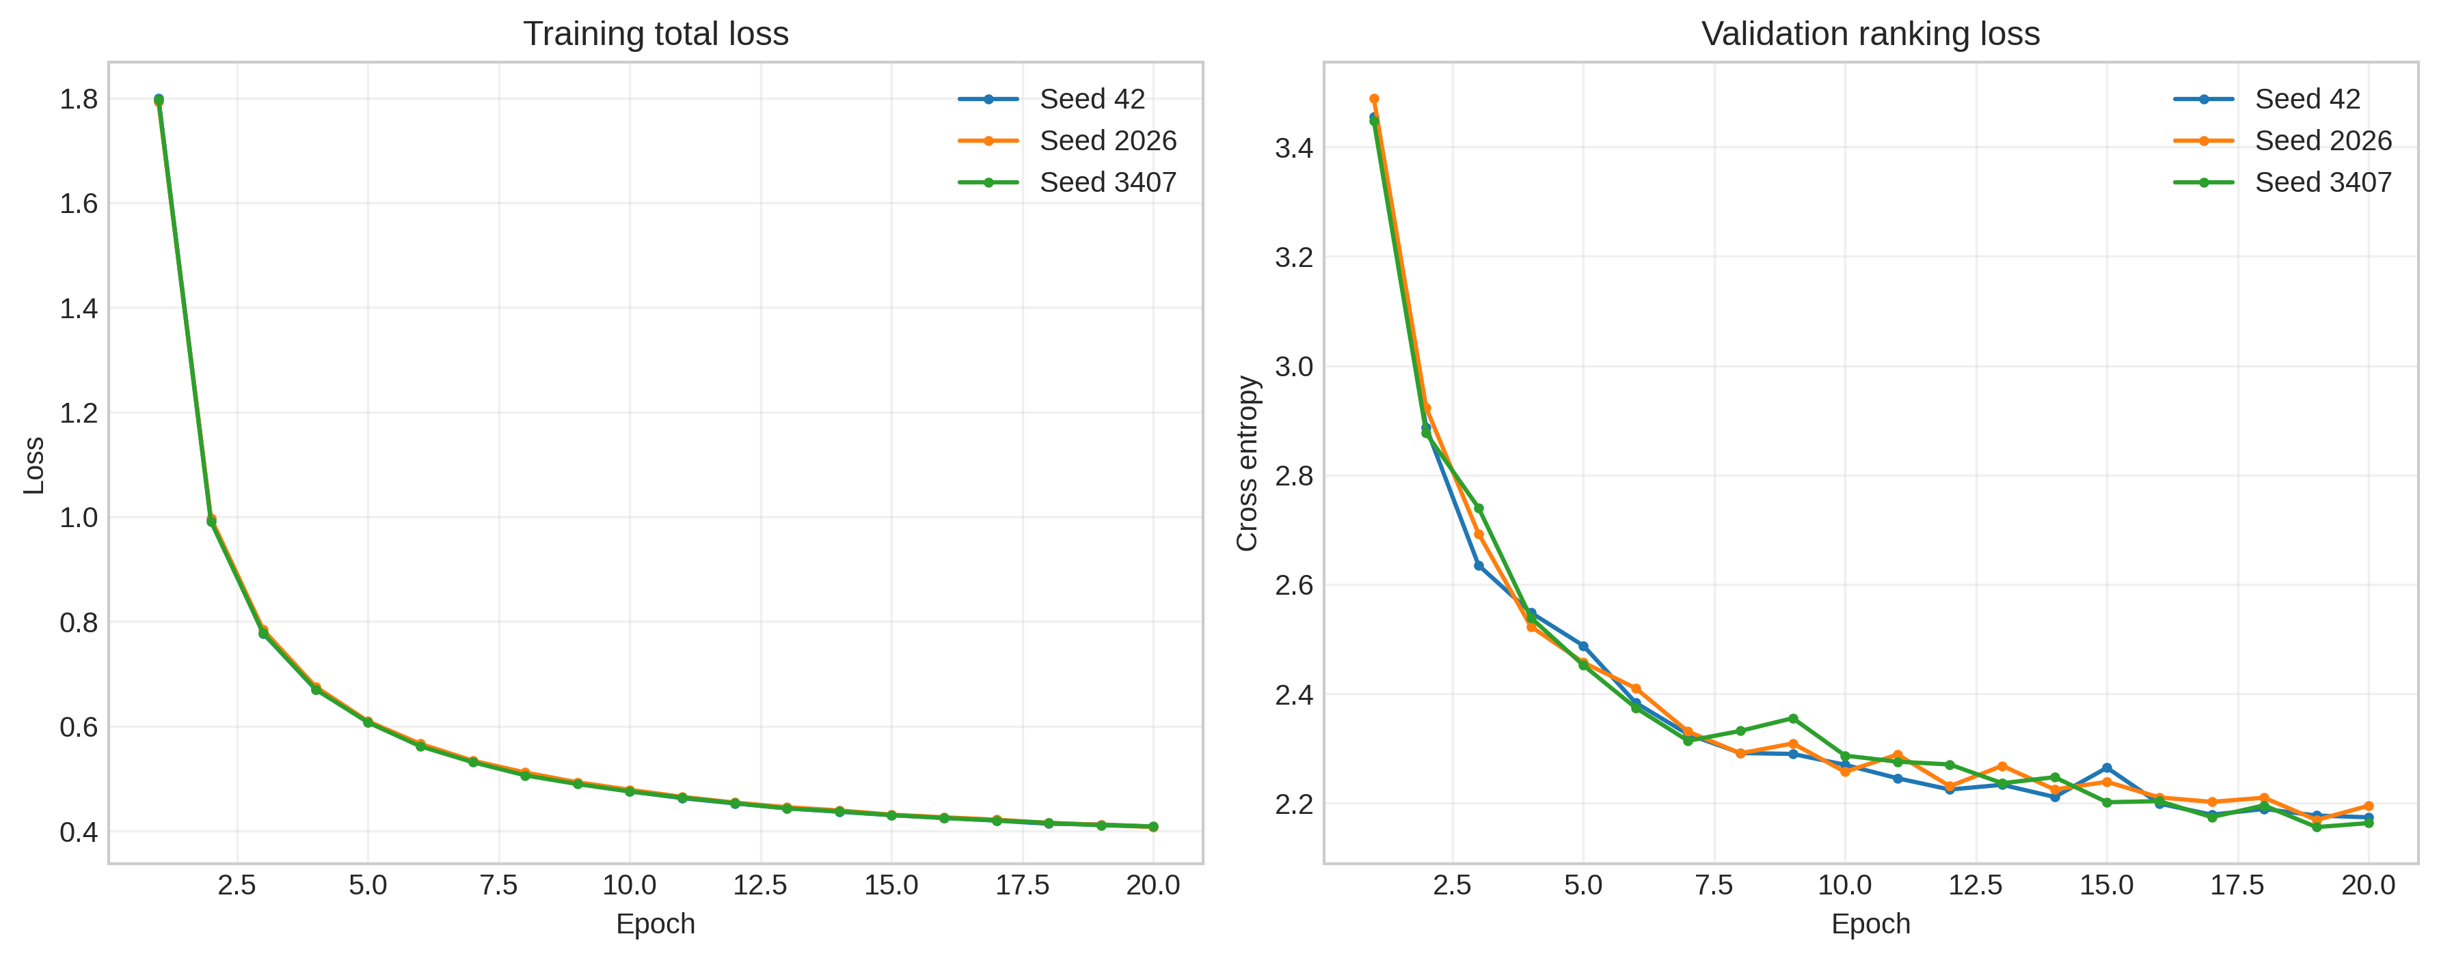
Figure 2. Training total loss and validation ranking loss for three random seeds.

According to Figure 2, when training the model, the total loss decreases significantly from around 1.8 at the first epoch to below 0.8 at the first several epochs and further narrows to approximately 0.41 at epoch 20. Moreover, the loss curves of the three various random seeds (42, 2026, 3407) are almost overlapping, which indicates that the optimization process is stable regardless of different initializations and minibatch orderings. Similarly, the validation ranking loss monotonically decreases, with only a few deviations during training. It is crucial to note that the training and validation losses should not be compared directly since the former uses one positive and 100 sampled negative items, while the latter ranks the target against all eligible items in the catalog. The validation NDCG@10, therefore, makes more sense in the case of the early stopping criterion than the training loss, which continues decreasing after the validation NDCG@10 stops improving.

4.3.2 Component-Loss Behaviour
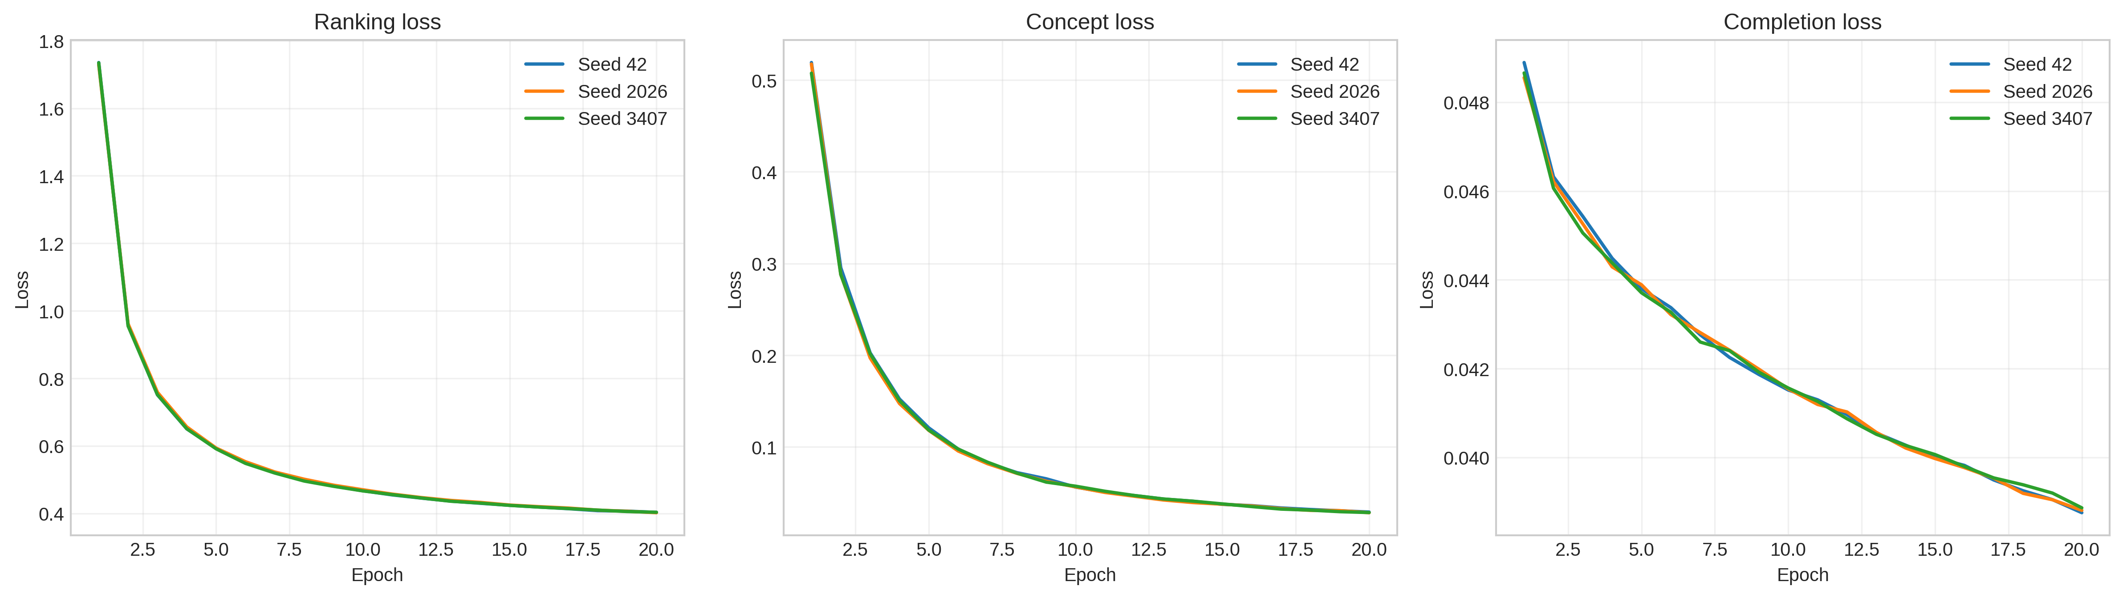
Figure 3. Ranking, concept-alignment, and completion-prediction loss curves for three random seeds.

As seen in Figure 3, all three loss components consistently decrease during the training process, implying that multiple objectives are optimized on a stable manifold. Indeed, ranking loss exhibits the largest decreases as next-video prediction is the core objective of the current model. Concept loss decreases rapidly due to the improved alignment between the learner representation and concepts associated with the target video. Finally, completion loss decreases slowly as the ability to watch a video to completion is affected by its length, playback speed, interruptions, rewinding, and the learner’s motivation. The proximity of curves for seeds 42, 2026, and 3407 suggests that none of the objectives is disproportionately impacted by a random seed choice. Still, the fact that auxiliary losses steadily decrease does not prove that they enhance the recommendation quality; one should also consider Concept Recall@10, completion-prediction errors, and the ablation study.

4.3.3 Validation NDCG
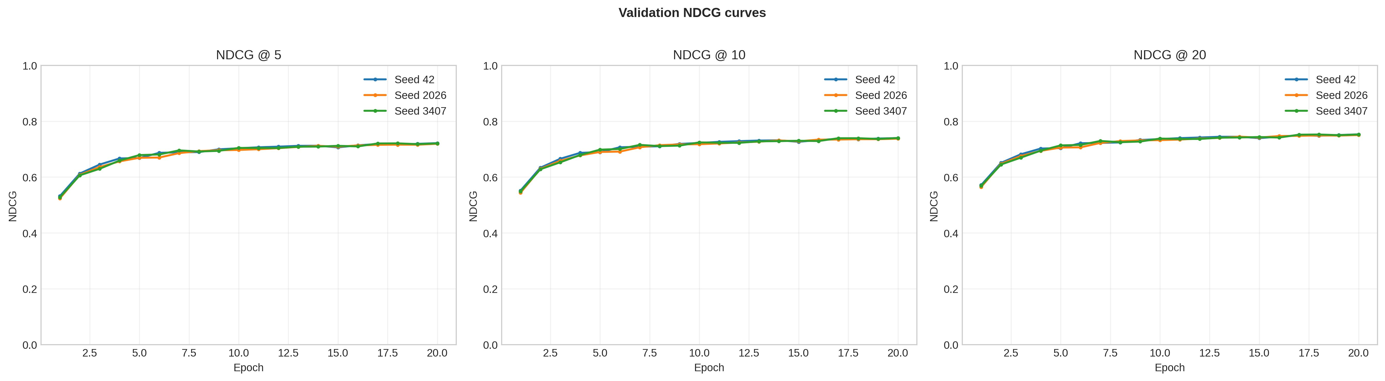

Figure 4. Validation NDCG at cutoffs 5, 10 and 20 for three randomly selected seeds.

As shown in Figure 4, the validation NDCG increases rapidly during the first five to seven epochs and then increases gradually until the curves start to converge. NDCG@5 focuses on the quality of the recommendation ranking for the shortest list, NDCG@10 focuses on the ranking relevant to the practical recommendation lists, and NDCG@20 considers a wider range of items in the ranked recommendations. The validation NDCG@10 reached approximately 0.74, and the results are close for seeds 42, 2026, and 3407. It can be seen that there are only a few gains in the later epochs; therefore, it is possible to use the validation NDCG@10 to select the best checkpoint and to apply early stopping.

4.3.4 Validation Recall

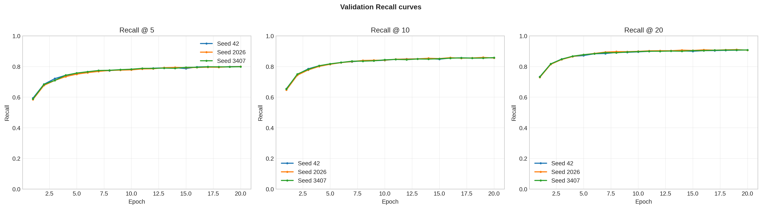

Figure 5. Validation Recall at cutoffs 5, 10, and 20 across three random seeds.

As seen in Figure 5, validation Recall rapidly rises during the early epochs and converges to a certain value. Recall is higher at larger cutoffs because the model has more positions in which it can place the held-out target video. The Recall@10 peaks at around 0.85–0.86, whereas Recall@20 is over 0.90 near the end of training. The difference between these values implies that there are some targets ranked in the positions 11–20 that could be promoted into the top ten with improved reranking. Additionally, the tight curves for the three seeds suggest stable retrieval performance and justify validation-based early stopping.

4.3.5 Validation Precision

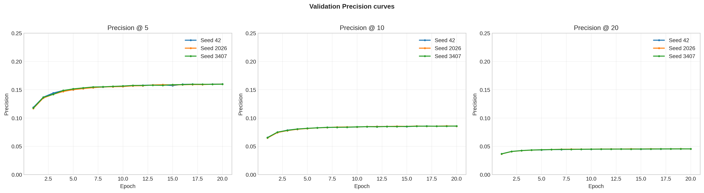

Figure 6. Validation Precision at cutoffs 5, 10, and 20 across three random seeds.

As illustrated in Figure 6, validation Precision improves during the first few epochs and converges. The precision decreases as the cutoff increases since the evaluation only contains one relevant target for each learner. Therefore, the best achievable Precision@5, Precision@10, and Precision@20 are 0.20, 0.10, and 0.05 respectively. Thus, a low Precision@20 does not necessarily signify poor recommendation quality if Recall@20 is high. Similarly, the curves are tight across all seeds, confirming stable behaviour, whereas NDCG and Recall remain informative primary metrics for this single-target recommendation task.

4.3.6 Validation F1 Score

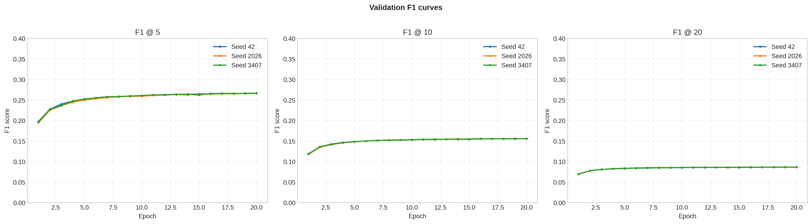

Figure 7. Validation F1 scores at cutoffs 5, 10, and 20 across three random seeds.

As can be seen in Figure 7, validation F1 rapidly increases during the first few epochs and converges to stable values. F1@5 is higher than F1@10 and F1@20 because of the lower achievable Precision when using a larger recommendation cutoff. Even though Recall is higher at large cutoffs, the reduced Precision lowers the F1. This is reflective of the single-target evaluation protocol rather than ineffective longer recommendation lists. F1 is therefore reported as a supplementary metric, whereas NDCG@10, Recall@10, Recall@20, and Concept Recall@10 are used as the main indicators of ranking quality, retrieval, and educational coverage..

4.4 Three-Seed Validation Performance

Table 4. BCE-SASRec validation performance across three random seeds
Seed | Best epoch | NDCG@10 | Recall@10 | MRR | Accuracy@1 | Concept Recall@10 | Recall@20
42 | 20 | 0.739854 | 0.855838 | 0.708513 | 0.629267 | 0.839174 | 0.908180
2026 | 20 | 0.737655 | 0.855727 | 0.705628 | 0.623531 | 0.837287 | 0.907010
3407 | 20 | 0.740081 | 0.858233 | 0.708064 | 0.628710 | 0.835331 | 0.908068
Mean | 20 | 0.739197 | 0.856599 | 0.707402 | 0.627169 | 0.837264 | 0.907753
SD | — | 0.001340 | 0.001416 | 0.001553 | 0.003163 | 0.001922 | 0.000645

The model achieves mean validation values of 0.7392 NDCG@10, 0.8566 Recall@10, 0.7074 MRR, 0.6272 Accuracy@1, 0.8373 Concept Recall@10, and 0.9078 Recall@20. The standard deviation is below 0.004 for every metric, demonstrating that BCE-SASRec produces consistent validation performance across the three random seeds.

4.5 Three-Seed Test Performance

Table 5. BCE-SASRec test performance across three random seeds
Seed | Best epoch | NDCG@10 | Recall@10 | MRR | Accuracy@1 | Concept Recall@10 | Recall@20
42 | 20 | 0.698548 | 0.823487 | 0.665666 | 0.582326 | 0.813591 | 0.883401
2026 | 20 | 0.688346 | 0.819199 | 0.653587 | 0.562838 | 0.815067 | 0.878612
3407 | 20 | 0.693732 | 0.824489 | 0.658819 | 0.570355 | 0.812913 | 0.881953
Mean | 20 | 0.693542 | 0.822392 | 0.659358 | 0.571840 | 0.813857 | 0.881322
SD | — | 0.005104 | 0.002810 | 0.006058 | 0.009829 | 0.001102 | 0.002456

The three-seed test mean reaches 0.6935 NDCG@10, 0.8224 Recall@10, and 0.8813 Recall@20. Accuracy@1 shows that the exact next video is ranked first for approximately 57.18% of learners, whereas Concept Recall@10 demonstrates that the recommendations cover approximately 81.39% of the target concepts. The small standard deviations indicate stable generalization across random seeds.

4.6 Validation Comparison with SASRec

Table 6. Validation-performance comparison between SASRec and BCE-SASRec
Metric | SASRec | BCE-SASRec mean | Difference
NDCG@10 | 0.739057 | 0.739197 | +0.000140
Recall@10 | 0.839189 | 0.856599 | +0.017410
MRR | 0.712314 | 0.707402 | −0.004912
Accuracy@1 | 0.644802 | 0.627169 | −0.017633
Concept Recall@10 | 0.803099 | 0.837264 | +0.034165
Recall@20 | 0.882399 | 0.907753 | +0.025354

BCE-SASRec improves validation NDCG@10, Recall@10, Concept Recall@10, and Recall@20. Its largest improvement occurs in Concept Recall@10, followed by Recall@20 and Recall@10. SASRec is slightly stronger in MRR and Accuracy@1, meaning that BCE-SASRec improves broad retrieval and educational concept coverage but sacrifices some exact first-position performance. Because SASRec is represented by a single run and BCE-SASRec by a three-seed mean, the comparison is primarily descriptive.

4.7 Ablation Study

The ablation study assesses the contribution of behaviour features, concept features, course information, metadata, temporal embeddings, concept loss, and completion loss. The full model and the first completed variants were trained for 20 epochs. The remaining variants can be trained for 10 epochs due to computational limitations; this reduced training budget must be stated clearly when interpreting the results.

Table 7. BCE-SASRec ablation-study structure
Variant | Removed component | Purpose
Full BCE-SASRec | None | Reference configuration
No Behaviour | Behaviour MLP | Measures the value of watch behaviour
No Concept Features | Concept representation | Measures content-level concept contribution
No Course | Course embedding | Measures curriculum-context contribution
No Metadata | Metadata MLP | Measures video-feature contribution
No Time | Time-gap embedding | Measures temporal-context contribution
No Concept Loss | Concept auxiliary objective | Measures concept regularization
No Completion Loss | Completion objective | Measures behavioural regularization
No Auxiliary Losses | Both auxiliary objectives | Measures joint auxiliary contribution
Sequence Only | All enhanced features | Provides a sequence-only reference

Preliminary validation results suggest that behaviour or concept features do not reduce NDCG@10. The No Behaviour variant reaches a best validation NDCG@10 of 0.7413, whereas the No Concept Features variant reaches 0.7428, compared to 0.7393 for the full model. However, these values alone are not sufficient for concluding that the components are unnecessary; their contribution must also be assessed using test generalization, Concept Recall@10, Recall@10, and Recall@20. The final ablation discussion should be completed only after every variant has been evaluated under the declared training budget.

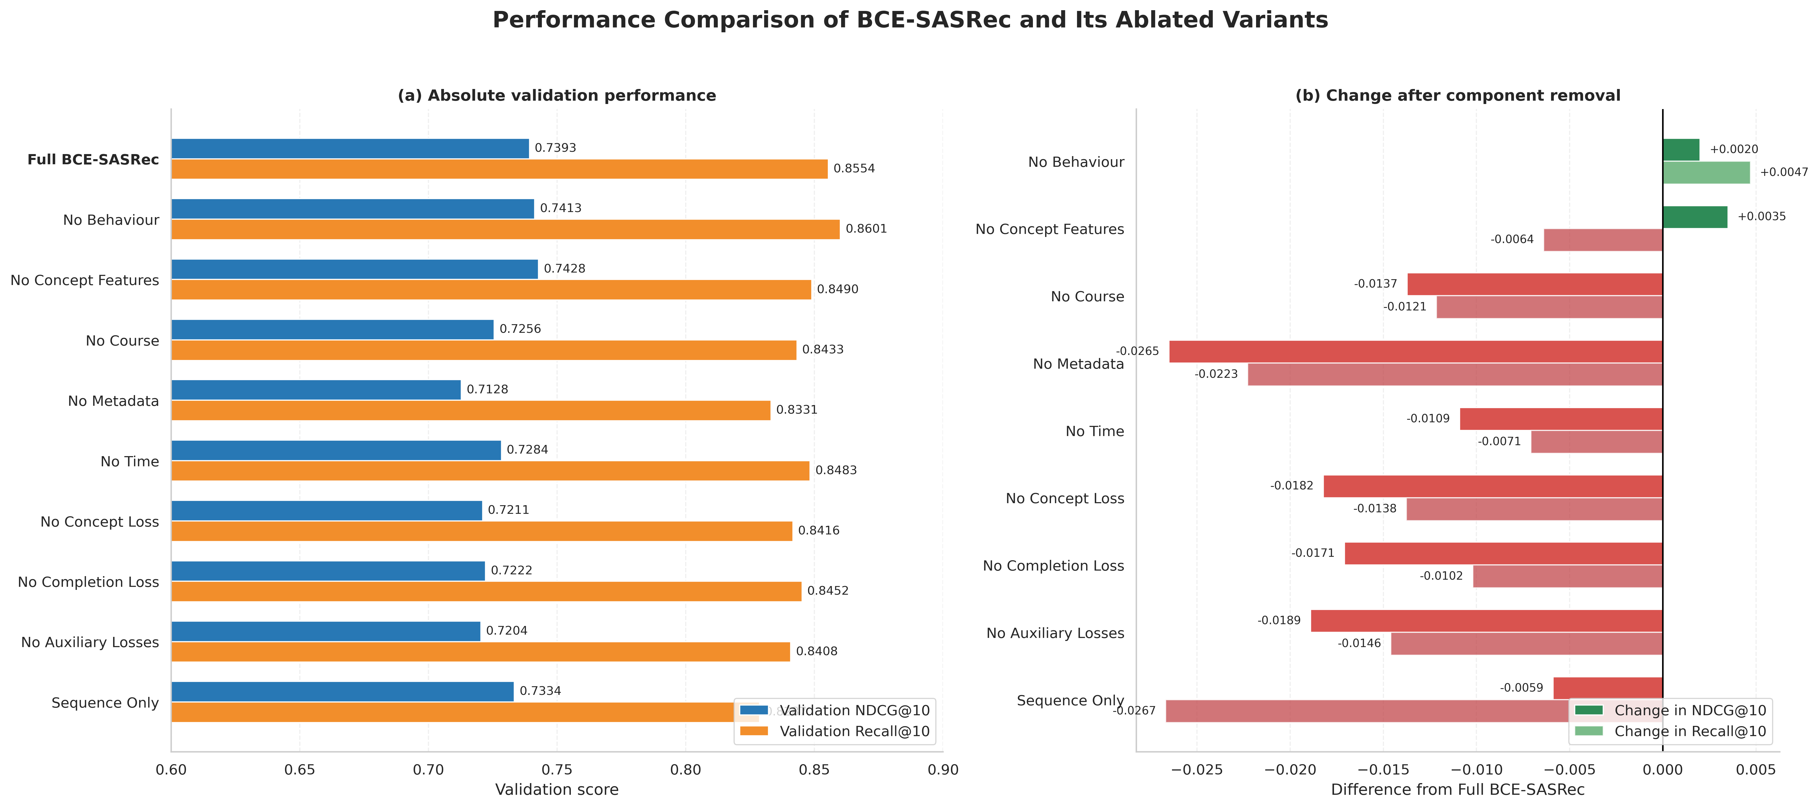

Figure 8. Results of the comparison between the full model and its ablated variants for the BCE-SASRec on the validation set. Panel (a) reports absolute values of NDCG@10 and Recall@10, and Panel (b) displays the same results in terms of the relative value with respect to the full BCE-SASRec.

4.9 Discussion

The experimental results illustrate that BCE-SASRec attains consistent performance on three random seeds and enhances both the breadth and educational relevance of its recommendations. Compared to SASRec, BCE-SASRec improves Recall@10 from 0.8027 to 0.8224, Recall@20 from 0.8581 to 0.8813, and Concept Recall@10 from 0.7827 to 0.8139. These gains suggest that the proposed approach can retrieve more relevant videos within the recommendation list and provide better coverage of concepts associated with the learner’s next interaction. While NDCG@10 increases slightly from 0.6920 to 0.6935, MRR decreases from 0.6632 to 0.6594 and Accuracy@1 drops from 0.5871 to 0.5718. Thus, the proposed approach offers broader item retrieval and stronger concept coverage at the expense of a small reduction in exact first-position prediction. The ablation results highlight that the video metadata has a substantial impact on the ranking quality, while the concept and completion objectives contribute to broader retrieval and concept coverage. However, since some ablation variants used different training budgets, their component-level effects should be interpreted with caution. Overall, the results justify the usage of BCE-SASRec in an educational setting, where learners are presented with several relevant learning alternatives instead of a single predicted video.

5. Conclusion and Future Work

In this paper we propose the BCE-SASRec, which is a behaviour- and concept-enhanced sequential model for personalized educational short-video recommendation. The model exploits chronological watching history as well as watch behaviour, video concept, course context, metadata, positional information, and time gaps via a causal Transformer, and introduces auxiliary concept-alignment and completion-prediction objectives to encourage educationally meaningful learner representations, with the focus on next-video ranking as the main task. Evaluated on three randomly initialized seeds, the proposed approach achieves the test mean of 0.6935 NDCG@10, 0.8224 Recall@10, 0.8139 Concept Recall@10, and 0.8813 Recall@20. Compared with the SASRec, our method has lifted broad item retrieval and concept coverage, although with slightly lower MRR and Accuracy@1. This suggests that the proposed framework is more appropriate for settings where users are presented with several educationally relevant alternatives rather than a single best match.

Our future work will focus on improving the early rank accuracy while maintaining the observed gains in coverage. The rich representations from video captions, transcripts, visual content, and learning objective may be helpful in bridging the semantic gap between learner needs and educational resources. A prerequisite-aware reranking and calibrated knowledge-tracing signals could be introduced to differentiate between watched concepts and the ones actually mastered. The framework's applicability to real-world learners should be validated in multiple subjects and institutions to evaluate its generalizability, fairness, satisfaction, and learning impact. Lastly, a concept-map interface can be created and evaluated using user experiments to determine if concept-level explanations increase the understanding, confidence, resource selection, and educational progress of the learners.

References

[1] Evangelista, E. and Bukhari, S.M.S., 2026. Fair and Explainable Educational Recommendations with a Hybrid Graph-GRU Framework. Computers and Education: Artificial Intelligence, p.100643.

[2] Cheng, X., Zhang, Z., Wang, J., Fang, L., He, C., Guan, Q., Pan, S. and Luo, W., 2026, March. GraphRAG-induced dual knowledge structure graphs for personalized learning path recommendation. In Proceedings of the AAAI Conference on Artificial Intelligence (Vol. 40, No. 17, pp. 14610-14620).

[3]Boubaker, N.B.H., Kodia, Z. and Ayadi, N.Y., 2025, October. Path-Based Explanations for Knowledge Graph-Driven Course Recommendation. In International Conference on Cooperative Information Systems (pp. 584-595). Cham: Springer Nature Switzerland.

[4] Yun, W., Akbayan, B., Aray, K. and Azamat, T., 2026. Generative LLMs for educational recommendation. Frontiers in Artificial Intelligence, 9, p.1827553.

[5] Li, A., Li, Y. and Gao, X., 2026. Personalized learning path recommendation based on knowledge graphs: A survey. Electronics, 15(1), p.238.

[6] Delianidi, M., Diamantaras, K., Kokkonis, G., Sidiropoulos, A., Evangelidis, G. and Karapiperis, D., 2026. DK-PRACTICE: An Intelligent Platform for Knowledge Tracing and Educational Content Recommendation: A Case Study in Higher Education. Information, 17(2), p.202.

[7] Zhang, H., 2026. Personalized Language Learning Path Intelligent Recommendation: Algorithm Design Based on Collaborative Filtering and Knowledge Graph. Procedia Computer Science, 279, pp.281-288.

[8] Li, Z., 2026. Knowledge graph-based adaptive recommendation model for training courses. International Journal of Information and Communication Technology, 27(3), pp.53-69.

[9] Qi, Z., Li, H. and Liu, Y., 2026, March. Personalized Learning Path Recommendation Based on Underachiever Profiles. In 2026 15th International Conference on Educational and Information Technology (ICEIT) (pp. 104-109). IEEE.

[10] Oubagine, R., Azzi, I., Laaouina, L., Jeghal, A. and Tairi, H., 2026, September. SAEF: An Adaptive and Explainable Feedback System for Personalized Learning. In Informatics (Vol. 13, No. 9, p. 142). MDPI.

[11] Khaled, I. and Iwidat, H., 2026. Improving Course Recommendations: An RBM-Based Explainable Framework for Student Performance in E-Learning. ECTI Transactions on Computer and Information Technology (ECTI-CIT), 20(3), pp.396-410.

[12] Striebel, J., Myers, R., Ringenberg, T., Shih, P.C. and Liu, X., 2026. Recommendations for Smoothing the Transition from Education to Career: A Heterogeneous Knowledge Graph Architecture for Career-Motivated Explainable Course Recommendation. Knowledge, 6(1),
p.5.

[13] Syed, A.H., Singh, Y. and Bhardwaj, H., 2026. Explainable multimodal student profiling and personalized course recommendation using attention-enhanced heterogeneous graph neural networks. Journal of Applied Science and Technology Trends, 7(1), pp.16-25.

[14] Deshmukh, P., Samrat, H. and Pervin, N., 2026. Personalized learning path generation using large language models and sequential recommendations. Data & Knowledge Engineering, p.102595.

[15] Zhou, G., Zhao, Z., Ma, J. and Xie, Z., 2026. Towards attribute-augmented course recommendation: an LLM-driven model-agnostic representation learning framework. Knowledge-Based Systems, p.115809.

[16] Gao, Y., Liu, X., Gao, X. and Zhang, J., 2026. ALP-CRS: enhancing course recommendation in online education through data mining and graph analysis. Egyptian Informatics Journal, 34, p.100955.

[17] Zhang, Y., 2026. Application of deep learning in intelligent recommendation and precise matching of educational resources. Discover Artificial Intelligence, 6(1), p.657.

[18] Chang, S.C. and Dao, N.D., 2025. An intelligent recommender system based on K-nearest neighbors to foster self-regulated learning and reduce cognitive load in online higher education. Computers & Education, p.105470.

[19] Xinyi, L.U.O., Sikai, W.A.N.G. and Khe Foon, H.E.W., 2025. Development and implementation of a generative AI-based personalized recommender system to improve students’ self-regulated learning and academic performance. Computers & Education, p.105486.

[20] Obeng, A.Y. and Opoku, S.K., 2026. Architectural Design and System-Level Evaluation of a Modular Adaptive Learning Recommender in Higher Education. Journal of Educational Technology Systems, p.00472395261453092.

[21] Li, Z., 2026. Design of a personalized recommendation system for ideological and political education using reinforcement learning. Discover Artificial Intelligence, 6(1), p.142.

[22] Hesari, F., Ayati, M. and Pourshafei, H., 2026. Recommender systems in complexity-informed curriculum design: A framework for enhancing personalized learning. Social Sciences & Humanities Open, 14, p.103094.

[23] Xu, X., 2026. Dynamic Construction and Intelligent Recommendation of English Teaching Content via Knowledge Graphs to Enhance Personalized Learning Impact. Journal of Advanced Computational Intelligence and Intelligent Informatics, 30(3), pp.625-636.

[24] Zhao, L., 2026. Intelligent analysis and recommendation of educational content in network engineering: a study on teaching effectiveness evaluation model based on knowledge reasoning and multimodal knowledge graph. Discover Artificial Intelligence, 6(1), p.175.

[25] Nizam, T., Zafar, S., Biswas, S.S. and Hussain, I., 2026. Interpretability-driven Course Recommendation: A Random Forest Approach with Explainable AI. Recent Advances in Electrical & Electronic Engineering, 19(1), p.E23520965401121.

[26] Chen, Y. and Wan, Y., 2026. A framework for predicting popularity and engagement of educational videos based on contrastive feature decomposition. Expert Systems with Applications, p.131027.

[27] Cao, Z., Liu, R. and Chen, Y., 2026, March. VBF++: Variational Bayesian Fusion with Context-Aware Priors and Recommendation-Guided Adversarial Refinement for Multimodal Video Recommendation. In Proceedings of the AAAI Conference on Artificial Intelligence (Vol. 40, No. 17, pp. 14520-14528).

[28] Cai, Q., Liu, S., Wang, X., Zuo, T., Xie, W., Yang, B., Zheng, D., Jiang, P. and Gai, K., 2023, April. Reinforcing user retention in a billion scale short video recommender system. In Companion Proceedings of the ACM Web Conference 2023 (pp. 421-426).

[29] Sunday, O.J., Jin, G. and Ajeigbe, O.J., 2026. The Effects of Learner Choice and Concept Map Format on Student Learning Outcomes in Undergraduate STEM Education. Journal for STEM Education Research, pp.1-27.

[30] Feng, F., Si, N. and Feng, L., 2026. Explainable Educational AI: Integrating Symbolic Reasoning and Diffusion Models for Transparent Knowledge Tracing. Computer Applications in Engineering Education, 34(3), p.e70194.

