KMF-Net: A Kinematic Cross-Fusion Mamba–Transformer Network for Sequence-ID-Disjoint Withheld-Attack Detection in Vehicular Ad Hoc Networks

Abstract

Detecting misbehaving vehicles from received Basic Safety Messages (BSMs) is challenging because attacks exhibit diverse kinematic signatures, attack classes are imbalanced, and previously unseen attacks may emerge after deployment. This paper proposes KMF-Net, a Kinematic Cross-Fusion Mamba–Transformer Network for closed-set and open-set vehicular ad hoc network (VANET) misbehaviour detection. The model processes windows of 32 consecutive BSMs from the minimized VeReMi Extension dataset using 19 effective input features after removing the constant latency channel. A kinematic-difference stem augments sequences with first- and second-order temporal differences. A CNN–Mamba branch captures local patterns and sequential dependencies, while a Transformer branch models global temporal relationships. KMF-Net jointly performs multiclass attack classification and binary benign-versus-attack detection using focal and hierarchical consistency losses. A validation-calibrated anomaly score evaluates three attack types withheld from training: DataReplaySybil, DoSDisruptiveSybil, and GridSybil. Across three random seeds, KMF-Net achieves an accuracy of 0.9116 ± 0.0030, macro-F1 of 0.8242 ± 0.0109, and Matthews correlation coefficient of 0.8562 ± 0.0049. The strongest baseline, MambaCNN, achieves a macro-F1 of 0.7078 ± 0.0075. Binary detection yields an F1-score of 0.9734 ± 0.0029 and AUPRC of 0.9885 ± 0.0006. For withheld attacks, the binary-head score achieves AUROC of 0.9857 ± 0.0047, detects 82.13% ± 1.48% of attack windows, and correctly accepts 99.26% ± 0.16% of benign windows at the validation-selected threshold. Ablations identify the kinematic-difference stem as the largest observed ablation decrease in macro-F1.

Keywords: VANET, misbehaviour detection, VeReMi, Mamba, Transformer, withheld-attack detection

1. Introduction
Jo et al. [1] proposed a lightweight temporal–spatial fusion method for intrusion detection in automotive Controller Area Networks (CANs). Their approach combines temporal dependencies with spatial feature relationships to improve attack identification while maintaining low computational complexity. Similarly, Xu et al. [2] introduced a lightweight and dynamically adaptive intrusion-detection framework based on the Mamba architecture. By using selective state-space modelling, their method captures long-term dependencies in CAN traffic more efficiently than conventional recurrent and Transformer-based models.

Feng et al. [3] developed MambaCNN, which combines Mamba layers with convolutional neural networks to capture long-range sequential behaviour and local attack patterns in Internet of Vehicles traffic. Although the model offers an effective balance between detection performance and computational efficiency, its ability to identify previously unseen attacks requires further investigation. Lin et al. [4] proposed RAG-HIDS, a multi-relational graph-based hierarchical intrusion-detection system that represents relationships among CAN messages and vehicle components. This approach improves relational modelling, but graph construction and hierarchical processing can increase deployment complexity.

Fu et al. [5] presented a dual-layer LSTM–CNN framework for precise, real-time, per-message intrusion detection in in-vehicle networks. The LSTM component captures temporal dependencies, while the CNN extracts discriminative local features from successive CAN messages. Nevertheless, existing temporal–spatial models, including those proposed by Jo et al. [1] and Fu et al. [5], primarily operate in closed-set environments and do not jointly address withheld-attack detection under a fixed evaluation protocol.

  - Aim

The aim of this study is to develop a reliable sequence-ID-disjoint deep-learning framework for detecting misbehaving vehicles from sequential Basic Safety Messages (BSMs). The framework classifies known attack behaviours, distinguishes benign from malicious messages, and evaluates detection of three attack classes withheld from model development.

1.2 Research Objectives

- To construct a sequence-ID-disjoint temporal representation of VeReMi BSM data using 32-message windows and 19 effective input features.
- To design Proposed KMF-Net for jointly modelling local kinematic patterns and long-range temporal dependencies.
- To evaluate known-attack classification and benign-versus-attack detection against four deep-learning baselines using identical partitions and three random seeds.
- To assess open-set detection of withheld attacks and quantify the contribution of the kinematic stem, CNN branch, Mamba branch, and Transformer branch through controlled ablation experiments.

1.3 Novelty

KMF-Net introduces a unified temporal-fusion framework for VANET misbehaviour detection by combining kinematic-difference augmentation with complementary CNN–Mamba and Transformer encoders. Bidirectional cross-attention enables information exchange between local sequential and global temporal representations, while adaptive gated fusion learns their relative contributions. The framework jointly supports multiclass classification, binary benign-versus-attack detection, and validation-calibrated detection of three attack classes withheld from model development. Its evaluation uses a sequence-ID-disjoint protocol and explicitly distinguishes withheld-attack detection from complete run-level, scenario-independent, or universal open-set recognition.

1.4 Contributions

- A kinematic-difference preprocessing stem that incorporates first- and second-order temporal information into the BSM representation.
- A cross-fusion architecture combining a CNN–Mamba temporal branch, a Transformer branch.
- A unified evaluation protocol covering 17-class known-attack classification, binary detection, and detection of DataReplaySybil, DoSDisruptiveSybil, and GridSybil windows withheld from model development.
- A reproducible experimental study using fixed sequence-ID-disjoint partitions, three random seeds, four baselines, and five component-level ablations, with explicit limitations concerning baseline training configuration and capacity.

2. Literature Survey

El-Fatyany et al. [6] proposed EF-IDS, an efficient intrusion-detection system that uses enriched features to improve the representation of CAN-bus messages. Although the approach improves detection efficiency, its dependence on engineered features may restrict adaptation to new traffic behaviours. Chen et al. [7] introduced IDS-MSVAC, integrating a multivariate spatiotemporal variational autoencoder with a classifier for detecting known and unknown attacks. However, its evaluation primarily concerns in-vehicle CAN traffic and does not fully represent dynamic V2X interactions.

Rai et al. [8] developed a deep Q-learning framework with feature fusion to secure automotive CAN-bus communication. The reinforcement-learning mechanism supports adaptive detection, but it can introduce training instability and additional computational costs. Cao et al. [9] proposed IoVFD, a federated anomaly-detection method using dual knowledge distillation to handle non-independent and identically distributed vehicular data. Nevertheless, protection against malicious federated clients and continual class expansion requires further investigation.

Heidari et al. [10] presented FedIoV, a secure and adaptive federated-learning framework for real-time intrusion detection in vehicular networks. It combines privacy-preserving training, robust aggregation and lightweight classification, although its multiple optimisation stages may complicate implementation. Norouzi et al. [11] designed a reliable cyberattack-detection architecture for software-defined Internet of Vehicles environments. While centralized SDN visibility improves network monitoring, dependence on the controller introduces scalability and single-point-of-failure concerns.

Zhao et al. [12] combined data dimensionality reduction with a genetically optimised Gradient Boosting Decision Tree for vehicle CAN-bus anomaly detection. The approach reduces redundant features, but it does not explicitly learn long-term temporal dependencies. Kayaoglu et al. [13] systematically reviewed intrusion-detection methods for CAN buses and external vehicular networks, identifying unresolved challenges related to dataset quality, inconsistent evaluation, zero-day detection and real-time deployment.

Wu et al. [14] surveyed multimodal intrusion detection based on large-scale temporal-semantic modelling in the Internet of Vehicles. The study highlighted problems involving multimodal alignment, incomplete observations, dataset scarcity and model complexity. Ferreira et al. [15] proposed a two-stage CAN-bus intrusion detector combining statistical thresholds with a Random Forest classifier. Although the method is interpretable and computationally practical, fixed thresholds may fail when legitimate vehicle behaviour changes.

Ayat et al. [16] introduced IDS_XGB, an XGBoost-based intrusion-detection system for automotive embedded environments. The model is efficient for tabular traffic features but has limited ability to directly capture long-range message dependencies. Naeem et al. [17] combined a Transformer, consensus ensemble learning and bio-inspired optimisation for smart-city IoV security. Despite its ability to model global relationships, its architectural complexity could increase training time, inference latency and deployment cost.

Zhang et al. [18] examined artificial-intelligence-driven anomaly detection for VANET communication channels. Their work demonstrates the usefulness of learning-based channel monitoring, but channel-level anomalies do not cover every message-level attack involving falsified position, speed or vehicle identity. Khan et al. [19] proposed a Transformer-based intrusion detector with SHAP explanations using the minimized VeReMi Extension dataset. The method offers contextual feature learning and interpretability but follows a static, closed-set training configuration.

Khan et al. [20] developed a secure deep-learning intrusion-detection framework for the Internet of Vehicles, demonstrating the effectiveness of deep representations for distinguishing legitimate and malicious network traffic. However, its generalisation to changing environments, unseen attacks and resource-constrained deployment requires additional validation. In comparison, Khan et al. [19] provide Transformer-based contextual modelling and explainability, but neither study fully integrates withheld-attack detection.

Overall, the reviewed works reveal that existing systems generally address individual requirements such as feature enrichment, withheld-attack detection, federated learning, explainability or computational efficiency. A unified framework is therefore required to combine kinematic-difference augmentation, complementary temporal encoders, cross-branch fusion, and withheld-attack rejection under sequence-ID-disjoint evaluation for comprehensive misbehaviour detection using the minimized VeReMi Extension dataset.

Table 1. Comparative analysis of recent intrusion- and misbehaviour-detection approaches for vehicular networks

Ref. | Author(s) | Model used | Dataset | Research gap
21 | Zhang and Sarkar et al. | LSTM–GRU deep-fusion network | IoV intrusion dataset | Lacks inter-vehicle modelling and withheld-attack detection.
22 | Aishwarya et al. | Mistral-7B teacher with attention-BiLSTM student | VeReMi Extension | Depends on synthetic data; lacks memory and open-set detection.
23 | Khan et al. | Topology-aware meta-learning with few-shot adapters | VeReMi | Limited performance and no forgetting-control mechanism.
24 | Kamal et al. | MLP, CNN, RNN and LSTM | VeReMi Extension | Uses standard models; lacks open-set and continual learning.
25 | Ragunthar et al. | Clustering with supervised classification | VANET-MaliciousNode | Single-dataset evaluation limits generalisation.
26 | Oualil et al. | CAN-TEMPO multi-period temporal encoding | Car-Hacking | CAN-specific; does not model V2X mobility features.
27 | Zhang et al. | Dual-branch GRU–1D CNN | OTIDS | Closed-set detection without persistent memory.
28 | Ghadi and Mohd et al. | Survey of ML, DL and hybrid IDS models | Multiple CAN datasets | No new model; highlights limited real-time validation.
29 | Murshed et al. | LSTM, XGBoost and combined meta-models | RF-jamming vehicular data | Limited to RF jamming attacks.
30 | Wang and Guo | Feature-gated compact MLP | IVN and EVN benchmarks | Limited temporal and inter-vehicle modelling.
31 | Heidari et al. | Federated GRU with deep Q-learning | Multiple vehicular datasets | Complex architecture; lacks multiclass open-set learning.

Table 1 summarises recent vehicular intrusion-detection studies in terms of their authors, models, datasets and research gaps. Existing approaches employ deep feature fusion [21], knowledge distillation [22], meta-learning [23], conventional deep-learning classifiers [24], clustering [25], temporal encoding [26], dual-branch networks [27], machine-learning surveys [28], ensemble models [29], feature-gated learning [30] and federated reinforcement learning [31]. Although these studies achieve promising detection performance, they generally lack a unified mechanism for kinematic-difference augmentation, complementary temporal encoders, cross-branch fusion, and withheld-attack detection.

3. Proposed Methodology

3.1 Overview of the Proposed Framework

This study proposes KMF-Net, a hybrid deep-learning framework for detecting and classifying misbehavior in vehicular ad hoc networks (VANETs). The framework uses Basic Safety Message (BSM) sequences from the minimized VeReMi Extension dataset.It is designed to classify attack types represented during training and to evaluate detection of attack types withheld from training.
Proposed KMF-Net combines temporal feature augmentation, parallel sequence encoders, bidirectional cross-attention, adaptive gated fusion, hierarchical supervision, and open-set scoring. First, a kinematic-difference stem augments the input with first- and second-order temporal differences. The resulting sequence is processed by two parallel branches. Branch A uses temporal convolution and a selective state-space encoder to model local patterns and sequential dependencies. Branch B uses a Transformer encoder to model relationships between temporal positions.
Bidirectional cross-attention allows the two branches to exchange contextual information. A learned element-wise gate then combines their representations. Mean, maximum, and last-token pooling summarise the fused sequence. The pooled representation is passed to multiclass and binary classification heads. A hierarchical consistency loss encourages fine-grained class predictions to agree with predefined coarse attack groups. Finally, a validation-calibrated score is used to assess whether a sample belongs to a known class or should be treated as an unknown attack.

Proposed KMF-Net consists of a kinematic-difference stem, a CNN–Mamba branch, a Transformer branch, bidirectional cross-attention, adaptive gated fusion, temporal pooling, and dual prediction heads. The final configuration used in all three-seed experiments is summarised in Table 2.

Table 2. Final Hyperparameter Configuration of the Proposed KMF-Net

Component | Final setting
Input features | 19
Sequence length | 32
Hidden dimension | 96
Attention heads | 8
Transformer layers | 3
State-space blocks | 2
State dimension | 16
CNN kernel | 3
Dropout | 0.10
Batch size | 256
EMA decay | 0.995
Trainable parameters | 575,844

The hidden dimension, attention-head count, number of Transformer layers, number of Mamba layers, state dimension, dropout, and optimization settings were selected using the training and validation partitions. The final configuration was then fixed before the three-seed test evaluation. No test or withheld-attack samples were used for selecting these settings.

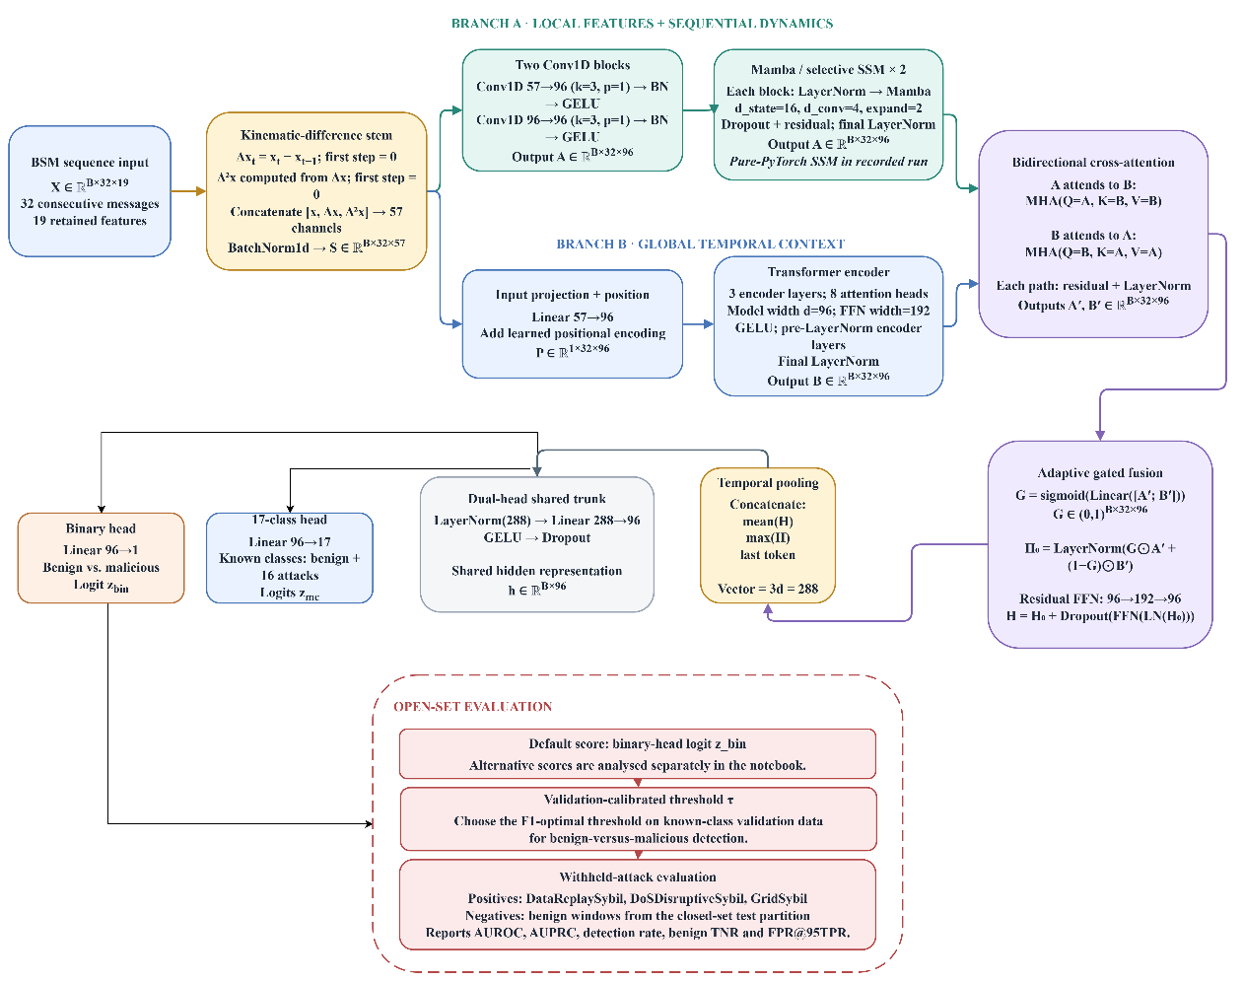
Figure 1. Overall Experimental Workflow for Sequence-ID-Disjoint Proposed KMF-Net Withheld-Attack Detection

The overall workflow begins with the minimized VeReMi Extension BSM logs containing 19 effective input features. Exploratory data analysis and auditing are first performed to examine class distributions, missing values, constant features, and audit fields. Sequence-ID-disjoint preprocessing then removes unsuitable fields, creates 32-step temporal windows, and verifies unique sequence identifiers. The resulting data are divided into fixed training, validation, closed-set test, and withheld-attack partitions. Four baselines, the proposed KMF-Net, and four ablation variants are trained using identical partitions and three random seeds. Checkpoints are selected using validation performance only, followed by validation-based binary and withheld-attack decision threshold calibration. Finally, closed-set, binary, and open-set metrics are computed and reported as mean ± standard deviation, together with per-class results, confusion matrices, ablation findings, and error analysis.

3.2 Dataset Description and Composition

The experiments use the minimized VeReMi Extension dataset , which contains BSMs received by vehicles and labels identifying benign or malicious messages. Malicious messages are additionally associated with attack-type labels.

The processed corpus contains 19 simulation runs, corresponding to 19 scenarios, and 11,649,834 received messages. Of these, 6,789,820 messages (58.28%) are benign and 4,860,014 (41.72%) are malicious. The overall benign-to-malicious ratio is approximately 1.40:1.

The 19 scenarios are organized into four families according to their attack characteristics. Table 3 summarises the scenario composition and malicious-message proportions.

Table 3. Scenario families and message-level class distribution

Scenario family | Scenarios | Messages per run | Malicious (%)
Standard single-behaviour attacks (12) | ConstPos, ConstPosOffset, ConstSpeed, ConstSpeedOffset, RandomPos, RandomPosOffset, RandomSpeed, DataReplay, DataReplaySybil, DelayedMessages, Disruptive, EventualStop | 534,424 each | 31.19
DoS variants (3) | DoS, DoSDisruptive, DoSRandom | 866,097; 851,630; 848,812, respectively | 57.31; 56.63; 56.42
DoS combined with Sybil attacks (2) | DoSDisruptiveSybil, DoSRandomSybil | 700,797 each | 47.44 each
Sybil and other scenarios (2) | GridSybil; RandomSpeedOffset | 1,038,237; 230,376, respectively | 64.42; 29.66

The scenario distribution reveals several characteristics relevant to model development.
First, the 12 standard single-behaviour scenarios have identical total-message and benign-message counts. These scenarios replay the same mobility trace with different attack behaviours injected. Consequently, a random message-level split could place highly similar benign traffic in training and test sets, leading to overly optimistic estimates of generalization.
Second, benign-message counts remain approximately 368,000–370,000 per run for most scenarios, while RandomSpeedOffset contains approximately 162,000 benign messages. The large variation in malicious-message counts therefore reflects substantial differences in attack volume. DoS variants produce considerably more malicious messages than standard single-behaviour scenarios, while GridSybil has a particularly high malicious-message proportion.
Third, the malicious-message percentage ranges from 29.66% in RandomSpeedOffset to 64.42% in GridSybil. Although the overall binary distribution is not severely imbalanced, the multiclass distribution is uneven because some attack scenarios contribute substantially more messages than others. Class-aware sampling and class-sensitive evaluation are therefore relevant to the experimental design.

Table 4. Overall message distribution across simulation time blocks

Time block | Number of runs | Total messages | Malicious messages | Malicious (%)
50400–54000 | 18 | 11,419,458 | 4,791,677 | 41.96
54000–57600 | 1 | 230,376 | 68,337 | 29.66
Total | 19 | 11,649,834 | 4,860,014 | 41.72

Every run contains both benign and malicious messages. Approximately 30% of vehicles are attackers in each reported run: 301 of 1,004 vehicles in the main group and 205 of 683 vehicles in the RandomSpeedOffset scenario.

3.3 Exploratory Data Analysis

The initial dataset contains 20 candidate kinematic and measurement channels. These comprise latency, position coordinates and position noise, speed components and speed noise, acceleration components and acceleration noise, and heading components and heading noise.
The latency channel is constant at zero in the processed corpus and is therefore removed from the model input. The final input contains 19 effective features.

Table 5. Effective Input Feature Groups Used by Proposed KMF-Net

Feature group | Included channels | Number of channels
Position and position noise | pos_x, pos_y, pos_noise_x, pos_noise_y | 4
Speed and speed noise | speed_x, speed_y, speed_norm, speed_noise_x, speed_noise_y | 5
Acceleration and acceleration noise | accel_x, accel_y, accel_norm, accel_noise_x, accel_noise_y | 5
Heading and heading noise | heading_x, heading_y, heading_norm, heading_noise_x, heading_noise_y | 5
Total effective model features | 19 effective input features | 19

The target variables are label_binary, which identifies benign versus malicious traffic, and label_attack, which identifies the corresponding attack class. The constant latency feature was removed because it had zero variance in the processed corpus. Audit fields and identifiers were excluded from model input because they contain ground-truth, ground-truth-derived, grouping, or provenance information.

The exploratory analysis reveals several useful characteristics. Latency has a single value at zero for both benign and malicious messages, supporting its exclusion from the input. The pos_noise_x distribution contains a substantial concentration at zero, with malicious messages exhibiting heavier tails. The speed_norm distribution is right-skewed, and malicious observations extend into higher values.

Acceleration-noise and speed-noise features overlap considerably between the benign and malicious classes. This indicates that individual feature distributions may not reliably separate all attack types. Detection therefore benefits from learning temporal changes and dependencies among multiple channels rather than relying on a single measurement.

The reported-position scatter plots show that benign messages generally follow the simulated road network, whereas some malicious messages appear away from plausible road locations. Large spatial deviations are particularly visible for position-related attacks. However, spatial analysis alone cannot reliably identify all attacks because speed manipulation, replay, and message-delay attacks may not generate conspicuous spatial anomalies.

Ground-truth audit fields include audit_position_error, audit_speed_error, audit_accel_error, and audit_heading_error. These errors are generally near zero for benign observations and larger for malicious observations. Their distributions are consistent with the intended attack effects in the simulated data, but these columns were excluded from model input because they are derived from simulator ground truth and can directly reveal the target label.
The audit fields are used only for exploratory analysis and data-quality assessment. The model receives the 19 retained input features and does not use ground-truth audit errors as predictive inputs.

The dataset summary reports 46,392 messages with missing ground-truth audit information, corresponding to approximately 0.40% of the full corpus. The affected-message counts vary by scenario, ranging from 1,614 to 4,161 messages per run.
The 19 retained model features are complete in the inspected dataset. Therefore, missing-value imputation is not required for these input channels. No imputation was applied to the 19 retained input features; any preprocessing parameters that were fitted were estimated from the training partition only.
The Spearman correlation analysis reveals strong dependencies among several derived channels, including the speed components and speed_norm, acceleration components and accel_norm, and heading components and heading_norm. Relationships also occur among position, speed, and heading channels.

These dependencies reflect the construction of the kinematic features rather than necessarily indicating data-quality problems. Proposed KMF-Net retains these channels to enable the model to learn useful cross-feature relationships. The CNN, state-space encoder, Transformer, and cross-attention modules can exploit different aspects of these dependencies.
Overall, the EDA indicates that the dataset contains variable attack prevalence, repeated mobility traces, spatial anomalies for some attack types, substantial inter-feature dependence, and attacks that cannot be distinguished reliably using isolated channels. These findings motivate temporal feature augmentation and complementary sequence modelling.

3.4 Preprocessing, Leakage Control, and Window Construction

The preprocessing pipeline converts message-level observations into temporal windows suitable for sequence classification. It also controls data leakage and excludes fields that could reveal labels or identify particular simulation runs.

The constant latency feature is excluded, leaving 19 input channels. The fields audit_truth_available, audit_position_error, audit_speed_error, audit_accel_error, and audit_heading_error are prohibited from model input because they contain simulator ground-truth information or ground-truth-derived errors. They are retained only for data inspection where appropriate.

The fields scenario, period, run_id, receiver_id, sender_id, sender_pseudo, message_id, attack_code, receive_time, and send_time are used for data grouping, ordering, or provenance rather than as predictive features. In particular, sender and receiver identifiers are excluded to prevent the classifier from relying on entity identity instead of learned traffic behaviour.
Any fitted scaler, imputer, or feature-selection procedure were estimated using training data only and then applied without refitting to validation and test data.

The dataset was partitioned at the sequence-identifier level before temporal-window construction. All windows generated from the same sequence identifier were assigned to a single partition, and no sequence identifier was shared between the training, validation, closed-set test, and withheld-attack partitions. The resulting evaluation is therefore sequence-ID-disjoint. Scenario-, vehicle-, and time-disjointness were not independently enforced, so possible overlap between related mobility traces cannot be excluded.

Each sample contains 32 consecutive Basic Safety Messages, and all windows derived from the same sequence identifier were assigned to only one partition. Sequence identifiers were compared across the training, validation, closed-set test, and withheld-attack partitions, with no identifier appearing in more than one partition. The constant latency feature was removed because it had zero variance, leaving 19 input features. Audit fields, attack codes, scenario identifiers, sender and receiver identifiers, message identifiers, and timestamp fields were excluded from predictive input and used only for ordering, grouping, provenance, exploratory analysis, and leakage checks
The processed dataset contains 19 effective input features after removing the constant latency channel. All preprocessing parameters were estimated from the training partition only and then applied unchanged to the other partitions. Validation data alone was used for early stopping, checkpoint selection, binary-threshold calibration, and anomaly-score fusion. The closed-set test and withheld-attack partitions were used only for final evaluation. All baselines, Proposed KMF-Net, and the four ablation models used identical partitions, features, labels, and random seeds. The processed split was verified using the manifest SHA-256 hash
92a24087bfbb7baadc0c3ba10de8d89138946d9e27e59e9901c3d3db2b67a91a.

The model uses sliding windows of 32 consecutive BSM observations. Each window contains 19 effective input features and is represented as X ∈ ℝ^(T×19) with T = 32. A kinematic-difference stem computes first- and second-order temporal differences ΔX and Δ²X and concatenates them with X, increasing the channel dimension from 19 to 57:

$U=[X‖ΔX‖Δ^{2}X]∈R^{T×57},$ (1)

The window-level dataset contains 17 known benign/attack classes, represented by C = 17, while selected attack types are reserved for withheld-attack evaluation.
Table 6 reports the window counts loaded from the processed data shards. These are window-level counts and are distinct from the message-level counts reported in Tables 3 and 4.

Table 6. Sequence-ID-Disjoint Dataset Partition and Window Distribution
Partition | Number of windows | Share (%)
Training | 133,470 | 68.1
Validation | 27,319 | 13.9
Closed-set test | 30,122 | 15.4
Withheld-attack evaluation | 5,043 | 2.6
Total | 195,954 | 100.0
The closed-set partitions together contain 190,911 windows. The additional 5,043 windows are reserved for the evaluation of attacks excluded from model training. The preprocessing manifest's SHA-256 value was verified, providing a record of the processed dataset version.
Three coarse groups—benign, minor, and other—are defined using the predefined class-to-group mapping matrix, denoted by M. This mapping is used for hierarchical supervision and coarse-grained evaluation.

3.5 Branch A: CNN–Mamba Temporal Encoder

The reported experiments use the pure-PyTorch selective state-space implementation included in the released code. This implementation contains input projection, depth-wise temporal convolution, input-dependent state parameters, a selective state recurrence, residual state propagation, and an output projection. It is not assumed to be numerically identical to the official mamba_ssm implementation. The exact implementation used for every reported checkpoint was recorded in the experiment configuration.

The stem representation is first processed by two one-dimensional temporal convolutions:

$$H^{\left(0\right)}=\operatorname{GELU}\left(\operatorname{BN}\left({Conv}_{k}\left(U\right)\right)\right), (2)$$
$$H^{\left(1\right)}=\operatorname{GELU}\left(\operatorname{BN}\left({Conv}_{k}\left(H^{\left(0\right)}\right)\right)\right), (3)$$
where $k$ denotes the convolutional kernel size. The convolutions operate along the temporal dimension, with padding and output dimensions configured to preserve the sequence length.
The convolutional representation is passed through $L_{m}$state-space blocks. Each block projects its input into content and gating streams. The content stream is processed by a depth-wise temporal convolution and a SiLU activation. Input-dependent projections generate the parameters used by the selective state-space recurrence.

The custom implementation uses the following generic selective state-space recurrence:

$h_{t}={\overline{A}}_{t}h_{t-1}+{\overline{B}}_{t}u_{t},$ (4)
$v_{t}=C_{t}h_{t}+Du_{t},$ (5)
where $h_{t}$is the latent state, $u_{t}$is the processed content input, and ${\overline{A}}_{t}, {\overline{B}}_{t},$and $C_{t}$are input-dependent or discretized state-space parameters. The gating stream modulates the block output. The implementation-specific parameterization, discretization, and parallel scan are defined by the released pure-PyTorch code and were used unchanged for all reported Proposed KMF-Net checkpoints.Pre-normalisation and residual connections are applied across the stacked blocks. The resulting sequence representation is denoted by

$H_{A}=CNN​-​Mamba\left(U\right), H_{A}∈R^{T×d},$ (6)
where $d$is the hidden representation width.
$H_{A}=CNN\text{-}SSM\left(U\right),$where $H_{A}∈R^{B×T×d}.$ (7)
This branch combines local temporal patterns extracted by the convolutions with longer-range sequential dependencies represented by the selective state-space blocks. Because the reported implementation is a pure-PyTorch selective state-space module, it is not assumed to be numerically identical to the official mamba_ssm implementation.

3.6 Branch B: Transformer Encoder
Branch B models global relationships between temporal positions through self-attention. The stem representation is linearly projected into the model dimension and augmented with learned positional embeddings:

$H_{B}^{\left(0\right)}=UW_{e}+P,$ (8)
where $W_{e}$ is the input projection matrix and $P∈R^{T×d}$contains learned positional embeddings.
Each Transformer layer applies pre-normalized multi-head self-attention followed by a position-wise feed-forward network. For layer $l$,

${\tilde{H}}_{B}^{\left(l\right)}=H_{B}^{\left(l-1\right)}+\operatorname{MHA}\left(\operatorname{LN}\left(H_{B}^{\left(l-1\right)}\right)\right),$ (9)
$H_{B}^{\left(l\right)}={\tilde{H}}_{B}^{\left(l\right)}+\operatorname{FFN}\left(\operatorname{LN}\left({\tilde{H}}_{B}^{\left(l\right)}\right)\right).$ (10)
The feed-forward network uses a GELU activation, with its hidden dimension determined by the selected feed-forward multiplier. After $L_{t}$Transformer layers, the output is

$H_{B}=H_{B}^{\left(L_{t}\right)}, H_{B}∈R^{T×d}.$ (11)
Unlike the convolutional branch, the Transformer can directly model relationships between distant positions in a window. Its output complements the sequential representation generated by Branch A.

3.7 Bidirectional Cross-Attention

The two branches are designed to provide complementary information. Rather than combining their outputs only by concatenation or addition, Proposed KMF-Net uses bidirectional cross-attention to exchange contextual information.

Branch A queries Branch B to obtain global context:

$C_{A}=\operatorname{MHA}\left(Q=H_{A},K=H_{B},V=H_{B}\right).$ (12)
Conversely, Branch B queries Branch A to retrieve convolutional and sequential context:

$C_{B}=\operatorname{MHA}\left(Q=H_{B},K=H_{A},V=H_{A}\right).$ (13)
The cross-attention outputs are incorporated into their corresponding branch representations using residual connections and normalisation, producing updated representations ${\hat{H}}_{A}$and ${\hat{H}}_{B}.$

3.8 Temporal Pooling and Prediction Heads

A single temporal position may not summarise all the information required for attack detection. Proposed KMF-Net therefore combines mean, maximum, and last-token pooling over the refined sequence:

$r_{mean}=\frac{1}{T}\sum_{t=1}^{T}{H_{R,t}},$ (14)

$r_{max}=\max_{1≤t≤T}{H_{R,t}}, r_{last}=H_{R,T}.$ (15)

The pooled representation is

$r=\left[r_{mean}‖r_{max}‖r_{last}\right].$ (16)
Mean pooling summarises average temporal behaviour, maximum pooling emphasises strong feature activations, and last-token pooling retains information from the most recent observation.
The shared representation feeds two prediction heads. The multiclass head produces logits for the 17 known classes, including benign:

$z^{\left(m\right)}=W_{m}r+b_{m}, p^{\left(m\right)}=\operatorname{softmax}\left(z^{\left(m\right)}\right).$ (17)
The binary head produces a logit and its corresponding attack probability:

$z^{\left(b\right)}=W_{b}r+b_{b}, p^{\left(b\right)}=σ\left(z^{\left(b\right)}\right).$ (18)
The multiclass head identifies the predicted known class, whereas the binary head estimates whether a window is benign or malicious. The three-group predictions are obtained by aggregating the multiclass probabilities using the predefined mapping matrix rather than introducing an additional independent classification head:

$p^{\left(g\right)}=M^{⊤}p^{\left(m\right)}.$ (19)

This formulation supports evaluation at the fine-grained and coarse-grained levels while maintaining a shared learned representation.
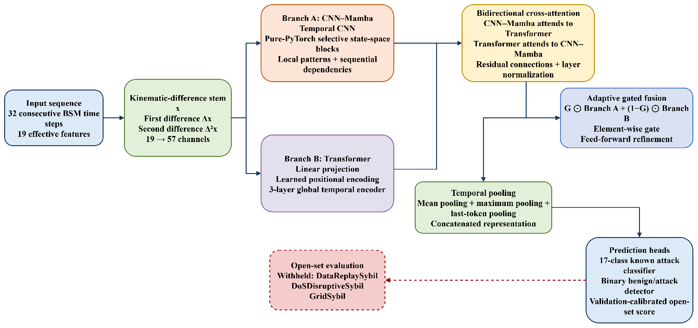
Figure 2. Proposed KMF-Net architecture for closed-set and withheld-attack detection in VANETs.

Proposed KMF-Net processes 32 consecutive BSMs containing 19 effective features. A kinematic-difference stem augments the original features with first- and second-order temporal differences, increasing the representation from 19 to 57 channels. The augmented sequence is then processed by two parallel branches: a CNN–Mamba branch extracts local temporal patterns and sequential dependencies, while a Transformer branch captures global relationships between distant time steps. Bidirectional cross-attention allows each branch to exchange information with the other, after which an adaptive gate learns the contribution of each branch. Mean, maximum, and last-token pooling produce a compact temporal representation that feeds a 17-class known-attack classifier and a binary benign-versus-attack detector. A validation-calibrated anomaly score is additionally used for withheld-attack evaluation on DataReplaySybil, DoSDisruptiveSybil, and GridSybil attacks.

3.9 Open-Set Evaluation Protocol

DataReplaySybil, DoSDisruptiveSybil, and GridSybil were excluded from model development and evaluated only after training, checkpoint selection, and threshold calibration were completed. The withheld-attack evaluation uses benign closed-set windows as negative examples and the three withheld attack classes as positive examples. It therefore measures the detection of withheld Sybil-variant attacks.
The primary withheld-attack score was the model’s direct binary attack probability,
$s_head(x) = p^(b)(x)$ (21)
The withheld-attack decision threshold was selected using validation data only and fixed before evaluation. The withheld-attack partition was then used once to calculate AUROC, AUPRC, detection rate, benign acceptance rate, and false-positive rate. No withheld-attack labels were used for training, checkpoint selection, or threshold calibration.
Known attack windows were not included as negative examples, and discrimination between unknown attacks and known attacks was not evaluated. Consequently, the reported AUROC, AUPRC, detection rate, and benign acceptance describe withheld-attack detection under the specified protocol and do not establish universal recognition of arbitrary unseen attack families.

4. Results

This section reports the empirical behaviour of KMF-Net on the window-level partitions defined in Table 6. Unless stated otherwise, every value is the mean ± the sample standard deviation (n − 1) over three independently trained models (seeds 42, 52 and 62) evaluated on the closed-set test partition (30,122 windows) or, for withheld-attack results, on the 5,043 windows of withheld attack types. Because all runs share one fixed partition, the reported spread reflects training randomness only and does not include variability caused by re-partitioning the data.

4.1 Experimental Setup

Implementation and training protocol. KMF-Net was implemented in PyTorch and trained on one NVIDIA Tesla T4 GPU with FP16 mixed precision. The state-space blocks use the pure-PyTorch implementation of the selective state-space module because the official mamba_ssm kernel was not available. The final KMF-Net configuration used in the main results contains 575,844 trainable parameters and was fixed before the final runs using the training and validation partitions only. Final models were trained for a maximum of 40 epochs with early stopping patience of eight epochs. Model selection used val_sel = 0.3 × macro-F1 + 0.3 × binary F1 + 0.4 × AUPRC, with all terms computed on the validation partition. Exponential-moving-average weights from the epoch with the highest val_sel were retained. Seeds 42 and 52 stopped after 11 and 37 epochs, with epochs 3 and 29 selected, respectively; seed 62 reached the 40-epoch limit, with epoch 35 selected. All decision thresholds and fused-score weights were determined using validation data only. The test partition was not used for configuration selection, checkpoint selection, threshold calibration, or score-weight selection.

Four baseline architectures were trained using the same preprocessed windows, partition manifest, known-class labels, withheld-attack assignment, and random seeds: CNN-BiLSTM-Attention, Transformer, MambaCNN , and STGAT. The models differed in parameter count, architecture settings, training duration, loss functions, sampling strategies, augmentation procedures, and checkpoint-selection criteria. KMF-Net also used the kinematic-difference stem and additional supervision components that were not provided to every baseline. The results therefore represent a comparison under the implemented configurations rather than a fully capacity- or training-matched benchmark.

Table 7. Separation of final and ablation-reference Proposed KMF-Net configurations

Model/configuration | Purpose | Parameters
KMF-Net final configuration | Main performance results | 575,844
KMF-Net ablation reference | Component-removal experiments only | 501,060

Two KMF-Net configurations are reported in this study. The final configuration is used for the principal performance results in Tables 9–13, whereas the 501,060-parameter configuration is used exclusively for the component-removal experiments in Table 14. Because the configurations differ, their parameter counts and results are not combined or interpreted as a single experiment.

Table 8. Model sizes and configurations used in the experiments

Model | Parameters | Configuration
KMF-Net  (ablation reference) | 501,060 | d=96; 4 attention heads; 2 Transformer layers; 2 pure-PyTorch state-space blocks; state dimension=16; CNN kernel=3; feed-forward multiplier=2; dropout=0.10; learning rate=1×10⁻³; weight decay=1×10⁻²; batch size=256; focal-loss γ=1; hierarchical-loss weight λ_hier=0.2; EMA decay=0.995
MambaCNN | 360,338 | d = 128; 3 layers; state size 16; dropout 0.2; learning rate 5 × 10⁻⁴; weight decay 10⁻⁴
Transformer | 410,642 | d = 128; 4 heads; 3 layers; feed-forward width 256; dropout 0.2; learning rate 5 × 10⁻⁴; weight decay 10⁻⁴
STGAT | 203,922 | d = 128; 4 heads; 3 layers; dropout 0.2; learning rate 5 × 10⁻⁴; weight decay 10⁻⁴
CNN-BiLSTM-Attn | 242,098 | 96 convolutional channels; 128 recurrent units; 1 layer; dropout 0.25; learning rate 10⁻³; weight decay 10⁻⁴

Evaluation metrics. Closed-set multiclass performance over the 17 known classes, including benign, is reported with accuracy, balanced accuracy, macro and weighted F1, multiclass MCC and macro one-vs-rest AUC. Because benign windows form about 60% of the test partition and many attack classes contain only 373 windows, macro-F1 and balanced accuracy are the primary multiclass indicators. Binary detection (benign versus malicious) is reported with precision, recall, F1, MCC, AUROC and AUPRC, and the three-group macro-F1 is obtained by aggregating class posteriors with the mapping M . For withheld-attack evaluation, the negatives are the 18,075 benign closed-set test windows and the positives are the 5,043 windows of three withheld Sybil-type attacks (DataReplaySybil, DoSDisruptiveSybil, GridSybil). We report AUROC, AUPRC, the fraction of withheld-attack windows detected at the validation-selected threshold (the F1-optimal threshold for known-class binary detection), the benign true-negative rate at that threshold, and the false-positive rate at 95% true-positive rate (FPR@95TPR).

4.2 Training Dynamics

Figure 3 shows the training behaviour. The validation selection score of Proposed KMF-Net rises from 0.8735–0.8738 at epoch 1 to 0.932–0.936 by epoch 3 for all three seeds, after which improvement is slow. The best scores were 0.9354 (seed 42, epoch 3), 0.9400 (seed 52, epoch 29) and 0.9388 (seed 62, epoch 35), giving 0.9381 ± 0.0024. Seed 42 peaked early and was stopped after 11 epochs, whereas seeds 52 and 62 gained a further 0.004 and 0.006 over many more epochs. The training loss decreased from about 0.80 at epoch 1 to 0.0009–0.0025 at the selected checkpoints of seeds 62 and 52 (Figure 3b), while the validation score plateaued; the later epochs therefore mainly fit the training data, and selecting the checkpoint on validation performance rather than on training loss is necessary.
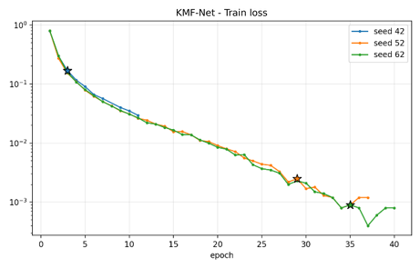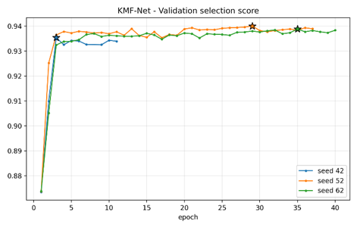
(a) (b)
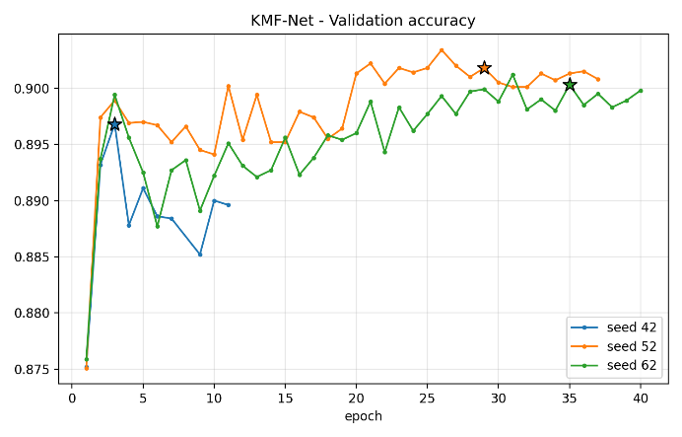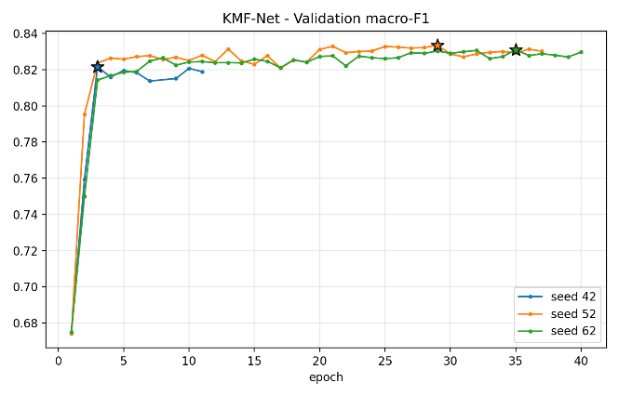
(c) (d)
Figure 3. Training dynamics. (a) KMF-Net training loss on a logarithmic scale.(b) KMF-Net validation selection score per epoch for the three seeds(c) Validation accuracy per epoch. (d) Validation macro-F1 per epoch.

4.3 Closed-Set Multiclass Classification

Table 9. Closed-set test performance over 17 known classes

Model | Params (k) | Accuracy | Balanced acc. | Macro-F1 | Weighted-F1 | MCC | Macro AUC
Proposed KMF-Net | 575 | 0.912 ± 0.003 | 0.804 ± 0.013 | 0.824 ± 0.011 | 0.908 ± 0.004 | 0.856 ± 0.005 | 0.979 ± 0.003
MambaCNN | 360 | 0.876 ± 0.012 | 0.697 ± 0.010 | 0.708 ± 0.008 | 0.863 ± 0.004 | 0.799 ± 0.020 | 0.930 ± 0.006
Transformer | 411 | 0.854 ± 0.007 | 0.638 ± 0.004 | 0.642 ± 0.005 | 0.821 ± 0.006 | 0.759 ± 0.011 | 0.943 ± 0.002
STGAT | 204 | 0.849 ± 0.031 | 0.596 ± 0.037 | 0.598 ± 0.032 | 0.802 ± 0.048 | 0.748 ± 0.055 | 0.941 ± 0.008
CNN-BiLSTM-Attn | 242 | 0.777 ± 0.018 | 0.587 ± 0.034 | 0.585 ± 0.011 | 0.737 ± 0.017 | 0.624 ± 0.030 | 0.937 ± 0.008

KMF-Net obtained an accuracy of 0.9116 ± 0.0030, a macro-F1 of 0.8242 ± 0.0109, a balanced accuracy of 0.8043 ± 0.0134 and an MCC of 0.8562 ± 0.0049. The strongest baseline, MambaCNN, reached 0.8765 ± 0.0118, 0.7078 ± 0.0075, 0.6972 ± 0.0099 and 0.7993 ± 0.0199 respectively; KMF-Net is therefore higher by 3.5 points in accuracy, 11.6 points in macro-F1, 10.7 points in balanced accuracy and 5.7 points in MCC. The advantage is largest for the class-balanced measures: the Transformer, STGAT and CNN-BiLSTM-Attn obtain accuracies of 0.854, 0.849 and 0.777 but macro-F1 values of only 0.642, 0.598 and 0.585, which suggests that they lose proportionally more on the smaller classes. The gap is also larger than the run-to-run variation: the lowest KMF-Net seed exceeds the highest baseline seed in macro-F1 (0.8117 versus 0.7158), accuracy (0.9086 versus 0.8855) and MCC (0.8512 versus 0.8146). With only three seeds per model, however, this statement describes the observed runs and is not a formal significance test.

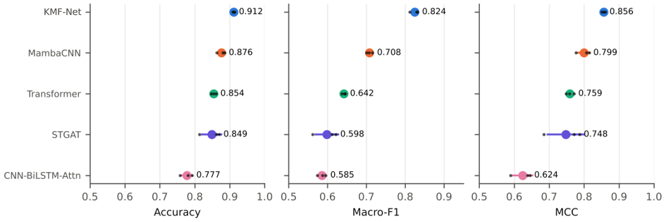
Figure 4. Closed-set comparison on the test partition. Large markers show the mean over three seeds, horizontal bars show ± one sample standard deviation, and small dark points are the individual seeds.

Further KMF-Net measures are a weighted F1 of 0.9079 ± 0.0037, a top-2 accuracy of 0.9896 ± 0.0005, a three-group macro-F1 of 0.9376 ± 0.0086, an expected calibration error of 0.0580 ± 0.0095 and a log-loss of 0.3811 ± 0.1066. The high top-2 accuracy relative to top-1 accuracy shows that most remaining errors involve a small number of confusable classes,three-group accuracy of 0.9770 (error rate 2.3% against 8.8% for the 17 classes) shows that about 74% of fine-grained errors stay inside the correct coarse group, although a corresponding baseline value is not available for comparison.

The comparison is not capacity-matched. KMF-Net has 575,844 parameters, 1.4 times as many as the Transformer and 2.8 times as many as STGAT (Figure 5). Parameter count alone does not order the baselines — the Transformer (411 k parameters) is clearly below MambaCNN (360 k) in macro-F1 — but the extent to which the improvement is architectural rather than a consequence of capacity can only be settled with baselines of matched size.

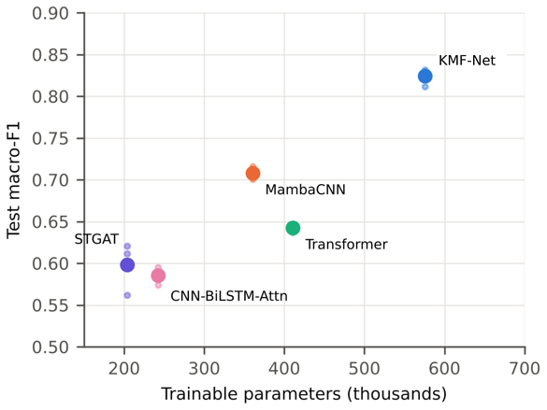
Figure 5. Test macro-F1 versus number of trainable parameters. Large markers are three-seed means and small points are the individual seeds.

4.4 Per-Class Analysis Of Proposed KMF-Net

Table 10. Per-class test results of Proposed KMF-Net
Class (raw label) | Support | Precision | Recall | F1
Benign (0) | 18,075 | 0.974 | 0.991 | 0.983 ± 0.002
ConstPos (2) | 373 | 0.951 | 0.730 | 0.826 ± 0.029
ConstPosOffset (4) | 373 | 0.720 | 0.481 | 0.573 ± 0.010
ConstSpeed (6) | 373 | 0.973 | 0.895 | 0.932 ± 0.010
ConstSpeedOffset (8) | 373 | 0.952 | 0.952 | 0.952 ± 0.007
DataReplay (10) | 373 | 0.885 | 0.870 | 0.878 ± 0.043
DelayedMessages (14) | 373 | 0.917 | 0.687 | 0.786 ± 0.012
Disruptive (16) | 373 | 0.340 | 0.255 | 0.290 ± 0.020
DoS (18) | 2,255 | 0.988 | 0.996 | 0.992 ± 0.002
DoSDisruptive (20) | 2,255 | 0.866 | 0.902 | 0.884 ± 0.014
DoSRandom (24) | 2,159 | 0.647 | 0.724 | 0.683 ± 0.020
DoSRandomSybil (26) | 1,210 | 0.381 | 0.302 | 0.336 ± 0.020
EventualStop (28) | 373 | 0.980 | 0.925 | 0.952 ± 0.006
RandomPos (32) | 373 | 0.997 | 1.000 | 0.999 ± 0.000
RandomPosOffset (34) | 373 | 0.946 | 0.963 | 0.955 ± 0.066
RandomSpeed (36) | 373 | 0.999 | 0.999 | 0.999 ± 0.001
RandomSpeedOffset (38) | 65 | 0.990 | 1.000 | 0.995 ± 0.009

Benign, DoS, RandomPos, RandomSpeed and RandomSpeedOffset are recognised almost perfectly (F1 ≥ 0.98), and the benign recall is 0.9913, so only 0.87% of benign windows are flagged as attacks. Five classes have F1 below 0.80: ConstPosOffset (0.57), DelayedMessages (0.79), Disruptive (0.29), DoSRandom (0.68) and DoSRandomSybil (0.34). Their errors are concentrated in three patterns that, summed over the three seeds, account for 88.9% of all misclassified test windows:

- Mutual confusion between DoSRandom and DoSRandomSybil (54.1% of all errors): 69.8% of DoSRandomSybil windows are labelled DoSRandom and 27.6% of DoSRandom windows are labelled DoSRandomSybil.
- Confusion between Disruptive and DoSDisruptive (17.0% of errors, both directions): 72.9% of Disruptive windows are assigned to DoSDisruptive, whereas only 8.0% of DoSDisruptive windows are assigned to Disruptive, so the confusion is strongly asymmetric.
- Attack windows predicted as benign (17.8% of errors), concentrated in ConstPosOffset (50.7% of its windows), DelayedMessages (31.2%) and ConstPos (21.9%).
Low F1 is not explained by class size: DoSRandom and DoSRandomSybil are among the largest attack classes (2,159 and 1,210 test windows) yet are difficult, whereas several classes with only 373 windows are recognised with F1 above 0.93. Patterns (i) and (ii) each pair an attack with its DoS or Sybil variant. A possible explanation is that the 19 input channels carry no timing information (latency is constant and send/receive times are excluded), so the sending rate that distinguishes a DoS variant is not observable within a 32-message window. The attack-to-benign errors for ConstPosOffset and DelayedMessages suggest that some manipulations produce windows locally consistent with normal driving. These explanations are hypotheses consistent with the confusion structure and were not tested here (for example by adding inter-arrival-time features). Seed-to-seed variability is largest for RandomPosOffset (F1 = 0.879, 0.991, 0.995 for seeds 42, 52 and 62) and DataReplay (s.d. 0.043); the other classes vary by less than 0.03.

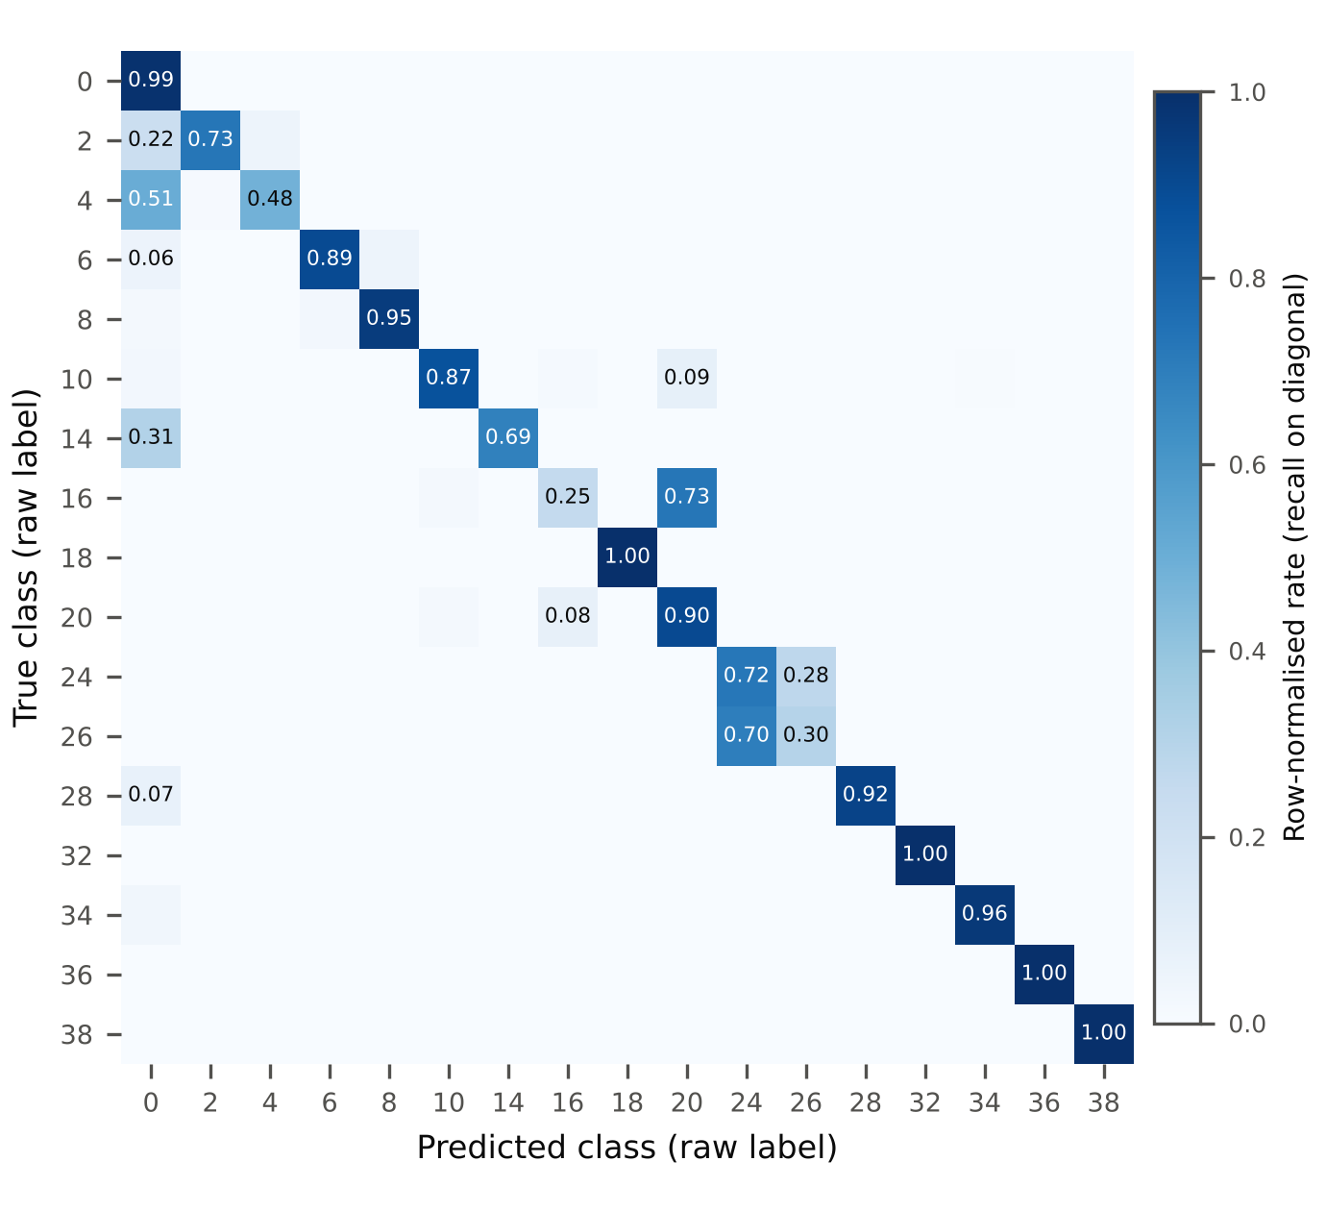
Figure 6. Row-normalised confusion matrix of Proposed KMF-Net on the closed-set test partition, averaged over the three seeds. Entries below 0.05 are left unlabelled.

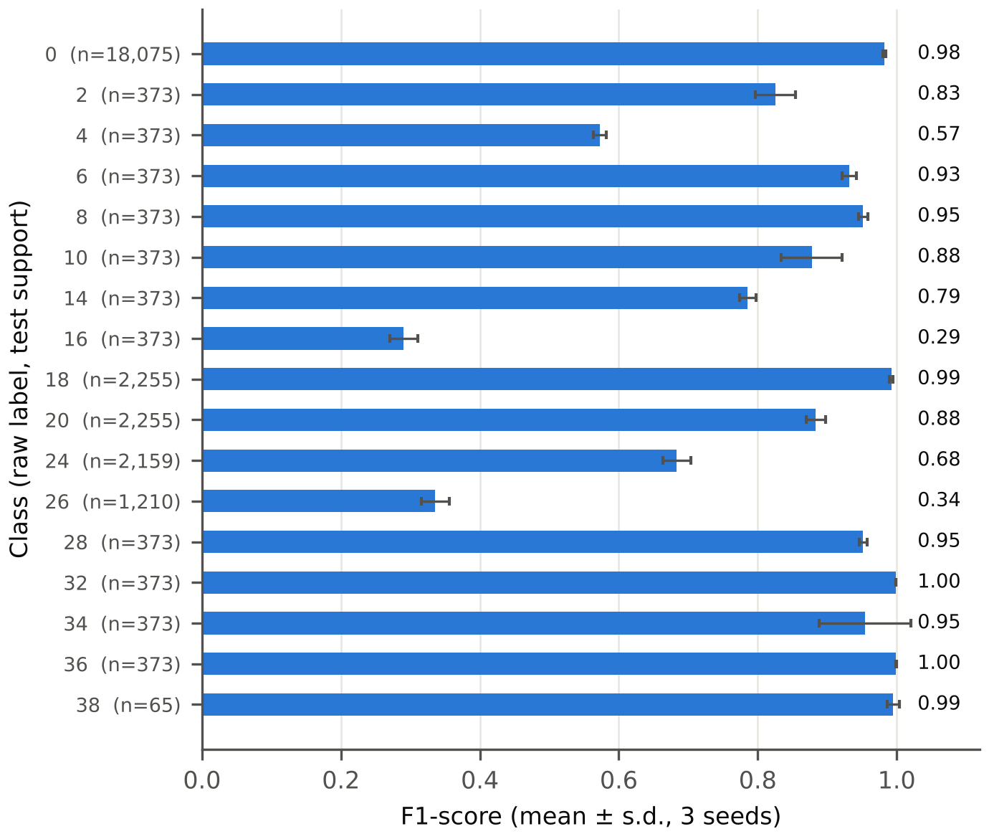
Figure 7. Per-class F1-score of Proposed KMF-Net (mean ± s.d. over three seeds) with test support in brackets.

4.5 Binary Detection and Withheld-Attack Detection

The binary-head attack probability was used as the default decision score because it is the model’s direct binary output; the fused, benign-probability and energy scores are alternative post-hoc scores and are reported for completeness. The scoring rule was therefore fixed by design and not chosen from test results.

Table 11. Binary detection on the closed-set test partition for four decision scores

Score | Precision | Recall | F1 | MCC | AUROC | AUPRC
Head score | 0.9885 ± 0.0025 | 0.9588 ± 0.0052 | 0.9734 ± 0.0029 | 0.9565 ± 0.0046 | 0.9881 ± 0.0005 | 0.9885 ± 0.0006
Fused score | 0.9865 ± 0.0034 | 0.9602 ± 0.0037 | 0.9732 ± 0.0033 | 0.9560 ± 0.0054 | 0.9881 ± 0.0006 | 0.9885 ± 0.0006
1 − P(benign) | 0.9861 ± 0.0020 | 0.9603 ± 0.0046 | 0.9730 ± 0.0030 | 0.9557 ± 0.0049 | 0.9884 ± 0.0009 | 0.9887 ± 0.0009
Energy score | 0.5882 ± 0.1686 | 0.8958 ± 0.1244 | 0.6933 ± 0.1217 | 0.3817 ± 0.3479 | 0.6846 ± 0.3124 | 0.6216 ± 0.2852

With the head score, KMF-Net reached a binary F1 of 0.9734 ± 0.0029, precision 0.9885 ± 0.0025, recall 0.9588 ± 0.0052, AUROC 0.9881 ± 0.0005 and AUPRC 0.9885 ± 0.0006, corresponding to a false-positive rate of 0.74% and a false-negative rate of 4.12%. The head, fused and benign-probability scores are practically equivalent (F1 differences below 0.001, smaller than the seed-to-seed standard deviation of about 0.003). The energy score is unsuitable for binary decisions: its validation-selected threshold collapsed to -9.55, -10.18, -11.75 for the three seeds, and for seed 42 every test window was labelled malicious (accuracy 0.3999, equal to the proportion of malicious windows).

Table 12 evaluates Proposed KMF-Net on 5,043 windows belonging to three attack classes withheld from model development: DataReplaySybil, DoSDisruptiveSybil, and GridSybil. These classes were excluded from training, checkpoint selection, and closed-set testing. The model was trained to classify 17 known classes, including benign, and the withheld-attack partition was evaluated only after all model and threshold decisions had been fixed.
The primary head score is the model’s direct binary attack probability:

$s_{head}(x)=p^{(b)}(x),$ (20)

where p^(b)(x) is the binary attack probability. The fused and energy scores are reported as secondary analyses.

Table 12. Withheld-attack results of Proposed KMF-Net for four scoring rules (mean ± s.d., 3 seeds)
Score | AUROC | AUPRC | Detection rate | Benign TNR | FPR@95TPR
Head score | 0.9857 ± 0.0047 | 0.9635 ± 0.0075 | 0.8213 ± 0.0148 | 0.9926 ± 0.0016 | 0.0564 ± 0.0306
Fused score | 0.9836 ± 0.0079 | 0.9599 ± 0.0118 | 0.8168 ± 0.0194 | 0.9912 ± 0.0022 | 0.0777 ± 0.0669
1 − P(benign) | 0.9803 ± 0.0149 | 0.9558 ± 0.0182 | 0.8166 ± 0.0119 | 0.9910 ± 0.0013 | 0.1103 ± 0.1233
Energy score | 0.8617 ± 0.1649 | 0.7668 ± 0.1836 | 0.9821 ± 0.0178 | 0.4934 ± 0.4281 | 0.4561 ± 0.4554

With the head score, KMF-Net achieved an AUROC of 0.9857 ± 0.0047, an AUPRC of 0.9635 ± 0.0075, and a withheld-attack detection rate of 0.8213 ± 0.0148. The corresponding benign true-negative rate was 0.9926 ± 0.0016, while the FPR at 95% TPR was 0.0564 ± 0.0306. The fused score and 1 − P(benign) score produced similar AUROC values, but their FPR@95TPR showed greater seed variation. The energy score was less stable and was therefore not selected as the primary withheld-attack score. All three withheld classes are Sybil variants, while the known-class set contains DoSRandomSybil. Consequently, these results demonstrate recognition of unseen Sybil variants rather than universal detection of every possible unseen attack family.

The baseline values in Table 13 were obtained under different implemented withheld-attack scoring and threshold protocols. They are included only as supplementary reference values and are not directly comparable with the KMF-Net results. A direct comparison would require the same withheld classes, score definition, validation calibration, and test partition for every model.
Table 13. Supplementary withheld-attack reference results for baselines under different protocols
Model | AUROC | Unknown recall at 95% known acceptance | Known acceptance
MambaCNN | 0.7517 ± 0.0134 | 0.3216 ± 0.0576 | 0.9508 ± 0.0051
Transformer | 0.7816 ± 0.0499 | 0.2869 ± 0.0539 | 0.9515 ± 0.0053
STGAT | 0.8617 ± 0.0090 | 0.4279 ± 0.0761 | 0.9589 ± 0.0042
CNN-BiLSTM-Attn | 0.7560 ± 0.0887 | 0.2112 ± 0.0972 | 0.9562 ± 0.0044

4.6 Ablation Study and Fusion Behaviour

Table 14 and Figure 8 report the effect of removing the kinematic-difference stem, CNN branch, Mamba branch, Transformer branch, from the fixed Proposed KMF-Net configuration. The ablations use the same partitions, training procedure, and three random seeds as the complete model. The configuration labelled “Full” contains 501,060 trainable parameters and represents the fixed ablation reference model; it is distinct from the 575,844-parameter final Proposed KMF-Net configuration used in the main baseline comparison.

Table 14. Component Ablation Results for the KMF-Net Reference Configuration

Configuration | Params | val_sel | Δ val_sel | Test macro-F1 | Δ macro-F1 | Test accuracy | Test MCC
Full (default) | 501,060 | 0.9389 ± 0.0001 | — | 0.8250 ± 0.0001 | — | 0.9094 ± 0.0033 | 0.8531 ± 0.0051
Without CNN | 462,180 | 0.9370 ± 0.0026 | −0.0019 | 0.8213 ± 0.0042 | −0.0036 | 0.9070 ± 0.0024 | 0.8494 ± 0.0042
Without Mamba | 364,356 | 0.9369 ± 0.0033 | −0.0020 | 0.8141 ± 0.0090 | −0.0108 | 0.9020 ± 0.0034 | 0.8416 ± 0.0056
Without Transformer | 249,252 | 0.9341 ± 0.0006 | −0.0048 | 0.8177 ± 0.0065 | −0.0073 | 0.9034 ± 0.0027 | 0.8438 ± 0.0041
Without kinematic stem | 486,392 | 0.9336 ± 0.0075 | −0.0052 | 0.8028 ± 0.0184 | −0.0222 | 0.8951 ± 0.0057 | 0.8310 ± 0.0092

The complete model achieved a validation selection score of 0.9389 and a test macro-F1 of 0.8250. Removing the kinematic-difference stem produced the largest reduction in test macro-F1, decreasing performance by 0.0222. Removing the Mamba branch reduced macro-F1 by 0.0108, while removing the Transformer and CNN branches reduced macro-F1 by 0.0073 and 0.0036, respectively. These results indicate that the kinematic-difference representation made the largest measured contribution among the evaluated components. However, the effects should be interpreted together with the reported seed-level standard deviations.
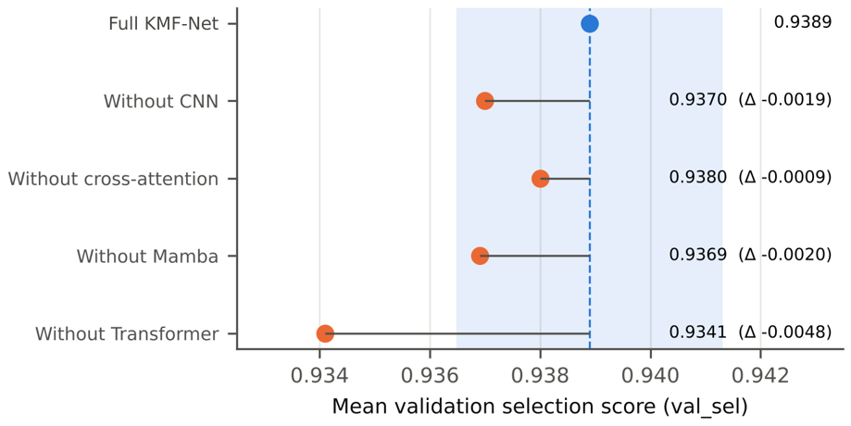

Figure 8. Ablation of Proposed KMF-Net components. Dashed line: full ablation reference model. Points are three-seed means and bars show ± one sample standard deviation; the label under each configuration gives the number of seeds below the full model in validation and test.

The average gate value assigned to the CNN–Mamba branch was 0.457, 0.471, and 0.443 for seeds 42, 52, and 62, respectively, giving a three-seed mean of 0.457. This indicates that both branches remained active on average during fusion. However, the mean gate value does not quantify class-specific or feature-specific contribution, and the gate was not independently removed in a separate ablation. Therefore, the gate statistics are interpreted as descriptive evidence of branch utilisation rather than proof of causal performance improvement.

5. Discussion and Limitations

KMF-Net achieved higher closed-set metrics than the evaluated baselines under the reported configurations, partitions, and random seeds. However, the models differed in parameter count, training duration, losses, sampling, augmentation, and checkpoint selection. KMF-Net also used a kinematic-difference stem and additional supervision components that were not provided to every baseline. Therefore, the results demonstrate comparative performance under the implemented configurations rather than capacity-independent architectural superiority.

The evaluation used one sequence-ID-disjoint partition and three random seeds. Scenario-, vehicle-, and time-disjointness was not independently verified, so possible mobility-trace overlap cannot be excluded. The withheld-attack experiment evaluated three Sybil variants against benign windows and did not test unknown-versus-known attack discrimination. The ablations used a separate 501,060-parameter reference model rather than the final 575,844-parameter model; therefore, the observed component differences are descriptive and do not establish causal importance.

6. Conclusion and Future Work

This study presented KMF-Net for VANET misbehaviour detection. On the evaluated sequence-ID-disjoint partition of the minimized VeReMi Extension dataset, KMF-Net achieved a closed-set accuracy of 0.9116 ± 0.0030, macro-F1 of 0.8242 ± 0.0109 and MCC of 0.8562 ± 0.0049, against a macro-F1 of 0.7078 ± 0.0075 for the strongest baseline (MambaCNN). Binary F1 was 0.9734 ± 0.0029, and on the three withheld Sybil-variant attacks the binary-head score gave an AUROC of 0.9857 ± 0.0047 with a detection rate of 82.13% ± 1.48% at a benign true-negative rate of 99.26% ± 0.16%. The results should be interpreted within the reported partition and training protocol because complete scenario-, vehicle-, and time-disjointness, capacity-matched baseline comparison, and unknown-versus-known attack discrimination were not evaluated.
The ablation results showed that removing the kinematic-difference stem produced the largest observed decrease in test macro-F1. This finding supports the usefulness of temporal-difference features but does not establish a definitive causal ranking of all model components. Future work will:
- Evaluate scenario-, vehicle-, and time-disjoint partitions across independently generated mobility scenarios, with additional seeds and repeated re-partitioning.
- Conduct capacity-matched baseline comparisons under identical training procedures and a common withheld-attack protocol, including binary-detection metrics for every baseline.
- Extend withheld-attack evaluation to include known-attack negatives, additional attack families, and unknown-versus-known discrimination, and test whether inter-arrival-time features resolve the confusable DoS and Sybil variants.
- Add explainability analysis, ablations of gated fusion and the hierarchical loss, evaluation on external datasets, inference-latency and resource measurements on in-vehicle hardware, and continual adaptation.

Data availability
The VeReMi Extension dataset is publicly available : https://zenodo.org/records/20090854

Code availability
The code for data preparation, training, and evaluation is available from the corresponding author on reasonable request.

References

- Jo, H. and Kim, D.H., 2026. Lightweight temporal and spatial fusion for intrusion detection in automotive controller area network. Ad Hoc Networks, p.104224.
- Xu, B., Li, Q., Cao, F. and Gao, Y., 2026. A Mamba-Based Lightweight and Dynamically Adaptive Intrusion Detection Framework for In-vehicle CAN Bus. Internet of Things, p.101918.
- Feng, H., Sun, M. and Wang, Y., 2026. Mambacnn: a lightweight intrusion detection system based on mamba for the internet of vehicles. Cybersecurity, 9(1), p.64.
- Lin, H., Yu, X., Chen, Z. and Cao, Y., 2025. RAG-HIDS: A multi-relational graph-based hierarchical intrusion detection system for in-vehicle networks. Ad Hoc Networks, p.104108.
- Fu, Y., She, J., Xu, Y., Xu, Y., Wang, Z. and Wu, Y., 2025. A dual layer LSTM-CNN framework for real time and precise per-message intrusion detection in in-vehicle networks. Ad Hoc Networks, p.104119.
- El-Fatyany, A., Wang, X., Lu, L. and Ren, K., 2025. EF-IDS: An efficient intrusion detection system with enriched features for CAN bus in modern vehicles. Journal of Systems Architecture, p.103646.
- Chen, A., He, Z., Chen, Y. and Zhang, D., 2026. IDS-MSVAC: A new intrusion detection system for unknown attacks in intelligent connected vehicle. Journal of Systems Architecture, p.103793.
- Rai, R., Grover, J., Babubhai, N.R. and Verma, N., 2026. A deep q-learning framework with feature fusion for securing automotive CAN bus communications. Information Sciences, p.123927.
- Cao, J., Di, X. and Jin, Y., 2026. IoVFD: Anomaly detection method for Internet of Vehicles based on federated learning with Dual Knowledge Distillation. Future Generation Computer Systems, p.108588.
- Heidari, A., Rastegar, S.H. and Khonsari, A., 2026. FedIoV: A secure and adaptive federated framework for real-time intrusion detection in vehicular networks. Future Generation Computer Systems, p.108448.
- Norouzi, M. and Gürkaş-Aydın, Z., 2026. A reliable cyber-attack detection architecture for cyber-physical systems in SDN-enabled internet of vehicles. Cluster Computing, 29(2), p.110.
- Zhao, X., Chen, B., Su, S., Lv, S., Xiao, Y. and Zhou, H., 2026. Vehicle CAN bus anomaly detection combining data dimensionality reduction and GA optimization of GBDT. Discover Artificial Intelligence, 6(1), p.506.
- Kayaoglu, D., Ulku, E.E. and Demir, O., 2026. Intrusion detection systems for the internet of vehicles: a systematic survey of techniques and challenges across CAN bus and vehicular networks: D. Kayaoglu et al. The Journal of Supercomputing, 82(12), p.611.
- Wu, W., Zhao, J., Ren, Y., Wang, Y., Tong, F., Zhao, D. and Peng, H., 2026. Intrusion detection for multi-modal data in the internet of vehicles employing large-scale temporal semantic modeling: A survey. Expert Systems with Applications, p.131046.
- Ferreira, L., Abreu, R., Branco, F., Reis, M.J., Serôdio, C. and Valente, A., 2026. A Two-Stage Hybrid Intrusion Detection System for CAN Bus Based on Statistical Thresholds and Random Forest Classifiers. Electronics, 15(11), p.2239.
- Ayat, Y., Benzekri, W., El Moussati, A., El Aouni, A. and Mir, I., 2026. IDS_XGB: Next-Generation Intrusion Detection for Automotive Embedded Systems. Peer-to-Peer Networking and Applications, 19(4), p.108.
- Naeem, H., Ullah, F., Mazhar, F. and Rafique, M.A., 2026. Securing smart city Internet of Vehicles via transformer integrated consensus ensemble learning and bio-inspired metaheuristics. International Journal of Critical Infrastructure Protection, p.100829.
- Zhang, Q., Li, H., Song, F. and Liu, K., 2026. Anomaly Detection of VANET Vehicle Communication Channel Driven by Artificial Intelligence. Transactions on Emerging Telecommunications Technologies, 37(2), p.e70371.
- Khan, W., Ahmad, J., Alasbali, N., Al Mazroa, A., Alshehri, M.S. and Khan, M.S., 2025. A novel transformer-based explainable AI approach using SHAP for intrusion detection in vehicular ad hoc networks. Computer Networks, p.111575.
- Khan, H., Tejani, G.G., AlGhamdi, R., Alasmari, S., Sharma, N.K. and Sharma, S.K., 2025. A secure and efficient deep learning-based intrusion detection framework for the internet of vehicles. Scientific Reports, 15(1), p.12236.
- Zhang, H. and Sarkar, A., 2025. Deep fusion for enhancing Internet of Vehicles security in sustainable smart vehicular communication with LSTM and GRU-guided artificial deep neural networks. Applied Soft Computing, 180, p.113346.
- Aishwarya, R., Vetriselvi, V. and Prahmodh, R., 2026. Lightweight misbehavior detection in the internet of vehicles using knowledge distillation from large language models. Computer Networks, p.112083.
- Khan, A., Junaid, A., Husnain, G., Alzahrani, K.J. and Alkahtani, H.K., 2026. An Efficient Intrusion Detection System Using Domain‐Aware Meta‐Learning with Adapter‐Based Few‐Shot Adaptation in Vehicular Ad‐Hoc Networks (VANETs). IET Intelligent Transport Systems, 20(1), p.e70182.
- Kamal, H., Haikal, A.Y. and Saafan, M.M., 2026. Deep learning-based multi-class misbehavior classification in fog-enabled vehicular ad hoc networks. Scientific Reports, 16(1), p.27814.
- Ragunthar, T., Christila, S.A., Jyoshna, B., Meenachi, L., Das, S. and Patro, P., 2026. Machine Learning‐Driven Intrusion Detection Systems for Anomaly Detection in Vehicular Ad‐Hoc Networks. Transactions on Emerging Telecommunications Technologies, 37(2), p.e70363.
- Oualil, S., Yahia, I.A., El Kamili, M., Fardousse, K. and Berrada, I., 2026. CAN-TEMPO: Unsupervised CAN Bus Intrusion Detection via Temporal Multi-Period Oscillation Encoding. Technologies, 14(6), p.375.
- Zhang, G., 2026. A dual-branch temporal-spatial deep learning architecture for efficient and accurate CAN bus intrusion detection. Kuwait Journal of Science, p.100566.
- Ghadi, A. and Mohd, T.K., 2026. Learning-Based Intrusion Detection Systems for In-Vehicle CAN Networks: A Comprehensive Survey with Deployment and Real-Time Considerations. Journal of the Brazilian Computer Society, 32(1), pp.1755-1785.
- Murshed, M., Wickramasurendra, N., Jubaida, A., De Grande, R.E. and Carvalho, G.H., 2026. Novel RF-jamming IDS for vehicular networks: LSTM, XGBoost, and meta-models approaches. International Journal of Critical Infrastructure Protection, p.100830.
- Wang, S. and Guo, J., 2026. FeatGate-IDS: A lightweight and interpretable feature-gated intrusion detector for vehicular traffic under limited and noisy supervision. Journal of Systems Architecture, p.103845.
- Heidari, A., Khonsari, A. and Rastegar, S.H., 2026. An energy-efficient privacy-preserving framework for intrusion detection in the internet of vehicles. Computers and Electrical Engineering, 132, p.111003.

