Retrospective Development of TECR-Net for Ranking Next-Year Recorded Incidents of Non-Compliance on U.S. Offshore Platforms

Abstract
A risk-based offshore regulation regime may benefit from research on ranking recorded administrative outcomes, provided that enforcement records are not treated as direct measures of platform condition or latent violation. This retrospective development study examines TECR-Net, a multi-branch temporal neural network for ranking whether a U.S. offshore platform-year is followed by a recorded Bureau of Safety and Environmental Enforcement Incident of Noncompliance (INC). The archived production-linked study uses exact three-year histories with 26 dynamic, 3 static numerical, and 8 categorical predictors. Because several static and administrative predictors originate from later snapshots or lack source-specific publication dates, the analysis measures retrospective association and does not establish historically deployable forecasting. The reused 2020-2021 development cohort contained 1,884 histories from 982 platforms, including 67 positive outcomes (3.56%). Across seven archived training seeds, mean development AP was 0.07401 +/- 0.00775 and mean development ROC-AUC was 0.63115 +/- 0.01119. The primary full probability-mapped TECR-Net ensemble produced apparent development AP of 0.07518 and ROC-AUC of 0.63855. A separate post-hoc symmetric cohort benchmark produced TECR-Net AP of 0.05897 and ROC-AUC of 0.64408 under a different comparison procedure; the benchmark value does not replace the full-ensemble AP. Neither estimate constitutes independent validation or evidence of superiority. A corrected cohort reconstruction produced 22,957 calendar-exact histories after removing the future-year production-continuity requirement. Equivalent corrected-cohort model comparisons, historically verified predictor timing, complete negative-outcome ascertainment, independently assessed calibration, and an untouched mature-outcome test cohort remain unavailable. Accordingly, the study documents a cohort-reconstruction and retrospective model-development exercise rather than a validated predictive or operational system.
Keywords: offshore platforms; recorded incident of non-compliance; temporal modelling; cross-modal learning; rare-event prediction; inspection prioritization; development study

1. Introduction
In the oil and gas industry, there are many technical, safety, environmental, and operational standards that must be applied to manage the risks associated with such complicated infrastructure. It is quite difficult to utilize the traditional method of supervision by means of periodic inspection and static checklist due to the heterogeneous standards and huge data involved in the operations. Liu et al. [1] suggested an LLM-assessment framework including semantic indicator extraction, integration weighting, and cloud-model assessment for international pipeline standards. Hui et al. [2] also revealed how the knowledge graph built from over 3,000 pipeline standards could enhance the semantic organization and intelligent retrieval of technical standards. However, both of the research works are about standard creation and knowledge retrieval but not the compliance of the facilities.
A further critical aspect of standardization evaluation that is essential to its effectiveness involves reliable data and sound performance measures. Xia et al. [3] proposed multidimensional control rules for the evaluation of normative compliance, integrity, consistency, accuracy, and timeliness of oil-and-gas surface engineering data using a combination of Analytic Hierarchy Process and entropy weighting. Khordoustan et al. [4] proposed fuzzy Analytic Network Process with machine learning feature importance for the evaluation of contractors’ health, safety, environment, and quality performance. The two studies highlight the utility of heterogeneous evidence in enabling systematic supervision. In this specific context of public BSEE, however, a review of relevant literature does not provide us with a comparable study using platform-year data to jointly model temporally ordered production exposure, operator inspection activity, accidents, platform attributes, and next-year INCs. This is a specific limitation of data and task; it does not suggest that there are no oil-and-gas industry studies combining heterogeneous data sources.
Risk-based asset integrity management provides context for the study. Wahono et al. [5] describe a broader shift from qualitative and deterministic integrity evaluation toward dynamic and probabilistic methods using machine learning. The narrower question examined here is how publicly available BSEE platform histories behave as retrospectively assembled indicators of subsequent recorded INC outcomes. The study does not establish real-time forecasting, identify latent violations, infer causality, or support regulatory decisions.

1.1 Aim

The goal of this study is to construct and critically assess a temporally ordered retrospective framework in which BSEE INC outcomes recorded in calendar year t+1 are ranked using administrative records associated with platform years t-2, t-1, and t. Because publication and effective dates are unavailable for several attributes, the study evaluates retrospective association and ranking rather than validated historical forecasting.

1.2 Objectives
- Integrate public BSEE production, structure, inspection, enforcement and accident records into auditable platform-year histories
- Develop TECR-Net using temporal, static-numerical and categorical features to analyse subsequent recorded INC outcomes
- Characterize apparent development-cohort discrimination, probability behavior, baseline comparisons, and component-removal sensitivity without treating them as independent validation
- Assess data provenance, temporal consistency and methodological limitations to establish a transparent and reproducible retrospective evaluation framework.

1.3 Novelty
The methodology novelty comes from the definition of a BSEE platform-year administrative outcome task as precisely ordered calendar history with a provenance-limited archive of dynamically structured, static numerical, and categorical branches, followed by attention-based pooling and residual fusion of learned queries. This novelty is task and implementation specific and does not claim the novelty of temporal networks, attention mechanisms, heterogeneous tabular branches, or multimodal learning within the oil and gas industry.
  - Contributions
- A temporally structured framework for integrating BSEE production, inspection, enforcement and accident records to analyse subsequent recorded non-compliance outcomes
- A development-stage assessment of TECR-Net using exact three-year platform histories, seven-seed training, and comparisons performed on an adaptively reused development cohort
- A corrected cohort reconstruction that removes the future-production-continuity requirement and corrects identified INC date-parsing inconsistencies, while leaving historical eligibility and predictor-timing questions unresolved
- A documented retrospective evaluation framework incorporating model ablation, apparent calibration diagnostics, temporal-integrity checks, and explicit limitations

2. Literature Survey
Zhang et al. [6] present an overview of risk assessment methods for oil and gas operations, which includes conventional qualitative, quantitative, probabilistic, and intelligent methods. The authors pay special attention to the high dependence of conventional techniques on experts' opinions, as well as the inability of traditional techniques to consider dynamic interaction between risks associated with operation, environment, and equipment. Wahono et al. [7] attempted to overcome this problem by developing intuitionistic fuzzy deep neural network for the purpose of risk assessment in pipelines. It utilizes the fuzzy technique to handle uncertainty and the nonlinear learning capabilities of deep neural networks. Thus, it is evident that these studies show the movement from the traditional risk estimation method to intelligent ones capable of dealing with uncertainty.
Zhou et al. [8] introduced a data-driven approach based on PCA (Principal Component Analysis) and hierarchical clustering to perform an adaptive assessment of gas pipeline networks. PCA decreased the redundancy of indicators, whereas hierarchical clustering allowed grouping of pipelines at risk through the absence of full reliance on pre-set classification. Ye et al. [9] used text mining and Apriori algorithm to classify risks of oil and natural gas pipeline through analysis of historic risk records. Their approach helped reveal common patterns between risk factors and establish a data-driven structure of risk classification. Both examples clearly show benefits of revealing patterns of risks using heterogeneous data. However, clustering and association rule approaches mostly describe existing structures and relations.
AlAbdouli and Al-Shihabi [10] investigated the effects, issues, and evaluation techniques related to the use of AI on the performance in the oil and gas sector. The authors noted the opportunities provided by AI for enhancing predictions, operations, maintenance, and decision making while outlining the issues related to data quality, integration, explainability, and organization readiness. Savari et al. [11] conducted a systematic review of the state of the art machine learning developments in the areas of pipeline reliability-based design, integrity assessment, inspection, and maintenance. According to the authors’ findings, machine learning became an increasingly important tool in assessing condition, predicting failures, planning inspections and optimizing maintenance activities. These papers demonstrate the broader scope of application of AI for industrial performance and pipeline integrity.
Bastek et al. [12] reviewed future directions for data-driven pipeline integrity management, with particular attention to risk assessment, in-line inspection, and machine-learning applications. They emphasized the need to integrate inspection information, physical degradation indicators, and operational data to support proactive integrity decisions. Jones et al. [13] examined artificial-intelligence applications for offshore oil and gas pipeline asset integrity management. Their study discussed how intelligent methods can enhance corrosion monitoring, defect assessment, predictive maintenance, and failure prevention throughout the asset lifecycle. Collectively, these studies support the transition from reactive maintenance toward predictive and risk-based integrity management. Nevertheless, existing research generally prioritizes physical asset condition and failure probability, while regulatory compliance, inspection history, and multidimensional standardization performance remain comparatively underexplored.
Al-Ammari et al. [14] reviewed and demonstrated digital-twin applications for gas-pipeline leak detection and fault diagnosis. Their work showed how virtual representations, sensor information, and analytical models can support continuous monitoring and timely identification of abnormal pipeline conditions. Cai and Wang [15] subsequently proposed a digital-twin-driven leakage-detection method for natural gas pipelines, further illustrating the potential of synchronized physical and virtual systems for real-time supervision. Both studies advance dynamic pipeline monitoring by linking operational data with intelligent diagnostic models. However, digital-twin systems often require dense sensor networks, detailed physical models, and continuous data streams. Such requirements limit their direct applicability to regulatory datasets, where observations are commonly periodic, heterogeneous, and recorded at facility or operator level rather than as continuous sensor measurements.
Ali et al. [16] reviewed artificial-intelligence and machine-learning methods for predicting and optimizing production in oil and gas surface networks. Their study demonstrated the ability of data-driven models to capture nonlinear relationships among operational variables and support production planning and network optimization. Chen et al. [17] extended production monitoring through a progression from clustering to federated learning for unconventional natural gas wells. Their collaborative approach enables multiple data sources or operational units to contribute to model development while reducing centralized data-sharing requirements. These studies demonstrate the importance of scalable learning from distributed and heterogeneous industrial data. However, production optimization alone does not represent standardization performance. A comprehensive supervision framework must connect operational behaviour with facility characteristics, inspection activities, incidents, and regulatory outcomes.
Lopes et al. [18] developed an open-world learning approach for detecting and classifying anomalies in oil-well production. Unlike closed-set classifiers, open-world learning can identify observations that do not belong to previously known event classes, making it relevant for evolving industrial environments. Aranha et al. [19] applied a Transformer-based method to anomaly detection in intelligent well completions, using the architecture’s ability to learn complex temporal dependencies within multivariate operational sequences. Both studies demonstrate that advanced learning methods can identify abnormal behaviour that conventional fixed-class models may overlook. Nevertheless, operational anomalies do not automatically represent regulatory non-compliance or inadequate standardization. Their practical use in supervision therefore requires integration with inspection records, compliance histories, interpretable risk indicators, and decision rules that translate anomalies into actionable regulatory or managerial priorities.
Verma et al. [20] proposed DeepPipeNet for deep-learning-based anomaly detection in oil and gas pipeline monitoring, illustrating the growing role of specialized neural architectures in identifying complex pipeline abnormalities. Its emphasis on automated monitoring complements the open-world anomaly framework of Lopes et al. [18], which addresses previously unseen operational conditions. While DeepPipeNet strengthens pattern-recognition capability, both approaches remain centred on detecting abnormal physical behaviour rather than evaluating broader compliance performance. This distinction is important because standardization supervision must account for operational exposure, structural characteristics, inspection frequency, previous violations, enforcement actions, and safety incidents. Consequently, anomaly-detection outputs should be treated as one component of a larger explainable evaluation framework rather than as a complete measure of facility standardization or regulatory risk.
The endpoint is also a part of the administrative decision data and selectively labeled data literature. As BSEE defines the INC as an official enforcement notice that results from an inspector identifying a regulatory violation and running a risk-based inspection program using facility-specific INC, incident, and production data, the attention of the inspection is drawn based on this process. Thus, selective labeling of observations depends on the manner in which inspections are conducted. In general terms, selective observation of administrative decisions allows the prediction of the decision process and not the underlying state itself.
Table 1. Comparative summary of AI-based oil and gas monitoring, integrity, and risk-assessment studies
Ref. | Author(s) | Dataset used | Model/method used | Research gap
[21] | Almahakeri et al. | Ultrasound-guided-wave measurements collected through pipeline-mounted transducers | Deep Neural Network-based structural health monitoring | Predicts crack location, width, and depth but does not evaluate regulatory compliance, inspection history, or facility-level risk.
[22] | Wang et al. | Historical operational and fault data from Shengli Oilfield production wells | ML-CSNN, expert rules, SVM, GBDT, and XGBoost | Strong predictive-maintenance performance, but validation is limited to one oilfield and equipment-fault context.
[23] | Sani et al. | Public corrosion dataset: 10,293 observations and eight operational features | Gradient Boosting, XGBoost, Random Forest, KNN, SVR, AdaBoost, and regression models | Uses a public tabular dataset and random split; limited evidence of temporal, geographic, and operator-level generalization.
[24] | Ansari et al. | TWI industrial dataset containing over 35,000 condition-monitoring locations | Direct regression and composite classification–regression models | Performs poorly for high corrosion rates and is affected by skewness, duplicate records, and limited severe cases.
[25] | Wu et al. | 402 burst-test and finite-element samples collected from published studies | Physics-informed deep forest optimized through Double Deep Q-Network domain generalization | Dataset mainly represents simplified single rectangular defects; operational and regulatory factors are excluded.
[26] | Wang and Lu | Datasets collected from 30 published residual-strength studies | Review of regression, Random Forest, SVM, neural networks, Gaussian Process Regression, and ensemble methods | Identifies small, heterogeneous datasets and inconsistent validation; does not propose a unified operational framework.
[27] | Chen et al. | Experimental and operating data for liquid holdup in hilly oil–gas pipelines | Comparative ML prediction with SHAP interpretation | Focuses on liquid holdup under specific terrain and flow conditions rather than broader integrity or compliance outcomes.
[28] | Lv et al. | High-pressure hydrate flow-loop experimental data from an oil–water system | XGBoost classification with SHAP explanations | High controlled-experiment accuracy, but field-scale and cross-pipeline validation remain limited.
[29] | Yang et al. | Geological, environmental, and hazard data from the Lishui–Wenzhou gas-pipeline corridor | Information Value Method, neural-network weighting, and data-driven susceptibility assessment | Case-study-specific geographic model; limited transferability to other regions and non-geological compliance risks.
[30] | Chen et al. | Field measurements combined with hydraulic-simulation benchmarks | Eight lightweight ML models optimized for edge deployment | Addresses short-term overpressure warning but not long-term integrity, inspection performance, or regulatory supervision.
[31] | Khalilzadeh et al. | Literature evidence, organizational information, and expert judgments from an oil and gas project | Fuzzy Delphi, probability–impact matrix, FBWM, and Grey CoCoSo | Relies strongly on expert assessment and lacks longitudinal operational validation or predictive regulatory outcomes.
[32] | Zhang et al. | Published studies and selected oilfield application cases; no single experimental dataset | Systematic review of big-data monitoring, ML, deep learning, anomaly detection, and parameter optimization | Provides broad conceptual coverage but lacks a reproducible dataset, unified model, and comparative experimental validation.

The nearest research areas are offshore asset-integrity analysis [13], anomaly detection in time series [18-20], production monitoring [16,17], and data-driven risk assessment [6-9]. These areas motivate multivariable industrial machine learning but differ in unit of analysis, endpoint, input density, or evaluation design. The contribution assessed here is the construction of exact three-year BSEE platform sequences and a retrospective analysis of dynamic operational and administrative history with static and categorical context. The study does not claim that TECR-Net is the first multimodal or temporal oil-and-gas model, that its architecture is superior to simpler alternatives, or that its scores constitute validated forecasts. Because recorded INCs depend on inspection and enforcement processes, the analysis concerns recorded administrative outcomes rather than latent platform condition.

3. Proposed Methodology

3.1 Prediction Target
For platform i and feature year t, the binary label equals 1 when the available data contain at least one recorded INC in calendar year t+1. No explicit t+1 outcome field is included in the predictor whitelist. The estimand is therefore the ranking of future recorded INC outcomes, not latent non-compliance, accident occurrence, or platform safety. Inspection frequency, reporting, enforcement, appeals, and delayed recording may affect whether an INC is observed. Platform-level labels use the calendar year of the INC date, and operator-level aggregates use the available INC date field; subsequent adjustments were not traced. The intended origin is the end of year t, but release-specific publication lags and effective dates are unavailable for several predictors. Consequently, the analysis does not establish that every predictor was available at a historical prediction origin. TECR-Net is evaluated only as a retrospective research-ranking model and not as a safety determination, enforcement decision, production-authorization tool, or real-time system.
$yᵢ,ₜ₊₁ = 1(INC_countᵢ,ₜ₊₁ > 0)$ (1)
The model input is an exact three-year history ending in feature year t. Measurements correspond to t-2, t-1, and t in chronological order; histories missing an intermediate calendar year are omitted rather than interpolated. The dynamic tensor is defined in Equation (2). Numerical static and categorical features are supplied separately rather than repeated at every time step. The three-year window was an archived implementation choice; alternative window lengths were not compared on identical eligible cohorts, so optimality is not claimed.
$Xᵢ,ₜ = [xᵢ,ₜ₋₂, xᵢ,ₜ₋₁, xᵢ,ₜ] ∈ R³ˣ²⁶$ (2)
Figure 1. Archived full-feature TECR-Net architecture for retrospective analysis of subsequent recorded INC outcomes; historical feature availability was not established.

As illustrated in Figure 1, the retrospectively constructed platform-year panel creates the true t−2, t−1, and t histories. For the full-fledged version stored in the archives, the 3×26 dynamic tensor undergoes global feature gating, bidirectional GRU, and temporal attention; three static numerical features and eight categorical features are concurrently transformed. These 80-dimensional vectors are then combined via learned cross-modal attention and residual mean pathway prior to classification. The dotted line for the target denotes the fact that the recorded INC value at t+1 serves only as the supervision signal.

3.2 Data Integration
Archival files on public BSEE releases for platform structures, platform-level production, platform INCs, operator inspections and INCs, accident investigations, and companies and lease ownership were merged at the platform-year level. The date of download from the original archives was not recorded; therefore, exact reconstruction of the original data vintage is impossible and is mentioned as a limitation. The release comparison audit performed on 17 October 2026 preserved the file hashes and found ongoing changes, with 127 new or changed rows for platform-INC in 2026 showing publication delay. The number of unique platform-years in the archived full panel was 148,672, and in the archived model panel, it was 141,730, with a difference of 6,942 rows. In the original design based on production linkage, there were 13,416 histories in the full panel for which the t−2 to t histories were exact and a t+1 observation row existed, while in the frozen panel, their number was 12,280; however, in all the missing histories, the t+1 row was missing in the model panel. Production was aggregated into platform years and merged to the structure, platform INCs, operator year inspection and enforcement, and lease year accident data. The archived panel is the foundation of the archived results; the corrected-cohort analysis in the corrected reconstruction analysis is a distinct reconstruction and its statistics should not be blended into the same results. The archived model assumes feature year 2014 due to the fact that it is the earliest year available in the frozen analysis pipeline which has at least three years of history as well as overlapping predictor generation. Year-specific source-specific completeness was not maintained and hence 2014 is a limitation of analysis and not a verified starting point for completeness in BSEE coverage. Production data in the archived builder is aggregated using normalized platform key and calendar year while operator, lease, area and block are from the last production data record in the year. Structure data is joined using normalized platform key after resolving duplicates, platform INCs using platform key and INC issue year, operator inspection/enforcement aggregates using operator code and year, and accident proxies using lease and year.Complete unmatched-row counts were not retained. Historical operator responsibility therefore represents the operator recorded in the final monthly production row, not a separately verified dated ownership assignment.

Table 2. Model input groups and information timing
Group | Count | Content | Use
Dynamic base | 20 | Production, wells, activity, change, age, operator activity, lagged accident indicators | Each of t−2, t−1, t
Current compliance | 6 | Year-specific INC, warning, shut-in, and inspection-derived history | Enhanced supervision only
Static numerical | 3 | Water depth, latitude, and longitude | Once per sequence
Categorical | 8 | Area, structure and operating-context categories | Training-derived vocabulary
Metadata | — | Platform, lease, operator, complex, and grouping identifiers | Not predictive inputs
Prohibited | — | Future targets, next_year fields, removal timing | Excluded before fitting
Table 2 shows that the archived experimental network used 26 dynamic variables at each of three time steps, together with three static numerical and eight categorical variables. Identifiers were omitted from the archived prediction feature whitelist; however, exclusion of explicit future columns does not establish historical availability of snapshot-derived inputs.

3.3 Temporal Design and Development Cohort
Table 3 documents the retrospective chronology. The 2020–2021 cohort was used for TECR-Net hyperparameter selection, early stopping, probability mapping, threshold selection, ablation, and performance reporting. Its results are therefore apparent development estimates, not independent validation estimates. The 2022–2024 cohort was inspected repeatedly during model development and is reported only for exploratory chronological accounting. It cannot provide independent confirmation. Moreover, feature year 2024 requires outcomes from 2025, whose reporting completeness was not verified. No claim of external validity, generalizability, predictive superiority, or deployment readiness is made.
Table 3. Temporal protocol and cohort sizes
Role | Feature years | Sequences | Platforms | Positive labels | Label rate
Model fitting | 2014–2019 | 8,200 | 1,607 | 538 | 6.56%
Development and selection | 2020–2021 | 1,884 | 982 | 67 | 3.56%
Exploratory later cohort | 2022–2024 | 2,196 | 876 | 94 | 4.28%
Total eligible sequences | 2014–2024 | 12,280 | — | 699 | 5.69%

Description of the original archival production-linked experiment is provided in Table 3. The eligibility criteria in this experiment stipulated feature years t-2, t-1, and t and a visible production-linked t+1 row, conditioning participation in the experiment on future activity. A subsequent reconciliation showed 1,136 histories that were otherwise eligible were excluded from the experiment at the t+1 model-panel step. The corrected reconceptualization then used eligibility in year t without requiring production in t+1, kept 8,562 platform-years without production in the current year, and yielded 22,957 calendar-exact histories. This corrects for the main production-continuation problem, although a full P2 pass is not guaranteed since installation and removal dates came from a more recent snapshot, eligibility according to regulations at each issuance date was not verified, and lack of an INC was not verified to be a negative outcome. The operational forecast convention thus consists of research information available at a documented cutoff after year t predicting an observed INC issuance in t+1; since source-specific publication lags are unknown, all analyses are retrospective.

3.4 Leakage Controls, Feature Provenance, and Preprocessing
Preprocessing of numerical variables was computed solely on the basis of the fitting period. Outliers beyond the 1st and 99th percentiles of the fitting period were truncated, missing values were imputed using medians for the fitting period, and the resulting variables were robustly standardized using the medians and interquartile ranges of the fitting period. The same parameters saved during this preprocessing step were used without modification on the development set. The categories were also trained on the fitting set, where missing and new categories were labeled unknown.
Installation, removal, datum-year and site-clearance variables have been detected from the source schema audit of the platform-structure dataset released. However, effective dates for individual attributes have not been detected. Installation dates could potentially be used to conduct platform existence validation; however, they do not validate the years when values for water depth, structure type, region, heliport, personnel attendance and manning became valid or available. The full-feature model does not make any historical availability claims on these attributes. No region code source attribute was identified as such; it is treated as derived. Operator inspection and enforcement counts are indexed by year, but they are not normalized by exposure of fleet and the historically responsible operator has not been independently verified. Accident values from lease-year periods may be shared among more than one platform; platforms-per-lease and unmatched event distribution has not been retained. These data are reported as retrospective contextual associations. A time valid model excluding unverifiable predictors has not been run yet.
$x̃ⱼ = min\left(max\left(xⱼ, Qⱼ,0.01\right), Qⱼ,0.99\right)$(3)
$\hat{x}ⱼ = \tilde{x}ⱼ if observed; otherwise {median}_{fit\left(xⱼ\right)}$(4)
$zⱼ = \frac{x̂ⱼ - median_fit(xⱼ)}{IQR_fit(xⱼ)}$ (5)
Table 4. Scoped leakage-prevention and temporal-integrity audit
Check | Status | Interpretation
Unique platform-year records | Pass | No duplicate platform-year records
Target fields in approved inputs | Pass | No next_year or outcome variables in the feature whitelist
Future or removal fields in inputs | Pass | No removal timing or future fields in predictive inputs
Identifiers in feature whitelist | Pass | Identifiers retained only for grouping and reporting
Consecutive three-year windows | Pass | No calendar-spacing violations in constructed sequences
Immediate next-year label alignment | Pass | No mismatches between t and t+1 labels

These six conditions, outlined in Table 4, pertain to verifiable aspects of the analyses carried out using the archived data files. They include unique platform-year observations, no explicit future events included among predictors, removal timing information excluded, identifiers excluded from predictive variables, input window observations consisting of three consecutive years, and label assignment for the following year (t + 1). Such conditions provide support for the development of an internal sequence but do not confirm the historical availability or publication of predictors.

3.5 TECR-Net Architecture

TECR-Net operationally separates predictors into three feature branches: dynamic platform-year history, static numerical attributes, and categorical platform context. These are feature groups, not sensor modalities such as image, text, or audio. Each branch has a separate encoder and a common latent width before learned-query pooling. The present experiments do not establish that this grouping is better than simple concatenation; the branch structure is therefore treated as an investigated design rather than a validated architectural advantage.

3.5.1 Feature Gate and Bidirectional Temporal Encoder
The learnable global feature-gating component provides a rescaling factor for each of the 26 dynamic inputs (set initially to 0.5); as the subsequent weights can correct for rescaling, they do not constitute identifiable features for predictive importance. The global gates are the same for all the platforms and time points; thus, the network is able to learn consistent rescaling of features. The gated features then get passed to a single-layer bidirectional gated recurrent unit (BiGRU) layer with 80 units each way, to account for temporal relationships of the three-year-long data. The GRU component utilizes the recurrent gated formulation.
$g=σ\left(θ\right), x'_{i,k}=g⊙x_{i,k}$ (6)
$\underset{i,k}{\overset{→}{h}}={GRU}_{f}\left(x'_{i,k},\underset{i,k-1}{\overset{→}{h}}\right)$ (7)
$\underset{i,k}{\overset{←}{h}}={GRU}_{b}\left(x'_{i,k},\underset{i,k+1}{\overset{←}{h}}\right)$ (8)
$h_{i,k}=\left[\underset{i,k}{\overset{→}{h}}∥\underset{i,k}{\overset{←}{h}}\right]∈R^{160}$ (9)
In Equations (6)–(9), theta denotes the trainable global gate parameters, sigma is the sigmoid function, and the multiplication is element-wise. The forward and backward hidden states are concatenated into a 160-dimensional representation at each of the three observed time steps. Bidirectional processing is confined to t-2 through t and therefore does not access the t+1 label.

3.5.2 Temporal Attention
A temporal additive attention scheme is used on the hidden representations from BiGRU for estimating the relevance of observations at t-2, t-1, and t. The normalized attention scores are obtained by applying a softmax function and the resultant weights are used for constructing a weighted temporal context vector which is projected non-linearly to the common latent space of 80 dimensions.
$e_{i,k}=v_{a}^{⊤}\tanh\left(W_{a}h_{i,k}+b_{a}\right)$ (10)
$α_{i,k}=\frac{\exp\left(e_{i,k}\right)}{\sum_{r=1}^{3}{\exp\left(e_{i,r}\right)}}$ (11)
$c_{i}=\sum_{k=1}^{3}{α_{i,k}}h_{i,k }$ (12)
$z_{i}^{T}=\operatorname{LN}\left(\operatorname{GELU}\left(W_{T}c_{i}+b_{T}\right)\right)∈R^{80}$ (13)

In Equations (10)-(13), “e” is the unnormalized attention score, while alpha is the normalized weight for time and “c” is the context vector weighted. The mapping function projects from the 160-dimensional space of context to the 80-dimensional shared space. The attention weights are learned correlations in the model, but not causal explanations for individual years.

3.5.3 Static and Categorical Encoders
Static encoder encodes three numerical attributes of the platform, namely water depth, latitude, and longitude, by applying the transformation through two feed-forward layers with GELU activation, followed by dropout and layer normalization. Simultaneously, eight categorical features of the platform are encoded by using eight separate embedding layers. These embeddings are concatenated and projected to the latent space with dimensionality 80.
$z_{i}^{S}=\operatorname{LN}\left(W_{S,2}\operatorname{Dropout}\left(\operatorname{GELU}\left(W_{S,1}s_{i}+b_{S,1}\right)\right)+b_{S,2}\right)$ (14)
$z_{i}^{C}=\operatorname{LN}\left(\operatorname{Dropout}\left(\operatorname{GELU}\left(W_{C}\left[E_{1}\left(c_{i,1}\right)∥⋯∥E_{8}\left(c_{i,8}\right)\right]+b_{C}\right)\right)\right)$ (15)

In Equations (14)–(15), the static vector contains water depth, latitude, and longitude, while each categorical variable has an independent training-derived embedding table. Both encoders produce 80-dimensional tokens. These branches reproduce the archived experiment; the historical validity of several attached snapshot attributes remains unresolved.

3.5.4 Cross-Modal Attention and Residual Fusion
The temporal-static-numerical and categorical tokens are combined using an eight-head learned query attention-pooling mechanism. A trainable query computes a weighted sum of the three independently encoded tokens; this is not token swapping. An arithmetic mean provides a residual pathway, retaining the information present in all branches. The concatenated pool and mean result in a 160-dimensional representation, which is inputted to a two-layer classification head with GELU activation and dropout layers, to yield a logit, the sigmoid of which is the model prediction for a recorded INC at t+1. $a_{i}=\operatorname{MHA}\left(q,Z_{i},Z_{i}\right)∈R^{80}, Z_{i}=\left[\begin{matrix}{\left(z_{i}^{T}\right)}^{⊤} \\ {\left(z_{i}^{S}\right)}^{⊤} \\ {\left(z_{i}^{C}\right)}^{⊤}\end{matrix}\right]$ (16)
$u_{i}=\left[a_{i}∥\frac{z_{i}^{T}+z_{i}^{S}+z_{i}^{C}}{3}\right]∈R^{160 }$ (17)
${\overset{ˆ}{p}}_{i}=σ\left(W_{2}\operatorname{Dropout}\left(\operatorname{GELU}\left(W_{1}u_{i}+b_{1}\right)\right)+b_{2}\right)$ (18)
Equations (16)–(18) show how the learned 80-dimensional query q operates on the three modality tokens in Z using attention pooling. Concatenation of the pool and mean produces the 160-dimensional fusion vector, which the classifier maps to the sigmoid probability of the outcome at t+1.
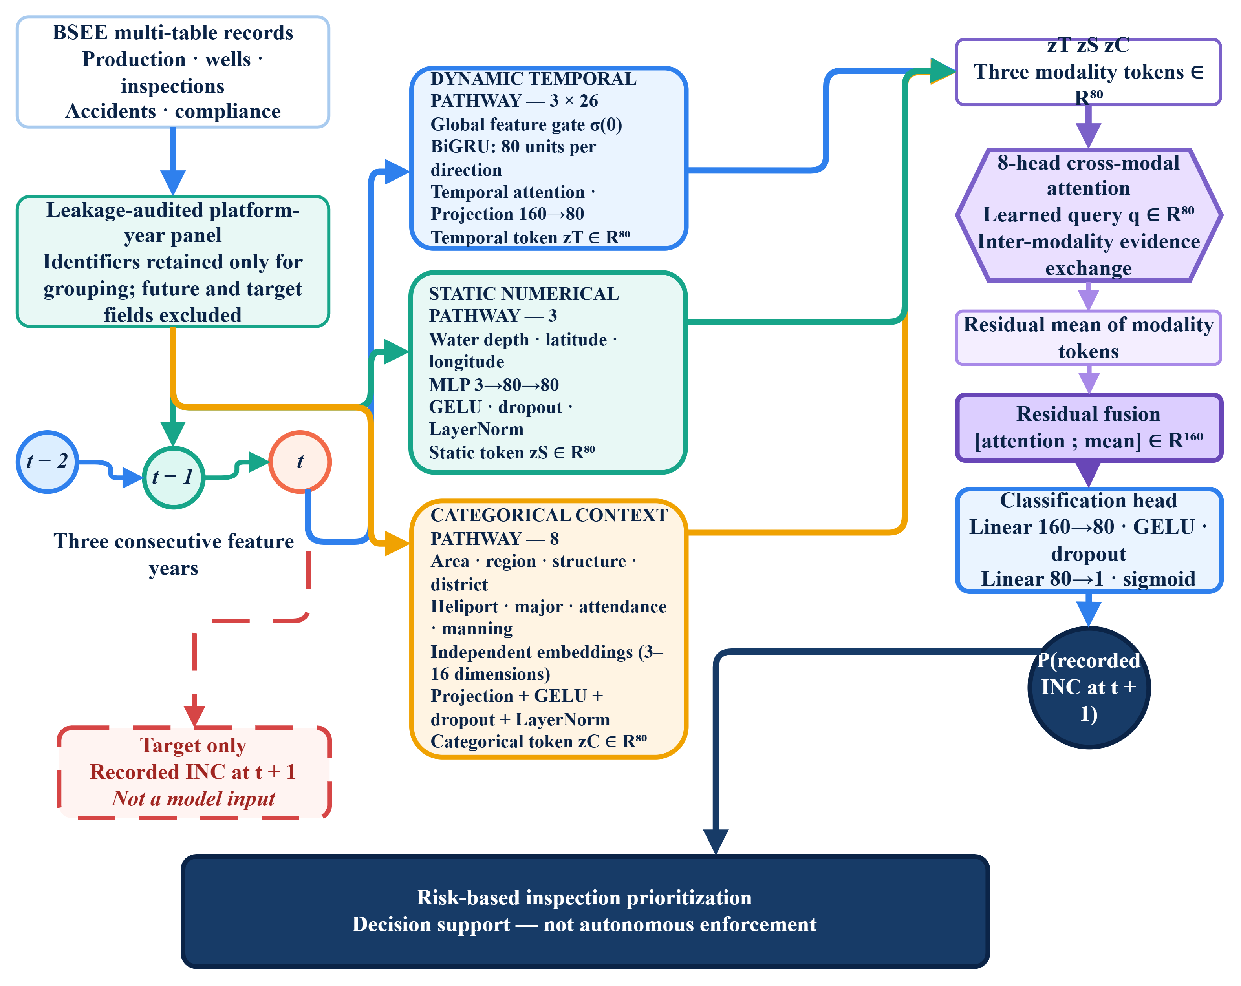
Figure 2. TECR-Net architecture evaluated retrospectively for ranking subsequent recorded INC outcomes. The diagram describes the implemented research model and does not imply validated forecasting, causal interpretation, or operational inspection prioritization.
Figure 2 traces the three feature branches and their tensor flow. The dynamic 3 x 26 history is gated, encoded by a bidirectional GRU, and summarized by temporal attention; static numerical and categorical inputs are encoded separately; and the three 80-dimensional tokens are combined by learned-query attention pooling and a residual mean before classification. The displayed gate and attention coefficients are fitted associations and are not causal explanations or validated feature-importance measures.

3.6 Optimization and Development Procedure
Alpha-balanced focal loss was applied to cope with class imbalance. For the logit z, probability p, and label y, p_t is equal to p if y = 1 and 1 − p if not, whereas the loss function is the batch-wise mean of α_t(1 − p_t)^γ multiplied by the binary cross-entropy, where α_t equals α for positives and 1 − α for negatives. The coefficient α is the ratio of negative labels in the training sequences of the fitting period (approximately 0.934 for 538 positives out of 8,200 sequences), constrained to the range from 0.55 to 0.95, and γ is the hyperparameter. The implementation leverages a gated bidirectional GRU, additive temporal attention, multi-head attention, layer normalization, AdamW optimizer, Optuna [39,40] with TPE sampler, and scikit-learn. TECR-Net hyperparameters and early stopping strategy were chosen using the 2020–2021 development cohort. For each random seed, a logistic regression model (L-BFGS solver with default L2 regularization and C = 1) implemented in scikit-learn was fitted to the output sigmoid probabilities of the 2020–2021 sequences using the Platt method but probability rather than logit inputs, after which the seven transformed values were averaged. The logits were cut off at ±30 before the sigmoid function. The probability-to-probability mapping for this transformation is referred to as Platt-like mapping as opposed to the standard logit input Platt scaling. The threshold for maximum F1 score was also chosen on the basis of the development set instead of the separate ensembles’ scores (or alternatively a quantile of 2,000 for those in excess). The ensemble threshold (0.04909, Table 8) is thus not equal to the average threshold for each of the seeds (0.04982, Table 7). The F1-maximizing threshold is a statistical convention and does not contain any considerations for the cost, benefits or budget for inspection. The original replacement tabular baseline had an inner holdout of 2018-2019 with 25 runs per model. A symmetric rerun of this process followed using the identical selection period (2018-2019), 25 trial budget and seven-seed sequence for TECR-Net, plain GRU, CatBoost, LightGBM, XGBoost, HistGradientBoosting and logistic regression. The untouched requirement has yet to be satisfied.
Table 5. TECR-Net architecture and optimization configuration
Component | Setting | Value
Dynamic encoder | One-layer bidirectional GRU | 80 units per direction
Temporal projection | Linear, GELU, layer normalization | 160 to 80
Static encoder | Two-layer MLP | 3 to 80 to 80
Categorical encoder | Eight embeddings plus projection | Embedding dimension 3–16
Cross-modal attention | Multi-head attention | 8 heads; 80-dimensional tokens
Optimizer | AdamW | Gradient norm clipped at 1.0
Scheduler | ReduceLROnPlateau | Factor 0.5; patience 4 in tuning, 5 in final fits
Dropout | Selected configuration | 0.2690
Learning rate | Selected configuration | 0.001617
Weight decay | Selected configuration | 2.439×10−5
Focal exponent γ | Selected configuration | 1.7523
Focal weight α | Fitting-period | Negative-class fraction of fitting labels, clipped to 0.55–0.95
Batch size | Selected configuration | 256
Maximum epochs | Early stopping | 100; patience 15
Hyperparameter search | Optuna TPE | 40 trials; TPE (sampler seed 2026), no pruning; objective = mean development AP − 0.25 × SD across tuning seeds 101, 202, 303
Replacement baselines | Optuna TPE | 25 trials/model on 2018–2019 inner holdout
Seeds | Repeated fitting | 11, 22, 33, 44, 55, 66, 77

The implementation configuration necessary to replicate the experiment from its archive is provided in Table 5. Explicitly specified are AdamW optimizer, adaptive learning rate decay, gradient clipping, focal loss parameters, Optuna search, and early stopping. The architecture is fixed for the seven final seeds, while initialization and mini-batch ordering are not; seed variation corresponds to stochastic training alone and not uncertainty in generalizing to a new hardware platform, year, or calibration. For Optuna search space, hidden size was {48, 64, 80, 96, 128}, GRU layers were {1, 2}, attention heads {2, 4, 8} of the hidden size, dropout was 0.12-0.38, learning rate 2×10−4 to 3×10−3 (logarithmic scale), weight decay 10−6 to 10−3 (logarithmic scale), γ was 1.25-3.0, and batch size was {128, 256, 512}. Every trial consisted of up to 75 epochs with patience 15. The chosen configuration had one GRU layer, hidden size of 80, and 8 heads. Implementation choices left out of reporting include sigmoid initialization of gates at 0.5, a learned query initialized with standard deviation 0.02, attention dropout being equal to model dropout, and categorical embeddings sizes min(16, max(3, √cardinality)). Excluding the categorical embeddings and encoder, the model has at least 123,788 trainable parameters. Because TECR-Net selection, probability mapping, threshold determination, and reporting used the same development period, the resulting estimates may be optimistic for unseen data.

3.7 Evaluation Measures
Average precision (AP), computed by sklearn.metrics.average_precision_score, is the main measure without any threshold since positives are scarce. Formerly archived figures and files had been labeled with a vague precision-recall name for this measure; the updated paper refers to AP because average precision is not equivalent to the trapezoid area under the precision-recall curve. When working with very imbalanced binary responses, the precision-recall approach focuses on positive gains and is more revealing than the ROC approach. ROC-AUC reflects ranking through all possible thresholds. F1, F2, precision, recall, specificity, balanced accuracy, MCC, and the confusion matrix rely on the threshold set during development. Brier score reflects squared probability error, while Brier skill is one minus model Brier score over constant-reference Brier score. The constant reference is the development prevalence. Precision and lift at k = 50, 100 and 200 refer to ranked platform-year pairs rather than guaranteed distinct platforms. Probability and calibration measures are reported only as apparent development diagnostics.
Table 6. Development metrics and interpretation
Metric | Type | Role
AP | Threshold-free | Primary ranking measure for rare positive outcomes
AP/prevalence | Threshold-free | Improvement over random prevalence baseline
ROC-AUC | Threshold-free | Global ranking discrimination
F1 and F2 | Threshold-dependent | Balance of precision and recall; F2 emphasizes recall
Precision and recall | Threshold-dependent | Yield and coverage of predicted positives
Balanced accuracy | Threshold-dependent | Mean sensitivity and specificity
MCC | Threshold-dependent | Correlation-like summary robust to imbalance
Brier score | Probability-based | Mean squared probability error
Precision@k | Budget-based | Observed yield among k highest-ranked sequences

Table 6 contrasts ranking metrics with threshold-dependent metrics. It is important to understand that the threshold used was chosen on development data. AP and ROC-AUC are order-based metrics, while F1 and the confusion matrix are order-based metrics that also consider the choice of operating point. Platform-clustered bootstrap confidence intervals are calculated on predictions based on paired bootstrap sampling of platforms. The archived evidence does not include a complete trace of the number of replicates, seed, treatment of zero-positive replicates, and higher-level operator/year/bootstraping. As such, the confidence intervals are considered descriptive archived outputs rather than independently reproducible confirmation.
3.8 Prototype Research Interface
The created interface was intended only for demonstration purposes for entering data and presenting results; no other purpose such as cohort creation, training, selection or evaluation was served by this interface. The required input years for the interface include t-2, t-1, and t; however, the recorded-INC result year is t+1 and does not go into the input tensor. Interface should be able to read the threshold, feature order, preprocessing object, and probability mapping function from the same manifest. Threshold value in the frozen manifest is 0.04908876769816646, mean seed threshold 0.04982 and symmetric-rerun threshold 0.07110931251823678 belong to different analytical models and hence are for comparisons only and not operating controls. No display of the interface is a validation or calibration.
The interface was developed only to demonstrate how archived research outputs could be displayed. It was not evaluated for usability, probability calibration, operational effectiveness, or regulatory decision support. Any displayed score or threshold band is an illustrative model output and must not be interpreted as an absolute probability, safety category, or validated inspection-priority class.

(a)

(b)
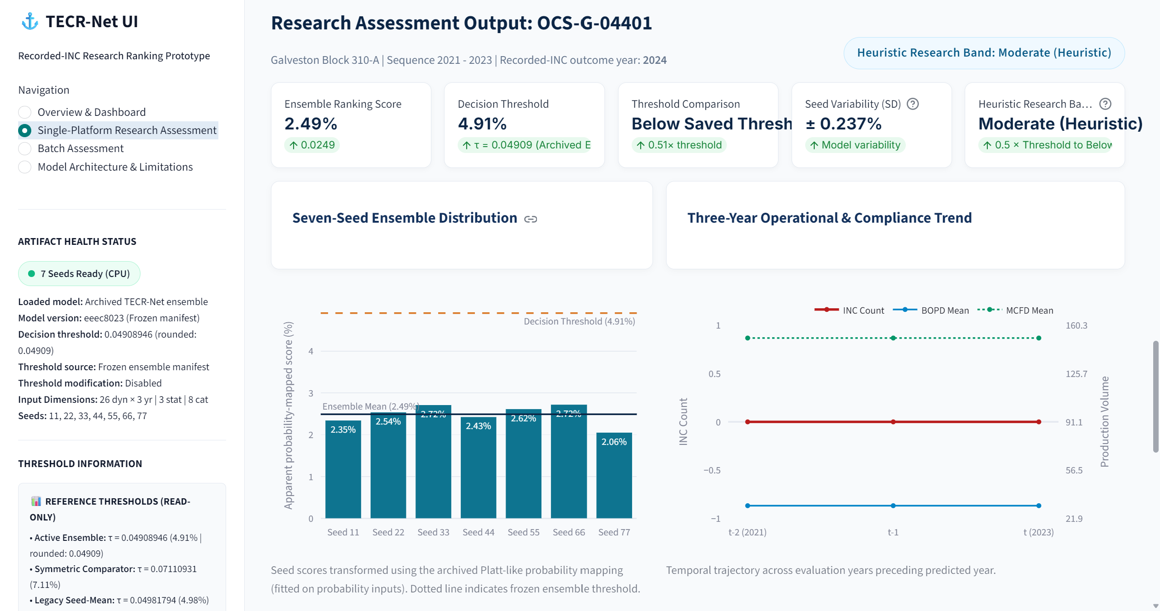
(c)
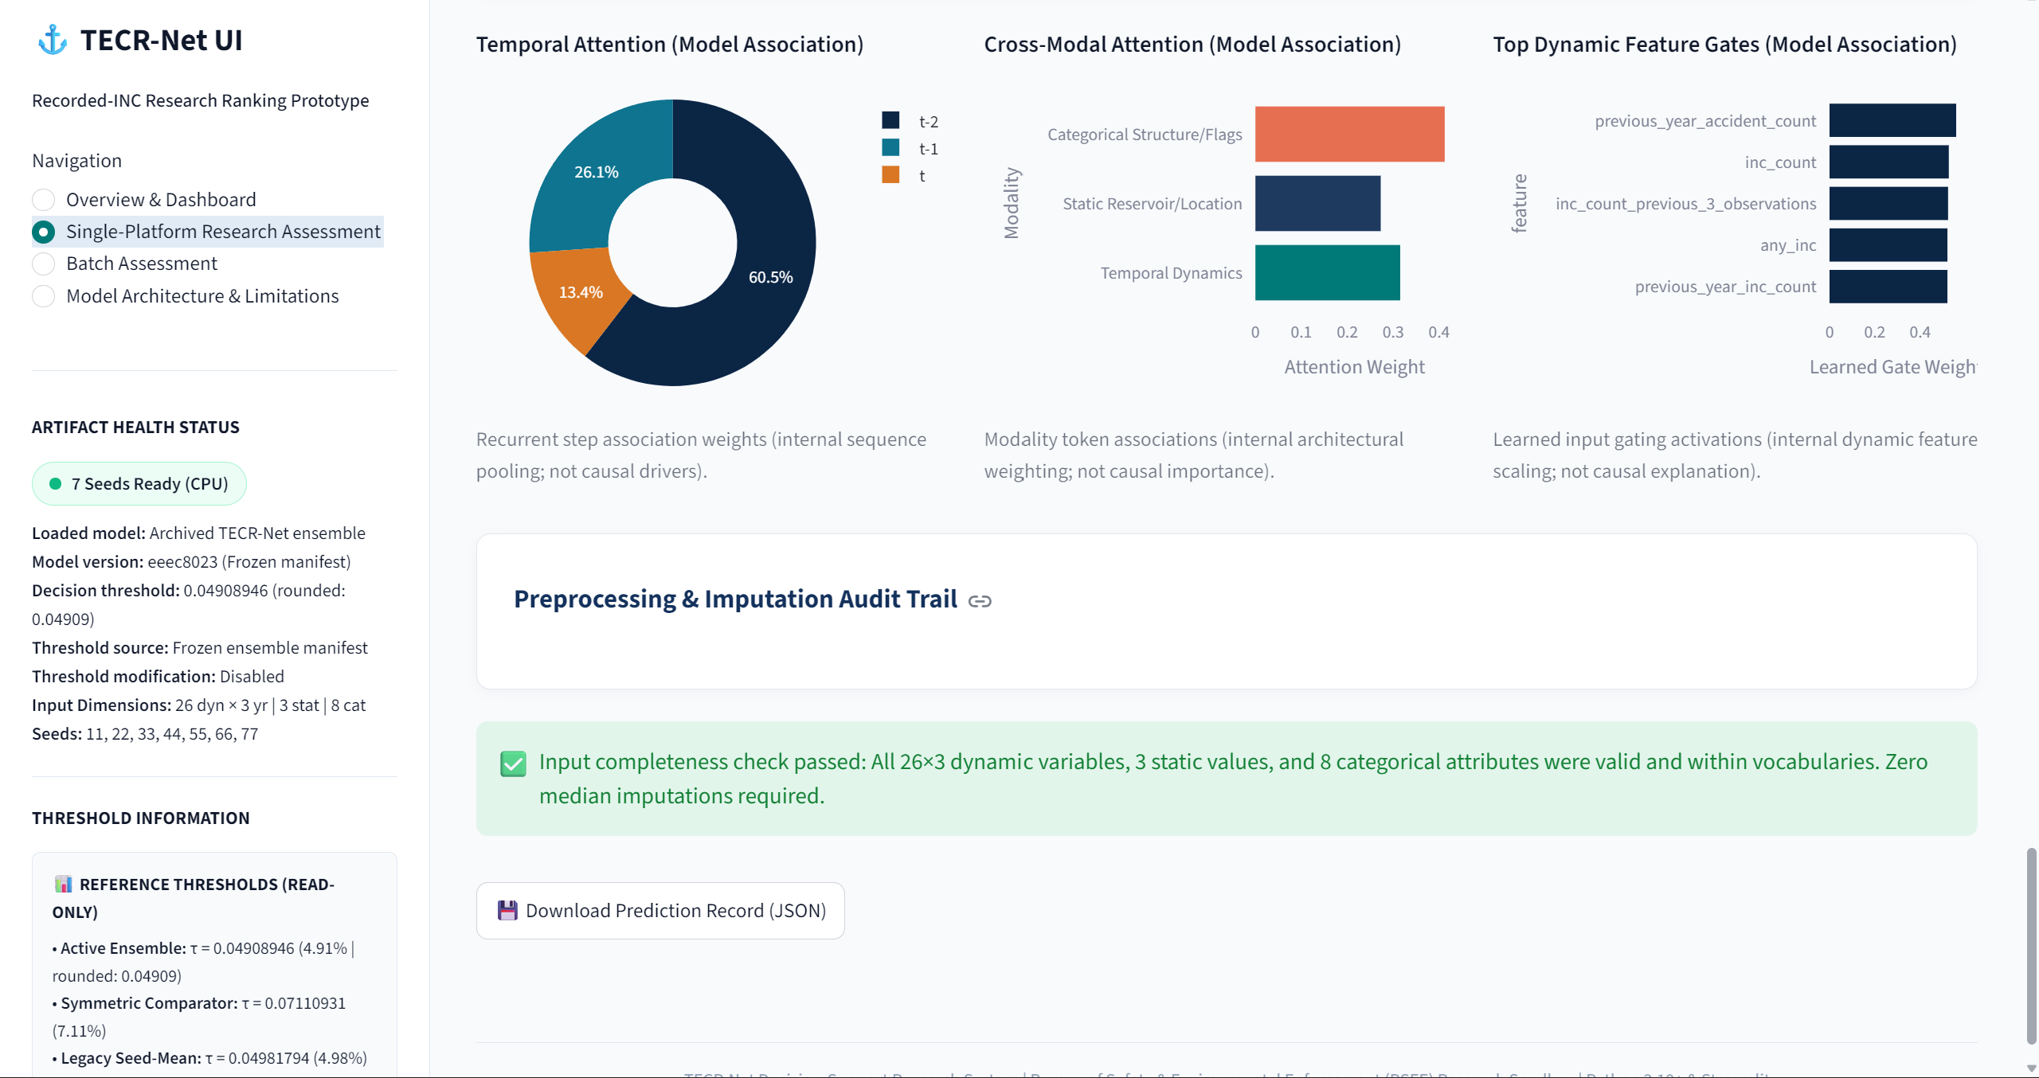
(d)
Figure 3. Prototype research interface displaying archived development outputs. Scores, bands, gate values, and attention displays are illustrative fitted quantities and are not validated probabilities, causal explanations, regulatory risk categories, or evidence of independent validation, usability, or operational effectiveness.
Figure 3 illustrates the intended interface workflow. Panel (a) summarizes the frozen seven-seed configuration and research-only scope. Panel (b) separates display-only identifiers from the t−2, t−1 and t model inputs and the t+1 recorded-INC outcome year. Panel (c) reports the ensemble ranking score, the manifest-matched threshold and seed-level variability. Panel (d) presents internal attention and gating quantities with explicit non-causal interpretation. Before publication, the screenshots must show the exact threshold associated with the loaded model package and must not describe any previously inspected cohort as independent evaluation.

4. Results
The 2020–2021 cohort supported hyperparameter selection, early stopping, probability mapping, threshold selection and performance reporting. Consequently, all results from this cohort are apparent development estimates rather than independent validation estimates. Confidence intervals reported in this section are development-cohort bootstrap intervals; they describe sampling uncertainty within the development cohort, not generalization.

4.1 Multi-Seed Stability
Table 7. Apparent development-cohort seed-level performance across seven TECR-Net fits
Metric | Mean | SD | Mean ± SD
Prevalence | 0.03556 | 0.00000 | 0.03556 ± 0.00000
AP | 0.07401 | 0.00775 | 0.07401 ± 0.00775
AP/prevalence | 2.08109 | 0.21780 | 2.08109 ± 0.21780
ROC-AUC | 0.63115 | 0.01119 | 0.63115 ± 0.01119
F1 | 0.12080 | 0.01976 | 0.12080 ± 0.01976
F2 | 0.15060 | 0.04063 | 0.15060 ± 0.04063
Precision | 0.10295 | 0.02972 | 0.10295 ± 0.02972
Recall | 0.22175 | 0.14861 | 0.22175 ± 0.14861
Balanced accuracy | 0.56197 | 0.02388 | 0.56197 ± 0.02388
Specificity | 0.90219 | 0.11113 | 0.90219 ± 0.11113
MCC | 0.08918 | 0.01780 | 0.08918 ± 0.01780
Brier score | 0.03407 | 0.00004 | 0.03407 ± 0.00004
Threshold | 0.04982 | 0.00516 | 0.04982 ± 0.00516
Precision@50 | 0.10857 | 0.02545 | 0.10857 ± 0.02545
Precision@100 | 0.08571 | 0.02225 | 0.08571 ± 0.02225
Precision@200 | 0.05857 | 0.01180 | 0.05857 ± 0.01180
The mean AP of the development data using TECR-Net was 0.07401 +/- 0.00775, and ROC-AUC was 0.63115 +/- 0.01119 over seven random seeds. Recall was highly varied over the seven seeds (SD 0.14861), suggesting that the behavior of the algorithm is sensitive to initialization and training variability. These are the metrics of stochasticity present in the adaptive development set; they are not confidence intervals, and therefore not indicative of independent generalization.
Figure 4 gives an overview of the threshold-dependent behavior of the seven-seed ensemble on the development set. The confusion matrix is presented as well since the regulator needs to know how many positive cases were missed and false alarms produced at the chosen threshold value.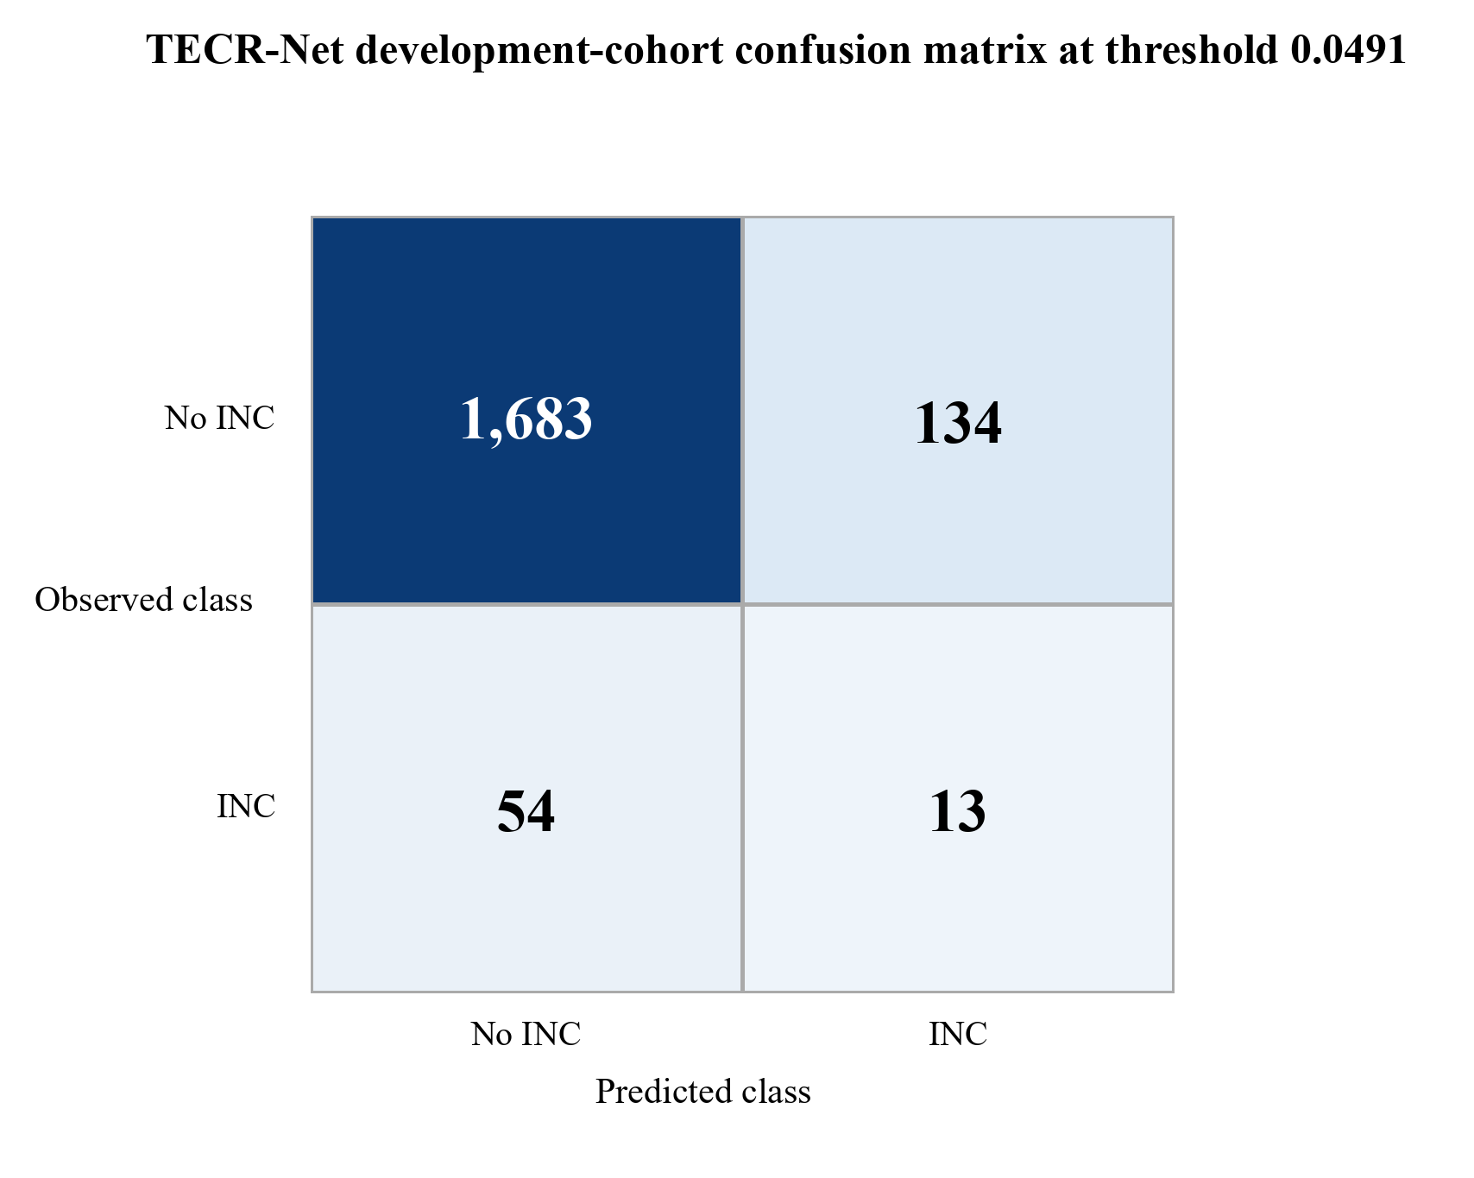

Figure 4. Development-cohort confusion matrix for the probability-mapped seven-seed TECR-Net ensemble.

As can be seen from Figure 4, there are 1,683 true negatives, 134 false positives, 54 false negatives, and 13 true positives when the cutoff value is 0.0491. Since there is a very high specificity as most negative sequences are below the cutoff value, it seems that a priority-based interpretation is possible.

4.2 Ensemble Discrimination and Risk Ranking
Table 8. Apparent seven-seed ensemble metrics on the development cohort
Metric | Value | Metric | Value
Prevalence | 0.03556 | AP/prevalence | 2.114×
AP | 0.07518 | ROC-AUC | 0.63855
F1 | 0.12150 | F2 | 0.15663
Precision | 0.08844 | Recall | 0.19403
Specificity | 0.92625 | Balanced accuracy | 0.56014
MCC | 0.08305 | Brier score | 0.03406
Threshold | 0.04909 | TN / FP / FN / TP | 1683 / 134 / 54 / 13
Precision@50 | 0.080 | Lift@50 | 2.250×
Precision@100 | 0.080 | Lift@100 | 2.250×
Precision@200 | 0.070 | Lift@200 | 1.968×
In Table 8, ensemble AP is 0.07518, or 2.11 times the 3.56% prevalence in development. In the 50 highest-ranking platform-year combinations, 4 were known to have positive results, giving a Precision@50 of 0.080, with about 2.25 times enrichment. There might be repeated measures from the same physical platform, and thus this is not the yield from 50 different platforms. The absolute yield is low and serves just as a prioritization purpose.
Figure 5 demonstrates discrimination independent of an operating point. The ROC curve describes sensitivity as a function of the false-positive rate, while the PR curve gives more information on the rare positive event because it is compared to the cohort prevalence.
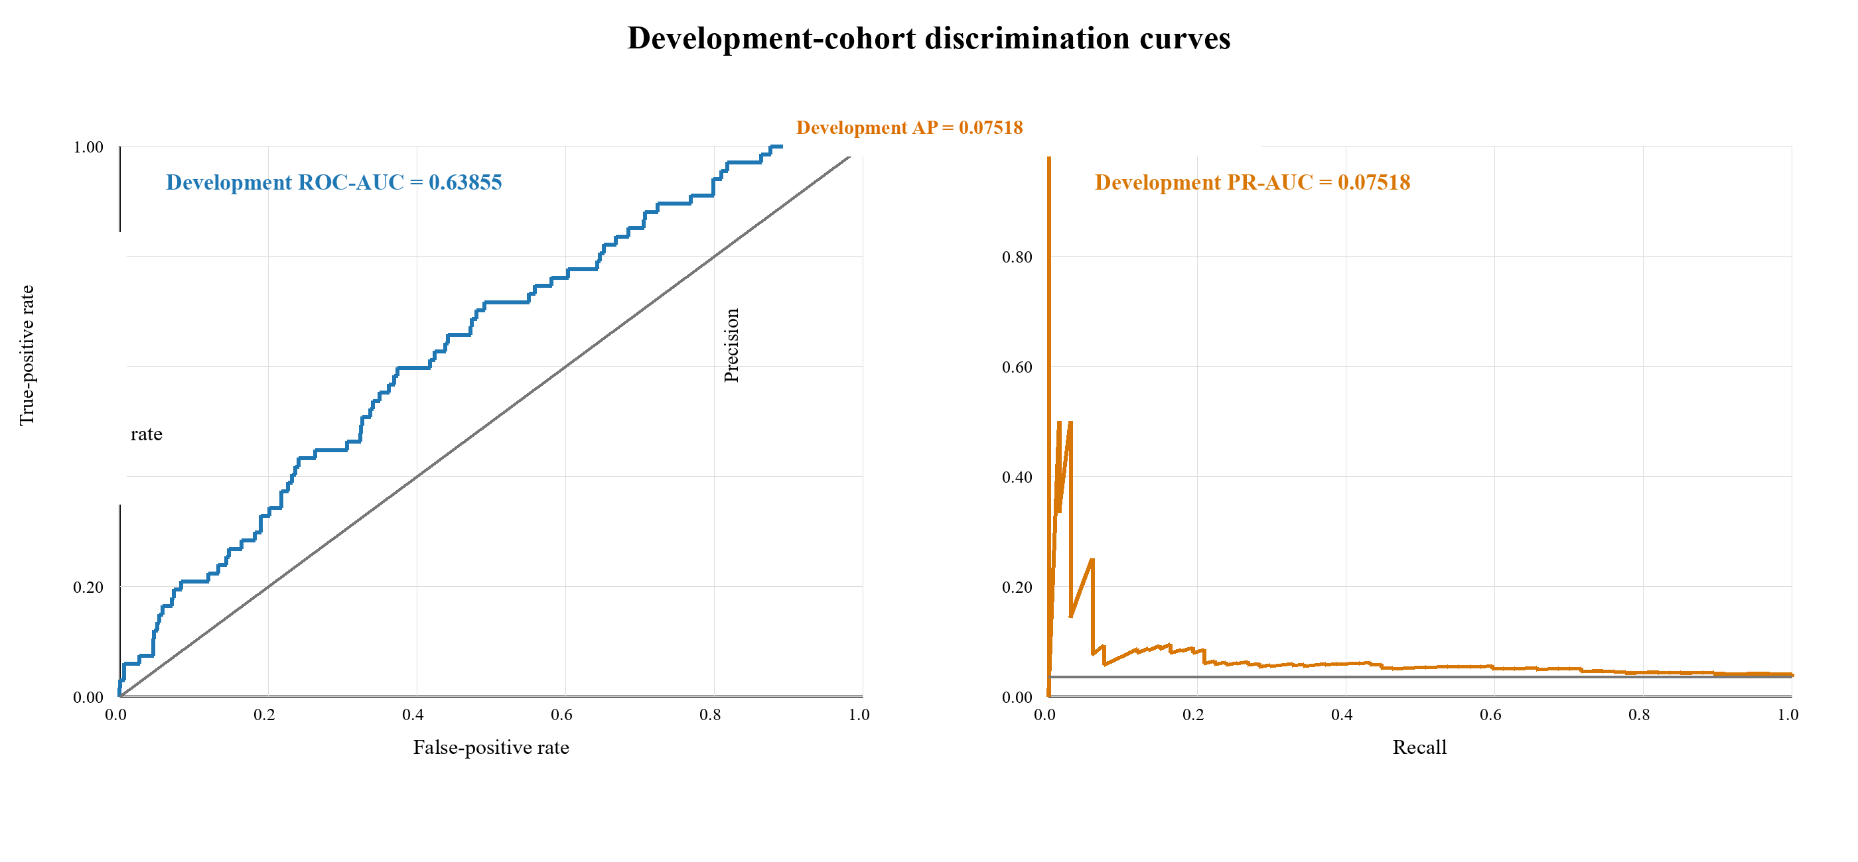
Figure 5. Development-cohort ROC and precision-recall curves from the probability-mapped seven-seed ensemble. The reported precision-recall summary is average precision.
Figure 5 shows development ROC-AUC of 0.63855 and AP of 0.07518. The ROC curve lies above the random diagonal, and the precision-recall curve exceeds the 0.03556 prevalence reference over part of the recall range. These are limited apparent development results and do not demonstrate operationally useful discrimination on unseen data.

4.3 Mean Development Metrics and Learning Behaviour
Figure 6 places the principal development measures and their between-seed variability on a common scale. The visualization is intended to distinguish stable ranking behaviour from the greater stochastic sensitivity of threshold-dependent precision and recall, rather than to suggest that numerically larger metrics are directly interchangeable.
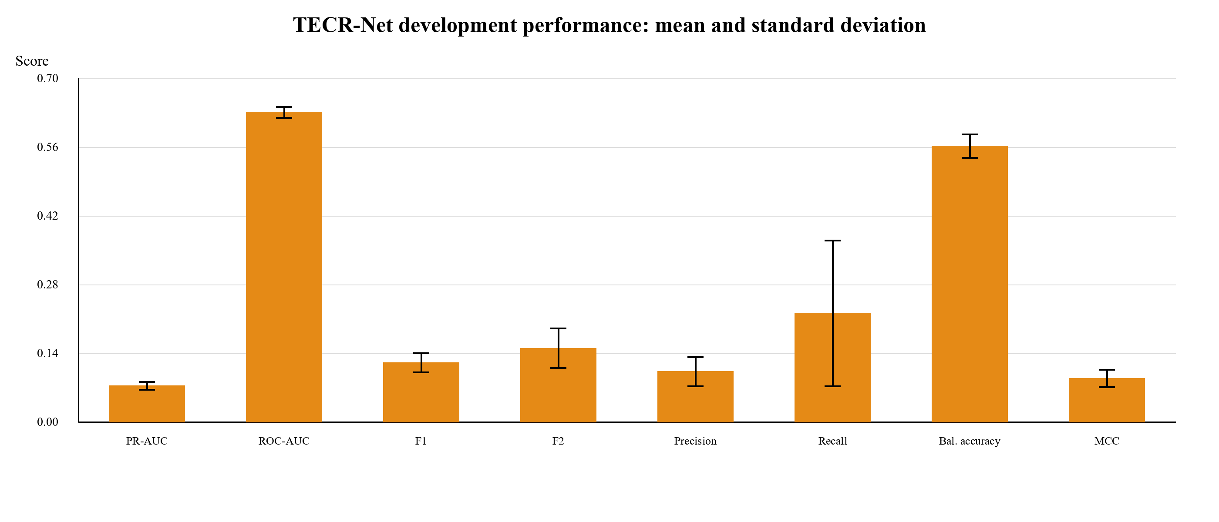
Figure 6. Seed-level development metrics across seven TECR-Net fits, reported as mean with one-standard-deviation error bars.
Threshold-Free Ranking vs. Threshold-Based Classification is illustrated in Figure 6. ROC-AUC is greater than both AP and F1 metrics, but they do not measure the same thing and thus cannot be compared using their numerical value. Small values of AP and F1 indicate low positive output in a population of rare outcomes, and the high recall variability indicates that the chosen operating point is stochastic. Seed variability is not a confidence interval.
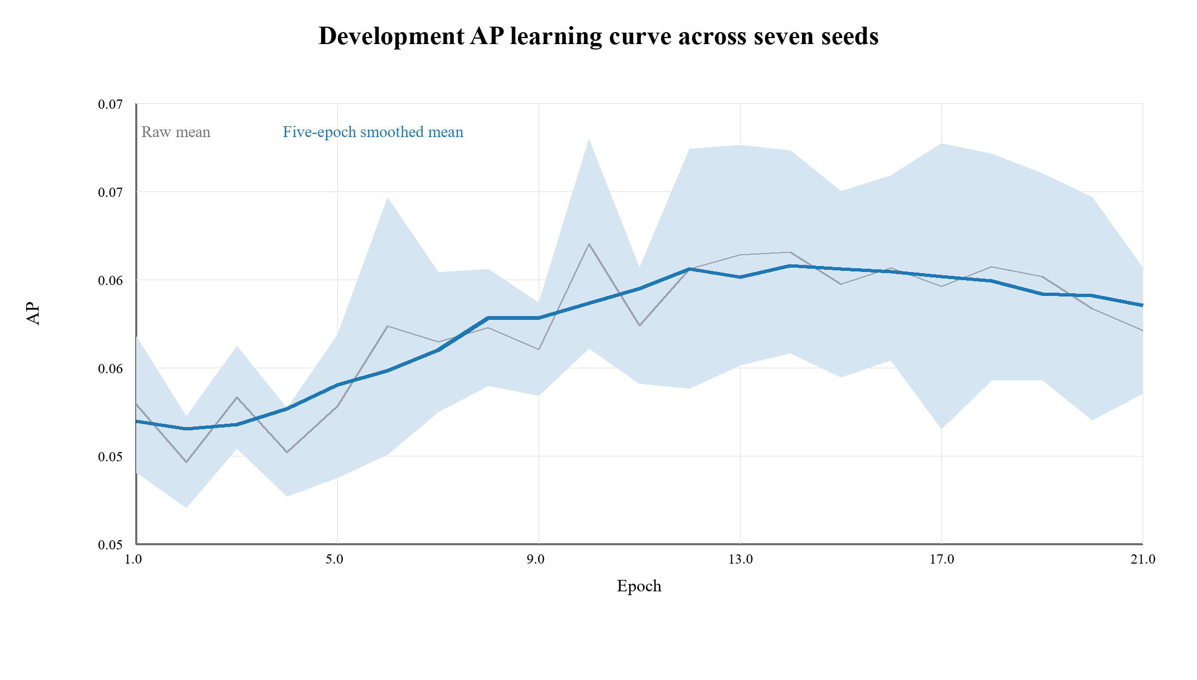
Figure 7. Seed-averaged development AP learning curve restricted to epochs completed by every seed.

Figure 7 displays an early increase in the mean AP development followed by leveling off and a slight decrease. This curve represents the mean value which is limited to epochs that have been completed by each seed included in the plot; it is smoothed over five epochs, and the uncertainty interval represents the variance between seeds at aligned epochs. It does not represent the average of selected best epochs. The lower peak displayed in Figure 7 compared with Table 7 stems from this fact.

4.4 Sequence-Aligned Development Baselines
Table 9 shows the results of the post-hoc symmetric eight-model benchmark on the same 1,884 development rows and 67 labels. All tunable models were optimized using the same inner-temporal AP criterion for 2018–2019, 25 Optuna trials, seven seeds, per-seed probability mapping and threshold-setting strategy; persistence was fixed beforehand. The set of compared models is composed of TECR-Net, bare GRU, four tree-based boosting techniques, logistic regression with regularization and administrative persistence criteria.
Table 9. Symmetric eight-model development-cohort benchmark on identical archived rows
Model | AP | ROC-AUC | F1 | Precision | Recall
TECR-Net | 0.05897 | 0.64408 | 0.12188 | 0.07483 | 0.32836
Plain GRU | 0.04873 | 0.56032 | 0.09026 | 0.05367 | 0.28358
CatBoost | 0.05153 | 0.62386 | 0.05085 | 0.05882 | 0.04478
LightGBM | 0.04694 | 0.62899 | 0.05333 | 0.04819 | 0.05970
XGBoost | 0.05035 | 0.62897 | 0.04819 | 0.04040 | 0.05970
HistGradientBoosting | 0.04891 | 0.62539 | 0.01408 | 0.01333 | 0.01493
Logistic regression | 0.04209 | 0.56141 | 0.06618 | 0.04390 | 0.13433
Persistence | 0.03874 | 0.52108 | 0.07634 | 0.07812 | 0.07463

The primary full probability-mapped TECR-Net ensemble reported elsewhere in this study has apparent development AP of 0.07518. Table 9 addresses a separate post-hoc symmetric cohort benchmark, in which TECR-Net produced AP of 0.05897, followed by CatBoost at 0.05153, XGBoost at 0.05035, HistGradientBoosting at 0.04891, plain GRU at 0.04873, LightGBM at 0.04694, logistic regression at 0.04209, and persistence at 0.03874. The value 0.07518 characterizes the primary full ensemble, whereas 0.05897 characterizes TECR-Net within the separate symmetric benchmark. Because the procedures differ, the two AP estimates are not interchangeable, and neither establishes statistical or external superiority.
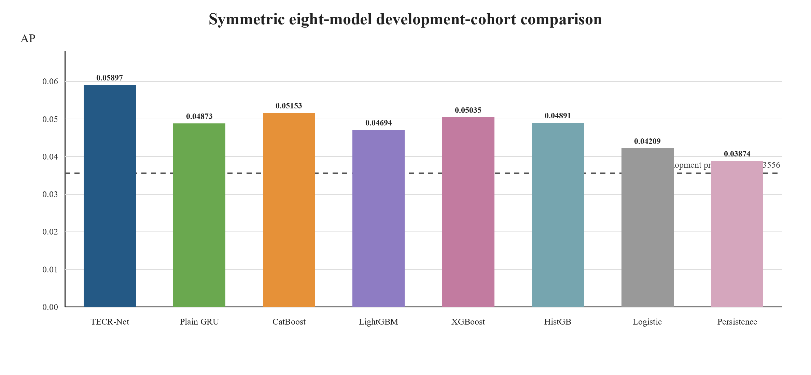
Figure 8. Average precision in the symmetric eight-model archived development-cohort benchmark.
Figure 8 displays observed AP values from the separate symmetric eight-model archived development benchmark. The TECR-Net bar represents the benchmark AP of 0.05897 and should not be interpreted as the primary full-ensemble AP of 0.07518 reported in Table 8 and Table 10. All benchmark values exceed the cohort prevalence reference of 0.03556, but they were obtained after adaptive development and were not confirmed on untouched data. They are therefore descriptive rather than evidence of superiority.
4.5 Architectural Ablation
Table 10 reports the full model and six component-removal variants using development results only.
Table 10. Development-cohort architectural ablation using saved ensemble outputs
Variant | AP | ROC-AUC
Full TECR-Net | 0.07518 | 0.63855
Without categorical encoder | 0.07374 | 0.60503
Without cross-modal attention | 0.07494 | 0.63760
Without feature gate | 0.06652 | 0.63832
Without GRU | 0.05556 | 0.63252
Without residual fusion | 0.07150 | 0.64479
Without temporal attention | 0.06938 | 0.63824

The removal of GRU resulted in the largest change in AP, decreasing from 0.07518 to 0.05556. The removal of feature gating and temporal attention resulted in lower changes, while the removal of cross-modal attention resulted in an AP change of only 0.00024. The removal of the categorical encoder led to a small decrease in AP to 0.07374, but a larger decrease in ROC-AUC from 0.63855 to 0.60503, indicating that the categorical context had more impact on ROC-AUC than the rare-event AP measure in this study. Removal of residual fusion lowered AP to 0.07150 but raised ROC-AUC to 0.64479.
Since the reduced models were not optimized through an independently validated hyperparameter search process, these results indicate sensitivities, not causative effects or necessities.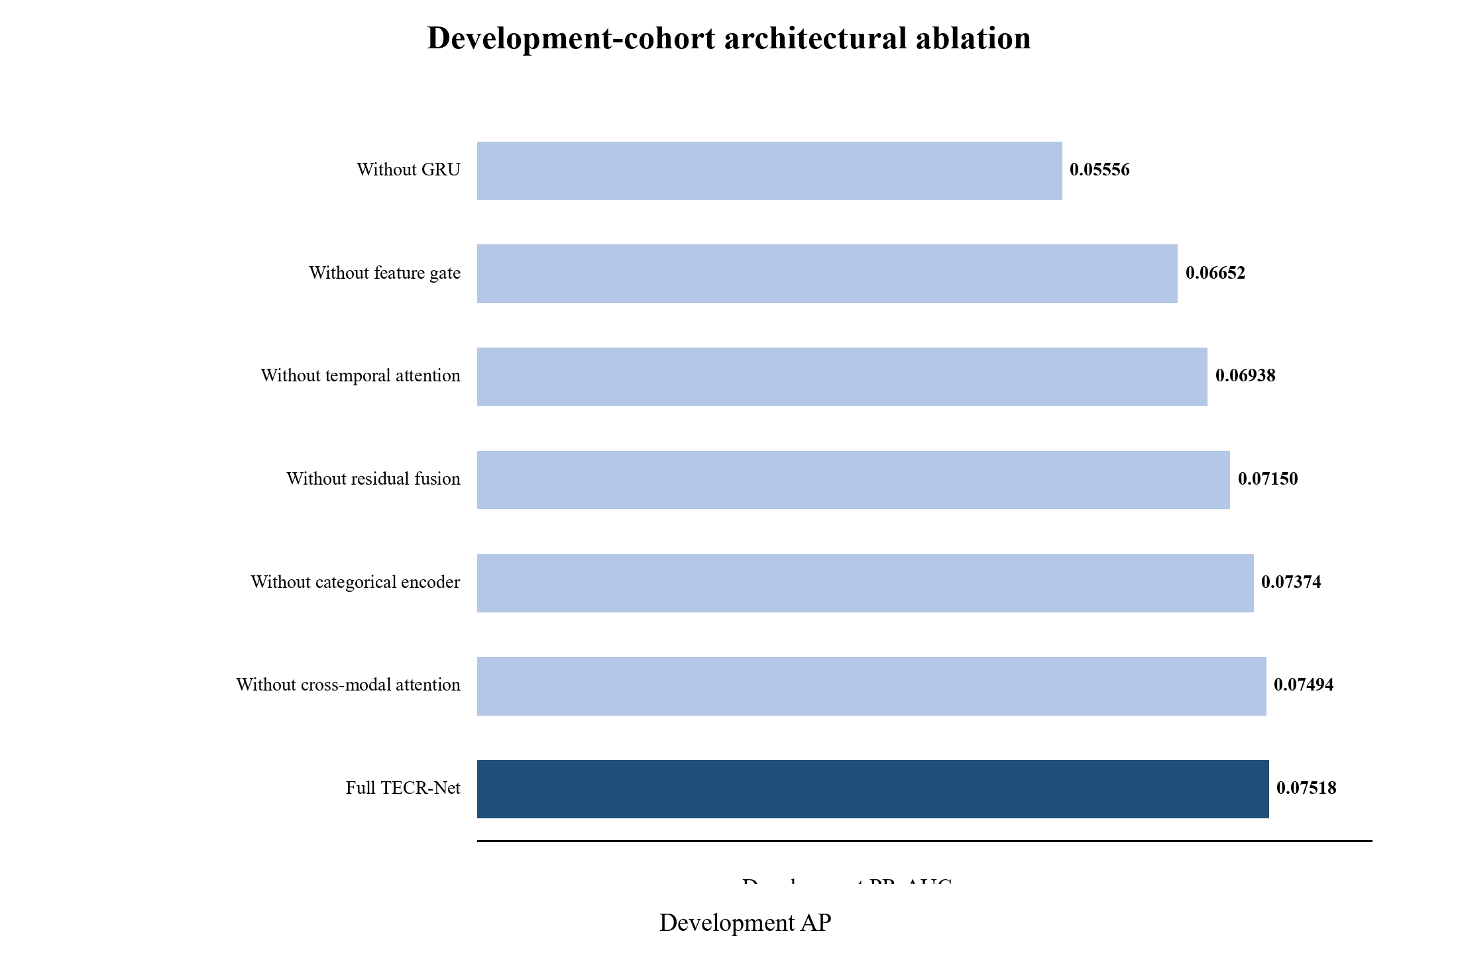
Figure 9. Development-cohort ensemble AP for the full TECR-Net and six component-removal variants.
Figure 9 makes the recurrent encoder contribution most visible: the no-GRU variant approaches the prevalence baseline more closely than the other variants. The small difference between the full model and removal of cross-modal attention indicates that this module contributes less development AP than the recurrent pathway, even though it may affect threshold-dependent behaviour.

4.6 Accident-Feature Sensitivity
Table 11 evaluates whether the primary development result depends on the three coarse lease-level accident proxies. Both variants use the same 1,884 sequences, 982 platforms, 67 positive labels, architecture, seven seeds, and probability-ensemble procedure.
Table 11. Development-cohort sensitivity to lease-level accident proxies
Variant | AP | ROC-AUC | F1 | Precision | Recall | MCC | P@50
Full TECR-Net | 0.07518 | 0.63855 | 0.12150 | 0.08844 | 0.19403 | 0.08305 | 0.080
Without lease-level accident proxies | 0.07478 | 0.62849 | 0.12091 | 0.07273 | 0.35821 | 0.09248 | 0.100

The removal of the three proxies for accident at the lease level caused the value of AP to change from 0.07518 to 0.07478 with an approximation of 0.00040 from the full minus reduced values. The 95% bootstrap confidence interval using paired platforms in clusters was between −0.02183 and 0.02153 with zero being within the range. There is a recall value that rose from 0.19403 to 0.35821 and a precision value that declined from 0.08844 to 0.07273, which shows that there were changes in the operating compromise due to the proxies.

4.7 Development Uncertainty and Apparent Calibration
Table 12 reports dependence-aware uncertainty and limited probability diagnostics calculated from the development ensemble predictions. Because the probability mapping was fitted on the same period, these quantities are apparent rather than independently validated calibration estimates.
Table 12. Platform-clustered development uncertainty and apparent calibration diagnostics
Diagnostic | Estimate | 95% development-cohort bootstrap interval / basis | Interpretation
AP | 0.07518 | 0.04269–0.12568 | Primary rare-event ranking
ROC-AUC | 0.63855 | 0.57197–0.70213 | Limited apparent discrimination
Brier score (apparent) | 0.03406 | 0.02671–0.04211 | Probability error
Brier skill score | 0.00692 | Reference = 0.03430 | Gain over constant prevalence
Calibration intercept | 2.57119 | Apparent | Ideal value 0
Calibration slope | 1.79530 | Apparent | Ideal value 1
Precision@50 | 0.080 | 0.000–0.191 | 50 highest-ranked sequences
Precision@100 | 0.080 | 0.020–0.140 | 100 highest-ranked sequences
Precision@200 | 0.070 | 0.035–0.115 | 200 highest-ranked sequences
Development prevalence | 0.03556 | 67 / 1,884 | Rare outcome

The archived probability mapping pipeline was compared to the saved pipeline: logits are truncated to ±30, transformed to probabilities through the sigmoid function, independently mapped for each seed through a regularized logistic regression (L-BFGS, C = 1, intercept included) with the raw probability as the sole input, and averaged across the seven probability maps. The intercept of 2.57119 and slope of 1.79530 obtained here are descriptive estimates from the development set and deviate significantly from the ideal intercept and slope of 0 and 1 respectively. This implementation check clears up the order of transformations but lacks a separate calibration check. The low Brier score is at least partially attributable to low prevalence, while the reference prediction employs retrospective prevalence figures.
The apparent calibration diagnostics are unfavorable: the intercept and slope differ from their ideal values, and the model Brier score of 0.03406 is only about 0.7% lower than the constant-prevalence reference of 0.03430. Because mapping and assessment used the same development cohort, the scores must not be interpreted as calibrated absolute probabilities. AP and ROC-AUC describe ranking on the development data, whereas the Brier score, reliability diagram, intercept, and slope are apparent development characteristics only.

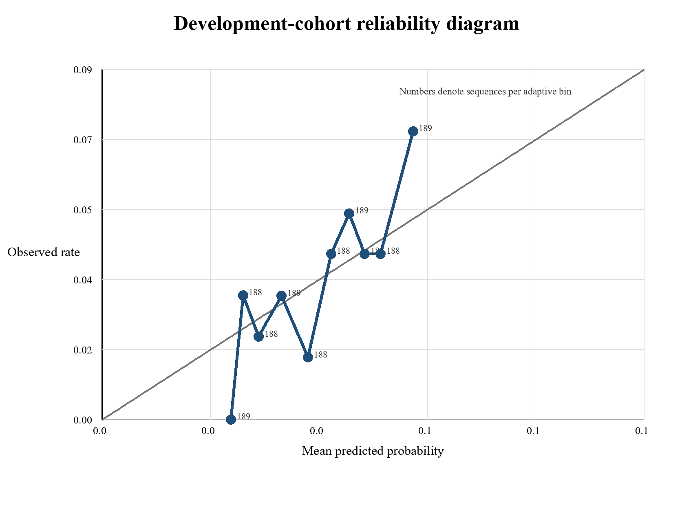
Figure 10. Apparent development-cohort reliability diagram from probability-mapped ensemble scores using ten equal-frequency bins.
Figure 10 compares mean mapped scores with observed outcome rates and labels each bin by sequence count. Departures from the diagonal, together with the calibration intercept of 2.57119 and slope of 1.79530, show that the score scale should not be interpreted as independently calibrated absolute risk. Because the logistic mappings were fitted on this same cohort, the figure represents apparent in-sample behaviour.
4.8 Exploratory Chronological Later-Cohort Findings
The archived TECR-Net experiment had a follow-up cohort, which spanned the feature years 2022 to 2024. This comprised 2,196 sequences on 876 platforms, of which 94 had recorded-INC results that were positive. The computed values of ensemble metrics were AP = 0.10318, ROC-AUC = 0.65592, precision = 0.12583, recall = 0.20213, F1 = 0.15510, and Brier score = 0.04068. Since this particular cohort was investigated multiple times during model development, it cannot be considered an independent verification cohort. Hence, there is no external validation of this model either.
Table 13. Exploratory probability-mapped results for the repeatedly inspected 2022–2024 cohort
Metric | Exploratory result
Sequences | 2,196
Platforms | 876
Positive outcomes | 94
Prevalence | 0.04281
AP | 0.10318
ROC-AUC | 0.65592
Precision | 0.12583
Recall | 0.20213
F1 | 0.15510
Brier score | 0.04068
ECE (recalculated) | 0.018004
MCE | 0.067951
Table 13 shows slightly higher discrimination than in the development cohort, but the difference must not be interpreted as prospective improvement because the later cohort influenced subsequent analytical choices. The recalculated calibration errors are non-zero, and no operational claim follows from these exploratory values. A new prospective BSEE release or compatible external cohort remains necessary for confirmatory evaluation.
Feature year 2024 has its target in 2025, and completeness of the 2025 outcome records could not be verified; later-cohort estimates that include feature year 2024 should therefore be interpreted with caution.

5. Discussion
The primary archived probability-mapped TECR-Net ensemble produced apparent development AP of 0.07518 and ROC-AUC of 0.63855 on the adaptively reused 2020-2021 cohort. At its selected threshold, 54 of 67 positive outcomes (80.6%) were missed, 134 of 147 predicted-positive sequences (91.2%) were negative, and 4 of the 50 highest-ranked sequences were positive. These results do not establish an efficient inspection-allocation rule. The separate post-hoc symmetric cohort benchmark produced TECR-Net AP of 0.05897; this lower value reflects a different comparison procedure and does not replace the primary full-ensemble estimate of 0.07518. Because the cohort was reused and no paired confirmation was performed on untouched corrected data, neither result establishes superiority. Component-removal findings likewise indicate sensitivity rather than architectural necessity: removing the GRU produced the largest AP decrease, whereas removing learned-query attention pooling changed AP by only 0.00024.
The interpretation is deliberately narrow. A recorded INC is an administrative enforcement outcome observed through inspection, reporting, and adjudication processes; it is not a direct measure of latent violation, safety, or fitness for production. The corrected reconstruction removes the future-year production-continuity requirement and corrects identified date-parsing problems, but it does not establish historical as-of-date validity, complete negative-outcome ascertainment, comparative model performance, independent calibration, or prospective usefulness.

6. Limitations
- Cohort Construction, Data Provenance, and Historical Eligibility: Even though the cohort construction increased the consistency of the data, resolved date parsing issues with INC dates, and dropped the necessity of production continuity the following year, there are still some uncertainties in terms of methodology. The original criteria were no longer available to be reconstructed, and historical eligibility for the regulation has not been confirmed independently for each platform year. Also, many of the structural and administrative variables come from subsequent data releases, whose exact dates and time of release are unknown.
- Model Comparison and Architectural Assessment: Seven seeds characterize stochastic training variation, not uncertainty across independent cohorts. Symmetric model comparisons and component removals were performed on the archived development data and do not establish predictive superiority or architectural necessity. Equivalent corrected-cohort comparisons, a tuned simple-concatenation model, fairly tuned ablations, and confirmation on an untouched cohort remain absent. Dependence among platform, operator, and lease records further limits conventional uncertainty estimates.
- Evaluation and Outcome Validity: Independent evaluation is not possible due to the use of the development cohorts to select the model and the reevaluation of the historical cohorts. In addition, the target for prediction is Incidents of Non-Compliance that have been documented as opposed to the actual regulatory violation, and missing inspections and reporting information can impact the labeling process. An evaluation methodology has been developed for the future, although there has been no independent evaluation of an untapped cohort with adequate maturity of the outcome.
- Probability Calibration, Interface Consistency, and Reproducibility: Probability mapping and the operating threshold were fitted using development observations, so calibration and threshold performance have not been independently assessed. The interface screenshots are illustrative and were not independently validated against a frozen corrected model package. Corrected-model checkpoints, preprocessing objects, calibrator, and threshold artifacts were not preserved and must be regenerated before a complete reproducibility package can be released.

7. Conclusion

This study documents TECR-Net as a retrospective method for ranking next-year recorded BSEE INC outcomes from exact three-year platform histories. The primary full probability-mapped ensemble produced apparent development AP of 0.07518 and ROC-AUC of 0.63855. A separate post-hoc symmetric eight-model cohort benchmark produced TECR-Net AP of 0.05897 and ROC-AUC of 0.64408 under a different procedure. The full-ensemble AP of 0.07518 is the principal TECR-Net estimate in this manuscript; the benchmark AP of 0.05897 is retained only for the protocol-specific comparator analysis. Neither estimate constitutes independent validation, and the values must not be combined. The corrected cohort reconstruction removes the future-year production-continuity requirement and corrects identified mixed-format INC dates, but it has not yet received equivalent model comparisons. Historical predictor availability, negative-outcome completeness, independent calibration, and an untouched mature-outcome evaluation remain unresolved. The defensible contribution is therefore the documented cohort reconstruction and retrospective development analysis, not a validated forecasting system or operational inspection tool.

Availability of Data and Code and Declarations. The data used in this study originate from public BSEE records. Archived materials include sequence indexes, model predictions, preprocessing parameters, weights, and internal replay reports for the frozen archived pipeline. These materials do not establish independent validity. Corrected-model weights and the associated preprocessing, calibration, and threshold artifacts were not preserved and must be regenerated and verified before release as a reproducibility package. Repository location, source-code version, environment and hardware details, licensing, funding, conflicts of interest, author contributions, affiliations, and other journal declarations must be completed by the authors. The computational study uses no human participants or personal information.

Appendix A Input Feature Dictionary
Table A1 inventories the 37 archived full-feature predictors as a record of what was used, not a recommendation for, or evidence of, their historical real-time availability. Dynamic variables are repeated at t−2, t−1 and t, while static and categorical values are attached once to each sequence.
Table A1. Predictive inputs, timing and administrative level
Feature | Group | Timing | Level | Historical provenance status
active_months | Dynamic | t−2, t−1 and t | Platform-year | Event-year indexed; historical publication timing not verified
producing_wells_mean | Dynamic | t−2, t−1 and t | Platform-year | Event-year indexed; historical publication timing not verified
producing_wells_max | Dynamic | t−2, t−1 and t | Platform-year | Event-year indexed; historical publication timing not verified
bopd_mean | Dynamic | t−2, t−1 and t | Platform-year | Event-year indexed; historical publication timing not verified
bopd_max | Dynamic | t−2, t−1 and t | Platform-year | Event-year indexed; historical publication timing not verified
mcfd_mean | Dynamic | t−2, t−1 and t | Platform-year | Event-year indexed; historical publication timing not verified
mcfd_max | Dynamic | t−2, t−1 and t | Platform-year | Event-year indexed; historical publication timing not verified
boepd_mean | Dynamic | t−2, t−1 and t | Platform-year | Event-year indexed; historical publication timing not verified
bwpd_mean | Dynamic | t−2, t−1 and t | Platform-year | Event-year indexed; historical publication timing not verified
platform_age | Dynamic | t−2, t−1 and t | Platform-year | Derived from installation date; later snapshot provenance limits historical certification
operator_facilities_inspected | Dynamic | t−2, t−1 and t | Operator-year | Year-indexed administrative aggregate; operator assignment, exposure and publication timing unverified
operator_inspection_records | Dynamic | t−2, t−1 and t | Operator-year | Year-indexed administrative aggregate; operator assignment, exposure and publication timing unverified
operator_inspection_types | Dynamic | t−2, t−1 and t | Operator-year | Year-indexed administrative aggregate; operator assignment, exposure and publication timing unverified
investigated_accident_count | Dynamic | t−2, t−1 and t | Lease-year proxy | Event-dated; linkage/shared-exposure and publication timing unverified
accident_type_count | Dynamic | t−2, t−1 and t | Lease-year proxy | Event-dated; linkage/shared-exposure and publication timing unverified
previous_year_inc_count | Dynamic | t−2, t−1 and t | Platform-year | Derived from preceding observed rows; not guaranteed to represent exact calendar lags
inc_count_previous_3_observations | Dynamic | t−2, t−1 and t | Platform-year | Derived from preceding observed rows; not guaranteed to represent exact calendar lags
previous_year_accident_count | Dynamic | t−2, t−1 and t | Lease-year proxy | Event-dated; linkage/shared-exposure and publication timing unverified
production_change_bopd | Dynamic | t−2, t−1 and t | Platform-year | Event-year production-derived; exact zero-denominator rule and publication timing not retained
production_change_mcfd | Dynamic | t−2, t−1 and t | Platform-year | Event-year production-derived; exact zero-denominator rule and publication timing not retained
inc_count | Dynamic | t−2, t−1 and t | Platform-year | INC-issuance-year dated; publication/revision latency not verified
enforcement_code_count | Dynamic | t−2, t−1 and t | Platform-year | INC-issuance-year dated; publication/revision latency not verified
any_inc | Dynamic | t−2, t−1 and t | Platform-year | INC-issuance-year dated; publication/revision latency not verified
operator_warning_incs | Dynamic | t−2, t−1 and t | Operator-year | Year-indexed administrative aggregate; operator assignment, exposure and publication timing unverified
operator_component_shutin_incs | Dynamic | t−2, t−1 and t | Operator-year | Year-indexed administrative aggregate; operator assignment, exposure and publication timing unverified
operator_facility_shutin_incs | Dynamic | t−2, t−1 and t | Operator-year | Year-indexed administrative aggregate; operator assignment, exposure and publication timing unverified
water_depth | Static numerical | Attached at t | Platform snapshot | Historically unverified snapshot; excluded from any time-validity claim
latitude | Static numerical | Attached at t | Platform snapshot | Historically unverified snapshot; excluded from any time-validity claim
longitude | Static numerical | Attached at t | Platform snapshot | Historically unverified snapshot; excluded from any time-validity claim
area_code | Categorical | Attached at t | Regional/platform | Historically unverified snapshot; excluded from any time-validity claim
region_code | Categorical | Attached at t | Regional/platform | Historically unverified snapshot; excluded from any time-validity claim
structure_type | Categorical | Attached at t | Platform snapshot | Historically unverified snapshot; excluded from any time-validity claim
major_structure_flag | Categorical | Attached at t | Platform snapshot | Historically unverified snapshot; excluded from any time-validity claim
district_code | Categorical | Attached at t | Regional/platform | Historically unverified snapshot; excluded from any time-validity claim
heliport_flag | Categorical | Attached at t | Platform snapshot | Historically unverified snapshot; excluded from any time-validity claim
attended_8hr_flag | Categorical | Attached at t | Platform snapshot | Historically unverified snapshot; excluded from any time-validity claim
manned_24hr_flag | Categorical | Attached at t | Platform snapshot | Historically unverified snapshot; excluded from any time-validity claim

Table A1 inventories every archived predictor and assigns a conservative provenance status. No predictor is treated as historically available merely because it appears in a contemporary release or carries an event year. Production and enforcement variables are event-year or issuance-year indexed, but their historical publication timing was not retained. Operator-year variables additionally lack independently dated operator responsibility and exposure normalization; lease-year accident variables have shared-exposure and linkage uncertainty; and all static and categorical snapshot attributes lack attribute-specific effective dates. Accordingly, the table documents analytical inputs and limitations rather than certifying a deployable historical feature set. Production units follow the source nomenclature: BOPD is barrels of oil per day, MCFD is thousand cubic feet per day, BOEPD is barrels of oil equivalent per day, BWPD is barrels of water per day, water depth is reported in feet, and coordinates are decimal degrees. Previous-observation and rolling variables are not assumed to equal exact calendar lags when records are discontinuous.

References
[1] Liu, B., Li, Z., Duan, Q., Yan, B. and Tan, X., 2025. Research on LLM-based assessment methods for international standards' intelligent contribution to oil and gas pipelines. Journal of Pipeline Science and Engineering, p.100405.
[2] Hui, Q., Liu, B., Fan, J., Guo, D., Chen, J., Tan, X. and Peng, Z., 2026. Knowledge graph construction for pipeline standards: Enhancing efficiency in the oil and gas industry. Journal of Pipeline Science and Engineering, p.100445.
[3] Xia, T., Wang, F., Huang, Z., Zhang, W., Chen, G., Zhou, J. and Liu, C., 2025. Multi-Dimensional Control Rules and Assessment Methods for Surface Engineering Data Quality in Oil and Gas Field. Information, 16(8), p.701.
[4] Khordoustan, P., Akbarzadeh, O., Gilani, N., Moshashaei, P. and Alizadeh, S.S., 2026. A hybrid ANP and machine learning framework for contractor health safety environment and quality performance evaluation. Discover Analytics, 4(1), p.16.
[5] Wahono, T., Purniawan, A., Mukhlash, I. and Putri, E.R., 2025. Risk-based asset integrity management in the oil and gas industry from traditional to machine learning approaches: A systematic review. Results in Engineering, p.107287.
[6] Zhang, X., Yan, L., Lai, F. and Wang, H., 2025. Research progress and prospects of risk assessment methods for oil and gas development. Geoenergy Science and Engineering, 253, p.213992.
[7] Wahono, T., Mukhlash, I., Putri, E.R. and Purniawan, A., 2026. An intuitionistic fuzzy deep neural network method for risk assessment of oil and gas pipelines. Cleaner Engineering and Technology, p.101299.
[8] Zhou, Y., Fan, J., Dai, B. and Wu, S., 2025. A data-driven PCA-hierarchical clustering framework for adaptive risk assessment of gas pipeline networks. Process Safety and Environmental Protection, p.107753.
[9] Ye, Z., Duan, Q. and Ma, S., 2026. Research on risk classification of oil and natural gas pipelines based on text mining and apriori algorithm. Journal of Loss Prevention in the Process Industries, 103, p.106059.
[10] AlAbdouli, M.A. and Al-Shihabi, S., 2025. Artificial intelligence and its performance impacts in the oil and gas industry: Challenges, insights, and evaluation approaches. Results in Engineering, p.107636.
[11] Savari, A., Li, Y., Alnefaie, K. and Singh, N.S.S., 2026. State-of-the-art Machine learning Advances in reliability-based design, integrity assessment, inspection and maintenance of pipelines: A Systematic review. Journal of Pipeline Science and Engineering, p.100528.
[12] Bastek, T., Denecke, J. and Schmidt, J., 2026. Future directions for data-driven approaches in pipeline integrity management: Risk assessment, in-line inspection, and machine learning. Reliability Engineering & System Safety, p.112300.
[13] Jones, J.F., Raj, V., Abas, P.E., Petra, M.I., Sivan, D., Satheesh Kumar, K., Jose, R. and Mathew, S., 2025. Application of artificial intelligence for asset integrity management of offshore oil and gas pipelines. Life Cycle Reliability and Safety Engineering, 14(4), pp.503-530.
[14] Al-Ammari, W.A., Sleiti, A.K., Rahman, M.A., Rezaei-Gomari, S., Hassan, I. and Hassan, R., 2025. Digital twin for leak detection and fault diagnostics in gas pipelines: A systematic review, model development, and case study. Alexandria Engineering Journal, 123, pp.91-111.
[15] Cai, X. and Wang, J., 2026. A digital twin-driven natural gas pipeline leakage detection method. International Journal of Pressure Vessels and Piping, p.105793.
[16] Ali, U., Naveen, P., Al-Shalabi, E.W. and Ait Abderrahmane, H., 2026. Artificial intelligence and machine learning for production prediction and optimization of oil and gas surface networks. Energy and AI, p.100772.
[17] Chen, Y., Chen, P., Wang, Y., Feng, G., Yang, C. and Wang, Q., 2025. From clustering to federated learning: A collaborative approach to optimizing data-driven models for the production monitoring of unconventional natural gas wells. Gas Science and Engineering, 137, p.205580.
[18] Lopes, L.G.O., de Almeida Vieira, T.M., Aranha, P.E., de Lima Junior, E.T. and Lira, W.W.M., 2025. Detection and classification of anomalies in oil well production using Open-World Learning. Engineering Applications of Artificial Intelligence, 159, p.111514.
[19] Aranha, E.P., Policarpo, A.N. and Sampaio, A.M., 2025. A Transformer-based approach for anomaly detection in intelligent well completions. Petroleum Exploration and Development, 52(4), pp.1029-1040.
[20] Verma, P., Gandhi, K., Cheema, A.M., Ashfaq, M., Shah, D., Ali, S. and Tahir, M., 2026. DeepPipeNet enables deep learning based anomaly detection for oil and gas pipeline monitoring. Discover Applied Sciences, 8(5), p.498.
[21] Almahakeri, M., Al-Mahasneh, A.J., Mallouh, M.A. and Jouda, B., 2025. Deep neural network-based intelligent health monitoring system for oil and gas pipelines. Applied Soft Computing, 171, p.112827.
[22] Wang, M., Su, X., Song, H., Wang, Y. and Yang, X., 2025. Enhancing predictive maintenance strategies for oil and gas equipment through ensemble learning modeling. Journal of Petroleum Exploration and Production Technology, 15(3), p.46.
[23] Sani, A.A., Wahab, M.M.A., Shafiq, N., Danyaro, K.U. and Aliyu, Y., 2026. Data-Driven Ensemble Machine Learning for Corrosion Risk Prediction and Maintenance Optimization in Oil and Gas Pipelines. Results in Engineering, p.110288.
[24] Ansari, E., Izadkhah, M., Mohimi, A., Akhtar, M.N. and Bakar, E.A., 2026. Prediction of Internal Corrosion in Oil and Gas Piping Systems—An Independent Analysis Using Machine Learning. Journal of Pipeline Science and Engineering, p.100522.
[25] Wu, T., Miao, X. and Song, F., 2025. Residual strength prediction of corroded pipelines based on physics-informed machine learning and domain generalization. npj Materials Degradation, 9(1), p.12.
[26] Wang, Q. and Lu, H., 2025. Machine learning methods for predicting residual strength in corroded oil and gas steel pipes. npj Materials Degradation, 9(1), p.30.
[27] Chen, X., Huang, S., Guan, T. and Fu, H., 2025. An interpretable predictive model for liquid holdup of hilly terrain oil-gas pipelines based on machine learning and Shapley additive explanations. ACS omega, 10(15), p.15160.
[28] Lv, X., Yin, Z., Chen, S., Liu, Y., Yao, H., Ma, Y., Wang, C., Ma, Q., Li, X. and Zhou, S., 2026. Risk assessment model for hydrate blockage in deep-sea oil and gas multiphase pipelines based on XGBoost and SHAP. Chemical Engineering Science, p.124205.
[29] Yang, Y., Wang, B., Cen, X., Shao, B., Zhu, B., Yang, J. and Hong, B., 2025. Susceptibility risk assessment of oil and gas pipeline geological hazards in mountainous areas based on data-driven model. Engineering Applications of Artificial Intelligence, 151, p.110732.
[30] Chen, S., Zhang, N., Shui, B., Zhang, T., Li, C. and Gong, Q., 2025. Real‐Time Prediction of Overpressure‐Induced Pipeline Failure via Edge‐Optimized Machine Learning. Energy Science & Engineering, 13(10), pp.4730-4744.
[31] Khalilzadeh, M., Banihashemi, S.A., Heidari, A., Orazani, S.M.H. and Taebi, P., 2025. Risk management in the production phase of oil and gas projects: evaluating risk responses and their impact on safety and damage reduction. Discover Civil Engineering, 2(1), p.91.
[32] Zhang, F., Feng, Y. and Li, X., 2025. Application of big data and artificial intelligence in oilfield production optimization and intelligent management: A systematic analysis of real-time monitoring and parameter optimization. Advances in Resources Research, 5(1), pp.16-30.

