Temporal Cross-Modal Learning for Next-Year Recorded INC Prioritization on Offshore Platforms

Abstract
The risk-based approach to offshore regulation necessitates temporally structured models capable of separating documented cases of enforcement outcome from hidden cases of non-compliance to regulation. This retrospective development study presents TECR-Net, a temporal cross-modal neural network capable of ranking the likelihood that a particular platform-year tied to production in the United States’ offshore region will be followed by documented incidence of non-compliance (INC). The public records of Bureau of Safety and Environmental Enforcement were included in a complete panel of 148,672 platform-years, where the analyzed archive of ready-to-use data comprised 141,730 platform-years. There were 1,884 sequences (from 982 platforms) in the 2020-2021 development cohort, including 67 positive cases (3.56%). TECR-Net combines dynamic-feature gating, bidirectional gated recurrent unit, temporal attention, two different encoders for static numerical and categorical features, cross-modal attention, residual fusion, and alpha-balanced focal loss. Over seven random seeds, average AP was 0.07401 ± 0.00775 and average ROC-AUC was 0.63115 ± 0.01119; for the seven-seed ensemble, average AP and average ROC-AUC were 0.07518 and 0.63855, respectively. Four sequence-aligned tabular baselines had worse average AP scores, but the preprocessing and model selection processes were not perfectly equalized, so this ordering is only descriptive. The 2022–2024 cohort examined multiple times achieved exploratory AP of 0.10318 and exploratory ROC-AUC of 0.65592, but this is not an independent test, and it is unclear whether outcome information from 2025 is complete for the feature year 2024. The TECR-Net model ranks the administrative outcomes recorded and does not predict latent violations, platform safety, or production readiness.
Keywords: offshore platforms; recorded incident of non-compliance; temporal modelling; cross-modal learning; rare-event prediction; inspection prioritization; development study

1. Introduction
In the oil and gas industry, there are many technical, safety, environmental, and operational standards that must be applied to manage the risks associated with such complicated infrastructure. It is quite difficult to utilize the traditional method of supervision by means of periodic inspection and static checklist due to the heterogeneous standards and huge data involved in the operations. Liu et al. [1] suggested an LLM-assessment framework including semantic indicator extraction, integration weighting, and cloud-model assessment for international pipeline standards. Hui et al. [2] also revealed how the knowledge graph built from over 3,000 pipeline standards could enhance the semantic organization and intelligent retrieval of technical standards. However, both of the research works are about standard creation and knowledge retrieval but not the compliance of the facilities.
A further critical aspect of standardization evaluation that is essential to its effectiveness involves reliable data and sound performance measures. Xia et al. [3] proposed multidimensional control rules for the evaluation of normative compliance, integrity, consistency, accuracy, and timeliness of oil-and-gas surface engineering data using a combination of Analytic Hierarchy Process and entropy weighting. Khordoustan et al. [4] proposed fuzzy Analytic Network Process with machine learning feature importance for the evaluation of contractors’ health, safety, environment, and quality performance. The two studies highlight the utility of heterogeneous evidence in enabling systematic supervision. In this specific context of public BSEE, however, a review of relevant literature does not provide us with a comparable study using platform-year data to jointly model temporally ordered production exposure, inspection by operators, accidents, platform attributes, and next-year INCs. This is a specific limitation of data and task; it does not suggest that there are no oil-and-gas industry studies combining heterogeneous data sources.
Risk-based asset integrity management offers an effective basis for the current study. According to Wahono et al. [5], integrity evaluation is shifting from its qualitative and deterministic form towards a dynamic and probabilistic form through machine learning techniques. However, previous research has failed to consider longitudinal exposure to production, platform context, inspection efforts, accident experience, and documentation of compliance outcome at platform level. Therefore, the current study examines TECR-Net as a framework for retrospective risk ranking before subsequent recorded INCs. The focus of the study will be on identifying the temporal and contextual relationships in the administrative records. The study is not geared towards discovering latent violation, establishing causality, or substituting regulatory decision-making.

2. Literature Survey
Zhang et al. [6] presents an overview of risk assessment methods for oil and gas operations, which includes conventional qualitative, quantitative, probabilistic, and intelligent methods. The authors pay special attention to the high dependence of conventional techniques on experts' opinions, as well as the inability of traditional techniques to consider dynamic interaction between risks associated with operation, environment, and equipment. Wahono et al. [7] attempted to overcome this problem by developing intuitionistic fuzzy deep neural network for the purpose of risk assessment in pipelines. It utilizes the fuzzy technique to handle uncertainty and the nonlinear learning capabilities of deep neural networks. Thus, it is evident that the researches show the movement from the traditional risk estimation method to intelligent ones capable of dealing with uncertainty.
Zhou et al. [8] introduced a data-driven approach based on PCA (Principal Component Analysis) and hierarchical clustering to perform an adaptive assessment of gas pipeline networks. PCA decreased the redundancy of indicators, whereas hierarchical clustering allowed grouping of pipelines at risk through the absence of full reliance on pre-set classification. Ye et al. [9] used text mining and Apriori algorithm to classify risks of oil and natural gas pipeline through analysis of historic risk records. Their approach helped reveal common patterns between risk factors and establish a data-driven structure of risk classification. Both examples clearly show benefits of revealing patterns of risks using heterogeneous data. However, clustering and association rule approaches mostly describe existing structures and relations.
AlAbdouli and Al-Shihabi [10] investigated the effects, issues, and evaluation techniques related to the use of AI on the performance in the oil and gas sector. The authors noted the opportunities provided by AI for enhancing predictions, operations, maintenance, and decision making while outlining the issues related to data quality, integration, explainability, and organization readiness. Savari et al. [11] conducted a systematic review of the state of the art machine learning developments in the areas of pipeline reliability-based design, integrity assessment, inspection, and maintenance. According to the authors’ findings, machine learning became an increasingly important tool in assessing condition, predicting failures, planning inspections and optimizing maintenance activities. These papers demonstrate the broader scope of application of AI for industrial performance and pipeline integrity.
Bastek et al. [12] reviewed future directions for data-driven pipeline integrity management, with particular attention to risk assessment, in-line inspection, and machine-learning applications. They emphasized the need to integrate inspection information, physical degradation indicators, and operational data to support proactive integrity decisions. Jones et al. [13] examined artificial-intelligence applications for offshore oil and gas pipeline asset integrity management. Their study discussed how intelligent methods can enhance corrosion monitoring, defect assessment, predictive maintenance, and failure prevention throughout the asset lifecycle. Collectively, these studies support the transition from reactive maintenance toward predictive and risk-based integrity management. Nevertheless, existing research generally prioritizes physical asset condition and failure probability, while regulatory compliance, inspection history, and multidimensional standardization performance remain comparatively underexplored.
Al-Ammari et al. [14] reviewed and demonstrated digital-twin applications for gas-pipeline leak detection and fault diagnosis. Their work showed how virtual representations, sensor information, and analytical models can support continuous monitoring and timely identification of abnormal pipeline conditions. Cai and Wang [15] subsequently proposed a digital-twin-driven leakage-detection method for natural gas pipelines, further illustrating the potential of synchronized physical and virtual systems for real-time supervision. Both studies advance dynamic pipeline monitoring by linking operational data with intelligent diagnostic models. However, digital-twin systems often require dense sensor networks, detailed physical models, and continuous data streams. Such requirements limit their direct applicability to regulatory datasets, where observations are commonly periodic, heterogeneous, and recorded at facility or operator level rather than as continuous sensor measurements.
Ali et al. [16] reviewed artificial-intelligence and machine-learning methods for predicting and optimizing production in oil and gas surface networks. Their study demonstrated the ability of data-driven models to capture nonlinear relationships among operational variables and support production planning and network optimization. Chen et al. [17] extended production monitoring through a progression from clustering to federated learning for unconventional natural gas wells. Their collaborative approach enables multiple data sources or operational units to contribute to model development while reducing centralized data-sharing requirements. These studies demonstrate the importance of scalable learning from distributed and heterogeneous industrial data. However, production optimization alone does not represent standardization performance. A comprehensive supervision framework must connect operational behaviour with facility characteristics, inspection activities, incidents, and regulatory outcomes.
Lopes et al. [18] developed an open-world learning approach for detecting and classifying anomalies in oil-well production. Unlike closed-set classifiers, open-world learning can identify observations that do not belong to previously known event classes, making it relevant for evolving industrial environments. Aranha et al. [19] applied a Transformer-based method to anomaly detection in intelligent well completions, using the architecture’s ability to learn complex temporal dependencies within multivariate operational sequences. Both studies demonstrate that advanced learning methods can identify abnormal behaviour that conventional fixed-class models may overlook. Nevertheless, operational anomalies do not automatically represent regulatory non-compliance or inadequate standardization. Their practical use in supervision therefore requires integration with inspection records, compliance histories, interpretable risk indicators, and decision rules that translate anomalies into actionable regulatory or managerial priorities.
Verma et al. [20] proposed DeepPipeNet for deep-learning-based anomaly detection in oil and gas pipeline monitoring, illustrating the growing role of specialized neural architectures in identifying complex pipeline abnormalities. Its emphasis on automated monitoring complements the open-world anomaly framework of Lopes et al. [18], which addresses previously unseen operational conditions. While DeepPipeNet strengthens pattern-recognition capability, both approaches remain centred on detecting abnormal physical behaviour rather than evaluating broader compliance performance. This distinction is important because standardization supervision must account for operational exposure, structural characteristics, inspection frequency, previous violations, enforcement actions, and safety incidents. Consequently, anomaly-detection outputs should be treated as one component of a larger explainable evaluation framework rather than as a complete measure of facility standardization or regulatory risk.
Table 1 consolidates the closest recent studies reviewed in this work by dataset, analytical method, and unresolved research gap. The comparison shows that most studies address physical integrity, corrosion, equipment failure, or operational optimization, whereas none of the listed investigations evaluates the same platform-year task of forecasting a subsequent recorded BSEE INC from temporally ordered operational, inspection, accident, and platform-context information. The table therefore motivates the present task definition without implying that TECR-Net is the first model to combine heterogeneous oil-and-gas data in general.
Table 1. Comparative summary of AI-based oil and gas monitoring, integrity, and risk-assessment studies
Ref. | Author(s) | Dataset used | Model/method used | Research gap
[21] | Almahakeri et al. | Ultrasound-guided-wave measurements collected through pipeline-mounted transducers | Deep Neural Network-based structural health monitoring | Predicts crack location, width, and depth but does not evaluate regulatory compliance, inspection history, or facility-level risk.
[22] | Wang et al. | Historical operational and fault data from Shengli Oilfield production wells | ML-CSNN, expert rules, SVM, GBDT, and XGBoost | Strong predictive-maintenance performance, but validation is limited to one oilfield and equipment-fault context.
[23] | Sani et al. | Public corrosion dataset: 10,293 observations and eight operational features | Gradient Boosting, XGBoost, Random Forest, KNN, SVR, AdaBoost, and regression models | Uses a public tabular dataset and random split; limited evidence of temporal, geographic, and operator-level generalization.
[24] | Ansari et al. | TWI industrial dataset containing over 35,000 condition-monitoring locations | Direct regression and composite classification–regression models | Performs poorly for high corrosion rates and is affected by skewness, duplicate records, and limited severe cases.
[25] | Wu et al. | 402 burst-test and finite-element samples collected from published studies | Physics-informed deep forest optimized through Double Deep Q-Network domain generalization | Dataset mainly represents simplified single rectangular defects; operational and regulatory factors are excluded.
[26] | Wang and Lu | Datasets collected from 30 published residual-strength studies | Review of regression, Random Forest, SVM, neural networks, Gaussian Process Regression, and ensemble methods | Identifies small, heterogeneous datasets and inconsistent validation; does not propose a unified operational framework.
[27] | Chen et al. | Experimental and operating data for liquid holdup in hilly oil–gas pipelines | Comparative ML prediction with SHAP interpretation | Focuses on liquid holdup under specific terrain and flow conditions rather than broader integrity or compliance outcomes.
[28] | Lv et al. | High-pressure hydrate flow-loop experimental data from an oil–water system | XGBoost classification with SHAP explanations | High controlled-experiment accuracy, but field-scale and cross-pipeline validation remain limited.
[29] | Yang et al. | Geological, environmental, and hazard data from the Lishui–Wenzhou gas-pipeline corridor | Information Value Method, neural-network weighting, and data-driven susceptibility assessment | Case-study-specific geographic model; limited transferability to other regions and non-geological compliance risks.
[30] | Chen et al. | Field measurements combined with hydraulic-simulation benchmarks | Eight lightweight ML models optimized for edge deployment | Addresses short-term overpressure warning but not long-term integrity, inspection performance, or regulatory supervision.
[31] | Khalilzadeh et al. | Literature evidence, organizational information, and expert judgments from an oil and gas project | Fuzzy Delphi, probability–impact matrix, FBWM, and Grey CoCoSo | Relies strongly on expert assessment and lacks longitudinal operational validation or predictive regulatory outcomes.
[32] | Zhang et al. | Published studies and selected oilfield application cases; no single experimental dataset | Systematic review of big-data monitoring, ML, deep learning, anomaly detection, and parameter optimization | Provides broad conceptual coverage but lacks a reproducible dataset, unified model, and comparative experimental validation.

The closest methodological strands are offshore asset-integrity analytics [13], temporal anomaly detection [18-20], production monitoring [16,17], and data-driven risk assessment [6-9]. They establish the value of multivariate industrial learning but generally use different units of analysis, physical-failure or anomaly endpoints, sensor-rich inputs, or non-chronological evaluation. The narrower contribution of this study is the construction of exact three-year BSEE platform sequences and the joint analysis of dynamic operational and administrative histories with static and categorical context for recorded next-year INC ranking. The novelty claim concerns this specific formulation and leakage-conscious evaluation protocol; it does not assert that TECR-Net is the first multimodal or temporal model used in the oil-and-gas domain. Recorded INCs also depend on inspection and enforcement processes, administrative predictors may be historically incomplete, and apparent development performance cannot substitute for prospective validation.

3. Proposed Methodology

3.1 Prediction Target
For platform i and feature year t, the binary label equals one when at least one incident of non-compliance (INC) is recorded in the next calendar year. This definition separates the prediction origin from the outcome window: no event from t+1 is permitted to enter the model input. The outcome is the occurrence of at least one recorded BSEE INC, not the presence of latent non-compliance, an accident, or an unsafe platform condition. Inspection frequency, reporting, and enforcement practice affect the opportunity to observe an INC. The intended prediction origin is after completion and availability of all year-t records, with the outcome defined over calendar year t+1. Release-specific publication delays could not be reconstructed. The analysis is therefore retrospective and does not establish that every predictor would have been available at a real-time prediction origin. Consequently, TECR-Net is framed as a retrospective risk-ranking aid for regulatory research, not as an automated finding of violation. The score is not a safety determination or a production-authorization decision, and the system is not operational or real-time.
$yᵢ,ₜ₊₁ = 1(INC_countᵢ,ₜ₊₁ > 0)$ (1)
The model input is an exact three-year history ending at the prediction origin. The sequence contains measurements from t−2, t−1 and t in chronological order; records with a missing intermediate calendar year are excluded rather than compressed into an apparently continuous trajectory. Equation (2) defines the resulting tensor. This construction allows the temporal encoder to distinguish persistence, change and recent deterioration while ensuring that the label year remains outside the input window. Static numerical and categorical descriptors are supplied through separate branches and are not repeated as though they were independently remeasured every year.
$Xᵢ,ₜ = [xᵢ,ₜ₋₂, xᵢ,ₜ₋₁, xᵢ,ₜ] ∈ R³ˣ²⁶$ (2)
Figure 1. Overall TECR-Net architecture for next-year recorded-INC risk estimation.
As shown in Figure 1, the leakage-audited platform-year panel first forms the exact t−2, t−1 and t history. The 3×26 dynamic tensor passes through global feature gating, a bidirectional GRU and temporal attention; three static numerical variables and eight categorical variables are encoded in parallel. The resulting 80-dimensional tokens are combined by learned cross-modal attention and a residual mean pathway before classification. The dashed target connection emphasizes that the recorded INC in t+1 is used only as the supervised outcome.

3.2 Data Integration
Public Bureau of Safety and Environmental Enforcement (BSEE) releases covering platform structures, platform-level production, production summaries, incidents of non-compliance (INCs), inspections, accident investigations, companies, and lease ownership were obtained from the official BSEE Data Center and integrated into a platform-year panel. The analytical files were downloaded on [insert the actual download date]. The archived build used the principal text releases mv_prod_by_platform_all, mv_platstruc_structures, mv_platstruc_platformincs, mv_insp_by_oper, mv_incs_by_oper, and mv_acc_investigations, together with the associated lookup tables. The complete reconstructed panel contained 148,672 platform-year observations, whereas the archived analysis-ready panel contained 141,730 observations representing 6,158 platforms and 49 variables over 1947–2025. The reduction of 6,942 platform-year observations was not accompanied by a retained, mutually exclusive row-level exclusion ledger. A post-hoc audit identified 13,416 full-panel histories satisfying the basic temporal requirements and 12,280 histories in the archived model panel, leaving an additional unreconciled difference of 1,136 potentially eligible histories. Consequently, the archived pipeline does not permit complete retrospective cohort reconstruction or attribution of these exclusions to specific filters. The frozen analytical cohort comprised 8,200 fitting sequences, 1,884 adaptively used development sequences, and 2,196 sequences in the repeatedly inspected later cohort. The complete archive was used only for neutral description and integrity auditing. TECR-Net preprocessing parameters were estimated from the fitting years, whereas the replacement tabular-baseline workflow followed its separately archived inner-temporal development procedure.

Table 2. Model input groups and information timing
Group | Count | Content | Use
Dynamic base | 20 | Production, wells, activity, change, age, operator activity, lagged accident indicators | Each of t−2, t−1, t
Current compliance | 6 | Year-specific INC, warning, shut-in, and inspection-derived history | Enhanced supervision only
Static numerical | 3 | Water depth, latitude, and longitude | Once per sequence
Categorical | 8 | Area, structure and operating-context categories | Training-derived vocabulary
Metadata | — | Platform, lease, operator, complex, and grouping identifiers | Not predictive inputs
Prohibited | — | Future targets, next_year fields, removal timing | Excluded before fitting
Table 2 shows that the enhanced-supervision network uses 26 dynamic variables at each of three time steps, together with three static numerical and eight categorical variables. Identifiers support grouping only, while future outcomes, next-year fields, and removal timing are excluded from predictive inputs.

3.3 Temporal Design and Development Cohort
Table 3 documents the retrospective chronology. The 2020–2021 cohort was used for TECR-Net hyperparameter selection, early stopping, probability mapping, threshold selection, ablation, and performance reporting. Its results are therefore apparent development estimates, not independent validation estimates. The 2022–2024 cohort was inspected repeatedly during model development and is reported only for exploratory chronological accounting. It cannot provide independent confirmation. Moreover, feature year 2024 requires outcomes from 2025, whose reporting completeness was not verified. No claim of external validity, generalizability, predictive superiority, or deployment readiness is made.
Table 3. Temporal protocol and cohort sizes
Role | Feature years | Sequences | Platforms | Positive labels | Label rate
Model fitting | 2014–2019 | 8,200 | 1,607 | 538 | 6.56%
Development and selection | 2020–2021 | 1,884 | 982 | 67 | 3.56%
Exploratory later cohort | 2022–2024 | 2,196 | 876 | 94 | 4.28%
Total eligible sequences | 2014–2024 | 12,280 | — | 699 | 5.69%

Table 3 shows marked temporal variation in outcome prevalence. Eligibility required an exact t-2, t-1, and t history and an observable t+1 production-linked record. Platforms without continuous history or a subsequent record were excluded, so the study population is a selected production-linked risk set rather than all offshore platforms. Platforms with a valid history but no observable t+1 record are classified as “outcome unobservable” and are not labelled negative; survivorship bias is retained as a limitation. The later cohort is included for complete accounting but cannot be treated as untouched confirmation because it was inspected during model development.

3.4 Leakage Controls, Feature Provenance, and Preprocessing
Numerical preprocessing was estimated exclusively from the fitting period. Values outside the 1st and 99th fitting-period percentiles were clipped, missing observations were replaced by fitting-period medians, and the completed variables were robustly scaled with fitting-period medians and interquartile ranges. The same stored parameters were applied unchanged to development observations. Category vocabularies were also learned from fitting data, with missing and previously unseen levels assigned to an explicit unknown category. No resampling, target encoding or preprocessing was performed before chronological separation.
A source-schema audit identified installation, removal, datum-year, and site-clearance fields in the released platform-structure table but no attribute-specific effective dates. Installation dates can establish platform existence; they cannot establish when water depth, coordinates, structure classification, district, heliport, attendance, or manning values became valid. These static values are therefore historically unverified snapshots. Region code was not identified as a direct source field and must be treated as a derived variable. The study retains this unresolved provenance as a limitation rather than describing the static inputs as proven leakage-free.
$x̃ⱼ = min\left(max\left(xⱼ, Qⱼ,0.01\right), Qⱼ,0.99\right)$(3)
$\hat{x}ⱼ = \tilde{x}ⱼ if observed; otherwise {median}_{fit\left(xⱼ\right)}$(4)
$zⱼ = \frac{x̂ⱼ - median_fit(xⱼ)}{IQR_fit(xⱼ)}$ (5)
Table 4. Scoped leakage-prevention and temporal-integrity audit
Check | Status | Interpretation
Unique platform-year records | Pass | No duplicate platform-year records
Target fields in approved inputs | Pass | No next_year or outcome variables in the feature whitelist
Future or removal fields in inputs | Pass | No removal timing or future fields in predictive inputs
Identifiers in feature whitelist | Pass | Identifiers retained only for grouping and reporting
Consecutive three-year windows | Pass | No calendar-spacing violations in constructed sequences
Immediate next-year label alignment | Pass | No mismatches between t and t+1 labels
Table 4 reports six checks that were verifiable from the archived analytical files. Platform-year records were unique; explicit future outcomes, removal-timing fields, and identifiers were excluded from predictive inputs; input windows contained three consecutive calendar years; and labels were aligned to the immediately following year (t+1). These checks support internal sequence construction but do not certify historical availability or publication timing of static, operator-year, or lease-year predictors. Those provenance questions remain unresolved.

3.5 TECR-Net Architecture
The Temporal Encoder with Cross-Modal Residual Network (TECR-Net) integrates sequential operational and compliance indicators with numerical and categorical platform context to produce a ranking score for a recorded INC in the subsequent calendar year. Its four principal elements are a global dynamic-feature gate, a bidirectional temporal encoder with additive attention, separate numerical and categorical encoders, and cross-modal attention with residual fusion. The formulation below describes the archived model used for the reported experiment. Architectural complexity alone does not establish predictive value; component results are descriptive development-cohort sensitivities.

3.5.1 Feature Gate and Bidirectional Temporal Encoder
A learnable global feature-gating mechanism assigns an individual importance coefficient to each of the 26 dynamic input variables. Unlike sample-dependent gating, the global coefficients are shared across platforms and temporal observations, allowing the network to learn consistent feature-wise rescaling during optimization. The gated sequence is subsequently processed by a single-layer bidirectional gated recurrent unit (BiGRU), with 80 hidden units in each direction, to capture temporal dependencies within the three-year observation window. The recurrent formulation follows the gated recurrent unit.

$g=σ\left(θ\right), x'_{i,k}=g⊙x_{i,k}$ (6)
$\underset{i,k}{\overset{→}{h}}={GRU}_{f}\left(x'_{i,k},\underset{i,k-1}{\overset{→}{h}}\right)$ (7)
$\underset{i,k}{\overset{←}{h}}={GRU}_{b}\left(x'_{i,k},\underset{i,k+1}{\overset{←}{h}}\right)$ (8)
$h_{i,k}=\left[\underset{i,k}{\overset{→}{h}}∥\underset{i,k}{\overset{←}{h}}\right]∈R^{160}$ (9)
In Equations (6)–(9), theta denotes the trainable global gate parameters, sigma is the sigmoid function, and the multiplication is element-wise. The forward and backward hidden states are concatenated into a 160-dimensional representation at each of the three observed time steps. Bidirectional processing is confined to t-2 through t and therefore does not access the t+1 label.

3.5.2 Temporal Attention
An additive temporal attention mechanism is applied to the BiGRU hidden states to learn the relative contributions of observations at t−2, t−1, and t. The attention scores are normalized using a softmax function, and the resulting weights are used to construct a weighted temporal context vector. A nonlinear projection with layer normalization then maps the context representation into the shared 80-dimensional latent space.

$e_{i,k}=v_{a}^{⊤}\tanh\left(W_{a}h_{i,k}+b_{a}\right)$ (10)
$α_{i,k}=\frac{\exp\left(e_{i,k}\right)}{\sum_{r=1}^{3}{\exp\left(e_{i,r}\right)}}$ (11)
$c_{i}=\sum_{k=1}^{3}{α_{i,k}}h_{i,k }$ (12)
$z_{i}^{T}=\operatorname{LN}\left(\operatorname{GELU}\left(W_{T}c_{i}+b_{T}\right)\right)∈R^{80}$ (13)
In Equations (10)–(13), e denotes an unnormalized attention score, alpha is the normalized temporal weight, and c is the weighted context vector. The projection maps the 160-dimensional context into the shared 80-dimensional space. Attention coefficients are learned associations within the fitted model and are not causal explanations of individual years.

3.5.3 Static and Categorical Encoders
The static encoder processes three numerical platform attributes—water depth, latitude, and longitude—through a two-layer feed-forward transformation with GELU activation, dropout, and layer normalization. In parallel, eight categorical platform descriptors are represented using independent embedding layers. The resulting categorical embeddings are concatenated and projected into the same 80-dimensional latent space, enabling their integration with the temporal representation.
$z_{i}^{S}=\operatorname{LN}\left(W_{S,2}\operatorname{Dropout}\left(\operatorname{GELU}\left(W_{S,1}s_{i}+b_{S,1}\right)\right)+b_{S,2}\right)$ (14)
$z_{i}^{C}=\operatorname{LN}\left(\operatorname{Dropout}\left(\operatorname{GELU}\left(W_{C}\left[E_{1}\left(c_{i,1}\right)∥⋯∥E_{8}\left(c_{i,8}\right)\right]+b_{C}\right)\right)\right)$ (15)

In Equations (14)–(15), the static vector contains water depth, latitude, and longitude, while each categorical variable has an independent training-derived embedding table. Both encoders produce 80-dimensional tokens. These branches reproduce the archived experiment; the historical validity of several attached snapshot attributes remains unresolved.

3.5.4 Cross-Modal Attention and Residual Fusion
The temporal, static and categorical tokens are integrated by eight-head cross-modal attention. A trainable query retrieves complementary information from the three tokens, while the parallel arithmetic mean forms a residual path that preserves every modality even if an attention head assigns it little weight. The attention output and residual mean are concatenated into a 160-dimensional fused representation. A two-layer classification head with GELU activation and dropout converts this representation to a logit, and the sigmoid function yields the probability of a recorded INC during t+1.
$a_{i}=\operatorname{MHA}\left(q,Z_{i},Z_{i}\right)∈R^{80}, Z_{i}=\left[\begin{matrix}{\left(z_{i}^{T}\right)}^{⊤} \\ {\left(z_{i}^{S}\right)}^{⊤} \\ {\left(z_{i}^{C}\right)}^{⊤}\end{matrix}\right]$ (16)
$u_{i}=\left[a_{i}∥\frac{z_{i}^{T}+z_{i}^{S}+z_{i}^{C}}{3}\right]∈R^{160 }$ (17)
${\overset{ˆ}{p}}_{i}=σ\left(W_{2}\operatorname{Dropout}\left(\operatorname{GELU}\left(W_{1}u_{i}+b_{1}\right)\right)+b_{2}\right)$ (18)
In Equations (16)–(18), q is the learned 80-dimensional query, Z contains the three modality tokens, and MHA denotes eight-head attention. Concatenating the attention output with the mean-token residual produces a 160-dimensional fusion vector. The classifier maps this representation to a sigmoid probability for the recorded t+1 outcome.
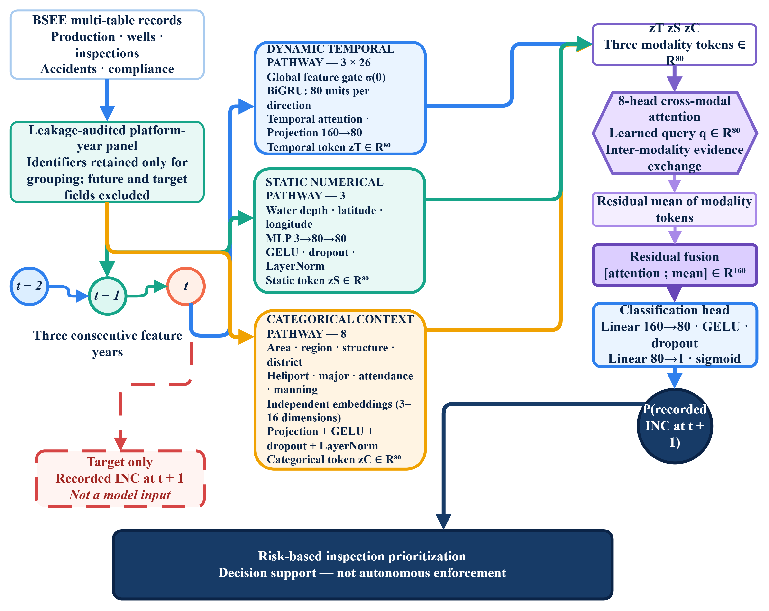
Figure 1. Proposed TECR-Net architecture for next-year recorded Incident of Non-Compliance (INC) prediction using dynamic temporal encoding, static numerical and categorical feature representations, eight-head cross-modal attention, and residual fusion for risk-based inspection prioritization.
Figure 1 illustrates the proposed TECR-Net architecture for predicting next-year recorded Incidents of Non-Compliance (INCs) by integrating temporal, static numerical, and categorical platform information. The dynamic pathway processes three consecutive years of 26 operational and compliance-related features using global feature gating, a bidirectional GRU with 80 hidden units per direction, and temporal attention to generate an 80-dimensional representation. Simultaneously, the static pathway encodes water depth, latitude, and longitude through a multilayer perceptron, while the categorical pathway processes eight platform-context variables using independent embedding layers. The three modality representations are combined through eight-head cross-modal attention and residual mean fusion, producing a 160-dimensional feature vector for probability estimation. The resulting predictions support exploratory risk-based inspection prioritization rather than autonomous enforcement. Although the architecture facilitates multimodal information integration, its complexity does not establish the necessity or superiority of individual components. Furthermore, the development-cohort ablation results do not provide independent causal evidence, and learned feature-gating and attention weights represent predictive associations rather than causal explanations of recorded non-compliance.

3.6 Optimization and Development Procedure
Alpha-balanced focal loss was used to address class imbalance; its positive-class weight and focusing parameter followed the archived implementation summarized in Table 5. TECR-Net hyperparameters and stopping were selected with the 2020–2021 development cohort. For each seed, a logistic mapping was fitted to sigmoid probabilities from that same cohort, after which the seven mapped outputs were averaged. This probability-on-probability transformation is described as Platt-like mapping rather than conventional logit-input Platt scaling. The F1-maximizing threshold was also selected on the development cohort. The replacement tabular baselines instead used a 2018–2019 inner holdout with 25 trials per model. Accordingly, all TECR-Net probability diagnostics are apparent, and aligned comparator results are descriptive rather than controlled evidence of superiority.
Table 5 reports the implemented architecture, optimization and selection settings.
Table 5. TECR-Net architecture and optimization configuration
Component | Setting | Value
Dynamic encoder | One-layer bidirectional GRU | 80 units per direction
Temporal projection | Linear, GELU, layer normalization | 160 to 80
Static encoder | Two-layer MLP | 3 to 80 to 80
Categorical encoder | Eight embeddings plus projection | Embedding dimension 3–16
Cross-modal attention | Multi-head attention | 8 heads; 80-dimensional tokens
Optimizer | AdamW | Gradient norm clipped at 1.0
Scheduler | ReduceLROnPlateau | Factor 0.5; patience 4
Dropout | Selected configuration | 0.2690
Learning rate | Selected configuration | 0.001617
Weight decay | Selected configuration | 2.439×10−5
Focal exponent γ | Selected configuration | 1.7523
Focal weight α | Development-derived | Clipped negative-class prevalence
Batch size | Selected configuration | 256
Maximum epochs | Early stopping | 100; patience 15
Hyperparameter search | Optuna TPE | 40 trials; mean AP across three tuning seeds
Replacement baselines | Optuna TPE | 25 trials/model on 2018–2019 inner holdout
Seeds | Repeated fitting | 11, 22, 33, 44, 55, 66, 77

Table 5 provides the implemented configuration required to reproduce the archived experiment. AdamW optimization, adaptive learning-rate reduction, gradient clipping, focal-loss parameters, Optuna search, and early stopping are stated explicitly. Architecture is constant across the seven final seeds, whereas initialization and minibatch ordering vary. Because TECR-Net selection, probability mapping, threshold determination, and reporting used the same development period, the resulting estimates may be optimistic for unseen data.

3.7 Evaluation Measures
Average precision (AP), implemented with sklearn.metrics.average_precision_score, is the primary threshold-free measure because positive outcomes are rare. Some archived figures use the label AP for this quantity; all numerical results in the text and tables are reported as AP. ROC-AUC summarizes ranking across thresholds. F1, F2, precision, recall, specificity, balanced accuracy, MCC, and the confusion matrix depend on the development-selected threshold. Brier score evaluates squared probability error, and Brier skill is defined as one minus the model Brier score divided by the constant-reference Brier score. The reference used here is the evaluated development-cohort prevalence, so the skill estimate is retrospective. Precision and lift at k = 50, 100, and 200 refer to the highest-ranked platform-year sequences, not necessarily unique physical platforms. AP and ROC-AUC are interpreted as ranking measures; the Brier score, reliability diagram, and calibration intercept and slope are reported as apparent development diagnostics only.
Table 6. Development metrics and interpretation
Metric | Type | Role
AP | Threshold-free | Primary ranking measure for rare positive outcomes
AP/prevalence | Threshold-free | Improvement over random prevalence baseline
ROC-AUC | Threshold-free | Global ranking discrimination
F1 and F2 | Threshold-dependent | Balance of precision and recall; F2 emphasizes recall
Precision and recall | Threshold-dependent | Yield and coverage of predicted positives
Balanced accuracy | Threshold-dependent | Mean sensitivity and specificity
MCC | Threshold-dependent | Correlation-like summary robust to imbalance
Brier score | Probability-based | Mean squared probability error
Precision@k | Budget-based | Observed yield among k highest-ranked sequences

Table 6 distinguishes ranking measures from threshold-dependent measures. This distinction is essential because the decision threshold was selected on development data. AP and ROC-AUC describe ordering, whereas F1 and the confusion matrix additionally reflect the selected operating point.
3.8 Prototype Research Interface
A prototype user interface was developed to demonstrate how the frozen TECR-Net pipeline accepts platform-level information and presents model outputs. The interface operates solely as a research demonstrator and was not involved in dataset construction, model training, hyperparameter optimization, probability mapping, threshold selection, or performance evaluation. It accepts exact three-year sequences corresponding to t-2, t-1, and t, comprising 26 dynamic variables per year, three static numerical attributes, and eight categorical descriptors. Platform identifiers and names are used only for display and reporting. The interface applies the stored fitting-period imputation, clipping, scaling, and categorical-encoding parameters without retraining or online modification. Seven frozen TECR-Net seed models generate outputs that are aggregated using the archived ensemble procedure. The interface reports an apparent probability-mapped ensemble score, the saved development-selected threshold, and the standard deviation across seed-level outputs. This standard deviation represents model variation across seeded fits and is not a confidence interval.
For visual interpretation, the score is assigned to a heuristic research-prioritization band defined relative to the saved threshold. These bands were not optimized through decision-curve analysis or validated against regulatory resource constraints and therefore do not represent confirmed regulatory-risk categories. The interface also displays selected temporal trends, temporal- and cross-modal-attention weights, global feature-gate coefficients, and an input-completeness audit. These quantities describe fitted-model associations and technical input processing; they do not establish causal importance, regulatory responsibility, source-record accuracy, or historical feature availability. TECR-Net predicts recorded administrative outcomes that may reflect inspection intensity, reporting practices, enforcement processes, and platform conditions. Accordingly, the displayed score is not a finding of non-compliance, a safety assessment, a production-suitability determination, or an enforcement recommendation. Independent prospective validation, external calibration assessment, usability testing, and decision-impact evaluation remain necessary before operational application.
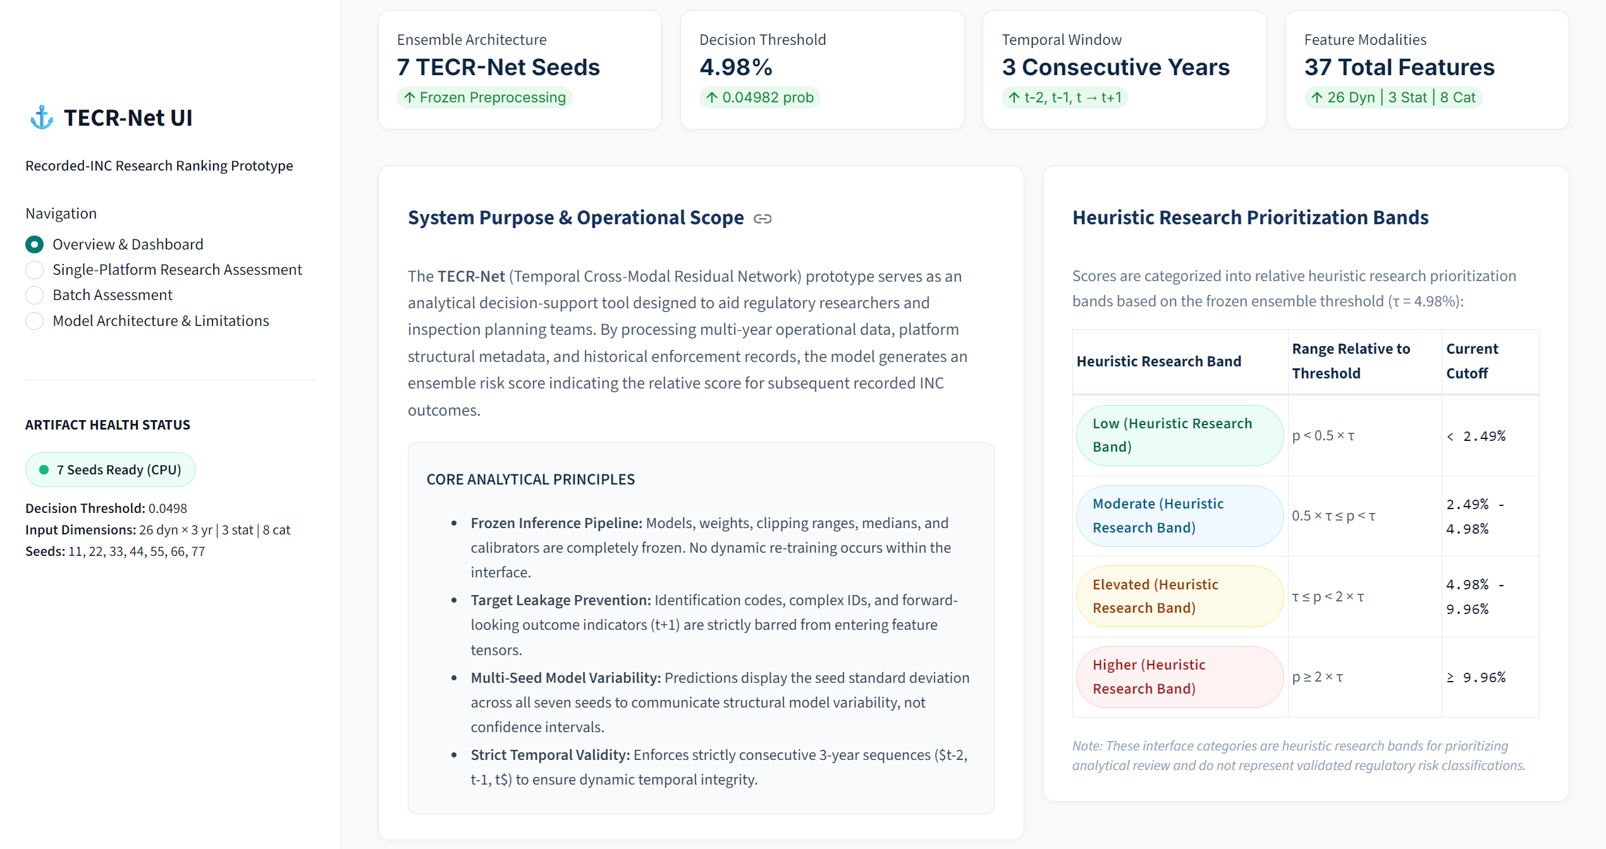
(a)

(b)
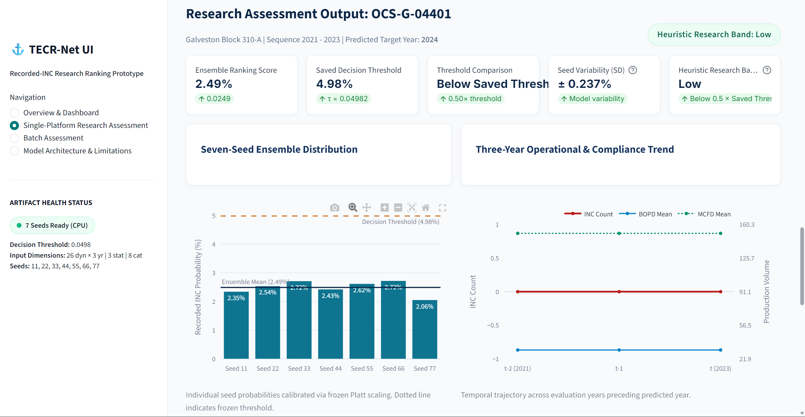
(c)
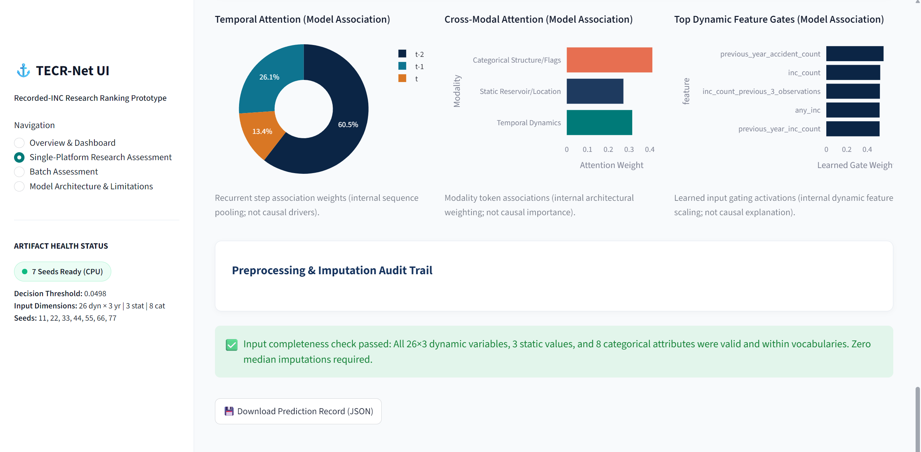
(d)
Figure 2. Prototype TECR-Net research interface. (a) Overview of the frozen analytical configuration and heuristic research-prioritization bands; (b) single-platform input interface for three consecutive feature years and associated contextual variables; (c) ensemble ranking score, saved threshold comparison, between-seed variability, and selected temporal trends; and (d) temporal-attention weights, cross-modal attention weights, global feature-gate coefficients, and input-completeness audit. The interface is a retrospective research demonstrator and has not been independently validated for regulatory or operational use.
Figure 2 illustrates the principal components of the prototype interface. Panel (a) presents the frozen seven-seed configuration, temporal window, feature modalities, and threshold-relative research bands. Panel (b) shows the collection of display-only platform metadata and the dynamic, static, and categorical inputs required for inference. Panel (c) reports the ensemble ranking score, its relationship to the saved development threshold, seed-level variability, and selected three-year operational trends. Panel (d) presents fitted-model attention and feature-gating quantities together with the technical input-completeness audit. These displays improve transparency concerning the computational workflow but do not constitute causal explanations or evidence of deployment readiness.

4. Results
The 2020–2021 cohort supported hyperparameter selection, early stopping, probability mapping, threshold selection and performance reporting. Consequently, all results from this cohort are apparent development estimates rather than independent validation estimates. Confidence intervals reported in this section are development-cohort bootstrap intervals; they describe sampling uncertainty within the development cohort, not generalization.

4.1 Multi-Seed Stability
Table 7. Apparent development-cohort seed-level performance across seven TECR-Net fits
Metric | Mean | SD | Mean ± SD
Prevalence | 0.03556 | 0.00000 | 0.03556 ± 0.00000
AP | 0.07401 | 0.00775 | 0.07401 ± 0.00775
AP/prevalence | 2.08109 | 0.21780 | 2.08109 ± 0.21780
ROC-AUC | 0.63115 | 0.01119 | 0.63115 ± 0.01119
F1 | 0.12080 | 0.01976 | 0.12080 ± 0.01976
F2 | 0.15060 | 0.04063 | 0.15060 ± 0.04063
Precision | 0.10295 | 0.02972 | 0.10295 ± 0.02972
Recall | 0.22175 | 0.14861 | 0.22175 ± 0.14861
Balanced accuracy | 0.56197 | 0.02388 | 0.56197 ± 0.02388
Specificity | 0.90219 | 0.11113 | 0.90219 ± 0.11113
MCC | 0.08918 | 0.01780 | 0.08918 ± 0.01780
Brier score | 0.03407 | 0.00004 | 0.03407 ± 0.00004
Threshold | 0.04982 | 0.00516 | 0.04982 ± 0.00516
Precision@50 | 0.10857 | 0.02545 | 0.10857 ± 0.02545
Precision@100 | 0.08571 | 0.02225 | 0.08571 ± 0.02225
Precision@200 | 0.05857 | 0.01180 | 0.05857 ± 0.01180

Across seven random seeds, TECR-Net achieved mean development AP of 0.07401 +/- 0.00775 and ROC-AUC of 0.63115 +/- 0.01119. Recall varied substantially across seeds (SD 0.14861), indicating sensitivity of threshold-dependent behaviour to initialization and training variation. These values characterize stochastic variation within the adaptively used development cohort; they are not confidence intervals and do not demonstrate independent generalization.
Figure 2 summarizes the threshold-dependent behaviour of the seven-seed ensemble on the development cohort. The confusion matrix is included because a regulator must understand the number of missed positive records and unnecessary alerts generated at the selected operating point, rather than relying only on threshold-free area measures.
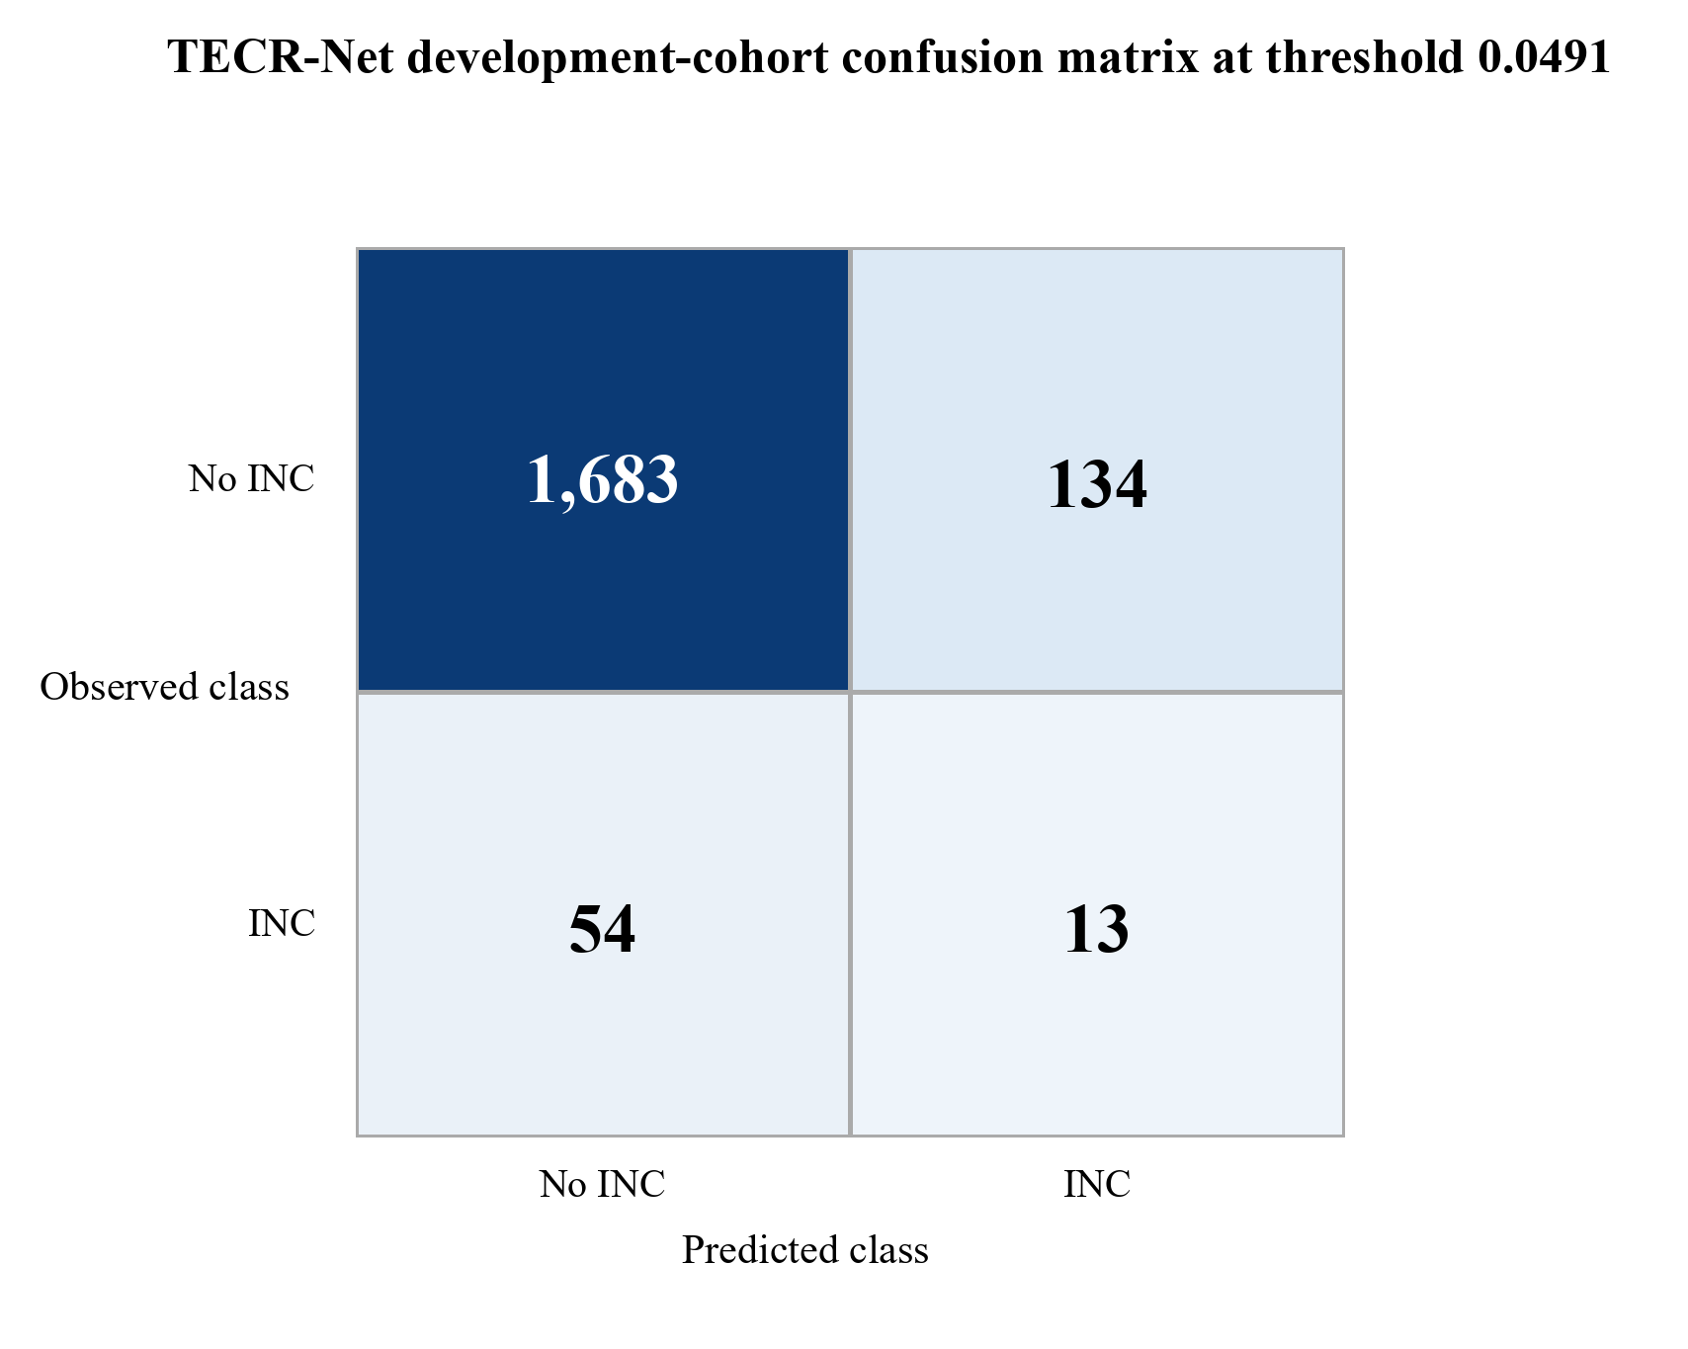

Figure 2. Development-cohort confusion matrix for the probability-mapped seven-seed TECR-Net ensemble.
Figure 2 shows 1,683 true negatives, 134 false positives, 54 false negatives, and 13 true positives at threshold 0.0491. Specificity is high because most negative sequences remain below the threshold, but only 19.4% of the 67 positive sequences are detected. The figure therefore supports a prioritization interpretation rather than a claim of comprehensive case detection.

4.2 Ensemble Discrimination and Risk Ranking
Table 8. Apparent seven-seed ensemble metrics on the development cohort
Metric | Value | Metric | Value
Prevalence | 0.03556 | AP/prevalence | 2.114×
AP | 0.07518 | ROC-AUC | 0.63855
F1 | 0.12150 | F2 | 0.15663
Precision | 0.08844 | Recall | 0.19403
Specificity | 0.92625 | Balanced accuracy | 0.56014
MCC | 0.08305 | Brier score | 0.03406
Threshold | 0.04909 | TN / FP / FN / TP | 1683 / 134 / 54 / 13
Precision@50 | 0.080 | Lift@50 | 2.250×
Precision@100 | 0.080 | Lift@100 | 2.250×
Precision@200 | 0.070 | Lift@200 | 1.968×

Table 8 shows ensemble AP of 0.07518, or 2.11 times the 3.56% development prevalence. Among the 50 highest-ranked platform-year sequences, four had positive recorded outcomes, yielding Precision@50 of 0.080 and approximately 2.25-fold enrichment. Repeated observations from the same physical platform may occur, so this quantity is not the yield among 50 distinct facilities. The absolute yield remains limited and supports only an exploratory prioritization interpretation.
Figure 3 displays the two threshold-free discrimination views for the development ensemble.
Figure 3 evaluates discrimination independently of a single operating threshold. The receiver-operating-characteristic curve describes sensitivity across false-positive rates, whereas the precision-recall curve is more informative for the rare positive outcome because it compares positive yield with the cohort prevalence reference.
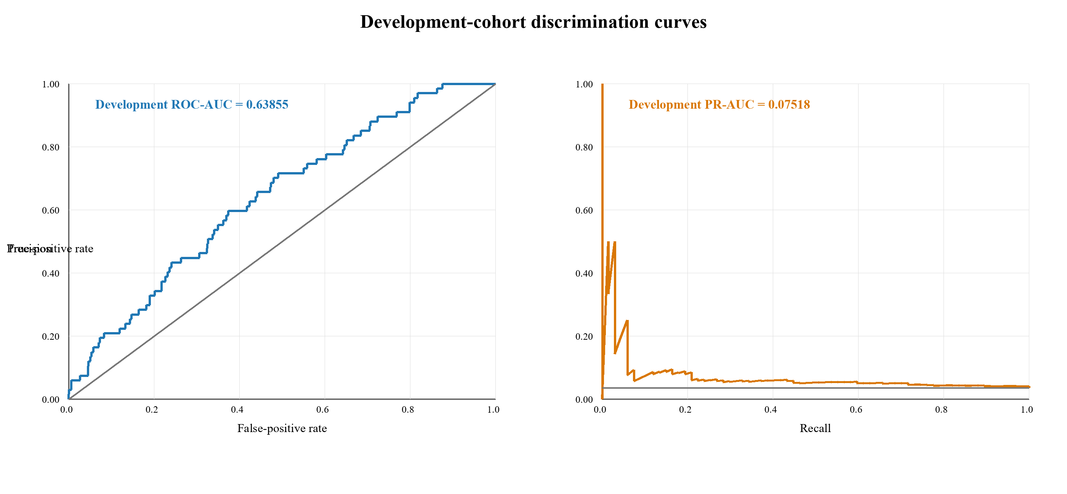
Figure 3. Development-cohort ROC and precision-recall curves from the probability-mapped seven-seed ensemble. The reported precision-recall summary is average precision.
Figure 3 shows development ROC-AUC of 0.63855 and AP of 0.07518. The ROC curve lies above the random diagonal, and the precision-recall curve exceeds the 0.03556 prevalence reference over part of the recall range. These are limited apparent development results and do not demonstrate clinically or operationally useful discrimination on unseen data.

4.3 Mean Development Metrics and Learning Behaviour
Figure 4 summarizes variation in the principal development metrics across seven TECR-Net fits.
Figure 4 places the principal development measures and their between-seed variability on a common scale. The visualization is intended to distinguish stable ranking behaviour from the greater stochastic sensitivity of threshold-dependent precision and recall, rather than to suggest that numerically larger metrics are directly interchangeable.
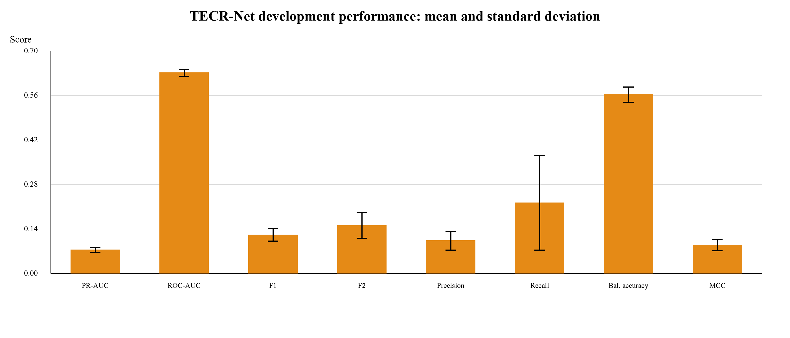
Figure 4. Seed-level development metrics across seven TECR-Net fits, reported as mean with one-standard-deviation error bars.
Figure 4 demonstrates the difference between threshold-free ranking and threshold-based classification. The ROC-AUC score is the largest score bound, while AP and F1 scores are relatively low due to a scarcity of positives and high similarity of positives and negatives. The large recall standard deviation reveals that operating-point behaviour is affected by stochastic fitting, and supports the use of ensemble probabilities and uncertainty estimation.
Figure 5 shows the epoch-by-epoch evolution of AP during training of the model.
Figure 5 investigates the optimization dynamics at the level of epochs run by all seeds. Showing the mean of seeds and its standard deviation makes it clear whether there is persistent progress, plateauing of the development goal, and possible overfitting through further optimization.
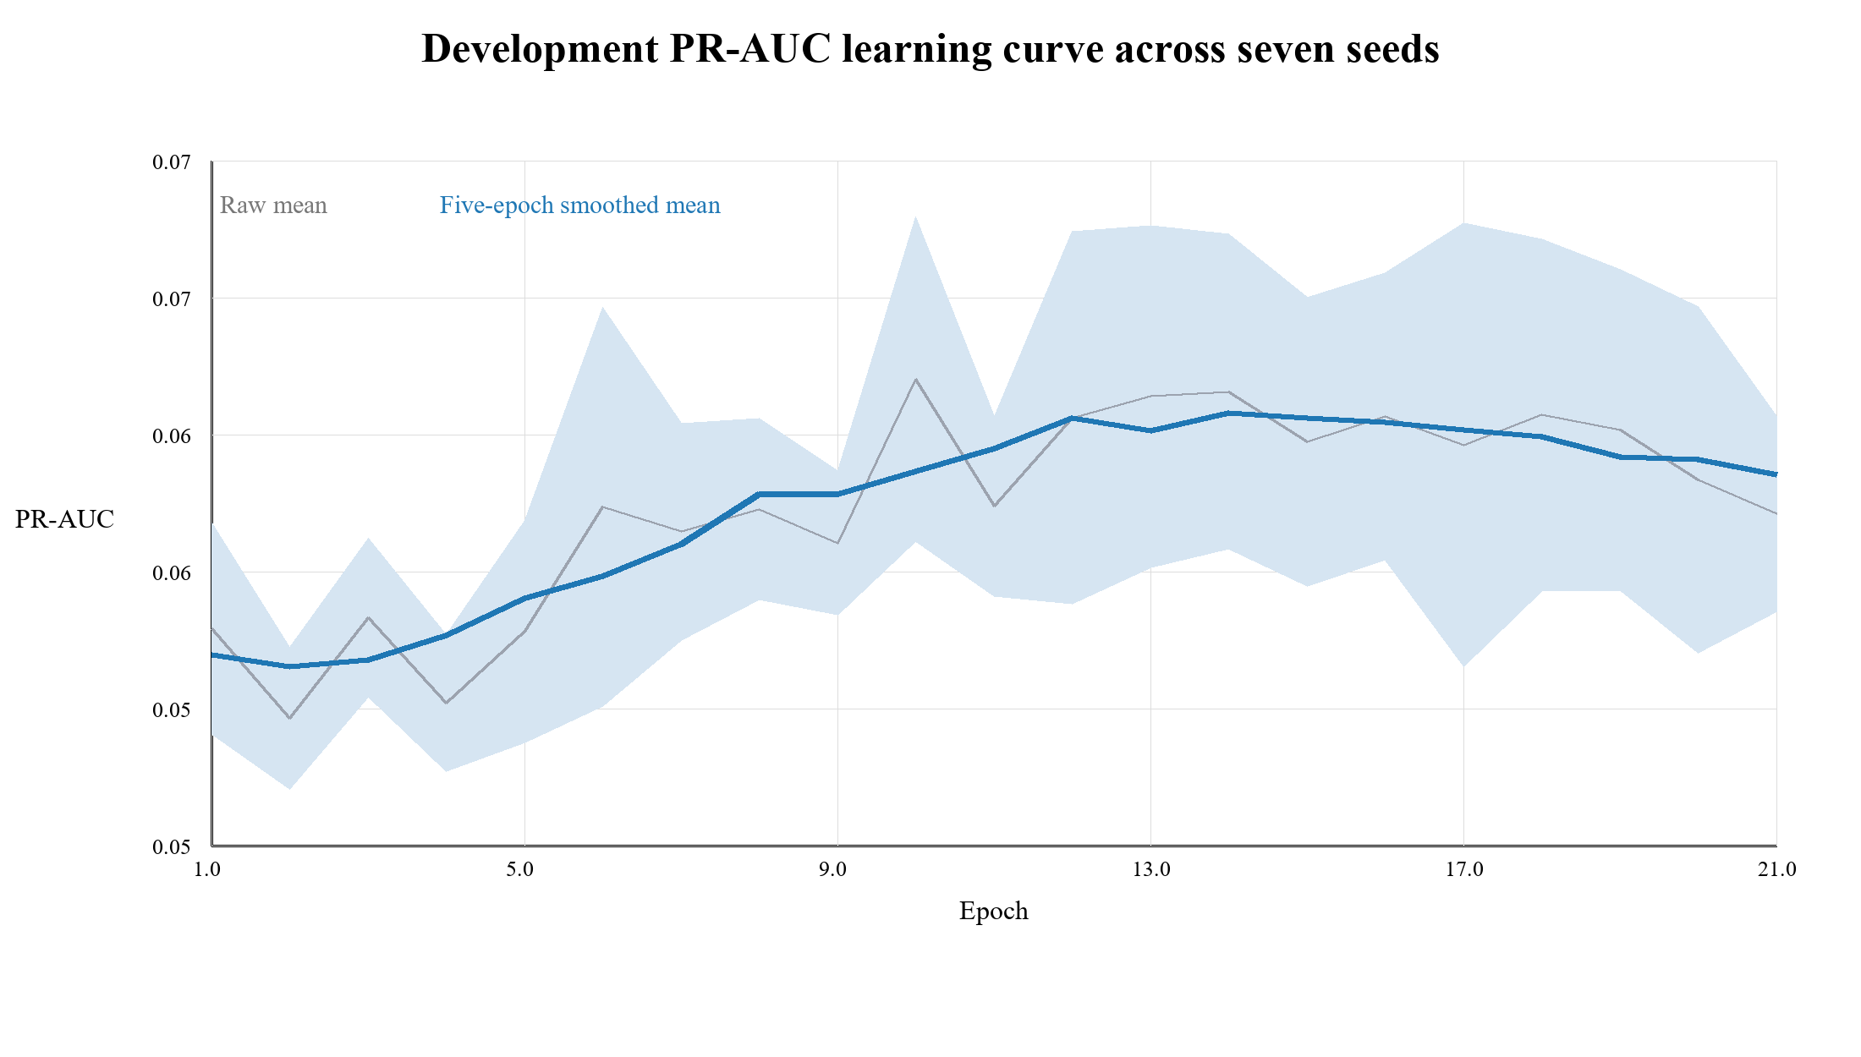
Figure 5. Seed-averaged development AP learning curve restricted to epochs completed by every seed.
Figure 5 shows an early rise in mean development AP followed by a plateau and mild decline. The plotted mean is restricted to epochs completed by every included seed and is smoothed over five epochs; the uncertainty band summarizes between-seed variation at aligned epochs. It is not the mean of individually selected best checkpoints. The lower plotted peak relative to Table 7 reflects this different construction, and neither view constitutes independent evidence of convergence or generalization.

4.4 Sequence-Aligned Development Baselines
Table 9 compares TECR-Net and four tabular baselines on identical sample identifiers, labels, three-year dynamic histories, static variables, categorical context, and 1,884 development sequences. Each tabular baseline received 25 inner-temporal Optuna trials and seven final seeds, whereas TECR-Net used the separate fitting-period preprocessing and development-based selection procedure described above. The comparison is therefore sample-aligned but not symmetrical in preprocessing, tuning, probability mapping, or selection. Observed differences are descriptive and cannot support a superiority claim.
Table 9. Descriptive sequence-aligned development-cohort comparison (not a controlled head-to-head test)
Model | AP | ROC-AUC | TECR-Net AP difference | 95% platform-clustered development-cohort bootstrap interval
TECR-Net | 0.07518 | 0.63855 | Reference | —
CatBoost | 0.05163 | 0.62390 | 0.02355 | -0.00133 to 0.06434
LightGBM | 0.04690 | 0.62848 | 0.02828 | 0.00177 to 0.07168
XGBoost | 0.05036 | 0.62903 | 0.02482 | -0.00095 to 0.06795
HistGradientBoosting | 0.04891 | 0.62539 | 0.02627 | 0.00080 to 0.06971

The aligned development predictions show that TECR-Net achieved AP of 0.07518, compared with 0.05163 for CatBoost, 0.05036 for XGBoost, 0.04891 for HistGradientBoosting, and 0.04690 for LightGBM. Exact sequence identifiers and labels were matched across the saved predictions. Nevertheless, TECR-Net and the baselines were selected using different development procedures. The observed ordering therefore does not establish an unbiased architectural advantage. Platform-clustered intervals quantify variability conditional on the saved predictions but do not correct adaptive model-selection bias.
Figure 6 emphasizes the primary development metric and its prevalence reference.
Figure 6 compares TECR-Net with four sequence-aligned tabular baselines using the same development sample identifiers and primary AP measure. The prevalence line provides the random-ranking reference, while the bars show the observed ordering under the reported but not fully symmetric model-selection procedures.
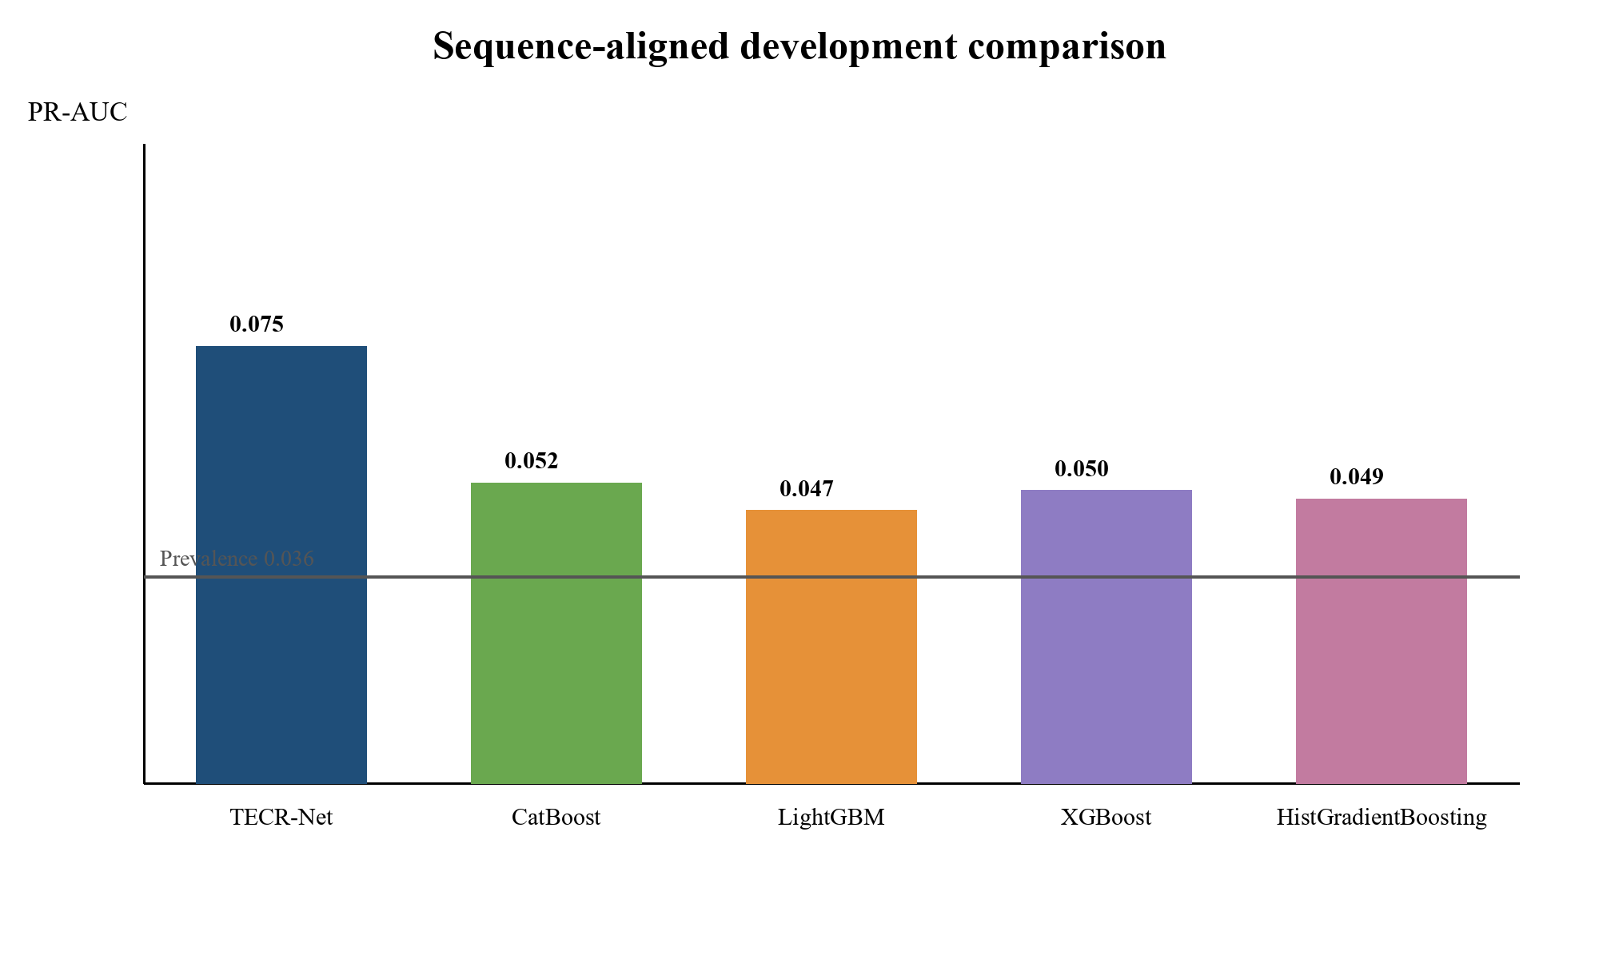
Figure 6. Development-cohort ensemble AP for TECR-Net and four sequence-aligned tabular baselines.
Figure 6 shows that TECR-Net and all four baselines exceed the 0.03556 prevalence reference, with TECR-Net showing the largest observed AP in this descriptive comparison. Because the proposed model was previously optimized against this development period, the chart documents the observed ordering but does not establish unbiased predictive superiority. A frozen evaluation on later or external data is required for that claim.

4.5 Architectural Ablation
Table 10 reports the full model and six component-removal variants using development results only.
Table 10. Development-cohort architectural ablation using saved ensemble outputs
Variant | AP | ROC-AUC
Full TECR-Net | 0.07518 | 0.63855
Without categorical encoder | 0.07374 | 0.60503
Without cross-modal attention | 0.07494 | 0.63760
Without feature gate | 0.06652 | 0.63832
Without GRU | 0.05556 | 0.63252
Without residual fusion | 0.07150 | 0.64479
Without temporal attention | 0.06938 | 0.63824

Removing the GRU produced the largest observed development AP reduction, from 0.07518 to 0.05556. Removing feature gating and temporal attention produced smaller reductions, whereas excluding cross-modal attention changed AP by only 0.00024. Removing the categorical encoder caused a modest AP reduction to 0.07374 but a larger ROC-AUC reduction from 0.63855 to 0.60503, suggesting that categorical context affected broader rank discrimination more than the primary rare-event AP metric in this experiment. Removing residual fusion reduced AP to 0.07150 but increased ROC-AUC to 0.64479. Because the reduced models did not undergo an independently verified equivalent hyperparameter search, these differences are descriptive sensitivities and do not establish isolated causal contributions or statistical necessity.
Figure 7 shows the empirical difference in development cohort and architectural performance for each component removal variant compared to the full architecture. This difference measures the sensitivity of the description using the stored parameters and is not a causal measure of effect; it does not serve as statistical evidence that a component is required.
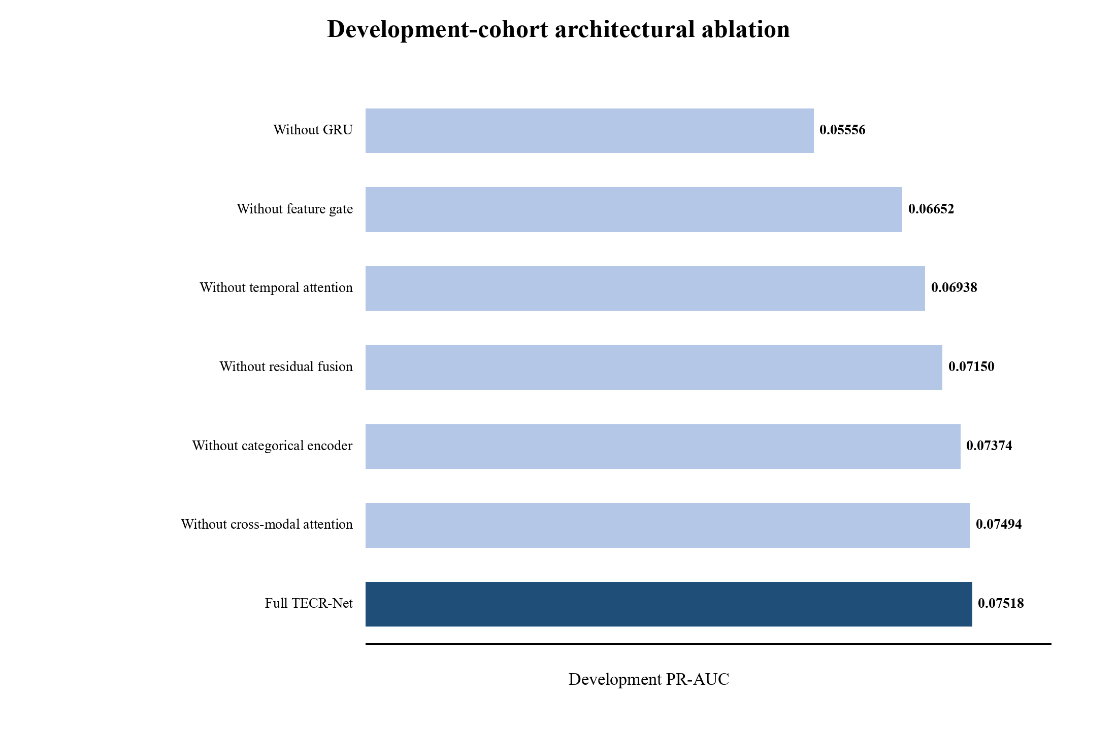
Figure 7. Development-cohort ensemble AP for the full TECR-Net and six component-removal variants.
Figure 7 makes the recurrent encoder contribution most visible: the no-GRU variant approaches the prevalence baseline more closely than the other variants. The small difference between the full model and removal of cross-modal attention indicates that this module contributes less development AP than the recurrent pathway, even though it may affect threshold-dependent behaviour.

4.6 Accident-Feature Sensitivity
Table 11 evaluates whether the primary development result depends on the three coarse lease-level accident proxies. Both variants use the same 1,884 sequences, 982 platforms, 67 positive labels, architecture, seven seeds, and probability-ensemble procedure.
Table 11. Development-cohort sensitivity to lease-level accident proxies
Variant | AP | ROC-AUC | F1 | Precision | Recall | MCC | P@50
Full TECR-Net | 0.07518 | 0.63855 | 0.12150 | 0.08844 | 0.19403 | 0.08305 | 0.080
Without lease-level accident proxies | 0.07478 | 0.62849 | 0.12091 | 0.07273 | 0.35821 | 0.09248 | 0.100

Removing the three lease-level accident proxies changed AP from 0.07518 to 0.07478, a full-minus-reduced difference of approximately 0.00040. The paired platform-clustered 95% bootstrap interval ranged from −0.02183 to 0.02153 and included zero. At the selected operating threshold, recall increased from 0.19403 to 0.35821 while precision decreased from 0.08844 to 0.07273, demonstrating that the proxies affected the operating trade-off even though the AP point estimate changed little. The analysis did not establish a statistically detectable AP difference, equivalence, or variable unimportance; it provides uncertainty-limited sensitivity evidence only.

4.7 Development Uncertainty and Apparent Calibration
Table 12 reports dependence-aware uncertainty and limited probability diagnostics calculated from the development ensemble predictions. Because the probability mapping was fitted on the same period, these quantities are apparent rather than independently validated calibration estimates.
Table 12. Platform-clustered development uncertainty and apparent calibration diagnostics
Diagnostic | Estimate | 95% development-cohort bootstrap interval / basis | Interpretation
AP | 0.07518 | 0.04269–0.12568 | Primary rare-event ranking
ROC-AUC | 0.63855 | 0.57197–0.70213 | Limited apparent discrimination
Brier score (apparent) | 0.03406 | 0.02671–0.04211 | Probability error
Brier skill score | 0.00692 | Reference = 0.03430 | Gain over constant prevalence
Calibration intercept | 2.57119 | Apparent | Ideal value 0
Calibration slope | 1.79530 | Apparent | Ideal value 1
Precision@50 | 0.080 | 0.000–0.191 | 50 highest-ranked sequences
Precision@100 | 0.080 | 0.020–0.140 | 100 highest-ranked sequences
Precision@200 | 0.070 | 0.035–0.115 | 200 highest-ranked sequences
Development prevalence | 0.03556 | 67 / 1,884 | Rare outcome

The development probability diagnostics were estimated from the same cohort used to fit probability mappings and select operating thresholds. They are therefore apparent calibration estimates. The reported intercept of 2.57119 and slope of 1.79530 depart materially from their ideal values of 0 and 1. In the archived procedure, predictions from multiple seeded models were aggregated after model-specific fitting; nonlinear probability mapping followed by aggregation does not mathematically guarantee an ensemble calibration intercept of 0 or a slope of 1. Nevertheless, the exact probability-mapping implementation has not been independently reconstructed line by line, so the values are treated as descriptive rather than as evidence of calibration adequacy. The small Brier score also partly reflects the low positive prevalence, and the Brier skill reference is the retrospectively observed development prevalence rather than an independently constructed historical forecast. Independent prospective assessment and recalibration are necessary before interpreting outputs as absolute risk probabilities.
The development probabilities showed limited apparent calibration, but the intercept and slope departed from their ideal values. Independent calibration performance remains unknown. AP and ROC-AUC are interpreted as ranking measures; the Brier score, reliability diagram, intercept and slope are apparent development diagnostics. The bootstrap intervals describe sampling uncertainty within the development cohort, not generalization.
Figure 8 evaluates apparent probability agreement by comparing mean predicted risk with observed event frequency across ten equal-frequency bins. This diagnostic complements discrimination metrics by showing whether predicted probabilities have the correct scale, although reuse of the development cohort for calibration prevents an independent calibration claim.
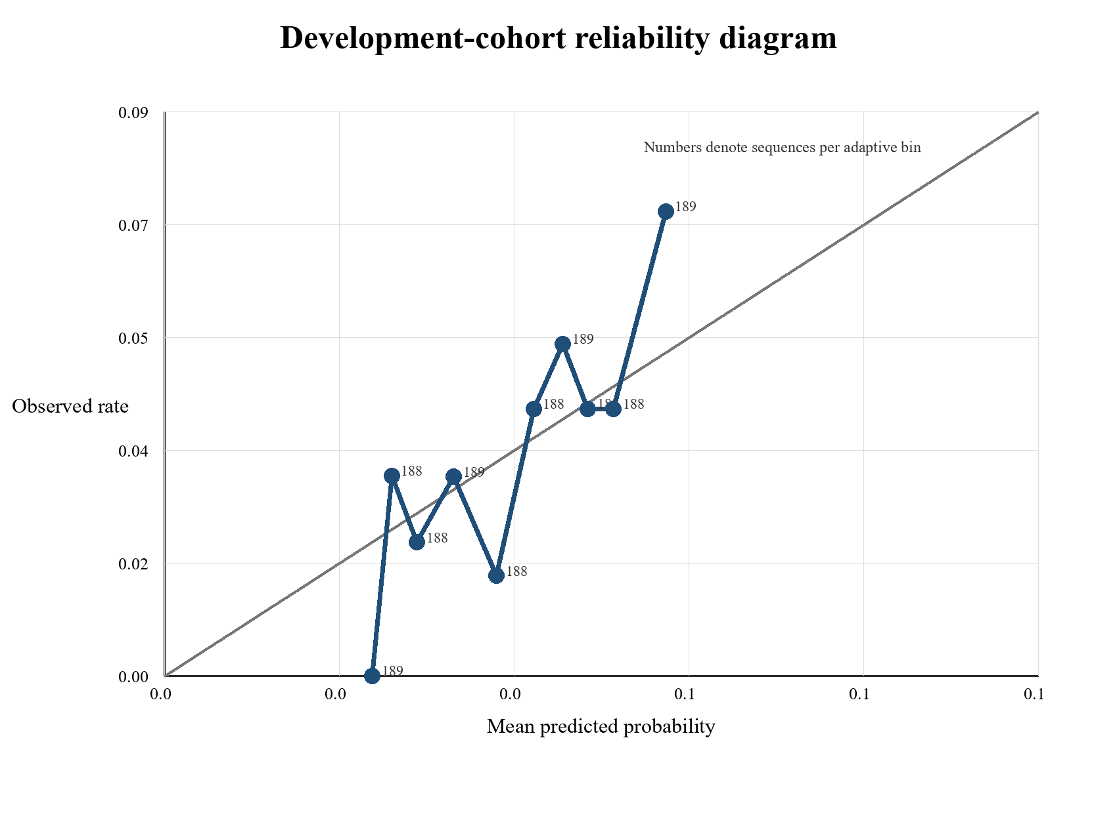
Figure 8. Apparent development-cohort reliability diagram from probability-mapped ensemble scores using ten equal-frequency bins.
Figure 8 compares mean mapped scores with observed outcome rates and labels each bin by sequence count. Departures from the diagonal, together with the calibration intercept of 2.57119 and slope of 1.79530, show that the score scale should not be interpreted as independently calibrated absolute risk. Because the logistic mappings were fitted on this same cohort, the figure represents apparent in-sample behaviour.

4.8 Exploratory Chronological Later-Cohort Findings
The archived TECR-Net experiment included a later cohort covering feature years 2022–2024. It contained 2,196 sequences from 876 platforms and 94 positive recorded-INC outcomes. Recomputed ensemble metrics were AP 0.10318, ROC-AUC 0.65592, precision 0.12583, recall 0.20213, F1 0.15510, and Brier score 0.04068. Because this cohort was examined repeatedly during model development, it does not constitute independent confirmation, and no claim of external validity or deployment readiness is made. Table 13 reports it for complete accounting of the experimental record, not as unbiased validation.
Table 13. Exploratory probability-mapped results for the repeatedly inspected 2022–2024 cohort
Metric | Exploratory result
Sequences | 2,196
Platforms | 876
Positive outcomes | 94
Prevalence | 0.04281
AP | 0.10318
ROC-AUC | 0.65592
Precision | 0.12583
Recall | 0.20213
F1 | 0.15510
Brier score | 0.04068
ECE (recalculated) | 0.018004
MCE | 0.067951
Table 13 shows slightly higher discrimination than in the development cohort, but the difference must not be interpreted as prospective improvement because the later cohort influenced subsequent analytical choices. The recalculated calibration errors are non-zero, and no operational claim follows from these exploratory values. A new prospective BSEE release or compatible external cohort remains necessary for confirmatory evaluation.
Feature year 2024 has its target in 2025, and completeness of the 2025 outcome records could not be verified; later-cohort estimates that include feature year 2024 should therefore be interpreted with caution.

4.9 Sensitivity to Pre-Installation Records
The temporal-integrity audit identified nine development sequences and 16 later-cohort sequences containing observations that predated their recorded platform installation years. Excluding these flagged observations at evaluation changed development AP from 0.075179 to 0.075619 and later-cohort AP from 0.103182 to 0.104099. The corresponding ROC-AUC changes were 0.638555 to 0.640000 and 0.655920 to 0.657014. Table 14 summarizes the sensitivity results.
Table 14. Evaluation-only sensitivity to sequences containing pre-installation observations
Cohort | Flagged | AP original | AP excluded | ROC-AUC original | ROC-AUC excluded
Development | 9 | 0.075179 | 0.075619 | 0.638555 | 0.640000
Exploratory later cohort | 16 | 0.103182 | 0.104099 | 0.655920 | 0.657014
Table 14 indicates that the archived evaluation scores were not dominated by the small set of flagged records. However, the model was not retrained after exclusion, and this sensitivity check does not establish the historical validity of the remaining structural and contextual snapshot variables.

5. Discussion
TECR-Net showed limited apparent development-stage ranking discrimination for subsequent recorded INC outcomes, with ensemble AP of 0.07518 and ROC-AUC of 0.63855. The repeatedly inspected later cohort produced exploratory AP of 0.10318 and ROC-AUC of 0.65592, but it is not independent evidence and its feature year 2024 depends on 2025 outcomes of unverified completeness. At the development-selected threshold, only 13 of 67 positive sequences were detected. These results do not establish operationally useful detection or generalization.
The sequence-aligned tabular comparisons showed higher observed development AP for TECR-Net, corresponding to approximately 2.11 times the development prevalence, but unequal model-selection procedures preclude a superiority claim, and the comparison is descriptive. Precision@50 was 0.080, equivalent to four positive sequences among the 50 highest-ranked records, so the practical yield remains modest and its operational benefit has not been tested. Architectural ablations produced their largest observed AP decrease when the recurrent encoder was removed, while cross-modal attention changed AP only marginally. Accident-proxy removal also produced a small point difference with wide uncertainty. These analyses are exploratory and do not establish causal component necessity.
Recorded INCs reflect inspection and enforcement processes as well as platform conditions. Production-linked eligibility (platforms that disappear before t+1 have unobservable outcomes and are not labelled negative, so survivorship bias remains), repeated platform observations, operator- and lease-level aggregation, historically unverified snapshot attributes, and adaptive use of development outcomes all restrict interpretation. The pre-installation sensitivity result reduces concern about a small flagged subset but does not solve broader provenance uncertainty. TECR-Net should therefore be regarded as a retrospective methodological prototype requiring historically defensible reconstruction, symmetric comparator selection, independent calibration, and genuinely prospective or external evaluation before operational consideration.

6. Limitations
1. TECR-Net hyperparameter selection, stopping, probability mapping, threshold determination, ablation assessment, and performance estimation used the same 2020-2021 development period. The reported estimates may therefore be optimistic for unseen data and are not independent validation results.
2. The outcome is a recorded INC rather than latent non-compliance. Inspection frequency, reporting practice, and regulatory attention affect label observation, and the available regional files do not provide a complete denominator of inspections with zero INC. Model-guided inspections could therefore reinforce historical observation patterns. The score is not a safety or production-authorization decision.
3. Eligibility requires consecutive t-2, t-1, and t production-linked records and an observable t+1 record. This creates possible survivorship selection and limits inference to the production-derived analytical cohort rather than every offshore platform. Platforms without a t+1 record are classified as outcome unobservable rather than negative; survivorship bias is retained.
4. Attribute-specific effective dates are unavailable for several static and categorical snapshot fields, including water depth, coordinates, structural class, district, heliport, attendance, and manning. Calendar-exact availability and source-publication timing also require further verification for lagged, operator-year, and lease-year aggregates.
5. Baseline samples were sequence-aligned, but baseline and TECR-Net optimization protocols were not fully symmetric. The observed baseline ordering is therefore descriptive, and simple-comparator evidence remains incomplete.
6. Repeated sequences from the same platform and operator- and lease-level variables create dependence that is only partly addressed by platform-clustered resampling. The 67 positive development outcomes also limit precision and transportability.
7. Discrimination is modest, calibration is apparent rather than independent, and no prospective deployment, external validation, decision-impact, fairness, or feedback-loop evaluation has been performed.
8. Feature year 2024 has its target in 2025, for which outcome completeness could not be verified. The later cohort was examined during model development and does not constitute independent confirmation, and no claim of external validity or deployment readiness is made.
9. Release-specific publication delays could not be reconstructed. The analysis is retrospective and does not establish that every predictor would have been available at a real-time prediction origin.
10. A post-hoc audit identified 13,416 full-panel histories and 12,280 archived model-panel histories; the original pipeline did not retain mutually exclusive row-level exclusion reasons for the 1,136-history difference, so complete retrospective cohort reconstruction was not possible.

7. Conclusion
This study investigated TECR-Net as a temporal cross-modal framework for ranking subsequent recorded INC outcomes from historical offshore-platform records. The apparent development ensemble achieved AP of 0.07518 and ROC-AUC of 0.63855. The repeatedly inspected 2022–2024 cohort produced exploratory AP of 0.10318 and ROC-AUC of 0.65592, but it does not constitute independent confirmation and includes feature year 2024, whose 2025 outcome completeness was unverified. Architectural and accident-feature analyses provide descriptive sensitivity evidence only.
The contribution is an exploratory integration of temporally ordered operational and administrative histories with static and categorical context. Recorded INCs are administrative outcomes influenced by inspection and enforcement intensity; they are not direct measures of latent violations, platform safety, or production suitability. Unresolved issues include production-linked selection, the unexplained 1,136-history cohort difference, historical feature provenance, publication timing, apparent rather than independent calibration, comparator asymmetry, and the absence of untouched confirmation. TECR-Net should therefore be treated as a retrospective methodological prototype, not a validated inspection-allocation or enforcement system.

Appendix A Input Feature Dictionary
Table A1 lists all 37 predictive inputs, their timing and their administrative level. Dynamic variables are repeated at t−2, t−1 and t, while static and categorical values are attached once to each sequence.
Table A1. Predictive inputs, timing and administrative level
Feature | Group | Timing | Level
active_months | Dynamic | t−2, t−1 and t | Platform-year
producing_wells_mean | Dynamic | t−2, t−1 and t | Platform-year
producing_wells_max | Dynamic | t−2, t−1 and t | Platform-year
bopd_mean | Dynamic | t−2, t−1 and t | Platform-year
bopd_max | Dynamic | t−2, t−1 and t | Platform-year
mcfd_mean | Dynamic | t−2, t−1 and t | Platform-year
mcfd_max | Dynamic | t−2, t−1 and t | Platform-year
boepd_mean | Dynamic | t−2, t−1 and t | Platform-year
bwpd_mean | Dynamic | t−2, t−1 and t | Platform-year
platform_age | Dynamic | t−2, t−1 and t | Platform-year
operator_facilities_inspected | Dynamic | t−2, t−1 and t | Operator-year
operator_inspection_records | Dynamic | t−2, t−1 and t | Operator-year
operator_inspection_types | Dynamic | t−2, t−1 and t | Operator-year
investigated_accident_count | Dynamic | t−2, t−1 and t | Lease-year proxy
accident_type_count | Dynamic | t−2, t−1 and t | Lease-year proxy
previous_year_inc_count | Dynamic | t−2, t−1 and t | Platform-year
inc_count_previous_3_observations | Dynamic | t−2, t−1 and t | Platform-year
previous_year_accident_count | Dynamic | t−2, t−1 and t | Lease-year proxy
production_change_bopd | Dynamic | t−2, t−1 and t | Platform-year
production_change_mcfd | Dynamic | t−2, t−1 and t | Platform-year
inc_count | Dynamic | t−2, t−1 and t | Platform-year
enforcement_code_count | Dynamic | t−2, t−1 and t | Platform-year
any_inc | Dynamic | t−2, t−1 and t | Platform-year
operator_warning_incs | Dynamic | t−2, t−1 and t | Operator-year
operator_component_shutin_incs | Dynamic | t−2, t−1 and t | Operator-year
operator_facility_shutin_incs | Dynamic | t−2, t−1 and t | Operator-year
water_depth | Static numerical | Attached at t | Platform snapshot
latitude | Static numerical | Attached at t | Platform snapshot
longitude | Static numerical | Attached at t | Platform snapshot
area_code | Categorical | Attached at t | Regional/platform
region_code | Categorical | Attached at t | Regional/platform
structure_type | Categorical | Attached at t | Platform snapshot
major_structure_flag | Categorical | Attached at t | Platform snapshot
district_code | Categorical | Attached at t | Regional/platform
heliport_flag | Categorical | Attached at t | Platform snapshot
attended_8hr_flag | Categorical | Attached at t | Platform snapshot
manned_24hr_flag | Categorical | Attached at t | Platform snapshot

Table A1 lists every archived model input by analytical name, modality, timing, and administrative level. Dynamic production fields are annual platform-year aggregates; operator inspection and enforcement fields are operator-year aggregates; accident fields are lease-year proxies repeated across eligible platforms; static numerical and categorical fields are platform or regional snapshots attached at feature year t. Training-pipeline audit files record missingness and transformation status, but the supplied source releases do not provide a complete field-level dictionary of measurement units, publication lags, or attribute-specific effective dates. Consequently, Table A1 is a model-input inventory rather than complete provenance certification. Release-specific units, raw-field mappings, source-file hashes, extraction dates, missingness summaries, and effective-date evidence must accompany the reproducibility package when available. Until then, static historical availability and annual-publication timing remain unresolved limitations.

References
[1] Liu, B., Li, Z., Duan, Q., Yan, B. and Tan, X., 2025. Research on LLM-based assessment methods for international standards' intelligent contribution to oil and gas pipelines. Journal of Pipeline Science and Engineering, p.100405.
[2] Hui, Q., Liu, B., Fan, J., Guo, D., Chen, J., Tan, X. and Peng, Z., 2026. Knowledge graph construction for pipeline standards: Enhancing efficiency in the oil and gas industry. Journal of Pipeline Science and Engineering, p.100445.
[3] Xia, T., Wang, F., Huang, Z., Zhang, W., Chen, G., Zhou, J. and Liu, C., 2025. Multi-Dimensional Control Rules and Assessment Methods for Surface Engineering Data Quality in Oil and Gas Field. Information, 16(8), p.701.
[4] Khordoustan, P., Akbarzadeh, O., Gilani, N., Moshashaei, P. and Alizadeh, S.S., 2026. A hybrid ANP and machine learning framework for contractor health safety environment and quality performance evaluation. Discover Analytics, 4(1), p.16.
[5] Wahono, T., Purniawan, A., Mukhlash, I. and Putri, E.R., 2025. Risk-based asset integrity management in the oil and gas industry from traditional to machine learning approaches: A systematic review. Results in Engineering, p.107287.
[6] Zhang, X., Yan, L., Lai, F. and Wang, H., 2025. Research progress and prospects of risk assessment methods for oil and gas development. Geoenergy Science and Engineering, 253, p.213992.
[7] Wahono, T., Mukhlash, I., Putri, E.R. and Purniawan, A., 2026. An intuitionistic fuzzy deep neural network method for risk assessment of oil and gas pipelines. Cleaner Engineering and Technology, p.101299.
[8] Zhou, Y., Fan, J., Dai, B. and Wu, S., 2025. A data-driven PCA-hierarchical clustering framework for adaptive risk assessment of gas pipeline networks. Process Safety and Environmental Protection, p.107753.
[9] Ye, Z., Duan, Q. and Ma, S., 2026. Research on risk classification of oil and natural gas pipelines based on text mining and apriori algorithm. Journal of Loss Prevention in the Process Industries, 103, p.106059.
[10] AlAbdouli, M.A. and Al-Shihabi, S., 2025. Artificial intelligence and its performance impacts in the oil and gas industry: Challenges, insights, and evaluation approaches. Results in Engineering, p.107636.
[11] Savari, A., Li, Y., Alnefaie, K. and Singh, N.S.S., 2026. State-of-the-art Machine learning Advances in reliability-based design, integrity assessment, inspection and maintenance of pipelines: A Systematic review. Journal of Pipeline Science and Engineering, p.100528.
[12] Bastek, T., Denecke, J. and Schmidt, J., 2026. Future directions for data-driven approaches in pipeline integrity management: Risk assessment, in-line inspection, and machine learning. Reliability Engineering & System Safety, p.112300.
[13] Jones, J.F., Raj, V., Abas, P.E., Petra, M.I., Sivan, D., Satheesh Kumar, K., Jose, R. and Mathew, S., 2025. Application of artificial intelligence for asset integrity management of offshore oil and gas pipelines. Life Cycle Reliability and Safety Engineering, 14(4), pp.503-530.
[14] Al-Ammari, W.A., Sleiti, A.K., Rahman, M.A., Rezaei-Gomari, S., Hassan, I. and Hassan, R., 2025. Digital twin for leak detection and fault diagnostics in gas pipelines: A systematic review, model development, and case study. Alexandria Engineering Journal, 123, pp.91-111.
[15] Cai, X. and Wang, J., 2026. A digital twin-driven natural gas pipeline leakage detection method. International Journal of Pressure Vessels and Piping, p.105793.
[16] Ali, U., Naveen, P., Al-Shalabi, E.W. and Ait Abderrahmane, H., 2026. Artificial intelligence and machine learning for production prediction and optimization of oil and gas surface networks. Energy and AI, p.100772.
[17] Chen, Y., Chen, P., Wang, Y., Feng, G., Yang, C. and Wang, Q., 2025. From clustering to federated learning: A collaborative approach to optimizing data-driven models for the production monitoring of unconventional natural gas wells. Gas Science and Engineering, 137, p.205580.
[18] Lopes, L.G.O., de Almeida Vieira, T.M., Aranha, P.E., de Lima Junior, E.T. and Lira, W.W.M., 2025. Detection and classification of anomalies in oil well production using Open-World Learning. Engineering Applications of Artificial Intelligence, 159, p.111514.
[19] Aranha, E.P., Policarpo, A.N. and Sampaio, A.M., 2025. A Transformer-based approach for anomaly detection in intelligent well completions. Petroleum Exploration and Development, 52(4), pp.1029-1040.
[20] Verma, P., Gandhi, K., Cheema, A.M., Ashfaq, M., Shah, D., Ali, S. and Tahir, M., 2026. DeepPipeNet enables deep learning based anomaly detection for oil and gas pipeline monitoring. Discover Applied Sciences, 8(5), p.498.
[21] Almahakeri, M., Al-Mahasneh, A.J., Mallouh, M.A. and Jouda, B., 2025. Deep neural network-based intelligent health monitoring system for oil and gas pipelines. Applied Soft Computing, 171, p.112827.
[22] Wang, M., Su, X., Song, H., Wang, Y. and Yang, X., 2025. Enhancing predictive maintenance strategies for oil and gas equipment through ensemble learning modeling. Journal of Petroleum Exploration and Production Technology, 15(3), p.46.
[23] Sani, A.A., Wahab, M.M.A., Shafiq, N., Danyaro, K.U. and Aliyu, Y., 2026. Data-Driven Ensemble Machine Learning for Corrosion Risk Prediction and Maintenance Optimization in Oil and Gas Pipelines. Results in Engineering, p.110288.
[24] Ansari, E., Izadkhah, M., Mohimi, A., Akhtar, M.N. and Bakar, E.A., 2026. Prediction of Internal Corrosion in Oil and Gas Piping Systems—An Independent Analysis Using Machine Learning. Journal of Pipeline Science and Engineering, p.100522.
[25] Wu, T., Miao, X. and Song, F., 2025. Residual strength prediction of corroded pipelines based on physics-informed machine learning and domain generalization. npj Materials Degradation, 9(1), p.12.
[26] Wang, Q. and Lu, H., 2025. Machine learning methods for predicting residual strength in corroded oil and gas steel pipes. npj Materials Degradation, 9(1), p.30.
[27] Chen, X., Huang, S., Guan, T. and Fu, H., 2025. An interpretable predictive model for liquid holdup of hilly terrain oil-gas pipelines based on machine learning and Shapley additive explanations. ACS omega, 10(15), p.15160.
[28] Lv, X., Yin, Z., Chen, S., Liu, Y., Yao, H., Ma, Y., Wang, C., Ma, Q., Li, X. and Zhou, S., 2026. Risk assessment model for hydrate blockage in deep-sea oil and gas multiphase pipelines based on XGBoost and SHAP. Chemical Engineering Science, p.124205.
[29] Yang, Y., Wang, B., Cen, X., Shao, B., Zhu, B., Yang, J. and Hong, B., 2025. Susceptibility risk assessment of oil and gas pipeline geological hazards in mountainous areas based on data-driven model. Engineering Applications of Artificial Intelligence, 151, p.110732.
[30] Chen, S., Zhang, N., Shui, B., Zhang, T., Li, C. and Gong, Q., 2025. Real‐Time Prediction of Overpressure‐Induced Pipeline Failure via Edge‐Optimized Machine Learning. Energy Science & Engineering, 13(10), pp.4730-4744.
[31] Khalilzadeh, M., Banihashemi, S.A., Heidari, A., Orazani, S.M.H. and Taebi, P., 2025. Risk management in the production phase of oil and gas projects: evaluating risk responses and their impact on safety and damage reduction. Discover Civil Engineering, 2(1), p.91.
[32] Zhang, F., Feng, Y. and Li, X., 2025. Application of big data and artificial intelligence in oilfield production optimization and intelligent management: A systematic analysis of real-time monitoring and parameter optimization. Advances in Resources Research, 5(1), pp.16-30.

