Temporal Cross-Modal Learning for Next-Year Recorded INC Prioritization on Offshore Platforms

Abstract
Risk-based offshore supervision requires temporally ordered models that distinguish recorded enforcement outcomes from latent non-compliance. This retrospective development study presents TECR-Net, a temporal cross-modal neural network that estimates whether a production-linked U.S. offshore platform-year will be followed by a recorded incident of non-compliance (INC). Public Bureau of Safety and Environmental Enforcement records were integrated into a 141,730-row platform-year panel, from which exact consecutive three-year histories were constructed. The 2020–2021 development cohort comprised 1,884 sequences from 982 platforms, including 67 positive outcomes (3.56%). TECR-Net combines dynamic-feature gating, a bidirectional gated recurrent unit, temporal attention, static and categorical encoders, cross-modal attention, residual fusion, and alpha-balanced focal loss. Across seven random seeds, apparent development average precision (AP) was 0.07401 +/- 0.00775 and ROC-AUC was 0.63115 +/- 0.01119. The seven-seed ensemble obtained AP of 0.07518 and ROC-AUC of 0.63855. Four sequence-aligned tabular baselines produced lower observed AP, although their model-selection protocol differed from that of TECR-Net. An already inspected 2022–2024 cohort yielded exploratory AP of 0.10318 and ROC-AUC of 0.65592. The results indicate limited ranking enrichment and do not constitute independent validation, confirmed superiority, or evidence of operational readiness.
Keywords: offshore platforms; recorded incident of non-compliance; temporal modelling; cross-modal learning; rare-event prediction; inspection prioritization; development study

1. Introduction
The oil and gas industry relies on extensive technical, safety, environmental, and operational standards to control risks across complex infrastructure. Conventional supervision based on periodic inspections and static checklists is often insufficient for processing heterogeneous standards and large operational datasets. Liu et al. [1] proposed an LLM-based assessment framework that combines semantic indicator extraction, integrated weighting, and cloud-model evaluation for international pipeline standards. Hui et al. [2] further demonstrated how a knowledge graph constructed from more than 3,000 pipeline standards can improve semantic organization, intelligent retrieval, and practical access to technical requirements. Although these studies advance the intelligent management of standards, they focus mainly on standard formulation and knowledge retrieval rather than evaluating whether operating facilities consistently satisfy those requirements.
Effective standardization evaluation also depends on reliable data and defensible performance indicators. Xia et al. [3] developed multidimensional control rules for assessing the normative compliance, integrity, consistency, accuracy, and timeliness of oil-and-gas surface-engineering data. Their approach combined the Analytic Hierarchy Process with entropy weighting to produce quantitative data-quality assessments. Khordoustan et al. [4] integrated fuzzy Analytic Network Process weighting with machine-learning feature importance to evaluate contractor health, safety, environmental, and quality performance. This hybrid approach showed that expert knowledge and empirical evidence can jointly support transparent and interpretable evaluation. Nevertheless, an important gap remains in integrating facility characteristics, production activity, inspection history, safety incidents, and regulatory outcomes into a unified standardization-supervision model.
Risk-based asset integrity management provides a useful foundation for this study. Wahono et al. [5] showed that integrity assessment is moving from qualitative and deterministic methods toward dynamic, probabilistic, and machine-learning approaches. Nevertheless, prior work rarely combines longitudinal production exposure, platform context, inspection activity, accident history, and recorded compliance outcomes at platform level. This study therefore investigates TECR-Net as a retrospective risk-ranking framework for subsequent recorded INCs. It evaluates temporal and contextual associations in administrative data; it does not detect latent violations, infer causality, or replace regulatory judgment. The analysis emphasizes leakage control, chronological evaluation, uncertainty, ablation, sensitivity testing, and explicit limits on generalization.

2. Literature Survey
Zhang et al. [6] reviewed the development of risk-assessment methods for oil and gas operations, covering conventional qualitative, quantitative, probabilistic, and intelligent techniques. They emphasized that traditional approaches depend heavily on expert judgment and often struggle to represent dynamic interactions among operational, environmental, and equipment-related risks. Wahono et al. [7] addressed these limitations through an intuitionistic fuzzy deep neural network for pipeline risk assessment. Their approach combines fuzzy representation of uncertain information with the nonlinear learning capability of deep neural networks. Together, these studies demonstrate the transition from static, expert-oriented risk evaluation toward intelligent models capable of managing uncertainty and complex relationships. However, their focus remains primarily on risk estimation rather than comprehensive standardization supervision and regulatory non-compliance prediction.
Zhou et al. [8] proposed a data-driven framework combining principal component analysis and hierarchical clustering for adaptive assessment of gas pipeline networks. Principal component analysis reduced indicator redundancy, while hierarchical clustering supported the identification of risk groups without relying entirely on predetermined categories. Ye et al. [9] employed text mining and the Apriori algorithm to classify oil and natural gas pipeline risks from historical risk records. Their method extracted recurring associations among risk factors and supported a data-driven risk-classification structure. Both studies demonstrate the value of discovering risk patterns directly from heterogeneous records. Nevertheless, clustering and association-rule methods mainly describe existing structures and relationships.
AlAbdouli and Al-Shihabi [10] examined the performance impacts, challenges, and evaluation approaches associated with artificial intelligence adoption in the oil and gas industry. They highlighted AI’s potential to improve prediction, operational efficiency, maintenance, and decision-making while identifying concerns related to data quality, integration, interpretability, and organizational readiness. Savari et al. [11] systematically reviewed machine-learning advances in pipeline reliability-based design, integrity assessment, inspection, and maintenance. Their review showed that machine learning increasingly supports condition assessment, failure prediction, inspection planning, and maintenance optimization. These studies establish the wider relevance of AI for industrial performance and pipeline integrity. However, they also indicate that reliable implementation requires transparent models, well-governed data, and evaluation frameworks aligned with operational and regulatory objectives.
Bastek et al. [12] reviewed future directions for data-driven pipeline integrity management, with particular attention to risk assessment, in-line inspection, and machine-learning applications. They emphasized the need to integrate inspection information, physical degradation indicators, and operational data to support proactive integrity decisions. Jones et al. [13] examined artificial-intelligence applications for offshore oil and gas pipeline asset integrity management. Their study discussed how intelligent methods can enhance corrosion monitoring, defect assessment, predictive maintenance, and failure prevention throughout the asset lifecycle. Collectively, these studies support the transition from reactive maintenance toward predictive and risk-based integrity management. Nevertheless, existing research generally prioritizes physical asset condition and failure probability, while regulatory compliance, inspection history, and multidimensional standardization performance remain comparatively underexplored.
Al-Ammari et al. [14] reviewed and demonstrated digital-twin applications for gas-pipeline leak detection and fault diagnosis. Their work showed how virtual representations, sensor information, and analytical models can support continuous monitoring and timely identification of abnormal pipeline conditions. Cai and Wang [15] subsequently proposed a digital-twin-driven leakage-detection method for natural gas pipelines, further illustrating the potential of synchronized physical and virtual systems for real-time supervision. Both studies advance dynamic pipeline monitoring by linking operational data with intelligent diagnostic models. However, digital-twin systems often require dense sensor networks, detailed physical models, and continuous data streams. Such requirements limit their direct applicability to regulatory datasets, where observations are commonly periodic, heterogeneous, and recorded at facility or operator level rather than as continuous sensor measurements.
Ali et al. [16] reviewed artificial-intelligence and machine-learning methods for predicting and optimizing production in oil and gas surface networks. Their study demonstrated the ability of data-driven models to capture nonlinear relationships among operational variables and support production planning and network optimization. Chen et al. [17] extended production monitoring through a progression from clustering to federated learning for unconventional natural gas wells. Their collaborative approach enables multiple data sources or operational units to contribute to model development while reducing centralized data-sharing requirements. These studies demonstrate the importance of scalable learning from distributed and heterogeneous industrial data. However, production optimization alone does not represent standardization performance. A comprehensive supervision framework must connect operational behaviour with facility characteristics, inspection activities, incidents, and regulatory outcomes.
Lopes et al. [18] developed an open-world learning approach for detecting and classifying anomalies in oil-well production. Unlike closed-set classifiers, open-world learning can identify observations that do not belong to previously known event classes, making it relevant for evolving industrial environments. Aranha et al. [19] applied a Transformer-based method to anomaly detection in intelligent well completions, using the architecture’s ability to learn complex temporal dependencies within multivariate operational sequences. Both studies demonstrate that advanced learning methods can identify abnormal behaviour that conventional fixed-class models may overlook. Nevertheless, operational anomalies do not automatically represent regulatory non-compliance or inadequate standardization. Their practical use in supervision therefore requires integration with inspection records, compliance histories, interpretable risk indicators, and decision rules that translate anomalies into actionable regulatory or managerial priorities.
Verma et al. [20] proposed DeepPipeNet for deep-learning-based anomaly detection in oil and gas pipeline monitoring, illustrating the growing role of specialized neural architectures in identifying complex pipeline abnormalities. Its emphasis on automated monitoring complements the open-world anomaly framework of Lopes et al. [18], which addresses previously unseen operational conditions. While DeepPipeNet strengthens pattern-recognition capability, both approaches remain centred on detecting abnormal physical behaviour rather than evaluating broader compliance performance. This distinction is important because standardization supervision must account for operational exposure, structural characteristics, inspection frequency, previous violations, enforcement actions, and safety incidents. Consequently, anomaly-detection outputs should be treated as one component of a larger explainable evaluation framework rather than as a complete measure of facility standardization or regulatory risk.
Table 1. Comparative summary of AI-based oil and gas monitoring, integrity, and risk-assessment studies
Ref. | Author(s) | Dataset used | Model/method used | Research gap
[21] | Almahakeri et al. | Ultrasound-guided-wave measurements collected through pipeline-mounted transducers | Deep Neural Network-based structural health monitoring | Predicts crack location, width, and depth but does not evaluate regulatory compliance, inspection history, or facility-level risk.
[22] | Wang et al. | Historical operational and fault data from Shengli Oilfield production wells | ML-CSNN, expert rules, SVM, GBDT, and XGBoost | Strong predictive-maintenance performance, but validation is limited to one oilfield and equipment-fault context.
[23] | Sani et al. | Public corrosion dataset: 10,293 observations and eight operational features | Gradient Boosting, XGBoost, Random Forest, KNN, SVR, AdaBoost, and regression models | Uses a public tabular dataset and random split; limited evidence of temporal, geographic, and operator-level generalization.
[24] | Ansari et al. | TWI industrial dataset containing over 35,000 condition-monitoring locations | Direct regression and composite classification–regression models | Performs poorly for high corrosion rates and is affected by skewness, duplicate records, and limited severe cases.
[25] | Wu et al. | 402 burst-test and finite-element samples collected from published studies | Physics-informed deep forest optimized through Double Deep Q-Network domain generalization | Dataset mainly represents simplified single rectangular defects; operational and regulatory factors are excluded.
[26] | Wang and Lu | Datasets collected from 30 published residual-strength studies | Review of regression, Random Forest, SVM, neural networks, Gaussian Process Regression, and ensemble methods | Identifies small, heterogeneous datasets and inconsistent validation; does not propose a unified operational framework.
[27] | Chen et al. | Experimental and operating data for liquid holdup in hilly oil–gas pipelines | Comparative ML prediction with SHAP interpretation | Focuses on liquid holdup under specific terrain and flow conditions rather than broader integrity or compliance outcomes.
[28] | Lv et al. | High-pressure hydrate flow-loop experimental data from an oil–water system | XGBoost classification with SHAP explanations | High controlled-experiment accuracy, but field-scale and cross-pipeline validation remain limited.
[29] | Yang et al. | Geological, environmental, and hazard data from the Lishui–Wenzhou gas-pipeline corridor | Information Value Method, neural-network weighting, and data-driven susceptibility assessment | Case-study-specific geographic model; limited transferability to other regions and non-geological compliance risks.
[30] | Chen et al. | Field measurements combined with hydraulic-simulation benchmarks | Eight lightweight ML models optimized for edge deployment | Addresses short-term overpressure warning but not long-term integrity, inspection performance, or regulatory supervision.
[31] | Khalilzadeh et al. | Literature evidence, organizational information, and expert judgments from an oil and gas project | Fuzzy Delphi, probability–impact matrix, FBWM, and Grey CoCoSo | Relies strongly on expert assessment and lacks longitudinal operational validation or predictive regulatory outcomes.
[32] | Zhang et al. | Published studies and selected oilfield application cases; no single experimental dataset | Systematic review of big-data monitoring, ML, deep learning, anomaly detection, and parameter optimization | Provides broad conceptual coverage but lacks a reproducible dataset, unified model, and comparative experimental validation.

The reviewed literature demonstrates substantial progress in integrity monitoring, predictive maintenance, corrosion assessment, anomaly detection, and production optimization. Most studies, however, address a single physical mechanism or a restricted operational setting, and many rely on experimental data, simulations, random partitions, or organization-specific samples. Comparatively little work examines rare recorded compliance outcomes with exact chronological histories and regulator-facing ranking measures. This gap motivates the present platform-year analysis while also requiring restrained claims: recorded INCs depend on inspection and enforcement processes, administrative predictors may be historically incomplete, and apparent development performance cannot substitute for prospective validation.

3. Proposed Methodology

3.1 Prediction Target
For platform i and feature year t, the binary label equals one when at least one incident of non-compliance (INC) is recorded in the next calendar year. This definition deliberately separates the prediction origin from the outcome window: no event from t+1 is permitted to enter the model input. The target is an administrative record rather than a direct observation of latent non-compliance, and its occurrence may depend partly on inspection intensity and enforcement practice. Consequently, TECR-Net is framed as a risk-ranking aid for regulatory planning, not as an automated finding of violation.
$yᵢ,ₜ₊₁ = 1(INC_countᵢ,ₜ₊₁ > 0)$(1)
The model input is an exact three-year history ending at the prediction origin. The sequence contains measurements from t−2, t−1 and t in chronological order; records with a missing intermediate calendar year are excluded rather than compressed into an apparently continuous trajectory. Equation (2) defines the resulting tensor. This construction allows the temporal encoder to distinguish persistence, change and recent deterioration while ensuring that the label year remains outside the input window. Static numerical and categorical descriptors are supplied through separate branches and are not repeated as though they were independently remeasured every year.
$Xᵢ,ₜ = [xᵢ,ₜ₋₂, xᵢ,ₜ₋₁, xᵢ,ₜ] ∈ R³ˣ²⁶$(2)

Figure 1 presents the complete information flow from the audited BSEE records to the operational risk ranking. It distinguishes the prediction target from the model inputs, shows the three modality-specific encoders, and makes explicit that the fusion and classification stages operate only after the temporal, static and categorical representations have been learned independently.
Figure 1. Overall TECR-Net architecture for next-year recorded-INC risk estimation. Source: authors’ model design.
As shown in Figure 1, the leakage-audited platform-year panel first forms the exact t−2, t−1 and t history. The 3×26 dynamic tensor passes through global feature gating, a bidirectional GRU and temporal attention; three static numerical variables and eight categorical variables are encoded in parallel. The resulting 80-dimensional tokens are combined by learned cross-modal attention and a residual mean pathway before classification. The dashed target connection emphasizes that the recorded INC in t+1 is used only as the supervised outcome.

3.2 Data Integration
Public BSEE releases covering platform structures, platform-level production, production summaries, INC and inspection records, accident investigations, companies, and lease ownership were integrated into a platform-year panel. The source panel contained 141,730 rows, 6,158 platforms, and 49 variables spanning 1947–2025. These counts describe the integrated archive rather than the eligible modelling population. Exact consecutive three-year histories, the production-linked inclusion rule, and availability of an immediately subsequent outcome year reduced the analytical cohort substantially. The full archive was used for neutral description and integrity auditing, whereas preprocessing parameters were estimated from fitting years only.
Table 2. Model input groups and information timing
Group | Count | Content | Use
Dynamic base | 20 | Production, wells, activity, change, age, operator activity, lagged accident indicators | Each of t−2, t−1, t
Current compliance | 6 | Year-specific INC, warning, shut-in, and inspection-derived history | Enhanced supervision only
Static numerical | 3 | Water depth, latitude, and longitude | Once per sequence
Categorical | 8 | Area, structure and operating-context categories | Training-derived vocabulary
Metadata | — | Platform, lease, operator, complex, and grouping identifiers | Not predictive inputs
Prohibited | — | Future targets, next_year fields, removal timing | Excluded before fitting
Table 2 shows that the enhanced-supervision network uses 26 dynamic variables at each of three time steps, together with three static numerical and eight categorical variables. Identifiers support grouping only, while future outcomes, next-year fields, and removal timing are excluded from predictive inputs.
3.3 Temporal Design and Development Cohort
Table 3 documents the complete retrospective chronology. The 2020–2021 cohort informed TECR-Net tuning, early stopping, probability mapping, threshold selection, ablation, and apparent performance reporting; it is therefore a development cohort rather than independent validation. The later 2022–2024 cohort was subsequently inspected in multiple analyses and is reported only as exploratory chronological evidence.
Table 3. Temporal protocol and cohort sizes
Role | Feature years | Sequences | Platforms | Positive labels | Label rate
Model fitting | 2014–2019 | 8,200 | 1,607 | 538 | 6.56%
Development and selection | 2020–2021 | 1,884 | 982 | 67 | 3.56%
Exploratory later cohort | 2022–2024 | 2,196 | 876 | 94 | 4.28%
Total eligible sequences | 2014–2024 | 12,280 | — | 699 | 5.69%

Table 3 shows marked temporal variation in outcome prevalence. Eligibility required an exact t-2, t-1, and t history and an observable t+1 production-linked record. Platforms without continuous history or a subsequent record were excluded, so the study population is a selected production-linked risk set rather than all offshore platforms. The later cohort is included for complete accounting but cannot be treated as untouched confirmation because it was inspected during model development.

3.4 Leakage Controls, Feature Provenance, and Preprocessing
Numerical preprocessing was estimated exclusively from the fitting period. Values outside the 1st and 99th fitting-period percentiles were clipped, missing observations were replaced by fitting-period medians, and the completed variables were robustly scaled with fitting-period medians and interquartile ranges. The same stored parameters were applied unchanged to development observations. Category vocabularies were also learned from fitting data, with missing and previously unseen levels assigned to an explicit unknown category. No resampling, target encoding or preprocessing was performed before chronological separation.
A source-schema audit identified installation, removal, datum-year, and site-clearance fields in the released platform-structure table but no attribute-specific effective dates. Installation dates can establish platform existence; they cannot establish when water depth, coordinates, structure classification, district, heliport, attendance, or manning values became valid. These static values are therefore historically unverified snapshots. Region code was not identified as a direct source field and must be treated as a derived variable. The study retains this unresolved provenance as a limitation rather than describing the static inputs as proven leakage-free.
$x̃ⱼ = min\left(max\left(xⱼ, Qⱼ,0.01\right), Qⱼ,0.99\right)$(3)
$\hat{x}ⱼ = \tilde{x}ⱼ if observed; otherwise {median}_{fit\left(xⱼ\right)}$(4)
$zⱼ =\frac{\left(\hat{x}ⱼ - {median}_{fit\left(xⱼ\right)}\right)}{}{IQR}_{fit\left(xⱼ\right)}$(5)
Table 4 summarizes the leakage audit that governs all subsequent modelling.
Table 4. Leakage and integrity controls
Check | Status | Interpretation
Unique platform-year records | Pass | No duplicate platform-year records
Target fields in approved inputs | Pass | No next_year or outcome variables in the feature whitelist
Future or removal fields in inputs | Pass | No removal timing or future fields in predictive inputs
Identifiers in feature whitelist | Pass | Identifiers retained only for grouping and reporting
Consecutive three-year windows | Pass | No calendar-spacing violations in constructed sequences
Immediate next-year label alignment | Pass | No mismatches between t and t+1 labels
Historical validity of static attributes | Unverified | Source release lacks attribute-specific effective dates
Region code provenance | Unverified | Derived field; direct source field not identified
Lease-year accident exposure | Flagged | May repeat across multiple platforms on the same lease
Production-linked eligibility | Limitation | May create selection and survivorship bias

Table 4 confirms that target, future, removal-timing, and identifier fields were excluded and that all constructed windows and labels obeyed the intended calendar alignment. These checks support internal pipeline consistency but do not certify the dataset as leakage-free. Historical availability of static snapshot attributes remains unverified, region code is derived, lease-level accident values can be repeated across platforms, and production-linked eligibility may induce selection. These unresolved issues are retained as limitations and sensitivity targets.

3.5 TECR-Net Architecture
The Temporal Encoder with Cross-Modal Residual Network (TECR-Net) integrates sequential operational and compliance indicators with numerical and categorical platform context to estimate the probability of a recorded INC in the subsequent calendar year. Its four principal elements are a global dynamic-feature gate, a bidirectional temporal encoder with additive attention, separate numerical and categorical encoders, and cross-modal attention with residual fusion. The formulation below describes the archived model that produced the reported results. Architectural complexity alone does not establish predictive value; component contributions are assessed descriptively through development-cohort ablations.

3.5.1 Feature Gate and Bidirectional Temporal Encoder
A learnable global feature-gating mechanism assigns an individual importance coefficient to each of the 26 dynamic input variables. Unlike sample-dependent gating, the global coefficients are shared across platforms and temporal observations, allowing the network to learn consistent feature-wise rescaling during optimization. The gated sequence is subsequently processed by a single-layer bidirectional gated recurrent unit (BiGRU), with 80 hidden units in each direction, to capture temporal dependencies within the three-year observation window.

$$g=σ\left(θ\right), x'_{i,k}=g⊙x_{i,k} (6)$$
$$\underset{i,k}{\overset{→}{h}}={GRU}_{f}\left(x'_{i,k},\underset{i,k-1}{\overset{→}{h}}\right) (7)$$
$$\underset{i,k}{\overset{←}{h}}={GRU}_{b}\left(x'_{i,k},\underset{i,k+1}{\overset{←}{h}}\right) (8)$$
$$h_{i,k}=\left[\underset{i,k}{\overset{→}{h}}∥\underset{i,k}{\overset{←}{h}}\right]∈R^{160}$$
In Equations (6)–(9), theta denotes the trainable global gate parameters, sigma is the sigmoid function, and the multiplication is element-wise. The forward and backward hidden states are concatenated into a 160-dimensional representation at each of the three observed time steps. Bidirectional processing is confined to t-2 through t and therefore does not access the t+1 label.

3.5.2 Temporal Attention
An additive temporal attention mechanism is applied to the BiGRU hidden states to learn the relative contributions of historical observations at t-2, t-1, and t. The attention scores are normalized using a softmax function, and the resulting weights are used to construct a weighted temporal context vector. A nonlinear projection with layer normalization then maps the context representation into the shared 80-dimensional latent space.

$$e_{i,k}=v_{a}^{⊤}\tanh\left(W_{a}h_{i,k}+b_{a}\right)$$
$$α_{i,k}=\frac{\exp\left(e_{i,k}\right)}{\sum_{r=1}^{3}{\exp\left(e_{i,r}\right)}}$$
$$c_{i}=\sum_{k=1}^{3}{α_{i,k}}h_{i,k}$$
$$z_{i}^{T}=\operatorname{LN}\left(\operatorname{GELU}\left(W_{T}c_{i}+b_{T}\right)\right)∈R^{80}$$
In Equations (10)–(13), e denotes an unnormalized attention score, alpha is the normalized temporal weight, and c is the weighted context vector. The projection maps the 160-dimensional context into the shared 80-dimensional space. Attention coefficients are learned associations within the fitted model and are not causal explanations of individual years.

3.5.3 Static and Categorical Encoders
The static encoder processes three numerical platform attributes—water depth, latitude, and longitude—through a two-layer feed-forward transformation with GELU activation, dropout, and layer normalization. In parallel, eight categorical platform descriptors are represented using independent embedding layers. The resulting categorical embeddings are concatenated and projected into the same 80-dimensional latent space, enabling their integration with the temporal representation.
$$z_{i}^{S}=\operatorname{LN}\left(W_{S,2}\operatorname{Dropout}\left(\operatorname{GELU}\left(W_{S,1}s_{i}+b_{S,1}\right)\right)+b_{S,2}\right)$$
$$z_{i}^{C}=\operatorname{LN}\left(\operatorname{Dropout}\left(\operatorname{GELU}\left(W_{C}\left[E_{1}\left(c_{i,1}\right)∥⋯∥E_{8}\left(c_{i,8}\right)\right]+b_{C}\right)\right)\right)$$

In Equations (14)–(15), the static vector contains water depth, latitude, and longitude, while each categorical variable has an independent training-derived embedding table. Both encoders produce 80-dimensional tokens. These branches reproduce the archived experiment; the historical validity of several attached snapshot attributes remains unresolved.

3.5.4 Cross-Modal Attention and Residual Fusion
The temporal, static and categorical tokens are integrated by eight-head cross-modal attention. A trainable query retrieves complementary information from the three tokens, while the parallel arithmetic mean forms a residual path that preserves every modality even if an attention head assigns it little weight. The attention output and residual mean are concatenated into a 160-dimensional fused representation. A two-layer classification head with GELU activation and dropout converts this representation to a logit, and the sigmoid function yields the probability of a recorded INC during t+1.
$$a_{i}=\operatorname{MHA}\left(q,Z_{i},Z_{i}\right)∈R^{80}, Z_{i}=\left[\begin{matrix}{\left(z_{i}^{T}\right)}^{⊤} \\ {\left(z_{i}^{S}\right)}^{⊤} \\ {\left(z_{i}^{C}\right)}^{⊤}\end{matrix}\right]$$
$$u_{i}=\left[a_{i}∥\frac{z_{i}^{T}+z_{i}^{S}+z_{i}^{C}}{3}\right]∈R^{160}$$
$${\overset{ˆ}{p}}_{i}=σ\left(W_{2}\operatorname{Dropout}\left(\operatorname{GELU}\left(W_{1}u_{i}+b_{1}\right)\right)+b_{2}\right)$$
In Equations (16)–(18), q is the learned 80-dimensional query, Z contains the three modality tokens, and MHA denotes eight-head attention. Concatenating the attention output with the mean-token residual produces a 160-dimensional fusion vector. The classifier maps this representation to a sigmoid probability for the recorded t+1 outcome.
The architecture provides a structured representation of temporal and platform-context information, but design complexity is not evidence of necessity. The ablation results were obtained within the adaptively used development cohort and do not provide independent causal evidence for individual modules. Feature gates and attention weights represent model associations rather than causal explanations of recorded non-compliance.

3.6 Optimization and Development Procedure
Alpha-balanced focal loss [35] was used to address class imbalance; its positive-class weight and focusing parameter followed the archived implementation summarized in Table 5. TECR-Net hyperparameters and stopping were selected with the 2020–2021 development cohort. Each seed probability was then transformed by a logistic model fitted to sigmoid probabilities from that same cohort, and the seven transformed probabilities were averaged. This probability-on-probability mapping is Platt-like calibration [36], not conventional logit-input Platt scaling. The classification threshold also maximized development F1. In contrast, the replacement tabular baselines were tuned on the earlier 2018–2019 inner holdout with 25 trials per model. Consequently, aligned model comparisons remain descriptive rather than controlled evidence of superiority.
Table 5 reports the implemented architecture, optimization and selection settings.
Table 5. TECR-Net architecture and optimization configuration
Component | Setting | Value
Dynamic encoder | One-layer bidirectional GRU | 80 units per direction
Temporal projection | Linear, GELU, layer normalization | 160 to 80
Static encoder | Two-layer MLP | 3 to 80 to 80
Categorical encoder | Eight embeddings plus projection | Embedding dimension 3–16
Cross-modal attention | Multi-head attention | 8 heads; 80-dimensional tokens
Optimizer | AdamW | Gradient norm clipped at 1.0
Scheduler | ReduceLROnPlateau | Factor 0.5; patience 4
Dropout | Selected configuration | 0.2690
Learning rate | Selected configuration | 0.001617
Weight decay | Selected configuration | 2.439×10−5
Focal exponent γ | Selected configuration | 1.7523
Focal weight α | Development-derived | Clipped negative-class prevalence
Batch size | Selected configuration | 256
Maximum epochs | Early stopping | 100; patience 15
Hyperparameter search | Optuna TPE | 40 trials; mean AP across three tuning seeds
Replacement baselines | Optuna TPE | 25 trials/model on 2018–2019 inner holdout
Seeds | Repeated fitting | 11, 22, 33, 44, 55, 66, 77

Table 5 provides the implemented configuration required to reproduce the reported experiment. AdamW optimization, adaptive learning-rate reduction, gradient clipping, focal-loss parameters,
Optuna search, and early stopping are stated explicitly. The architecture is constant across the seven final seeds, while initialization and minibatch ordering vary. TECR-Net selection, calibration and
threshold determination used the reported development period, so its estimates remain optimistic for unseen data.

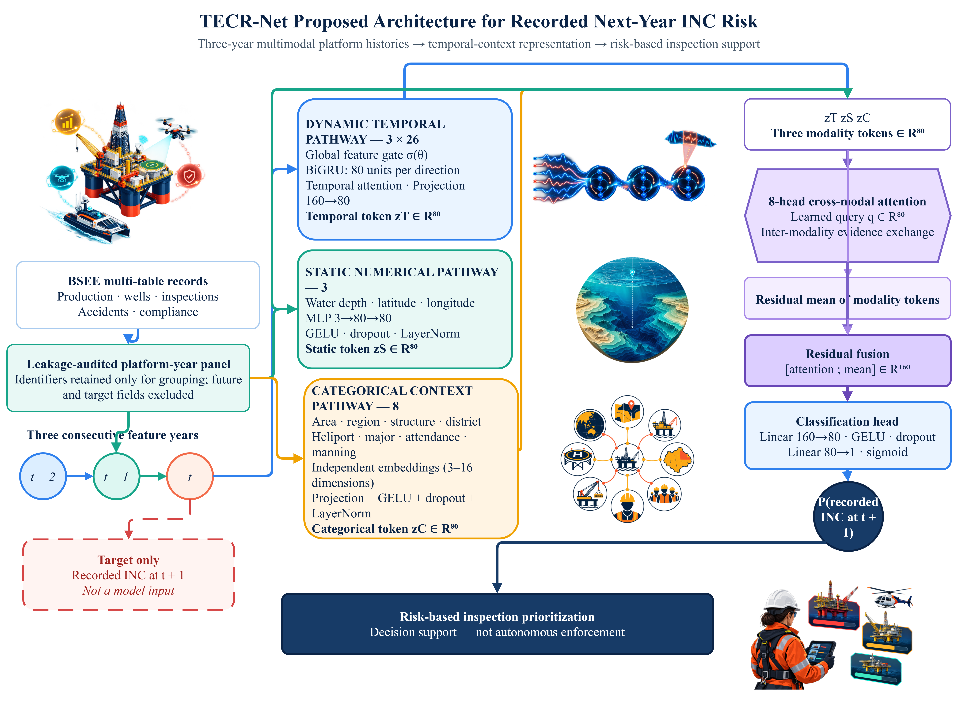

3.7 Evaluation Measures
Average precision (AP), implemented with sklearn.metrics.average_precision_score, is the primary threshold-free measure because positive outcomes are rare. Some archived figures use the label AP for this quantity; all numerical results in the text and tables are reported as AP. ROC-AUC summarizes ranking across thresholds. F1, F2, precision, recall, specificity, balanced accuracy, MCC, and the confusion matrix depend on the development-selected threshold. Brier score evaluates squared probability error, and Brier skill is defined as one minus the model Brier score divided by the constant-reference Brier score. The reference used here is the evaluated development-cohort prevalence, so the skill estimate is retrospective. Precision and lift at k = 50, 100, and 200 refer to the highest-ranked platform-year sequences, not necessarily unique physical platforms.
Table 6. Development metrics and interpretation
Metric | Type | Role
AP | Threshold-free | Primary ranking measure for rare positive outcomes
AP/prevalence | Threshold-free | Improvement over random prevalence baseline
ROC-AUC | Threshold-free | Global ranking discrimination
F1 and F2 | Threshold-dependent | Balance of precision and recall; F2 emphasizes recall
Precision and recall | Threshold-dependent | Yield and coverage of predicted positives
Balanced accuracy | Threshold-dependent | Mean sensitivity and specificity
MCC | Threshold-dependent | Correlation-like summary robust to imbalance
Brier score | Probability-based | Mean squared probability error
Precision@k | Budget-based | Observed yield among k highest-ranked sequences

Table 6 distinguishes ranking measures from threshold-dependent measures. This distinction is essential because the decision threshold was selected on development data. AP and ROC-AUC describe ordering, whereas F1 and the confusion matrix additionally reflect the selected operating point.

4. Results and Discussion

4.1 Multi-Seed Stability
Table 7. TECR-Net apparent development performance across seven random seeds
Metric | Mean | SD | Mean ± SD
Prevalence | 0.03556 | 0.00000 | 0.03556 ± 0.00000
AP | 0.07401 | 0.00775 | 0.07401 ± 0.00775
AP/prevalence | 2.08109 | 0.21780 | 2.08109 ± 0.21780
ROC-AUC | 0.63115 | 0.01119 | 0.63115 ± 0.01119
F1 | 0.12080 | 0.01976 | 0.12080 ± 0.01976
F2 | 0.15060 | 0.04063 | 0.15060 ± 0.04063
Precision | 0.10295 | 0.02972 | 0.10295 ± 0.02972
Recall | 0.22175 | 0.14861 | 0.22175 ± 0.14861
Balanced accuracy | 0.56197 | 0.02388 | 0.56197 ± 0.02388
Specificity | 0.90219 | 0.11113 | 0.90219 ± 0.11113
MCC | 0.08918 | 0.01780 | 0.08918 ± 0.01780
Brier score | 0.03407 | 0.00004 | 0.03407 ± 0.00004
Threshold | 0.04982 | 0.00516 | 0.04982 ± 0.00516
Precision@50 | 0.10857 | 0.02545 | 0.10857 ± 0.02545
Precision@100 | 0.08571 | 0.02225 | 0.08571 ± 0.02225
Precision@200 | 0.05857 | 0.01180 | 0.05857 ± 0.01180

Across seven random seeds, TECR-Net achieved mean development AP of 0.07401 +/- 0.00775 and ROC-AUC of 0.63115 +/- 0.01119. Recall varied substantially across seeds (SD 0.14861), indicating sensitivity of threshold-dependent behaviour to initialization and training variation. These values characterize stochastic variation within the adaptively used development cohort; they are not confidence intervals and do not demonstrate independent generalization.
Figure 2 summarizes the threshold-dependent behaviour of the seven-seed ensemble on the development cohort. The confusion matrix is included because a regulator must understand the number of missed positive records and unnecessary alerts generated at the selected operating point, rather than relying only on threshold-free area measures.
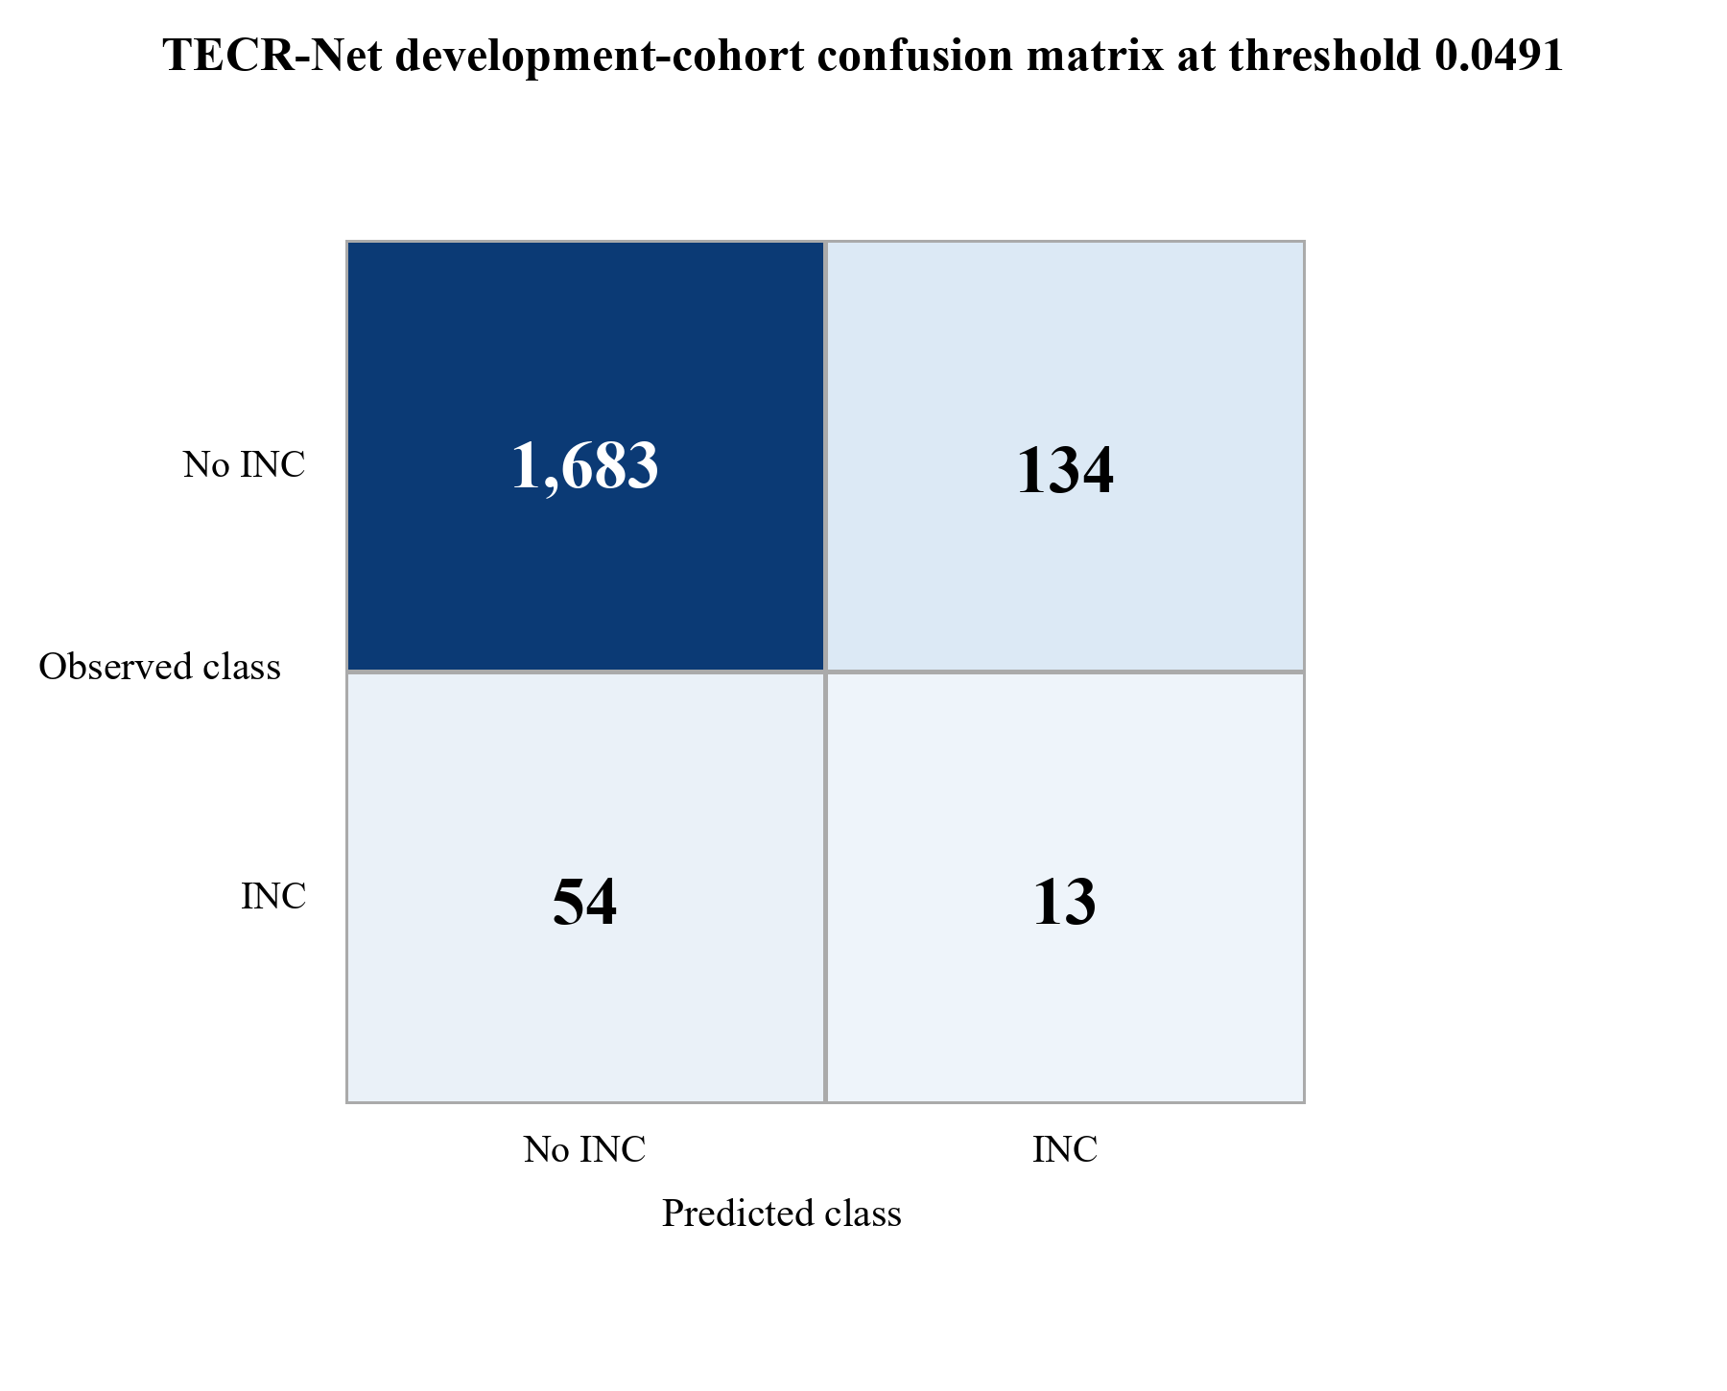

Figure 2. Development-cohort confusion matrix for the seven-seed TECR-Net probability ensemble. Source: authors’ development predictions.
Figure 2 shows 1,683 true negatives, 134 false positives, 54 false negatives, and 13 true positives at threshold 0.0491. Specificity is high because most negative sequences remain below the threshold, but only 19.4% of the 67 positive sequences are detected. The figure therefore supports a prioritization interpretation rather than a claim of comprehensive case detection.

4.2 Ensemble Discrimination and Operational Ranking
Table 8. TECR-Net ensemble metrics on the development cohort
Metric | Value | Metric | Value
Prevalence | 0.03556 | AP/prevalence | 2.114×
AP | 0.07518 | ROC-AUC | 0.63855
F1 | 0.12150 | F2 | 0.15663
Precision | 0.08844 | Recall | 0.19403
Specificity | 0.92625 | Balanced accuracy | 0.56014
MCC | 0.08305 | Brier score | 0.03406
Threshold | 0.04909 | TN / FP / FN / TP | 1683 / 134 / 54 / 13
Precision@50 | 0.080 | Lift@50 | 2.250×
Precision@100 | 0.080 | Lift@100 | 2.250×
Precision@200 | 0.070 | Lift@200 | 1.968×

Table 8 shows ensemble AP of 0.07518, or 2.11 times the 3.56% development prevalence. Among the 50 highest-ranked platform-year sequences, four had positive recorded outcomes, yielding Precision@50 of 0.080 and approximately 2.25-fold enrichment. Repeated observations from the same physical platform may occur, so this quantity is not the yield among 50 distinct facilities. The absolute yield remains limited and supports only an exploratory prioritization interpretation.
Figure 3 displays the two threshold-free discrimination views for the development ensemble.
Figure 3 evaluates discrimination independently of a single operating threshold. The receiver-operating-characteristic curve describes sensitivity across false-positive rates, whereas the precision-recall curve is more informative for the rare positive outcome because it compares positive yield with the cohort prevalence reference.
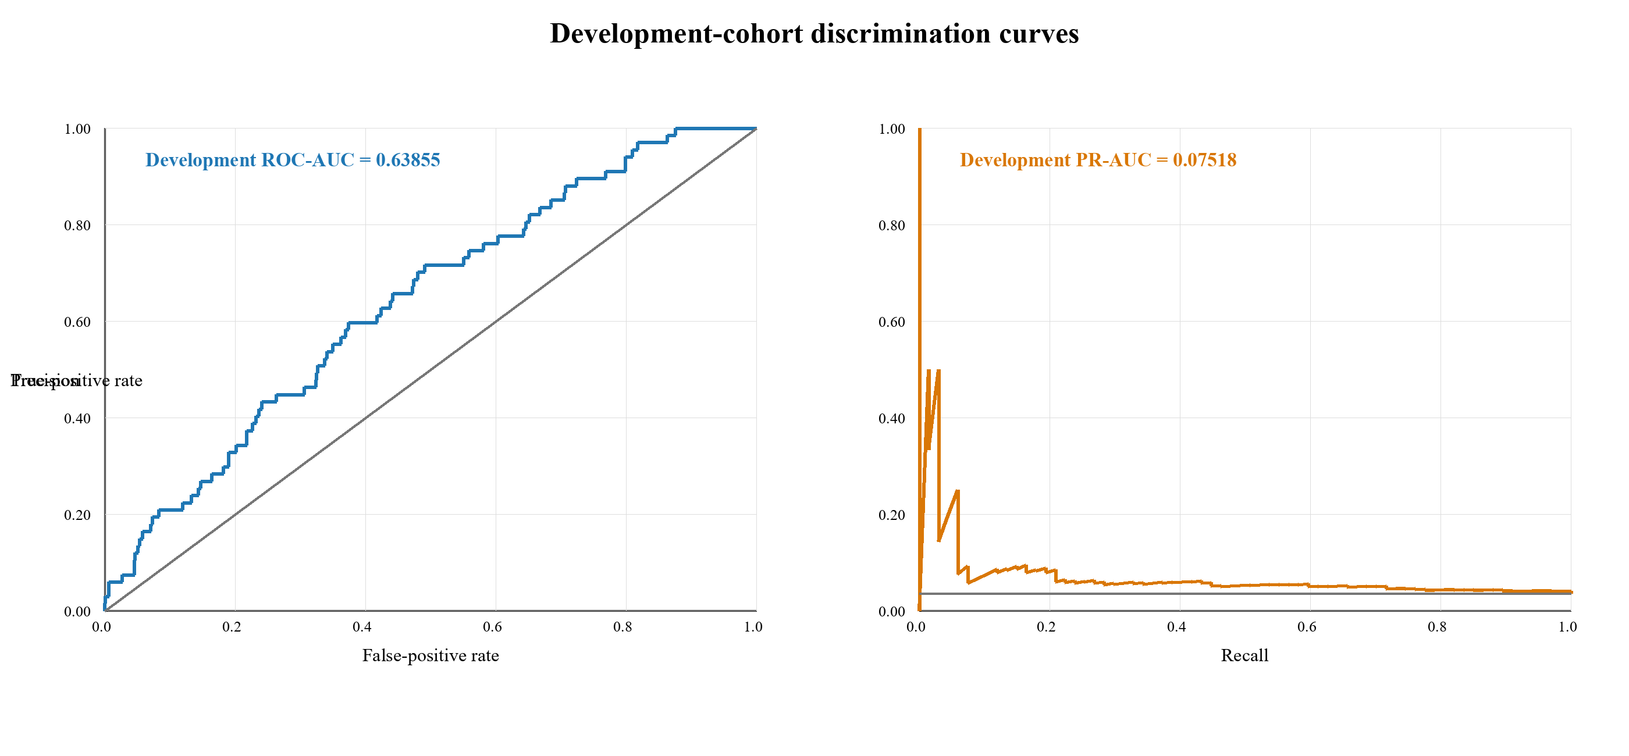
Figure 3. Development-cohort ROC and precision-recall curves for the TECR-Net ensemble. Source: authors’ development predictions.
Figure 3 shows development ROC-AUC 0.63855 and AP 0.07518. The ROC curve lies above the random diagonal, while the precision-recall curve remains above the 0.03556 prevalence reference over part of the recall range. The modest separation confirms useful but limited discrimination and rules out descriptions such as excellent or near-perfect performance.
4.3 Mean Development Metrics and Learning Behaviour
Figure 4 summarizes variation in the principal development metrics across seven TECR-Net fits.
Figure 4 places the principal validation measures and their between-seed variability on a common scale. The visualization is intended to distinguish stable ranking behaviour from the greater stochastic sensitivity of threshold-dependent precision and recall, rather than to suggest that numerically larger metrics are directly interchangeable.
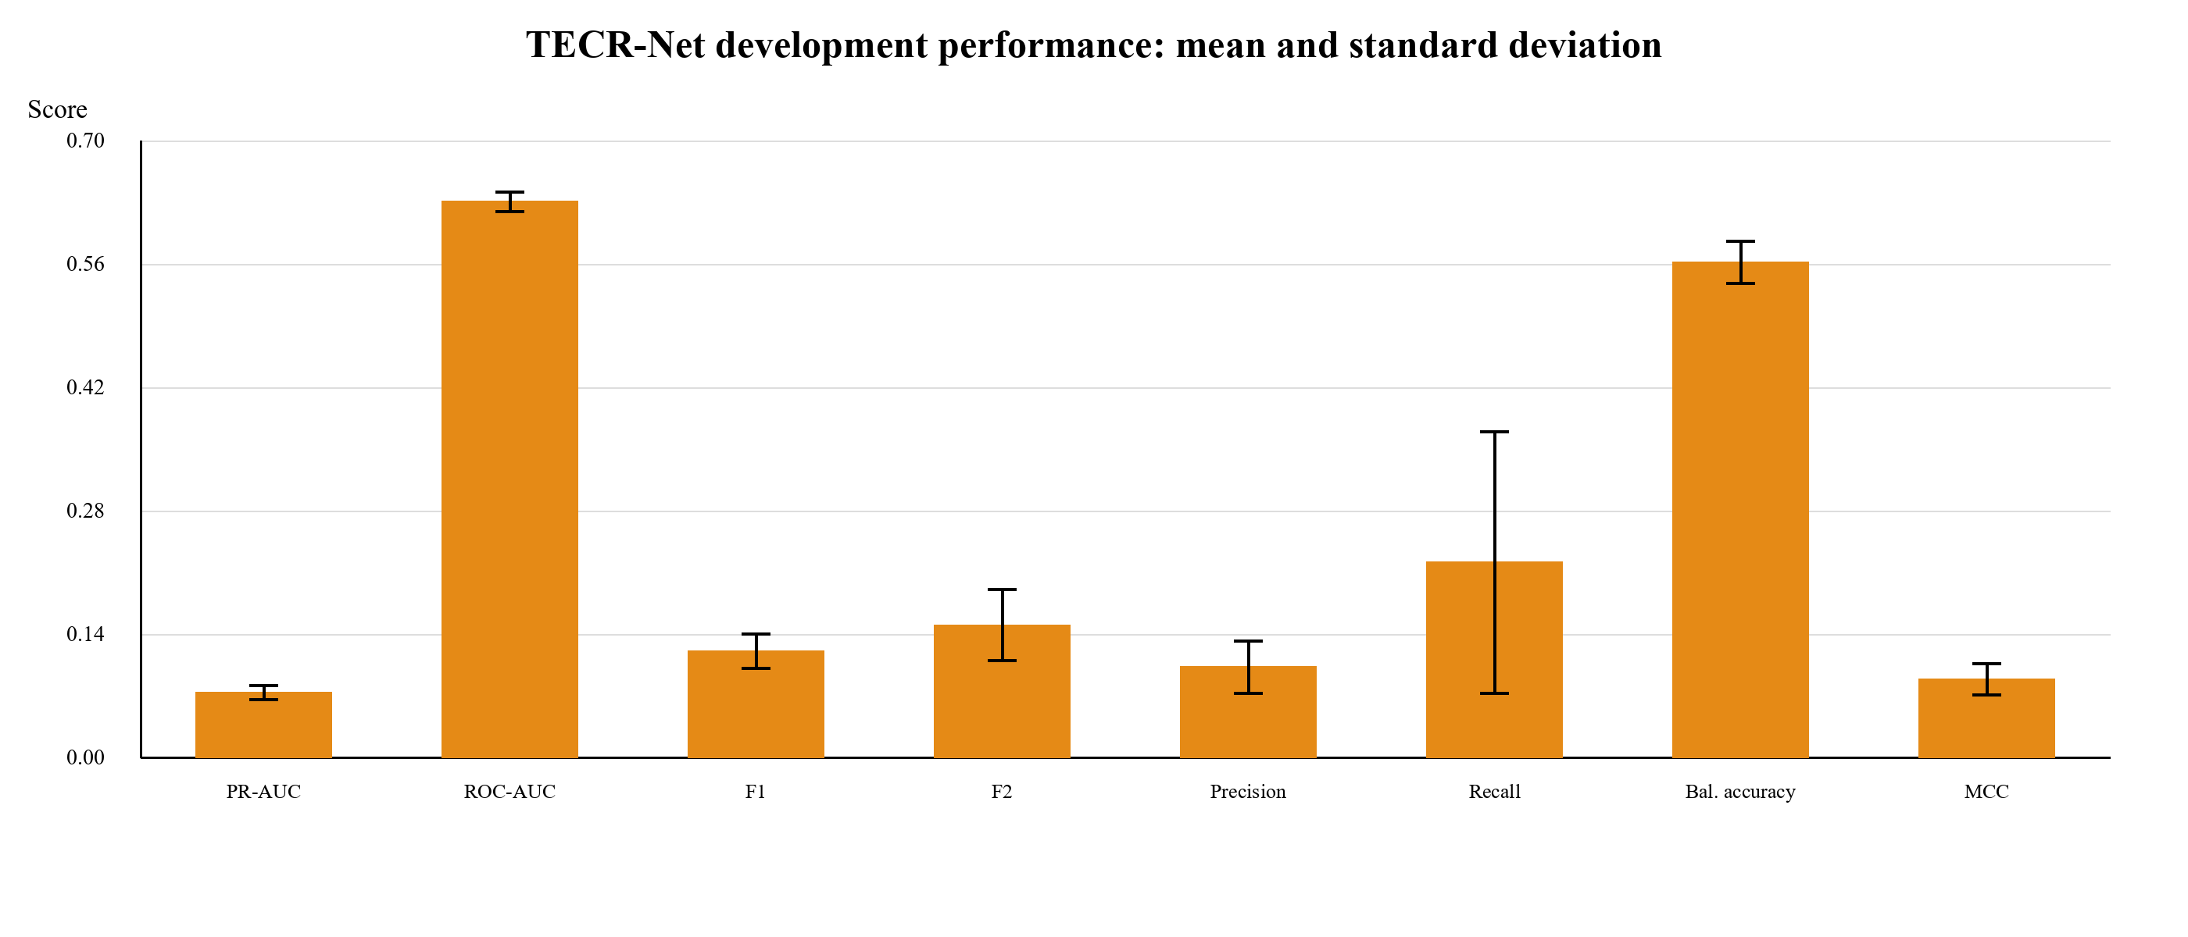
Figure 4. Mean development metrics across seven TECR-Net seeds with one-standard-deviation error bars. Source: authors’ development summary.
Figure 4 highlights the difference between threshold-free ranking and threshold-dependent classification. ROC-AUC is the largest bounded score, whereas AP and F1 remain low in absolute terms because positives are rare and overlap substantially with negatives.The wide recall error bar shows that operating-point behaviour is sensitive to stochastic fitting, strengthening the case for ensemble probabilities and explicit uncertainty reporting.
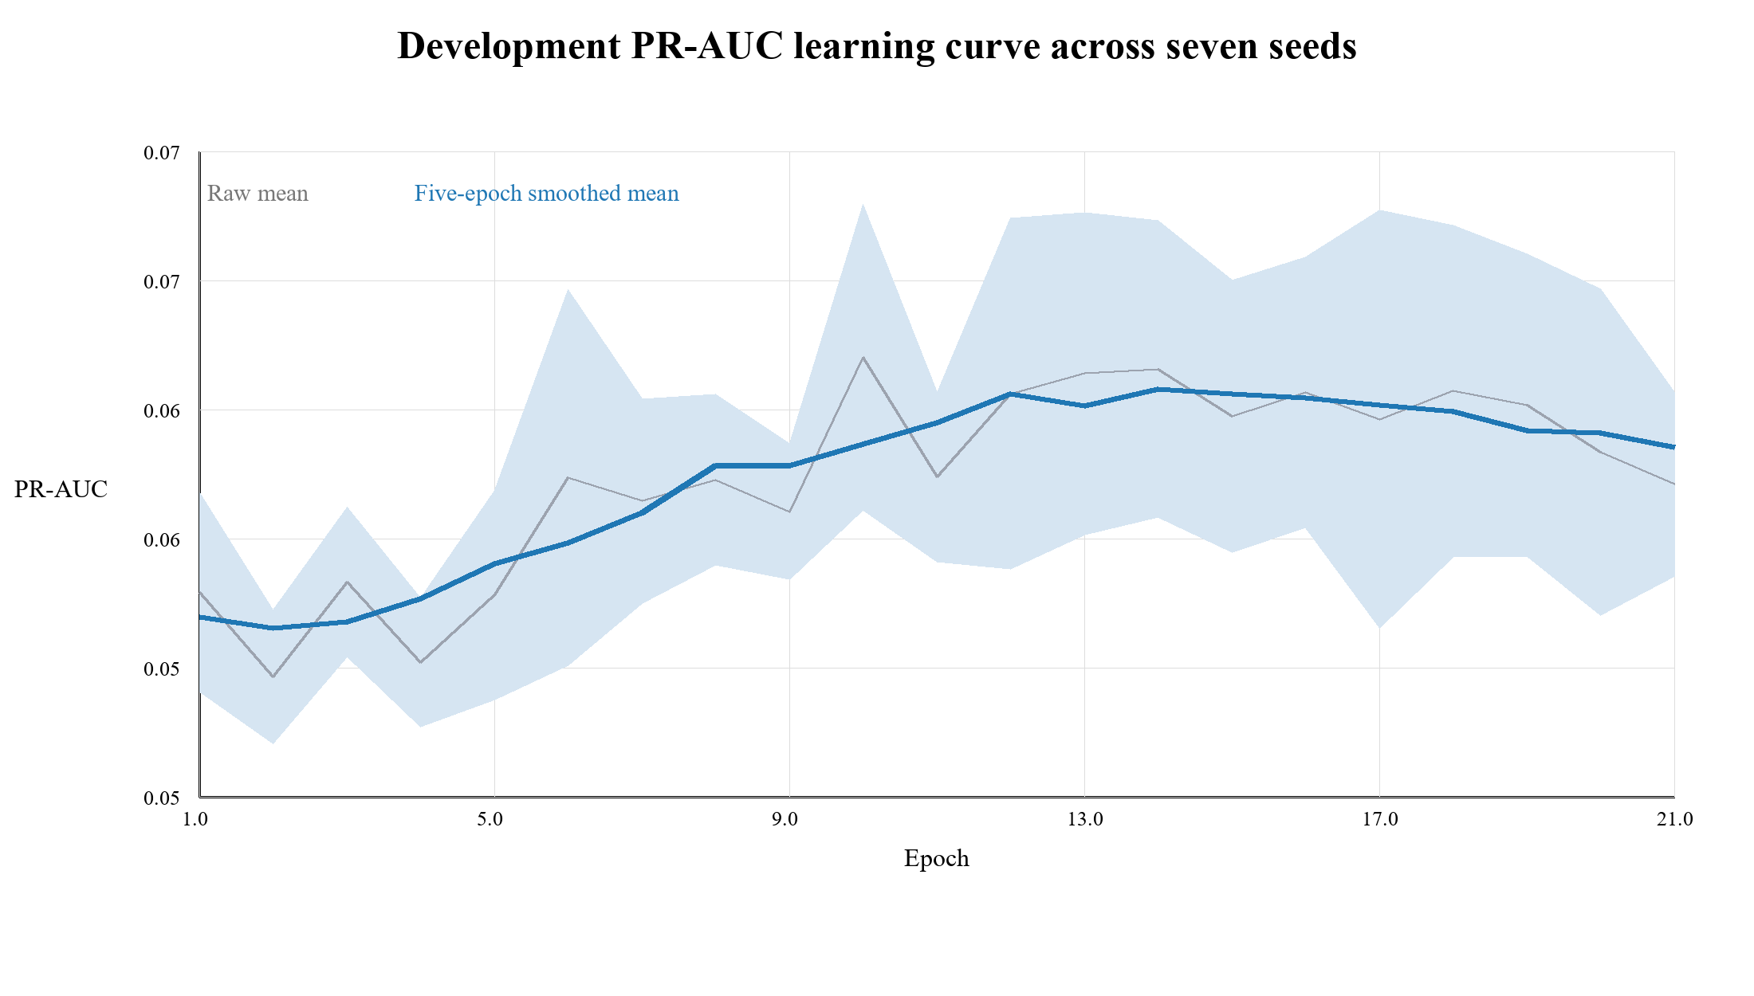
Figure 5. Development AP learning curve averaged across seven seeds and restricted to epochs completed by every seed. Source: authors’ development histories.
Figure 5 shows an early rise in mean development AP followed by a plateau and mild decline. The plotted mean is restricted to epochs completed by every included seed and is smoothed over five epochs; the uncertainty band summarizes between-seed variation at aligned epochs. It is not the mean of individually selected best checkpoints. The lower plotted peak relative to Table 7 reflects this different construction, and neither view constitutes independent evidence of convergence or generalization.

4.4 Sequence-Aligned Development Baselines
Table 9 compares TECR-Net and four rerun tabular baselines on identical sample identifiers, labels, three-year dynamic histories, static variables, categorical context and 1,884 development sequences. The baseline preprocessing was fitted within development data, and each baseline received 25 inner-temporal Optuna trials and seven final seeds [37–40].
Table 9. Sequence-aligned development comparison
Model | AP | ROC-AUC | TECR-Net AP difference | 95% platform-clustered CI
TECR-Net | 0.07518 | 0.63855 | Reference | —
CatBoost | 0.05163 | 0.62390 | 0.02355 | -0.00133 to 0.06434
LightGBM | 0.04690 | 0.62848 | 0.02828 | 0.00177 to 0.07168
XGBoost | 0.05036 | 0.62903 | 0.02482 | -0.00095 to 0.06795
HistGradientBoosting | 0.04891 | 0.62539 | 0.02627 | 0.00080 to 0.06971

The aligned development predictions show that TECR-Net achieved AP of 0.07518, compared with 0.05163 for CatBoost, 0.05036 for XGBoost, 0.04891 for HistGradientBoosting, and 0.04690 for LightGBM. Exact sequence identifiers and labels were matched across the saved predictions. Nevertheless, TECR-Net and the baselines were selected using different development procedures. The observed ordering therefore does not establish an unbiased architectural advantage. Platform-clustered intervals quantify variability conditional on the saved predictions but do not correct adaptive model-selection bias.
Figure 6 compares TECR-Net with four sequence-aligned tabular baselines using the same development sample identifiers and primary AP measure. The prevalence line provides the random-ranking reference, while the bars show the observed ordering under the reported but not fully symmetric model-selection procedures.

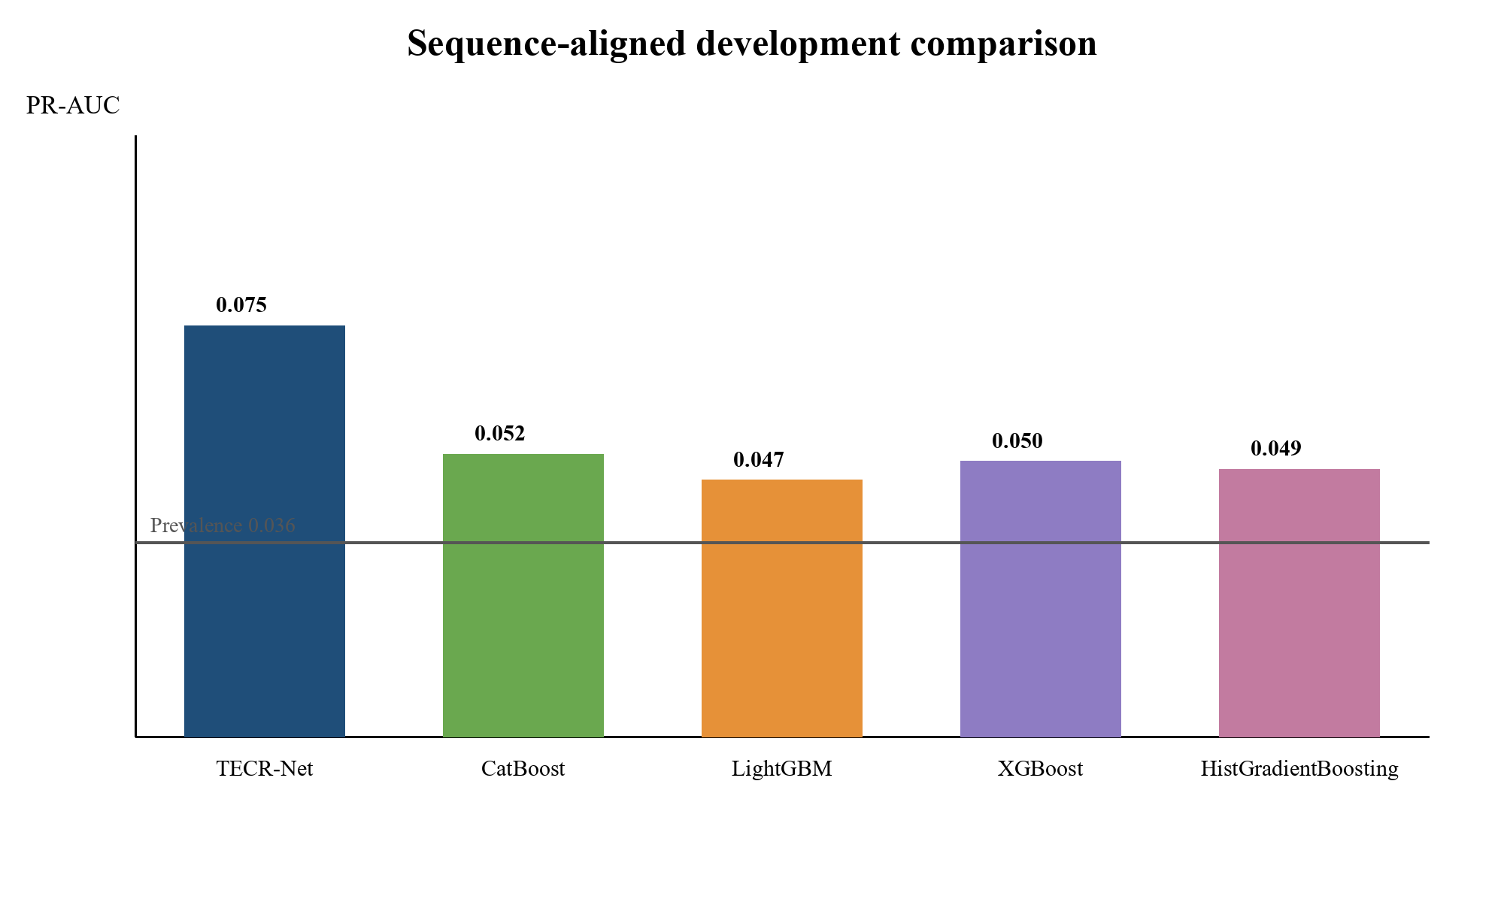
Figure 6. Development AP for TECR-Net and four sequence-aligned tabular baselines.
Figure 6 shows that TECR-Net and all four baselines exceed the 0.03556 prevalence reference, with TECR-Net producing the largest observed AP. Because the proposed model was previously optimized against this development period, the chart documents the observed ordering but does not establish unbiased predictive superiority. A frozen evaluation on later or external data is required for that claim.
4.5 Architectural Ablation
Table 10 reports the full model and six component-removal variants using development results only.
Table 10. Development-only TECR-Net architectural ablation
Variant | AP | ROC-AUC
Full TECR-Net | 0.07518 | 0.63855
Without categorical encoder | 0.07374 | 0.60503
Without cross-modal attention | 0.07494 | 0.63760
Without feature gate | 0.06652 | 0.63832
Without GRU | 0.05556 | 0.63252
Without residual fusion | 0.07150 | 0.64479
Without temporal attention | 0.06938 | 0.63824

Removing the GRU produced the largest observed development AP reduction, from 0.07518 to 0.05556. Removing feature gating and temporal attention produced smaller reductions, whereas excluding cross-modal attention changed AP by only 0.00024. Removing residual fusion reduced AP to 0.07150 but increased ROC-AUC to 0.64479. These results describe sensitivity within the development experiment. Because the reduced models did not undergo an independently verified equivalent hyperparameter search, the differences do not establish isolated causal contributions or statistical necessity.
Figure 7 provides a visual component analysis under the primary rare-event ranking metric. Every ablation removes one architectural element while retaining the remaining data representation and evaluation cohort, so the magnitude of each AP reduction indicates the observed contribution of that component within the development experiment.

4.5 Architectural Ablation
Table 10 reports the full model and six component-removal variants using development results only.
Table 10. Development-only TECR-Net architectural ablation

Removing the GRU produced the largest observed development AP reduction, from 0.07518 to 0.05556. Removing feature gating and temporal attention produced smaller reductions, whereas excluding cross-modal attention changed AP by only 0.00024. Removing residual fusion reduced AP to 0.07150 but increased ROC-AUC to 0.64479. These results describe sensitivity within the development experiment. Because the reduced models did not undergo an independently verified equivalent hyperparameter search, the differences do not establish isolated causal contributions or statistical necessity.
Figure 7 provides a visual component analysis under the primary rare-event ranking metric. Every ablation removes one architectural element while retaining the remaining data representation and evaluation cohort, so the magnitude of each AP reduction indicates the observed contribution of that component within the development experiment.

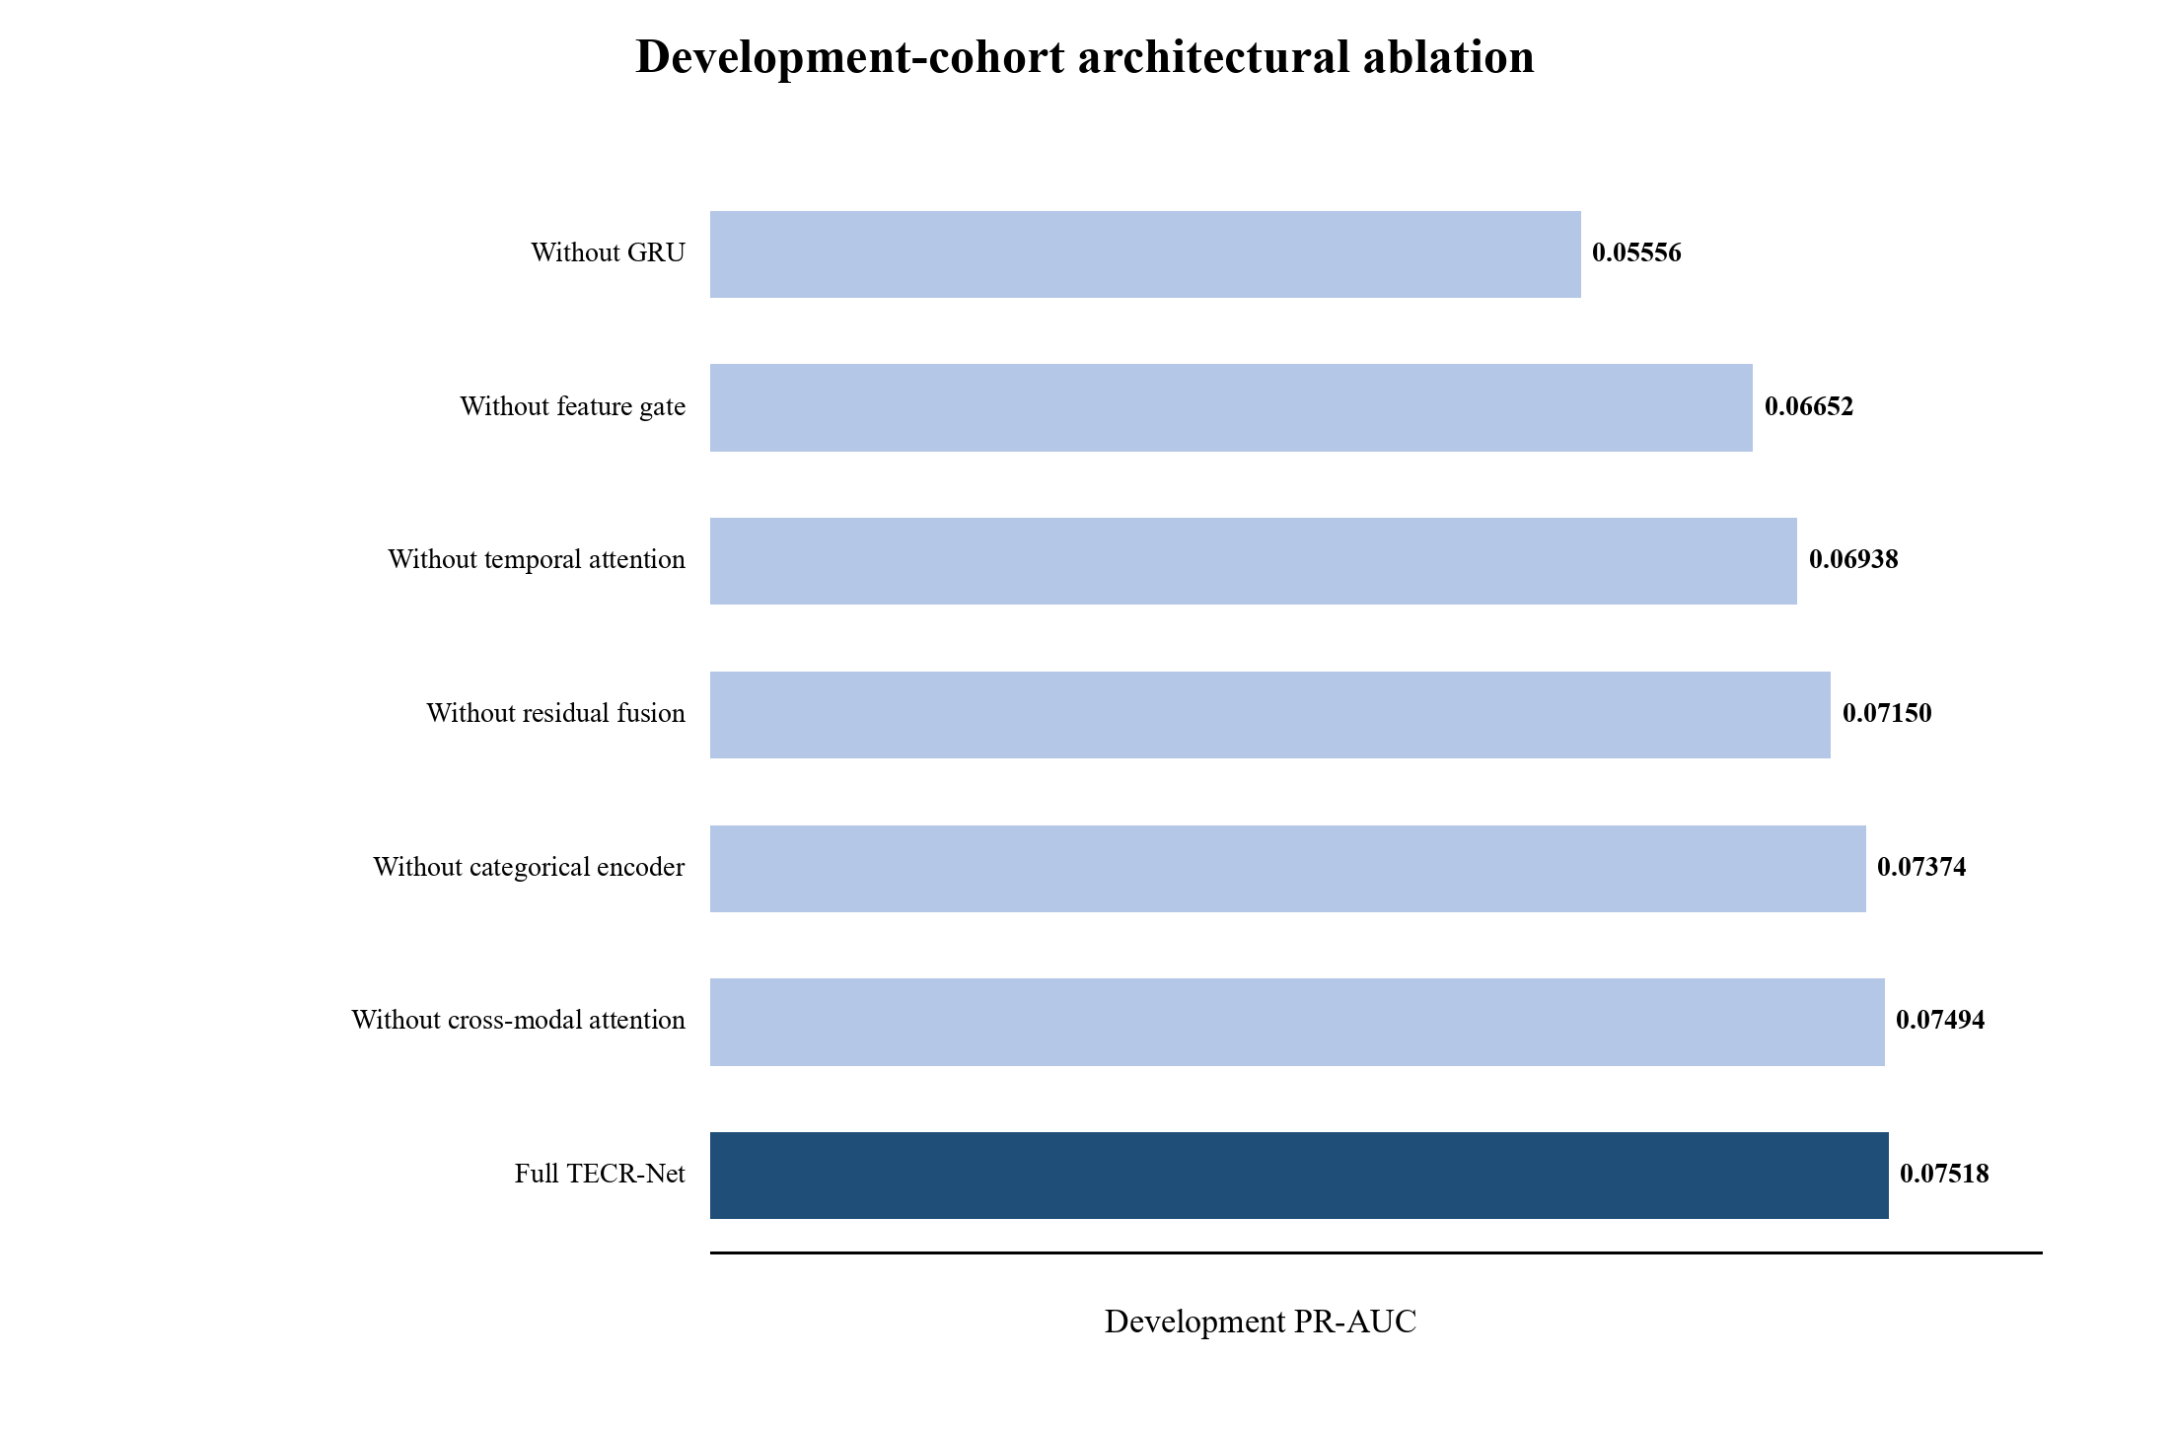
Figure 7. Development AP for the full TECR-Net and six architectural ablations. Source: authors’ development ablation outputs.
Figure 7 makes the recurrent encoder contribution most visible: the no-GRU variant approaches the prevalence baseline more closely than the other variants. The small difference between the full model and removal of cross-modal attention indicates that this module contributes less development AP than the recurrent pathway, even though it may affect threshold-dependent behaviour.

4.6 Accident-Feature Sensitivity
Table 11 evaluates whether the primary development result depends on the three coarse lease-level accident proxies. Both variants use the same 1,884 sequences, 982 platforms, 67 positive labels, architecture, seven seeds, and probability-ensemble procedure.
Table 11. Development sensitivity to lease-level accident proxies
Variant | AP | ROC-AUC | F1 | Precision | Recall | MCC | P@50
Full TECR-Net | 0.07518 | 0.63855 | 0.12150 | 0.08844 | 0.19403 | 0.08305 | 0.080
Without lease-level accident proxies | 0.07478 | 0.62849 | 0.12091 | 0.07273 | 0.35821 | 0.09248 | 0.100

Removing the three lease-level accident proxies changed AP from 0.07518 to 0.07478, a full-minus-reduced difference of approximately 0.00040. The paired platform-clustered 95% bootstrap interval ranged from -0.02183 to 0.02153 and included zero. The analysis therefore did not establish a statistically detectable AP difference. The interval is too wide to establish equivalence or prove that the variables are unimportant; it provides uncertainty-limited sensitivity evidence only.

4.7 Development Uncertainty and Apparent Calibration
Table 12 reports dependence-aware uncertainty and limited probability diagnostics calculated from the development ensemble predictions. Because the probability mapping was fitted on the same period, these quantities are apparent rather than independently validated calibration estimates.
Table 12. Development uncertainty and apparent probability diagnostics
Diagnostic | Estimate | 95% bootstrap CI / basis | Interpretation
AP | 0.07518 | 0.04269–0.12568 | Primary rare-event ranking
ROC-AUC | 0.63855 | 0.57197–0.70213 | Moderate discrimination
Brier score | 0.03406 | 0.02671–0.04211 | Probability error
Brier skill score | 0.00692 | Reference = 0.03430 | Gain over constant prevalence
Calibration intercept | 2.57119 | Apparent | Ideal value 0
Calibration slope | 1.79530 | Apparent | Ideal value 1
Precision@50 | 0.080 | 0.000–0.191 | 50 highest-ranked sequences
Precision@100 | 0.080 | 0.020–0.140 | 100 highest-ranked sequences
Precision@200 | 0.070 | 0.035–0.115 | 200 highest-ranked sequences
Development prevalence | 0.03556 | 67 / 1,884 | Rare outcome

The development probability diagnostics were estimated from the same cohort used to fit probability mappings and select operating thresholds. They are therefore apparent calibration estimates. The calibration intercept and slope depart from their ideal values, and the small Brier score partly reflects the low positive prevalence. The Brier skill reference is the retrospectively observed development prevalence rather than an independently constructed historical forecast. Prospective assessment and recalibration are necessary before interpreting outputs as absolute risk probabilities.
Figure 8 evaluates apparent probability agreement by comparing mean predicted risk with observed event frequency across ten equal-frequency bins. This diagnostic complements discrimination metrics by showing whether predicted probabilities have the correct scale, although reuse of the development cohort for calibration prevents an independent calibration claim.
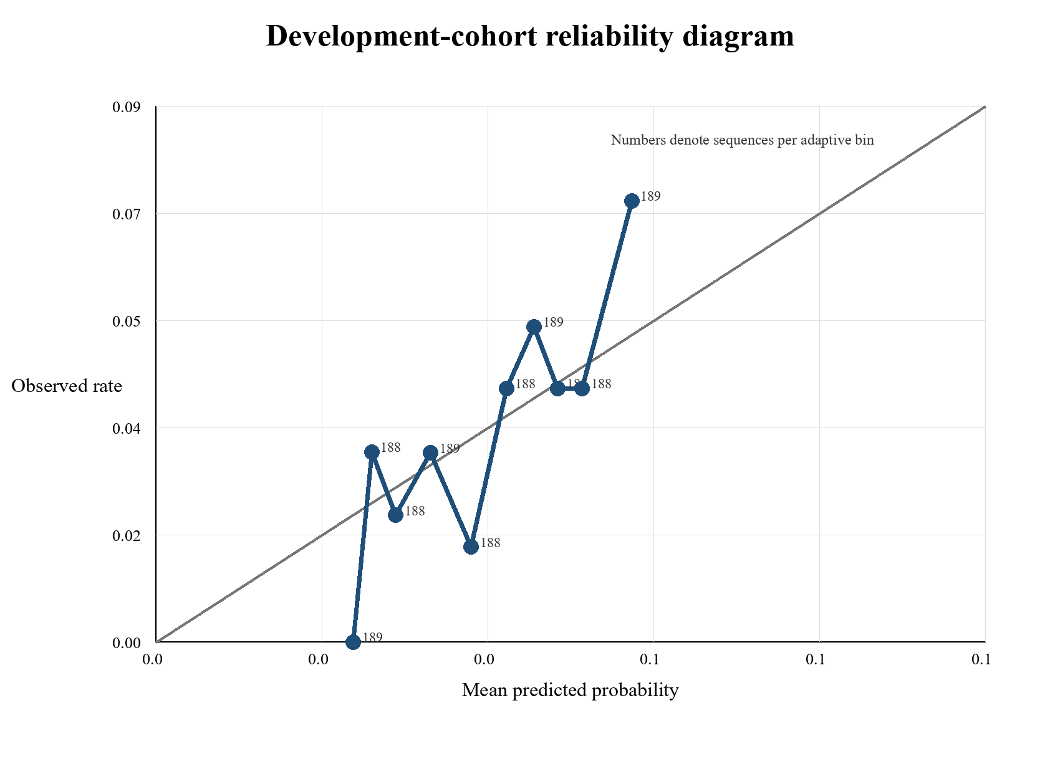
Figure 8. Development reliability diagram using ten equal-frequency bins. Source: authors’ development ensemble predictions.
Figure 8 compares mean predicted probabilities with observed outcome rates and labels each bin by its sequence count. Deviations from the diagonal show that calibration is not perfect despite the low Brier score. Because the Platt maps were fitted on this cohort, the figure describes in-sample probability behaviour and cannot establish calibration on future platforms.
4.8 Exploratory Chronological Later-Cohort Findings
The archived TECR-Net experiment included a later cohort covering feature years 2022–2024. It contained 2,196 sequences from 876 platforms and 94 positive recorded-INC outcomes. Recomputed ensemble metrics were AP 0.10318, ROC-AUC 0.65592, precision 0.12583, recall 0.20213, F1 0.15510, and Brier score 0.04068. Because this cohort was inspected repeatedly during exploratory model development, it is not a genuinely untouched confirmatory test. Table 13 reports it for complete accounting of the experimental record, not as unbiased validation.
Table 13. Exploratory chronological later-cohort results
Metric | Exploratory result
Sequences | 2,196
Platforms | 876
Positive outcomes | 94
Prevalence | 0.04281
AP | 0.10318
ROC-AUC | 0.65592
Precision | 0.12583
Recall | 0.20213
F1 | 0.15510
Brier score | 0.04068
ECE (recalculated) | 0.018004
MCE | 0.067951
Table 13 shows slightly higher discrimination than in the development cohort, but the difference must not be interpreted as prospective improvement because the later cohort influenced subsequent analytical choices. The recalculated calibration errors are non-zero, and no operational claim follows from these exploratory values. A new prospective BSEE release or compatible external cohort remains necessary for confirmatory evaluation.

4.9 Sensitivity to Pre-Installation Records
The temporal-integrity audit identified nine development sequences and 16 later-cohort sequences containing observations that predated their recorded platform installation years. Excluding these flagged observations at evaluation changed development AP from 0.075179 to 0.075619 and later-cohort AP from 0.103182 to 0.104099. The corresponding ROC-AUC changes were 0.638555 to 0.640000 and 0.655920 to 0.657014. Table 14 summarizes the sensitivity results.
Table 14. Sensitivity to sequences containing pre-installation observations
Cohort | Flagged | AP original | AP excluded | ROC-AUC original | ROC-AUC excluded
Development | 9 | 0.075179 | 0.075619 | 0.638555 | 0.640000
Exploratory later cohort | 16 | 0.103182 | 0.104099 | 0.655920 | 0.657014
Table 14 indicates that the archived evaluation scores were not dominated by the small set of flagged records. However, the model was not retrained after exclusion, and this sensitivity check does not establish the historical validity of the remaining structural and contextual snapshot variables.

5. Discussion
TECR-Net exhibited limited but measurable development-stage ranking discrimination for subsequent recorded INC outcomes, with ensemble AP of 0.07518 and ROC-AUC of 0.63855. The archived later cohort yielded exploratory AP of 0.10318 and ROC-AUC of 0.65592, but repeated inspection of that period prevents a confirmatory interpretation. At the development-selected threshold, only 13 of 67 positive sequences were detected, illustrating that the model cannot provide comprehensive case identification.The sequence-aligned tabular comparisons showed higher observed development AP for TECR-Net, but unequal model-selection procedures preclude an unbiased superiority claim. Architectural ablations produced their largest observed AP decrease when the recurrent encoder was removed, while cross-modal attention changed AP only marginally. Accident-proxy removal also produced a small point difference with wide uncertainty. These analyses are exploratory and do not establish causal component necessity.
Recorded INCs reflect inspection and enforcement processes as well as platform conditions. Production-linked eligibility, repeated platform observations, operator- and lease-level aggregation, historically unverified snapshot attributes, and adaptive use of development outcomes all restrict interpretation. The pre-installation sensitivity result reduces concern about a small flagged subset but does not solve broader provenance uncertainty. TECR-Net should therefore be regarded as a retrospective methodological prototype requiring historically defensible reconstruction, symmetric comparator selection, independent calibration, and genuinely prospective or external evaluation before operational consideration.

6. Limitations
1. TECR-Net hyperparameter selection, stopping, probability mapping, threshold determination, ablation assessment and performance estimation used the same 2020–2021 development period. The reported estimates may therefore be optimistic for unseen data and are not independent validation results.
2. The outcome is a recorded INC rather than latent non-compliance. Inspection frequency, reporting practice and regulatory attention affect label observation, and the available regional files do not contain a complete denominator of facility inspections with zero INC. Model-guided inspections could therefore reinforce historical observation patterns.
3. Eligibility requires consecutive t−2, t−1 and t production-linked records and an observable t+1 record, creating possible survivorship selection and limiting inference to the production-derived analytical cohort. The target population is not every offshore platform.
4. The structure source provides installation, removal and site-clearance dates but no attribute-specific effective dates. Historical availability of water depth, coordinates, structural class, district, heliport, attendance and manning values is therefore unverified. Only 67 positive development outcomes are available, and transportability to other periods, regions, regulators and asset classes has not been established.
5. Attribute-specific historical effective dates are unavailable for several static and categorical snapshot variables, and a small number of pre-installation observations were flagged.
6. Calendar-exact feature construction and source-publication timing require continued verification, particularly for lagged, operator-year, and lease-year aggregates.
7. Baseline samples were aligned, but baseline and TECR-Net optimization protocols were not fully symmetric; simple comparator evidence therefore remains incomplete.
8. Repeated sequences from the same platform and operator- and lease-level variables create dependence that is only partly addressed by platform-clustered resampling.
9. Discrimination is modest, calibration is apparent rather than independent, and no prospective deployment, decision-impact, fairness, or feedback-loop evaluation has been performed.

7. Conclusion
This study investigated TECR-Net as a temporal cross-modal neural framework for estimating subsequent recorded INC outcomes from historical offshore-platform records. The seven-seed ensemble achieved apparent development AP of 0.07518 and ROC-AUC of 0.63855, while the already inspected later cohort yielded exploratory AP of 0.10318 and ROC-AUC of 0.65592. Architectural and accident-feature analyses provided descriptive sensitivity evidence but did not establish definitive component contributions or predictive superiority under independent evaluation.
The main contribution is an exploratory integration of temporally structured operational, regulatory, static, and categorical information within a multimodal architecture. Important unresolved issues include production-linked cohort selection, historical attribute provenance, calendar-exact feature construction, probability calibration, unequal model-selection protocols, and the absence of genuinely untouched confirmation. TECR-Net should therefore be regarded as a methodological research prototype rather than a validated system for regulatory enforcement or inspection allocation. Future work should prioritize historically defensible data reconstruction, low-complexity and symmetrically tuned comparators, dependence-aware evaluation, and independent prospective assessment.

Appendix A Input Feature Dictionary
Table A1 lists all 37 predictive inputs, their timing and their administrative level. Dynamic variables are repeated at t−2, t−1 and t, while static and categorical values are attached once to each sequence.
Table A1. Predictive inputs, timing and administrative level
Feature | Group | Timing | Level
active_months | Dynamic | t−2, t−1 and t | Platform-year
producing_wells_mean | Dynamic | t−2, t−1 and t | Platform-year
producing_wells_max | Dynamic | t−2, t−1 and t | Platform-year
bopd_mean | Dynamic | t−2, t−1 and t | Platform-year
bopd_max | Dynamic | t−2, t−1 and t | Platform-year
mcfd_mean | Dynamic | t−2, t−1 and t | Platform-year
mcfd_max | Dynamic | t−2, t−1 and t | Platform-year
boepd_mean | Dynamic | t−2, t−1 and t | Platform-year
bwpd_mean | Dynamic | t−2, t−1 and t | Platform-year
platform_age | Dynamic | t−2, t−1 and t | Platform-year
operator_facilities_inspected | Dynamic | t−2, t−1 and t | Operator-year
operator_inspection_records | Dynamic | t−2, t−1 and t | Operator-year
operator_inspection_types | Dynamic | t−2, t−1 and t | Operator-year
investigated_accident_count | Dynamic | t−2, t−1 and t | Lease-year proxy
accident_type_count | Dynamic | t−2, t−1 and t | Lease-year proxy
previous_year_inc_count | Dynamic | t−2, t−1 and t | Platform-year
inc_count_previous_3_observations | Dynamic | t−2, t−1 and t | Platform-year
previous_year_accident_count | Dynamic | t−2, t−1 and t | Lease-year proxy
production_change_bopd | Dynamic | t−2, t−1 and t | Platform-year
production_change_mcfd | Dynamic | t−2, t−1 and t | Platform-year
inc_count | Dynamic | t−2, t−1 and t | Platform-year
enforcement_code_count | Dynamic | t−2, t−1 and t | Platform-year
any_inc | Dynamic | t−2, t−1 and t | Platform-year
operator_warning_incs | Dynamic | t−2, t−1 and t | Operator-year
operator_component_shutin_incs | Dynamic | t−2, t−1 and t | Operator-year
operator_facility_shutin_incs | Dynamic | t−2, t−1 and t | Operator-year
water_depth | Static numerical | Attached at t | Platform snapshot
latitude | Static numerical | Attached at t | Platform snapshot
longitude | Static numerical | Attached at t | Platform snapshot
area_code | Categorical | Attached at t | Regional/platform
region_code | Categorical | Attached at t | Regional/platform
structure_type | Categorical | Attached at t | Platform snapshot
major_structure_flag | Categorical | Attached at t | Platform snapshot
district_code | Categorical | Attached at t | Regional/platform
heliport_flag | Categorical | Attached at t | Platform snapshot
attended_8hr_flag | Categorical | Attached at t | Platform snapshot
manned_24hr_flag | Categorical | Attached at t | Platform snapshot

Table A1 clarifies that most predictors are platform-year measurements, while inspection aggregates operate at operator-year level and accident indicators are coarse lease-year proxies. The static and categorical snapshot fields require source-date verification before they can be described as historically observed at each prediction origin.

References
[1] Liu, B., Li, Z., Duan, Q., Yan, B. and Tan, X., 2025. Research on LLM-based assessment methods for international standards' intelligent contribution to oil and gas pipelines. Journal of Pipeline Science and Engineering, p.100405.
[2] Hui, Q., Liu, B., Fan, J., Guo, D., Chen, J., Tan, X. and Peng, Z., 2026. Knowledge graph construction for pipeline standards: Enhancing efficiency in the oil and gas industry. Journal of Pipeline Science and Engineering, p.100445.
[3] Xia, T., Wang, F., Huang, Z., Zhang, W., Chen, G., Zhou, J. and Liu, C., 2025. Multi-Dimensional Control Rules and Assessment Methods for Surface Engineering Data Quality in Oil and Gas Field. Information, 16(8), p.701.
[4] Khordoustan, P., Akbarzadeh, O., Gilani, N., Moshashaei, P. and Alizadeh, S.S., 2026. A hybrid ANP and machine learning framework for contractor health safety environment and quality performance evaluation. Discover Analytics, 4(1), p.16.
[5] Wahono, T., Purniawan, A., Mukhlash, I. and Putri, E.R., 2025. Risk-based asset integrity management in the oil and gas industry from traditional to machine learning approaches: A systematic review. Results in Engineering, p.107287.
[6] Zhang, X., Yan, L., Lai, F. and Wang, H., 2025. Research progress and prospects of risk assessment methods for oil and gas development. Geoenergy Science and Engineering, 253, p.213992.
[7] Wahono, T., Mukhlash, I., Putri, E.R. and Purniawan, A., 2026. An intuitionistic fuzzy deep neural network method for risk assessment of oil and gas pipelines. Cleaner Engineering and Technology, p.101299.
[8] Zhou, Y., Fan, J., Dai, B. and Wu, S., 2025. A data-driven PCA-hierarchical clustering framework for adaptive risk assessment of gas pipeline networks. Process Safety and Environmental Protection, p.107753.
[9] Ye, Z., Duan, Q. and Ma, S., 2026. Research on risk classification of oil and natural gas pipelines based on text mining and apriori algorithm. Journal of Loss Prevention in the Process Industries, 103, p.106059.
[10] AlAbdouli, M.A. and Al-Shihabi, S., 2025. Artificial intelligence and its performance impacts in the oil and gas industry: Challenges, insights, and evaluation approaches. Results in Engineering, p.107636.
[11] Savari, A., Li, Y., Alnefaie, K. and Singh, N.S.S., 2026. State-of-the-art Machine learning Advances in reliability-based design, integrity assessment, inspection and maintenance of pipelines: A Systematic review. Journal of Pipeline Science and Engineering, p.100528.
[12] Bastek, T., Denecke, J. and Schmidt, J., 2026. Future directions for data-driven approaches in pipeline integrity management: Risk assessment, in-line inspection, and machine learning. Reliability Engineering & System Safety, p.112300.
[13] Jones, J.F., Raj, V., Abas, P.E., Petra, M.I., Sivan, D., Satheesh Kumar, K., Jose, R. and Mathew, S., 2025. Application of artificial intelligence for asset integrity management of offshore oil and gas pipelines. Life Cycle Reliability and Safety Engineering, 14(4), pp.503-530.
[14] Al-Ammari, W.A., Sleiti, A.K., Rahman, M.A., Rezaei-Gomari, S., Hassan, I. and Hassan, R., 2025. Digital twin for leak detection and fault diagnostics in gas pipelines: A systematic review, model development, and case study. Alexandria Engineering Journal, 123, pp.91-111.
[15] Cai, X. and Wang, J., 2026. A digital twin-driven natural gas pipeline leakage detection method. International Journal of Pressure Vessels and Piping, p.105793.
[16] Ali, U., Naveen, P., Al-Shalabi, E.W. and Ait Abderrahmane, H., 2026. Artificial intelligence and machine learning for production prediction and optimization of oil and gas surface networks. Energy and AI, p.100772.
[17] Chen, Y., Chen, P., Wang, Y., Feng, G., Yang, C. and Wang, Q., 2025. From clustering to federated learning: A collaborative approach to optimizing data-driven models for the production monitoring of unconventional natural gas wells. Gas Science and Engineering, 137, p.205580.
[18] Lopes, L.G.O., de Almeida Vieira, T.M., Aranha, P.E., de Lima Junior, E.T. and Lira, W.W.M., 2025. Detection and classification of anomalies in oil well production using Open-World Learning. Engineering Applications of Artificial Intelligence, 159, p.111514.
[19] Aranha, E.P., Policarpo, A.N. and Sampaio, A.M., 2025. A Transformer-based approach for anomaly detection in intelligent well completions. Petroleum Exploration and Development, 52(4), pp.1029-1040.
[20] Verma, P., Gandhi, K., Cheema, A.M., Ashfaq, M., Shah, D., Ali, S. and Tahir, M., 2026. DeepPipeNet enables deep learning based anomaly detection for oil and gas pipeline monitoring. Discover Applied Sciences, 8(5), p.498.
[21] Almahakeri, M., Al-Mahasneh, A.J., Mallouh, M.A. and Jouda, B., 2025. Deep neural network-based intelligent health monitoring system for oil and gas pipelines. Applied Soft Computing, 171, p.112827.
[22] Wang, M., Su, X., Song, H., Wang, Y. and Yang, X., 2025. Enhancing predictive maintenance strategies for oil and gas equipment through ensemble learning modeling. Journal of Petroleum Exploration and Production Technology, 15(3), p.46.
[23] Sani, A.A., Wahab, M.M.A., Shafiq, N., Danyaro, K.U. and Aliyu, Y., 2026. Data-Driven Ensemble Machine Learning for Corrosion Risk Prediction and Maintenance Optimization in Oil and Gas Pipelines. Results in Engineering, p.110288.
[24] Ansari, E., Izadkhah, M., Mohimi, A., Akhtar, M.N. and Bakar, E.A., 2026. Prediction of Internal Corrosion in Oil and Gas Piping Systems—An Independent Analysis Using Machine Learning. Journal of Pipeline Science and Engineering, p.100522.
[25] Wu, T., Miao, X. and Song, F., 2025. Residual strength prediction of corroded pipelines based on physics-informed machine learning and domain generalization. npj Materials Degradation, 9(1), p.12.
[26] Wang, Q. and Lu, H., 2025. Machine learning methods for predicting residual strength in corroded oil and gas steel pipes. npj Materials Degradation, 9(1), p.30.
[27] Chen, X., Huang, S., Guan, T. and Fu, H., 2025. An interpretable predictive model for liquid holdup of hilly terrain oil-gas pipelines based on machine learning and Shapley additive explanations. ACS omega, 10(15), p.15160.
[28] Lv, X., Yin, Z., Chen, S., Liu, Y., Yao, H., Ma, Y., Wang, C., Ma, Q., Li, X. and Zhou, S., 2026. Risk assessment model for hydrate blockage in deep-sea oil and gas multiphase pipelines based on XGBoost and SHAP. Chemical Engineering Science, p.124205.
[29] Yang, Y., Wang, B., Cen, X., Shao, B., Zhu, B., Yang, J. and Hong, B., 2025. Susceptibility risk assessment of oil and gas pipeline geological hazards in mountainous areas based on data-driven model. Engineering Applications of Artificial Intelligence, 151, p.110732.
[30] Chen, S., Zhang, N., Shui, B., Zhang, T., Li, C. and Gong, Q., 2025. Real‐Time Prediction of Overpressure‐Induced Pipeline Failure via Edge‐Optimized Machine Learning. Energy Science & Engineering, 13(10), pp.4730-4744.
[31] Khalilzadeh, M., Banihashemi, S.A., Heidari, A., Orazani, S.M.H. and Taebi, P., 2025. Risk management in the production phase of oil and gas projects: evaluating risk responses and their impact on safety and damage reduction. Discover Civil Engineering, 2(1), p.91.
[32] Zhang, F., Feng, Y. and Li, X., 2025. Application of big data and artificial intelligence in oilfield production optimization and intelligent management: A systematic analysis of real-time monitoring and parameter optimization. Advances in Resources Research, 5(1), pp.16-30.

