Temporal Cross Modal Learning for Next Year Recorded INC Prioritization on Offshore Platforms

Abstract
Risk-based offshore supervision requires temporally ordered models that distinguish recorded enforcement outcomes from latent non-compliance. This retrospective study develops TECR-Net, a temporal cross-modal neural network that estimates whether a production-linked U.S. offshore platform-year will be followed by a recorded incident of non-compliance. Public Bureau of Safety and Environmental Enforcement records were integrated into a 141,730-row analytical panel, from which exact consecutive three-year histories were constructed. The 2020–2021 development cohort comprised 1,884 sequences from 982 platforms, including 67 positive outcomes (3.56%). TECR-Net combines dynamic-feature gating, a bidirectional gated recurrent unit, temporal attention, static and categorical encoders, cross-modal attention, residual fusion, and alpha-balanced focal loss. Across seven random seeds, apparent development average precision was 0.0740 ± 0.0077 and ROC-AUC was 0.6312 ± 0.0112. The seven-seed ensemble obtained average precision 0.0752, 2.11 times prevalence, and ROC-AUC 0.6386. Four sequence-aligned tabular baselines produced lower observed average precision, but model-selection protocols were unequal. Removing lease-level accident proxies changed average precision by only 0.00040; a paired platform-clustered 95% interval included zero. These findings indicate limited development-period ranking enrichment, not independent validation, confirmed superiority, or deployment readiness.
Keywords: offshore platforms; recorded incident of non-compliance; temporal modelling; cross-modal learning; rare-event prediction; inspection prioritization; development study
Introduction
The oil and gas industry relies on extensive technical, safety, environmental, and operational standards to control risks across complex infrastructure. Conventional supervision based on periodic inspections and static checklists is often insufficient for processing heterogeneous standards and large operational datasets. Liu et al. [1] proposed an LLM-based assessment framework that combines semantic indicator extraction, integrated weighting, and cloud-model evaluation for international pipeline standards. Hui et al. [2] further demonstrated how a knowledge graph constructed from more than 3,000 pipeline standards can improve semantic organization, intelligent retrieval, and practical access to technical requirements. Although these studies advance the intelligent management of standards, they focus mainly on standard formulation and knowledge retrieval rather than evaluating whether operating facilities consistently satisfy those requirements.
Effective standardization evaluation also depends on reliable data and defensible performance indicators. Xia et al. [3] developed multidimensional control rules for assessing the normative compliance, integrity, consistency, accuracy, and timeliness of oil-and-gas surface-engineering data. Their approach combined the Analytic Hierarchy Process with entropy weighting to produce quantitative data-quality assessments. Khordoustan et al. [4] integrated fuzzy Analytic Network Process weighting with machine-learning feature importance to evaluate contractor health, safety, environmental, and quality performance. This hybrid approach showed that expert knowledge and empirical evidence can jointly support transparent and interpretable evaluation. Nevertheless, an important gap remains in integrating facility characteristics, production activity, inspection history, safety incidents, and regulatory outcomes into a unified standardization-supervision model.
Risk-based asset integrity management provides a suitable foundation for addressing this gap. Wahono et al. [5] showed that integrity assessment is progressing from qualitative and deterministic methods toward dynamic, probabilistic, and machine-learning approaches using real operational data. However, existing studies rarely combine multidimensional indicators, longitudinal regulatory records, predictive modelling, and explainable AI at the facility level. Therefore, this study proposes a data-driven standardization supervision and evaluation framework for offshore oil and gas platforms. Using structural, production, inspection, incident, and non-compliance data, the framework will evaluate present performance, predict future regulatory non-compliance, identify abnormal risk patterns, and explain the principal factors influencing each prediction. The resulting system is intended to support transparent, proactive, and risk-based supervisory decision-making.

Literature Survey
Zhang et al. [6] reviewed the development of risk-assessment methods for oil and gas operations, covering conventional qualitative, quantitative, probabilistic, and intelligent techniques. They emphasized that traditional approaches depend heavily on expert judgment and often struggle to represent dynamic interactions among operational, environmental, and equipment-related risks. Wahono et al. [7] addressed these limitations through an intuitionistic fuzzy deep neural network for pipeline risk assessment. Their approach combines fuzzy representation of uncertain information with the nonlinear learning capability of deep neural networks. Together, these studies demonstrate the transition from static, expert-oriented risk evaluation toward intelligent models capable of managing uncertainty and complex relationships. However, their focus remains primarily on risk estimation rather than comprehensive standardization supervision and regulatory non-compliance prediction.
Zhou et al. [8] proposed a data-driven framework combining principal component analysis and hierarchical clustering for adaptive assessment of gas pipeline networks. Principal component analysis reduced indicator redundancy, while hierarchical clustering supported the identification of risk groups without relying entirely on predetermined categories. Ye et al. [9] employed text mining and the Apriori algorithm to classify oil and natural gas pipeline risks from historical risk records. Their method extracted recurring associations among risk factors and supported a data-driven risk-classification structure. Both studies demonstrate the value of discovering risk patterns directly from heterogeneous records. Nevertheless, clustering and association-rule methods mainly describe existing structures and relationships.
AlAbdouli and Al-Shihabi [10] examined the performance impacts, challenges, and evaluation approaches associated with artificial intelligence adoption in the oil and gas industry. They highlighted AI’s potential to improve prediction, operational efficiency, maintenance, and decision-making while identifying concerns related to data quality, integration, interpretability, and organizational readiness. Savari et al. [11] systematically reviewed machine-learning advances in pipeline reliability-based design, integrity assessment, inspection, and maintenance. Their review showed that machine learning increasingly supports condition assessment, failure prediction, inspection planning, and maintenance optimization. These studies establish the wider relevance of AI for industrial performance and pipeline integrity. However, they also indicate that reliable implementation requires transparent models, well-governed data, and evaluation frameworks aligned with operational and regulatory objectives.
Bastek et al. [12] reviewed future directions for data-driven pipeline integrity management, with particular attention to risk assessment, in-line inspection, and machine-learning applications. They emphasized the need to integrate inspection information, physical degradation indicators, and operational data to support proactive integrity decisions. Jones et al. [13] examined artificial-intelligence applications for offshore oil and gas pipeline asset integrity management. Their study discussed how intelligent methods can enhance corrosion monitoring, defect assessment, predictive maintenance, and failure prevention throughout the asset lifecycle. Collectively, these studies support the transition from reactive maintenance toward predictive and risk-based integrity management. Nevertheless, existing research generally prioritizes physical asset condition and failure probability, while regulatory compliance, inspection history, and multidimensional standardization performance remain comparatively underexplored.
Al-Ammari et al. [14] reviewed and demonstrated digital-twin applications for gas-pipeline leak detection and fault diagnosis. Their work showed how virtual representations, sensor information, and analytical models can support continuous monitoring and timely identification of abnormal pipeline conditions. Cai and Wang [15] subsequently proposed a digital-twin-driven leakage-detection method for natural gas pipelines, further illustrating the potential of synchronized physical and virtual systems for real-time supervision. Both studies advance dynamic pipeline monitoring by linking operational data with intelligent diagnostic models. However, digital-twin systems often require dense sensor networks, detailed physical models, and continuous data streams. Such requirements limit their direct applicability to regulatory datasets, where observations are commonly periodic, heterogeneous, and recorded at facility or operator level rather than as continuous sensor measurements.
Ali et al. [16] reviewed artificial-intelligence and machine-learning methods for predicting and optimizing production in oil and gas surface networks. Their study demonstrated the ability of data-driven models to capture nonlinear relationships among operational variables and support production planning and network optimization. Chen et al. [17] extended production monitoring through a progression from clustering to federated learning for unconventional natural gas wells. Their collaborative approach enables multiple data sources or operational units to contribute to model development while reducing centralized data-sharing requirements. These studies demonstrate the importance of scalable learning from distributed and heterogeneous industrial data. However, production optimization alone does not represent standardization performance. A comprehensive supervision framework must connect operational behaviour with facility characteristics, inspection activities, incidents, and regulatory outcomes.
Lopes et al. [18] developed an open-world learning approach for detecting and classifying anomalies in oil-well production. Unlike closed-set classifiers, open-world learning can identify observations that do not belong to previously known event classes, making it relevant for evolving industrial environments. Aranha et al. [19] applied a Transformer-based method to anomaly detection in intelligent well completions, using the architecture’s ability to learn complex temporal dependencies within multivariate operational sequences. Both studies demonstrate that advanced learning methods can identify abnormal behaviour that conventional fixed-class models may overlook. Nevertheless, operational anomalies do not automatically represent regulatory non-compliance or inadequate standardization. Their practical use in supervision therefore requires integration with inspection records, compliance histories, interpretable risk indicators, and decision rules that translate anomalies into actionable regulatory or managerial priorities.
Verma et al. [20] proposed DeepPipeNet for deep-learning-based anomaly detection in oil and gas pipeline monitoring, illustrating the growing role of specialized neural architectures in identifying complex pipeline abnormalities. Its emphasis on automated monitoring complements the open-world anomaly framework of Lopes et al. [18], which addresses previously unseen operational conditions. While DeepPipeNet strengthens pattern-recognition capability, both approaches remain centred on detecting abnormal physical behaviour rather than evaluating broader compliance performance. This distinction is important because standardization supervision must account for operational exposure, structural characteristics, inspection frequency, previous violations, enforcement actions, and safety incidents. Consequently, anomaly-detection outputs should be treated as one component of a larger explainable evaluation framework rather than as a complete measure of facility standardization or regulatory risk.
Table 2. Comparative summary of AI-based oil and gas monitoring, integrity, and risk-assessment studies
Ref. | Author(s) | Dataset used | Model/method used | Research gap
[21] | Almahakeri et al. | Ultrasound-guided-wave measurements collected through pipeline-mounted transducers | Deep Neural Network-based structural health monitoring | Predicts crack location, width, and depth but does not evaluate regulatory compliance, inspection history, or facility-level risk.
[22] | Wang et al. | Historical operational and fault data from Shengli Oilfield production wells | ML-CSNN, expert rules, SVM, GBDT, and XGBoost | Strong predictive-maintenance performance, but validation is limited to one oilfield and equipment-fault context.
[23] | Sani et al. | Public corrosion dataset: 10,293 observations and eight operational features | Gradient Boosting, XGBoost, Random Forest, KNN, SVR, AdaBoost, and regression models | Uses a public tabular dataset and random split; limited evidence of temporal, geographic, and operator-level generalization.
[24] | Ansari et al. | TWI industrial dataset containing over 35,000 condition-monitoring locations | Direct regression and composite classification–regression models | Performs poorly for high corrosion rates and is affected by skewness, duplicate records, and limited severe cases.
[25] | Wu et al. | 402 burst-test and finite-element samples collected from published studies | Physics-informed deep forest optimized through Double Deep Q-Network domain generalization | Dataset mainly represents simplified single rectangular defects; operational and regulatory factors are excluded.
[26] | Wang and Lu | Datasets collected from 30 published residual-strength studies | Review of regression, Random Forest, SVM, neural networks, Gaussian Process Regression, and ensemble methods | Identifies small, heterogeneous datasets and inconsistent validation; does not propose a unified operational framework.
[27] | Chen et al. | Experimental and operating data for liquid holdup in hilly oil–gas pipelines | Comparative ML prediction with SHAP interpretation | Focuses on liquid holdup under specific terrain and flow conditions rather than broader integrity or compliance outcomes.
[28] | Lv et al. | High-pressure hydrate flow-loop experimental data from an oil–water system | XGBoost classification with SHAP explanations | High controlled-experiment accuracy, but field-scale and cross-pipeline validation remain limited.
[29] | Yang et al. | Geological, environmental, and hazard data from the Lishui–Wenzhou gas-pipeline corridor | Information Value Method, neural-network weighting, and data-driven susceptibility assessment | Case-study-specific geographic model; limited transferability to other regions and non-geological compliance risks.
[30] | Chen et al. | Field measurements combined with hydraulic-simulation benchmarks | Eight lightweight ML models optimized for edge deployment | Addresses short-term overpressure warning but not long-term integrity, inspection performance, or regulatory supervision.
[31] | Khalilzadeh et al. | Literature evidence, organizational information, and expert judgments from an oil and gas project | Fuzzy Delphi, probability–impact matrix, FBWM, and Grey CoCoSo | Relies strongly on expert assessment and lacks longitudinal operational validation or predictive regulatory outcomes.
[32] | Zhang et al. | Published studies and selected oilfield application cases; no single experimental dataset | Systematic review of big-data monitoring, ML, deep learning, anomaly detection, and parameter optimization | Provides broad conceptual coverage but lacks a reproducible dataset, unified model, and comparative experimental validation.

The reviewed studies demonstrate substantial progress in pipeline crack monitoring, equipment maintenance, corrosion prediction, residual-strength estimation, flow assurance, geological-hazard assessment, and real-time failure warning. However, most use specialized experimental, simulation, or single-organization datasets and address one physical failure mechanism. Several studies also rely on random data partitions, small samples, expert judgments, or geographically restricted case studies, limiting temporal and cross-facility generalization. Few integrate production exposure, infrastructure characteristics, inspection activity, incident history, enforcement actions, and regulatory non-compliance within one longitudinal framework. These limitations motivate the proposed study, which uses multi-source BSEE platform-year data to predict future non-compliance and provide explainable, facility-level evidence for risk-based standardization supervision.

3. Proposed Methodology

3.1 Prediction Target
For platform i and feature year t, the binary label equals one when at least one INC is recorded during the next calendar year.
$yᵢ,ₜ₊₁ = 1(INC_countᵢ,ₜ₊₁ > 0)$ (1)
The model input is an exact three-year sequence; non-consecutive records are excluded rather than treated as adjacent observations.
$Xᵢ,ₜ = [xᵢ,ₜ₋₂, xᵢ,ₜ₋₁, xᵢ,ₜ] ∈ R³ˣ²⁶$ (2)

3.2 Data Integration
Seven public BSEE collections were combined: platform structures, platform-level production, production summaries, INC and inspection records, accident investigations, company records, and lease ownership. The integrated panel contained 141,730 platform-years, 6,158 platforms, and 49 variables spanning 1947–2025. The modelling interval was restricted to recent years with consistent coverage, and sequence construction produced 12,280 exact histories.
Table 2 specifies what enters each TECR-Net branch and which fields remain metadata or prohibited variables.
Table 2. Model input groups and information timing
Group | Count | Content | Use
Dynamic base | 20 | Production, wells, activity, change, age, operator activity, lagged accident indicators | Each of t−2, t−1, t
Current compliance | 6 | Year-specific INC, warning, shut-in, and inspection-derived history | Enhanced supervision only
Static numerical | 3 | Water depth and stable structural quantities | Once per sequence
Categorical | 8 | Area, structure and operating-context categories | Training-derived vocabulary
Metadata | — | Platform, lease, operator, complex, and grouping identifiers | Not predictive inputs
Prohibited | — | Future targets, next_year fields, removal timing | Excluded before fitting

Table 2 shows that the enhanced-supervision network uses 26 dynamic variables at each of three time steps, together with three static numerical and eight categorical variables. Identifiers support grouping only, while future outcomes, next-year fields, and removal timing are excluded from predictive inputs.

3.3 Temporal Design and Development Cohort
Table 3 documents the retrospective development protocol. The 2020–2021 period informed tuning, stopping, calibration, threshold selection, ablation, and apparent performance estimation; it is therefore not an independent validation period.
Table 3. Temporal protocol and cohort sizes
Role | Feature years | Sequences | Platforms | Positive labels | Label rate
Model fitting | 2014–2019 | 8,200 | 1,607 | 538 | 6.56%
Development and selection | 2020–2021 | 1,884 | 982 | 67 | 3.56%

Table 3 demonstrates a substantial decline in label prevalence between fitting and development periods, indicating temporal distribution shift before any model metric is considered. Exact t−2, t−1, and t histories and an observable t+1 record are required, so platforms lacking either historical continuity or a subsequent production-linked record do not enter the modelling cohort. This requirement may introduce survivorship selection.

3.4 Leakage Controls Feature Provenance and Preprocessing
Quantile clipping, median imputation, robust scaling, and category vocabularies were learned from the fitting period only and applied unchanged to development records. No oversampling was conducted before temporal separation. Target variables, next-year outcomes, removal timing, and administrative identifiers were excluded from predictive inputs.
A source-schema audit identified installation, removal, datum-year, and site-clearance fields in the released platform-structure table but no attribute-specific effective dates. Installation dates can establish platform existence; they cannot establish when water depth, coordinates, structure classification, district, heliport, attendance, or manning values became valid. These static values are therefore historically unverified snapshots. Region code was not identified as a direct source field and must be treated as a derived variable. The study retains this unresolved provenance as a limitation rather than describing the static inputs as proven leakage-free.
$x̃ⱼ = min(max(xⱼ, Qⱼ,0.01), Qⱼ,0.99)$ (3)
$x̂ⱼ = x̃ⱼ if observed; otherwise median_fit(xⱼ)$ (4)
$zⱼ = (x̂ⱼ - median_fit(xⱼ)) / IQR_fit(xⱼ)$ (5)
Table 4 summarizes the leakage audit that governs all subsequent modelling.
Table 4. Leakage and integrity controls
Check | Status | Interpretation
Unique platform-year records | Pass | No duplicates
Target fields in approved inputs | Pass | None
Future or removal fields in inputs | Pass | None
Identifiers in feature whitelist | Pass | None
Consecutive three-year windows | Pass | No spacing violations
Immediate next-year label alignment | Pass | No mismatches

Table 4 confirms that the constructed dataset satisfies the principal leakage and temporal-integrity checks. Every platform-year record is unique, and no target, future, removal-timing, or identifier variable enters the approved predictive feature set. All model sequences contain three consecutive calendar years, preventing irregularly spaced observations from being treated as continuous histories. Moreover, each outcome corresponds to the immediately following calendar year, with no identified label-alignment mismatch. These results support the internal consistency of the modelling pipeline. However, they do not independently verify the historical availability of static platform attributes, which remains a separate data-provenance limitation.

3.5 TECR-Net Architecture

The proposed Temporal Encoder with Cross-Modal Residual Network (TECR-Net) integrates longitudinal, static numerical, and categorical information through modality-specific encoders and attention-based feature fusion. The architecture comprises four principal components: (i) a learnable feature-gating mechanism and bidirectional temporal encoder, (ii) temporal attention for identifying informative observation periods, (iii) dedicated static and categorical feature encoders, and (iv) cross-modal attention with residual fusion for final risk prediction. All three modalities are projected into a shared 80-dimensional representation space to support attention-based integration.

3.5.1 Feature Gate and Bidirectional Temporal Encoder

A learnable feature-gating mechanism assigns a global importance weight to each dynamic input variable, enabling the network to regulate the contribution of individual temporal features. The gated sequence is subsequently processed using a single-layer bidirectional gated recurrent unit (BiGRU) with 80 hidden units in each direction. The forward and backward hidden representations are concatenated to obtain a 160-dimensional temporal representation at each observation step [33].
$$g=σ\left(θ\right), x'_{i,k}=g⊙x_{i,k}$$
$$\underset{i,k}{\overset{→}{h}}={GRU}_{f}\left(x'_{i,k},\underset{i,k-1}{\overset{→}{h}}\right)$$
$$\underset{i,k}{\overset{←}{h}}={GRU}_{b}\left(x'_{i,k},\underset{i,k+1}{\overset{←}{h}}\right)$$
$$h_{i,k}=\left[\underset{i,k}{\overset{→}{h}}∥\underset{i,k}{\overset{←}{h}}\right]∈R^{160}$$
Here, \(\mathbf{x}_{i,k}\) denotes the dynamic input vector for sample \(i\) at temporal step \(k\), \(\boldsymbol{\theta}\) represents trainable gating parameters, \(\sigma\) denotes the sigmoid activation function, and \(\odot\) indicates element-wise multiplication. The operator \(\parallel\) denotes vector concatenation.
3.5.2 Temporal Attention
An additive attention mechanism is employed to capture the relative importance of the three temporal observations, \(t-2\), \(t-1\), and \(t\). Attention scores are computed from the bidirectional hidden states and normalized using the softmax function. The resulting attention-weighted context vector is transformed through a fully connected projection, Gaussian Error Linear Unit (GELU) activation, and layer normalization to obtain an 80-dimensional temporal feature representation [34].
$$e_{i,k}=v_{a}^{⊤}\tanh\left(W_{a}h_{i,k}+b_{a}\right)$$
$$α_{i,k}=\frac{\exp\left(e_{i,k}\right)}{\sum_{r=1}^{3}{\exp\left(e_{i,r}\right)}}$$
$$c_{i}=\sum_{k=1}^{3}{α_{i,k}}h_{i,k}$$
$$z_{i}^{T}=\operatorname{LN}\left(\operatorname{GELU}\left(W_{T}c_{i}+b_{T}\right)\right)∈R^{80}$$
Here, \(e_{i,k}\) denotes the unnormalized attention score, \(\alpha_{i,k}\) represents the normalized temporal attention weight, and \(\mathbf{c}_{i}\in\mathbb{R}^{160}\) is the aggregated temporal context vector. The projection matrix \(\mathbf{W}_{T}\in\mathbb{R}^{80\times160}\) maps the temporal context into the shared feature space, while \(\operatorname{LN}\) denotes layer normalization.
3.5.3 Static and Categorical Encoders
Static numerical and categorical variables are processed through separate encoding pathways to preserve their distinct feature characteristics. Static numerical features undergo a two-layer nonlinear projection with GELU activation, dropout regularization, and layer normalization. For categorical inputs, eight independently learned embedding tables transform discrete feature values into continuous representations. The resulting embeddings are concatenated and projected into the shared 80-dimensional feature space.
$$z_{i}^{S}=\operatorname{LN}\left(W_{S,2}\operatorname{Dropout}\left(\operatorname{GELU}\left(W_{S,1}s_{i}+b_{S,1}\right)\right)+b_{S,2}\right)$$
$$z_{i}^{C}=\operatorname{LN}\left(\operatorname{Dropout}\left(\operatorname{GELU}\left(W_{C}\left[E_{1}\left(c_{i,1}\right)∥⋯∥E_{8}\left(c_{i,8}\right)\right]+b_{C}\right)\right)\right)$$
Here, \(\mathbf{s}_{i}\) denotes the static numerical feature vector, while \(c_{i,j}\) represents the \(j\)-th categorical variable. The embedding function \(E_j(\cdot)\) maps categorical values into trainable dense vectors. The projection parameters \(\mathbf{W}_{S,1}\), \(\mathbf{W}_{S,2}\), and \(\mathbf{W}_{C}\) transform the respective feature representations into \(\mathbf{z}_{i}^{S},\mathbf{z}_{i}^{C}\in\mathbb{R}^{80}\).
3.5.4 Cross-Modal Attention and Residual Fusion
The temporal, static, and categorical representations are integrated using an eight-head cross-modal attention mechanism. A trainable query vector attends to the three modality tokens, enabling the network to learn their relative contributions to risk prediction. The resulting attention representation is concatenated with the mean of the modality embeddings, providing a residual feature pathway that preserves information from all three modalities. The fused representation is subsequently processed using a nonlinear classification head to generate the final predicted probability.
$$a_{i}=\operatorname{MHA}\left(q,Z_{i},Z_{i}\right)∈R^{80}, Z_{i}=\left[\begin{matrix}{\left(z_{i}^{T}\right)}^{⊤} \\ {\left(z_{i}^{S}\right)}^{⊤} \\ {\left(z_{i}^{C}\right)}^{⊤}\end{matrix}\right]$$
$$u_{i}=\left[a_{i}∥\frac{z_{i}^{T}+z_{i}^{S}+z_{i}^{C}}{3}\right]∈R^{160}$$
$${\overset{ˆ}{p}}_{i}=σ\left(W_{2}\operatorname{Dropout}\left(\operatorname{GELU}\left(W_{1}u_{i}+b_{1}\right)\right)+b_{2}\right)$$
Here, \(\mathbf{q}\in\mathbb{R}^{80}\) denotes the learned query vector, \(\mathbf{Z}_{i}\in\mathbb{R}^{3\times80}\) represents the stacked modality embeddings, and \(\operatorname{MHA}\) denotes multi-head attention with eight attention heads. The fusion vector \(\mathbf{u}_{i}\in\mathbb{R}^{160}\) combines the attention-derived representation and the mean modality representation. The output \(\hat{p}_{i}\in(0,1)\) represents the predicted probability of the positive outcome for sample \(i\).

3.6 Optimization and Development Procedure
Alpha-balanced focal loss addresses the rare positive class [35]. The positive-class weighting term is estimated from fitting-period prevalence, while the focusing parameter controls emphasis on difficult observations. Each seed is subsequently mapped through a logistic calibration model fitted to its development probabilities, and the reported ensemble is the arithmetic mean of seven mapped probabilities. Calibration, threshold selection, and probability assessment use the same development cohort; their results are therefore apparent and must not be interpreted as independent probability validation [36].
Table 5 reports the implemented architecture, optimization and selection settings.
Table 5. TECR-Net architecture and optimization configuration
Component | Setting | Value
Dynamic encoder | One-layer bidirectional GRU | 80 units per direction
Temporal projection | Linear, GELU, layer normalization | 160 to 80
Static encoder | Two-layer MLP | 3 to 80 to 80
Categorical encoder | Eight embeddings plus projection | Embedding dimension 3–16
Cross-modal attention | Multi-head attention | 8 heads; 80-dimensional tokens
Optimizer | AdamW | Gradient norm clipped at 1.0
Scheduler | ReduceLROnPlateau | Factor 0.5; patience 4
Dropout | Selected configuration | 0.2690
Learning rate | Selected configuration | 0.001617
Weight decay | Selected configuration | 2.439×10−5
Focal exponent γ | Selected configuration | 1.7523
Focal weight α | Development-derived | Clipped negative-class prevalence
Batch size | Selected configuration | 256
Maximum epochs | Early stopping | 100; patience 15
Hyperparameter search | Optuna TPE [40] | 40 trials; mean PR-AUC across three tuning seeds
Replacement baselines | Optuna TPE | 25 trials/model on 2018–2019 inner holdout
Seeds | Repeated fitting | 11, 22, 33, 44, 55, 66, 77

Table 5 provides the implemented configuration required to reproduce the reported experiment. AdamW optimization, adaptive learning-rate reduction, gradient clipping, focal-loss parameters, Optuna search, and early stopping are stated explicitly. The architecture is constant across the seven final seeds, while initialization and minibatch ordering vary. TECR-Net selection, calibration and threshold determination used the reported development period, so its estimates remain optimistic for unseen data.

3.7 Evaluation Measures
PR-AUC is primary because the development prevalence is 3.56%. ROC-AUC measures ranking over all thresholds. F1, F2, precision, recall, specificity, balanced accuracy, MCC, and the confusion matrix depend on the development-selected threshold. Brier score and reliability diagnostics evaluate probability quality. Precision, recall, and lift at budgets of 50, 100, and 200 platforms describe operational prioritization.
Table 6 defines the reported metrics and their intended interpretation.
Table 6. Development metrics and interpretation
Metric | Type | Role
PR-AUC | Threshold-free | Primary ranking measure for rare positive outcomes
PR-AUC/prevalence | Threshold-free | Improvement over random prevalence baseline
ROC-AUC | Threshold-free | Global ranking discrimination
F1 and F2 | Threshold-dependent | Balance of precision and recall; F2 emphasizes recall
Precision and recall | Threshold-dependent | Yield and coverage of predicted positives
Balanced accuracy | Threshold-dependent | Mean sensitivity and specificity
MCC | Threshold-dependent | Correlation-like summary robust to imbalance
Brier score | Probability-based | Mean squared probability error
Precision@k | Budget-based | Observed yield among k highest-risk platforms

Table 6 distinguishes ranking measures from threshold-dependent measures. This distinction is essential because the decision threshold was selected on development data. PR-AUC and ROC-AUC describe ordering, whereas F1 and the confusion matrix additionally reflect the selected operating point.

4. Development Results

4.1 Multi-Seed Stability

Table 7. TECR-Net apparent development performance across Multi seeds
Metric | Mean | SD | Mean ± SD
Prevalence | 0.03556 | 0.00000 | 0.03556 ± 0.00000
PR-AUC | 0.07401 | 0.00775 | 0.07401 ± 0.00775
PR-AUC/prevalence | 2.08109 | 0.21780 | 2.08109 ± 0.21780
ROC-AUC | 0.63115 | 0.01119 | 0.63115 ± 0.01119
F1 | 0.12080 | 0.01976 | 0.12080 ± 0.01976
F2 | 0.15060 | 0.04063 | 0.15060 ± 0.04063
Precision | 0.10295 | 0.02972 | 0.10295 ± 0.02972
Recall | 0.22175 | 0.14861 | 0.22175 ± 0.14861
Balanced accuracy | 0.56197 | 0.02388 | 0.56197 ± 0.02388
Specificity | 0.90219 | 0.11113 | 0.90219 ± 0.11113
MCC | 0.08918 | 0.01780 | 0.08918 ± 0.01780
Brier score | 0.03407 | 0.00004 | 0.03407 ± 0.00004
Threshold | 0.04982 | 0.00516 | 0.04982 ± 0.00516
Precision@50 | 0.10857 | 0.02545 | 0.10857 ± 0.02545
Precision@100 | 0.08571 | 0.02225 | 0.08571 ± 0.02225
Precision@200 | 0.05857 | 0.01180 | 0.05857 ± 0.01180

Table 7 shows that development PR-AUC averaged 0.07401 ± 0.00775, equivalent to 2.08 times prevalence, while ROC-AUC averaged 0.63115 ± 0.01119. Recall varied markedly across seeds, which explains the comparatively large variability in threshold-dependent measures. The more stable ranking measures support probability ensembling but do not demonstrate external generalization.
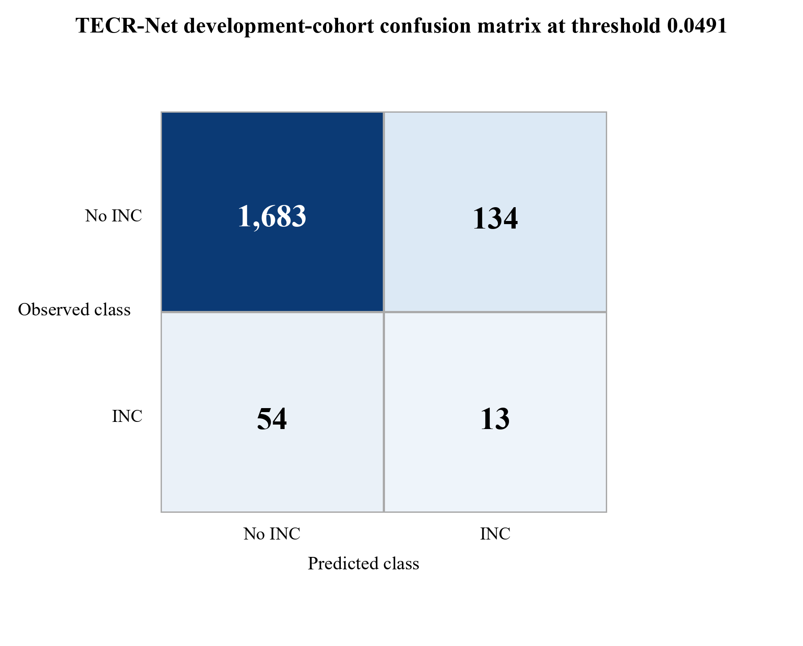

Figure 1. Development-cohort confusion matrix for the seven-seed TECR-Net probability ensemble. Source: authors’ development predictions.
Figure 1 shows 1,683 true negatives, 134 false positives, 54 false negatives, and 13 true positives at threshold 0.0491. Specificity is high because most negative sequences remain below the threshold, but only 19.4% of the 67 positive sequences are detected. The figure therefore supports a prioritization interpretation rather than a claim of comprehensive case detection.

4.2 Ensemble Discrimination and Operational Ranking
Table 8. TECR-Net ensemble metrics on the development cohort
Metric | Value | Metric | Value
Prevalence | 0.03556 | PR-AUC/prevalence | 2.114×
PR-AUC | 0.07518 | ROC-AUC | 0.63855
F1 | 0.12150 | F2 | 0.15663
Precision | 0.08844 | Recall | 0.19403
Specificity | 0.92625 | Balanced accuracy | 0.56014
MCC | 0.08305 | Brier score | 0.03406
Threshold | 0.04909 | TN / FP / FN / TP | 1683 / 134 / 54 / 13
Precision@50 | 0.080 | Lift@50 | 2.250×
Precision@100 | 0.080 | Lift@100 | 2.250×
Precision@200 | 0.070 | Lift@200 | 1.968×

Table 8 indicates that the ensemble PR-AUC of 0.07518 is 2.11 times the 3.56% development prevalence. At a budget of 50 platforms, precision is 0.08, corresponding to approximately four positive cases and a 2.25-fold lift over random selection. The absolute yield remains limited, so the score should complement, not replace, broad regulatory surveillance.
Figure 2 displays the two threshold-free discrimination views for the development ensemble.
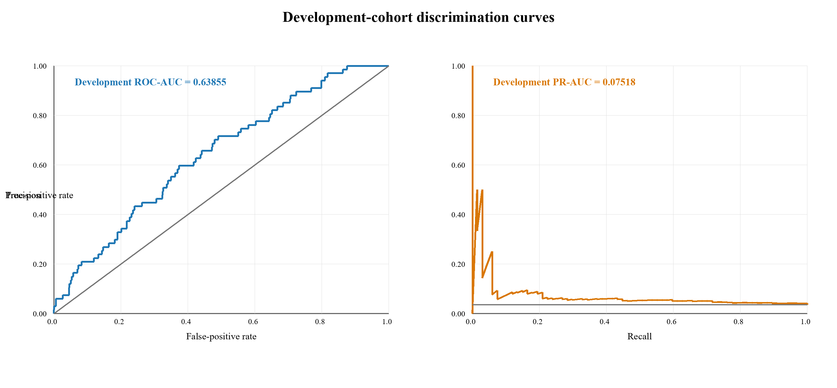
Figure 2. Development-cohort ROC and precision-recall curves for the TECR-Net ensemble. Source: authors’ development predictions.
Figure 2 shows development ROC-AUC 0.63855 and PR-AUC 0.07518. The ROC curve lies above the random diagonal, while the precision-recall curve remains above the 0.03556 prevalence reference over part of the recall range. The modest separation confirms useful but limited discrimination and rules out descriptions such as excellent or near-perfect performance.
4.3 Mean Development Metrics and Learning Behaviour
Figure 3 summarizes variation in the principal development metrics across seven TECR-Net fits.
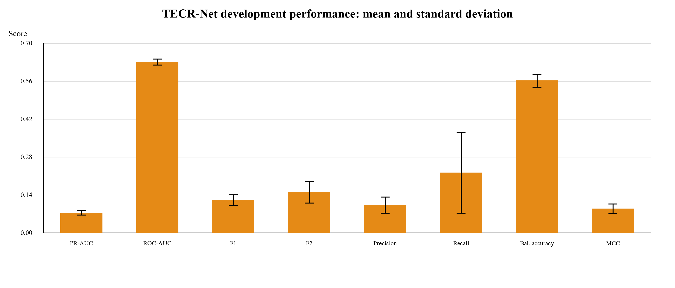
Figure 3. Mean development metrics across seven TECR-Net seeds with one-standard-deviation error bars. Source: authors’ development summary.
Figure 3 highlights the difference between threshold-free ranking and threshold-dependent classification. ROC-AUC is the largest bounded score, whereas PR-AUC and F1 remain low in absolute terms because positives are rare and overlap substantially with negatives. The wide recall error bar shows that operating-point behaviour is sensitive to stochastic fitting, strengthening the case for ensemble probabilities and explicit uncertainty reporting.
Figure 4 presents the epoch-wise development PR-AUC recorded during model fitting.
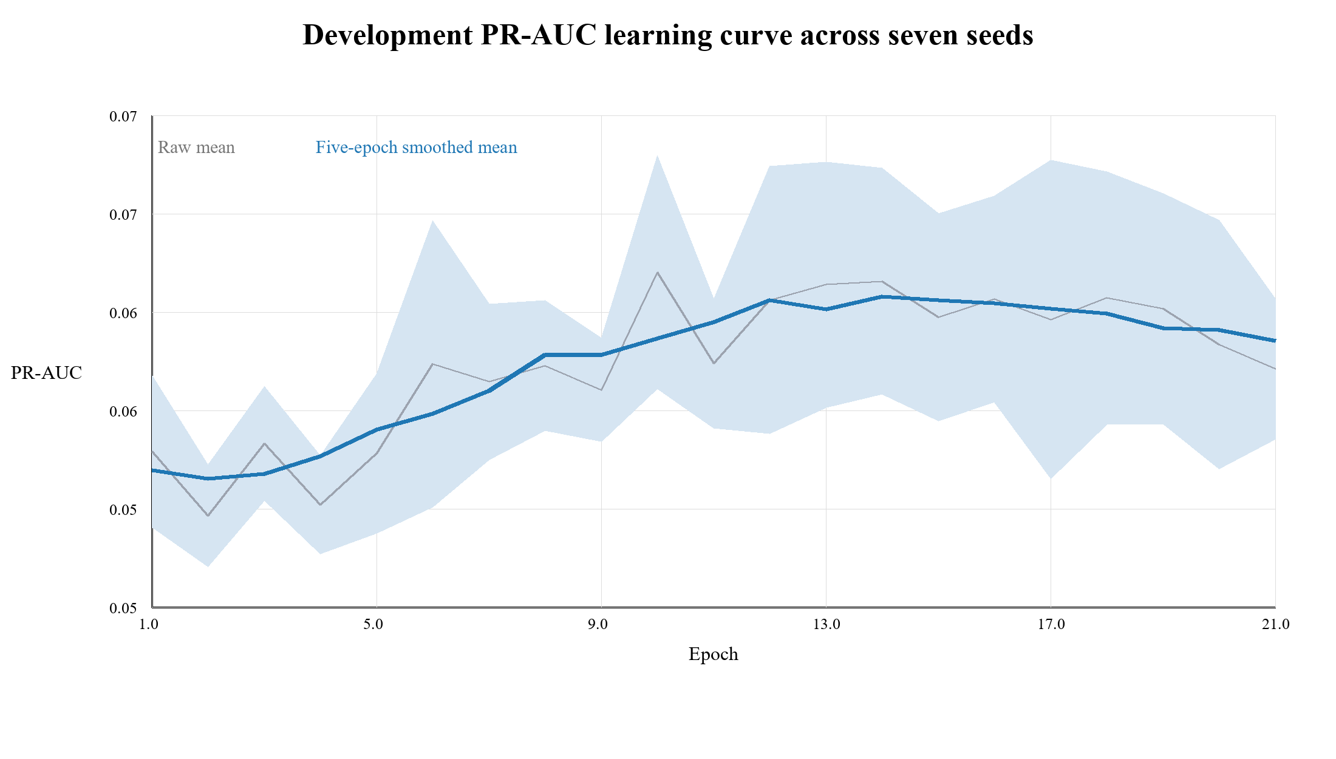
Figure 4. Development PR-AUC learning curve averaged across seven seeds and restricted to epochs completed by every seed. Source: authors’ development histories.
Figure 4 shows an early rise in mean development PR-AUC followed by a broad plateau and mild decline. Its smoothed peak near 0.064 is lower than the 0.0740 seed-average summary in Table 7 because the curve is truncated to epochs completed by every seed, whereas Table 7 evaluates each seed at its own selected best epoch after early stopping. This distinction should not be interpreted as an independent confirmation of performance because both summaries use the same development period.

4.4 Sequence-Aligned Development Baselines
Table 9 compares TECR-Net and four rerun tabular baselines on identical sample identifiers, labels, three-year dynamic histories, static variables, categorical context and 1,884 development sequences. The baseline preprocessing was fitted within development data, and each baseline received 25 inner-temporal Optuna trials and seven final seeds [37–40].
Table 9. Sequence-aligned development comparison
Model | PR-AUC | ROC-AUC | TECR-Net PR-AUC difference | 95% platform-clustered CI
TECR-Net | 0.07518 | 0.63855 | Reference | —
CatBoost | 0.05163 | 0.62390 | 0.02355 | -0.00133 to 0.06434
LightGBM | 0.04690 | 0.62848 | 0.02828 | 0.00177 to 0.07168
XGBoost | 0.05036 | 0.62903 | 0.02482 | -0.00095 to 0.06795
HistGradientBoosting | 0.04891 | 0.62539 | 0.02627 | 0.00080 to 0.06971

Table 9 shows that TECR-Net has the highest observed development PR-AUC (0.07518), followed by CatBoost (0.05163), XGBoost (0.05036), HistGradientBoosting (0.04891), and LightGBM (0.04690). The paired differences and 95% intervals use 2,000 bootstrap replicates with platforms as the resampling unit. The comparison remains provisional because TECR-Net was selected using the reported development period, whereas the replacement baselines were tuned on the earlier 2018–2019 inner holdout; sequence alignment does not remove that protocol asymmetry.
Figure 5 emphasizes the primary development metric and its prevalence reference.
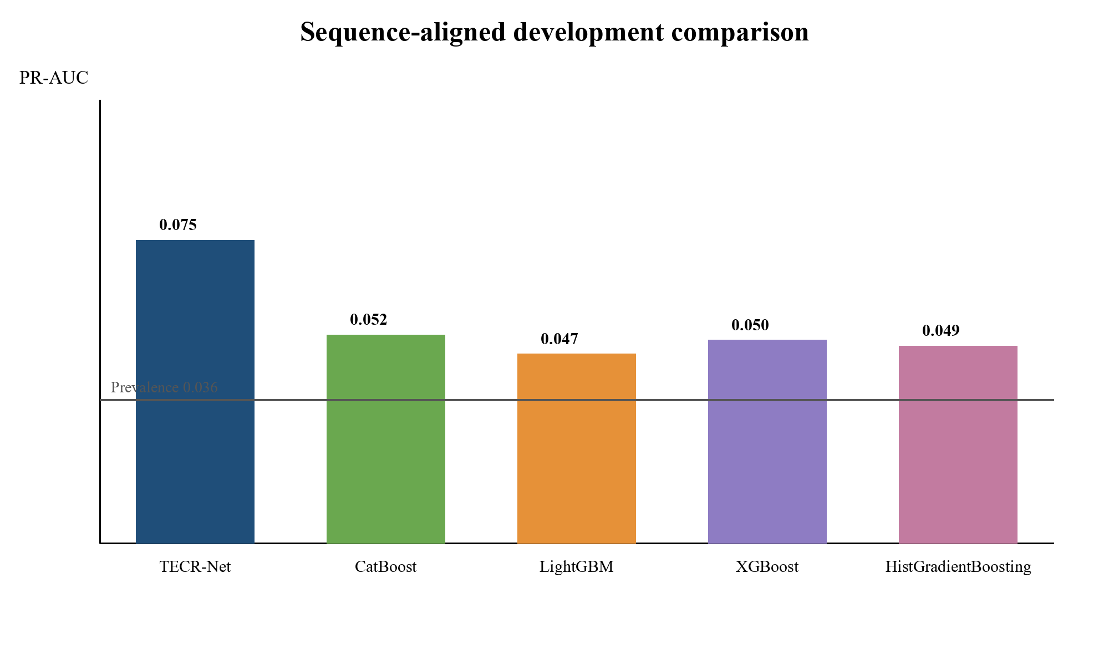
Figure 5. Development PR-AUC for TECR-Net and four sequence-aligned tabular baselines. Source: authors’ development ensemble outputs.
Figure 5 shows that TECR-Net and all four baselines exceed the 0.03556 prevalence reference, with TECR-Net producing the largest observed PR-AUC. Because the proposed model was previously optimized against this development period, the chart documents the observed ordering but does not establish unbiased predictive superiority. A frozen evaluation on later or external data is required for that claim.

4.5 Architectural Ablation
Table 10 reports the full model and six component-removal variants using development results only.
Table 10. Development-only TECR-Net architectural ablation
Variant | PR-AUC | ROC-AUC
Full TECR-Net | 0.07518 | 0.63855
Without categorical encoder | 0.07374 | 0.60503
Without cross-modal attention | 0.07494 | 0.63760
Without feature gate | 0.06652 | 0.63832
Without GRU | 0.05556 | 0.63252
Without residual fusion | 0.07150 | 0.64479
Without temporal attention | 0.06938 | 0.63824

Table 10 shows that the full TECR-Net achieved the highest PR-AUC of 0.07518, demonstrating the strongest rare-event ranking performance. Removing the GRU caused the largest reduction in PR-AUC, to 0.05556, confirming that sequential modelling is the architecture’s most important component. Removing the feature gate and temporal attention reduced PR-AUC to 0.06652 and 0.06938, respectively, indicating that feature weighting and temporal aggregation also contribute substantially. Excluding residual fusion produced a smaller decrease to 0.07150, while removing the categorical encoder resulted in 0.07374. Cross-modal attention had the smallest observed PR-AUC contribution, as its removal produced 0.07494. Although removing residual fusion increased ROC-AUC to 0.64479, it reduced the primary PR-AUC measure; therefore, the full architecture provides the best overall rare-event ranking configuration.

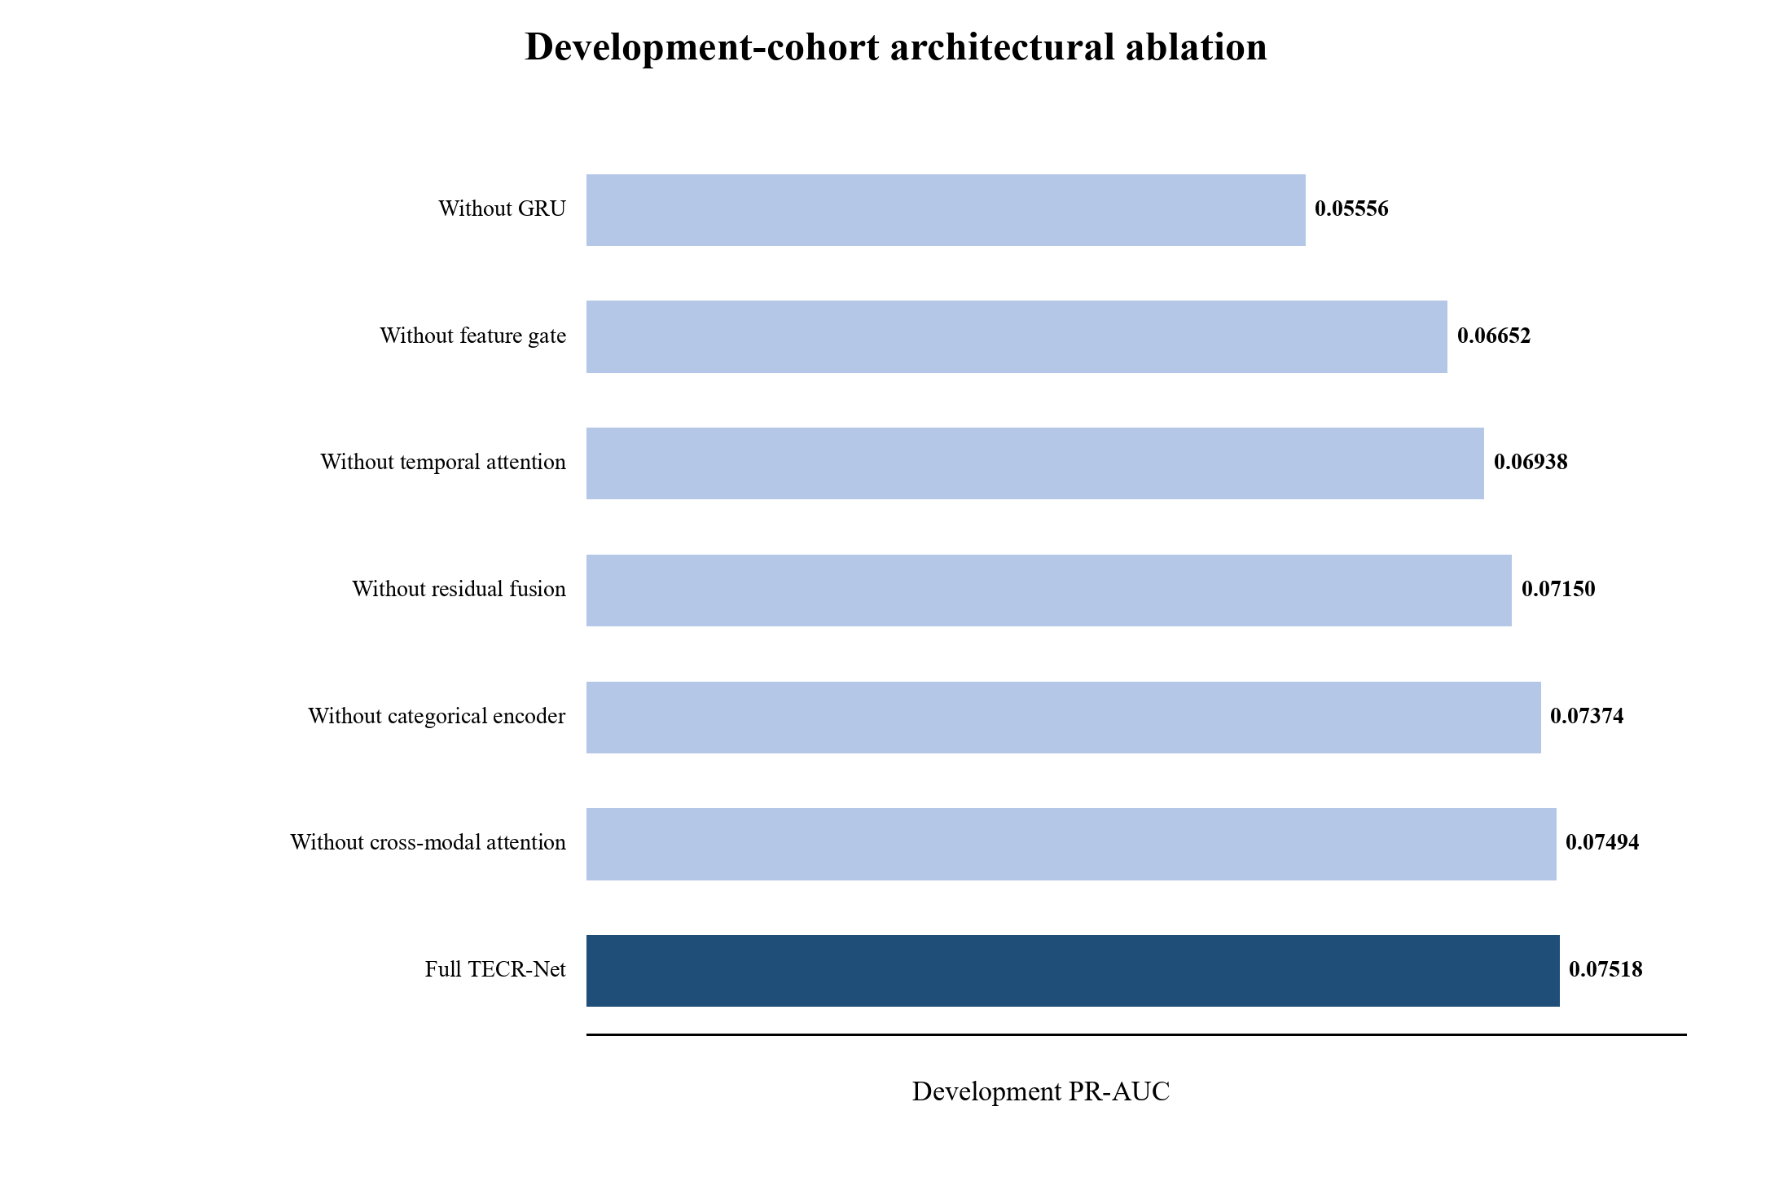
Figure 6. Development PR-AUC for the full TECR-Net and six architectural ablations. Source: authors’ development ablation outputs.
Figure 6 makes the recurrent encoder contribution most visible: the no-GRU variant approaches the prevalence baseline more closely than the other variants. The small difference between the full model and removal of cross-modal attention indicates that this module contributes less development PR-AUC than the recurrent pathway, even though it may affect threshold-dependent behaviour.

4.6 Accident-Feature Sensitivity
Table 11 evaluates whether the primary development result depends on the three coarse lease-level accident proxies. Both variants use the same 1,884 sequences, 982 platforms, 67 positive labels, architecture, seven seeds, and probability-ensemble procedure.
Table 11. Development sensitivity to lease-level accident proxies
Variant | PR-AUC | ROC-AUC | F1 | Precision | Recall | MCC | P@50
Full TECR-Net | 0.07518 | 0.63855 | 0.12150 | 0.08844 | 0.19403 | 0.08305 | 0.080
Without lease-level accident proxies | 0.07478 | 0.62849 | 0.12091 | 0.07273 | 0.35821 | 0.09248 | 0.100

Table 11 shows nearly unchanged average precision after removal of the accident proxies (0.07518 versus 0.07478). The paired full-minus-reduced difference was 0.00040. A nonparametric bootstrap that resampled 982 platforms and retained all repeated sequences produced a 95% interval from −0.02183 to 0.02153 and a two-sided p value of 0.9756 over 5,000 replicates. The interval includes zero and excludes evidence that development ranking materially depends on these duplicated lease-level variables. The ROC-AUC difference was 0.01006 (95% interval −0.00267 to 0.02335; p = 0.1176).

4.7 Development Uncertainty and Apparent Calibration
Table 12 reports dependence-aware uncertainty and limited probability diagnostics calculated from the development ensemble predictions. Because the probability mapping was fitted on the same period, these quantities are apparent rather than independently validated calibration estimates.
Table 12. Development uncertainty and apparent probability diagnostics
Diagnostic | Estimate | 95% bootstrap CI / basis | Interpretation
PR-AUC | 0.07518 | 0.04269–0.12568 | Primary rare-event ranking
ROC-AUC | 0.63855 | 0.57197–0.70213 | Moderate discrimination
Brier score | 0.03406 | 0.02671–0.04211 | Probability error
Brier skill score | 0.00692 | Reference = 0.03430 | Gain over constant prevalence
Calibration intercept | 2.57119 | Apparent | Ideal value 0
Calibration slope | 1.79530 | Apparent | Ideal value 1
Precision@50 | 0.080 | 0.000–0.191 | 50 highest-ranked sequences
Precision@100 | 0.080 | 0.020–0.140 | 100 highest-ranked sequences
Precision@200 | 0.070 | 0.035–0.115 | 200 highest-ranked sequences
Development prevalence | 0.03556 | 67 / 1,884 | Rare outcome

Table 12 shows wide uncertainty because only 67 positive development outcomes are available. The Brier skill score compares the model with a constant-prevalence forecast. Calibration intercept and slope are apparent because the logistic probability maps and diagnostic regression use the same development predictions. These values describe resubstitution behaviour and do not establish probability reliability on unseen data; separate evaluation and, if necessary, recalibration are required before operational use.
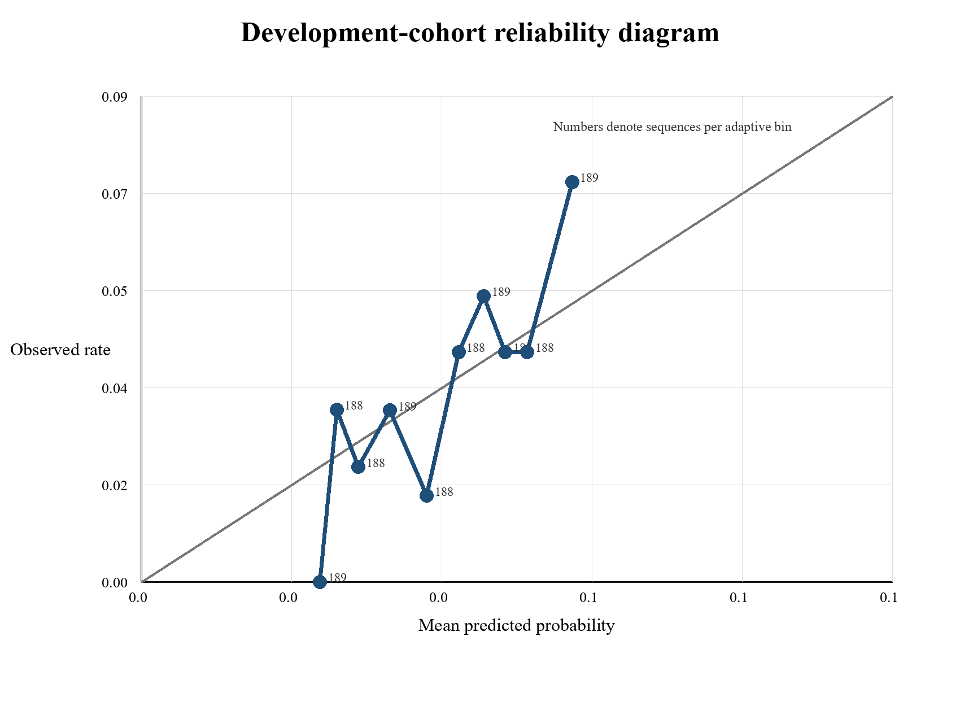
Figure 7. Development reliability diagram using ten equal-frequency bins. Source: authors’ development ensemble predictions.
Figure 7 compares mean predicted probabilities with observed outcome rates and labels each bin by its sequence count. Deviations from the diagonal show that calibration is not perfect despite the low Brier score. Because the Platt maps were fitted on this cohort, the figure describes in-sample probability behaviour and cannot establish calibration on future platforms.

5. Discussion
TECR-Net produced apparent development average precision of 0.07518, approximately 2.11 times the 3.56% outcome prevalence, and ROC-AUC of 0.63855. These measurements indicate limited enrichment in the ordering of recorded next-year INC outcomes rather than strong classification. At the selected operating point, the ensemble detected 13 of 67 positive sequences, while Precision@50 of 0.08 corresponded to four positive sequences among the 50 highest-ranked observations. The system should therefore be interpreted as an exploratory prioritization aid and not as a substitute for broad inspection coverage. The recurrent pathway showed the largest observed ablation decrease, but inherited hyperparameters and reuse of the development cohort prevent causal or definitive component claims. TECR-Net also produced higher observed average precision than four sequence-aligned tabular baselines. That ordering remains descriptive because the proposed network and baselines did not undergo identical selection procedures. The accident sensitivity provides stronger robustness evidence: removing three lease-level proxies changed average precision by 0.00040, with a platform-clustered interval spanning zero. Static feature provenance remains unresolved because the source table lacks attribute-specific effective dates. Probability diagnostics are likewise apparent because calibration and assessment used the same development period. The frozen artifact package records these decisions and prohibits treating the previously inspected 2022–2024 records as confirmatory. Operational use requires a genuinely unseen prospective or external cohort, independent probability assessment, inspection-capacity analysis, and monitoring for temporal drift and inspection-generated feedback loops.

6. Limitations
1. TECR-Net hyperparameter selection, stopping, probability mapping, threshold determination, ablation assessment and performance estimation used the same 2020–2021 development period. The reported estimates may therefore be optimistic for unseen data and are not independent validation results.
2. The outcome is a recorded INC rather than latent non-compliance. Inspection frequency, reporting practice and regulatory attention affect label observation, and the available regional files do not contain a complete denominator of facility inspections with zero INC. Model-guided inspections could therefore reinforce historical observation patterns.
3. Eligibility requires consecutive t−2, t−1 and t production-linked records and an observable t+1 record, creating possible survivorship selection and limiting inference to the production-derived analytical cohort. The target population is not every offshore platform.
4. The structure source provides installation, removal and site-clearance dates but no attribute-specific effective dates. Historical availability of water depth, coordinates, structural class, district, heliport, attendance and manning values is therefore unverified. Only 67 positive development outcomes are available, and transportability to other periods, regions, regulators and asset classes has not been established.

7. Conclusion
TECR-Net provides a temporal cross-modal framework for prioritizing production-linked offshore platform-year sequences according to the probability of a recorded next-year INC. The seven-seed ensemble achieved apparent development average precision of 0.07518, a 2.11-fold ratio to prevalence, and ROC-AUC of 0.63855. Removal of the recurrent encoder produced the largest observed ablation decrease, while removal of coarse accident proxies caused a negligible average-precision change whose platform-clustered interval included zero. TECR-Net exceeded four aligned tabular baselines in observed development average precision, but unequal selection procedures preclude a confirmed superiority claim. The evidence supports exploratory methodological promise rather than independent validation or deployment readiness. The pipeline and its hashes have been frozen; confirmation now requires a genuinely unseen prospective BSEE release or compatible external cohort, followed by independent probability assessment and monitoring for inspection-mediated feedback.

Data Availability
The source records are publicly available from the U.S. Bureau of Safety and Environmental Enforcement. The processed cohort, feature dictionary, sequence index, and leakage audit should accompany any submission, subject to repository policy.

Code Availability
The frozen preprocessing, seven-seed TECR-Net fitting, development-cohort ensembling, baseline alignment, ablation, sensitivity, and figure-generation scripts should be archived with versioned dependencies and seeds.

Ethics and Intended Use
The model uses facility-level administrative records rather than personal data. Scores should support human review and should never be the sole basis for sanctions, reduced oversight, or conclusions about operator culpability. Inspection-prioritization models can create feedback loops because frequently inspected platforms have more opportunities to receive recorded INCs; deployment would therefore require monitoring by region, operator and inspection intensity.

Appendix A Input Feature Dictionary
Table A1 lists all 37 predictive inputs, their timing and their administrative level. Dynamic variables are repeated at t−2, t−1 and t, while static and categorical values are attached once to each sequence.
Table A1. Predictive inputs, timing and administrative level
Feature | Group | Timing | Level
active_months | Dynamic | t−2, t−1 and t | Platform-year
producing_wells_mean | Dynamic | t−2, t−1 and t | Platform-year
producing_wells_max | Dynamic | t−2, t−1 and t | Platform-year
bopd_mean | Dynamic | t−2, t−1 and t | Platform-year
bopd_max | Dynamic | t−2, t−1 and t | Platform-year
mcfd_mean | Dynamic | t−2, t−1 and t | Platform-year
mcfd_max | Dynamic | t−2, t−1 and t | Platform-year
boepd_mean | Dynamic | t−2, t−1 and t | Platform-year
bwpd_mean | Dynamic | t−2, t−1 and t | Platform-year
platform_age | Dynamic | t−2, t−1 and t | Platform-year
operator_facilities_inspected | Dynamic | t−2, t−1 and t | Operator-year
operator_inspection_records | Dynamic | t−2, t−1 and t | Operator-year
operator_inspection_types | Dynamic | t−2, t−1 and t | Operator-year
investigated_accident_count | Dynamic | t−2, t−1 and t | Lease-year proxy
accident_type_count | Dynamic | t−2, t−1 and t | Lease-year proxy
previous_year_inc_count | Dynamic | t−2, t−1 and t | Platform-year
inc_count_previous_3_observations | Dynamic | t−2, t−1 and t | Platform-year
previous_year_accident_count | Dynamic | t−2, t−1 and t | Lease-year proxy
production_change_bopd | Dynamic | t−2, t−1 and t | Platform-year
production_change_mcfd | Dynamic | t−2, t−1 and t | Platform-year
inc_count | Dynamic | t−2, t−1 and t | Platform-year
enforcement_code_count | Dynamic | t−2, t−1 and t | Platform-year
any_inc | Dynamic | t−2, t−1 and t | Platform-year
operator_warning_incs | Dynamic | t−2, t−1 and t | Operator-year
operator_component_shutin_incs | Dynamic | t−2, t−1 and t | Operator-year
operator_facility_shutin_incs | Dynamic | t−2, t−1 and t | Operator-year
water_depth | Static numerical | Attached at t | Platform snapshot
latitude | Static numerical | Attached at t | Platform snapshot
longitude | Static numerical | Attached at t | Platform snapshot
area_code | Categorical | Attached at t | Regional/platform
region_code | Categorical | Attached at t | Regional/platform
structure_type | Categorical | Attached at t | Platform snapshot
major_structure_flag | Categorical | Attached at t | Platform snapshot
district_code | Categorical | Attached at t | Regional/platform
heliport_flag | Categorical | Attached at t | Platform snapshot
attended_8hr_flag | Categorical | Attached at t | Platform snapshot
manned_24hr_flag | Categorical | Attached at t | Platform snapshot

Table A1 clarifies that most predictors are platform-year measurements, while inspection aggregates operate at operator-year level and accident indicators are coarse lease-year proxies. The static and categorical snapshot fields require source-date verification before they can be described as historically observed at each prediction origin.

References
[1] Liu, B., Li, Z., Duan, Q., Yan, B. and Tan, X., 2025. Research on LLM-based assessment methods for international standards' intelligent contribution to oil and gas pipelines. Journal of Pipeline Science and Engineering, p.100405.
[2] Hui, Q., Liu, B., Fan, J., Guo, D., Chen, J., Tan, X. and Peng, Z., 2026. Knowledge graph construction for pipeline standards: Enhancing efficiency in the oil and gas industry. Journal of Pipeline Science and Engineering, p.100445.
[3] Xia, T., Wang, F., Huang, Z., Zhang, W., Chen, G., Zhou, J. and Liu, C., 2025. Multi-Dimensional Control Rules and Assessment Methods for Surface Engineering Data Quality in Oil and Gas Field. Information, 16(8), p.701.
[4] Khordoustan, P., Akbarzadeh, O., Gilani, N., Moshashaei, P. and Alizadeh, S.S., 2026. A hybrid ANP and machine learning framework for contractor health safety environment and quality performance evaluation. Discover Analytics, 4(1), p.16.
[5] Wahono, T., Purniawan, A., Mukhlash, I. and Putri, E.R., 2025. Risk-based asset integrity management in the oil and gas industry from traditional to machine learning approaches: A systematic review. Results in Engineering, p.107287.
[6] Zhang, X., Yan, L., Lai, F. and Wang, H., 2025. Research progress and prospects of risk assessment methods for oil and gas development. Geoenergy Science and Engineering, 253, p.213992.
[7] Wahono, T., Mukhlash, I., Putri, E.R. and Purniawan, A., 2026. An intuitionistic fuzzy deep neural network method for risk assessment of oil and gas pipelines. Cleaner Engineering and Technology, p.101299.
[8] Zhou, Y., Fan, J., Dai, B. and Wu, S., 2025. A data-driven PCA-hierarchical clustering framework for adaptive risk assessment of gas pipeline networks. Process Safety and Environmental Protection, p.107753.
[9] Ye, Z., Duan, Q. and Ma, S., 2026. Research on risk classification of oil and natural gas pipelines based on text mining and apriori algorithm. Journal of Loss Prevention in the Process Industries, 103, p.106059.
[10] AlAbdouli, M.A. and Al-Shihabi, S., 2025. Artificial intelligence and its performance impacts in the oil and gas industry: Challenges, insights, and evaluation approaches. Results in Engineering, p.107636.
[11] Savari, A., Li, Y., Alnefaie, K. and Singh, N.S.S., 2026. State-of-the-art Machine learning Advances in reliability-based design, integrity assessment, inspection and maintenance of pipelines: A Systematic review. Journal of Pipeline Science and Engineering, p.100528.
[12] Bastek, T., Denecke, J. and Schmidt, J., 2026. Future directions for data-driven approaches in pipeline integrity management: Risk assessment, in-line inspection, and machine learning. Reliability Engineering & System Safety, p.112300.
[13] Jones, J.F., Raj, V., Abas, P.E., Petra, M.I., Sivan, D., Satheesh Kumar, K., Jose, R. and Mathew, S., 2025. Application of artificial intelligence for asset integrity management of offshore oil and gas pipelines. Life Cycle Reliability and Safety Engineering, 14(4), pp.503-530.
[14] Al-Ammari, W.A., Sleiti, A.K., Rahman, M.A., Rezaei-Gomari, S., Hassan, I. and Hassan, R., 2025. Digital twin for leak detection and fault diagnostics in gas pipelines: A systematic review, model development, and case study. Alexandria Engineering Journal, 123, pp.91-111.
[15] Cai, X. and Wang, J., 2026. A digital twin-driven natural gas pipeline leakage detection method. International Journal of Pressure Vessels and Piping, p.105793.
[16] Ali, U., Naveen, P., Al-Shalabi, E.W. and Ait Abderrahmane, H., 2026. Artificial intelligence and machine learning for production prediction and optimization of oil and gas surface networks. Energy and AI, p.100772.
[17] Chen, Y., Chen, P., Wang, Y., Feng, G., Yang, C. and Wang, Q., 2025. From clustering to federated learning: A collaborative approach to optimizing data-driven models for the production monitoring of unconventional natural gas wells. Gas Science and Engineering, 137, p.205580.
[18] Lopes, L.G.O., de Almeida Vieira, T.M., Aranha, P.E., de Lima Junior, E.T. and Lira, W.W.M., 2025. Detection and classification of anomalies in oil well production using Open-World Learning. Engineering Applications of Artificial Intelligence, 159, p.111514.
[19] Aranha, E.P., Policarpo, A.N. and Sampaio, A.M., 2025. A Transformer-based approach for anomaly detection in intelligent well completions. Petroleum Exploration and Development, 52(4), pp.1029-1040.
[20] Verma, P., Gandhi, K., Cheema, A.M., Ashfaq, M., Shah, D., Ali, S. and Tahir, M., 2026. DeepPipeNet enables deep learning based anomaly detection for oil and gas pipeline monitoring. Discover Applied Sciences, 8(5), p.498.
[21] Almahakeri, M., Al-Mahasneh, A.J., Mallouh, M.A. and Jouda, B., 2025. Deep neural network-based intelligent health monitoring system for oil and gas pipelines. Applied Soft Computing, 171, p.112827.
[22] Wang, M., Su, X., Song, H., Wang, Y. and Yang, X., 2025. Enhancing predictive maintenance strategies for oil and gas equipment through ensemble learning modeling. Journal of Petroleum Exploration and Production Technology, 15(3), p.46.
[23] Sani, A.A., Wahab, M.M.A., Shafiq, N., Danyaro, K.U. and Aliyu, Y., 2026. Data-Driven Ensemble Machine Learning for Corrosion Risk Prediction and Maintenance Optimization in Oil and Gas Pipelines. Results in Engineering, p.110288.
[24] Ansari, E., Izadkhah, M., Mohimi, A., Akhtar, M.N. and Bakar, E.A., 2026. Prediction of Internal Corrosion in Oil and Gas Piping Systems—An Independent Analysis Using Machine Learning. Journal of Pipeline Science and Engineering, p.100522.
[25] Wu, T., Miao, X. and Song, F., 2025. Residual strength prediction of corroded pipelines based on physics-informed machine learning and domain generalization. npj Materials Degradation, 9(1), p.12.
[26] Wang, Q. and Lu, H., 2025. Machine learning methods for predicting residual strength in corroded oil and gas steel pipes. npj Materials Degradation, 9(1), p.30.
[27] Chen, X., Huang, S., Guan, T. and Fu, H., 2025. An interpretable predictive model for liquid holdup of hilly terrain oil-gas pipelines based on machine learning and Shapley additive explanations. ACS omega, 10(15), p.15160.
[28] Lv, X., Yin, Z., Chen, S., Liu, Y., Yao, H., Ma, Y., Wang, C., Ma, Q., Li, X. and Zhou, S., 2026. Risk assessment model for hydrate blockage in deep-sea oil and gas multiphase pipelines based on XGBoost and SHAP. Chemical Engineering Science, p.124205.
[29] Yang, Y., Wang, B., Cen, X., Shao, B., Zhu, B., Yang, J. and Hong, B., 2025. Susceptibility risk assessment of oil and gas pipeline geological hazards in mountainous areas based on data-driven model. Engineering Applications of Artificial Intelligence, 151, p.110732.
[30] Chen, S., Zhang, N., Shui, B., Zhang, T., Li, C. and Gong, Q., 2025. Real‐Time Prediction of Overpressure‐Induced Pipeline Failure via Edge‐Optimized Machine Learning. Energy Science & Engineering, 13(10), pp.4730-4744.
[31] Khalilzadeh, M., Banihashemi, S.A., Heidari, A., Orazani, S.M.H. and Taebi, P., 2025. Risk management in the production phase of oil and gas projects: evaluating risk responses and their impact on safety and damage reduction. Discover Civil Engineering, 2(1), p.91.
[32] Zhang, F., Feng, Y. and Li, X., 2025. Application of big data and artificial intelligence in oilfield production optimization and intelligent management: A systematic analysis of real-time monitoring and parameter optimization. Advances in Resources Research, 5(1), pp.16-30.
[33] Cho, K., van Merriënboer, B., Gulcehre, C., Bahdanau, D., Bougares, F., Schwenk, H. and Bengio, Y., 2014. Learning phrase representations using RNN encoder-decoder for statistical machine translation. Proceedings of EMNLP, pp.1724–1734.
[34] Bahdanau, D., Cho, K. and Bengio, Y., 2015. Neural machine translation by jointly learning to align and translate. Proceedings of ICLR.
[35] Lin, T.Y., Goyal, P., Girshick, R., He, K. and Dollár, P., 2017. Focal loss for dense object detection. Proceedings of ICCV, pp.2980–2988.
[36] Platt, J.C., 1999. Probabilistic outputs for support vector machines and comparisons to regularized likelihood methods. Advances in Large Margin Classifiers, pp.61–74.
[37] Prokhorenkova, L., Gusev, G., Vorobev, A., Dorogush, A.V. and Gulin, A., 2018. CatBoost: unbiased boosting with categorical features. Advances in Neural Information Processing Systems, 31.
[38] Ke, G., Meng, Q., Finley, T., Wang, T., Chen, W., Ma, W., Ye, Q. and Liu, T.Y., 2017. LightGBM: a highly efficient gradient boosting decision tree. Advances in Neural Information Processing Systems, 30.
[39] Chen, T. and Guestrin, C., 2016. XGBoost: a scalable tree boosting system. Proceedings of the 22nd ACM SIGKDD Conference, pp.785–794.
[40] Akiba, T., Sano, S., Yanase, T., Ohta, T. and Koyama, M., 2019. Optuna: a next-generation hyperparameter optimization framework. Proceedings of the 25th ACM SIGKDD Conference, pp.2623–2631.

