TECR Net for Validation Based Next Year Recorded Regulatory Non Compliance Risk in Offshore Platforms

Abstract

Risk-based offshore supervision requires models that respect temporal order, severe class imbalance, and the distinction between recorded enforcement outcomes and latent non-compliance. This study develops TECR-Net, a temporal cross-modal neural network that estimates whether a U.S. offshore platform will have a recorded incident of non-compliance in the next calendar year. Seven public Bureau of Safety and Environmental Enforcement data collections were integrated into a 141,730-row platform-year panel. Exact consecutive three-year histories were constructed, and the internal validation cohort comprised 1,884 sequences from 982 platforms during 2020–2021, including 67 positive outcomes (3.56%). TECR-Net combines gated dynamic inputs, a bidirectional gated recurrent unit, temporal attention, static and categorical encoders, cross-modal attention, residual fusion, and class-balanced focal loss. Across seven random seeds, validation PR-AUC was 0.0740 ± 0.0077 and validation ROC-AUC was 0.6312 ± 0.0112. The seven-seed probability ensemble obtained validation PR-AUC 0.0752, 2.11 times prevalence, ROC-AUC 0.6386, F1 0.1215, and Brier score 0.0341. At the validation-selected threshold, the model identified 13 of 67 positives and produced 134 false positives.

Keywords: offshore platforms; recorded incident of non-compliance; internal validation; temporal modelling; cross-modal learning; rare-event prediction; regulatory supervision

Introduction
The oil and gas industry relies on extensive technical, safety, environmental, and operational standards to control risks across complex infrastructure. Conventional supervision based on periodic inspections and static checklists is often insufficient for processing heterogeneous standards and large operational datasets. Liu et al. [1] proposed an LLM-based assessment framework that combines semantic indicator extraction, integrated weighting, and cloud-model evaluation for international pipeline standards. Hui et al. [2] further demonstrated how a knowledge graph constructed from more than 3,000 pipeline standards can improve semantic organization, intelligent retrieval, and practical access to technical requirements. Although these studies advance the intelligent management of standards, they focus mainly on standard formulation and knowledge retrieval rather than evaluating whether operating facilities consistently satisfy those requirements.
Effective standardization evaluation also depends on reliable data and defensible performance indicators. Xia et al. [3] developed multidimensional control rules for assessing the normative compliance, integrity, consistency, accuracy, and timeliness of oil-and-gas surface-engineering data. Their approach combined the Analytic Hierarchy Process with entropy weighting to produce quantitative data-quality assessments. Khordoustan et al. [4] integrated fuzzy Analytic Network Process weighting with machine-learning feature importance to evaluate contractor health, safety, environmental, and quality performance. This hybrid approach showed that expert knowledge and empirical evidence can jointly support transparent and interpretable evaluation. Nevertheless, an important gap remains in integrating facility characteristics, production activity, inspection history, safety incidents, and regulatory outcomes into a unified standardization-supervision model.
Risk-based asset integrity management provides a suitable foundation for addressing this gap. Wahono et al. [5] showed that integrity assessment is progressing from qualitative and deterministic methods toward dynamic, probabilistic, and machine-learning approaches using real operational data. However, existing studies rarely combine multidimensional indicators, longitudinal regulatory records, predictive modelling, and explainable AI at the facility level. Therefore, this study proposes a data-driven standardization supervision and evaluation framework for offshore oil and gas platforms. Using structural, production, inspection, incident, and non-compliance data, the framework will evaluate present performance, predict future regulatory non-compliance, identify abnormal risk patterns, and explain the principal factors influencing each prediction. The resulting system is intended to support transparent, proactive, and risk-based supervisory decision-making.

Literature Survey
Zhang et al. [6] reviewed the development of risk-assessment methods for oil and gas operations, covering conventional qualitative, quantitative, probabilistic, and intelligent techniques. They emphasized that traditional approaches depend heavily on expert judgment and often struggle to represent dynamic interactions among operational, environmental, and equipment-related risks. Wahono et al. [7] addressed these limitations through an intuitionistic fuzzy deep neural network for pipeline risk assessment. Their approach combines fuzzy representation of uncertain information with the nonlinear learning capability of deep neural networks. Together, these studies demonstrate the transition from static, expert-oriented risk evaluation toward intelligent models capable of managing uncertainty and complex relationships. However, their focus remains primarily on risk estimation rather than comprehensive standardization supervision and regulatory non-compliance prediction.
Zhou et al. [8] proposed a data-driven framework combining principal component analysis and hierarchical clustering for adaptive assessment of gas pipeline networks. Principal component analysis reduced indicator redundancy, while hierarchical clustering supported the identification of risk groups without relying entirely on predetermined categories. Ye et al. [9] employed text mining and the Apriori algorithm to classify oil and natural gas pipeline risks from historical risk records. Their method extracted recurring associations among risk factors and supported a data-driven risk-classification structure. Both studies demonstrate the value of discovering risk patterns directly from heterogeneous records. Nevertheless, clustering and association-rule methods mainly describe existing structures and relationships; they provide limited capability for predicting future non-compliance events or explaining facility-level regulatory performance within a longitudinal supervision framework.
AlAbdouli and Al-Shihabi [10] examined the performance impacts, challenges, and evaluation approaches associated with artificial intelligence adoption in the oil and gas industry. They highlighted AI’s potential to improve prediction, operational efficiency, maintenance, and decision-making while identifying concerns related to data quality, integration, interpretability, and organizational readiness. Savari et al. [11] systematically reviewed machine-learning advances in pipeline reliability-based design, integrity assessment, inspection, and maintenance. Their review showed that machine learning increasingly supports condition assessment, failure prediction, inspection planning, and maintenance optimization. These studies establish the wider relevance of AI for industrial performance and pipeline integrity. However, they also indicate that reliable implementation requires transparent models, well-governed data, and evaluation frameworks aligned with operational and regulatory objectives.
Bastek et al. [12] reviewed future directions for data-driven pipeline integrity management, with particular attention to risk assessment, in-line inspection, and machine-learning applications. They emphasized the need to integrate inspection information, physical degradation indicators, and operational data to support proactive integrity decisions. Jones et al. [13] examined artificial-intelligence applications for offshore oil and gas pipeline asset integrity management. Their study discussed how intelligent methods can enhance corrosion monitoring, defect assessment, predictive maintenance, and failure prevention throughout the asset lifecycle. Collectively, these studies support the transition from reactive maintenance toward predictive and risk-based integrity management. Nevertheless, existing research generally prioritizes physical asset condition and failure probability, while regulatory compliance, inspection history, and multidimensional standardization performance remain comparatively underexplored.
Al-Ammari et al. [14] reviewed and demonstrated digital-twin applications for gas-pipeline leak detection and fault diagnosis. Their work showed how virtual representations, sensor information, and analytical models can support continuous monitoring and timely identification of abnormal pipeline conditions. Cai and Wang [15] subsequently proposed a digital-twin-driven leakage-detection method for natural gas pipelines, further illustrating the potential of synchronized physical and virtual systems for real-time supervision. Both studies advance dynamic pipeline monitoring by linking operational data with intelligent diagnostic models. However, digital-twin systems often require dense sensor networks, detailed physical models, and continuous data streams. Such requirements limit their direct applicability to regulatory datasets, where observations are commonly periodic, heterogeneous, and recorded at facility or operator level rather than as continuous sensor measurements.
Ali et al. [16] reviewed artificial-intelligence and machine-learning methods for predicting and optimizing production in oil and gas surface networks. Their study demonstrated the ability of data-driven models to capture nonlinear relationships among operational variables and support production planning and network optimization. Chen et al. [17] extended production monitoring through a progression from clustering to federated learning for unconventional natural gas wells. Their collaborative approach enables multiple data sources or operational units to contribute to model development while reducing centralized data-sharing requirements. These studies demonstrate the importance of scalable learning from distributed and heterogeneous industrial data. However, production optimization alone does not represent standardization performance. A comprehensive supervision framework must connect operational behaviour with facility characteristics, inspection activities, incidents, and regulatory outcomes.
Lopes et al. [18] developed an open-world learning approach for detecting and classifying anomalies in oil-well production. Unlike closed-set classifiers, open-world learning can identify observations that do not belong to previously known event classes, making it relevant for evolving industrial environments. Aranha et al. [19] applied a Transformer-based method to anomaly detection in intelligent well completions, using the architecture’s ability to learn complex temporal dependencies within multivariate operational sequences. Both studies demonstrate that advanced learning methods can identify abnormal behaviour that conventional fixed-class models may overlook. Nevertheless, operational anomalies do not automatically represent regulatory non-compliance or inadequate standardization. Their practical use in supervision therefore requires integration with inspection records, compliance histories, interpretable risk indicators, and decision rules that translate anomalies into actionable regulatory or managerial priorities.
Verma et al. [20] proposed DeepPipeNet for deep-learning-based anomaly detection in oil and gas pipeline monitoring, illustrating the growing role of specialized neural architectures in identifying complex pipeline abnormalities. Its emphasis on automated monitoring complements the open-world anomaly framework of Lopes et al. [18], which addresses previously unseen operational conditions. While DeepPipeNet strengthens pattern-recognition capability, both approaches remain centred on detecting abnormal physical behaviour rather than evaluating broader compliance performance. This distinction is important because standardization supervision must account for operational exposure, structural characteristics, inspection frequency, previous violations, enforcement actions, and safety incidents. Consequently, anomaly-detection outputs should be treated as one component of a larger explainable evaluation framework rather than as a complete measure of facility standardization or regulatory risk.
Table 2. Comparative summary of AI-based oil and gas monitoring, integrity, and risk-assessment studies
Ref. | Author(s) | Dataset used | Model/method used | Research gap
[21] | Almahakeri et al. | Ultrasound-guided-wave measurements collected through pipeline-mounted transducers | Deep Neural Network-based structural health monitoring; compared with five ML models | Predicts crack location, width, and depth but does not evaluate regulatory compliance, inspection history, or facility-level risk.
[22] | Wang et al. | Historical operational and fault data from Shengli Oilfield production wells | ML-CSNN, expert rules, SVM, GBDT, and XGBoost | Strong predictive-maintenance performance, but validation is limited to one oilfield and equipment-fault context.
[23] | Sani et al. | Public corrosion dataset: 10,293 observations and eight operational features | Gradient Boosting, XGBoost, Random Forest, KNN, SVR, AdaBoost, and regression models | Uses a public tabular dataset and random split; limited evidence of temporal, geographic, and operator-level generalization.
[24] | Ansari et al. | TWI industrial dataset containing over 35,000 condition-monitoring locations | Direct regression and composite classification–regression models | Performs poorly for high corrosion rates and is affected by skewness, duplicate records, and limited severe cases.
[25] | Wu et al. | 402 burst-test and finite-element samples collected from published studies | Physics-informed deep forest optimized through Double Deep Q-Network domain generalization | Dataset mainly represents simplified single rectangular defects; operational and regulatory factors are excluded.
[26] | Wang and Lu | Datasets collected from 30 published residual-strength studies | Review of regression, Random Forest, SVM, neural networks, Gaussian Process Regression, and ensemble methods | Identifies small, heterogeneous datasets and inconsistent validation; does not propose a unified operational framework.
[27] | Chen et al. | Experimental and operating data for liquid holdup in hilly oil–gas pipelines | Comparative ML prediction with SHAP interpretation | Focuses on liquid holdup under specific terrain and flow conditions rather than broader integrity or compliance outcomes.
[28] | Lv et al. | High-pressure hydrate flow-loop experimental data from an oil–water system | XGBoost classification with SHAP explanations | High controlled-experiment accuracy, but field-scale and cross-pipeline validation remain limited.
[29] | Yang et al. | Geological, environmental, and hazard data from the Lishui–Wenzhou gas-pipeline corridor | Information Value Method, neural-network weighting, and data-driven susceptibility assessment | Case-study-specific geographic model; limited transferability to other regions and non-geological compliance risks.
[30] | Chen et al. | Field measurements combined with hydraulic-simulation benchmarks | Eight lightweight ML models optimized for edge deployment | Addresses short-term overpressure warning but not long-term integrity, inspection performance, or regulatory supervision.
[31] | Khalilzadeh et al. | Literature evidence, organizational information, and expert judgments from an oil and gas project | Fuzzy Delphi, probability–impact matrix, FBWM, and Grey CoCoSo | Relies strongly on expert assessment and lacks longitudinal operational validation or predictive regulatory outcomes.
[32] | Zhang et al. | Published studies and selected oilfield application cases; no single experimental dataset | Systematic review of big-data monitoring, ML, deep learning, anomaly detection, and parameter optimization | Provides broad conceptual coverage but lacks a reproducible dataset, unified model, and comparative experimental validation.
The reviewed studies demonstrate substantial progress in pipeline crack monitoring, equipment maintenance, corrosion prediction, residual-strength estimation, flow assurance, geological-hazard assessment, and real-time failure warning. However, most use specialized experimental, simulation, or single-organization datasets and address one physical failure mechanism. Several studies also rely on random data partitions, small samples, expert judgments, or geographically restricted case studies, limiting temporal and cross-facility generalization. Few integrate production exposure, infrastructure characteristics, inspection activity, incident history, enforcement actions, and regulatory non-compliance within one longitudinal framework. These limitations motivate the proposed study, which uses multi-source BSEE platform-year data to predict future non-compliance and provide explainable, facility-level evidence for risk-based standardization supervision.

3. Proposed Methodology

3.1 Prediction Target

For platform i and feature year t, the binary label equals one when at least one INC is recorded during the next calendar year.
$yᵢ,ₜ₊₁ = 1(INC_countᵢ,ₜ₊₁ > 0)$ (1)
The model input is an exact three-year sequence; non-consecutive records are excluded rather than treated as adjacent observations.
$Xᵢ,ₜ = [xᵢ,ₜ₋₂, xᵢ,ₜ₋₁, xᵢ,ₜ] ∈ R³ˣ²⁶$ (2)

3.2 Data Integration

Seven public BSEE collections were combined: platform structures, platform-level production, production summaries, INC and inspection records, accident investigations, company records, and lease ownership. The integrated panel contained 141,730 platform-years, 6,158 platforms, and 49 variables spanning 1947–2025. The modelling interval was restricted to recent years with consistent coverage, and sequence construction produced 12,280 exact histories.

Table 2 specifies what enters each TECR-Net branch and which fields remain metadata or prohibited variables.

Table 2. Prespecified model input groups and their timing
Group | Count | Content | Use
Dynamic base | 20 | Production, wells, activity, change, age, operator activity, lagged accident indicators | Each of t−2, t−1, t
Current compliance | 6 | Year-specific INC, warning, shut-in, and inspection-derived history | Enhanced supervision only
Static numerical | 3 | Water depth and stable structural quantities | Once per sequence
Categorical | 8 | Area, structure and operating-context categories | Training-derived vocabulary
Metadata | — | Platform, lease, operator, complex, and grouping identifiers | Not predictive inputs
Prohibited | — | Future targets, next_year fields, removal timing | Excluded before fitting

Table 2 shows that the enhanced-supervision network uses 26 dynamic variables at each of three time steps, together with three static numerical and eight categorical variables. Identifiers support grouping only, and all future or target-derived fields are prohibited. This corrects the earlier inconsistent description of 29 dynamic variables.

3.3 Temporal Design and Validation Cohort

Table 3 documents the temporal protocol. The row counts describe dataset construction rather than model performance; only the validation period contributes performance results in this manuscript.
Table 3. Temporal protocol and cohort sizes
Role | Feature years | Sequences | Platforms | Positive labels | Label rate
Model fitting | 2014–2019 | 8,200 | 1,607 | 538 | 6.56%
Internal validation | 2020–2021 | 1,884 | 982 | 67 | 3.56%
Reserved later cohort | 2022–2024 | 2,196 | 876 | 94 | 4.28%

Table 3 demonstrates a substantial decline in label prevalence between the fitting and validation periods, indicating temporal distribution shift before any model metric is considered. The reserved later cohort is listed only to document the protocol; no model result from that cohort appears anywhere in this manuscript.

3.4 Leakage Controls and Preprocessing
Quantile clipping, median imputation, robust scaling, and category vocabularies were learned from the fitting period only and applied unchanged to validation records. No oversampling was conducted before temporal separation.
$x̃ⱼ = min(max(xⱼ, Qⱼ,0.01), Qⱼ,0.99)$ (3)
$x̂ⱼ = x̃ⱼ if observed; otherwise median_fit(xⱼ)$ (4)
$zⱼ = (x̂ⱼ - median_fit(xⱼ)) / IQR_fit(xⱼ)$ (5)
Table 4 summarizes the leakage audit that governs all subsequent modelling.
Table 4. Leakage and integrity controls
Check | Status | Interpretation
Unique platform-year records | Pass | No duplicates
Target fields in approved inputs | Pass | None
Future or removal fields in inputs | Pass | None
Identifiers in feature whitelist | Pass | None
Consecutive three-year windows | Pass | No spacing violations
Immediate next-year label alignment | Pass | No mismatches
Lease-level accident repetition | Flag | Coarse proxy; sensitivity analysis required
Historical validity of static snapshots | Flag | Source-date verification remains necessary

Table 4 supports the absence of direct target leakage in the approved feature list and confirms exact temporal alignment. The two flagged issues are not evidence of future leakage, but they limit causal and platform-specific interpretation and are therefore carried into the sensitivity analysis and limitations.

3.5 TECR-Net Architecture

3.5.1 Feature Gate and Bidirectional Temporal Encoder
A sigmoid feature gate rescales every dynamic variable before a one-layer bidirectional GRU with 80 hidden units in each direction.
$gᵢ,ₖ = σ(Wg xᵢ,ₖ + bg), x'ᵢ,ₖ = gᵢ,ₖ ⊙ xᵢ,ₖ$ (6)
$h⃗ᵢ,ₖ = GRU⃗(x'ᵢ,ₖ, h⃗ᵢ,ₖ₋₁)$ (7)
$h⃖ᵢ,ₖ = GRU⃖(x'ᵢ,ₖ, h⃖ᵢ,ₖ₊₁)$ (8)
$hᵢ,ₖ = [h⃗ᵢ,ₖ ∥ h⃖ᵢ,ₖ] ∈ R¹⁶⁰$ (9)

3.5.2 Temporal Attention
Additive attention learns the relative contribution of t−2, t−1, and t.
$eᵢ,ₖ = vₐᵀ tanh(Wₐhᵢ,ₖ + bₐ)$ (10)
$αᵢ,ₖ = exp(eᵢ,ₖ) / Σᵣ exp(eᵢ,ᵣ)$ (11)
$cᵢ = Σₖ αᵢ,ₖ hᵢ,ₖ$ (12)
$zᵀᵢ = LN(GELU(Wₜcᵢ + bₜ))$ (13)

3.5.3 Static and Categorical Encoders
Static numerical variables pass through a two-layer projection. Eight independent categorical embeddings are concatenated and projected into the shared 80-dimensional token space.
$zˢᵢ = LN(Ws,2 Dropout(GELU(Ws,1sᵢ + bs,1)) + bs,2)$ (14)
$zᶜᵢ = LN(Dropout(GELU(Wc [E₁(cᵢ1) ∥ … ∥ E₈(cᵢ8)] + bc)))$ (15)

3.5.4 Cross-Modal Attention and Residual Fusion
A learned query attends to the temporal, static, and categorical tokens through eight attention heads. The attention output is concatenated with the mean token to preserve a residual multimodal pathway.
$aᵢ = MHA(q, [zᵀᵢ,zˢᵢ,zᶜᵢ], [zᵀᵢ,zˢᵢ,zᶜᵢ])$ (16)
$uᵢ = [aᵢ ∥ (zᵀᵢ + zˢᵢ + zᶜᵢ)/3]$ (17)
$pᵢ = σ(W₂ Dropout(GELU(W₁uᵢ + b₁)) + b₂)$ (18)

3.6 Optimization and Validation Procedure
Class-balanced focal loss addresses the rare positive class. Each seed is calibrated through a logistic Platt map using validation predictions, and the final validation score is the mean of seven calibrated probabilities.
$L = -αy(1-p)ᵞlog(p) - (1-α)(1-y)pᵞlog(1-p)$ (19)
$p̄ᵢ = (1/7) Σˢ⁼¹⁷ σ(aₛ·logit(pᵢ,ₛ)+bₛ)$ (20)
Table 5 reports the locked settings used for the proposed configuration.
Table 5. Locked TECR-Net configuration
Component | Setting | Value
Dynamic encoder | One-layer bidirectional GRU | 80 units per direction
Temporal projection | Linear, GELU, layer normalization | 160 to 80
Static encoder | Two-layer MLP | 3 to 80 to 80
Categorical encoder | Eight embeddings plus projection | Embedding dimension 3–16
Cross-modal attention | Multi-head attention | 8 heads; 80-dimensional tokens
Dropout | Locked | 0.2690
Learning rate | Locked | 0.001617
Weight decay | Locked | 2.439×10−5
Focal exponent | Locked | 1.7523
Batch size | Locked | 256
Maximum epochs | Early stopping | 100; patience 15
Seeds | Repeated fitting | 11, 22, 33, 44, 55, 66, 77

Table 5 provides the exact configuration needed to reproduce the internal validation experiment. The architecture is held constant across seeds; stochastic variation arises from initialization and minibatch ordering. Calibration and threshold optimization on the same validation cohort make threshold-dependent validation measures optimistic and unsuitable as external-performance estimates.

3.7 Evaluation Measures
PR-AUC is primary because the validation prevalence is 3.56%. ROC-AUC measures ranking over all thresholds. F1, F2, precision, recall, specificity, balanced accuracy, MCC, and the confusion matrix depend on the validation-selected threshold. Brier score and reliability diagnostics evaluate probability quality. Precision, recall, and lift at budgets of 50, 100, and 200 platforms describe operational prioritization.
Table 6 defines the reported metrics and their intended interpretation.
Table 6. Validation metrics and interpretation
Metric | Type | Role
PR-AUC | Threshold-free | Primary ranking measure for rare positive outcomes
PR-AUC/prevalence | Threshold-free | Improvement over random prevalence baseline
ROC-AUC | Threshold-free | Global ranking discrimination
F1 and F2 | Threshold-dependent | Balance of precision and recall; F2 emphasizes recall
Precision and recall | Threshold-dependent | Yield and coverage of predicted positives
Balanced accuracy | Threshold-dependent | Mean sensitivity and specificity
MCC | Threshold-dependent | Correlation-like summary robust to imbalance
Brier score | Probability-based | Mean squared probability error
Precision@k | Budget-based | Observed yield among k highest-risk platforms

Table 6 distinguishes ranking measures from threshold-dependent measures. This distinction is essential because the decision threshold was selected on validation data. PR-AUC and ROC-AUC describe ordering, whereas F1 and the confusion matrix additionally reflect the selected operating point.

4. Validation Results

4.1 Seven-Seed Stability
Table 7 presents only validation results averaged across the seven prespecified seeds.
Table 7. TECR-Net validation performance across seven seeds
Metric | Mean | SD | Mean ± SD
Prevalence | 0.03556 | 0.00000 | 0.03556 ± 0.00000
PR-AUC | 0.07401 | 0.00775 | 0.07401 ± 0.00775
PR-AUC/prevalence | 2.08109 | 0.21780 | 2.08109 ± 0.21780
ROC-AUC | 0.63115 | 0.01119 | 0.63115 ± 0.01119
F1 | 0.12080 | 0.01976 | 0.12080 ± 0.01976
F2 | 0.15060 | 0.04063 | 0.15060 ± 0.04063
Precision | 0.10295 | 0.02972 | 0.10295 ± 0.02972
Recall | 0.22175 | 0.14861 | 0.22175 ± 0.14861
Balanced accuracy | 0.56197 | 0.02388 | 0.56197 ± 0.02388
Specificity | 0.90219 | 0.11113 | 0.90219 ± 0.11113
MCC | 0.08918 | 0.01780 | 0.08918 ± 0.01780
Brier score | 0.03407 | 0.00004 | 0.03407 ± 0.00004
Threshold | 0.04982 | 0.00516 | 0.04982 ± 0.00516
Precision@50 | 0.10857 | 0.02545 | 0.10857 ± 0.02545
Precision@100 | 0.08571 | 0.02225 | 0.08571 ± 0.02225
Precision@200 | 0.05857 | 0.01180 | 0.05857 ± 0.01180

Table 7 shows that validation PR-AUC averaged 0.07401 ± 0.00775, equivalent to 2.08 times prevalence, while ROC-AUC averaged 0.63115 ± 0.01119. Recall varied markedly across seeds, which explains the comparatively large variability in threshold-dependent measures. The more stable ranking measures support probability ensembling but do not demonstrate external generalization.
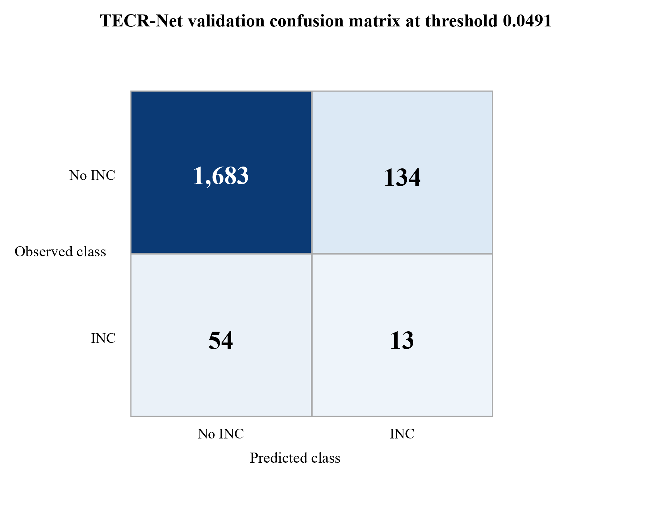
Figure 1. Validation-only confusion matrix for the seven-seed TECR-Net probability ensemble.
Figure 1 shows 1,683 true negatives, 134 false positives, 54 false negatives, and 13 true positives at threshold 0.0491. Specificity is high because most negative sequences remain below the threshold, but only 19.4% of the 67 positive sequences are detected. The figure therefore supports a prioritization interpretation rather than a claim of comprehensive case detection.
4.2 Ensemble Discrimination and Operational Ranking
Table 8 reports the locked seven-seed ensemble using validation records only.
Table 8. Locked TECR-Net ensemble metrics on internal validation
Metric | Value | Metric | Value
Prevalence | 0.03556 | PR-AUC/prevalence | 2.114×
PR-AUC | 0.07518 | ROC-AUC | 0.63855
F1 | 0.12150 | F2 | 0.15663
Precision | 0.08844 | Recall | 0.19403
Specificity | 0.92625 | Balanced accuracy | 0.56014
MCC | 0.08305 | Brier score | 0.03406
Threshold | 0.04909 | TN / FP / FN / TP | 1683 / 134 / 54 / 13
Precision@50 | 0.080 | Lift@50 | 2.250×
Precision@100 | 0.080 | Lift@100 | 2.250×
Precision@200 | 0.070 | Lift@200 | 1.968×

Table 8 indicates that the ensemble PR-AUC of 0.07518 is 2.11 times the 3.56% validation prevalence. At a budget of 50 platforms, precision is 0.08, corresponding to approximately four positive cases and a 2.25-fold lift over random selection. The absolute yield remains limited, so the score should complement, not replace, broad regulatory surveillance.
Figure 2 displays the two threshold-free discrimination views for the validation ensemble.
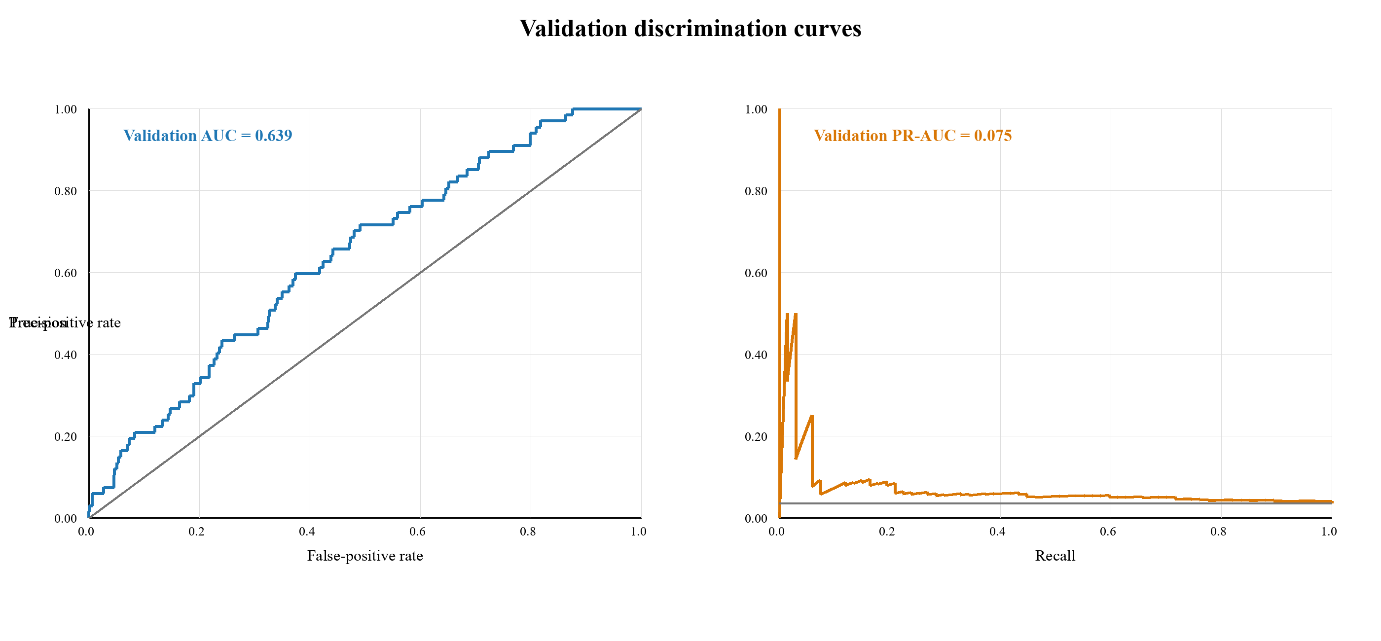
Figure 2. Validation-only ROC and precision-recall curves for the TECR-Net ensemble.
Figure 2 shows validation ROC-AUC 0.639 and PR-AUC 0.075. The ROC curve lies above the random diagonal, while the precision-recall curve remains above the 0.0356 prevalence reference over part of the recall range. The modest separation confirms useful but limited discrimination and rules out descriptions such as excellent or near-perfect performance.

4.3 Mean Validation Metrics and Learning Behaviour
Figure 3 reformats the supplied multi-split mean-metrics chart to retain only validation values, as required by the reporting scope.
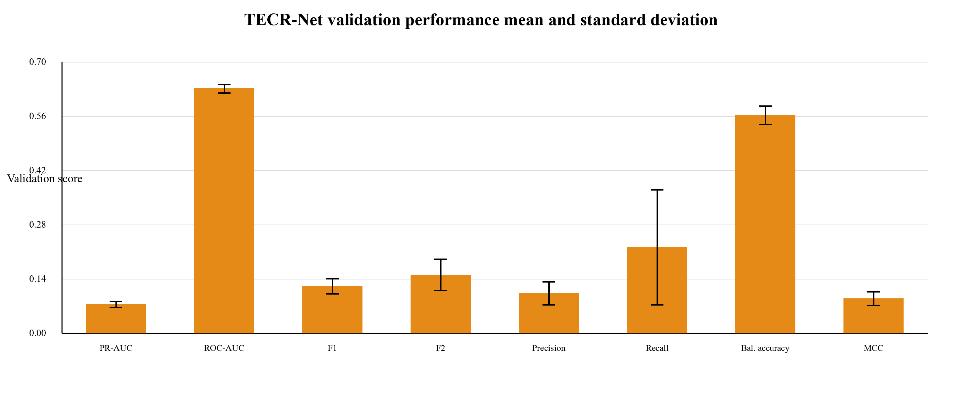Figure 3. Mean validation metrics across seven TECR-Net seeds with one-standard-deviation error bars.
Figure 3 highlights the difference between threshold-free ranking and threshold-dependent classification. ROC-AUC is the largest bounded score, whereas PR-AUC and F1 remain low in absolute terms because positives are rare and overlap substantially with negatives. The wide recall error bar shows that operating-point behaviour is sensitive to stochastic fitting, strengthening the case for ensemble probabilities and explicit uncertainty reporting.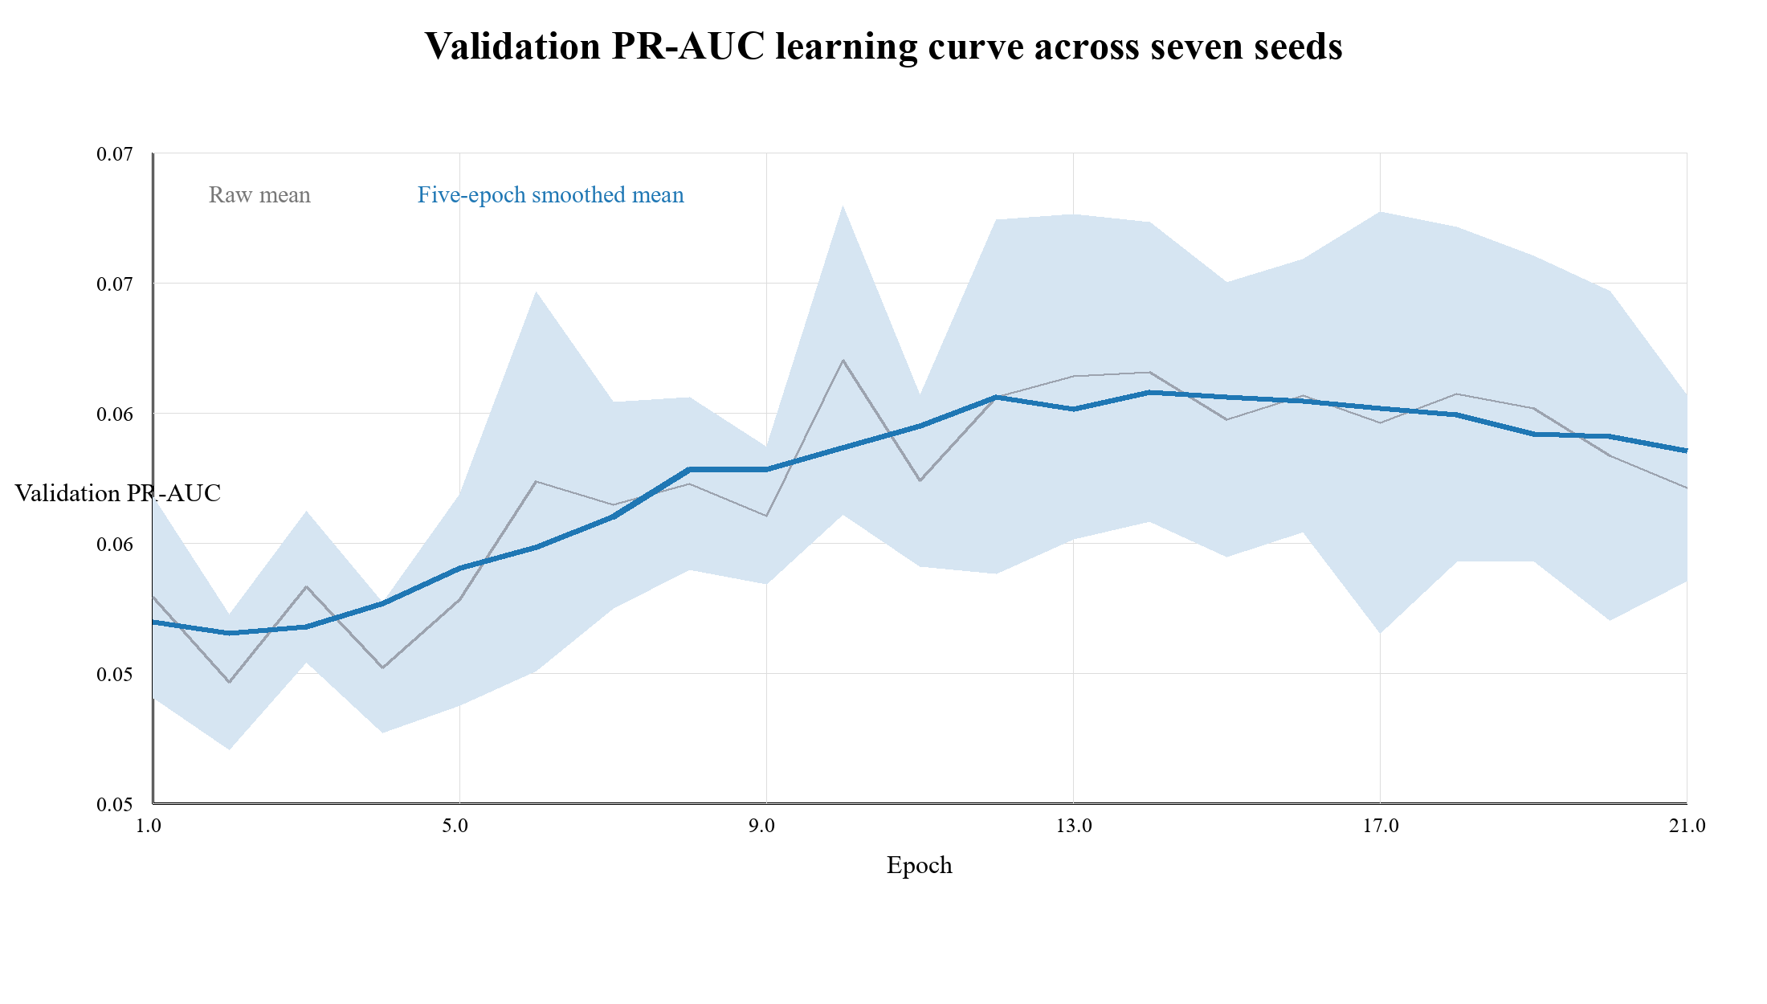Figure 4. Validation PR-AUC learning curve averaged across seven seeds and restricted to epochs completed by every seed.
Figure 4 shows an early rise in validation PR-AUC followed by a broad plateau and mild decline. The smoothed curve peaks around the middle epochs rather than at the maximum epoch limit, supporting early stopping. The widening interval also indicates increasing between-seed uncertainty, so selecting a single visually favorable epoch would overstate stability.

4.4 Sequence-Aligned Validation Baselines
Table 9. Sequence-aligned validation performance comparison of TECR-Net and four baseline models
Model | PR-AUC | ROC-AUC | F1 | Precision | Recall | Brier
TECR-Net | 0.07518 | 0.63855 | 0.12150 | 0.08844 | 0.19403 | 0.03406
CatBoost | 0.05163 | 0.62390 | 0.05405 | 0.06818 | 0.04478 | 0.07926
XGBoost | 0.05036 | 0.62903 | 0.05000 | 0.04301 | 0.05970 | 0.08115
HistGradientBoosting | 0.04891 | 0.62539 | 0.01408 | 0.01333 | 0.01493 | 0.09438
LightGBM | 0.04690 | 0.62848 | 0.04054 | 0.03704 | 0.04478 | 0.05195

Table 9 presents the validation performance of the proposed TECR-Net and four machine learning baselines, including CatBoost, XGBoost, HistGradientBoosting, and LightGBM. TECR-Net achieves the highest reported PR-AUC (0.07518), outperforming CatBoost (0.05163), XGBoost (0.05036), HistGradientBoosting (0.04891), and LightGBM (0.04690). The proposed model also records the highest ROC-AUC (0.63855), F1-score (0.12150), and recall (0.19403), indicating improved minority-class detection. Furthermore, TECR-Net achieves the lowest Brier score (0.03406), suggesting better probabilistic prediction accuracy. These results indicate promising validation performance for TECR-Net relative to the newly evaluated baselines, although its comparative advantage requires confirmation under an identical evaluation protocol and on an independent test set.
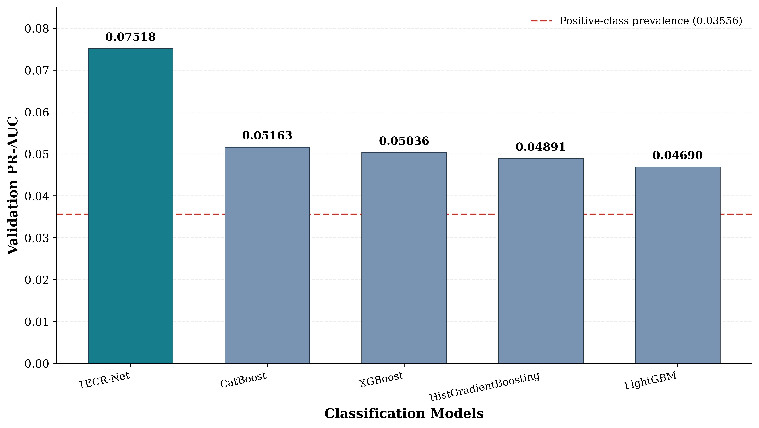
Figure 5 illustrates the reported validation PR-AUC performance of TECR-Net against four baseline models. TECR-Net achieves the highest PR-AUC of 0.07518, followed by CatBoost (0.05163), XGBoost (0.05036), HistGradientBoosting (0.04891), and LightGBM (0.04690). Relative to the strongest new baseline, CatBoost, TECR-Net achieves a 45.61% higher PR-AUC. All models exceed the positive-class prevalence baseline of approximately 0.03556, although their absolute PR-AUC values remain relatively low. The results suggest that TECR-Net offers improved positive-class ranking performance, subject to verification of identical validation sequences and experimental settings.

4.5 Architectural Ablation
Table 10 reports the full model and six prespecified removal variants using validation results only.
Table 10. Validation-only TECR-Net architectural ablation
Variant | PR-AUC | ROC-AUC
Full TECR-Net | 0.07518 | 0.63855
Without categorical encoder | 0.07374 | 0.60503
Without cross-modal attention | 0.07494 | 0.63760
Without feature gate | 0.06652 | 0.63832
Without GRU | 0.05556 | 0.63252
Without residual fusion | 0.07150 | 0.64479
Without temporal attention | 0.06938 | 0.63824

Table 10 shows that the full TECR-Net has the highest validation PR-AUC. Removing the GRU produces the largest PR-AUC reduction, from 0.07518 to 0.05556, which supports the value of ordered temporal encoding. Some variants improve individual threshold-dependent measures, such as recall or balanced accuracy, illustrating that no single operating metric captures all design trade-offs.

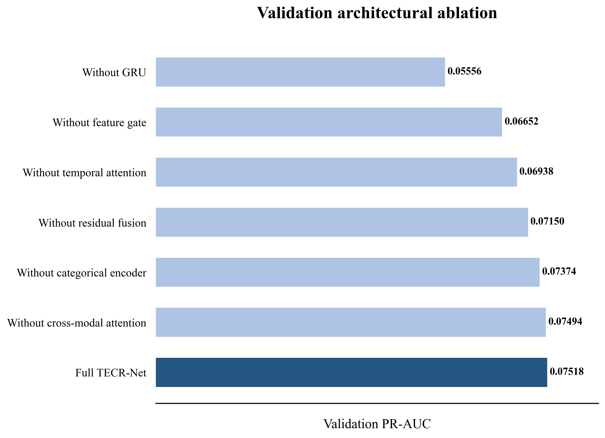
Figure 6. Validation PR-AUC for the full TECR-Net and six architectural ablations.
Figure 6 makes the recurrent encoder contribution most visible: the no-GRU variant approaches the prevalence baseline more closely than the other variants. The small difference between the full model and removal of cross-modal attention indicates that this module contributes less validation PR-AUC than the recurrent pathway, even though it may affect threshold-dependent behaviour.

4.6 Accident-Feature Sensitivity
Table 11 evaluates whether the primary validation result depends on the three coarse lease-level accident proxies.
Table 11. Validation sensitivity to lease-level accident proxies
Variant | PR-AUC | ROC-AUC | F1 | Precision
Full TECR-Net | 0.07518 | 0.63855 | 0.12150 | 0.08844
Without lease-level accident proxies | 0.07478 | 0.62849 | 0.12091 | 0.07273

Table 11 shows nearly unchanged validation PR-AUC after removing the accident proxies (0.07518 versus 0.07478). The reduced model increases recall and precision@50 but lowers ROC-AUC slightly. The primary ranking conclusion is therefore not materially dependent on these duplicated lease-level variables, although threshold-dependent operating behaviour changes.

4.7 Validation Uncertainty and Calibration
Table 12 reports uncertainty and calibration diagnostics calculated exclusively from the validation ensemble predictions.
Table 12. Validation bootstrap intervals and calibration diagnostics
Diagnostic | Estimate | 95% bootstrap CI / basis | Interpretation
PR-AUC | 0.07518 | 0.04457–0.13278 | Primary rare-event ranking
ROC-AUC | 0.63855 | 0.57499–0.70282 | Moderate discrimination
Brier score | 0.03406 | 0.02632–0.04188 | Probability error
Expected calibration error | 0.00000 | Descriptive | Weighted bin-wise gap
Maximum calibration error | 0.00000 | Descriptive | Largest occupied-bin gap
Validation prevalence | 0.03556 | 67 / 1,884 | Rare outcome

Table 12 shows wide uncertainty around discrimination because only 67 validation positives are available. The Brier score is numerically low, but this partly reflects the low event rate. Moreover, Platt calibration was fitted on the same validation cohort, so the calibration errors are apparent rather than independently verified. External recalibration remains mandatory before us
5. Discussion
TECR-Net demonstrated modest but meaningful risk-ranking ability, achieving a validation PR-AUC of 0.07518—approximately 2.11 times the outcome prevalence—and a ROC-AUC of 0.63855. However, the confusion matrix identified only 13 of 67 positive cases at the selected threshold. Precision@50 was 0.08, corresponding to approximately four INC-positive platforms among the 50 highest-ranked facilities. Therefore, TECR-Net should be interpreted as an inspection-prioritization tool rather than an autonomous screening or enforcement system.The ablation analysis supports the importance of temporal modelling. Removing the GRU caused the largest PR-AUC reduction, whereas removing cross-modal attention produced only a marginal decline. This indicates that ordered historical information contributes more strongly than individual fusion components. Nevertheless, attention and feature-gating weights represent model associations and should not be interpreted as causal risk factors.

Among the aligned baselines. TECR-Net’s contribution instead lies in its explicit temporal structure, multimodal feature integration and transparent ablation design. Because model selection, threshold determination and calibration involved the validation period, the reported performance remains internally estimated. Independent prospective evaluation, separate probability recalibration and inspection-capacity-based threshold selection are required before operational deployment.

6. Limitations

The reported results are based on internal validation. Model selection, threshold optimization and calibration involving the same period may produce optimistic performance estimates; an untouched external or prospective cohort is required.

The target represents a recorded INC rather than latent non-compliance. Its occurrence depends on inspection frequency, reporting practices and regulatory activity, while complete facility-level records of inspections without INCs were unavailable.

Inclusion requires an observable next-year platform record, potentially excluding facilities that cease production or disappear. Lease-level accident variables may also be repeated across multiple platforms, limiting platform-specific attribution.

The validation cohort contained only 67 positive cases, resulting in uncertain and seed-sensitive estimates. Furthermore, the model was developed using U.S. offshore BSEE data, and its transferability to other jurisdictions, asset classes and enforcement systems remains unverified.

7. Conclusion

TECR-Net provides a coherent temporal cross-modal framework for next-year recorded INC prioritization in offshore platforms. On internal validation, the seven-seed ensemble achieved PR-AUC 0.0752, 2.11-fold lift over prevalence, ROC-AUC 0.6386, F1 0.1215, and Brier score 0.0341. The recurrent temporal encoder made the clearest contribution in ablation, and removal of coarse accident proxies had little effect on primary validation PR-AUC.. The accurate scientific conclusion is therefore not that TECR-Net is decisively superior, but that it is a promising structured model requiring independent prospective confirmation. Until such evidence is available, TECR-Net should be presented as a research prototype for ranking and inspection-planning analysis rather than a deployable regulatory decision system.

References
[1] Liu, B., Li, Z., Duan, Q., Yan, B. and Tan, X., 2025. Research on LLM-based assessment methods for international standards' intelligent contribution to oil and gas pipelines. Journal of Pipeline Science and Engineering, p.100405.
[2] Hui, Q., Liu, B., Fan, J., Guo, D., Chen, J., Tan, X. and Peng, Z., 2026. Knowledge graph construction for pipeline standards: Enhancing efficiency in the oil and gas industry. Journal of Pipeline Science and Engineering, p.100445.
[3] Xia, T., Wang, F., Huang, Z., Zhang, W., Chen, G., Zhou, J. and Liu, C., 2025. Multi-Dimensional Control Rules and Assessment Methods for Surface Engineering Data Quality in Oil and Gas Field. Information, 16(8), p.701.
[4] Khordoustan, P., Akbarzadeh, O., Gilani, N., Moshashaei, P. and Alizadeh, S.S., 2026. A hybrid ANP and machine learning framework for contractor health safety environment and quality performance evaluation. Discover Analytics, 4(1), p.16.
[5] Wahono, T., Purniawan, A., Mukhlash, I. and Putri, E.R., 2025. Risk-based asset integrity management in the oil and gas industry from traditional to machine learning approaches: A systematic review. Results in Engineering, p.107287.
[6] Zhang, X., Yan, L., Lai, F. and Wang, H., 2025. Research progress and prospects of risk assessment methods for oil and gas development. Geoenergy Science and Engineering, 253, p.213992.
[7] Wahono, T., Mukhlash, I., Putri, E.R. and Purniawan, A., 2026. An intuitionistic fuzzy deep neural network method for risk assessment of oil and gas pipelines. Cleaner Engineering and Technology, p.101299.
[8] Zhou, Y., Fan, J., Dai, B. and Wu, S., 2025. A data-driven PCA-hierarchical clustering framework for adaptive risk assessment of gas pipeline networks. Process Safety and Environmental Protection, p.107753.
[9] Ye, Z., Duan, Q. and Ma, S., 2026. Research on risk classification of oil and natural gas pipelines based on text mining and apriori algorithm. Journal of Loss Prevention in the Process Industries, 103, p.106059.
[10] AlAbdouli, M.A. and Al-Shihabi, S., 2025. Artificial intelligence and its performance impacts in the oil and gas industry: Challenges, insights, and evaluation approaches. Results in Engineering, p.107636.
[11] Savari, A., Li, Y., Alnefaie, K. and Singh, N.S.S., 2026. State-of-the-art Machine learning Advances in reliability-based design, integrity assessment, inspection and maintenance of pipelines: A Systematic review. Journal of Pipeline Science and Engineering, p.100528.
[12] Bastek, T., Denecke, J. and Schmidt, J., 2026. Future directions for data-driven approaches in pipeline integrity management: Risk assessment, in-line inspection, and machine learning. Reliability Engineering & System Safety, p.112300.
[13] Jones, J.F., Raj, V., Abas, P.E., Petra, M.I., Sivan, D., Satheesh Kumar, K., Jose, R. and Mathew, S., 2025. Application of artificial intelligence for asset integrity management of offshore oil and gas pipelines. Life Cycle Reliability and Safety Engineering, 14(4), pp.503-530.
[14] Al-Ammari, W.A., Sleiti, A.K., Rahman, M.A., Rezaei-Gomari, S., Hassan, I. and Hassan, R., 2025. Digital twin for leak detection and fault diagnostics in gas pipelines: A systematic review, model development, and case study. Alexandria Engineering Journal, 123, pp.91-111.
[15] Cai, X. and Wang, J., 2026. A digital twin-driven natural gas pipeline leakage detection method. International Journal of Pressure Vessels and Piping, p.105793.
[16] Ali, U., Naveen, P., Al-Shalabi, E.W. and Ait Abderrahmane, H., 2026. Artificial intelligence and machine learning for production prediction and optimization of oil and gas surface networks. Energy and AI, p.100772.
[17] Chen, Y., Chen, P., Wang, Y., Feng, G., Yang, C. and Wang, Q., 2025. From clustering to federated learning: A collaborative approach to optimizing data-driven models for the production monitoring of unconventional natural gas wells. Gas Science and Engineering, 137, p.205580.
[18] Lopes, L.G.O., de Almeida Vieira, T.M., Aranha, P.E., de Lima Junior, E.T. and Lira, W.W.M., 2025. Detection and classification of anomalies in oil well production using Open-World Learning. Engineering Applications of Artificial Intelligence, 159, p.111514.
[19] Aranha, E.P., Policarpo, A.N. and Sampaio, A.M., 2025. A Transformer-based approach for anomaly detection in intelligent well completions. Petroleum Exploration and Development, 52(4), pp.1029-1040.
[20] Verma, P., Gandhi, K., Cheema, A.M., Ashfaq, M., Shah, D., Ali, S. and Tahir, M., 2026. DeepPipeNet enables deep learning based anomaly detection for oil and gas pipeline monitoring. Discover Applied Sciences, 8(5), p.498.
[21] Almahakeri, M., Al-Mahasneh, A.J., Mallouh, M.A. and Jouda, B., 2025. Deep neural network-based intelligent health monitoring system for oil and gas pipelines. Applied Soft Computing, 171, p.112827.
[22] Wang, M., Su, X., Song, H., Wang, Y. and Yang, X., 2025. Enhancing predictive maintenance strategies for oil and gas equipment through ensemble learning modeling. Journal of Petroleum Exploration and Production Technology, 15(3), p.46.
[23] Sani, A.A., Wahab, M.M.A., Shafiq, N., Danyaro, K.U. and Aliyu, Y., 2026. Data-Driven Ensemble Machine Learning for Corrosion Risk Prediction and Maintenance Optimization in Oil and Gas Pipelines. Results in Engineering, p.110288.
[24] Ansari, E., Izadkhah, M., Mohimi, A., Akhtar, M.N. and Bakar, E.A., 2026. Prediction of Internal Corrosion in Oil and Gas Piping Systems—An Independent Analysis Using Machine Learning. Journal of Pipeline Science and Engineering, p.100522.
[25] Wu, T., Miao, X. and Song, F., 2025. Residual strength prediction of corroded pipelines based on physics-informed machine learning and domain generalization. npj Materials Degradation, 9(1), p.12.
[26] Wang, Q. and Lu, H., 2025. Machine learning methods for predicting residual strength in corroded oil and gas steel pipes. npj Materials Degradation, 9(1), p.30.
[27] Chen, X., Huang, S., Guan, T. and Fu, H., 2025. An interpretable predictive model for liquid holdup of hilly terrain oil-gas pipelines based on machine learning and Shapley additive explanations. ACS omega, 10(15), p.15160.
[28] Lv, X., Yin, Z., Chen, S., Liu, Y., Yao, H., Ma, Y., Wang, C., Ma, Q., Li, X. and Zhou, S., 2026. Risk assessment model for hydrate blockage in deep-sea oil and gas multiphase pipelines based on XGBoost and SHAP. Chemical Engineering Science, p.124205.
[29] Yang, Y., Wang, B., Cen, X., Shao, B., Zhu, B., Yang, J. and Hong, B., 2025. Susceptibility risk assessment of oil and gas pipeline geological hazards in mountainous areas based on data-driven model. Engineering Applications of Artificial Intelligence, 151, p.110732.
[30] Chen, S., Zhang, N., Shui, B., Zhang, T., Li, C. and Gong, Q., 2025. Real‐Time Prediction of Overpressure‐Induced Pipeline Failure via Edge‐Optimized Machine Learning. Energy Science & Engineering, 13(10), pp.4730-4744.
[31] Khalilzadeh, M., Banihashemi, S.A., Heidari, A., Orazani, S.M.H. and Taebi, P., 2025. Risk management in the production phase of oil and gas projects: evaluating risk responses and their impact on safety and damage reduction. Discover Civil Engineering, 2(1), p.91.
[32] Zhang, F., Feng, Y. and Li, X., 2025. Application of big data and artificial intelligence in oilfield production optimization and intelligent management: A systematic analysis of real-time monitoring and parameter optimization. Advances in Resources Research, 5(1), pp.16-30.

