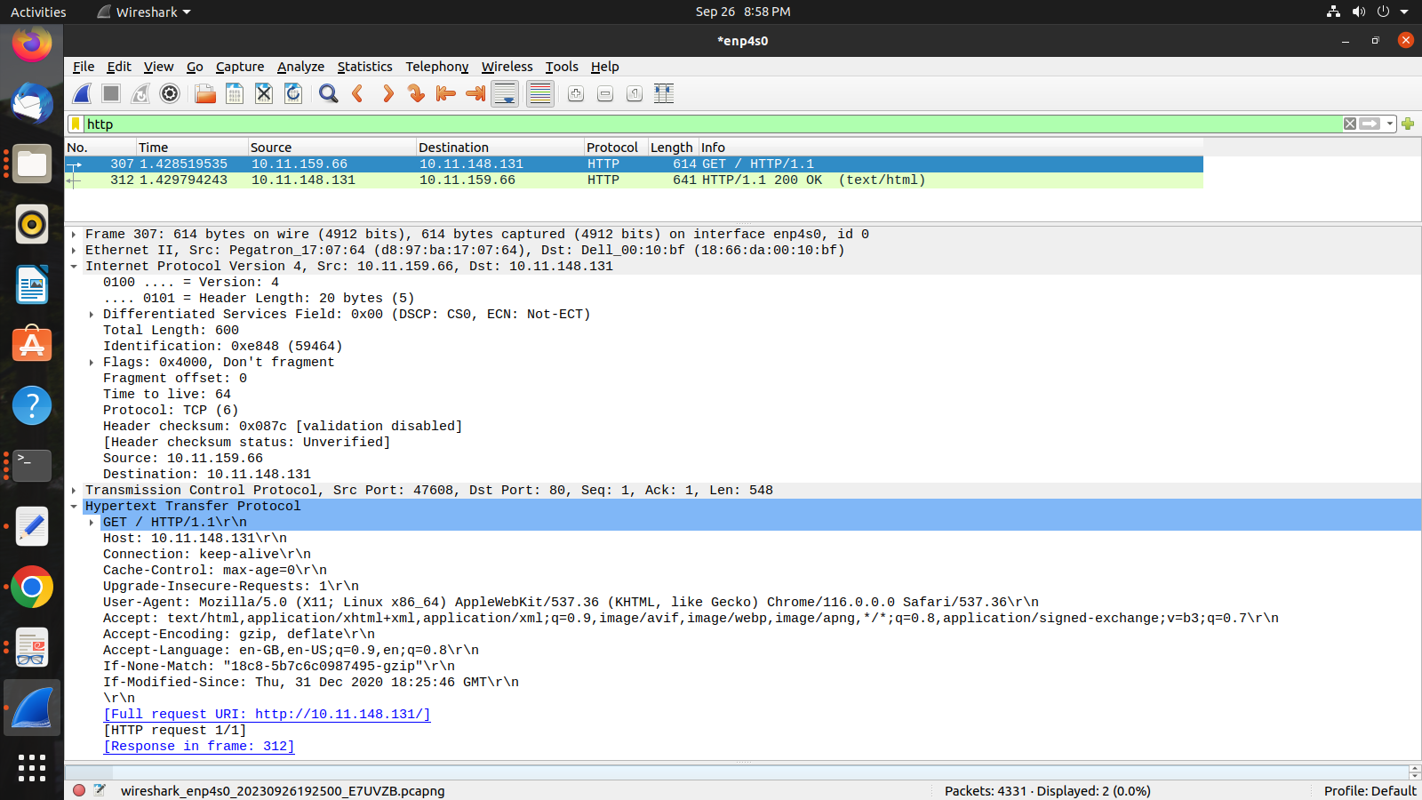
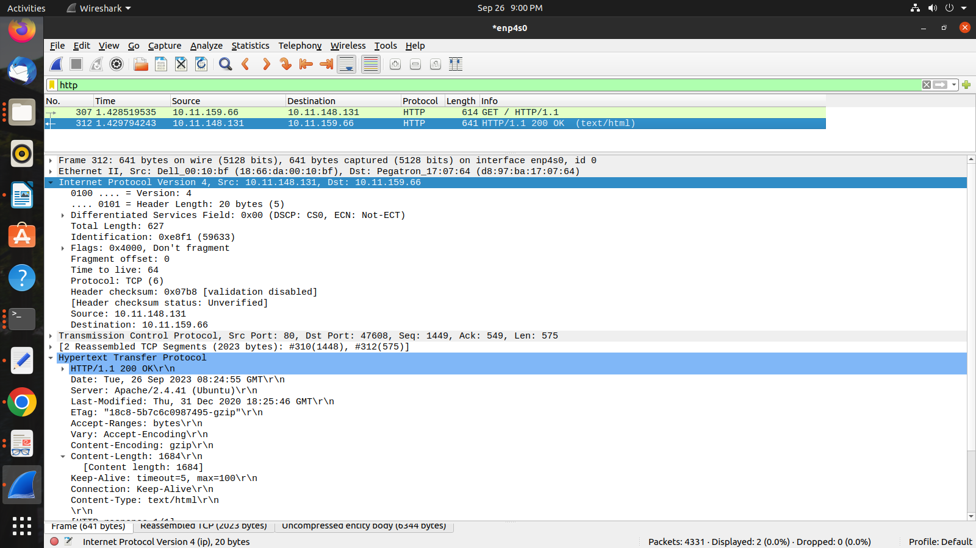
1. Is your browser running HTTP version 1.0 or 1.1? What version of HTTP is the server running?
Answer: 1.1

2. What languages (if any) does your browser indicate that it can accept to the server?
Answer: Accept-Language: en-GB,en-US;q=0.9,en;q=0.8\r\n

3. What is the IP address of your computer? Of the gaia.cs.umass.edu server?
Answer:Internet Protocol Version 4, Src: 10.11.159.66, Dst: 10.11.148.131

4. What is the status code returned from the server to your browser?
Answer: 200

5. When was the HTML file that you are retrieving last modified at the server?
Answer: Last-Modified: Thu, 31 Dec 2020 18:25:46 GMT\r\n

6. How many bytes of content are being returned to your browser?
Answer: Content-Length: 1684\r\n

7. By inspecting the raw data in the packet content window, do you see any headers within
the data that are not displayed in the packet-listing window? If so, name one.
Answer:
no, I don’t see any in the HTTP Message below

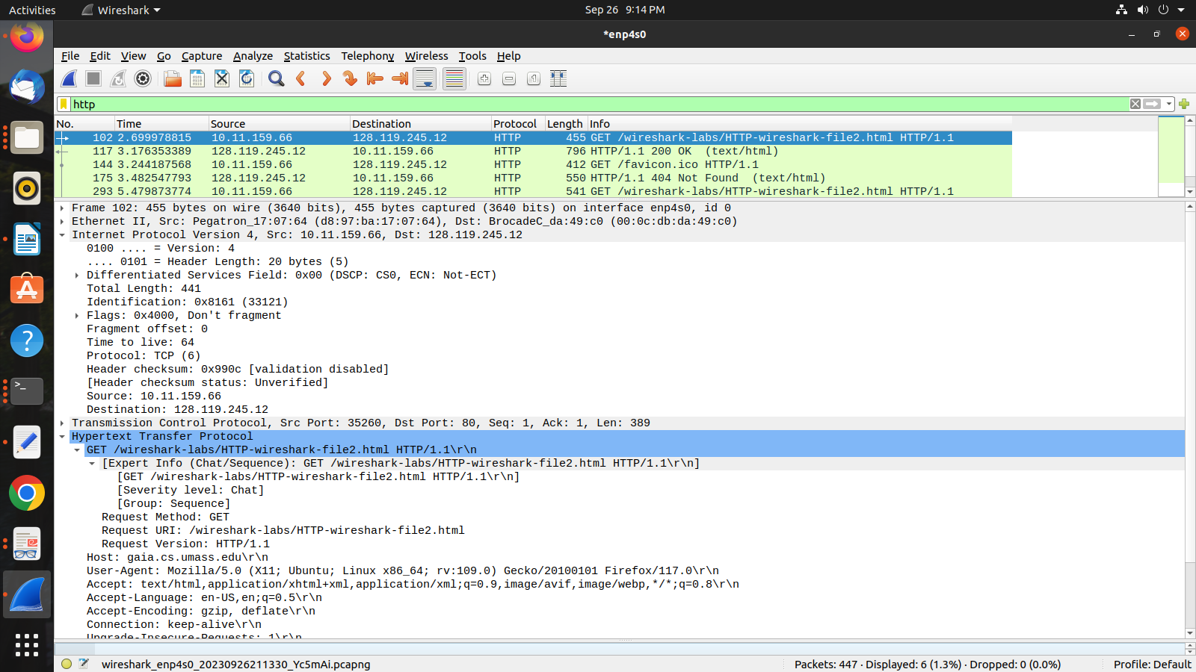
8. Inspect the contents of the first HTTP GET request from your browser to the server.
Do you see an “IF-MODIFIED-SINCE” line in the HTTP GET?

There is no IF-MODIFIED-SINCE in first get
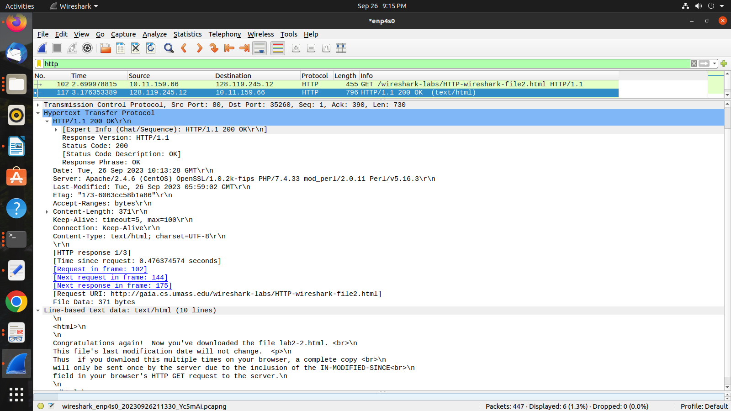

9. Inspect the contents of the server response. Did the server explicitly return the
contents of the file? How can you tell?

Yes, text returned in response to first get

10. Now inspect the contents of the second HTTP GET request from your browser to the
server. Do you see an “IF-MODIFIED-SINCE:” line in the HTTP GET? If so, what
information follows the “IF-MODIFIED-SINCE:” header?

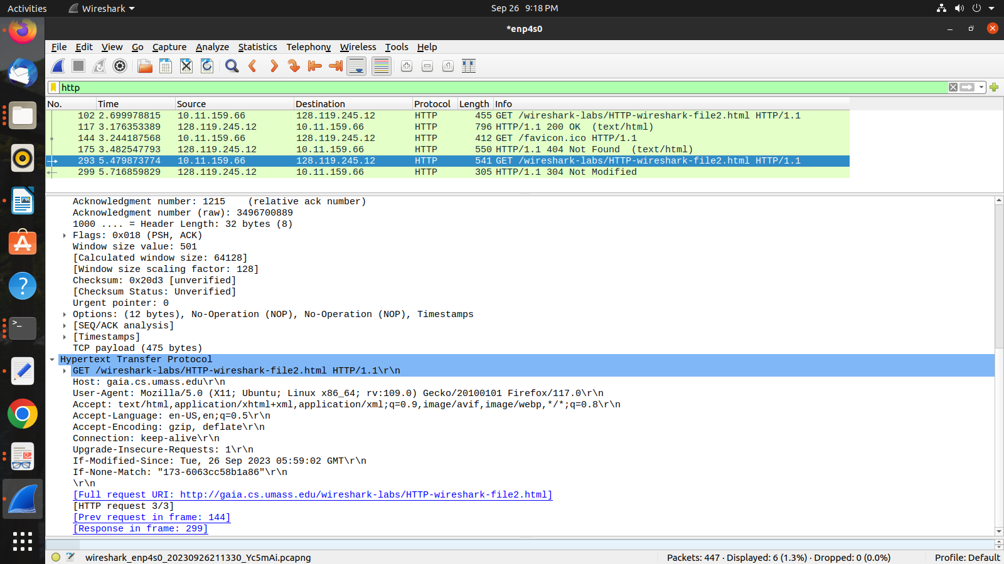

If-Modified-Since: Tue, 26 Sep 2023 05:59:02 GMT\r\n

11. What is the HTTP status code and phrase returned from the server in response to this
second HTTP GET? Did the server explicitly return the contents of the file?
Explain.

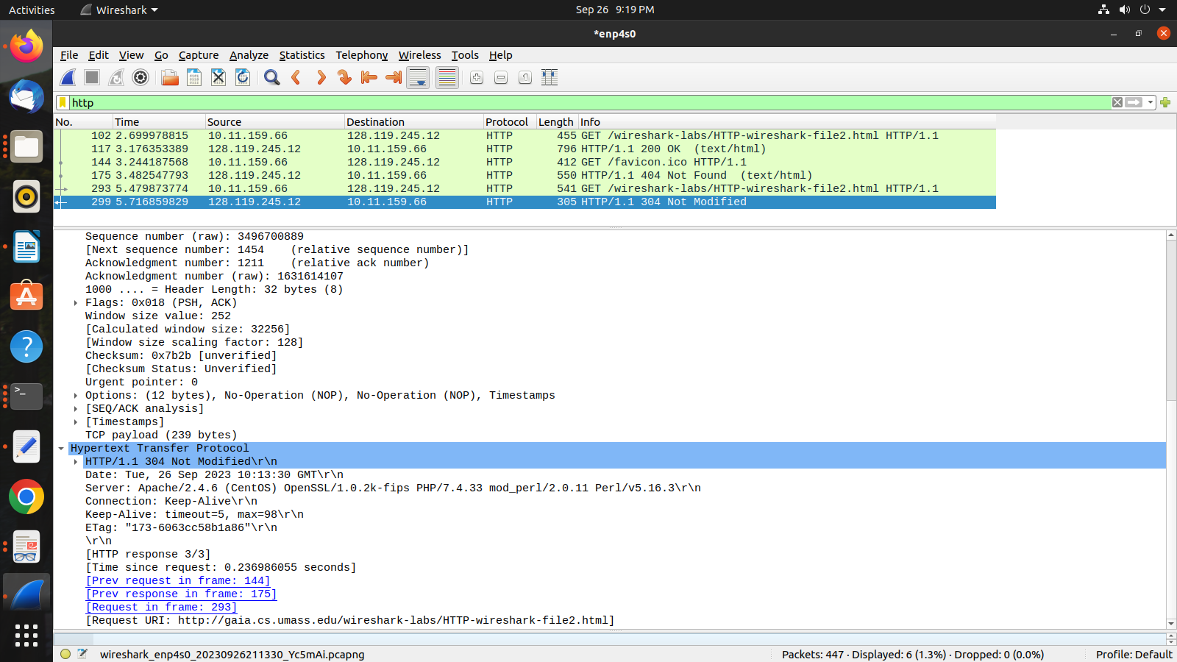
Answer: HTTP/1.1 304 Not Modified\r\n

12. How many HTTP GET request messages did your browser send? Answer: 1. Which
packet number in the trace contains the GET message for the Bill or Rights? Answer: 8.
13. Which packet number in the trace contains the status code and phrase associated with the
response to the HTTP GET request? Answer: packet 10.
14. What is the status code and Phrase in the response? Answer: 200 (OK)
15. How many data-containing TCP segments were needed to carry the single HTTP
response and the text of the Bill of Rights? Answer: three packets (10, 11, 13 in the trace)

