<!DOCTYPE html>

<html lang="en">

<head>

<link rel="stylesheet" href="cal.css">

<title>Calulator</title>

</head>

<center><h1><b>CALCULATOR</b></h1></center>

<body>

<div class="main">

<input type="text" id = 'res'>

<div class="btn">

<input type="button" value = 'C' onclick = "Clear()">

<input type="button" value = '%' onclick = "Solve('%')">

<input type="button" value = '←' onclick ="Back('←')">

<input type="button" value = '/' onclick = "Solve('/')">

<br>

<input type="button" value = '7' onclick = "Solve('7')">

<input type="button" value = '8' onclick = "Solve('8')">

<input type="button" value = '9' onclick = "Solve('9')">

<input type="button" value = 'x' onclick = "Solve('\*')">

<br>

<input type="button" value = '4' onclick = "Solve('4')">

<input type="button" value = '5' onclick = "Solve('5')">

<input type="button" value = '6' onclick = "Solve('6')">

<input type="button" value = '-' onclick = "Solve('-')">

<br>

<input type="button" value = '1' onclick = "Solve('1')">

<input type="button" value = '2' onclick = "Solve('2')">

<input type="button" value = '3' onclick = "Solve('3')">

<input type="button" value = '+' onclick = "Solve('+')">

<br>

<input type="button" value = '00'onclick = "Solve('00')">

<input type="button" value = '0' onclick = "Solve('0')">

<input type="button" value = '.' onclick = "Solve('.')">

<input type="button" value = '=' onclick = "Result()">

</div>

</div>

<script src = 'cal.js' ></script>

</body>

</html>

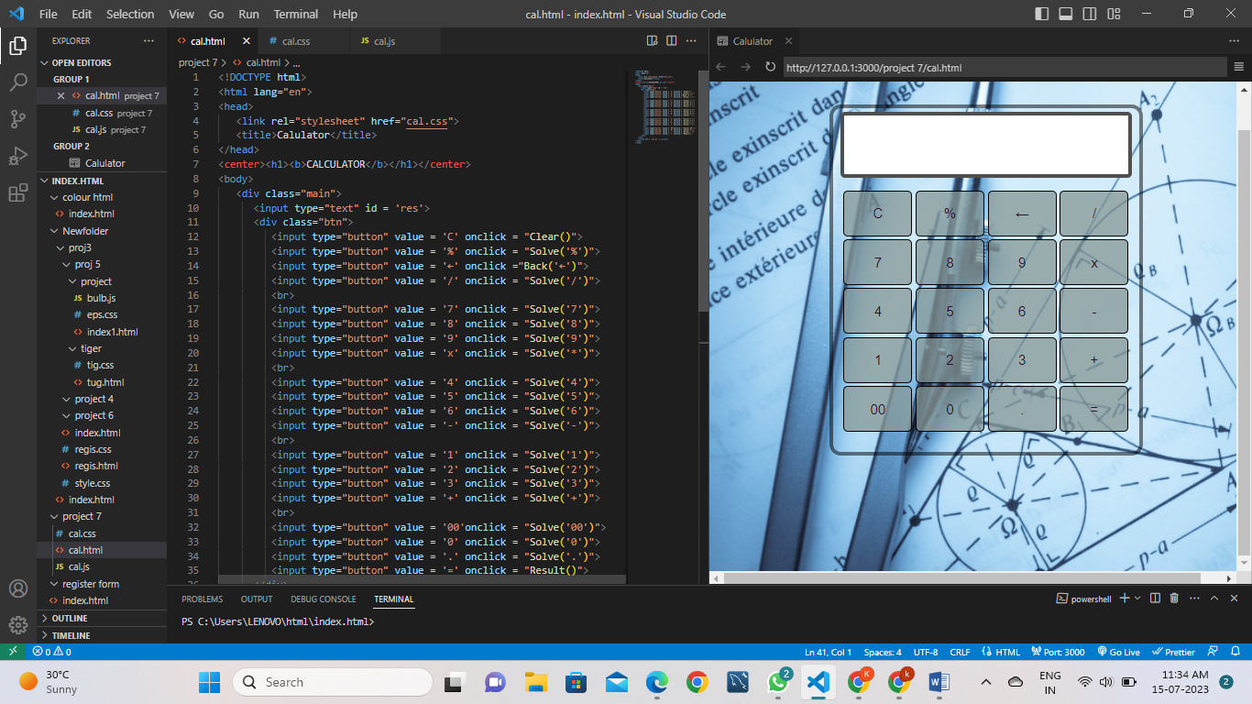

\*{

padding: 0;

margin: 15;

font-family: 'poppins', sans-serif;

}

h1{

Color:rgb(11, 11, 11);

}

body{

background-image: url("https://www.theeducationpeople.org/media/4537/untitled-design-49.png");

background-repeat: no-repeat;

background-size: cover;

width: 100vw;

height: 100vh;

}

.main{

margin-left: auto;

margin-right: auto;

width: 400px;

height: 450px;

background-color: rgba(193, 82, 82, 0);

position: center;

border: 5px solid rgba(0, 0, 0, 0.5);

border-radius: 15px;

}

.main input[type='text'] {

width: 90%;

position: relative;

height: 70px;

top: 5px;

text-align: right;

padding: 3px 6px;

outline: none;

font-size: 40px;

border: 5px solid rgba(0, 0, 0, 0.689);

display: flex;

margin: auto;

border-radius: 6px;

color: rgb(0, 0, 0)034;

}

.btn input[type='button']{

width:90px;

padding: 2px;

margin: 2px 0px;

position: relative;

left: 13px;

top: 20px;

height: 60px;

cursor: pointer;

font-size: 18px;

transition: 0.5s;

background-color: #859794bf;

border-radius: 6px;

color: rgb(46, 17, 47);

}

.btn input[type='button']:hover{

background-color: rgb(24, 233, 34);

color: rgb(255, 255, 255);

}

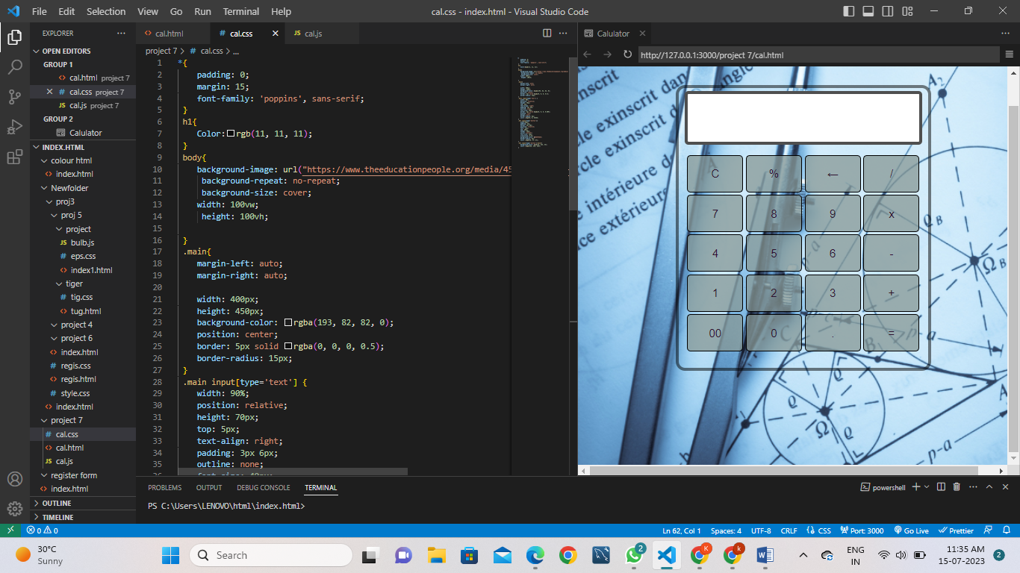

function Solve(val) {

var v = document.getElementById('res');

v.value += val;

}

function Result() {

var num1 = document.getElementById('res').value;

var num2 = eval(num1);

document.getElementById('res').value = num2;

}

function Clear() {

var inp = document.getElementById('res');

inp.value = '';

}

function Back() {

var ev = document.getElementById('res');

ev.value = ev.value.slice(0,-1);

}

