BMES 550

Group 1: Tony Okeke, Cooper Molloy, Ali Youssef

Project Name: Cancer Biomarker Discovery (CaBiD)

Design & Schema

**Flowchart:**

**File: curation.py**

**Creator:** Tony Okeke

**Purpose**: Downloads GEO & CuMiDa datasets and stores the files within a temporary directory, then create a database

**Input:** None (Runs by default)

**Output:** Curated database (CaBiD.db)

**Main functions/classes within curation.py:**

* **Geodlparse:** Download, parse, and cache data from GEO
* **CuMiDa:** class that manipulates data and combine it with corresponding GPL
* **Curate:** download data from CuMiDa, build the database
* **Datacheck:** checks if CaBiD database exists and create it if it doesn’t

Transition 1

**File: gui.py**

**Creator:** Ali Youssef

**Purpose**: Allows user to select preferred cancer type and dataset to perform gene expression analysis

**Input:** Cancer type, dataset (User select from dropdown menu on the GUI)

**Output:** Displays GUI with analyzed results from dge.py

**File: dge.py**

**Creator:** Cooper Molloy

**Purpose**: Retrieves input values from gui.py and perform analysis by generating: p-values, full change (FC), volcano map, heat map

**Input:** Cancer type, dataset from gui.py

**Output:** Analyzed data table and figures: p-values, full change (FC), volcano map, heat map

Transition 2

dge.py feeds back analyzed data and figures to gui.py to publish the analyzed gene expression data

Transition 3

**Main function/classes within dge.py:**

* **dge():** function responsible for performing data analysis: Welch’s t-test, p-val, and plots
* **Plot_volcano():** creates the volcano map
* **Plot_heatmap():** create a clustered heat map

**Main function/classes within gui.py:**

* **ControlBox:** Class to create UI controls
* **GUIPanel:** main GUI panel
* **CaBiD GUI:** main GUI window for CaBiD

**Summary Table:**

|  |  |  |
| --- | --- | --- |
| **Function/Feature Name** | **Description** | **Creator** |
| **curation.py** | Downloads GEO & CuMiDa datasets and stores the files within a temporary directory, then create a database | Tony Okeke |
| geodlparse: Function | Download, parse, and cache data from GEO | Tony Okeke |
| CuMiDa: Class | Class that manipulates data and combine it with corresponding GPL | Tony Okeke |
| curate: Function | Download data from CuMiDa | Tony Okeke |
| datacheck: Function | Checks if CaBiD database exists and create it if it doesn’t | Tony Okeke |
| **gui.py** | Allows user to select preferred cancer type and dataset to perform gene expression analysis | Ali Youssef |
| ControlBox: Class | Class to create UI controls for | Ali Youssef |
| GUIPanel: Class | Main GUI panel | Ali Youssef |
| CaBiD GUI: Class | Main GUI window for CaBiD | Ali Youssef |
| **dge.py** | Retrieves input values from gui.py and perform analysis by generating: p-values, full change (FC), volcano map, heat map | Cooper Molloy |
| dge(): Function | Function responsible for performing data analysis: Welch’s t-test, p-val, and plots | Cooper Molloy |
| Plot_volcano(): Function | Creates the volcano map that have threshold for both the FC (x-axis)and adjusted p-values (y-axis) | Cooper Molloy |
| Plot_heatmap(): Function | Create a clustered heat map that have genes (x-axis) and samples (y-axis) | Cooper Molloy |

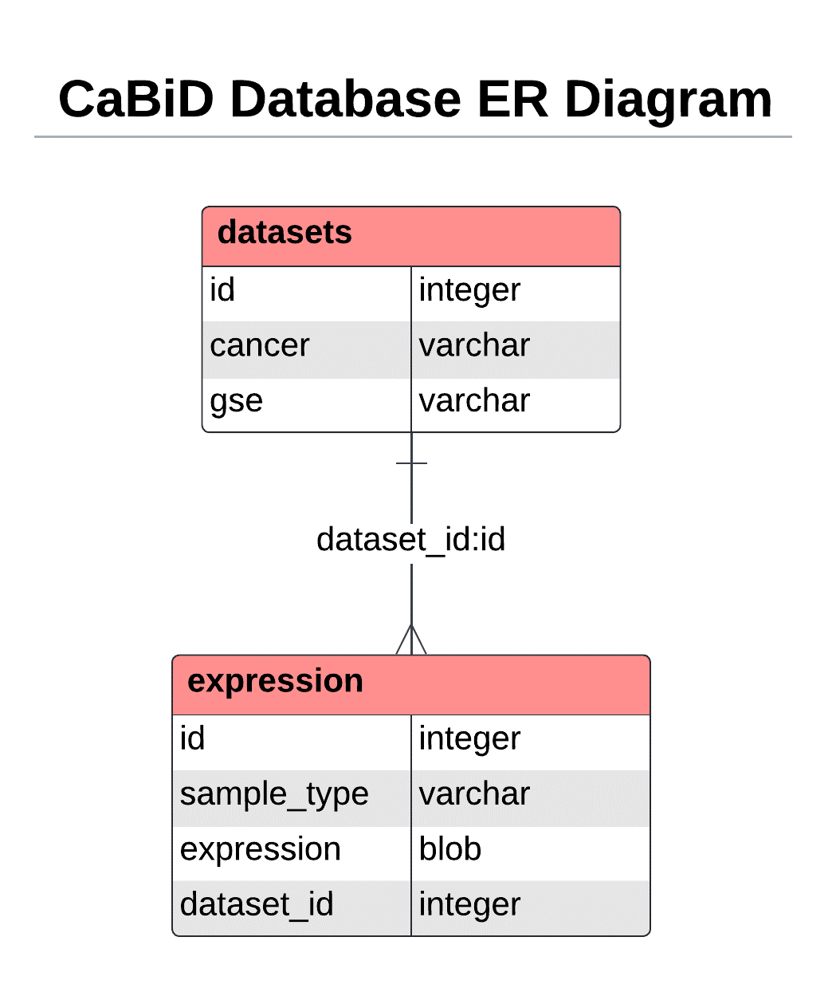**Schema (ER Diagram):**