|  |
| --- |
| **Identifying Immune-Related Genes in Calcific Aortic Valve Stenosis[1]**  Ryan Byrne 1, Pratishtha Guckhool 1  1 School of Biomedical Engineering, Drexel University, USA  Course : Bmes543  Instructor: Ahmet Sacan  Date : 2022-06-07  Original Paper(s) : <http://www.aimspress.com/article/doi/10.3934/mbe.2022174>  Dataset(s) : <https://www-ncbi-nlm-nih-gov.ezproxy2.library.drexel.edu/geo/query/acc.cgi?acc=GSE12644>  <https://www-ncbi-nlm-nih-gov.ezproxy2.library.drexel.edu/geo/query/acc.cgi?acc=GSE51472>  <https://www-ncbi-nlm-nih-gov.ezproxy2.library.drexel.edu/geo/query/acc.cgi?acc=GSE83453> |

[2]*abstract

A one-paragraph summary of the project. Introduce the problem. Describe your model and implementation (mention the programming/modeling environment you used). Summarize your results/findings.

# introduction

Problem description, Motivation. Why are we studying this problem? What is the biomedical need? Public health stats, if available.

Calcific Aortic Valve Stenosis (CAVS) is the

Biology/Physiology:

* Describe the underlying biology/physiology.

* Find figures illustrating the system (remember to cite the sources).

Goals:

* What do you/authors hope to find/accomplish with this study?

* If successful, how will your findings/result influence our understanding or medical practice?

Related Work:

* Provide a short survey of related work. Put this study in the context of others. Check out the papers cited by your project paper and the papers that cite your project paper to find out what else is being done in this area. Use a citation manager (e.g., Endnote) to automate creation of references, e.g., [1].

# Dataset

* Describe the experiment(s) that produced the datasets you are analyzing in your project. What are the experimental groups? How was the data collected?

# methods

* Describe your analysis workflow. e.g, normalization, types of statistical tests, thresholds, etc.

* Describe the methods and software you used.

* Give implementation details (programming language, operating system, etc.)

* If you used code developed by others, provide reference. Describe how you modified/improved/adapted their code.

# Experiments and REsults

* Show your main findings.

* Prefer figures (e.g., bar charts) over tables to present your results.

* Compare your results to those from publications using these datasets.

* If you use tables to report your results, use References->Insert Caption->Table,OnlyLabel&Number to insert cross-reference to tables. E.g., See Table 1).

* Have something intelligible to say about each figure/table you include.

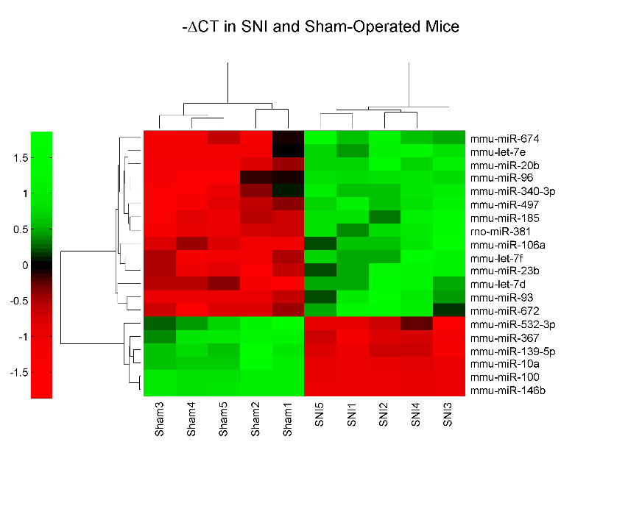

**Figure 1. This is an example figure.** Each figure must have a title (Use References -> Insert Caption in MS Word) and additional text describing what the figure shows. When referring to a figure in the text, always use References->Cross-reference. Do not manually write the figure number.

|  |  |  |
| --- | --- | --- |
| Name | Fold Change | p-value |
| hsa-miR-25# | -3.9 | 1.1E-06 |
| hsa-let-7c | -2.5 | 2.1E-05 |
| hsa-miR-939 | -4.6 | 5.6E-06 |
| hsa-let-7a | -2.5 | 0.002 |
| hsa-let-7b | -2.4 | 5.5E-05 |

**Table 1. Top-5 most significantly differentially expressed miRNAs.** Each table must have a title. Use References -> Insert Caption in MS Word to insert the caption. Provide additional text describing what the table shows. Make the table appear close to its cross-reference, but move it around to avoid spanning multiple pages.

# DISCUSSION

* Summarize/discuss your results, without repeating verbatim what you already have in the Abstract or Results.

* Do your results make sense biologically? Find studies that support your findings. (E.g., you found 10 genes in your Alzheimer's dataset analysis, check literature to see if these genes are known for their involvement in Alzheimer's).

* What are the limitations of your study?

* What follow up studies can be performed to improve upon your findings?

# References

1. Sacan, A., I.H. Toroslu, and H. Ferhatosmanoglu, *Integrated search and alignment of protein structures.* Bioinformatics, 2008. **24**(24): p. 2872-9.

1. Avoid using identical title to any other publication. Scholarly articles are supposed to be unique identifiers and you do not want your report to appear as a version of the original appear on search engines. If your project is based on a paper, use a title that reflects what you did.
2.