|  |
| --- |
| **Multiple Sleep Latency Application[1]**  Matthew Czaja 1 , Ansh Gandhi  1, Hope Seybold 1  1 School of Biomedical Engineering, Drexel University, USA  Course : Bmes550  Instructor: Ahmet Sacan  Date : 2022-12-07 |

[2]*abstract

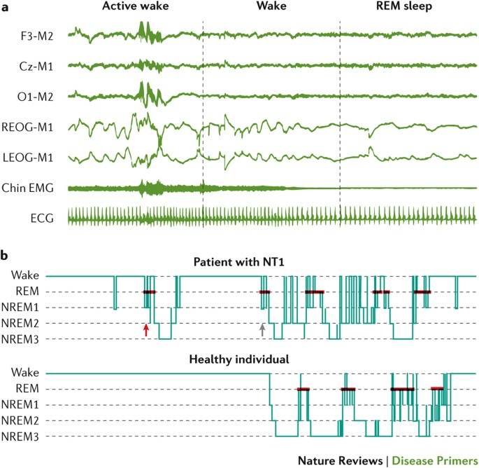The Multiple Sleep Latency Application is a MATLAB GUI that analyzes the results of multiple sleep latency tests based on the inputs of the user. The target user is health care providers performing sleep studies. A multiple sleep latency test is a standard used to diagnose narcolepsy through polysomnography. During the test, a patient is given five opportunities to take scheduled 30-minute naps while wearing electroencephalogram (EEG) sensors to record brain waves and eye movements. The sensors determine the patient’s stages of sleep. Test results are currently analyzed by a sleep specialist, leaving patients waiting for results for up to a month. This application decreases the analysis time requires and allows patients to receive diagnoses quicker. The MATLAB GUI application analyzes sleep scores produced from EEG signals and returns narcolepsy test results. A positive result is obtained when a

Fig. 1. Polysomnography Results for Narcolepsy2

patient has reached REM sleep within 30 minutes for 2 or more naps. Users can view EEG graphs for each nap and a summary of patient results.

# introduction

Narcolepsy is a chronic neurological disorder that disrupt the brain’s ability to regulate sleep-wake cycles. Narcolepsy affects 1 in every 2,000 people in the United States. However, many people struggle with these sleep disorders for years without knowing it. It is estimated that only 25% of people who have narcolepsy have been diagnosed and are receiving treatment1.

Narcolepsy is often misdiagnosed as depression, insomnia, or sleep apnea. This is likely due to the inaccessibility of sleep studies which are required to diagnose narcolepsy. The national average cost for a sleep study is $3,0753. One of the factors that impacts the cost of a sleep study is the prevailing fees for sleep specialists. This MATLAB GUI application will reduce these fees by reaching its goal to decrease the amount of time necessary for analysis of polysomnography results by a specialist, thus making sleep studies more accessible.

Existing work in this area includes that of the Sleep Disorders Center of the Ospedale Maggiore of Parma, Italy. The Sleep Disorders Center of the Ospedale Maggiore has published a collection of polysomnographic recordings and their scorings performed using REMlogicTM software, along with a MATLAB script aiding in reading score files. This script outputs an array containing time and sleep stage which can be reviewed for diagnosis4.

The Multiple Sleep Latency GUI Application uses score files from this database, along with ideas from the MATLAB script in order to provide diagnosis through visualization of signals and analysis polysomnography score results.

# Dataset

The Cyclic Alternating Pattern (CAP) of EEG Activity During Sleep Database is a collection of 108 polysomnographic recordings registered at the Sleep Disorders Center of the Ospedale Maggiore of Parma, Italy4. The recordings include those of 5 narcoleptic individuals. Data was collected through EEG, EOG, EMG, and EKG channels. The intention of the CAP database was to provide examples of CAP for development and evaluation of automated CAP analyzers.

# methods and IMplementation

MATLAB’s App Designer was utilized to create the Graphical User Interface. Using MATLAB programming language, a .mlapp file was generated with a GUI that allows for users with MATLAB, regardless of operating system, can run and interface with. The application allows the user to add raw trial data through a file upload button. This raw sleep latency data is then graphically visualized and analyzed for REM sleep using the REMsleepanalysis function. Trial data is stored and a diagnosis is presented after 5 trials are uploaded. Our implementation is visualized in Figure 2.

Fig 2. Flowchart for Workflow and Implementation.

Once the GUI was developed, multiple sleep latency trial data, sourced from PhysioNet3, was inputted into the GUI to validate functionality.

# Experiments and REsults

An example use case of this application would be in situations where patients who report trouble sleeping can be diagnosed with narcolepsy. Narcolepsy can be a harmful condition to a patient’s quality of life, and this application would be able to diagnose a patient through quicker analysis and allow for faster diagnosis and prescription. Our results show effective detection of REM sleep and diagnosis of narcolepsy.

Fig 3. The GUI with all 5 trials added. REM sleep was accurately detected or not detected in all 5 trials. The patient was accurately diagnosed.

As Figure 3 demonstrates, with the addition of each nap trial, the sleep stage data is visualized and overlayed on previous trials. As each nap trial is added, the application uses our external function to detect the presence of REM sleep. After all 5 trials have been analyzed and overlaid, the application is able to accurately diagnose narcolepsy.

# DISCUSSION

Based on our data source, the application is able to correctly detect REM sleep and diagnose narcolepsy. This has major implications in the streamlining of the diagnostic and prescription process for patients with narcolepsy and the health care providers that are treating them. Biologically, the patient REM sleep data does lead to a valid narcolepsy diagnosis4. There are some limitations with our application. Our GUI is not completely self-sufficient, and thus cannot completely automate diagnosis of narcolepsy. The main function of this application is to serve as a catalyst to the diagnosis process to prevent significant delay in analysis of the data sets acquired in the multiple sleep latency tests. Our GUI’s robustness only allows it to inform the diagnosis of narcolepsy by a trained healthcare professional. Another limitation we had was the testing data available to us. There is a lack of free, open-source EEG data available online, and hence, we were limited in the datasets we were able to use. Follow up studies can include increased trial data in order to create a more robust diagnostic tool. Future work should also focus on being able to visualize the raw EEG data, as well as statistical testing of multiple trials.

# References

1. https://narcolepsynetwork.org/about-narcolepsy/narcolepsy-fast-facts/

2. Kornum, B., Knudsen, S., Ollila, H. *et al.* Narcolepsy. *Nat Rev Dis Primers* **3**,16100(2017).https://doi.org/10.1038/nrdp.2016.100

3. https://physionet.org/content/capslpdb/1.0.0/

4. https://www.xyremhcp.com/mslt-narcolepsy-screening#:~:text=In%20narcolepsy%2C%20mean%20sleep%20latency,or%205%20daytime%20nap%20periods.

1.
2.