**Melanoma Tracker: Image Processing Application for Tracking  
 Changes in Mole Size1**

Ashley Bishop1, Danielle Shoshany1, Giselle Matlis1

1 School of Biomedical Engineering, Drexel University, USA

Course: BMES550

Instructor: Ahmet Sacan

Date: 2022-12-07

**ABSTRACT**

Melanoma is a rapidly growing and fatal cancer. However, if caught early, it can be treated. Early detection and self-monitoring is crucial to decrease mortality. With melanoma’s prevalence in the United States on the rise, there is a need for a self-monitoring app that can track the growth and assess the risk of potentially malignant moles. Therefore, a series of linked web pages, Matlab code, and a database were created for individuals to track the progression or advancement of a potentially malignant mole that could be diagnosed as Melanoma. The web pages were created in PHP, where user can login or create an account which compares and/or stores this user information into a table in SQLite database. Then able to upload an image of a suspicious mole. The image was then evaluated in Matlab based on diameter with a qualitative (i.e., high, moderate, or low) risk based on the diameter. The image, diameter, and risk were then presented to the user on a new page where they can also evaluate the growth history of the given mole. This mole information was also stored in the database. This process can be used for multiple users and multiple moles per user. In conclusion, the hope for this project is to assist patients in self-assessment of suspicious moles to potentially increase the detection rate, which could reduce unnecessary melanoma related deaths due to late-stage diagnosis.

**1** **INTRODUCTION**

Melanoma is the fifth most common cancer in the United States today with approximately 99,780 new cases in 2022 [1]. Melanoma’s prevalence increases continually worldwide with a current individual lifetime risk of 1 in 63 [2]. Of all skin cancers, melanoma is the most invasive and has the highest risk of death accounting for approximately 73% of skin cancer related deaths [2, 3].

Melanoma is caused by melanocytes, a type of skin cell, that produce melanin which creates dark pigmentation. As a result, most melanoma spots are discolored (i.e. black, brown, pink, red, purple or skin colored). Melanoma can start on normal skin, however, approximately 30% start in existing moles. Signs of melanoma include mole asymmetry, irregular borders discoloration, increased diameter (>6mm) and evolving size, shape, or color. [3]

Although melanoma is fast growing and can be fatal, there is a 99% cure rate if it is caught in the early stages [3,4]. Therefore, early detection and self-monitoring is crucial to decrease mortality [2,3,4]. This is especially important for high-risk patients which include men, people with fair complexions, those exposed to extended periods of natural or artificial sunlight, and people with a personal history of melanoma who are at increased risk [1, 2]. Studies have shown that self-assessment can lead to an increased diagnosis of earlier stage melanomas. Methodologies for educating the public on completing accurate self-assessments are needed to assist in early self-identification of potentially malignant moles. [4]

*Goals:* The objective of this project is to develop a web-based application where users can upload multiple images of a mole and assess if the change in size is a cause for concern or may be indicative of melanoma. The application itself will determine both the size and risk of melanoma of the mole based on the image uploaded.

The targeted end users of this application will be individuals who either have a previous history of melanoma and/or are concerned about their status being of an increased risk (i.e., history of severe sunburn, excess exposure to ultraviolet light, etc.). Additionally, this application may be used by healthcare providers, such as dermatologists. This will help providers assess the *changes* in the patient’s mole size over time, especially if a patient is unable to get an appointment when the mole is considered early-stage melanoma. Eventually, this application may eliminate the need for multiple in-person appointments and the dermatologist may be able to both make diagnoses and determine a plan of action earlier.

This application will assist in furthering the development of personalized medicine practices. This application may allow patients to receive a diagnosis earlier since it will eliminate the need for multiple in-person visits, while still providing physicians with both qualitative and quantitative data. This application will promote the self-assessment of one’s own moles which will in turn increase the early detection of melanoma, which will increase survival rates and/or a patient’s quality of life.

*Related Work:* In terms of related work, there are a few options that are similar, but have both benefits and drawbacks. The NIH’s National Cancer Institute has a Melanoma risk tracker; however, it is based on a given patient’s demographics and physical parameters, not specific patient moles [5]. There are other cell phone apps including Miiskin, MoleMapper, [MoleScope](https://www.molescope.com/), [SkinVision](https://www.skinvision.com/), and [UMSkinCheck](https://www.uofmhealth.org/patient%20and%20visitor%20guide/my-skin-check-app) which range in purpose from research to self-use [6,7,8,9,10,11]. However, these apps must be purchased, do not track the mole over time (only baselines), or require additional devices to function, all of which make these apps less accessible to the public [6,7,8,9,10,11].

**2** **DATASET**

A dataset was not used for this project. The images for this project were sources from the Skin Cancer Foundation [12]. Both before and after melanoma images were used.

**3** **METHODS AND IMPLEMENTATION**

This application utilizes several softwares, including Matlab, SQL database, and HTML. HTML was used to create the four web pages in which users will directly interact with including index.php, newuser_connection.php, test_submitting.php, and history.php. A flowchart detailing the connections between the four php pages, the molesize.m Matlab function, and the MelanomaDatabase.db database are depicted in figure 1.

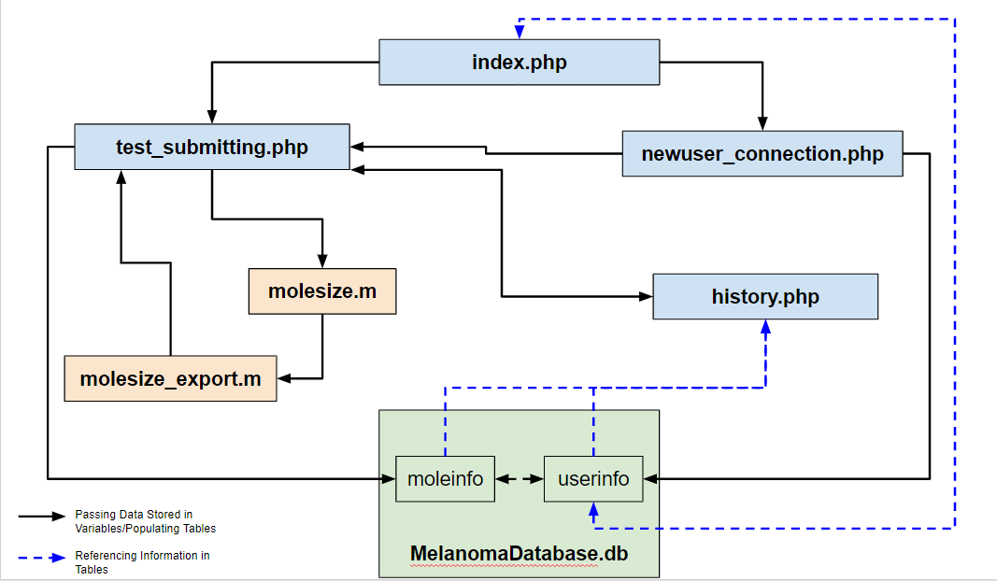

**Figure 1. Flowchart of Interconnected Components.**

These interfaces utilized php session variables to access user entries across different php pages as well as to populate the tables (userinfo and moleinfo) in the MelanomaDatabase.db. In addition, session variables were used to assist in both populating tables in the database as well as verifying whether user inputs (i.e., username and password) matched those previously stored in the database.

There are two tables in the MelanomaDatabase.db. The first is the userinfo table. This table stores all user credentials including an automatically assigned user ID (used as this table’s primary key), the user’s firstname, lastname, username, and password. The second table is the moleinfo table. The moleinfo table stores information including the user ID of the user uploading the image (this is used to link information between the two tables), the date of the image, the user-assigned mole ID, as well as the mole size and its melanoma risk. See figure 2 for the diagram of our database schema.

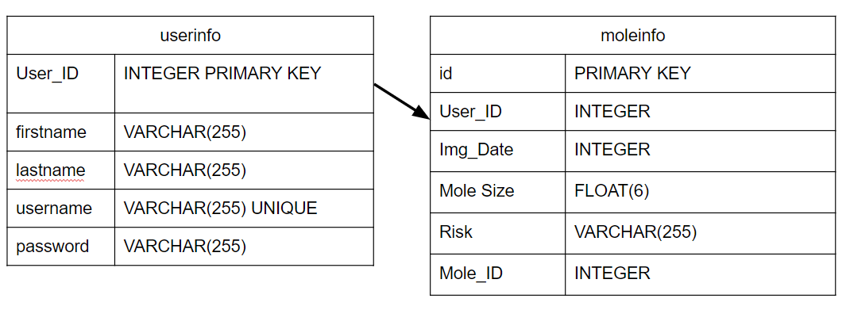

**Figure 2. ER diagram of MelanomaDatabase.db schema.** The primary key from the userinfo table, ‘User_ID’, is used to link to data entries between the userinfo and moleinfo tables.

The following steps were used in order to populate tables in MelanomaDatabase.db using entries to a php form: 1) find the path to MelanomaDatabase.db, 2) creating the database connection using the path, 3) creating the necessary table, including all of its columns, if it did not previously exist, 4) collecting the user entries into php variables using session variables, 5) populating the tables using the newly created php variables. The newuser.php page utilized these steps to populate the userinfo table.

The steps used to verify that the user inputs to username and password matched those in the userinfo table in our MelanomaDatabase.db are similar to the steps used to populate the tables themselves. This verification process takes place in the index.php web page. Index.php allows users to enter login credentials or create a new user, by redirecting them to the newuser_connection.php. First, the path to MelanomaDatabase.db was determined. The database connection was then created using the path. Then a SELECT query was used to check if a table existed within the sqlite_master database information. If the table did not exist, it was created. The user’s information was then checked with the userinfo table by counting the number of users with the unique username. If the correct username and password were submitted, then the value of the select statement would be 1, since only one row in the userinfo table would have that exact username and password. Otherwise, the select statement would return a 0. Based on the value determined by the select statement, the index.php page would either display an error (i.e., select statement returns a 0) or redirect the user to the test_submitting.php page.

The test_subitting.php page allows users to select the date their image was taken, assign a number to the mole, and upload an image of the mole. The path of where the image of the mole is located on the user’s computer is then passed on to the molesize.m MATLab function. The molesize.m function was used to determine both the risk and the diameter of the mole in mm. In this function, the image path was provided as an input and the image itself was processed using the following steps: 1) detection of the edges in the image, 2) dilation of edge pixels detected in the image, 3) filling in objects in the image with complete edges, 4) removing objects below a minimum threshold which are unlikely to be the mole itself, and 5) determining the length of the diameter of the mole using the MATLab function ‘regionprops’ with the variable 'MajorAxisLength'.

To obtain the ratio of pixels to mm, we used a standard image of a melanoma mole with a predetermined length of 8mm [15]. After finding the length in pixels, using the image processing steps previously mentioned, we divided 8mm by this value in pixels to get a ratio of 0.0615 mm/pixel. This ratio was then applied to outputs of the regionprops function within our molesize.m function to determine diameter of the mole in mm.

This function also categorizes each mole image into one of three risk categories based on the size determined, in mm. Moles less than 6mm in diameter were determined to be “Low” risk, moles between 6-8mm in diameter were determined to be “Moderate” risk, and moles more than 8mm in diameter were determined to be “High” risk [13,14]. The molesize.m function utilized an if statement to determine and assign risk to the submitted mole image.

The outputs of molesize.m are then provided to molesize_export.m and the outputs of that function are provided back to test_submitting.php which then populates the moleinfo table in MelanomaDatabase.db using the method described previously. Molesize_export.m writes the outputs of molesize.m, which are the risk and diameter of the mole, into a new file. The test_submitting.php page is then able to access the first line of the file created by molesize_export.m which contains the risk and diameter.

After an image is submitted on the test_submitting.php page, the submitted image, as well as the user’s risk and mole size are displayed below the form. The image displayed is the output of the molesize.m function. This image overlays an image which isolates the mole alone on top of the original image submitted.

The user can then access a graph displaying results of all submitted images for a mole by navigating to the ‘View History’ link which will redirect the user to the history.php tab. The history.php page creates a plot of the size entries of a given mole indicated by its mole id. This plot was created in a javascript program named history.js that changes the display of an html canvas. The canvas is divided into pixel segments so that up to 12 weeks of data entries can be plotted from the first entry date. The y-axis is configured to display moles up to 14 mm in diameter. This decision was made since high is based on diameters above 8 mm [13,14]. Users can select the mole growth they wish to see through a dropdown menu. Users will be required to remember information about the mole id. By default, the graph will display information for mole id 1.

**4** **EXPERIMENTS AND RESULTS**

Figures 3 and 4 demonstrate the html interface that takes the username and password as inputs. If the user is a returning user,the user should fill in the username and password and click the 'submit button'. Once the submit is clicked, the username and encrypted password are compared to the stored values. If the incorrect combination is input, an error will be displayed directing the user to input the correct username and password (Figure 4). If the correct username and password are inputted, the user will be taken to test_submitting.php*.* If the user is new, they should click the 'create new user' button which will send the user to newuser_connected.php(Figures 5&6). The show password checkbox allows the user to choose if they want to see the password text.

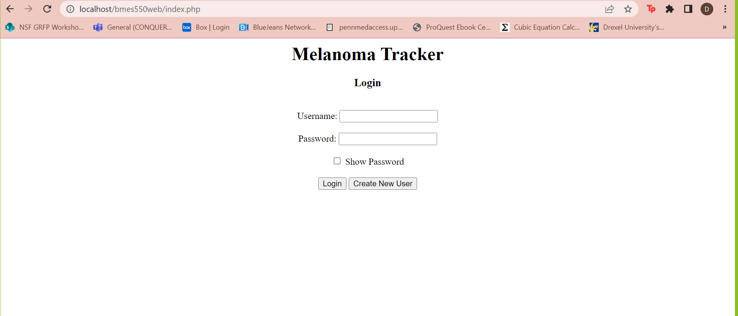

**Figure 3. A Blank Login**

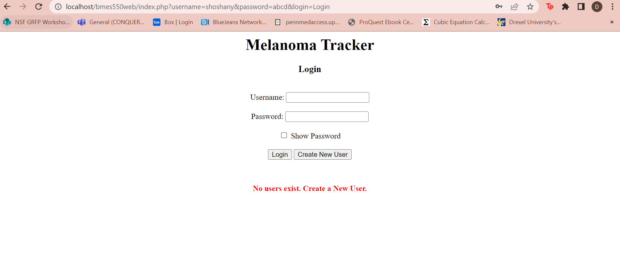

**Figure 4. An incorrect username or password was submitted**

The newuser_connection page asks the user for their first name, last name, username and password as inputs and adds them to the database. Once the user clicks the 'submit' button, the data is then stored into the database and the user is redirected to the 'test_submitting.php'.

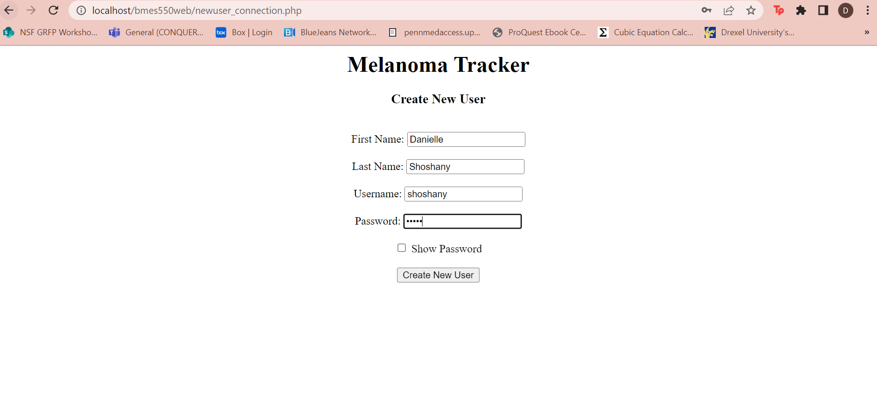

**Figure 5. The page to create a new user**

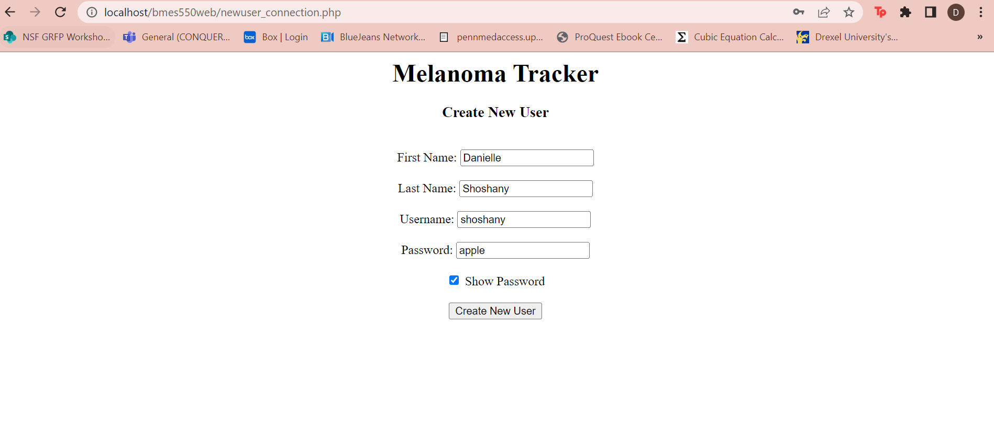

**Figure 6. The page to create a new user with the show password option**

The test_submitting.php (figures 7) asks the user for the date of the image, mole number, and for them to upload the mole image. Once submitted, this information is then sent to molesize.m where it is processed. Once the submit button is pressed, the user can either submit another image (figure 8) or choose to click the "view history' button to redirect to history.php where results can be viewed.

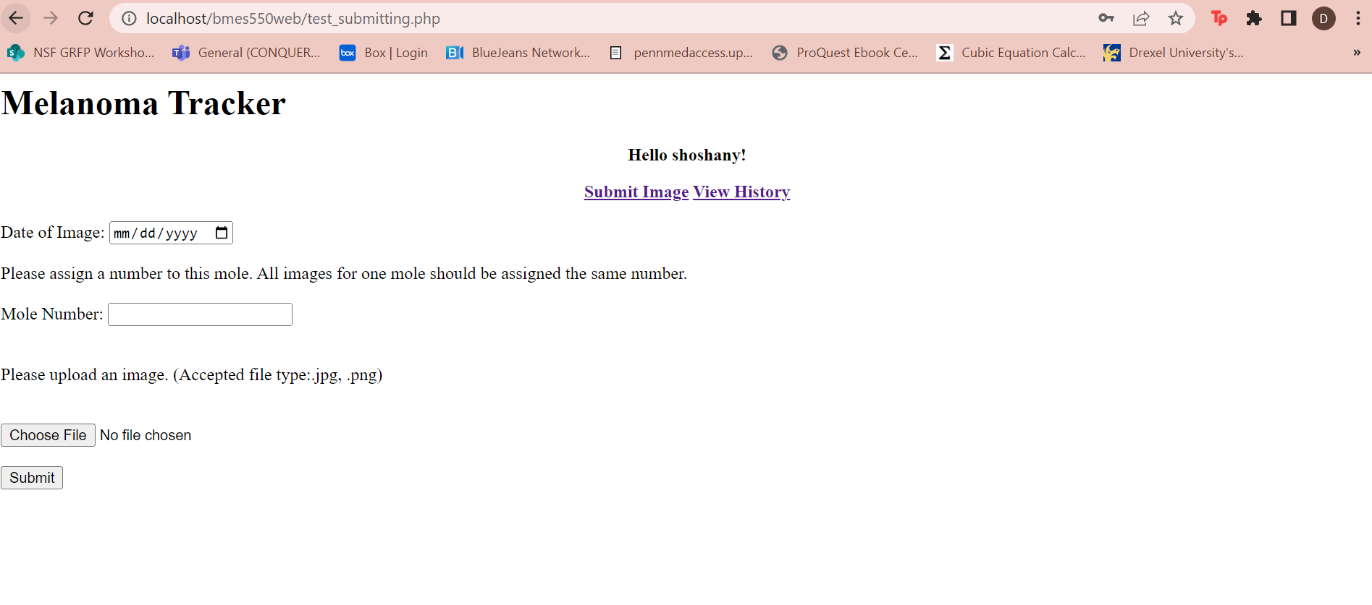

**Figure 7. The page to input the date, mole number and image**

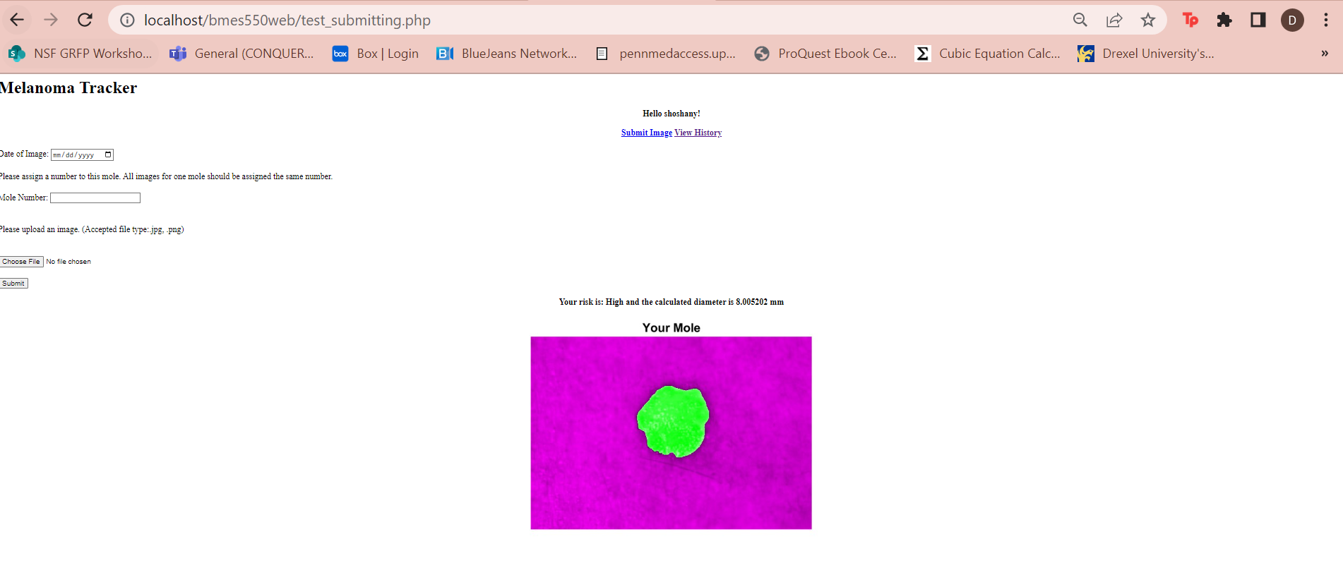

**Figure 8. Displays the processed image, risk and diameter of the mole as well as allowing the option to submit another image**

The history.php displays the analyzed image from molesize.m and the diameter. This page also includes a graph tracking the past diameter and risk of the same mole (figure 9). Other mole histories can be displayed on the plot using the hover-over drop-down menu.

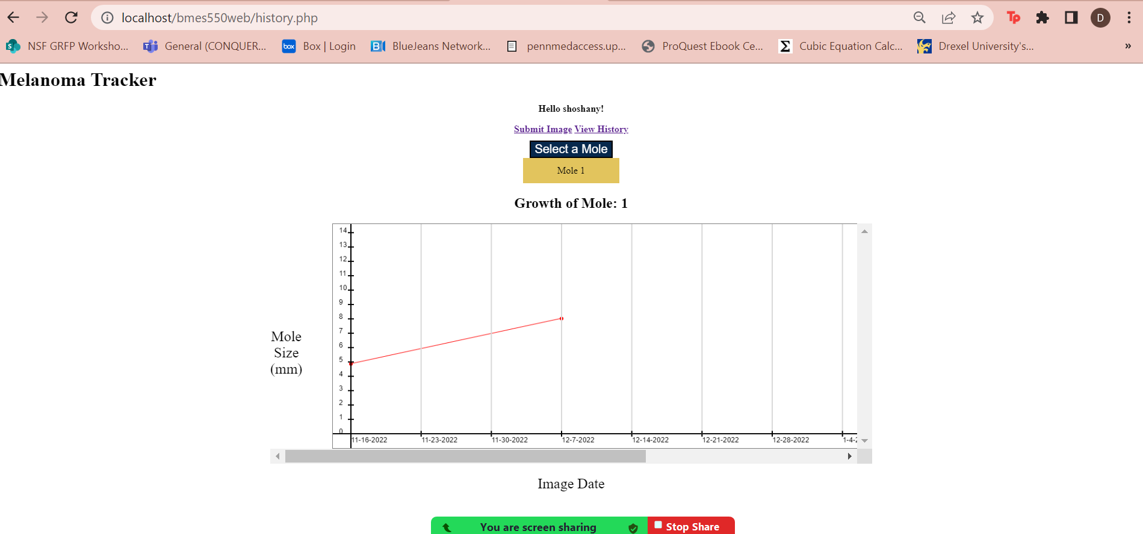

**Figure 9. Displays a summary plot of a given mole based on the submissions allowing a drop down to select which image to view**

The MelanomaData database (figure 10) has two tables that are linked via user ID. The 'userinfo' table stores the user information including 'User_ID' as an INTEGER and PRIMARY KEY, 'firstname' as a VARCHAR(255), 'lastname' as a VARCHAR(255), 'username' as a VARCHAR(255) and UNIQUE character so that two users cannot have the same username, and 'password' as a VARCHAR(255). The second table, 'moleinfo' stores the mole information including the 'id' as a PRIMARY KEY, 'User_ID' as an INTEGER, 'Img_Date' as a VARCHAR(255), 'Mole_Size' as a FLOAT(6), 'Risk' as a VARCHAR(255), and 'Mole_ID' as an INTEGER. This information is stored and accessed by the above listed .php pages.

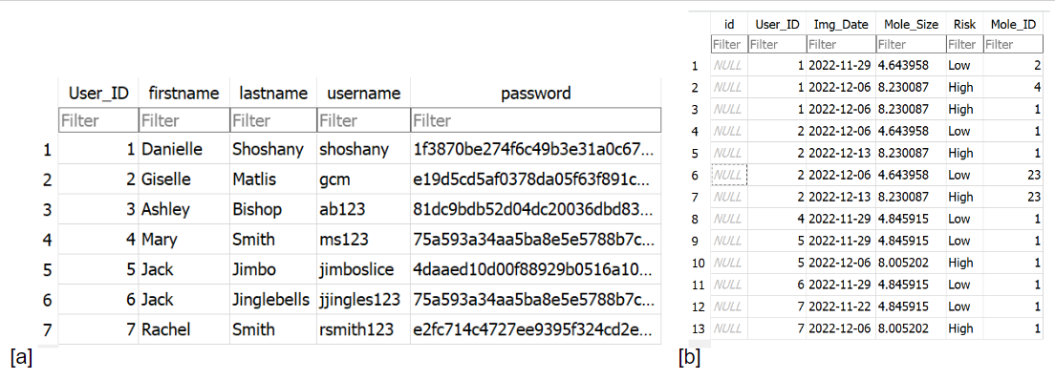

**Figure 10. Displays both tables in MelanomaDatabase.** a) userinfo table stores user information (i.e.,user ID, first name, last name, username, and encrypted password), b) moleinfo stores the user’s ID, date image was taken, the moles size in mm, the melanoma risk, and the mole ID.

**5** **DISCUSSION**

In conclusion, four web pages, a matlab code, and a database were successfully created and used to collect and analyze data from patients’ moles over an extended period. These codes took user inputs and shepherded them within the websites, through matlab analysis codes, into databases and successfully outputted the analyzed information back to the user in a user friendly and aesthetically pleasing environment. This web-based platform can be used to help patients and doctors track melanoma over time to help ensure quicker diagnosis and treatment of malignant moles which has been proven to increase the rates of successful melanoma treatment and remission.

**6** **REFERENCES**

1. S. E. E. R. NIH, “Melanoma of the skin - cancer stat facts,” *Cancer Stat Facts: Melanoma of the Skin*, 2022. [Online]. Available: https://seer.cancer.gov/statfacts/html/melan.html. [Accessed: 01-Dec-2022].

2. S. Carr, C. Smith, and J. Wernberg, “Epidemiology and risk factors of melanoma,” *Surgical Clinics of North America*, vol. 100, no. 1, pp. 1–12, Feb. 2020.

3. Cleveland Clinic, “Melanoma: Symptoms, stages, diagnosis, treatment & prevention,” *Melanoma*, 21-Jun-2021. [Online]. Available: https://my.clevelandclinic.org/health/diseases/14391-melanoma. [Accessed: 01-Dec-2022].

4. R. Hamidi, D. Peng, and M. Cockburn, “Efficacy of skin self-examination for the early detection of melanoma,” *International Journal of Dermatology*, vol. 49, no. 2, pp. 126–134, Jan. 2010.

5. National Cancer Institute, NIH , “Personalized risk of developing melanoma cancer,” *Melanoma Risk Assessment Tool*, 2022. [Online]. Available: https://mrisktool.cancer.gov/calculator.html. [Accessed: 05-Dec-2022].

6. Miiskin, “Miiskin is your personal skin check app,” *Miiskin App*, 10-Nov-2022. [Online]. Available: https://miiskin.com/app/. [Accessed: 05-Dec-2022].

7. Oregon Health & Science University, “Take control of your skin health - from the palm of your hand,” *molemapper.org*, 2017. [Online]. Available: https://molemapper.org/. [Accessed: 05-Dec-2022].

8. MetaOptima Technology Inc., “MoleScope™ | Skin Screening Made Simple,” *MoleScope by MetaOptima*, 2022. [Online]. Available: https://molescope.com/. [Accessed: 06-Dec-2022].

9. SkinVision, “Skin cancer melanoma detection app,” *SkinVision*, 24-Aug-2022. [Online]. Available: https://www.skinvision.com/. [Accessed: 05-Dec-2022].

10. University of Michigan Health , “Skin Cancer Self-Exam Mobile App,” *UMSkinCheck | Michigan Medicine*, 2022. [Online]. Available: https://www.uofmhealth.org/patient%20and%20visitor%20guide/my-skin-check-app. [Accessed: 05-Dec-2022].

11. Willamette Valley Cancer Institute and Research Center , “5 apps that help detect skin changes that may lead to skin cancer,” *WVCI - Cancer Centers in Eugene, Corvallis, Florence, Oregon*, 2022. [Online]. Available: https://www.oregoncancer.com/blog/apps-to-help-detect-skin-cancer. [Accessed: 05-Dec-2022].

12. Skin Cancer Foundation, “Melanoma warning signs and images,” *The Skin Cancer Foundation*, 14-Sep-2022. [Online]. Available: https://www.skincancer.org/skin-cancer-information/melanoma/melanoma-warning-signs-and-images/. [Accessed: 07-Dec-2022].

13. N. I. H. National Cancer Institute, “Common moles, dysplastic nevi, and risk of melanoma,” *National Cancer Institute*, 17-Nov-2022. [Online]. Available: https://www.cancer.gov/types/skin/moles-fact-sheet#:~:text=There%20is%20a%20change%20in,past%20few%20weeks%20or%20months. [Accessed: 01-Dec-2022].

14. Skin Cancer Foundation, “Atypical moles,” *The Skin Cancer Foundation*, 16-Feb-2022. [Online]. Available: https://www.skincancer.org/risk-factors/atypical-moles/#:~:text=People%20with%20atypical%20mole%20syndrome,One%20or%20more%20atypical%20moles. [Accessed: 01-Dec-2022].

15. J. Kelly, A. Chamberlain, M. Staples, and B. Mcavoy, “Table 3 from nodular melanoma. no longer as simple as abc.: Semantic scholar,” *Semantic Scholar*, 01-Jan-1970. [Online]. Available: https://www.semanticscholar.org/paper/Nodular-melanoma.-No-longer-as-simple-as-ABC.-Kelly-Chamberlain/3a190e6b6f7c84ce8b71b4194393e47bacb0ef86/figure/2. [Accessed: 07-Dec-2022].