|  |
| --- |
| **Monkeypox Risk Calculator**  Madison White1 , Dimitri Kounis1 , Joshua Yang1  1 *School of Biomedical Engineering, Drexel University, USA*  Course: BMES 550  Instructor: Ahmet Sacan  Date: 2022-Dec-04 |

# **Abstract**

We developed a Monkeypox Risk Calculator (MRC) that will calculate the risk of a person’s demographic. Specific parameters include the user’s age, ethnicity, gender, vaccination status, and region they live in. Data from the Center of Disease Control and Prevention (CDC) was imported to create a SQL database which had the number of cases based on demographic parameters such as ethnicity and vaccination status. The MRC was created through MATLAB’s AppDesigner. The MRC will display a user’s risk as well as summary plots. Once a parameter is chosen by the user, all the cases are shown binned by that parameter (i.e. age ranges, cases per state). The percent of cases that match their demographic, for example, all male cases, will be shown to them next to the summary plots.

# **1) Introduction**

Monkeypox (MPX) is a viral zoonosis - which is a virus that is transmitted from an animal to a human. The principal mode of infection is through close contact during sexual activity - and there has been a small number of infections that have been due to injuries with a sharp instrument (tattoing, piecing). Monkeypox cases are increasing worldwide and has been declared a national health emergency. Worldwide, there are more than 25,000 confirmed cases and the World Health Organization has activated its highest level of alert for the outbreak. Furthermore, the United States has reported the highest number of cases. The first case of MPX outbreak outside of Africa was linked to mammal importation which carried the virus in 2003. However, in 2022, for the first time, multiple cases of Monkeypox were identified in EU/EEA countries and non-endemic countries. [1]

Furthermore, there is a need to develop a convenient and easy-to-use application that can calculate the risk of catching monkeypox in order to raise awareness of the spread of the disease as well as identify if a user is at risk of the disease.

Monkeypox can spread to anyone through close, personal, and skin-to-skin contact. Treatment to MPX is mainly symptomatic and supportive, however, health professionals emphasized that a benefit, or risk assessment, should be performed for exposed individuals. Factors such as ethnicity, age, gender, vaccination status, and residency have MPX cases associated with them in the CDC databases, linking to a higher risk of contracting this virus. Not much is known about the biological effects of MPX due to its more recent prevalence, but it is known to be a highly transmissible virus [1].

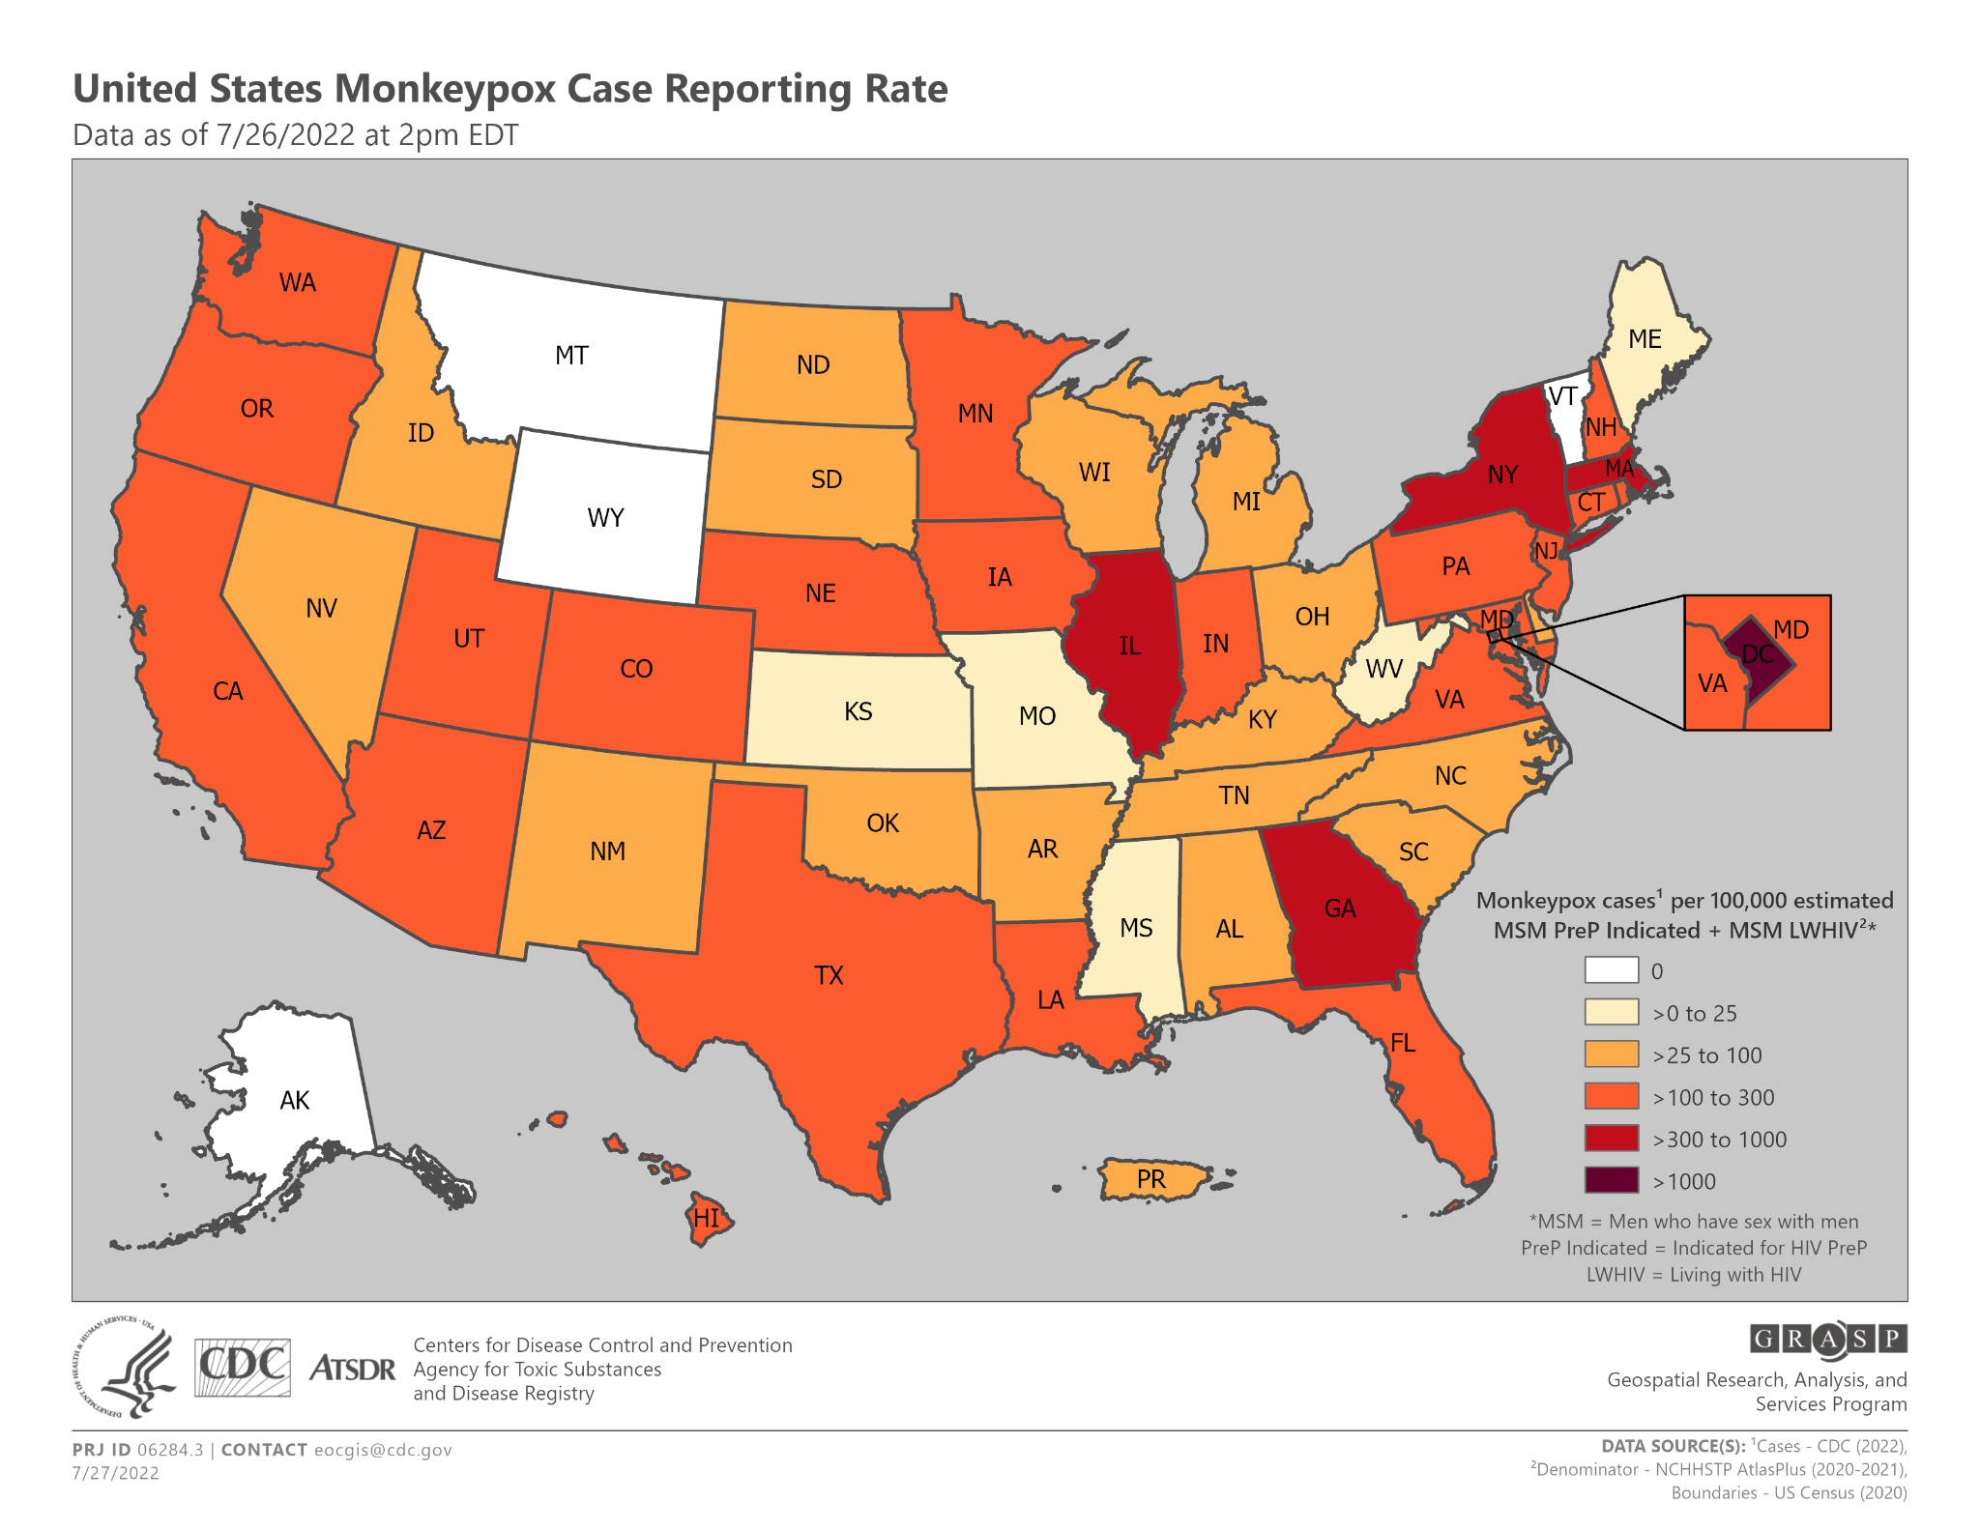 Figure 1 -Monkeypox case incidence from CDC as of 7/26/2022 [4]

The Monkeypox Risk Calculator (MRC) was developed with the goal of assessing the risk of an individual based on their gender, age, ethnicity, vaccination status, and state of residency. The target users are the general public based in the United States, since calculated risks are mainly based on data of cases in the United States. Since not much of the US population is aware of their individual risk, this risk calculator aims to help inform user decisions based on their baseline risk.

If successful, our application would be helpful in giving a preliminary, and general, risk calculation to residents of the United States. We hope to use the MRC to bring attention to those who are at higher risk of being infected to monitor their health or monitor for signs and symptoms. Additionally, the MRC could influence our understanding of the risk assessment of MPX by creating a foundation of what parameters affect the risk of an individual the most.

Currently there is only an exposure risk calculator meant for healthcare works through the Colorado Department of Public Health and Environment [3]. The survey asks questions regarding exposure to aerosols and possibly infected patients to inform whether the healthcare worker should stay at home in quarantine for 2 to 4 weeks after a known possible exposure [3]. There are currently no approved risk evaluations for the general public with questions related to day to day activities, which is what our risk calculator aims to be.

**2) Dataset**

The dataset created is composed of data generated from the CDC website about cases of Monkeypox. The data collected here is less of experimental nature and more of positive case tracking. They have various information regarding the number of positive cases based on certain parameters, such as age, region, race, etc. This data, downloaded in the form of Excel sheets, are then processed into a database regarding each parameter. The data is collected on a report basis. When a positive case is detected in a lab, hospital, doctor’s office, or other setting it is required to then report the infection and testing for tracking. The data does not come directly from each setting to the CDC but from each state’s health department, which in turn receives it from settings under their jurisdiction.

The database itself is composed of multiple tables, each being a parameter for the risk calculator. This includes a patient’s age and gender, ethnicity, region/state, and vaccination status. Each table has an id component.

First, the age table is composed of age groups split per 5 years with the exception of the first group being 0-5 (including 0 makes six years) and the last group which is 76+. The ages are then split by gender, being male, female, transgender man, trangender women and other. There is a total for both each age group and each gender.

After that, the ethnicity table is split into races and percentages of positive cases. This includes Native Americans, Asian, African American, Hispanic, Hawaii, White, Multiple, and Other. A total is calculated at the bottom, which should be close to 100%.

Next, the region table is composed of state/region, case number, and case range. The states/regions contain all the US states, a territory ( Puerto Rico), DC, and Non US Residents. A total of the cases are calculated at the bottom. Case ranges are split into less than 1-10, between 11-50, between 51-100, between 101-500, and over 500.

Finally, the last table is the vaccination status table. This has the number of cases per vaccination status, vaccinated or unvaccinated. The total is calculated at the bottom.

# **3) Methods and Implementation**

The user input and summary tables & plots GUIs were developed using MATLAB’s AppDesigner. MATLAB 2022 was the primary software used in order to create an SQLite database with MPX data from CDC databases. The two MATLAB GUIs were run through one file, the user input GUI, and both called upon the data in the SQLite database to perform risk calculations and display the overall summary data. The flow of how the .mlapp files connect to each other and to the database is shown in Figure 2. All of these were completed using computers on Windows 10 or 11.

The database comprised of tables based on different parameters (age, gender, etc) which showed the number of cases reported within certain ranges (10-15 year olds). In order to calculate a risk value, a percentage was calculated for each parameter given the user’s input as:

% Risk = (# of cases for a specific demographic) / (total # of cases).

In order to calculate the overall risk value for a user, the average percentage was calculated. For example, if an Asian Woman from New York aged 25 years old used the MRC, the average percentage was calculated based on the percentage of MPX cases for women, Asian population, 25 year olds, and New York cases.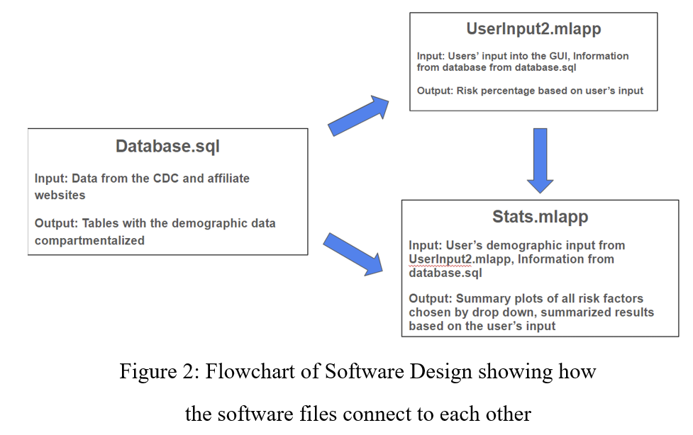

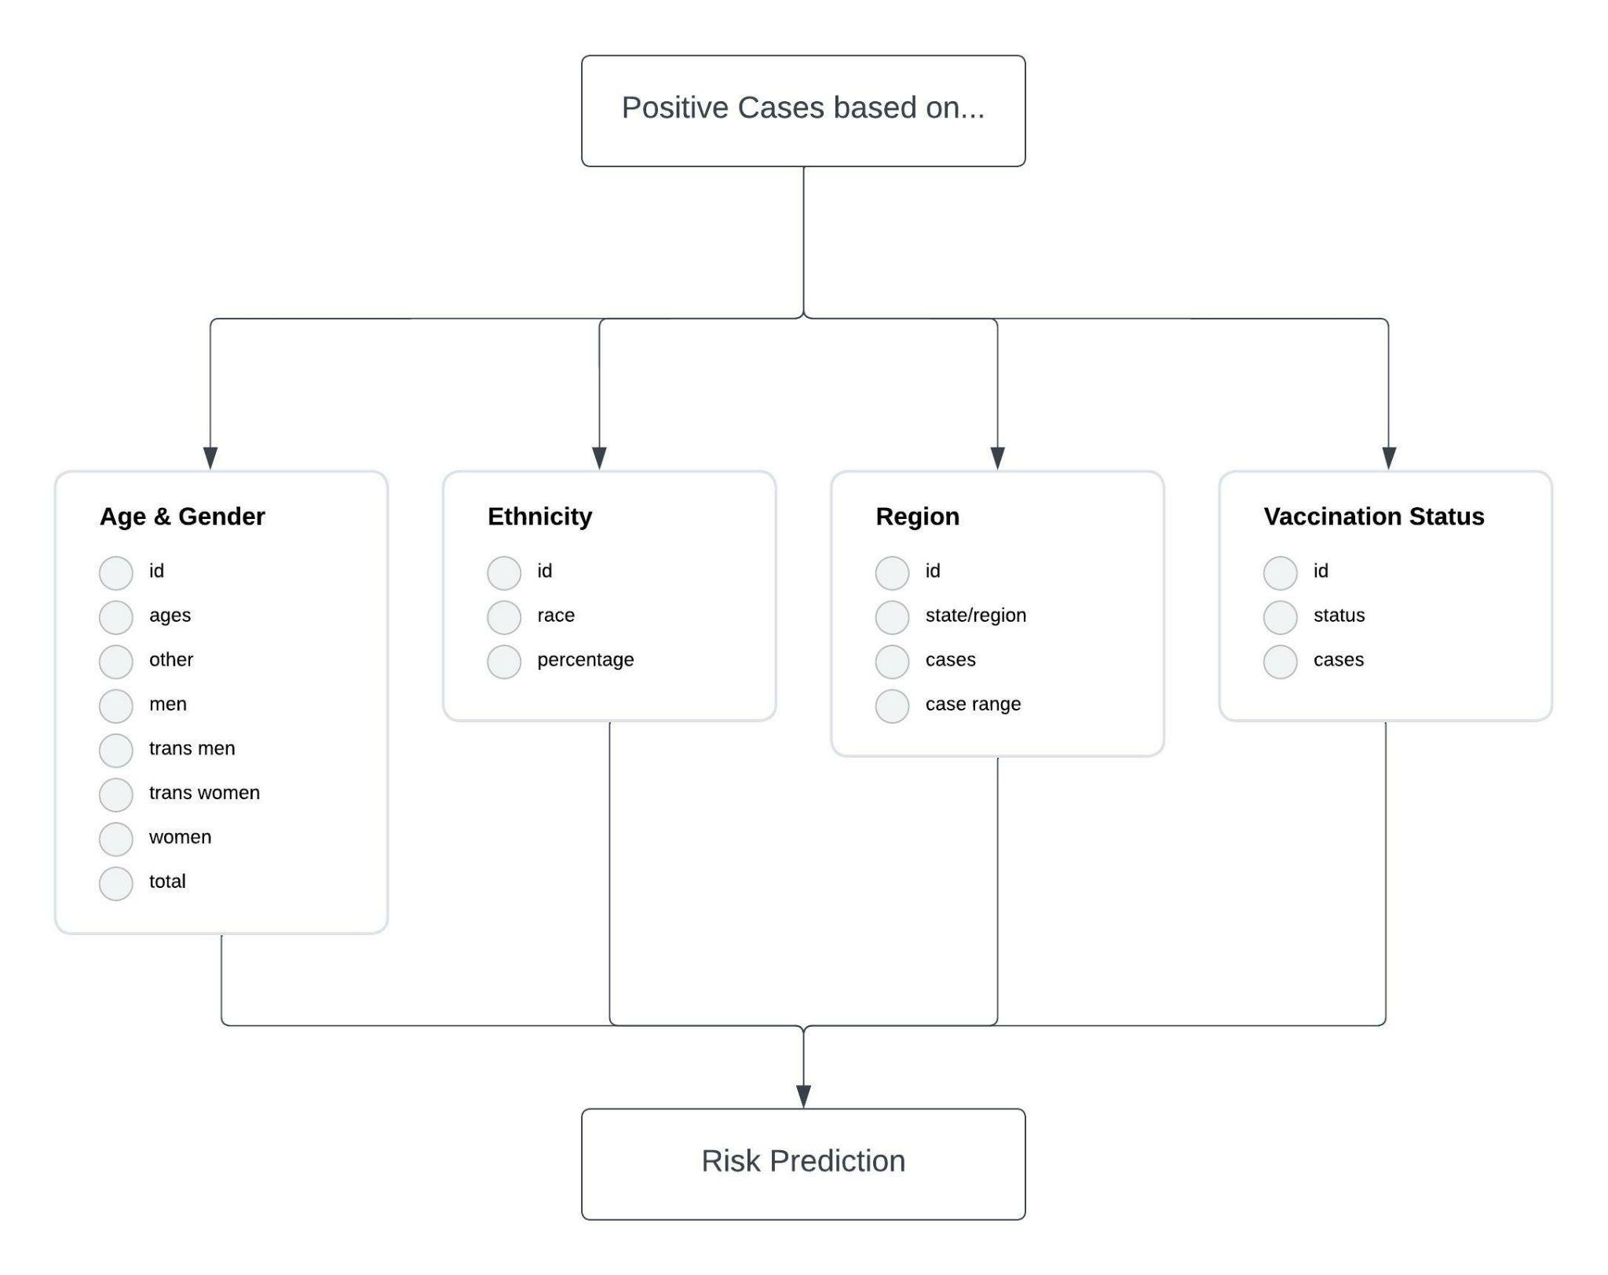

Figure 3: ER Diagram based on SQL Database. Case numbers are split into age and gender, ethnicity, region, and vaccination status. These parameters are used to calculate the Risk Prediction Percentage.

# **4) Experiments and Results**

To give an idea of how the final software works, we will use the following scenario. A 33 year old transgender man is looking to see what his risk of Monkeypox is, and decides to input his demographics into our Monkeypox Risk Calculator. When he opens the risk calculator he will see what is shown in Figure 4. He will input the remainder of his demographics, that he is white, vaccinated, and from Oregon. He will then hit the submit button and his risk will appear below the inputs. The final look of this GUI is shown in Figure 5.

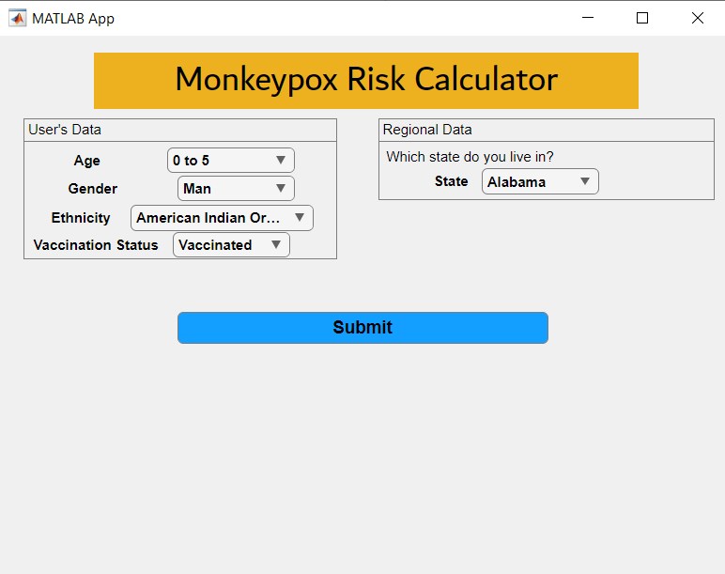

Figure 4: MRC User Input before any changes have been made by the users

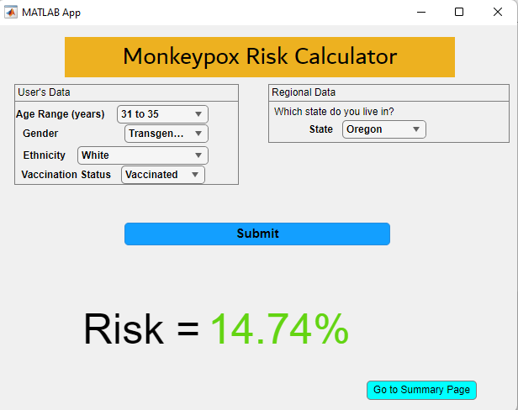

Figure 5: MRC User Input GUI after inputs are submitted

Once he has seen his final risk, he is curious about the overall stats of the population and what about his demographics causes his risk to be at this level. So he hits the summary page button which takes him to the GUI shown in Figure 6. Looking at his percentages, he decided to look at the breakdown of the ethnicity statistics, which GUI is shown in Figure 7.

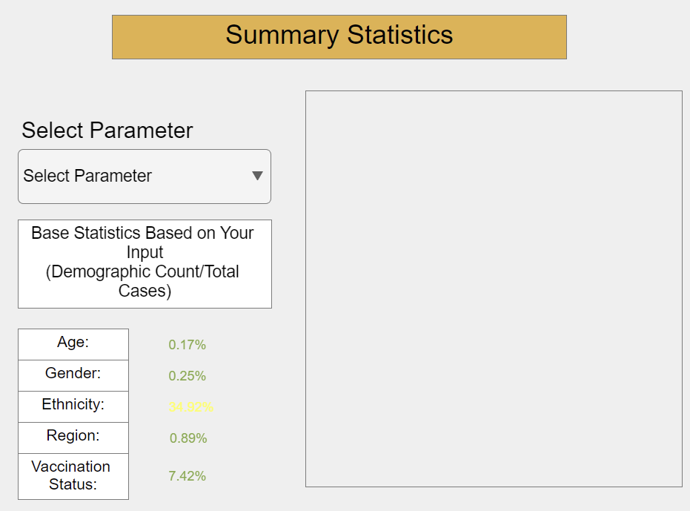

Figure 6: Summary Statistics GUI before a parameter is chosen

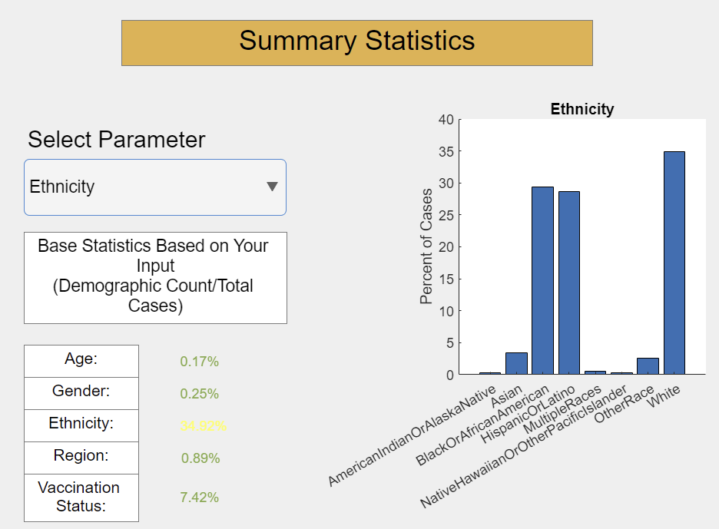

Figure 7: Summary Statistics GUI after the “Ethnicity” parameter is chosen. A bar graph showing percent of cases is then displayed after parameter is chosen

Overall the user input GUI will ask for the user’s age (select from age ranges), gender, ethnicity, vaccination status, and where they live. This is then used to calculate the risk. Their input is also used to find the individual breakdown of their risks. Once the user has gone to the summary page, they were able to choose the parameter they wanted to see the US population’s relative risk given certain parameters.

The Colorado Department of Public Health & Environment would display a message telling the user if they are exposed or not, as opposed to a quantitative value which is displayed when the MRC is used.

**5 ) Discussion**

The application demonstrates an easy-to-use application that anyone, including non-healthcare workers - could use to get quantitative risk values. Additionally, the user can see summary statistic figures of their choice (ex. Percent of MPX cases based on ethnicity). Moreover, this GUI is meant to give a sense of risk to the user. The MPC is meant for a general audience rather than specifically for healthcare workers.

The MPC uses very general parameters in order to calculate risk, which is a limitation. Risk calculations were based on existing databases from the CDC - therefore, more accurate risk calculation could be made with updated databases. Another limitation of our application would be the risk calculations. The MPC could benefit from using machine learning in order to predict risk, however, we do not have enough experience with machine learning to implement those concepts into our calculator. A possible follow up study would be to identify the most accurate machine learning model that can calculate and predict how at-risk an individual is. The MPC could be extended, and improved, by taking into account countries outside the United States - since the databases were based primarily on cases in the United States. A more rigid risk calculation would also benefit the application and give more accurate risk calculations to users.

Future work for this project could incorporate negative cases into the database for each parameter, if found and available to act as a control and have a more accurate risk percentage. Another way this project could be extended is the addition of new parameters. One example could be sexuality, as this disease has heavily affected the LGBT male communities around the world. This would need to be done through a survey or study done through the CDC to get a sense of the actual risk here. This can be slightly ascertained from the much higher percentage of the cases being cis-males.

# **6 References**

[1] *Factsheet for Health Professionals on mpox (monkeypox)*. European Centre for Disease Prevention and Control. (2022, December 7). Retrieved December 7, 2022, from https://www.ecdc.europa.eu/en/all-topics-z/monkeypox/factsheet-health-professionals

[2] Centers for Disease Control and Prevention. (2022, July 28). *Technical report 1: Multi-national MPOX outbreak, United States, 2022*. Centers for Disease Control and Prevention. Retrieved December 7, 2022, from https://www.cdc.gov/poxvirus/monkeypox/cases-data/technical-report/report-1.html

[3] *MPOX exposure risk calculator*. Department of Public Health & Environment. (n.d.). Retrieved December 7, 2022, from https://cdphe.colorado.gov/mpox/calc/exposure-risk-calculator

[4] Centers for Disease Control and Prevention. (2022, July 28). *Technical report 1: Multi-national MPOX outbreak, United States, 2022*. Centers for Disease Control and Prevention. Retrieved December 7, 2022, from https://www.cdc.gov/poxvirus/monkeypox/cases-data/technical-report/report-1.html