| **Dietary Tracker Using Food and Nutrient Database for Dietary Studies (FNDDS)**  Nicholas Fioravanti1, Michael Mathews1 , Dimitrios Dogias1  1 School of Biomedical Engineering, Drexel University, USA  Course: Bmes 550 - Advanced Biocomputational Languages  Instructor: Ahmet Sacan  Date: 2022-12-07 |
| --- |

**abstract**

Tracking and quantifying individuals’ dietary consumption over time can be critical for actively maintaining/achieving a healthy lifestyle. Monitoring parameters like caloric, carbohydrate, vitamin, and fat intake throughout one’s everyday life can inform them of necessary dietary changes, exercise regimens, weight loss, supplements, et cetera to employ to live a healthy life. However, the time-consuming burden of reading labels and doing math for every meal consumed can discourage individuals from tracking nutritional information manually. This study, therefore, aims to create a user-friendly graphical user interface (GUI) in MATLAB that allows users to input the meals they consume over a certain period, and automatically generate different nutritional information about those meals like consumed calories over time and body-mass index (BMI) by accessing data from the USDA’s Food and Nutrient Database for Dietary Studies (FNDDS) databases and requesting user height and weight to provide users a more active way to take control of their health.

# **introduction**

1.1 Problem:

In recent years, studies have shown that there is an increasing prevalence of obesity, reaching up to 41.9% thus showing an 11.4% increase in prevalence since 2000 [2]. Individuals often attribute the prevalence of obesity to socioeconomic status; however, the root cause of the issue is that dietary habits have become detrimental to the health of individuals. As a result, there is a need to motivate the tracking of dietary impact on health in hopes of providing constructive knowledge to refine caloric and nutritional intake. Various dietary plans that reduce caloric intake have shown to have benefits such as minimized risk of heart disease and factors such as obesity [3]. Studies have shown that diets are only being utilized by 17.1% of adults over 20 years old, suggesting that there is a need to improve awareness of the benefits of dieting and accessibility to dieting [4]. By incorporating data into one’s daily life, an individual could receive active feedback to manage their diet differently and be provided with encouragement to hit goals that will reduce the likelihood of obesity.

1.2 Physiological Connection and Quantification:

The underlying effects of obesity can be seen throughout several diseases as it is a significant, confounding risk factor. A few examples suggest that obesity can impact the health of one’s heart, reproductive system, and respiratory efficiency [5]. Often these impacts are caused by mechanisms such as increased weight-bearing, nutritional impact on metabolic efficiency, and hormonal control. The measurement of obesity can be evaluated based on the quantitative scale of Body Mass Index (BMI), such that a 25 < BMI < 29.9 is considered overweight, and a BMI => 30 is obese [6].

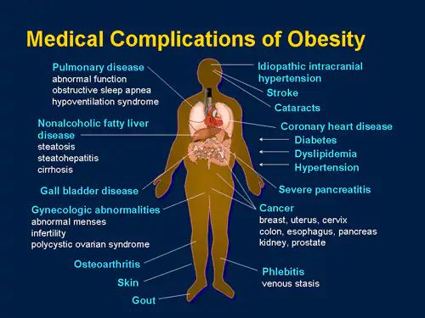

**Figure 1. Complications of Obesity.** This figure shows some of the medical impacts of obesity on health [7].

1.3 Goals:

1) Develop a graphical user interface (GUI) that will allow for tracking of specific food consumption to reduce time-consuming burden on dieting and tracking.

2) Use food descriptions to monitor caloric intake and have access to other key nutrients.

3) Users that would most benefit from this tool would be people trying to lose weight, patients (e.g., transplant recipients) with clinically restricted diets due to nutrient imbalances or potential negative interactions, and individuals that would like to maintain a healthy lifestyle by accounting for their caloric intake.

4) The application will allow for users to determine what foods are contributing to changes in their BMI as well as affecting their overall caloric intake. Based on real-time visual feedback, the end-users will be able to determine how they should plan their meals to optimize their BMI and recognize potential issues with certain consumption to alert them as to when they need to get in contact with a clinician.

1.4 Making Clinical Impact from Previous Research:

Prior work has investigated weight loss with respect to particular dietary methods [6]. These methods can include reductions in fat and carbohydrates; however, the study found no statistical difference in weight loss across dietary restrictions and no relationship between a particular dietary method and reduction in obesity. As a result, there is a significant need to emphasize the case-by-case system of dietary tracking where individuals track their specific dietary patterns and uniquely adjust instead of having individuals adhere to a generalized model that may work well for some while failing for others.

# **Dataset**

Both food and beverage and FNDDS nutrient data were obtained from the U.S. Department of Agriculture and the Department of Health and Human Services based on the National Health and Nutrition Examination Survey [6]. This survey was part of the “What We Eat in America” initiative. This initiative incorporated two national surveys that were both executed in an interview format to determine the foods eaten in a day as well as the respective nutrients and portions.

# **methods and Implementation**

* 1. Software

The project required the implementation of two software programs.

The first application was SQLite, which is a library with a database engine allowing for data storage, manipulation, and querying.

The second application was MATLAB, which is both a programming language and simulation environment. MATLAB was used to manipulate data and generate GUIs for user interactivity.

* 1. Workflow

The user is first prompted to run the DB_initialization.m script, which will download the necessary data files from FNDDS and create a SQLite database. It will then initialize the DataEntry.mlapp application where data entry will be possible. There are edit fields for the Date (mm/dd/yyyy), Food Name, and Portion (g) with a button that adds this information to its respective column in a new row in a table. Additionally, there are numeric edit fields for the user to input Height (ft) and Weight (lb). Lastly, there is a Submit button that calls the DataAnalysis.mlapp GUI application with the user inputted data. DataAnalysis.mlapp will calculate the user’s BMI according to the previous inputs and graph the user’s caloric intake vs time.

* 1. Entity Relationship Diagram:

Due to the data intensive extraction and analysis, the connections made between tables is elaborated in Figure 2, showing the entity relationship diagram between the food and beverages table as well as the FNDDS nutrient values. This table is a condensed version of the overall SQLite database, which also incorporates various nutrients such as fats, alcohols, etc.; however, the energy in kilocalories was the specific quantity that is anticipated to have the largest effect over time relative to the food description and BMI calculation, thus it is the highlight of this application.

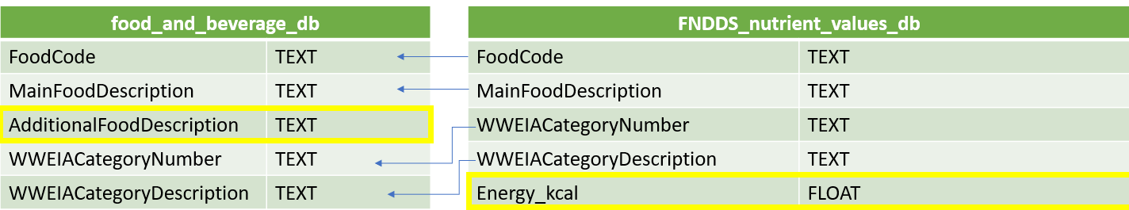**Figure 2. Entity Relationship Diagram.** This figure shows the entity relationship diagram between the data tables in SQLite. These connections show the overlap in parameters between the food and beverage database table as well as the FNDDS nutrient value database table. The food code from the food and beverage database is used to connect with the FNDDS nutrient values database table to find related energy values in kilocalories.

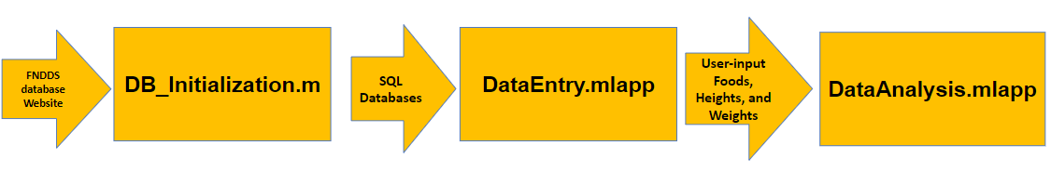

**Figure 3. Design Flow Chart.** This figure provides an overview of the design workflow starting from generating SQL databases from the FNDDS data to creating SQL queries to creating the DataEntry and DataAnalysis GUIs.

# **Experiments and Results**

Since this programming application has particularly been developed for consistent use and variability, the inputs of the DataEntry.mlapp may vary. Figure 4 shows an example of Data Entry in the initial GUI with various types of milk, portions, and dates while Figure 5 shows the Data Analysis GUI, which visualizes the consumption of kilocalories based on user-inputted food descriptions and displays the calculated BMI based on the user’s height in feet and weight in pounds as inputs.

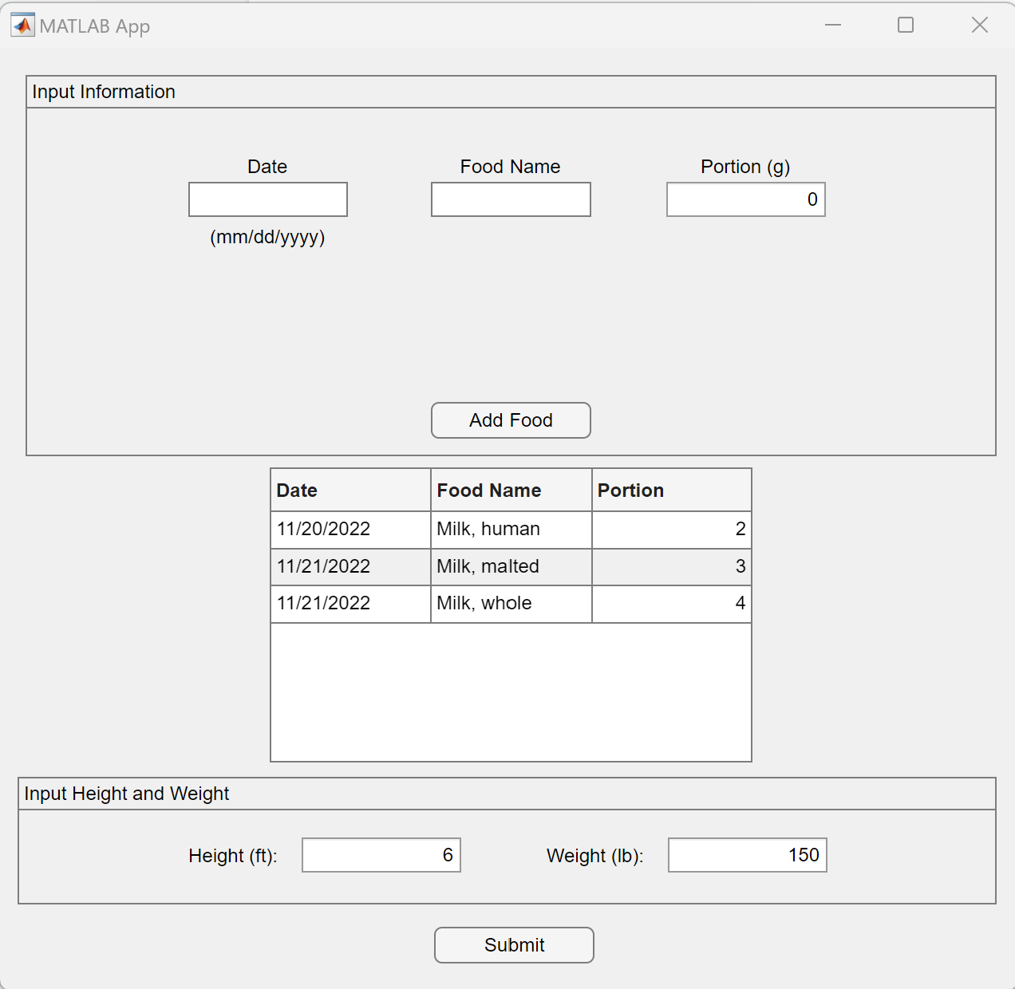

**Figure 4. DataEntry GUI.** This figure shows an example of the DataEntry GUI that provides input fields for the user to enter the meals consumed, date consumed, portion (in grams) and height/weight, along with the entered meals in a growing table.

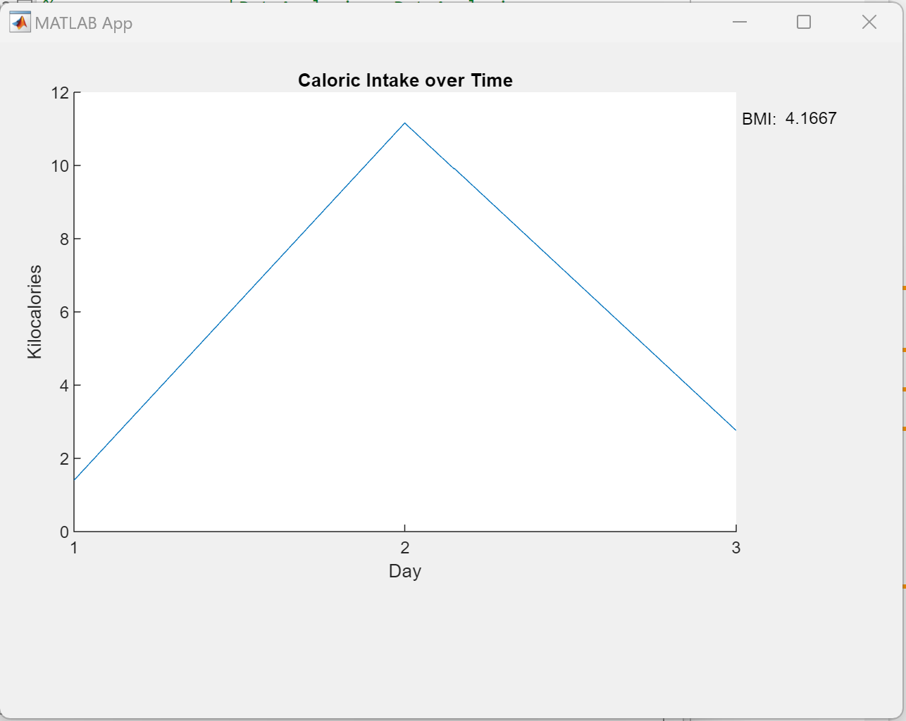

**Figure 5. DataAnalysis GUI.** This figure shows an example of the DataAnalysis GUI that displays the user’s consumed calories over time and a calculation of BMI from the user’s inputted meals and height/weight, respectively from the DataEntry GUI.

Additional trackers are available on the market, with MyFitnessPal being rated as one of the best tracking apps. MyFitnessPal is a dietary tracker that similarly enables the logging of specific food from a database of descriptions; however the breakdown of nutrients is restricted behind a premium price [8]. While the nutritional breakdown is not currently included in the iteration of this graphical user interface, the FNDDS databases have more than enough information on nutrients such as alcohol, fat, carbohydrates, and more.

# **DISCUSSION**

Based on the clinical need to reduce the prevalence of obesity, the current system of database initialization and the functionalities of both GUIs for data entry and analysis should be sufficient for accurately tracking one’s caloric intake and BMI. The data used alongside this graphical interface is based on surveyed populations and thus literature on caloric intake for a particular food name and portion size is not widely available, but the system does appear to be operational and functions as intended. While the system is functional in this representation, additional investigations of the usability of the GUIs should be performed. The system should be evaluated with a randomized population of individuals against a popular system such as MyFitnessPal to determine the benefit of one tracking system over another. This would help to determine the usability and accessibility of the programming system, dictating whether an individual would continue to use the software.

Furthermore, there are a number of key limitations and findings that could be improved in future iterations. The largest limitation is the available space within the GUIs. The databases from the FNDDS provided extensive information on nutritional breakdowns of specific foods, and these values could be visualized to determine the viability of one’s diet based on their condition-specific restrictions, such as in the case of transplant recipients. In addition, the BMI of the user could be visualized over time with conditional statements to alert the user if they are overweight or obese based on the BMI thresholds.

# **References**

1. U.S. Department of Agriculture. (2022, October 21). *Food and Nutrient Database for Dietary Studies*. Agricultural Research Service. Retrieved December1,2022,from https://www.ars.usda.gov/northeast-area/beltsville-md-bhnrc/beltsville-human-nutrition-research-center/food-surveys-research-group/docs/fndds/

2. Centers for Disease Control and Prevention. (2022, May 17). *Adult obesity facts*. Centers for Disease Control and Prevention. Retrieved December 7, 2022, from https://www.cdc.gov/obesity/data/adult.html

3. Kraus, W. E., Bhapkar, M., Huffman, K. M., Pieper, C. F., Krupa Das, S., Redman, L. M., Villareal, D. T., Rochon, J., Roberts, S. B., Ravussin, E., Holloszy, J. O., Fontana, L., & CALERIE Investigators (2019). 2 years of calorie restriction and cardiometabolic risk (CALERIE): exploratory outcomes of a multicentre, phase 2, randomised controlled trial. *The lancet. Diabetes & endocrinology*, *7*(9), 673–683. https://doi.org/10.1016/S2213-8587(19)30151-2

4. Centers for Disease Control and Prevention. (2020, November 3). *Special Diets Among Adults: United States, 2015–2018*. Centers for Disease Control and Prevention. Retrieved December 7, 2022, from https://www.cdc.gov/nchs/products/databriefs/db389.htm#:~:text=Key%20findings,-Data%20from%20the&text=In%202015%E2%80%932018%2C%2017.1%25,than%20adults%20aged%2020%E2%80%9339

5. *Health risks*. Obesity Prevention Source. (2016, April 13). Retrieved December 7, 2022, from https://www.hsph.harvard.edu/obesity-prevention-source/obesity-consequences/health-effects/#:~:text=Obesity%20increases%20the%20risk%20of,changes%20in%20hormones%20and%20metabolism

6. U.S. Department of Health and Human Services. (2018, February 27). *Biological factors and weight loss methods*. National Institutes of Health. Retrieved December 7, 2022, from https://www.nih.gov/news-events/nih-research-matters/biological-factors-weight-loss-methods

7. Buse, J. (2009, August 7). *The science of obesity across time and ages*. Medscape. Retrieved December 7, 2022, from https://www.medscape.org/viewarticle/706177_transcript

8. Link, M. R. S. (2022, October 14). *A Dietitian’s Picks of the 10 Best Nutrition Apps to Download*. Healthline. https://www.healthline.com/nutrition/top-iphone-android-apps