Some problems are from the book Dynamical Systems with Matlab.

1. Evaluate the following limits if they exist:
$\lim_{x→0 }{\frac{\sin{x}}{x}}$

$\lim_{x→∞ }{\frac{x^{3}+3x^{2}-5}{2x^{3}-6x}}$

$\lim_{x→0^{+} }{\frac{1}{x}}$

2. Find the derivatives of the following functions:
$y=3x^{3}+7x^{2}-6$

$y=\sqrt{1+x^{4}}$

$y=x^{\ln{x}}$

3. Evaluate the following definite integrals:
$\int_{x=0}^{1}{3x^{3}+2x^{2}-8 dx}$

$\int_{x=0}^{1}{\frac{1}{\sqrt{x}} dx}$

$\int_{x=0}^{1}{e^{-x^{2}} dx}$

4. Graph the following:
   1. $y=e^{-x^{2}}$ for $-5≤x≤5$
 $x^{2}-7xy-y^{2}=2$

 $x=t^{2}-3t, y=t^{3}-9t$ 2. for $-4≤t≤4$
5. Show the following differential equations:
   1. $\frac{dy}{dx}=\frac{x}{2y}$ given that y(1)=1. Plot y for $0≤x≤10$
   2. $\frac{dy}{dx}=\frac{-y}{x}$ given that y(2)=3. Plot y for $0≤x≤1$ 0
   3. $\frac{d^{2}x}{dt^{2}}+5\frac{dx}{dt}+6x=0$ given that x(0)=1 and $\dot{x}(0)=0$ Plot x for $0≤t≤1$ 0
6. [Courtesy of Ken Barbee] A cell has a total receptor concentration, RT. When a ligand, with concentration L, is added, irreversible receptor-ligand bonds are formed according to the following reaction scheme:

, where R, L, and B are the concentrations of free (unbound) receptors, free ligands, and bound receptors on the surface of the cell, respectively. Bound receptors are also internalized (removed from the surface) at a rate proportional (internalization rate constant, kint) to the surface concentration of bound receptors.

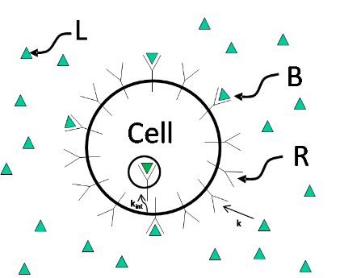

1. Write the differential equation for the surface concentration of free and bound receptors in terms of the B, L, R, k and kint.
2. In many cases, ligand is present in concentrations much greater than the receptor concentration such that the concentration of ligand may be treated as a constant. Assuming a constant ligand concentration, L, solve for the bond concentration as a function of time with the initial condition that there are no bonds (B(0) = 0) and the initial surface receptor concentration is R0. Sketch a graph of the solution (B vs. time; use your own example values for the constants). You need to come up with your own values for the constants; these values have to be realistic (e.g., using 0 or negative concentrations would not be appropriate).