PHASE 4: DEVELOPMENT PART 2

PROJECT TITLE: ASSESSMENT OF MARGINAL WORKERS IN TAMILNADU-A SOCIO ECONOMIC ANALYSIS

DEVELOPMENT PART 2: DEMOGRAPHIC ANALYSIS AND CREATING VISUALIZATIONS USINGS IBM COGNOS

OBJECTIVES:

* Perform demographic analysis on the marginal workers dataset.
* Create visualizations using data visualization libraries (e.g., Matplotlib, Seaborn) to show the distribution of marginal workers based on age, industrial category, and sex.

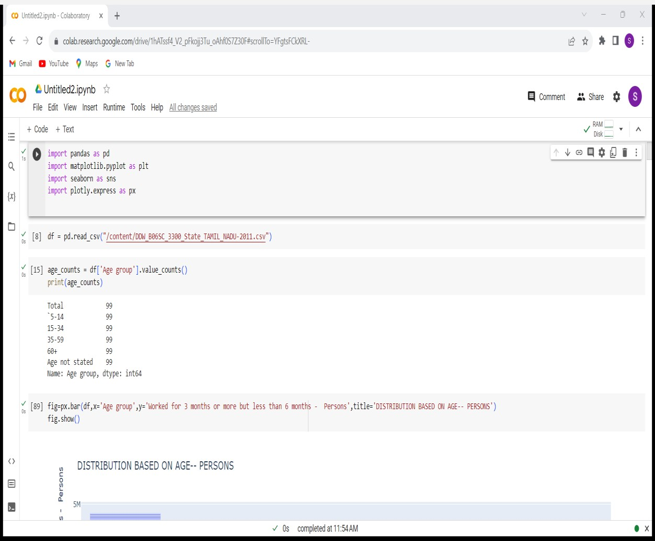DISTRIBUTION MARGINAL WORKERS BASED ON AGE: DEMOGRAPHIC ANALYSIS:

VISUALIZATION( Worked for 3 months or more but less than 6 months Persons WITH RESPECT TO AGE GROUP ):

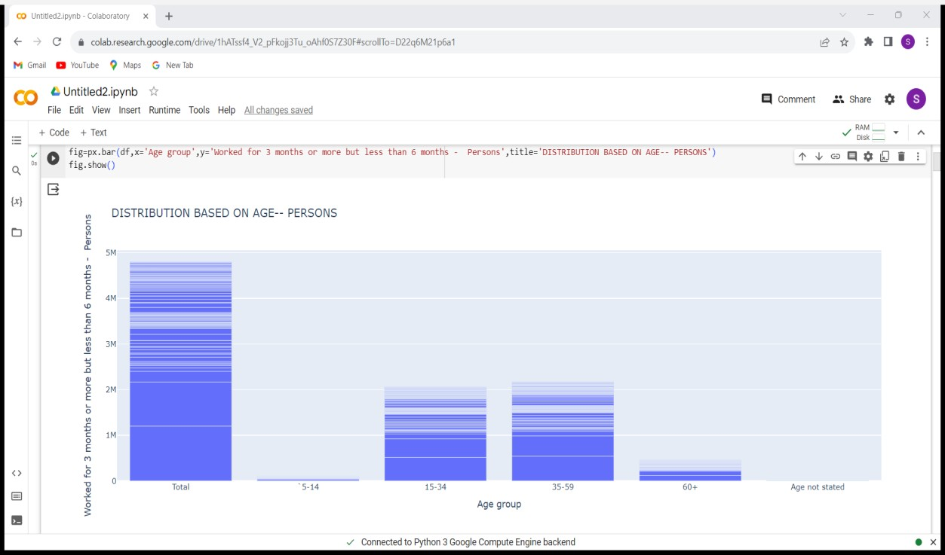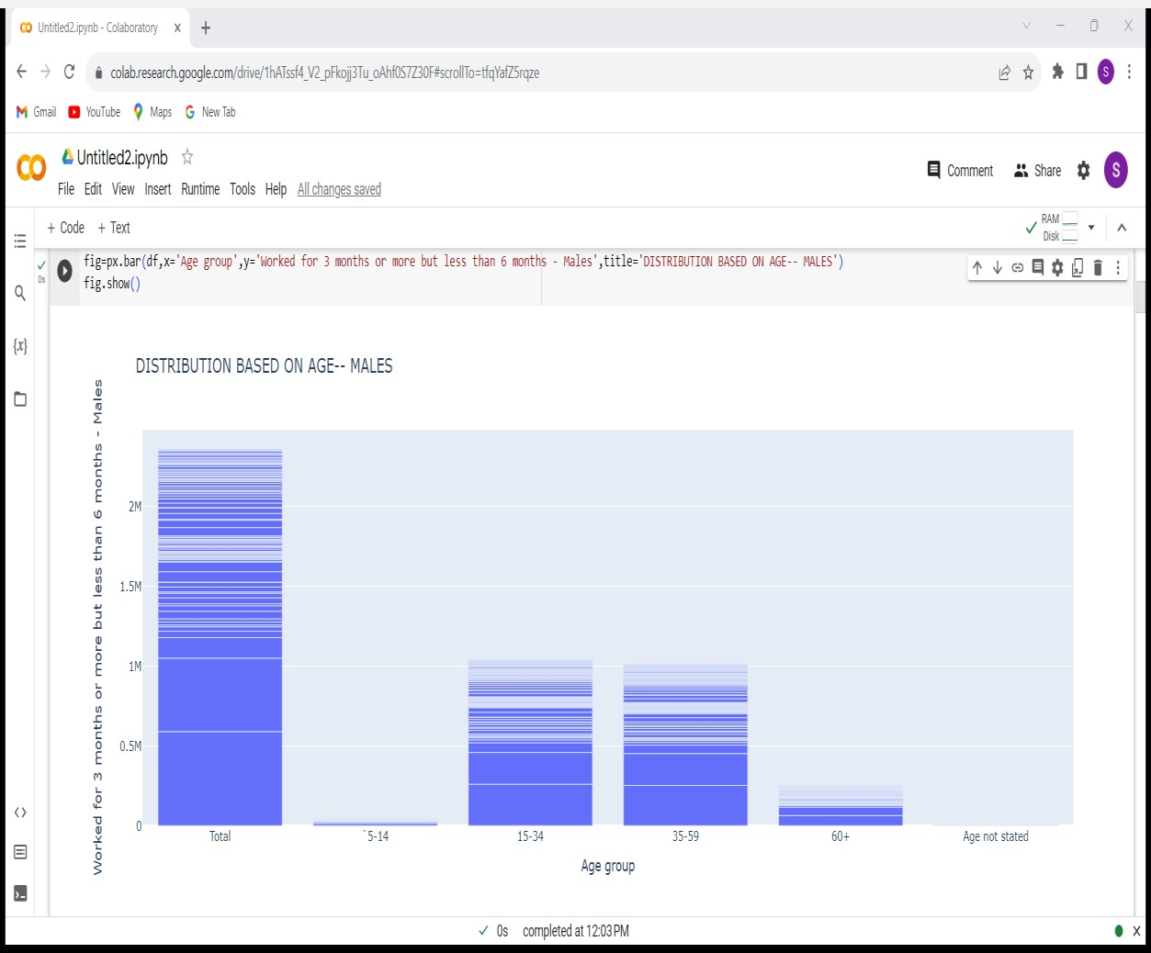

VISUALIZATION( Worked for 3 months or more but less than 6 months Males WITH RESPECT TO AGE GROUP ):

VISUALIZATION( Worked for 3 months or more but less than 6 months Females WITH RESPECT TO AGE GROUP ):

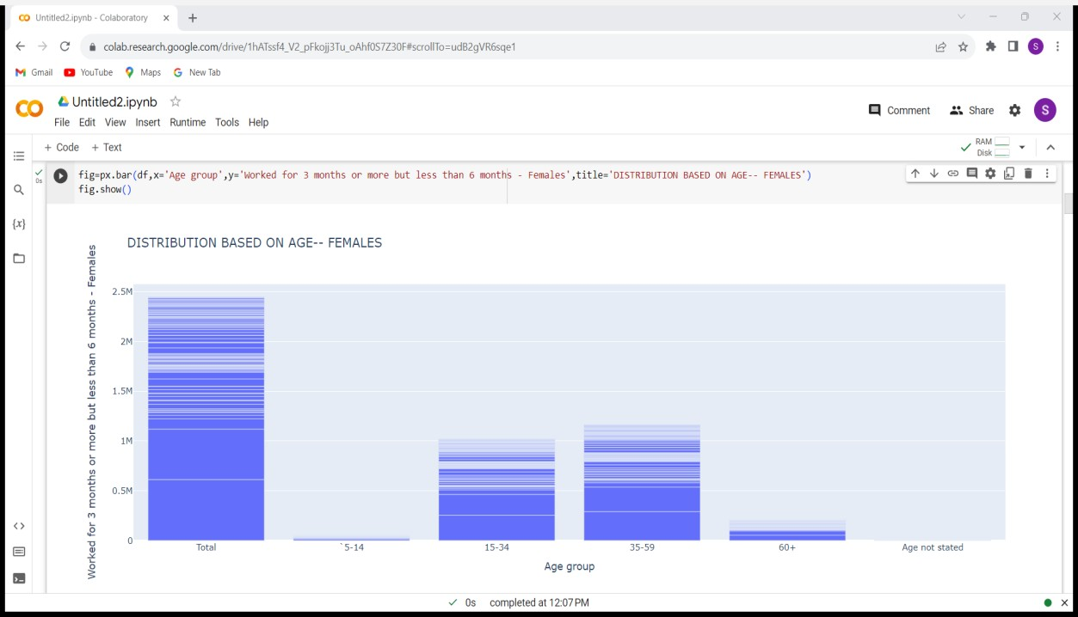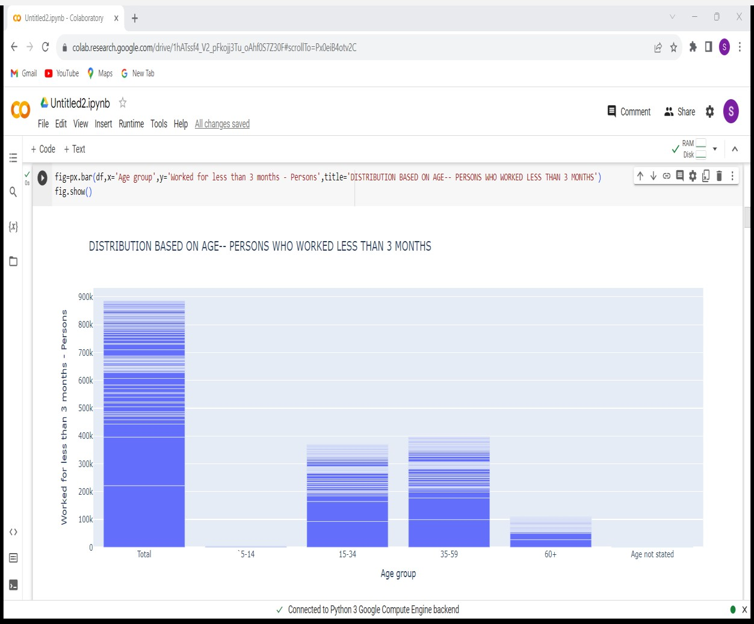

VISUALIZATION( Worked less than 3 months-Persons WITH RESPECT TO AGE GROUP ):

VISUALIZATION( Worked less than 3 months-Males WITH RESPECT TO AGE GROUP ):

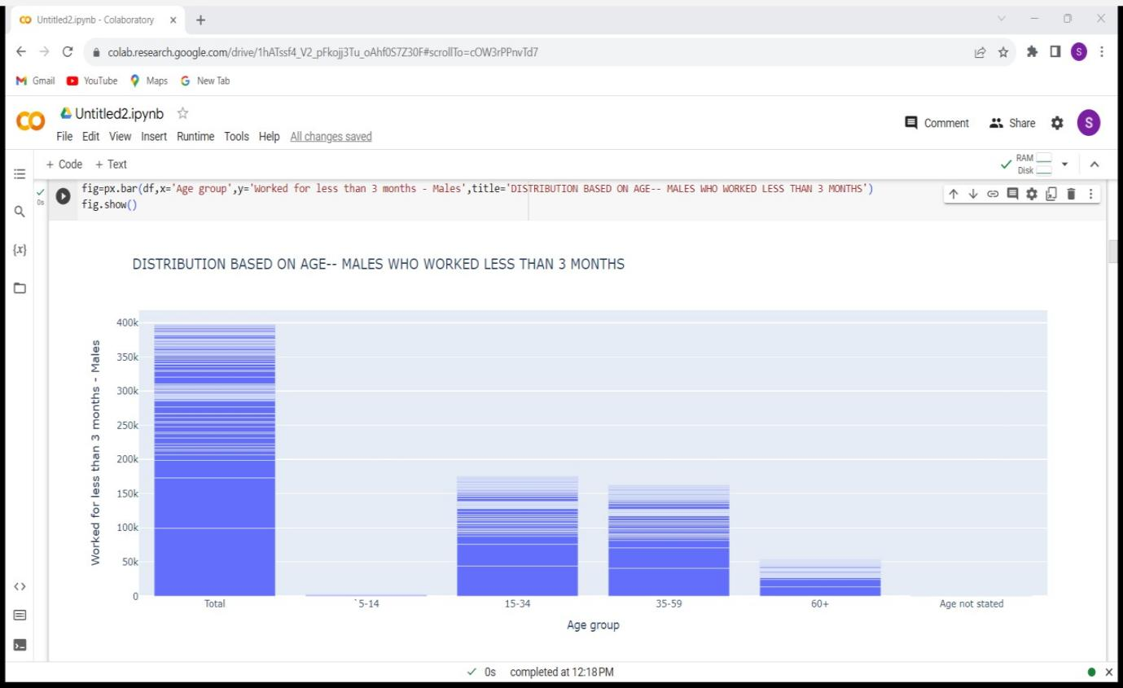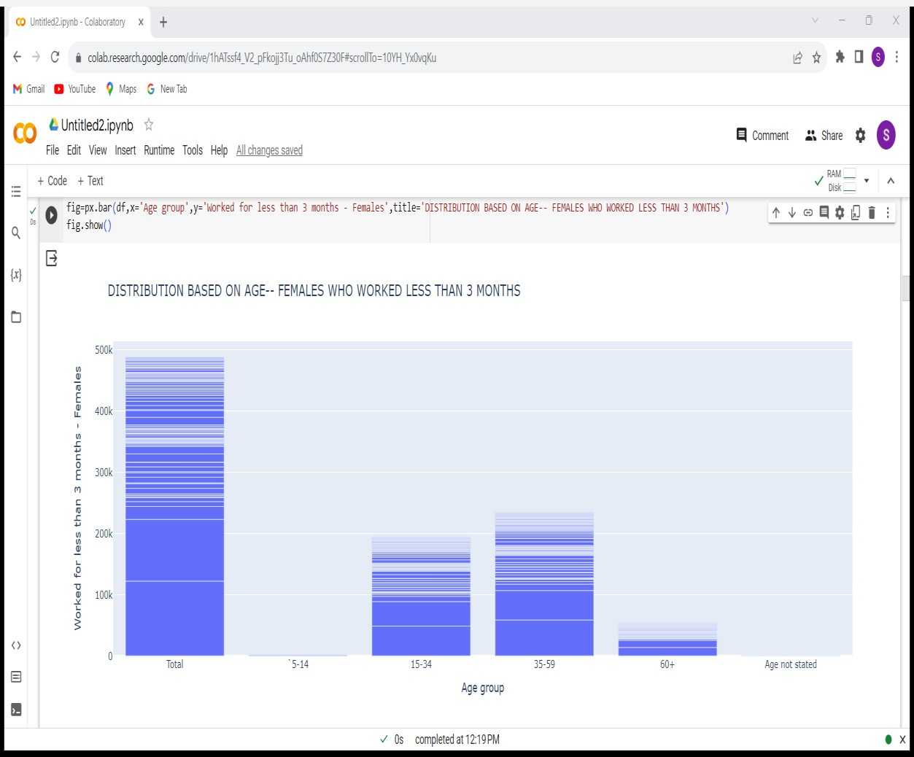

VISUALIZATION( Worked less than 3 months-Females WITH RESPECT TO AGE GROUP ):

DISTRIBUTION MARGINAL WORKERS BASED ON INDUSTRIAL CATEGORY: DEMOGRAPHIC ANALYSIS(CULTIVATORS):

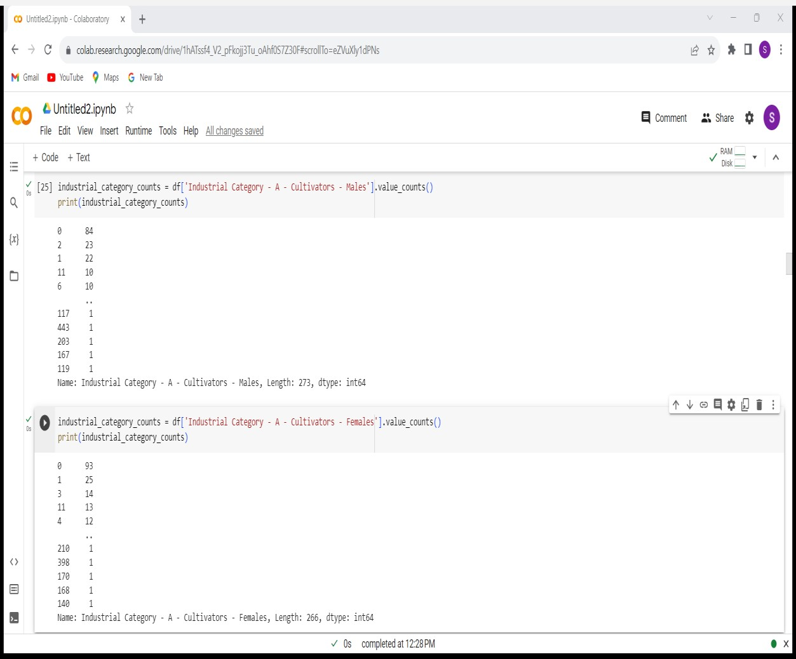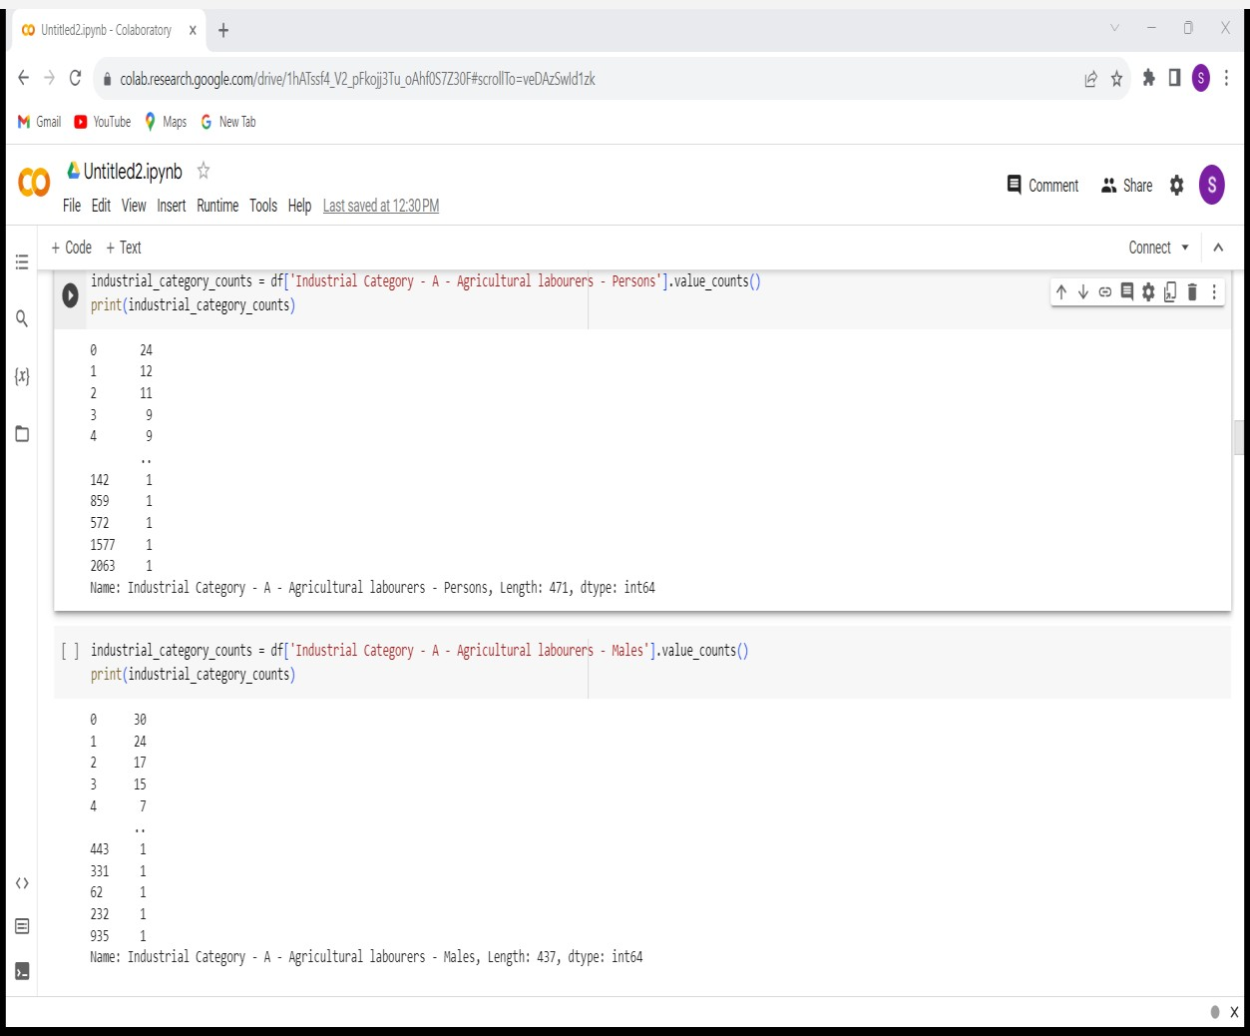

DEMOGRAPHIC ANALYSIS(AGRICULTUAL LABORS):

DEMOGRAPHIC ANALYSIS(INDUSTRIAL CATEGORY -A):

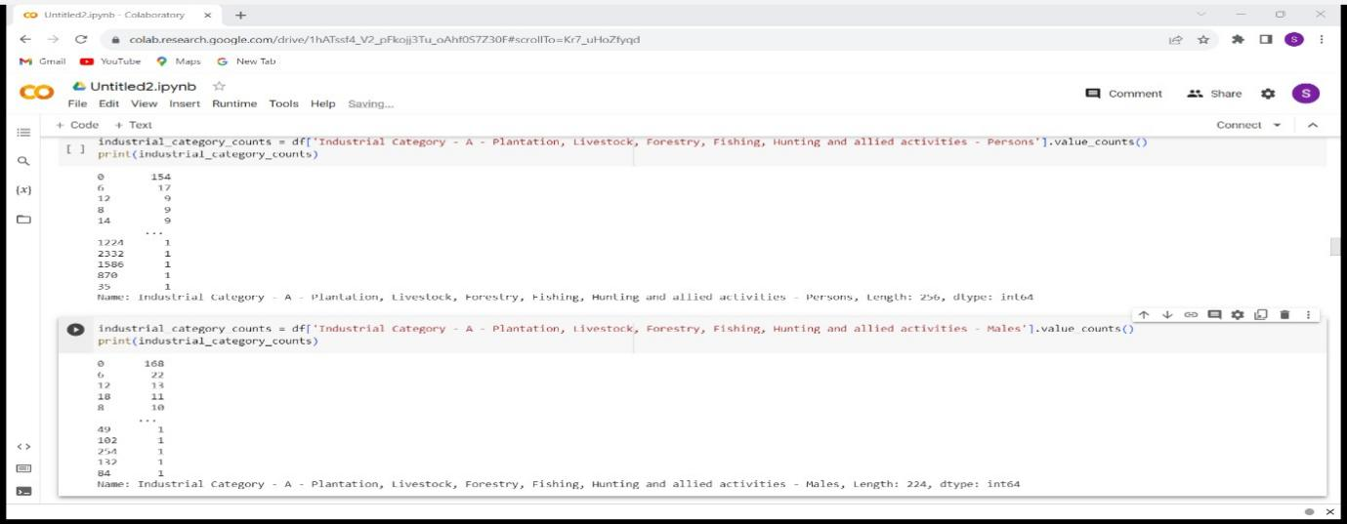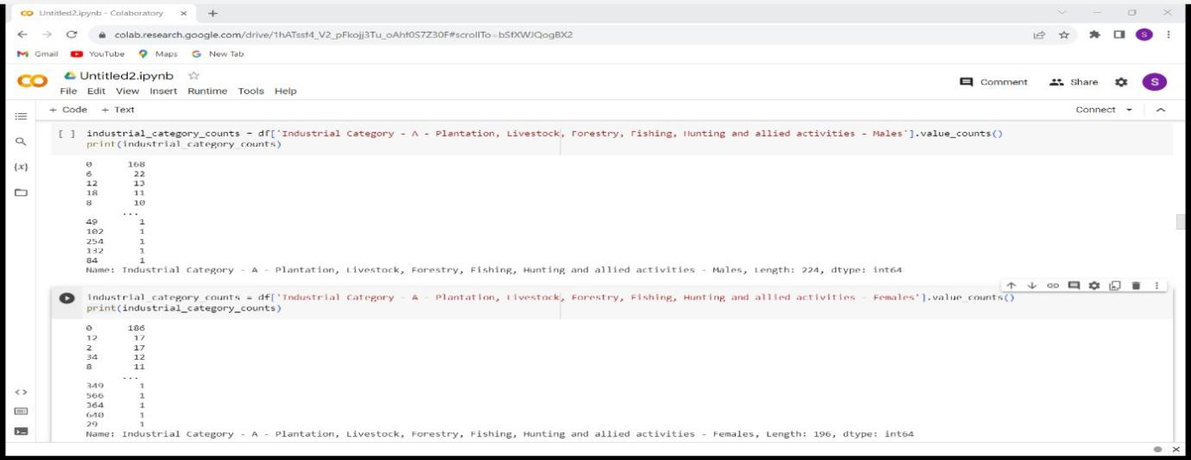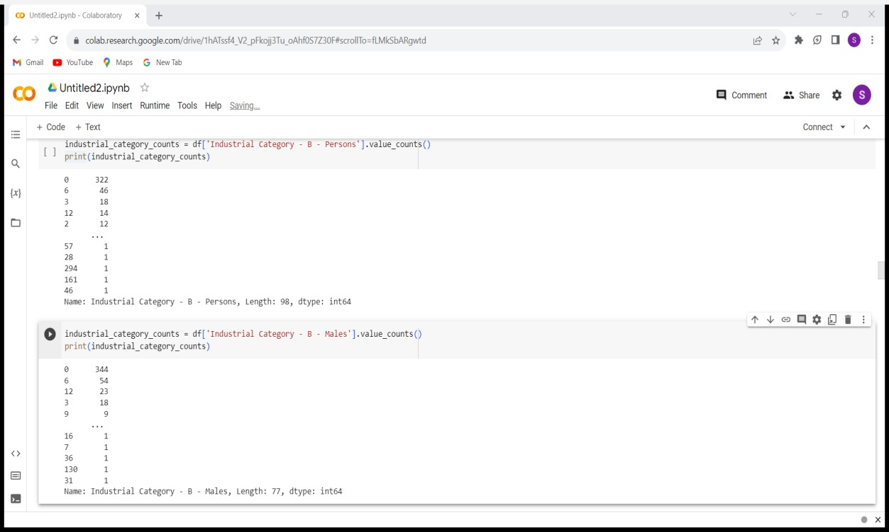

DEMOGRAPHIC ANALYSIS(I NDUSTRIAL CATEGORY B):

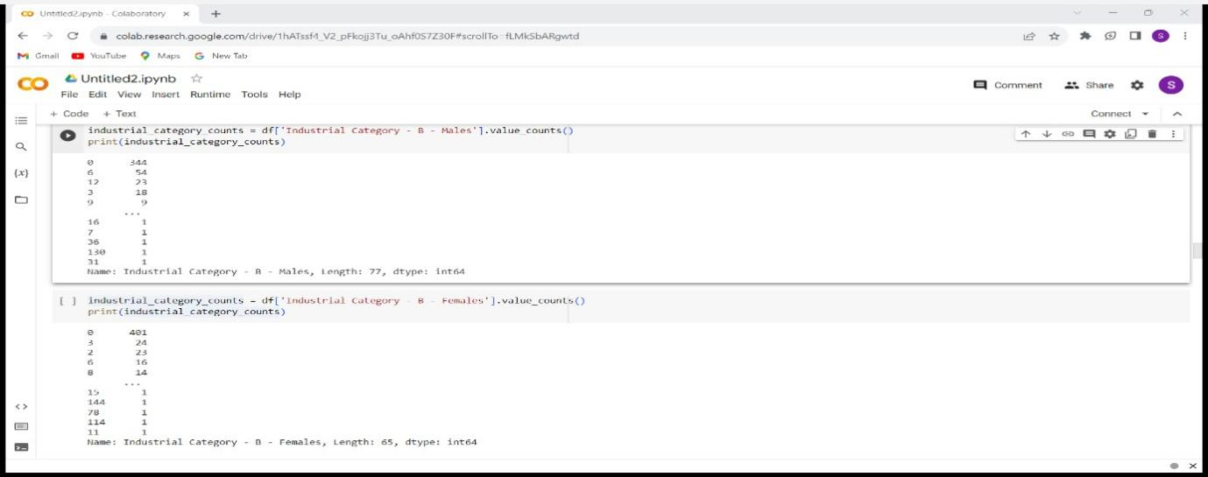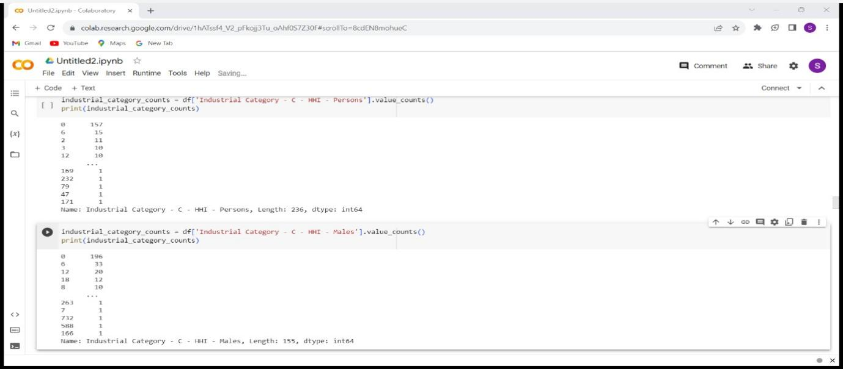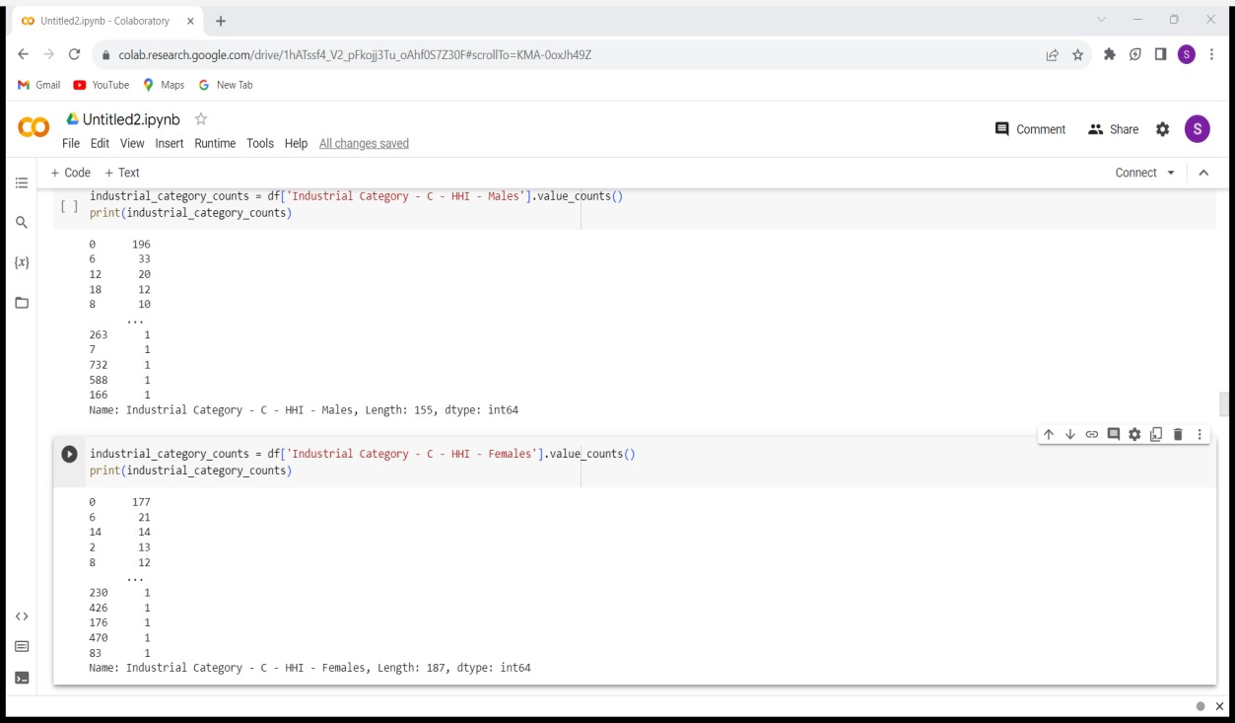

DEMOGRAPHIC ANALYSIS(INDUSTRIAL CATEGORY C):

DEMOGRAPHIC ANALYSIS(INDUSTRIAL CATEGORY D&E):

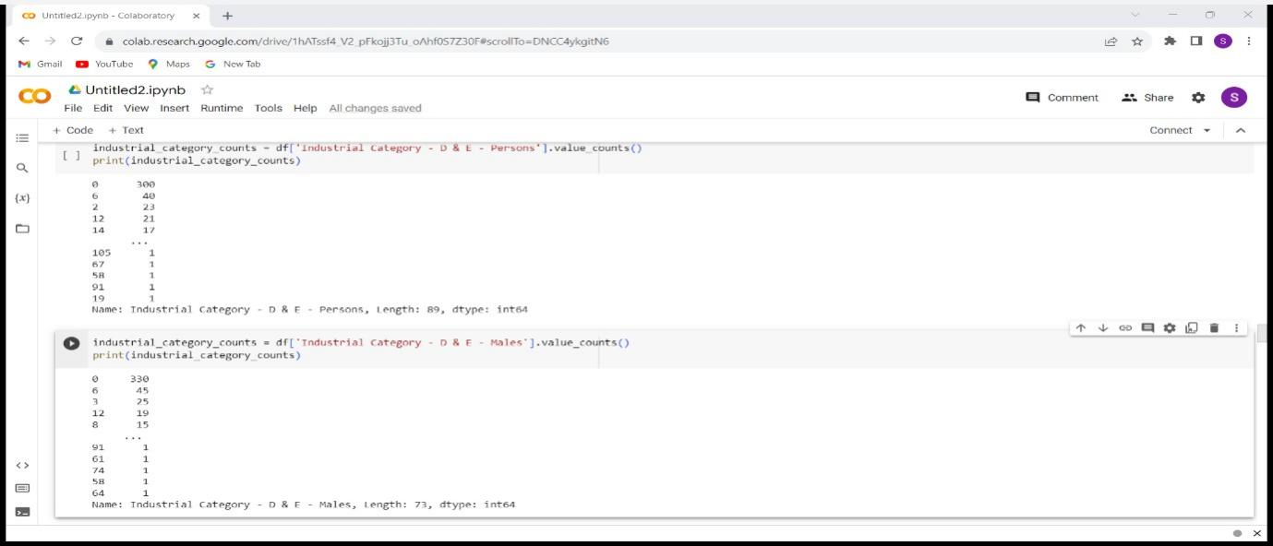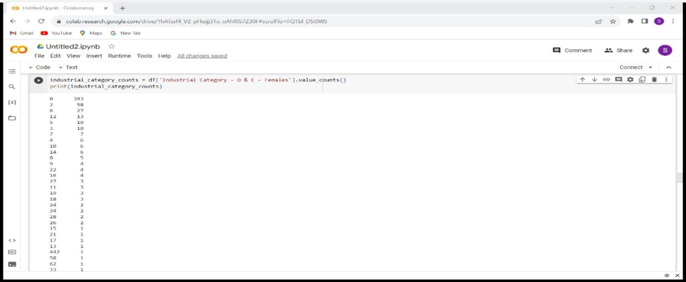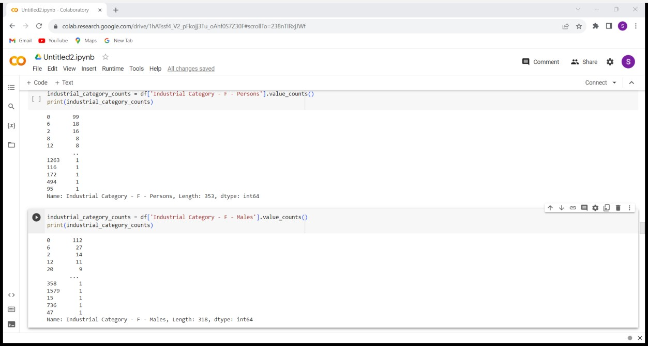

DEMOGRAPHIC ANALYSIS(INDUSTRIAL CATEGORY F):

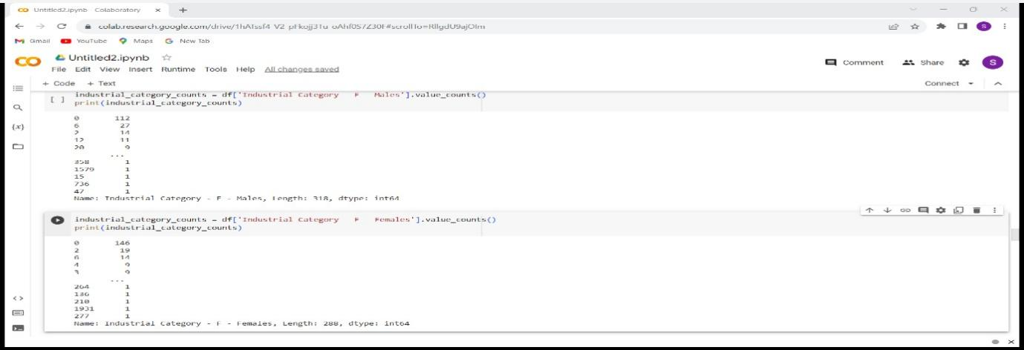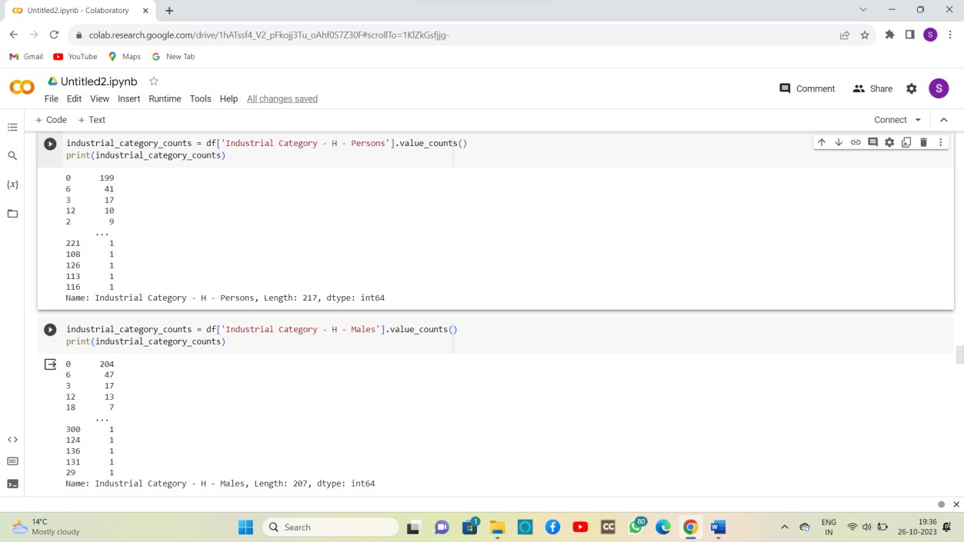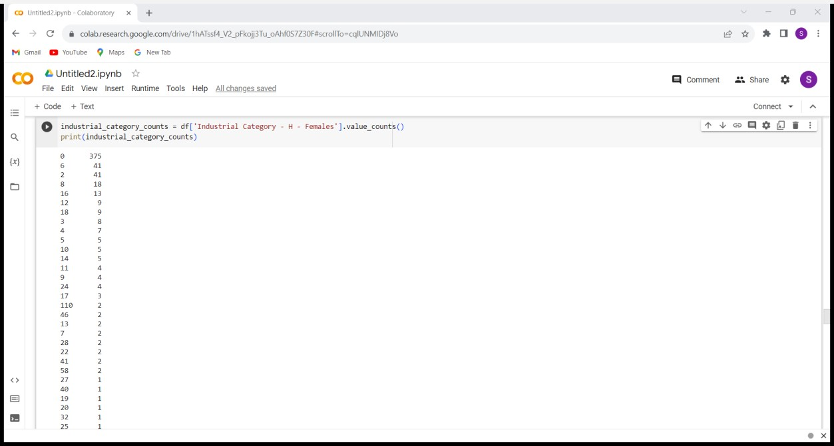

DEMOGRAPHIC ANALYSIS(INDUSTRIAL CATEGORY H):

DEMOGRAPHIC ANALYSIS(INDUSTRIAL CATEGORY I):

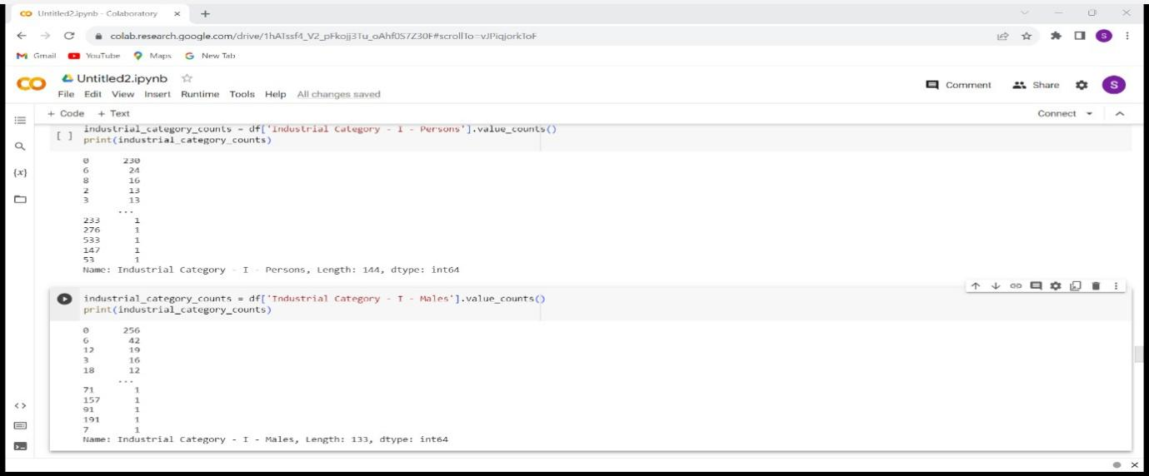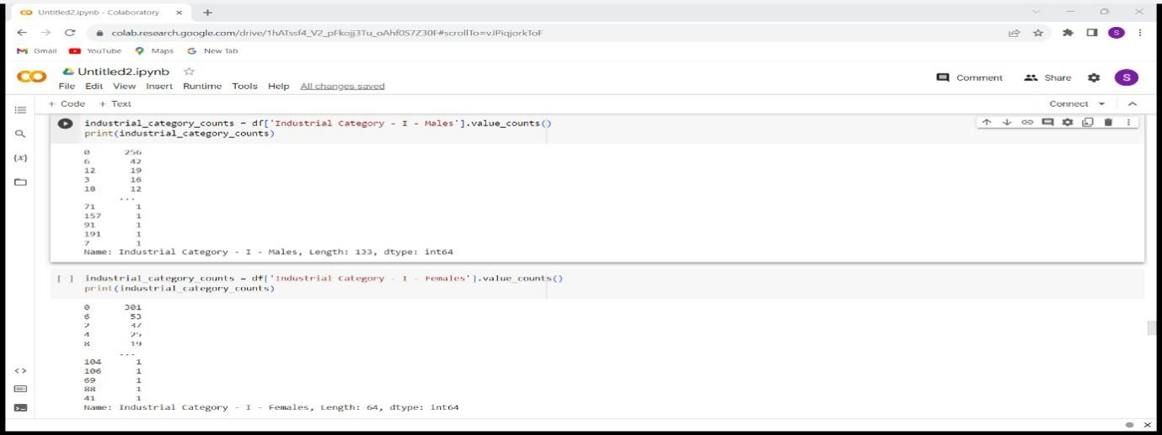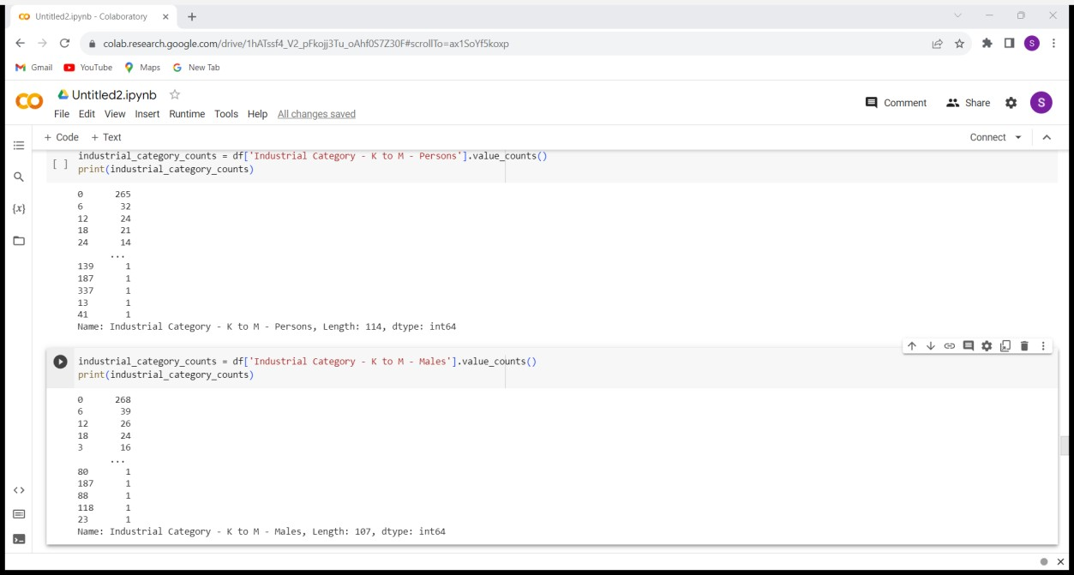

DEMOGRAPHIC ANALYSIS(INDUSTRIAL CATEGORK K&M):

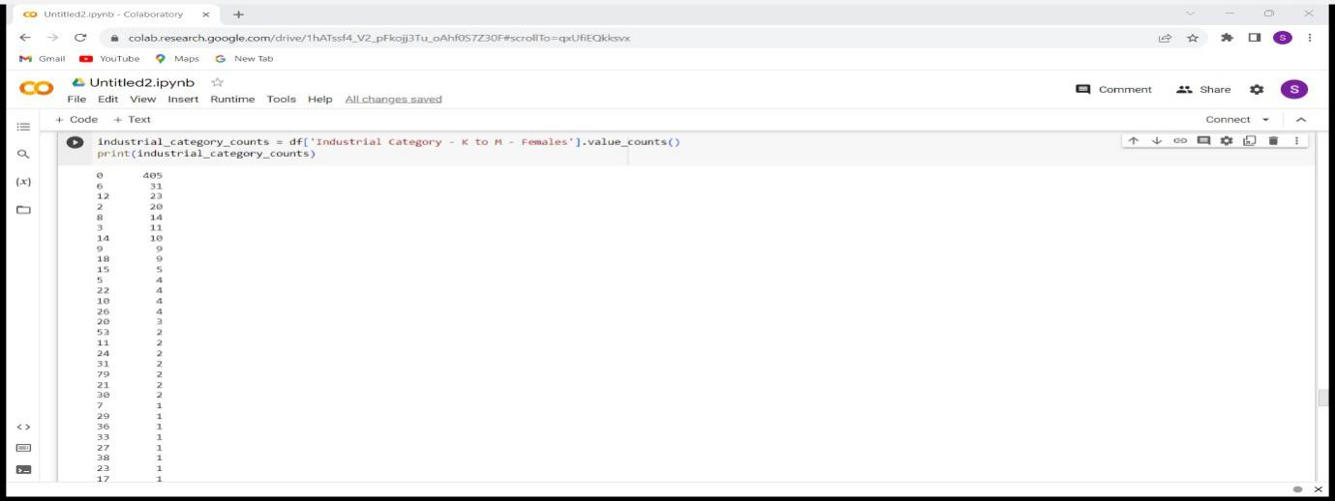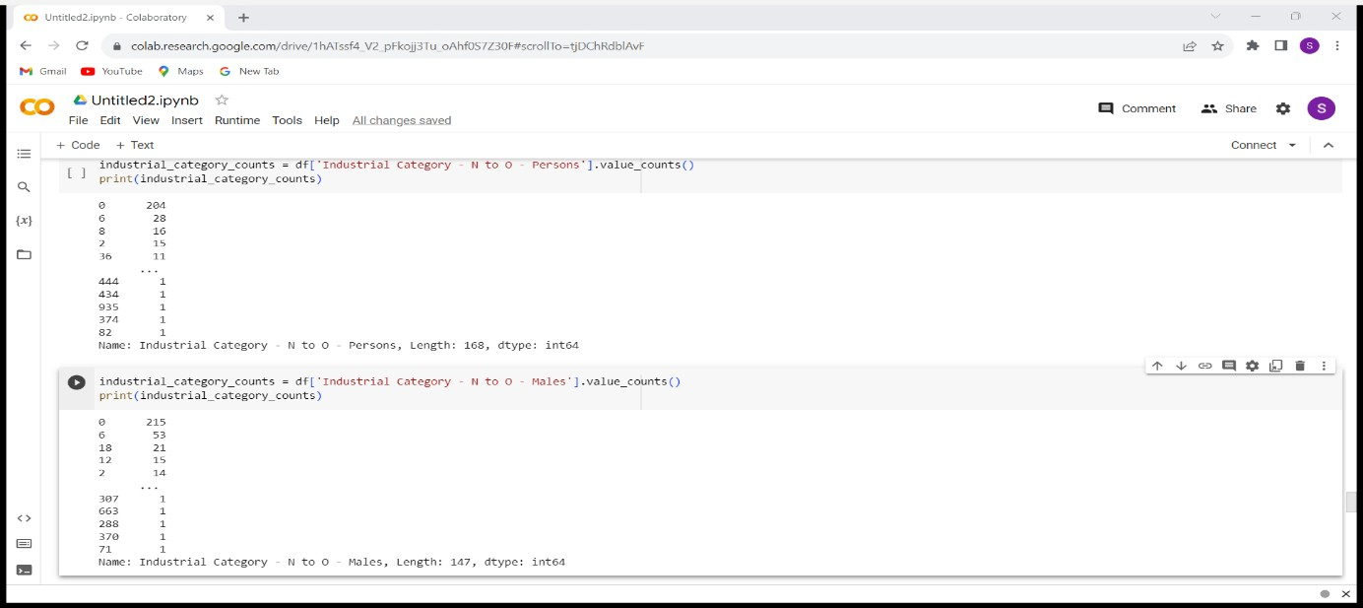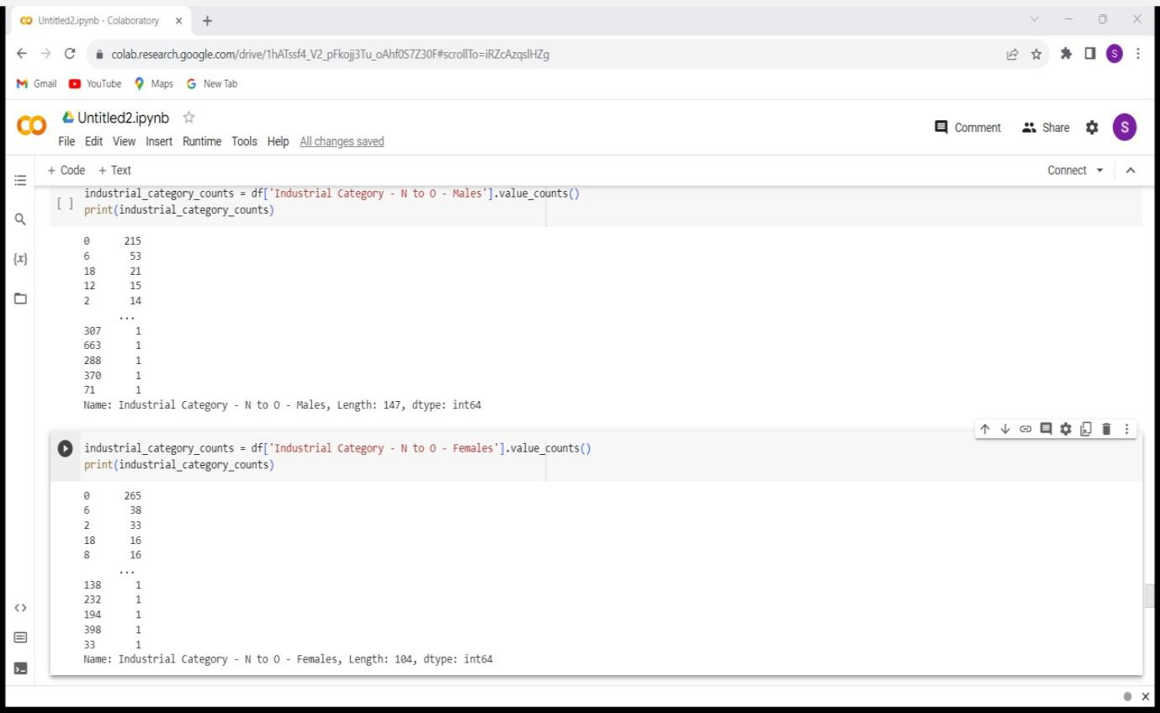

DEMOGRAPHIC ANALYSIS(INDUSTRIAL CATEGORY N TO O):

DEMOGRAPHIC ANALYSIS(INDUSTRIAL CATEGORY P TO Q):

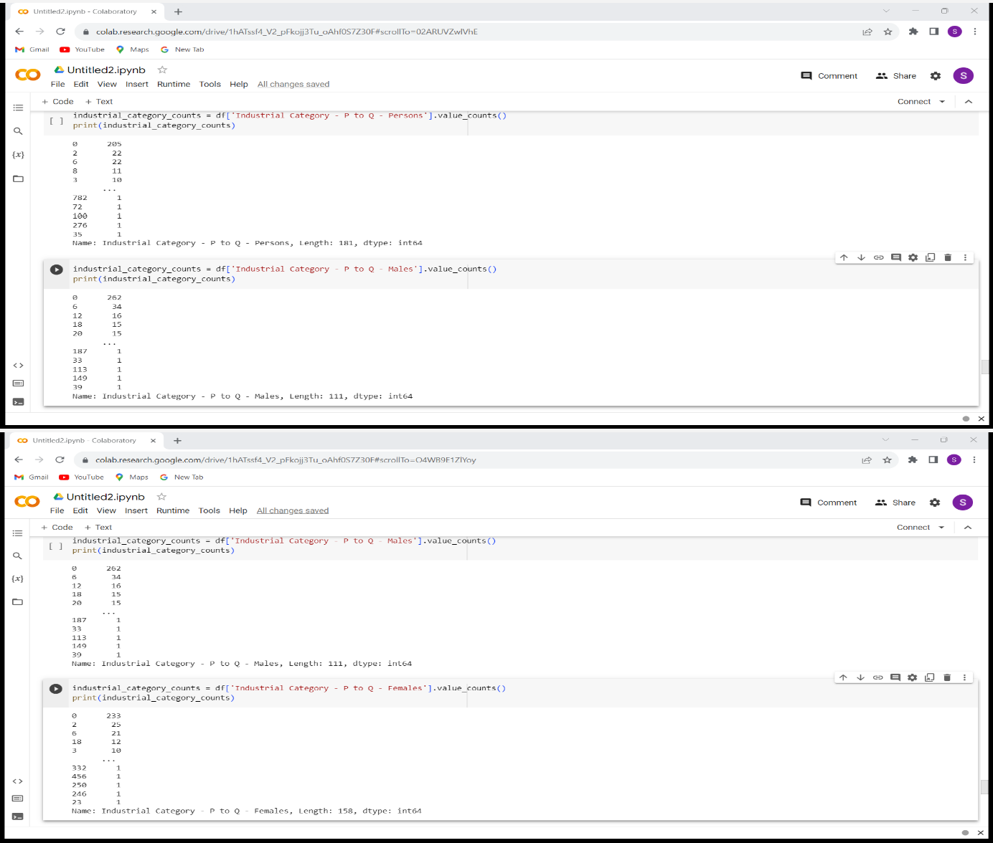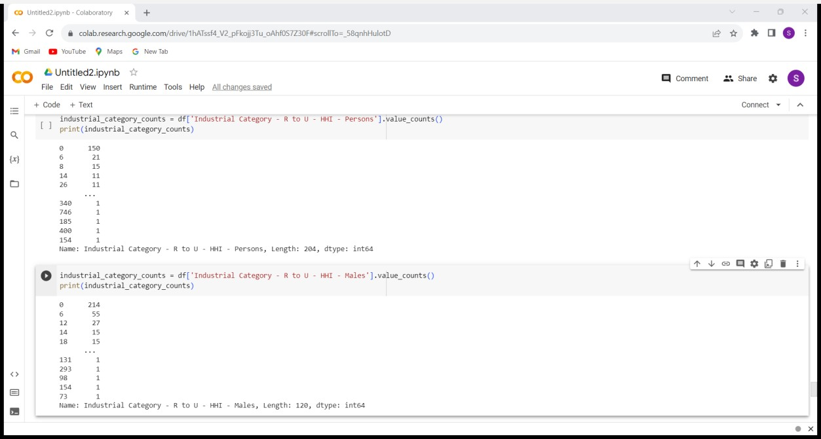

DEMOGRAPHIC ANALYSIS(INDUSTRIAL CATEGORY R TO U):

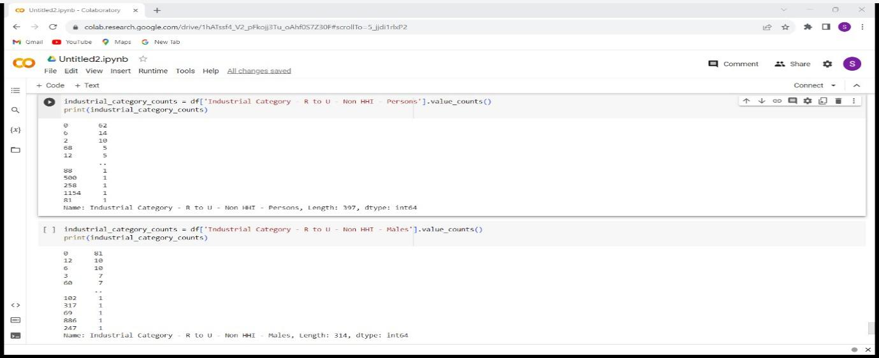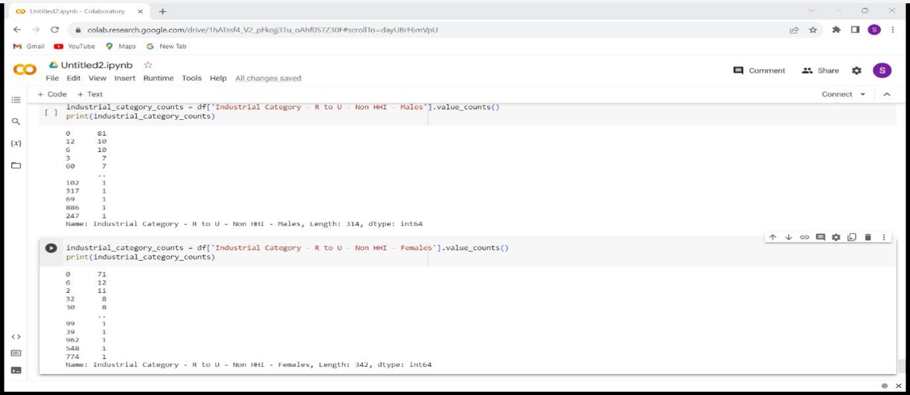

DEMOGRAPHIC ANALYSIS(INDUSTRIAL CATEGORY (R TO U NON HHI):

CONCLUSION:

Thus the demographic analysis and create visualizations are created

The distribution of marginal workers based on age, industrial category, and sex are calculated using data aggregation and manipulation.