[DETAILS REQUIRED] — Name of the University / Institute
[DETAILS REQUIRED] — Department
LABORATORY PROJECT REPORT
StructRender: Engine-Grounded Real-Time
Neural Rendering of a Game
in Learned Painterly Styles
Submitted by
[DETAILS REQUIRED] — Student name(s)
Register number: [DETAILS REQUIRED]
Course: [DETAILS REQUIRED]
Under the guidance of [DETAILS REQUIRED] — Supervisor name and designation
October 2026

ABSTRACT
Generative world models can produce playable game footage from pixels, but they hold no authoritative game state, so geometry, items and object appearance can drift. StructRender takes the opposite approach: a deterministic game engine (Godot 4) keeps sole authority over physics, game logic and entity identity, and a neural network only decides how each frame looks. Every frame, the engine exports its own structural buffers (depth, normals, albedo, analytic motion vectors and an entity-identity map), and a compact image-to-image network renders them in a painted style.
Because no paired data exists for artistic styles, a Stable Diffusion 1.5 + depth-ControlNet teacher generates targets offline, accepted only if they pass four pre-registered alignment gates. The deployed renderer is a U-Net whose previous-frame features are warped by the engine's motion field and gated by a disocclusion mask; a 16-dimensional style vector applied through FiLM layers lets one model render two styles. It was trained on 24 recorded play sessions (23,760 frames at 512 × 288; 18/3/3 session split) and deployed through ONNX and TensorRT in a C++ GDExtension.
On the held-out test sessions, the two-style model reaches 35.33 dB PSNR (oil) and 34.79 dB (watercolour), LPIPS 0.0225 and 0.0243, and a sharpness ratio of 0.946 and 0.937 against a 0.90 gate. It flickers about half as much as its own teacher (0.54× and 0.48×). Live in the playable game it runs at 44.6 fps (FP16; 4.53 ms per network step on an RTX 5060 Laptop GPU), with zero fallbacks over 3,000 frames and graceful recovery from injected failures. Negative results are reported as measured: a windowed-transformer renderer never matched the U-Net at parameter parity, and a persistent per-entity appearance memory (EPAM) did not improve output on this data.
Keywords: neural rendering, game engines, image-to-image translation, diffusion teacher, temporal consistency, TensorRT, real-time inference.
TABLE OF CONTENTS
ABSTRACT i
LIST OF TABLES iii
LIST OF FIGURES iv
LIST OF ABBREVIATIONS v
CHAPTER 1: INTRODUCTION 1
1.1 Project Overview 1
1.2 Problem Statement 2
1.3 Objectives 2
1.4 Scope of Work and Social Contribution 3
CHAPTER 2: LITERATURE REVIEW 4
2.1 Background 4
2.1.1 Review of Related Work 4
2.2 Research Gaps 6
CHAPTER 3: PROPOSED METHODOLOGY 7
3.1 Architecture in a Nutshell 7
3.1.1 Dataset Description 8
3.1.2 Preprocessing 9
3.1.3 Encoder Layer (Feature-Extraction and Rendering Network) 10
3.2 Hardware Specifications 12
3.3 Software Specifications 13
CHAPTER 4: PERFORMANCE EVALUATION 14
4.1 Experimental Setup 14
4.2 Evaluation Metrics 14
4.3 Results and Analysis 15
4.3.1 Training Behaviour 15
4.3.2 Ablation Ladder 16
4.3.3 The Deployed Two-Style Model 17
4.3.4 Live Deployment 18
4.3.5 Assessment of Objectives and Limitations 19
CHAPTER 5: CONCLUSION AND FUTURE WORK 20
5.1 Summary of the Contributions 20
5.2 Future Work 20
REFERENCES 21
APPENDICES 24
Appendix A: Deployed Model Configuration (abridged) 24
Appendix B: Milestone Scorecard 24
Appendix C: Supplementary Screenshots 24

LIST OF TABLES
Table 2.1: Comparison of related work 6
Table 2.2: Research gaps and how StructRender addresses them 6
Table 3.1: Dataset summary 8
Table 3.2: Offline teacher configuration 9
Table 3.3: Alignment gates (thresholds fixed before the data) 9
Table 3.4: Parameters of StyleTemporalUNet by block (counted from the model) 12
Table 3.5: Hardware used for all experiments 12
Table 3.6: Software environment (versions read from the environment) 13
Table 4.1: Training and evaluation configuration of the deployed model 14
Table 4.2: Ablation ladder on the sealed seed-scene test split 16
Table 4.3: Game test sessions (2,968 frames per style) 17
Table 4.4: Equivalence chain from evaluator to live game 18
Table 4.5: M10 exit criteria, measured on the playable game 19
Table 4.6: Objectives and the evidence for each 19
Table B.1: Milestones M0–M10 and their verdicts 24

LIST OF FIGURES
Figure 1.1: The playable game rendered natively and by live StructRender (watercolour) 1
Figure 3.1: System architecture: offline data and supervision, and the runtime loop 7
Figure 3.2: Structural inputs, motion and confidence mask for one test frame 10
Figure 3.3: StyleTemporalUNet: style-free encoder, temporal fusion, FiLM decoder 11
Figure 4.1: Training objective and validation L1/PSNR of the deployed model 16
Figure 4.2: Native input, teacher target and model output for one sealed test frame 18
Figure 4.3: Live frame rate of the whole loop, and TensorRT latency alone 19
Figure C.1: Street scene: the original frame (top left) and 16 visual themes 25
Figure C.2: Swinging scene: the original frame (top left) and 16 visual themes 25

LIST OF ABBREVIATIONS
CNN | Convolutional neural network
EPAM | Engine-Keyed Persistent Appearance Memory
FiLM | Feature-wise linear modulation
FP16 / FP32 / TF32 | 16-bit, 32-bit and TensorFloat-32 floating-point formats
fps | Frames per second
GDExtension | Godot's native-code (C++) extension interface
GN | Group normalisation
GPU | Graphics processing unit
KB | The project's knowledge base and Decision Log
L1 | Mean absolute error
LPIPS | Learned Perceptual Image Patch Similarity
ONNX | Open Neural Network Exchange
PSNR | Peak signal-to-noise ratio
SD 1.5 | Stable Diffusion version 1.5
SSIM | Structural similarity index
TE | Temporal (motion-warp) error
UV | Normalised screen coordinates in [0, 1]

CHAPTER 1: INTRODUCTION

1.1 Project Overview
Changing the look of a game, for example rendering it as an oil painting, normally means re-authoring its materials and shaders. Neural rendering offers another route: a network learns to map scene information to an image in a target appearance [1]. Game engines already compute that information every frame as per-pixel depth, normals and albedo, the so-called G-buffer [2]. A second line of work replaces the engine altogether: GameGAN, GameNGen and Genie learn to predict the next frame of a game from earlier frames and player actions [3], [4], [5]. Because such models hold no authoritative state, world facts such as a collected coin or the position of a wall can drift.
StructRender takes the opposite position: the engine is the single source of truth, and the network decides appearance only. Every frame, the Godot engine [6] exports its structural buffers and a compact convolutional network [7] renders them in a painted style. The network runs live through ONNX [8], TensorRT [9] and C++. Paired data for painterly styles does not exist, so Stable Diffusion 1.5 [10] with a depth ControlNet [11] is used offline only, to generate training targets. Because the network never touches game state, the style can be switched during play without changing the game (Figure 1.1).
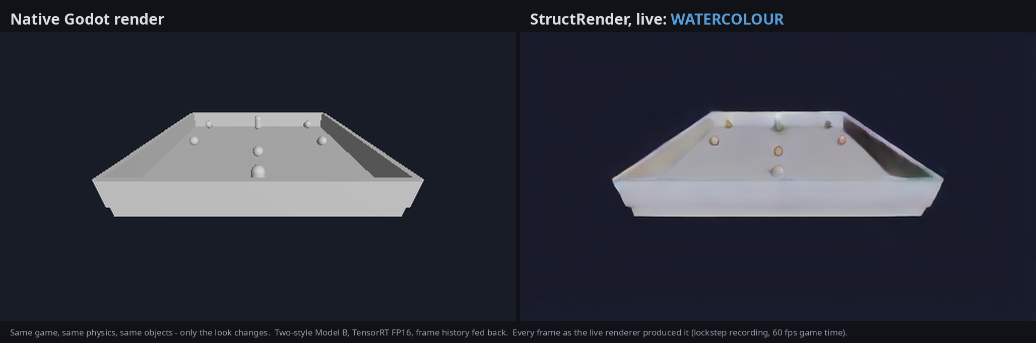
Figure 1.1: The playable game rendered natively and by live StructRender (watercolour)
The work was organised as eleven milestones (M0–M10) whose exit criteria, like every threshold used to judge a result, were fixed before the results existed [12]; negative findings are reported rather than tuned away. Potential applications include stylised rendering for small studios and education, rapid look-development, and research on engine-grounded generative rendering.

1.2 Problem Statement
Problem. Given the structure a game engine already computes for each frame, render that frame in a learned artistic style at interactive frame rates, such that the engine, not the network, determines what exists and where; the output is temporally stable; and the style can be switched while the game runs.
Shortcomings and challenges. Pixel-space world models do not own game state [4], [5]. G-buffer-based enhancement targets photorealism using large real-image datasets [13]. Per-frame stylisation flickers on video [14]. Diffusion models stylise well but need many network evaluations per image [15], [10]. In addition, there is no paired ground truth for painted game frames; a diffusion teacher can invent geometry and is itself temporally unstable; and the live renderer must fit an 8 GB laptop GPU and must provably be the same model that was evaluated.
Measurable outcome. On held-out play sessions: a sharpness ratio of at least 0.90 and colour-histogram travel of at least 0.80 relative to the teacher; a temporal-error reduction beyond a pre-registered noise threshold; about 30 fps for the whole live loop at 512 × 288; standalone network latency of at most about 20 ms; and no gameplay interruption when the renderer fails.

1.3 Objectives
Primary objective. To design, implement and evaluate an engine-grounded neural renderer that re-renders a playable Godot game in learned painterly styles in real time, with the engine retaining authority over all game state.
Secondary objectives.
- O1 – Data pipeline. Export depth, normals, albedo, motion, entity-ID maps and lifecycle events from Godot, and record validated, frame-aligned datasets.
- O2 – Supervision. Generate styled targets with an offline diffusion teacher and accept only targets that pass four pre-defined alignment gates.
- O3 – Image quality. Reach held-out sharpness ≥ 0.90 and colour-histogram travel ≥ 0.80 relative to the teacher.
- O4 – Temporal stability. Reduce temporal error through engine-guided reprojection by more than a pre-registered noise threshold.
- O5 – Ablation. Compare U-Net and transformer backbones, temporal conditioning, entity awareness and appearance memory at parameter parity.
- O6 – Style switching. Render two styles with one model and switch between them during play.
- O7 – Deployment. Run in the game through ONNX, TensorRT and a C++ GDExtension at about 30 fps, with standalone latency ≤ about 20 ms and a native-frame fallback.
- O8 – Appearance memory. Test whether EPAM, a per-entity memory keyed by engine identity, improves output over an identical no-memory model.

1.4 Scope of Work and Social Contribution
Scope. One Godot 4 game (an arena collector with a player, coins and spawned enemies); structural instrumentation; dataset recording and validation; an offline teacher with alignment gates; six renderer variants plus controls; and an ONNX → TensorRT → C++ → Godot runtime, at 512 × 288 with two styles (oil impasto and a bold watercolour). The network never computes gameplay state; EPAM is session-local; runtime diffusion and mandatory adversarial training are out of scope [12]. All results concern one game and are not evidence about other games or styles.
Contribution and ethics. The project shows that a learned style can be added to a game without letting a generative model alter gameplay, on consumer hardware, and documents its evaluation discipline, including negative results, which makes it useful for teaching. The impact is modest: the styles are mild and the evidence covers one simple game. All data is synthetic and produced by the project; no personal data is collected. The teacher weights are used under their licences (CreativeML OpenRAIL-M [16]; Apache-2.0 [17]). Because the renderer cannot change game state, a renderer error cannot cause a gameplay error.

CHAPTER 2: LITERATURE REVIEW

2.1 Background
G-buffers and U-Nets. Deferred rendering stores per-pixel geometric attributes in separate buffers and shades them later [2]; Godot's Forward+ renderer [6] computes the same attributes, which StructRender re-renders with override shaders and exports. The U-Net [7] is an encoder–decoder CNN whose skip connections carry high-resolution detail to the decoder; it is the standard generator for dense image translation [18]. StructRender's renderer is a four-level U-Net with group normalisation [19], which is independent of batch size and exports cleanly to ONNX.
Style and conditioning. Gatys et al. represented artistic style by correlations of deep CNN features [20]. Dumoulin et al. showed that one network can hold many styles through per-style normalisation parameters [21]. FiLM generalises this as a learned per-channel scale and shift computed from a conditioning vector [22]; StructRender's decoder uses FiLM driven by a learned 16-dimensional style vector.
Diffusion and control. Diffusion models generate images by iterative denoising [15]; latent diffusion made this practical on consumer GPUs [10]. Image-to-image editing starts from a partially noised input, and the noise level (strength) trades faithfulness against change [23]. ControlNet conditions a frozen diffusion model on depth, edges or pose through a trainable branch joined by zero-initialised convolutions [11].
Quality and time. SSIM compares local luminance, contrast and structure [24]; LPIPS compares deep features and tracks human judgement [25]. Distortion and perceptual quality are in tension [26], so a regressor trained on pixel error tends to blur; the project therefore pairs pixel metrics with a sharpness measure. Real-time graphics reuses earlier frames by warping them with engine motion vectors [27]; StructRender does this at the network's bottleneck. Window attention (Swin Transformer [28]) underlies the StructFormer variant evaluated against the U-Net.

2.1.1 Review of Related Work
The reviewed works fall into four groups; Table 2.1 summarises them. Bibliographic details were checked against Crossref DOI records or arXiv.
Learned rendering from engine buffers. Deep Shading [29] showed that a CNN can map G-buffer attributes to screen-space shading effects at interactive rates. Neural supersampling [27] warps past frames with engine motion vectors and depth to reconstruct high-resolution images in real time. Enhancing Photorealism Enhancement [13] conditions an enhancement network on GTA V's G-buffers and trains it adversarially against real-image datasets such as Cityscapes, achieving stable, geometry-consistent photorealism. These works establish that engine buffers make neural rendering stable; none targets learned artistic styles, for which no real-image domain exists.
Structure-to-image and video translation. pix2pix [18] translates label maps to images with a conditional GAN and a U-Net generator, but needs paired data. vid2vid [30] adds flow-based warping for temporally coherent video, and World-Consistent vid2vid [31] keeps appearance consistent on revisits by projecting earlier output from a reconstructed 3D point cloud, the closest analogue of EPAM's goal. Both rely on estimated flow or geometry and heavy generators.
Temporal consistency. Lai et al. [14] train a post-processing network with short- and long-term temporal losses on optical-flow-warped frames (DAVIS and Videvo data) to remove flicker from per-frame processed video. StructRender's masked temporal loss follows the same principle, but uses exact engine motion and an engine-derived disocclusion mask instead of estimated flow.
Generative game engines. GameGAN [3] learns Pac-Man and VizDoom simulators with an explicit memory module; GameNGen [4] simulates DOOM with a diffusion model conditioned on past frames and actions; Genie [5] learns playable worlds with latent actions from unlabelled Internet 2D-platformer video. All keep game state implicit in pixels or latents, which motivates StructRender's engine-authoritative design. ControlNet [11], finally, supplies the teacher's depth conditioning, and its zero-initialisation idea is reused in StructRender's temporal and FiLM layers so that each new mechanism starts as an exact no-op.
Table 2.1: Comparison of related work
Reference | Year | Methodology | Dataset | Key findings | Limitations (for this project)
Nalbach et al. [29] | 2017 | CNN on G-buffers → screen-space shading | Rendered 3D scenes | Engine buffers suffice for learned shading | Single frame; photographic goal
Xiao et al. [27] | 2020 | Motion-vector warping of past frames + CNN | Rendered game-like scenes | Real-time multi-frame reconstruction | Engine look only
Richter et al. [13] | 2023 | G-buffer-conditioned enhancement, adversarial | GTA V + real datasets | Stable photorealism enhancement | Real-image domain; not artistic
Isola et al. [18] | 2017 | Conditional GAN, U-Net generator | Paired sets (e.g. Cityscapes) | General structure-to-image translation | Needs paired data; per-frame
Wang et al. [30] | 2018 | Sequential generator + flow warping | Street-scene video | Temporally coherent synthesis | Estimated flow; heavy model
Mallya et al. [31] | 2020 | Guidance from 3D point cloud of past output | Street-scene video | Consistency on revisits | Needs reconstructed 3D
Lai et al. [14] | 2018 | Post-hoc network with temporal losses | DAVIS, Videvo | Task-agnostic consistency | Estimated flow; extra pass
Kim et al. [3] | 2020 | GAN simulator with memory module | Pac-Man, VizDoom | Learned playable simulation | State implicit; drift
Valevski et al. [4] | 2025 | Diffusion next-frame model | Agent play of DOOM | Interactive diffusion game | No authoritative state
Bruce et al. [5] | 2024 | Latent-action foundation world model | Internet platformer video | Playable worlds from video | No engine truth; drift
Zhang et al. [11] | 2023 | Zero-initialised control branch | Paired condition/image sets | Depth-controlled generation | Slow; no temporal consistency

2.2 Research Gaps
Table 2.2 links each gap to its evidence. G1–G4 follow from the literature; G5–G6 are opportunities identified by the project team.
Table 2.2: Research gaps and how StructRender addresses them
Gap | Evidence | How this project addresses it
G1. Generative game models do not own game state, so world facts can drift | [3], [4], [5] | Engine is the single source of truth; the network renders appearance only
G2. Buffer-conditioned enhancement targets photorealism with real-image data | [13], [29] | Artistic styles supervised by an offline diffusion teacher
G3. Diffusion stylises well but needs many network evaluations per image | [15], [10], [11] | Diffusion offline only; a one-pass CNN runs live
G4. Per-frame stylisation flickers; consistency methods use estimated flow | [14], [30] | Engine motion vectors and an engine-derived disocclusion mask
G5. (Team) No standard acceptance test for aligned stylised targets | Project measurement [12] | Four pre-registered alignment gates; per-frame exclusion
G6. (Team) Appearance memory keyed by engine identity is unexplored | [31] | EPAM tested against a built-in no-memory control

CHAPTER 3: PROPOSED METHODOLOGY

3.1 Architecture in a Nutshell
Figure 3.1 shows the system: an offline part that produces a validated dataset and a trained model, and a runtime loop that runs once per game frame inside Godot.
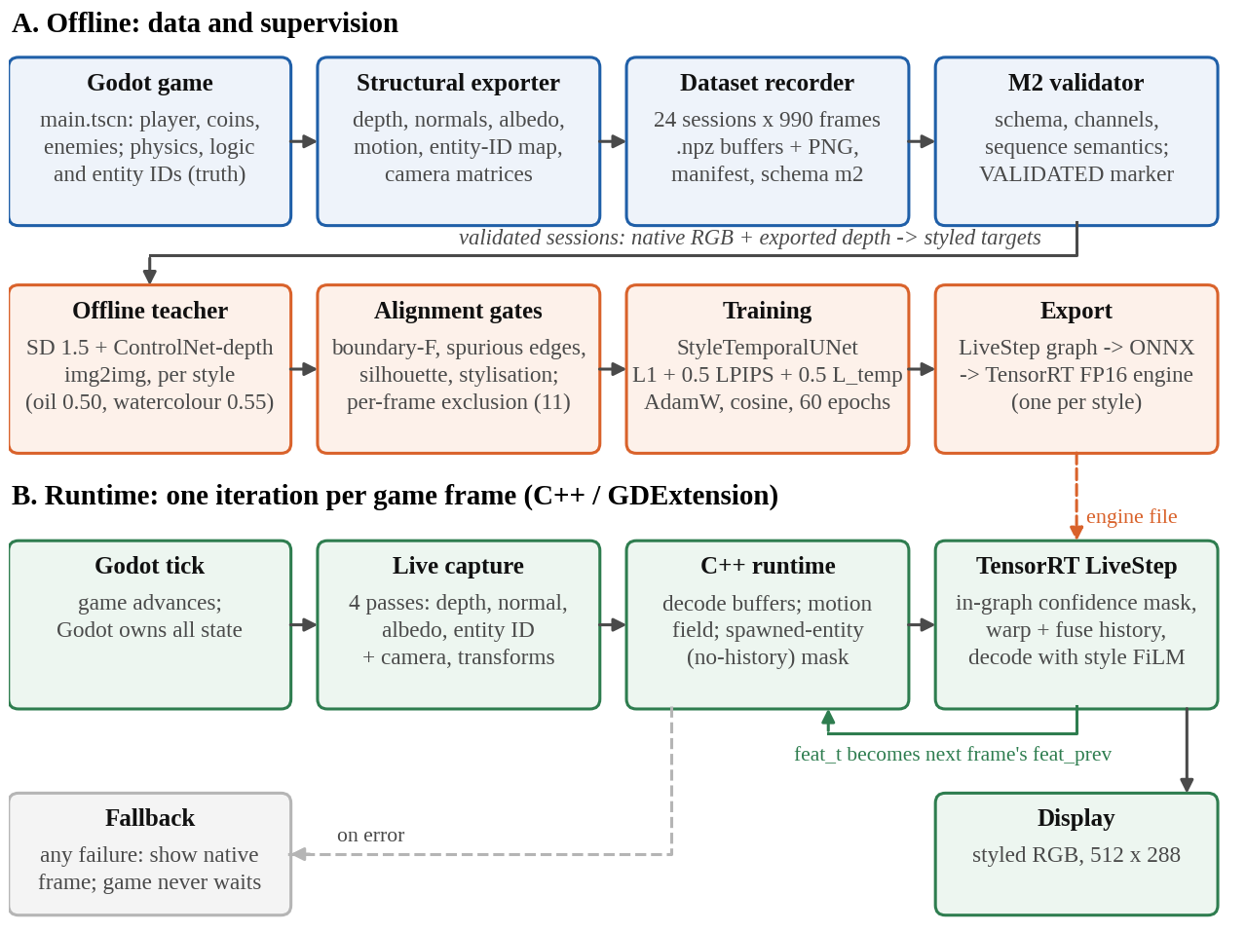
Figure 3.1: System architecture: offline data and supervision, and the runtime loop
- Game and exporter. The playable arena collector (main.tscn) runs Godot physics at 60 Hz. Override-shader passes re-render each frame as depth, normals, albedo and an entity-ID map; motion vectors are computed analytically from camera and entity transforms.
- Recorder and validator. Scripted play drives the game through its own input actions; each frame advances exactly one physics step with the scene paused while passes render, so all buffers show the same instant. The validator rejects sessions with schema, channel or sequence errors.
- Teacher and gates. SD 1.5 with a depth ControlNet stylises each native frame, conditioned on the engine's depth; four gates reject targets that lose structure, invent edges, damage silhouettes or fail to stylise.
- Training and export. StyleTemporalUNet (Section 3.1.3) learns structure → target with one frame of engine-warped history; one step of it (LiveStep), including the confidence mask, is exported to ONNX and compiled to one TensorRT FP16 engine per style on the target laptop.
- Runtime loop. Each frame, Godot captures four passes; the C++ GDExtension computes motion and the mask of newly spawned entities, runs the engine with the previous frame's features, displays the result and keeps the new features. Any failure shows the native frame, so the game never waits.

3.1.1 Dataset Description
Both datasets were generated by the project with the same exporter, recorder and validator, so there is no external source, URL or DOI (Table 3.1). The game dataset, recorded from the playable game, trained and tested the deployed model. The seed-scene dataset, recorded earlier from an arena built in code, was used for the ablation ladder.
Table 3.1: Dataset summary
Property | Game dataset (deployed model) | Seed-scene dataset (ablation)
Sessions | 24 recorded, 24 valid | 30 recorded, 29 valid
Frames | 990 per session; 23,760 total | 990 per session; 28,710 total
Resolution | 512 × 288 | 512 × 288
Split (sessions) | 18 / 3 / 3 (train / val / test) | 21 / 4 / 4
Split (frames) | 17,820 / 2,970 / 2,970 | 20,790 / 3,960 / 3,960
Targets (styles) | oil_impasto 0.50; watercolor_bold 0.55 | oil_impasto 0.50
Excluded by gates | 11 frames (0.05 %) | whole-session rule
Per-frame record | native RGB (PNG); depth, normals, albedo, motion (float16); entity ID (int32); camera matrices; lifecycle events | same
Size / licence | 2.9 GB structural data; project-generated | same

The task is dense regression from structure to a styled RGB image, so there are no classes; a frame's label is the teacher image for the selected style, stored in a per-style sidecar dataset. No manual annotation is involved. Limitations: the game uses flat, untextured grey geometry, so the targets are mild; only a few entity types occur; routes are scripted rather than human; and the 11 excluded frames are the hardest-to-align views, which are therefore slightly under-represented [12].

3.1.2 Preprocessing
(a) Validation. Sessions with schema errors, partially dropped channels, non-finite values or inconsistent lifecycle sequences are rejected; one seed-scene session was rejected for non-finite motion before reaching training.
(b) Teacher targets. For each validated frame and style, SD 1.5 img2img with a depth ControlNet generates the target, conditioned on the exported engine depth (Table 3.2). Generation is seed-pinned and cached by content hash.
Table 3.2: Offline teacher configuration
Parameter | oil_impasto | watercolor_bold_s055
Models | SD 1.5 [16] + ControlNet depth [17] | same
Steps / guidance / ControlNet scale | 24 / 7.5 / 1.6 | 24 / 7.5 / 1.6
img2img strength / seed | 0.50 / 20260906 | 0.55 / 20260930
Prompt (abridged) | thick oil painting, heavy impasto, ochre and deep blue palette | bold watercolour on cream paper, saturated washes, colour blooms

(c) Alignment gates. Each target is scored against the engine's own structure with thresholds fixed before the game data existed (Table 3.3). Gate 4 exists because gates 1–3 are passed trivially by a teacher that changes nothing. Style strength was chosen by a pre-registered rule (strongest setting with zero failures on a 45-frame probe, then a full 990-frame session); the original watercolour failed on the game's flat grey surfaces and a bolder prompt passed at 0.55 [12].
Table 3.3: Alignment gates (thresholds fixed before the data)
Gate | Measures | Threshold
1. Boundary F-measure | structural edges preserved (2 px tolerance) | ≥ 0.60
2. Spurious-edge ratio | strong edges with no structural support (invented geometry) | ≤ 0.35
3. Silhouette support | each entity of ≥ 200 visible px keeps its outline | ≥ 0.60
4. Stylisation | colour-histogram L1 distance from the native frame | ≥ 0.15

(d) Exclusion and leakage prevention. A frame failing any gate in either style is excluded from both, with every temporal sample touching it (11 of 23,760 frames). The split is by whole session, fixed by position before any target or model existed; the test split was scored once, at the end.
(e) Input encoding. The input has 7 channels: inverse depth, normals (3) and albedo (3). Depth d in metres is bounded, with background (d = +∞) mapped to 0:
x_{depth} = 1 / (1 + d) (3.1)
Motion and entity IDs are deliberately not input channels: motion is used for warping, and IDs are addresses, since a numeric ID channel would make a recycled ID look like the entity it replaced [12]. No augmentation is used, because it would break the exact correspondence between structure, motion and target.
(f) Confidence mask. A training sample is three consecutive frames (t−2, t−1, t). A per-pixel mask M_{t} decides which pixels may trust history. With W(·, V_{t}) the backward warp by the engine motion field, D depth and N normals:
M_{t} = exp(−α |D_{t} − W(D_{t−1}, V_{t})| − β (1 − N_{t} · W(N_{t−1}, V_{t}))) · H_{t} (3.2)
where α = ln 2 / 0.175 m and β = ln 2 / (1 − cos 30°), and H_{t} ∈ {0, 1} zeroes pixels with no valid history: frame 0, off-screen motion, background, and newly spawned entities. The 0.175 m scale was calibrated on the data as the best separation (Youden index) between depth steps within surfaces and across silhouettes. Figure 3.2 shows these inputs for a sealed test frame.
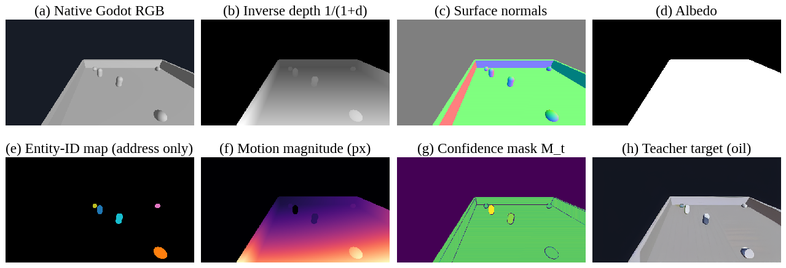
Figure 3.2: Structural inputs, motion and confidence mask for one test frame

3.1.3 Encoder Layer (Feature-Extraction and Rendering Network)
Heading adapted to the project: the network is a convolutional encoder–decoder whose encoder is the feature extractor. The deployed StyleTemporalUNet (Figure 3.3, Table 3.4) has 8,394,915 parameters.
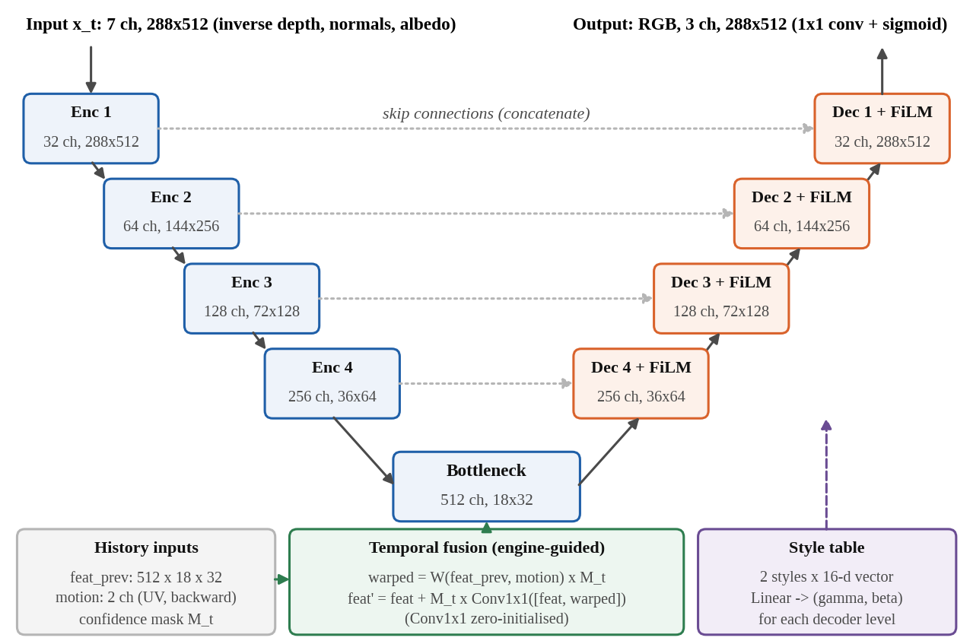
Figure 3.3: StyleTemporalUNet: style-free encoder, temporal fusion, FiLM decoder
Encoder. Four levels, each of two 3 × 3 convolutions with group normalisation (8 groups) [19] and ReLU followed by 2 × 2 max pooling, give 32, 64, 128 and 256 channels at 288 × 512 down to 36 × 64; a bottleneck produces 512 channels at 18 × 32. The encoder reads only structure, never the style, so its features are the same whichever style is shown and can serve as history across a live style switch.
Temporal fusion. The previous frame's bottleneck features are warped by the engine motion, masked, and fused through a zero-initialised 1 × 1 convolution, so an untrained model equals the single-frame U-Net and history is ignored wherever M_{t} = 0:
F′_{t} = F_{t} + M_{t} ⊙ Conv_{1×1}( [ F_{t} , M_{t} ⊙ W(F_{t−1}, V_{t}) ] ) (3.3)
Decoder with FiLM. Each level upsamples by 2, concatenates the encoder skip, applies two convolution blocks, and is modulated by FiLM [22] from the selected style's learned 16-dimensional vector s; zero-initialised projections make an untrained two-style model exactly the single-style one. A 1 × 1 convolution and sigmoid output RGB in [0, 1].
h′ = h ⊙ (1 + γ_{s}) + β_{s} , [ γ_{s} ; β_{s} ] = A_{l} s + b_{l} (3.4)
Table 3.4: Parameters of StyleTemporalUNet by block (counted from the model)
Block | Output (channels × H × W) | Parameters
Encoder, 4 levels | 32 × 288 × 512 → 256 × 36 × 64 | 1,175,328
Bottleneck | 512 × 18 × 32 | 3,542,016
Temporal fusion (1 × 1 conv) | 512 × 18 × 32 | 524,800
Decoder, 4 levels | 256 × 36 × 64 → 32 × 288 × 512 | 3,136,320
FiLM projections + style table | per decoder level | 16,320 + 32
Head (1 × 1 conv + sigmoid) | 3 × 288 × 512 | 99
Total |  | 8,394,915

Training objective. With teacher target I_{t}, prediction Î_{t} and pixel p, the same weights are used for every model in the project; the temporal term uses the prediction on both sides and the same mask as the evaluation metric:
L = ‖ Î_{t} − I_{t} ‖₁ + 0.5 · LPIPS(Î_{t}, I_{t}) + 0.5 · Σ_{p} M_{t} | Î_{t} − W(Î_{t−1}, V_{t}) | / Σ_{p} M_{t} (3.5)
Comparison models. For the ablation, Model A is the same U-Net without history; StructFormer (Models C–F) uses a convolutional stem, window-attention encoder and decoder [28] and a convolutional head; E adds entity-masked cross-attention and F adds the EPAM memory. All rungs were trained at parameter parity (0.9–1.1×) with the same data, seed, objective and selection rule [12].

3.2 Hardware Specifications
All recording, teacher generation, training, evaluation and live deployment ran on one laptop (Table 3.5); the project's logs record no cloud run behind any reported result. TensorRT engines were built on this GPU, as engines are specific to the GPU and version they are built with [9].
Table 3.5: Hardware used for all experiments
Component | Specification
Machine | Laptop — make and model [DETAILS REQUIRED]
CPU | AMD Ryzen 9 8940HX, 16 cores / 32 threads
System memory | 30 GiB visible to the operating system
GPU | NVIDIA GeForce RTX 5060 Laptop GPU, 8 GB (Blackwell, compute capability 12.0), driver 610.57.04
Storage | 2 × 1 TB NVMe SSD
Operating system | Omarchy (Arch Linux based), Linux kernel 7.2.5

The CPU runs Godot, data loading (8 workers) and the C++ motion computation; the GPU runs teacher generation, bfloat16 training, evaluation and TensorRT inference. The 8 GB of GPU memory, shared with the desktop display, was the binding constraint: training used batch 4 with gradient accumulation 2 (effective batch 8).

3.3 Software Specifications
Table 3.6: Software environment (versions read from the environment)
Category | Software and version | Purpose
Game engine | Godot 4.7.2, Forward+ [6] | Game, structural export, live loop
Native extension | C++17, godot-cpp [32], GCC 16.2.1, CMake 4.4.4 | GDExtension and C++ runtime
Deep learning | Python 3.10.21; PyTorch 2.13.0 (CUDA 13.2) [33]; torchvision 0.28.0 | Models, training, evaluation
Inference | TensorRT 11.2.1.2 [9]; ONNX 1.22.0 [8]; ONNX Runtime 1.23.2 | Export and runtime engines
Teacher | Diffusers 0.40.0 [34]; Transformers 5.16.1 | Target generation
Metrics and tools | lpips 0.1.4 [25]; NumPy 2.2.6; matplotlib 3.10.9; pytest 9.1.1 | Metrics, figures, tests

Godot scripts record the dataset; Python reads it for teacher generation, training and evaluation; a checkpoint is exported once to ONNX and compiled by TensorRT; the C++ GDExtension loads the engines and is called from GDScript every frame. Python and C++ share one TensorRT build, so engines and numerical checks are shared.

CHAPTER 4: PERFORMANCE EVALUATION

4.1 Experimental Setup
The environment, data and preprocessing are given in Chapter 3. Table 4.1 lists the configuration of the deployed model (configs/game/model_b_two_style.json); the ablation rungs used the same optimiser, schedule, objective and selection rule on the seed-scene dataset.
Table 4.1: Training and evaluation configuration of the deployed model
Item | Setting
Data | 18 training sessions, both styles: 35,526 training samples; 5,936 validation frames
Objective | 1 · L1 + 0.5 · LPIPS (AlexNet) + 0.5 · temporal term — Eq. (3.5)
Optimiser / schedule | AdamW [35], learning rate 2 × 10⁻⁴, weight decay 10⁻⁴; cosine annealing [36]
Batch / precision | 4 × gradient accumulation 2 (effective 8); bfloat16 mixed precision
Epochs / stopping | 60 maximum, validation every 2; early-stopping patience 6 evaluations (not triggered)
Selection / seed | lowest validation L1 over both styles; seed 20260905
Wall time / best | 29.2 h; best epoch 49 (validation L1 0.007435)
Test protocol | 3 sealed sessions, 2,968 frames per style, each with its real previous frame; flicker on 2,451 moving pairs

Baselines. The ablation ladder compares A (U-Net), B (A + temporal), C (StructFormer), D (C + temporal), E (C + entity masks), the control N (C + raw ID channel), and F/F0 (E with and without EPAM). On the game, the deployed model is compared with an oil-only Model B and with the unstyled native frame (the do-nothing anchor).
Reproducibility. Thresholds were written into evaluator code or the Decision Log before results existed; seeds, configurations and JSON reports are under version control; weights are published as GitHub releases. Seed variance measured on the seed scene (three seeds of Models C and E) sets the noise thresholds; game models were trained once, so small differences between them are not claimed. The automated test suite (548 tests) passed in full when re-run on 23 October 2026.

4.2 Evaluation Metrics
The task is image regression with temporal and real-time requirements, so classification metrics do not apply. Below, Î is the prediction and I the target in [0, 1], and N the number of pixel values.
L1 and PSNR. Mean absolute error, and peak signal-to-noise ratio in dB (higher is better); both reward blur when targets are uncertain [26].
L1 = (1/N) Σ_{i} | Î_{i} − I_{i} | , PSNR = 10 · log₁₀( 1 / MSE ) (4.1)
SSIM [24] compares local means µ, variances σ² and covariance σ_{xy} (11 × 11 Gaussian windows; 1 = identical). LPIPS [25] is a distance between deep AlexNet features (lower is better); being part of the objective, it is never quoted alone.
SSIM = (2µ_{x}µ_{y} + C₁)(2σ_{xy} + C₂) / ((µ_{x}² + µ_{y}² + C₁)(σ_{x}² + σ_{y}² + C₂)) (4.2)
Sharpness ratio. High-pass energy of the prediction relative to the target (squared Sobel gradients of luma Y, summed over the test set). A value of 0.90 corresponds to roughly a 1-pixel Gaussian blur of the target. It is a blur guard, not proof of quality.
S = Σ ‖ ∇Y(Î) ‖² / Σ ‖ ∇Y(I) ‖² (4.3)
Histogram travel (style acquisition). With h the 32-bin per-channel colour histogram and I_{nat} the native frame, the ratio of how far the model moves the palette relative to the teacher (gate ≥ 0.80).
travel ratio = ‖ h(Î) − h(I_{nat}) ‖₁ / ‖ h(I) − h(I_{nat}) ‖₁ (4.4)
Temporal error (flicker). Mean difference between a frame and the previous frame warped by engine motion, on confident pixels, over pairs with at least 1 pixel of median motion; lower is steadier. Since a frozen output scores zero, it is always reported with sharpness.
TE = Σ_{p} M_{t} | I_{t} − W(I_{t−1}, V_{t}) | / Σ_{p} M_{t} (4.5)
Noise threshold. A difference between two single runs is claimed only if it exceeds 2√2 · sd_{rel}, where sd_{rel} is the relative seed-to-seed standard deviation. Runtime. Frames per second = 1000 / median loop time (ms) for the whole live loop; engine latency is the median of 500 standalone TensorRT runs; the fallback rate is the fraction of styled frames that showed the native image.

4.3 Results and Analysis

4.3.1 Training Behaviour
Figure 4.1 shows the training of the deployed model. Validation L1 reaches its minimum of 0.007435 at epoch 49 and then flattens. The temporal term rises during training as the initially smooth (hence stable) output acquires the teacher's texture, which is why temporal error is always reported with sharpness.
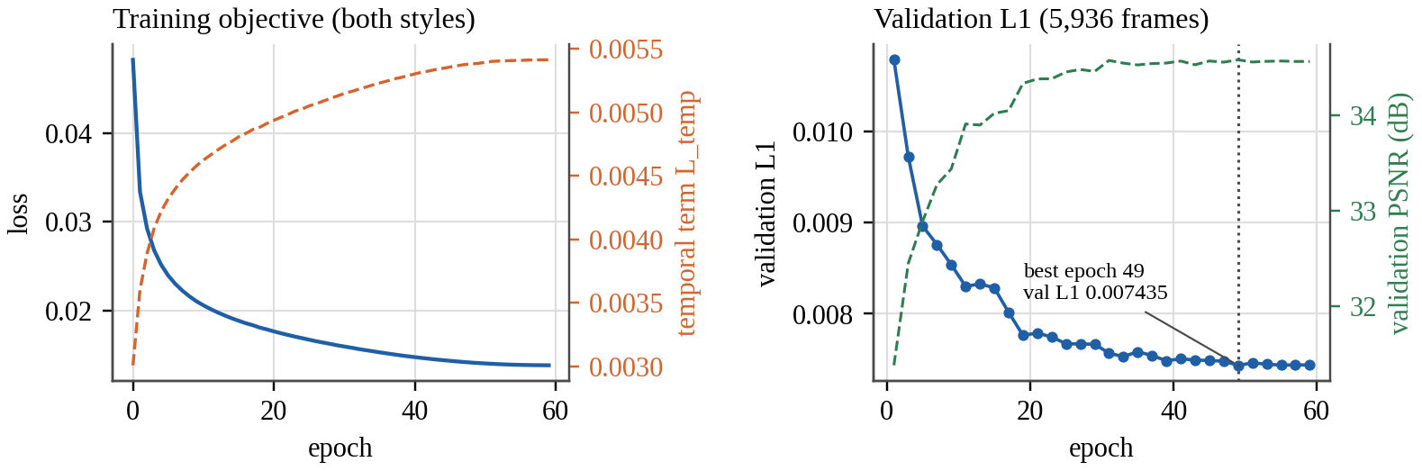
Figure 4.1: Training objective and validation L1/PSNR of the deployed model

4.3.2 Ablation Ladder
Table 4.2 reports every rung on the same 3,960 sealed test frames of the seed scene, scored by one evaluation script; temporal error is measured on 501 moving pairs.
Table 4.2: Ablation ladder on the sealed seed-scene test split
Rung | PSNR (dB) | SSIM | LPIPS | Sharpness | Temporal error | Parameters
A U-Net | 34.04 | 0.9747 | 0.0459 | 0.912 | 0.003175 | 7.85 M
B U-Net + temporal | 33.64 | 0.9734 | 0.0489 | 0.897 | 0.002692 (−15.2 %) | 8.38 M
C StructFormer | 33.86 | 0.9728 | 0.0466 | 0.853 | 0.004191 | 7.78 M
D StructFormer + temporal | 33.56 | 0.9727 | 0.0485 | 0.858 | 0.003741 (−10.7 %) | 8.24 M
E StructFormer + entity | 33.79 | 0.9726 | 0.0463 | 0.884 | 0.004172 | 7.05 M
N raw-ID control | 33.86 | 0.9732 | 0.0459 | 0.880 | – | 7.78 M
Teacher targets / native engine | – | – | – | – | 0.006265 / 0.000241 | –

The plain U-Net (A) is best on every image-quality metric and is the only rung above the 0.90 sharpness gate. StructFormer's sharpness was 0.833, 0.886 and 0.851 at 644, 10,890 and 20,790 training frames, against a pre-recorded projection of 0.898: more data did not close the gap, so at this scale the CNN's inductive bias suits the task better. Temporal conditioning cuts flicker on both backbones by 15.2 % (B vs A) and 10.7 % (D vs C), well beyond the pre-registered threshold of 3.85 % (2√2 × 1.36 %), at a cost of 1.8–3.9 % in per-frame L1; since flicker is the more visible defect live, Model B was chosen for the game. Entity awareness sharpens StructFormer (+0.015 over C across three seeds, 2.5σ), but the naive raw-ID control N recovers about 87 % of that gain: with two or three stable IDs in this scene, exposing the IDs is enough.
EPAM (O8) is a negative result. Model F (memory on) and its twin F0 (memory off) share code, data, schedule and selection rule. On 3,912 test clips, F − F0 sharpness is −0.0127 (0.8829 vs 0.8956), inside the pre-registered threshold of 0.0206 and in the wrong direction. Three independent measurements agree that this data gives memory nothing to recover, most likely because the diffusion teacher re-invents each object's look every frame. The memory's lifecycle rules (retrieval after leaving view, no leakage after destruction, clearing on style change) are met and covered by 17 tests.

4.3.3 The Deployed Two-Style Model
Table 4.3: Game test sessions (2,968 frames per style)
Model, style | PSNR (dB) | SSIM | LPIPS | Sharpness | Travel ratio | Flicker vs teacher
Two-style B, oil | 35.33 | 0.9807 | 0.0225 | 0.946 | 0.995 | 0.54×
Two-style B, watercolour | 34.79 | 0.9786 | 0.0243 | 0.937 | 0.987 | 0.48×
Oil-only B, oil (reference) | 35.43 | 0.9814 | 0.0216 | 0.946 | 0.980 | 0.54×
Do-nothing (native frame), oil / watercolour | 28.06 / 26.96 | – | – | – | – | –

Table 4.3 shows that both styles clear the sharpness and travel gates and beat doing nothing by 7.3–7.8 dB. Sharing one model between two styles costs oil 0.10 dB, which is not claimed as significant with one run per model. The renderer flickers about half as much as its own teacher but still about 57× the native engine. The style switch is real, not a blend: on a sampled test session each style's output is about 4× closer to its own targets than to the other style's, reproducing 93 % of the difference between the two teachers. Figure 4.2 shows a sealed test frame rendered through exactly the evaluated path: geometry is the engine's in every column; only appearance changes. The styles are mild because the game is grey and plainly lit, and stronger settings fail the gates.
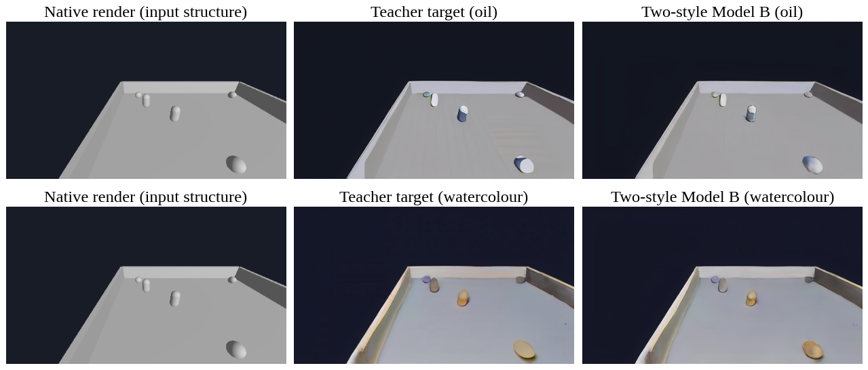
Figure 4.2: Native input, teacher target and model output for one sealed test frame
Value of history. Run as a cold start every frame, the same model drops from 35.33 to 33.58 dB (oil) and from 34.79 to 32.82 dB (watercolour), so the live runtime feeds history back every frame.

4.3.4 Live Deployment
To ensure the game shows the evaluated model, each link from evaluator to screen was checked with identical inputs (Table 4.4).
Table 4.4: Equivalence chain from evaluator to live game
Link | Maximum difference
Exported LiveStep graph vs Python evaluator (RGB) | 2.4 × 10⁻⁶
TensorRT strict FP32 vs PyTorch (RGB / fed-back features) | 1.6 × 10⁻⁶ / 7.3 × 10⁻⁶
C++ motion vs engine GDScript motion (120 lockstep frames) | 7.5 × 10⁻⁸ UV
Live game frame vs evaluated model | 1/255 (rounding); 0 pixels above
Enemy spawned mid-game: no-history pixels, C++ vs engine ID map | 998 = 998 pixels

The FP16 engine passed a tolerance fixed before measurement (mean |ΔPSNR| < 0.05 dB, mean pixel change < 1/255) with 0.044 / 0.039 dB and 0.0004; its few larger pixel differences lie on one-pixel object outlines. Figure 4.3 and Table 4.5 report the live measurements on the playable game.
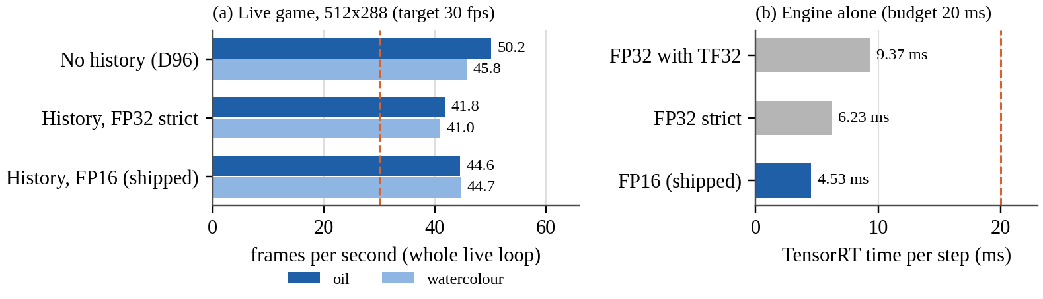
Figure 4.3: Live frame rate of the whole loop, and TensorRT latency alone
Table 4.5: M10 exit criteria, measured on the playable game
Criterion (KB target) | Result | Verdict
Stable live loop | 3,000 frames, 0 fallbacks; median 22.4 ms (first half) vs 22.3 ms (second half); p99 25.2 ms | Met
About 30 fps at 512 × 288 | 44.6 fps oil, 44.7 fps watercolour (FP16) | Met
TensorRT alone ≤ about 20 ms | 4.53 ms FP16; 6.23 ms strict FP32; 9.37 ms with TF32 | Met
Failure does not break gameplay | 8 of 8 forced failures fell back to the native frame; play continued; next frame rendered | Met

FP16 is 27 % faster than strict FP32, so it ships. In a manual play session on 23 October 2026 (free play, desktop applications open), 2,059 styled frames ran at 40.1 fps (oil) and 38.0 fps (watercolour) with 0 fallbacks.

4.3.5 Assessment of Objectives and Limitations
Table 4.6: Objectives and the evidence for each
Objective | Status | Evidence
O1 Data pipeline | Achieved | 24/24 game and 29/30 seed sessions validated; corrupt session rejected
O2 Gated supervision | Achieved | Two gate-passing styles; 11 of 23,760 frames excluded by rule
O3 Image quality | Achieved | Sharpness 0.946 / 0.937; travel 0.995 / 0.987
O4 Temporal stability | Achieved | −15.2 % and −10.7 % vs 3.85 % threshold; 0.54× / 0.48× teacher flicker
O5 Ablation | Achieved | All rungs at parity on one scoring path; U-Net best
O6 Style switching | Achieved | One model, two styles; switch keeps history
O7 Deployment | Achieved | 44.6 fps; 4.53 ms; 0 fallbacks in 3,000 frames
O8 EPAM improves output | Not achieved | F − F0 = −0.0127 sharpness, inside noise

Limitations. The evidence covers one simple game and two mild styles; teacher flicker bounds temporal quality; game models were trained once; and style strength is limited by the gates. A move to 768 × 432 was stopped before the bulk run because the teacher's look changes with resolution: the best re-tuned settings were no closer to the committed look than the unstyled frame (LPIPS 0.094 / 0.100 vs 0.099 / 0.117).

CHAPTER 5: CONCLUSION AND FUTURE WORK

5.1 Summary of the Contributions
The project set out to add a learned artistic style to a playable game without letting a neural network decide anything about the game. It delivered a complete, verified pipeline, from engine instrumentation and a 23,760-frame validated dataset to a gated diffusion teacher, a temporally conditioned two-style U-Net, and an ONNX → TensorRT → C++ → Godot runtime. Its main contributions are:
- An engine-grounded design in which structure is the input, engine motion drives warping, and entity identity addresses masks and memory; none of them becomes a source of gameplay truth.
- Gated supervision from a diffusion teacher, including a stylisation gate that rejects a teacher that does nothing, and an explicit per-frame exclusion rule.
- A style-free encoder with FiLM decoding, so one 8.39 M-parameter model renders two styles and keeps its temporal memory across a live switch.
- A verified live deployment at 44.6 fps (4.53 ms per FP16 step), with a link-by-link proof that the live frame equals the evaluated model's frame within rounding, and pre-registered, honest evaluation, including two negative results (StructFormer and EPAM).

5.2 Future Work
- A temporally consistent teacher (video-consistent diffusion or authored per-entity textures), which bounds both stability and EPAM's usefulness.
- Re-testing EPAM in scenes with many entities, occlusions and recycled IDs, as a new pre-registered experiment with repeated seeds.
- Higher resolution with a matched look, for example super-resolution from 512 × 288 targets, or new styles designed at 768 × 432.
- Broader evaluation: more games and textured scenes, human-play data, seed variance on the game, optional adversarial sharpening, and INT8/FP8 inference.

REFERENCES
[1] A. Tewari et al., "State of the art on neural rendering," Comput. Graph. Forum, vol. 39, no. 2, pp. 701–727, 2020, doi: 10.1111/cgf.14022.
[2] T. Saito and T. Takahashi, "Comprehensible rendering of 3-D shapes," ACM SIGGRAPH Comput. Graph., vol. 24, no. 4, pp. 197–206, 1990, doi: 10.1145/97880.97901.
[3] S. W. Kim, Y. Zhou, J. Philion, A. Torralba, and S. Fidler, "Learning to simulate dynamic environments with GameGAN," in Proc. IEEE/CVF Conf. Comput. Vis. Pattern Recognit. (CVPR), 2020, pp. 1228–1237, doi: 10.1109/CVPR42600.2020.00131.
[4] D. Valevski, Y. Leviathan, M. Arar, and S. Fruchter, "Diffusion models are real-time game engines," in Proc. Int. Conf. Learn. Represent. (ICLR), 2025, arXiv:2408.14837.
[5] J. Bruce et al., "Genie: Generative interactive environments," arXiv preprint arXiv:2402.15391, 2024.
[6] Godot Engine contributors, "Godot Engine documentation." [Online]. Available: https://docs.godotengine.org/en/stable/ (accessed Oct. 23, 2026).
[7] O. Ronneberger, P. Fischer, and T. Brox, "U-Net: Convolutional networks for biomedical image segmentation," in Medical Image Computing and Computer-Assisted Intervention – MICCAI 2015 (Lecture Notes in Computer Science). Cham, Switzerland: Springer, 2015, pp. 234–241, doi: 10.1007/978-3-319-24574-4_28.
[8] ONNX Project, "Open Neural Network Exchange (ONNX)." [Online]. Available: https://onnx.ai/ (accessed Oct. 23, 2026).
[9] NVIDIA Corporation, "NVIDIA TensorRT documentation." [Online]. Available: https://docs.nvidia.com/deeplearning/tensorrt/latest/ (accessed Oct. 23, 2026).
[10] R. Rombach, A. Blattmann, D. Lorenz, P. Esser, and B. Ommer, "High-resolution image synthesis with latent diffusion models," in Proc. IEEE/CVF Conf. Comput. Vis. Pattern Recognit. (CVPR), 2022, pp. 10674–10685, doi: 10.1109/CVPR52688.2022.01042.
[11] L. Zhang, A. Rao, and M. Agrawala, "Adding conditional control to text-to-image diffusion models," in Proc. IEEE/CVF Int. Conf. Comput. Vis. (ICCV), 2023, pp. 3813–3824, doi: 10.1109/ICCV51070.2023.00355.
[12] StructRender project, "StructRender: System architecture and knowledge base, including the Decision Log (Decisions 1–102)," unpublished technical document, docs/StructRender_KB.md, Oct. 2026.
[13] S. R. Richter, H. A. Alhaija, and V. Koltun, "Enhancing photorealism enhancement," IEEE Trans. Pattern Anal. Mach. Intell., vol. 45, no. 2, pp. 1700–1715, 2023, doi: 10.1109/TPAMI.2022.3166687.
[14] W.-S. Lai, J.-B. Huang, O. Wang, E. Shechtman, E. Yumer, and M.-H. Yang, "Learning blind video temporal consistency," in Computer Vision – ECCV 2018 (Lecture Notes in Computer Science). Cham, Switzerland: Springer, 2018, pp. 179–195, doi: 10.1007/978-3-030-01267-0_11.
[15] J. Ho, A. Jain, and P. Abbeel, "Denoising diffusion probabilistic models," in Advances in Neural Information Processing Systems (NeurIPS), 2020, arXiv:2006.11239.
[16] Hugging Face model repository "stable-diffusion-v1-5/stable-diffusion-v1-5," revision 451f4fe1. [Online]. Available: https://huggingface.co/stable-diffusion-v1-5/stable-diffusion-v1-5 (accessed Oct. 23, 2026).
[17] Hugging Face model repository "lllyasviel/sd-controlnet-depth," revision 35e42a3e. [Online]. Available: https://huggingface.co/lllyasviel/sd-controlnet-depth (accessed Oct. 23, 2026).
[18] P. Isola, J.-Y. Zhu, T. Zhou, and A. A. Efros, "Image-to-image translation with conditional adversarial networks," in Proc. IEEE Conf. Comput. Vis. Pattern Recognit. (CVPR), 2017, pp. 5967–5976, doi: 10.1109/CVPR.2017.632.
[19] Y. Wu and K. He, "Group normalization," in Computer Vision – ECCV 2018 (Lecture Notes in Computer Science). Cham, Switzerland: Springer, 2018, pp. 3–19, doi: 10.1007/978-3-030-01261-8_1.
[20] L. A. Gatys, A. S. Ecker, and M. Bethge, "Image style transfer using convolutional neural networks," in Proc. IEEE Conf. Comput. Vis. Pattern Recognit. (CVPR), 2016, pp. 2414–2423, doi: 10.1109/CVPR.2016.265.
[21] V. Dumoulin, J. Shlens, and M. Kudlur, "A learned representation for artistic style," in Proc. Int. Conf. Learn. Represent. (ICLR), 2017, arXiv:1610.07629.
[22] E. Perez, F. Strub, H. de Vries, V. Dumoulin, and A. Courville, "FiLM: Visual reasoning with a general conditioning layer," in Proc. AAAI Conf. Artif. Intell., vol. 32, no. 1, 2018, doi: 10.1609/aaai.v32i1.11671.
[23] C. Meng, Y. He, Y. Song, J. Song, J. Wu, J.-Y. Zhu, and S. Ermon, "SDEdit: Guided image synthesis and editing with stochastic differential equations," in Proc. Int. Conf. Learn. Represent. (ICLR), 2022, arXiv:2108.01073.
[24] Z. Wang, A. C. Bovik, H. R. Sheikh, and E. P. Simoncelli, "Image quality assessment: From error visibility to structural similarity," IEEE Trans. Image Process., vol. 13, no. 4, pp. 600–612, 2004, doi: 10.1109/TIP.2003.819861.
[25] R. Zhang, P. Isola, A. A. Efros, E. Shechtman, and O. Wang, "The unreasonable effectiveness of deep features as a perceptual metric," in Proc. IEEE/CVF Conf. Comput. Vis. Pattern Recognit. (CVPR), 2018, pp. 586–595, doi: 10.1109/CVPR.2018.00068.
[26] Y. Blau and T. Michaeli, "The perception-distortion tradeoff," in Proc. IEEE/CVF Conf. Comput. Vis. Pattern Recognit. (CVPR), 2018, pp. 6228–6237, doi: 10.1109/CVPR.2018.00652.
[27] L. Xiao, S. Nouri, M. Chapman, A. Fix, D. Lanman, and A. Kaplanyan, "Neural supersampling for real-time rendering," ACM Trans. Graph., vol. 39, no. 4, 2020, doi: 10.1145/3386569.3392376.
[28] Z. Liu, Y. Lin, Y. Cao, H. Hu, Y. Wei, Z. Zhang, S. Lin, and B. Guo, "Swin Transformer: Hierarchical vision transformer using shifted windows," in Proc. IEEE/CVF Int. Conf. Comput. Vis. (ICCV), 2021, pp. 9992–10002, doi: 10.1109/ICCV48922.2021.00986.
[29] O. Nalbach, E. Arabadzhiyska, D. Mehta, H.-P. Seidel, and T. Ritschel, "Deep shading: Convolutional neural networks for screen space shading," Comput. Graph. Forum, vol. 36, no. 4, pp. 65–78, 2017, doi: 10.1111/cgf.13225.
[30] T.-C. Wang, M.-Y. Liu, J.-Y. Zhu, G. Liu, A. Tao, J. Kautz, and B. Catanzaro, "Video-to-video synthesis," in Advances in Neural Information Processing Systems (NeurIPS), 2018, arXiv:1808.06601.
[31] A. Mallya, T.-C. Wang, K. Sapra, and M.-Y. Liu, "World-consistent video-to-video synthesis," in Computer Vision – ECCV 2020 (Lecture Notes in Computer Science). Cham, Switzerland: Springer, 2020, pp. 359–378, doi: 10.1007/978-3-030-58598-3_22.
[32] Godot Engine contributors, "godot-cpp: C++ bindings for the Godot script API (GDExtension)," GitHub repository. [Online]. Available: https://github.com/godotengine/godot-cpp (accessed Oct. 23, 2026).
[33] A. Paszke et al., "PyTorch: An imperative style, high-performance deep learning library," in Advances in Neural Information Processing Systems (NeurIPS), 2019, arXiv:1912.01703.
[34] Hugging Face, "Diffusers: State-of-the-art diffusion models," GitHub repository. [Online]. Available: https://github.com/huggingface/diffusers (accessed Oct. 23, 2026).
[35] I. Loshchilov and F. Hutter, "Decoupled weight decay regularization," in Proc. Int. Conf. Learn. Represent. (ICLR), 2019, arXiv:1711.05101.
[36] I. Loshchilov and F. Hutter, "SGDR: Stochastic gradient descent with warm restarts," in Proc. Int. Conf. Learn. Represent. (ICLR), 2017, arXiv:1608.03983.

APPENDICES

Appendix A: Deployed Model Configuration (abridged)
{ "data": { "styles": ["oil_impasto", "watercolor_bold_s055"],
"split_file": "configs/data/game_split_v1.json",
"frame_exclusions":
"configs/data/game_frame_exclusions_v1.json" },
"model": { "in_channels": 7, "out_channels": 3, "base_channels": 32,
"image_size": [288, 512], "arch": "style_temporal_unet" },
"train": { "seed": 20260905, "epochs": 60, "lr": 0.0002,
"weight_decay": 0.0001, "amp_dtype": "bfloat16",
"batch_size": 4, "accum_steps": 2, "eval_every_epochs": 2,
"early_stopping": { "patience_evals": 6,
"min_rel_delta": 0.001 } },
"loss": { "l1": 1.0, "perceptual": 0.5, "perceptual_net": "alex",
"temporal": 0.5 } }
Evidence for every number in this report is in the repository: eval/reports/ (JSON reports), eval/logs/ (logs) and docs/StructRender_KB.md (Decision Log).

Appendix B: Milestone Scorecard
Table B.1: Milestones M0–M10 and their verdicts
Milestone | Verdict
M0 Repository and minimal Godot game | Complete
M1 Structural export | Complete
M2 Dataset recorder and validator | Complete
M3 Offline teacher targets and alignment gates | Complete
M4 CNN / U-Net baseline | Passes at every dataset size
M5 StructFormer baseline | Fails: below the U-Net at all three data sizes
M6 Temporal reprojection | Passes; replicated on new data
M7 Structured entity awareness | Complete
M8 EPAM | Criteria 1–3 met; criterion 4 (improves output) not met
M9 Full evaluation (ablation ladder) | Complete
M10 ONNX → TensorRT → C++ → Godot | Passes all exit criteria

Appendix C: Supplementary Screenshots
Figures C.1 and C.2 show screenshots of https://structrender.vercel.app/, a separate project: a Spider-Man web-swinging game for the browser (Three.js), and an unofficial fan project not affiliated with Marvel, Disney, Sony or Insomniac Games. Its 16 themes are drawn by its own rendering pipeline, not by the StructRender model of Chapter 4. The originals are in docs/screenshots/.
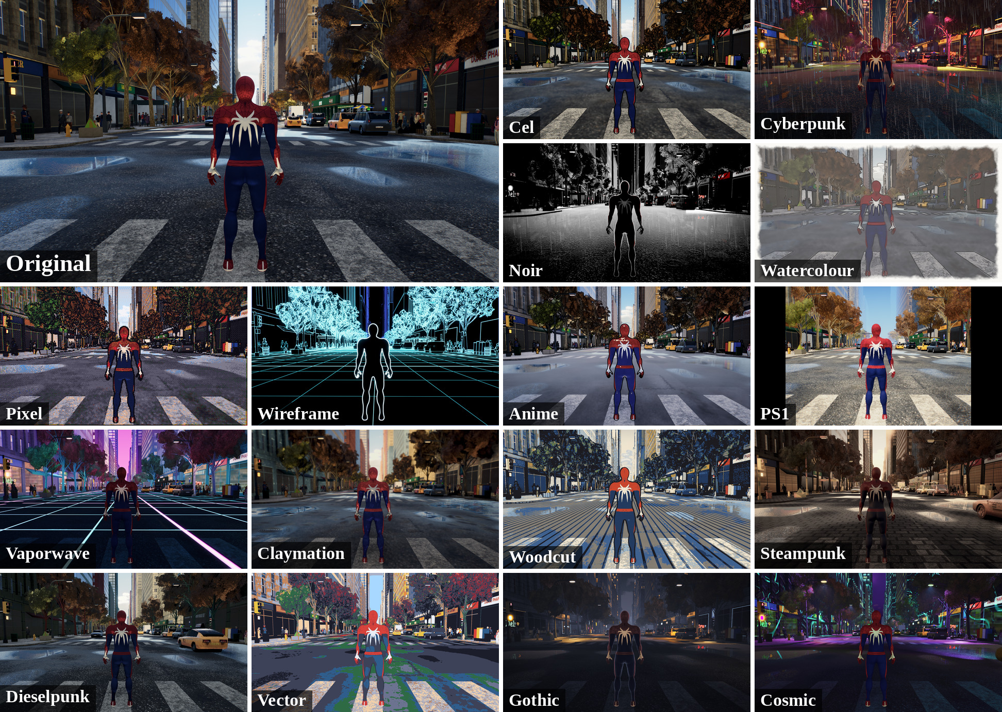
Figure C.1: Street scene: the original frame (top left) and 16 visual themes
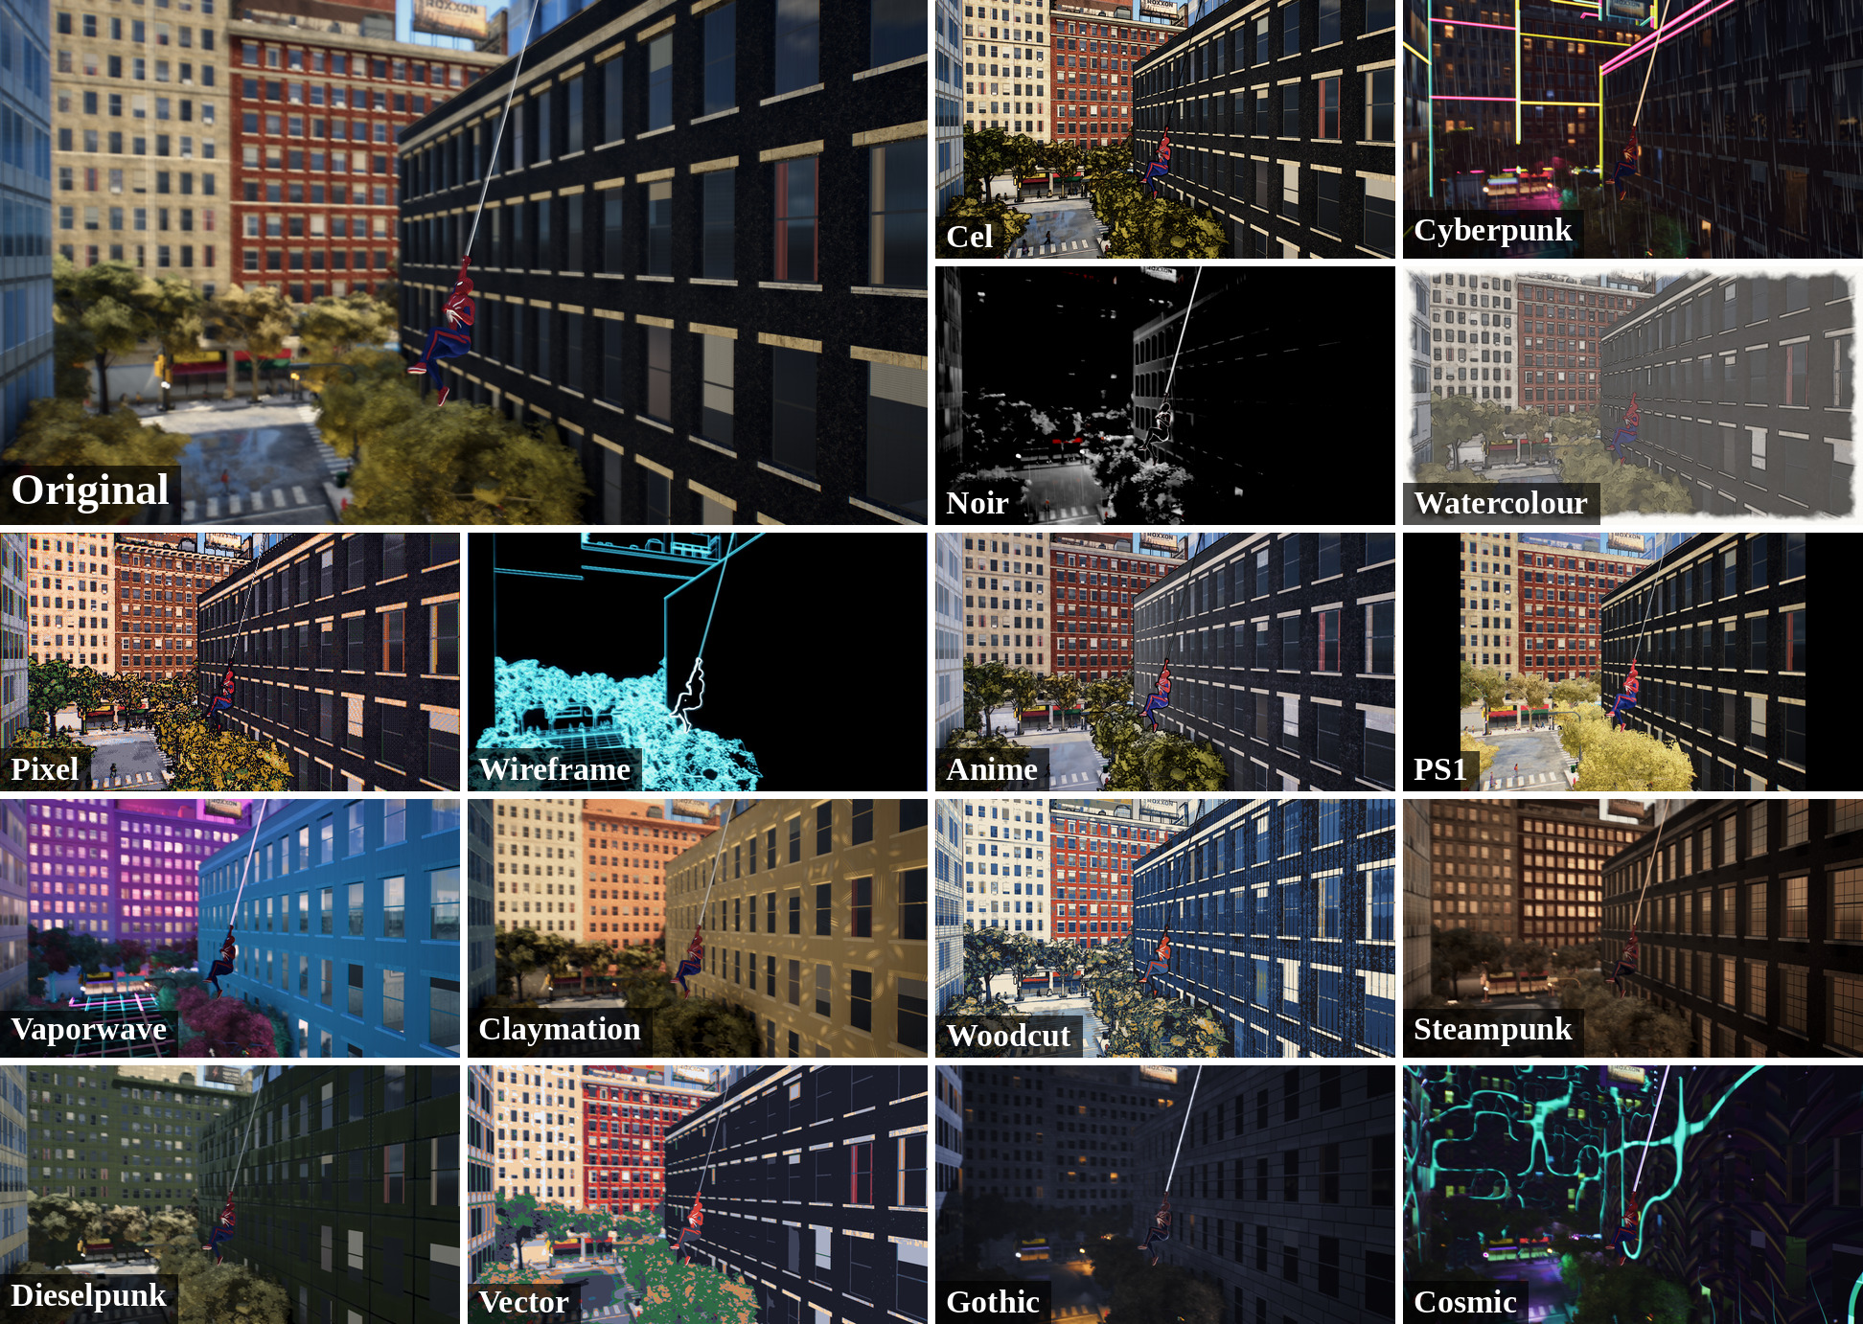
Figure C.2: Swinging scene: the original frame (top left) and 16 visual themes

