
StructRender
The Complete Project Guide
Everything we built, why, how it works, what we found, and how to explain it
Engine-Grounded Real-Time Neural Rendering of a Game in Learned Painterly Styles
Kabilash S – E0323036
Pavitra P – E0323038
Guide: Dr. V. Vanitha, Associate Professor, Department of CSE (AIML)
ADA23DLU06 – Recent Trends in Deep Learning Laboratory
Sri Ramachandra Faculty of Engineering and Technology, SRIHER, Chennai
November 2026
CONTENTS
How to Use This Guide 1
1. The Project on One Page 2
1.1 The idea 2
1.2 What was built 2
1.3 Headline numbers 2
1.4 What did not work (reported honestly) 3
2. Background Concepts from Scratch 4
2.1 How a game draws a frame 4
2.2 The G-buffer: structure without appearance 4
2.3 Motion vectors, warping and disocclusion 4
2.4 Neural networks in five minutes 5
2.5 The U-Net 5
2.6 Transformers and window attention (StructFormer) 5
2.7 Conditioning a network on a style: FiLM 6
2.8 Diffusion models, img2img and ControlNet 6
2.9 Losses and metrics 6
2.10 Training tools 7
2.11 Deployment: ONNX, TensorRT and precision 7
2.12 Research discipline used throughout 7
3. The System from Start to End 8
3.1 Stage 1 – The Godot game 8
3.2 Stage 2 – Structural export 8
3.3 Stage 3 – Recording and validation 9
3.4 Stage 4 – The diffusion teacher 9
3.5 Stage 5 – The four alignment gates 9
3.6 The confidence mask 9
3.7 Stage 6 – The network: StyleTemporalUNet 10
3.8 Training 11
3.9 Stages 7 and 8 – Deployment and the live loop 11
4. Results 13
4.1 The ablation ladder 13
4.2 The deployed two-style model on the game 14
4.3 Temporal stability and the value of history 14
4.4 Live performance 15
4.5 EPAM: the headline idea that did not help 16
5. The Project Story, Milestone by Milestone 17
5.1 Turning points worth knowing 17
6. Limitations 19
7. How to Run Everything 20
7.1 Commands 20
7.2 Where things are in the repository 20
7.3 Related deliverables 20
8. Glossary 21
9. Viva Questions and Answers 22
Appendix: All 102 Decisions 24

How to Use This Guide
This guide is written so that someone who has never seen the project, or has forgotten it, can read it once from start to end and then explain every part of StructRender: what it does, why each choice was made, how every component works, what the experiments showed, and what went wrong along the way.
- Chapter 1 gives the whole project on one page. Read it first, and again just before a viva.
- Chapter 2 teaches every background idea from scratch: how a game draws a frame, neural networks, U-Nets, diffusion models, losses, metrics and deployment. Skip what you already know.
- Chapter 3 walks the pipeline from the game to the live screen, stage by stage.
- Chapter 4 gives every result with its numbers. Chapter 5 tells the project's history, including the bugs and the ideas that were refuted.
- Chapters 6 to 9 cover limitations, how to run everything, a glossary and likely viva questions with answers. The appendix lists all 102 recorded decisions.
Numbers in this guide are copied from the project's own records: docs/REPORT.md, the lab report and the Decision Log in docs/StructRender_KB.md. Decisions are cited as D1 to D102.

1. The Project on One Page
A game engine keeps all gameplay truth; a small neural network only decides how each frame looks, in a learned painted style, live.

1.1 The idea
Recent research builds generative world models (GameNGen, Genie) that predict a game's next frame directly from earlier frames. They are impressive, but they hold no real game state, so a collected coin can come back or a wall can move. StructRender takes the opposite position: a normal game engine (Godot 4) runs the game and owns everything that is true (physics, rules, which object is which). Every frame, the engine tells a neural network what is where: depth, surface directions, base colours and object identities. The network paints that structure in an artistic style. Because the network never touches game state, a renderer error can never become a gameplay error.

1.2 What was built
- A playable Godot game (an arena: a player collects coins while spawned enemies chase) instrumented to export its structure every frame.
- A recorder and validator that captured 24 play sessions × 990 frames = 23,760 frames at 512 × 288.
- An offline diffusion teacher (Stable Diffusion 1.5 + depth ControlNet) that paints each frame in a style, with four alignment gates that reject paintings that lose or invent structure, or do nothing.
- StyleTemporalUNet, an 8,394,915-parameter U-Net that uses the previous frame (warped by the engine's motion) and a 16-number style vector, so one model renders two styles: oil and watercolour.
- A live runtime: ONNX → TensorRT FP16 → C++ GDExtension inside Godot, with a fallback to the plain frame on any error.
- A full ablation ladder comparing U-Net, transformer (StructFormer), temporal input, entity awareness and a per-entity memory (EPAM), with thresholds fixed before results.

1.3 Headline numbers
Table 1: The numbers to remember
What | Result
Image quality on held-out game sessions | 35.33 dB PSNR (oil), 34.79 dB (watercolour); sharpness 0.946 / 0.937 (gate 0.90)
Style learned, not ignored | colour travel 0.995 / 0.987 of the teacher's (gate 0.80); 7.3–7.8 dB better than showing the plain frame
Flicker | 0.54× (oil) and 0.48× (watercolour) the teacher's own flicker
Live speed | 44.6 fps oil, 44.7 fps watercolour (target 30); 4.53 ms per TensorRT FP16 step
Reliability | 0 fallbacks in 3,000 live frames; 8 of 8 forced failures recovered
Live = evaluated | live frame matches the scored model to within 1/255
Training | 60 epochs, 29.2 h on an RTX 5060 Laptop GPU; best epoch 49
Tests | 548 automated tests pass

1.4 What did not work (reported honestly)
- StructFormer, the window-attention transformer that was planned as the final renderer, never beat the plain U-Net, even with 32× more data (D49, D71).
- EPAM, the per-entity appearance memory that was the headline research idea, did not improve output on this data (F − F0 sharpness −0.0127, inside noise; D79).
- Moving to 768 × 432 was stopped because the teacher's look changes with resolution (D101, D102).
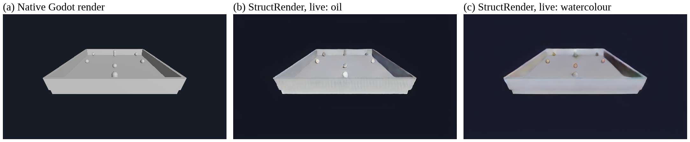
Figure 1: One live game frame: the native Godot render, and the same frame rendered live by StructRender in oil and in watercolour.

2. Background Concepts from Scratch
Every idea the project uses, explained so the rest of the guide reads easily.

2.1 How a game draws a frame
A game is a loop. Many times a second it (1) reads the player's input, (2) advances the simulation by a fixed step (physics, rules, enemy behaviour) and (3) draws a picture of the current state. The drawing step is rendering: the engine projects every 3D object through a virtual camera onto a 2D grid of pixels, works out which surface is nearest at each pixel, and shades it using materials and lights. Our game runs its physics at 60 Hz (60 steps per second). Godot is an open-source engine; we use version 4.7.2 with its Forward+ renderer.
The key point: the engine knows exactly where everything is. It does not guess. That exact knowledge is what StructRender gives to the neural network.

2.2 The G-buffer: structure without appearance
While rendering, an engine can write several per-pixel images besides the final colour. Together they are called a G-buffer (geometry buffer). StructRender exports four of them every frame:
- Depth: distance from the camera to the surface at each pixel, in metres. It tells the network the 3D shape. We feed inverse depth x = 1 / (1 + d), which stays between 0 and 1 and maps the empty sky (d = ∞) to 0.
- Normals: the direction each surface faces, as a 3D vector (3 channels). It tells the network how surfaces are oriented, which drives shading.
- Albedo: the plain base colour of the material, with no lighting (3 channels).
- Entity-ID map: an integer per pixel saying which object (player, coin, enemy) covers it. It is used only as an address: to find an object's pixels or key its memory. It is never fed to the network as a number, because a recycled ID would make a new object look like the old one (D9).
So the network input is 7 channels: inverse depth (1) + normals (3) + albedo (3), at 512 × 288 pixels.

2.3 Motion vectors, warping and disocclusion
A motion vector says, for each pixel, where that bit of surface was in the previous frame. Because the engine knows every object's and the camera's transform in both frames, it can compute motion exactly (analytically), instead of estimating it from images with an optical-flow network such as RAFT (D7).
Warping uses motion to move an image from the previous frame into the current frame's positions. If the previous frame's painted output is warped forward, it should line up with the current frame. Where it does not, something changed.
Disocclusion is a pixel that was hidden last frame and is visible now, for example the floor behind a coin that just moved. There is no valid history for it, so the network must not trust warped information there. StructRender builds a confidence mask M_{t} from the engine's own depth and normals to mark these pixels (Section 3.6).

2.4 Neural networks in five minutes
- A neural network is a function with millions of adjustable numbers called parameters (weights). It takes an input (our 7-channel image) and produces an output (an RGB image).
- A convolution slides a small filter (for example 3 × 3) across the image; each output pixel is a weighted sum of a small neighbourhood. Stacking many convolutions lets the network recognise edges, shapes and textures.
- Training shows the network many input–target pairs. A loss function measures how wrong the output is. Backpropagation computes the gradient, the direction that reduces the loss, and an optimiser nudges every parameter that way.
- One pass over the training data is an epoch. A batch is how many samples are processed before one update. Gradient accumulation adds the gradients of several small batches before updating, to simulate a bigger batch when GPU memory is short.
- Data is split into training (learn), validation (choose the best checkpoint, tune) and test (scored once, at the end). StructRender splits by whole play session, so test frames never come from a session the model trained on.
- Overfitting is when a model memorises training data and fails on new data. A seed fixes the random starting point; different seeds give slightly different models, which is run-to-run noise.

2.5 The U-Net
A U-Net is an encoder–decoder network shaped like a U. The encoder repeatedly applies convolutions and max pooling (halving the image size) so features become more abstract and cover more of the image. The bottleneck is the smallest, most abstract representation. The decoder upsamples step by step back to full size. Skip connections copy each encoder level's features straight across to the matching decoder level, so fine detail is not lost. U-Nets are the standard network for image-to-image tasks.
Our U-Net has four encoder levels with 32, 64, 128 and 256 channels, a bottleneck of 512 channels at 18 × 32, and a mirrored decoder. Each block uses group normalisation (which normalises groups of channels and does not depend on batch size) and ReLU (a simple non-linearity: negative values become zero).

2.6 Transformers and window attention (StructFormer)
A transformer uses attention: every position looks at other positions and takes a weighted mix of their features, with weights learned from content. Attention over a whole high-resolution image is too expensive, so window attention (as in the Swin Transformer) restricts it to small windows. StructFormer was the project's transformer renderer: a convolutional stem, window-attention encoder and decoder, and a convolutional head. A variant added entity-masked cross-attention, where each object's pixels attend to that object's own token. StructFormer was the planned final renderer (D3), but it lost to the U-Net (Section 4.1).

2.7 Conditioning a network on a style: FiLM
To let one network produce several styles, we give it a style vector s: 16 learned numbers per style. FiLM (feature-wise linear modulation) turns s into a per-channel scale γ and shift β for each decoder layer: h′ = h ⊙ (1 + γ) + β, where ⊙ means element-wise multiplication. Choosing a different s changes the look; nothing else in the network changes. Only the decoder is modulated, so the encoder is style-free: its features are the same whichever style is shown, which lets the frame-to-frame history survive a live style switch.
Zero initialisation is used everywhere a new mechanism is added: its last layer starts at zero, so an untrained network behaves exactly like the network without the mechanism. Training then decides whether to use it.

2.8 Diffusion models, img2img and ControlNet
A diffusion model learns to remove noise from images. To generate, it starts from noise and denoises in many small steps. Stable Diffusion 1.5 does this in a compressed latent space guided by a text prompt. img2img starts not from pure noise but from a real image with some noise added; the strength (0 to 1) sets how much is replaced: low strength keeps the image, high strength restyles more but may invent things.
ControlNet adds spatial control to a frozen diffusion model through a trainable side branch joined by zero-initialised layers. A depth ControlNet forces the generated image to follow a given depth map. StructRender feeds it the engine's own depth, so the painting keeps the real geometry. Diffusion is far too slow for live play (24 denoising steps per image), so it is used offline only, as a teacher that makes training targets (D6).

2.9 Losses and metrics
Table 2: Every loss and metric used
Name | What it measures | Better is
L1 (mean absolute error) | Average absolute difference per pixel value | Lower
MSE / PSNR | Mean squared error; PSNR = 10 · log₁₀(1 / MSE) in decibels | Higher PSNR
SSIM | Similarity of local brightness, contrast and structure (1 = identical) | Higher
LPIPS | Distance between deep (AlexNet) features; tracks human judgement | Lower
Sharpness ratio | High-frequency (Sobel gradient) energy of output ÷ target; 0.90 ≈ a 1-pixel blur | Close to 1; gate ≥ 0.90
Colour (histogram) travel | How far the model moves the colour histogram from the plain frame, relative to the teacher | Gate ≥ 0.80
Temporal error (flicker) | Difference between a frame and its warped predecessor on confident pixels | Lower, read with sharpness

Two subtleties matter. First, pixel losses like L1 reward blur: when the target is uncertain, the average is the safest guess (the perception–distortion trade-off). That is why every result is paired with the sharpness ratio. Second, a frozen or blurred output has tiny temporal error, so temporal error is never reported without sharpness.
The training loss is L = L1 + 0.5 · LPIPS + 0.5 · (masked temporal term). The temporal term compares each predicted frame with the previous predicted frame warped forward, only where the confidence mask trusts history.

2.10 Training tools
- AdamW: an adaptive optimiser with decoupled weight decay (a pull of weights toward zero that reduces overfitting). Learning rate 2 × 10⁻⁴, weight decay 10⁻⁴.
- Cosine schedule: the learning rate decreases smoothly along a cosine curve over training.
- bfloat16 mixed precision: computing in 16-bit floats where safe, to save memory and time on the GPU.
- Early stopping: stop if validation stops improving for a set number of checks (patience 6 evaluations); it was not triggered in the final run.
- Checkpoint selection: keep the epoch with the lowest validation L1 (epoch 49 of 60).

2.11 Deployment: ONNX, TensorRT and precision
- ONNX (Open Neural Network Exchange) is a standard file format for a trained network's computation graph, so it can leave PyTorch.
- TensorRT is NVIDIA's inference optimiser. It compiles an ONNX graph into an engine tuned for one specific GPU and driver, which is why engines are built on the target laptop (D16).
- Precision: FP32 (32-bit floats) is exact; TF32 is a faster, slightly less precise mode for FP32 maths on NVIDIA GPUs; FP16 (16-bit) is fastest. StructRender ships FP16 after checking it changes PSNR by under 0.05 dB.
- Latency is the time for one network step (4.53 ms for FP16). Frame rate (fps) is for the whole loop: capture, motion, inference and display (44.6 fps).
- A GDExtension is Godot's way to call native C++ code from game scripts. Our C++ runtime loads the TensorRT engines and is called from GDScript every frame.

2.12 Research discipline used throughout
- Pre-registration: every pass/fail threshold was written into the evaluator code or the Decision Log before the result existed, so no goalpost could move after seeing numbers.
- Noise threshold: a difference between two single training runs is claimed only if it exceeds 2√2 × the relative seed-to-seed standard deviation (from three seeds).
- Sealed test sets: test sessions were chosen by position before any model existed and scored once, at the end.
- Ablation ladder: models that differ by one idea each, at the same parameter count (0.9–1.1×), same data, loss and stopping rule, scored by one script.
- Negative results are kept: when a hypothesis failed, the result was recorded, not tuned away.

3. The System from Start to End
Eight stages: Godot game → export → record → teacher → gates → train → deploy → live.
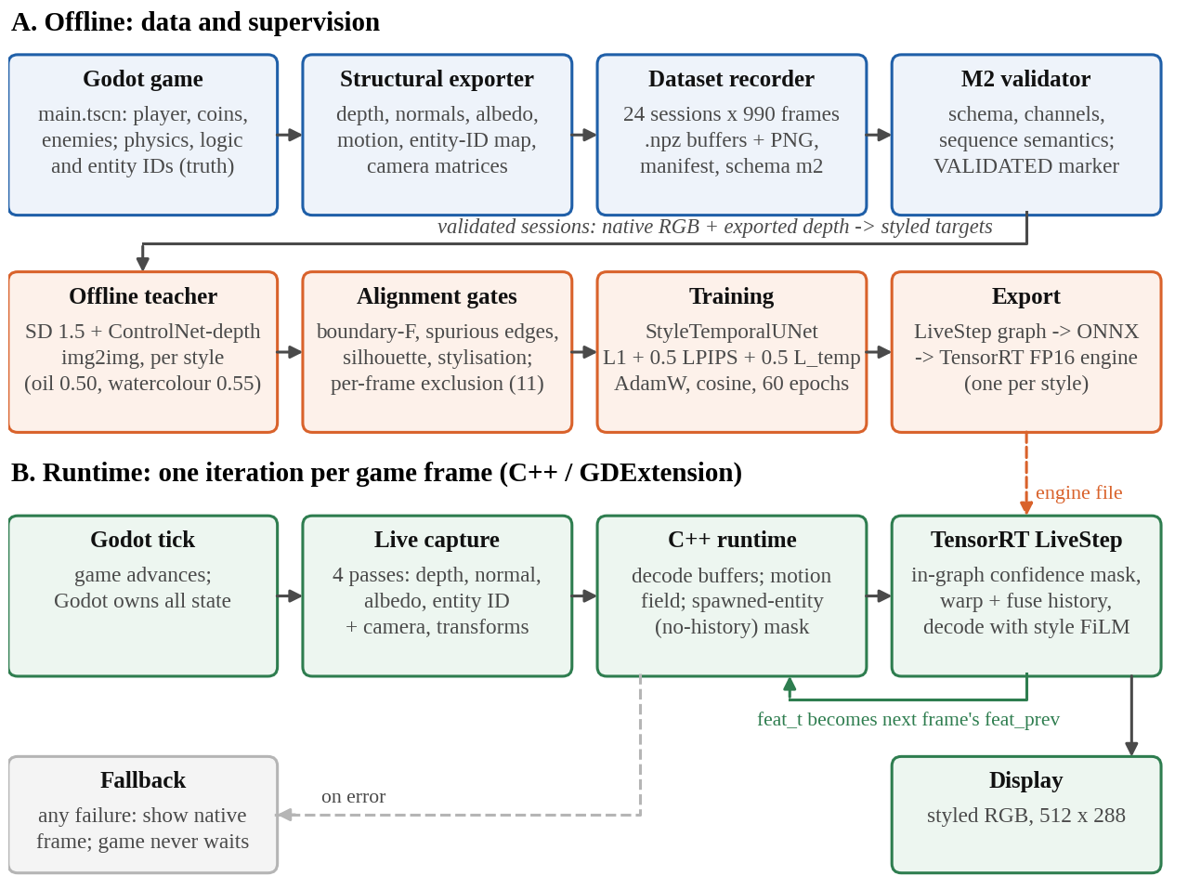
Figure 2: The whole system: the offline part (top) produces a validated dataset and a trained model; the runtime loop (bottom) runs once per game frame inside Godot.

3.1 Stage 1 – The Godot game
The game (game_project/, scene main.tscn) is a small arena: the player collects coins while enemies spawn and chase. Physics runs at 60 Hz. The engine is the single source of truth for physics, rules and entity identity (D1, D2). The live controls are WASD or arrow keys plus Space; in the live renderer, key 1 selects oil, 2 watercolour and 0 the native look.

3.2 Stage 2 – Structural export
The exporter renders the scene several more times into an off-screen viewport, each time replacing every material with a simple unshaded shader that writes one quantity: depth, normals, albedo or a packed entity ID. Each image is read back. Motion vectors are computed on the CPU from the stored camera and object transforms (D26). This override-shader approach was chosen because Godot gives no stable script access to its internal G-buffer, and because each pass can be checked directly.

3.3 Stage 3 – Recording and validation
A scripted recorder drives the game through its own input actions. For each frame it advances exactly one physics step and pauses the scene while all passes render, so every buffer shows the same instant. A validator then rejects sessions with schema errors, missing channels, non-finite values or inconsistent object lifecycles. One seed-scene session was rejected for non-finite motion at frame 616.
Table 3: The two datasets
 | Game dataset (deployed model) | Seed-scene dataset (ablation ladder)
Source | The playable game, scripted play | An arena built in code
Sessions | 24 recorded, 24 valid | 30 recorded, 29 valid
Frames | 990 per session; 23,760 total | 990 per session; 28,710 total
Split (sessions) | 18 / 3 / 3 (train / val / test) | 21 / 4 / 4
Split (frames) | 17,820 / 2,970 / 2,970 | 20,790 / 3,960 / 3,960
Styles | oil 0.50; bold watercolour 0.55 | oil 0.50

3.4 Stage 4 – The diffusion teacher
No painted versions of game frames exist, so the project makes them. For each frame and style, Stable Diffusion 1.5 img2img with a depth ControlNet restyles the native frame, guided by the engine's depth. Settings: 24 steps, guidance 7.5, ControlNet scale 1.6; strength 0.50 for oil impasto (seed 20260906) and 0.55 for bold watercolour (seed 20260930). Generation is seed-pinned and cached by content, so it is reproducible. The teacher never runs during play.

3.5 Stage 5 – The four alignment gates
A painting is only accepted as a training target if it passes four gates, measured against the engine's own structure, with thresholds fixed before the game data existed:
Table 4: Alignment gates
Gate | Question it asks | Pass if
1. Boundary F-measure | Are the real structural edges still there (2-pixel tolerance)? | ≥ 0.60
2. Spurious-edge ratio | Did the painting invent strong edges with no structure behind them? | ≤ 0.35
3. Silhouette support | Does every object of ≥ 200 visible pixels keep its outline? | ≥ 0.60
4. Stylisation | Did the painting actually change the colours (histogram L1 from the native frame)? | ≥ 0.15

Gate 4 exists because gates 1–3 are passed perfectly by a teacher that changes nothing: the untouched native frame scored boundary F 0.976 and spurious 0.000, better than any real painting (D32). A frame failing any gate in either style is excluded from both styles, along with every training sample that touches it: 11 of 23,760 frames (D94).

3.6 The confidence mask
For each pixel, the mask compares the current depth and normal with the previous frame's, warped by motion:
M_{t} = exp(−κ_{D} · e_{D} − κ_{N} · e_{N}) · H_{t}
Here e_{D} is the depth disagreement, e_{N} = 1 − (normal · warped normal), κ_{D} = ln 2 / 0.175 m and κ_{N} = ln 2 / (1 − cos 30°). So a depth step of 0.175 m, or a surface turning by 30°, halves the confidence. H_{t} is 0 where there is no valid history at all: the first frame, motion from off-screen, the background, and newly spawned objects (found from the entity-ID map). The 0.175 m scale was calibrated on the data as the best separation between depth changes within a surface and across an object's edge.
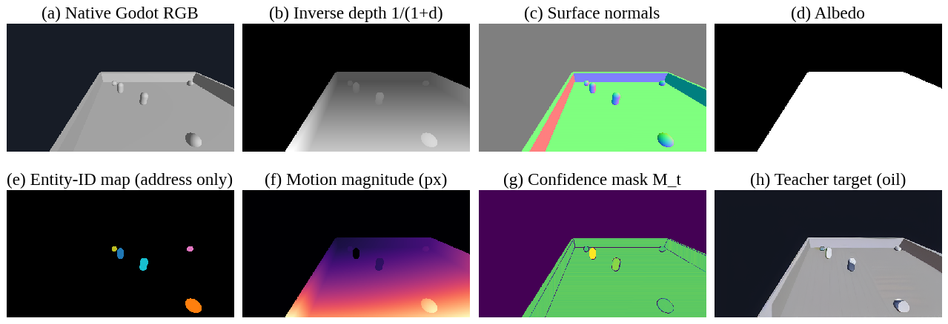
Figure 3: One sealed test frame: (a) native render, (b)–(d) the network inputs, (e) entity IDs (address only), (f) motion magnitude, (g) confidence mask, (h) oil teacher target.

3.7 Stage 6 – The network: StyleTemporalUNet
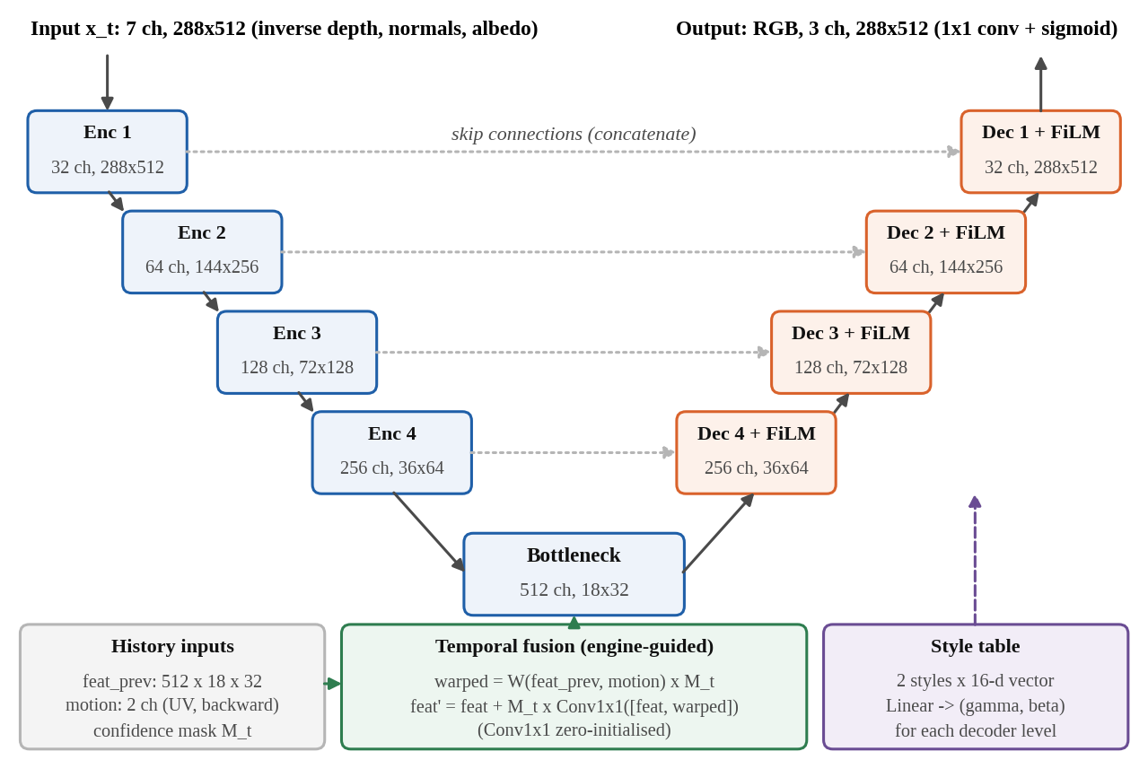
Figure 4: StyleTemporalUNet: style-free encoder, temporal fusion at the bottleneck, FiLM-modulated decoder.
- Encoder: four levels (32, 64, 128, 256 channels), each two 3 × 3 convolutions with group norm and ReLU, then 2 × 2 max pooling; bottleneck 512 × 18 × 32.
- Temporal fusion: last frame's bottleneck features are warped by engine motion, multiplied by the mask, and fused with a zero-initialised 1 × 1 convolution: F′ = F + M ⊙ Conv([F, M ⊙ W(F_{prev})]). Where M = 0, history is ignored.
- Decoder: four upsampling levels with skip connections, each modulated by FiLM from the 16-number style vector.
- Head: a 1 × 1 convolution and a sigmoid give RGB in [0, 1].
- Size: 8,394,915 parameters (encoder 1,175,328; bottleneck 3,542,016; temporal fusion 524,800; decoder 3,136,320; FiLM 16,320 + 32; head 99).

3.8 Training
Table 5: Training configuration of the deployed model
Item | Setting
Samples | 35,526 training samples (both styles); 5,936 validation frames
Each sample | three consecutive frames, so the model learns to use the previous frame
Loss | L1 + 0.5 · LPIPS (AlexNet) + 0.5 · masked temporal term
Optimiser | AdamW, learning rate 2 × 10⁻⁴, weight decay 10⁻⁴, cosine schedule
Batch | 4 × gradient accumulation 2 (effective 8); bfloat16
Length | 60 epochs, validation every 2; 29.2 hours; best epoch 49 (validation L1 0.007435)
Hardware | ASUS ROG Strix G16 (2025): Ryzen 9 8940HX, RTX 5060 Laptop GPU 8 GB, 30 GiB RAM

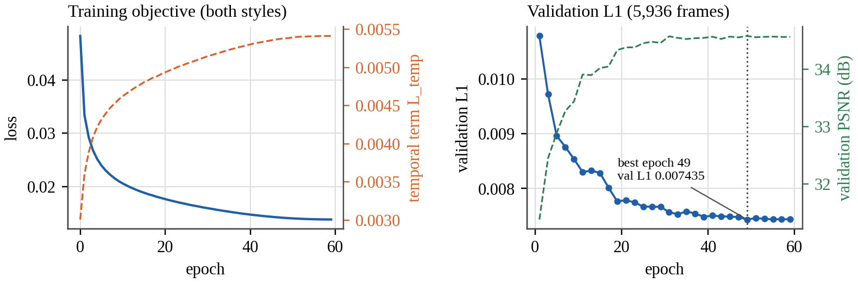
Figure 5: Training of the deployed model. The temporal term rises as the output gains texture, which is why flicker is always read together with sharpness.

3.9 Stages 7 and 8 – Deployment and the live loop
One step of the model, including the confidence mask, is exported as a graph called LiveStep: six inputs (current structure, previous structure, previous features, motion, new-object mask, motion validity) and two outputs (the frame, and this frame's features for next time). It is compiled to one TensorRT FP16 engine per style, with the style fixed inside each engine. Each game frame:
- Godot steps physics and captures four passes (depth, normals, albedo, entity ID).
- The C++ GDExtension computes motion and the mask of newly spawned objects, ported line by line from the training code.
- TensorRT runs LiveStep for the selected style with the previous frame's features.
- The frame is displayed and its features are kept for the next frame. A style switch keeps the history, because the encoder is style-free.
- If anything fails, the native frame is shown instead and the game never waits.
Table 6: Proof that the live frame is the evaluated model
Link checked with identical inputs | Maximum difference
Exported LiveStep vs the Python evaluator | 2.4 × 10⁻⁶
TensorRT strict FP32 vs PyTorch (frame / features) | 1.6 × 10⁻⁶ / 7.3 × 10⁻⁶
C++ motion vs the engine's own motion, 120 frames | 7.5 × 10⁻⁸
Live game frame vs the scored model | 1/255 (rounding); 0 pixels above
Spawned enemy: no-history pixels, C++ vs engine | 998 = 998 pixels

4. Results
The U-Net with temporal input wins; the deployed two-style model passes every gate and runs at 44.6 fps.

4.1 The ablation ladder
Every rung was scored on the same 3,960 sealed test frames of the seed scene by one script; temporal error uses 501 moving frame pairs.
Table 7: Ablation ladder
Rung | PSNR | SSIM | LPIPS | Sharpness | Temporal error | Params
A U-Net | 34.04 | 0.9747 | 0.0459 | 0.912 | 0.003175 | 7.85 M
B U-Net + temporal | 33.64 | 0.9734 | 0.0489 | 0.897 | 0.002692 (−15.2 %) | 8.38 M
C StructFormer | 33.86 | 0.9728 | 0.0466 | 0.853 | 0.004191 | 7.78 M
D StructFormer + temporal | 33.56 | 0.9727 | 0.0485 | 0.858 | 0.003741 (−10.7 %) | 8.24 M
E StructFormer + entity | 33.79 | 0.9726 | 0.0463 | 0.884 | 0.004172 | 7.05 M
N raw-ID control | 33.86 | 0.9732 | 0.0459 | 0.880 | – | 7.78 M
Teacher / native engine | – | – | – | – | 0.006265 / 0.000241 | –

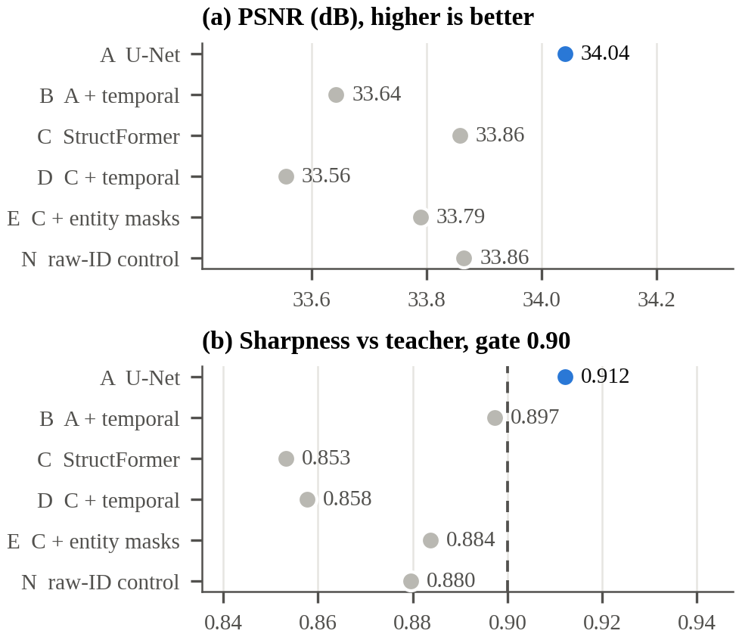
Figure 6: Ablation ladder: the plain U-Net (A) leads on PSNR and is the only rung above the 0.90 sharpness gate.
- The U-Net (A) is best on every image metric and the only rung above the sharpness gate. StructFormer's sharpness was 0.833, 0.886 and 0.851 at 644, 10,890 and 20,790 training frames, against a pre-recorded projection of 0.898: more data did not close the gap (D71).
- Temporal input cuts flicker on both backbones: −15.2 % (B vs A) and −10.7 % (D vs C), far beyond the pre-registered 3.85 % threshold, at a cost of 1.8–3.9 % in per-frame L1. Flicker is the more visible defect in play, so B was taken to the game.
- Entity awareness helps a little: E is +0.015 sharper than C over three seeds (2.5σ). But the naive control N, which just feeds the raw ID, gets about 87 % of that gain: with only two or three objects, exposing the IDs is enough (D89).

4.2 The deployed two-style model on the game
Table 8: Game test sessions, 2,968 frames per style
Model, style | PSNR | SSIM | LPIPS | Sharpness | Travel | Flicker vs teacher
Two-style B, oil | 35.33 | 0.9807 | 0.0225 | 0.946 | 0.995 | 0.54×
Two-style B, watercolour | 34.79 | 0.9786 | 0.0243 | 0.937 | 0.987 | 0.48×
Oil-only B (reference) | 35.43 | 0.9814 | 0.0216 | 0.946 | 0.980 | 0.54×
Plain frame (do nothing) | 28.06 / 26.96 | – | – | – | – | –

- Both styles pass the sharpness and travel gates and beat doing nothing by 7.3–7.8 dB.
- Sharing one model between two styles costs oil 0.10 dB, which is not claimed as real with one run per model.
- The switch is real, not a blend: each style's output is about 4× closer to its own targets than to the other style's, reproducing 93 % of the difference between the two teachers.
- The styles are mild because the game is grey and plainly lit, and stronger teacher settings fail the gates.
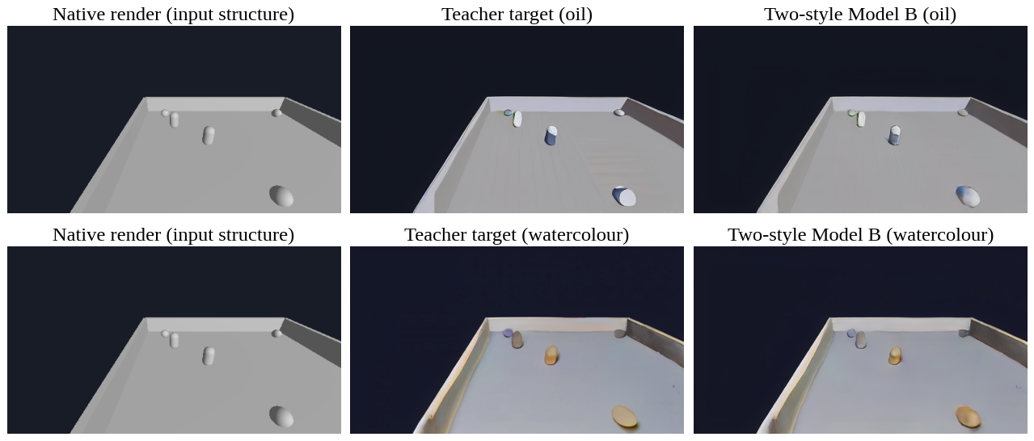
Figure 7: A sealed test frame through exactly the evaluated path: native input, teacher target and model output for both styles.

4.3 Temporal stability and the value of history
The renderer flickers about half as much as its own teacher (0.54× oil, 0.48× watercolour, on 2,451 moving frame pairs), but still about 57× the native engine: the teacher's flicker is the ceiling. History also improves image quality: run cold every frame, the same model drops from 35.33 to 33.58 dB (oil) and from 34.79 to 32.82 dB (watercolour), which is why the live runtime feeds features back every frame.
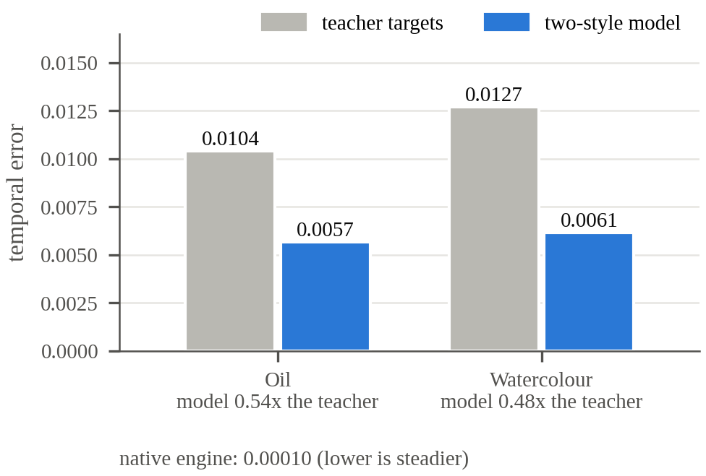
Figure 8: Flicker of the teacher's targets and of the two-style model on the game's test sessions.
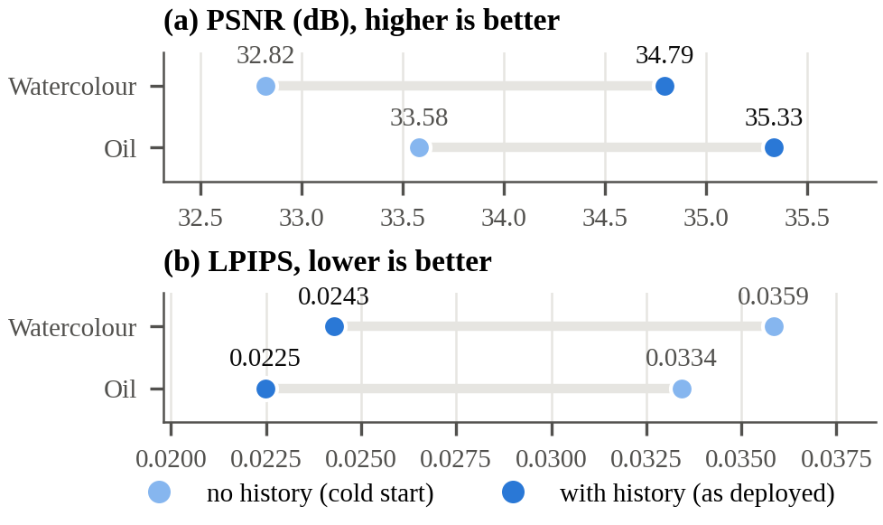
Figure 9: The same model with and without its one frame of engine-warped history.

4.4 Live performance
Table 9: Live measurements on the playable game
Criterion | Result | Verdict
About 30 fps at 512 × 288 | 44.6 fps oil, 44.7 fps watercolour (FP16) | Met
Network alone ≤ about 20 ms | 4.53 ms FP16; 6.23 ms strict FP32; 9.37 ms with TF32 | Met
Stable loop | 3,000 frames, 0 fallbacks; median 22.4 vs 22.3 ms (first vs second half); p99 25.2 ms | Met
Failure does not break play | 8 of 8 forced failures fell back to the native frame; play continued | Met
Manual play session (23 Oct 2026) | 2,059 styled frames, 40.1 fps oil and 38.0 fps watercolour, 0 fallbacks | –

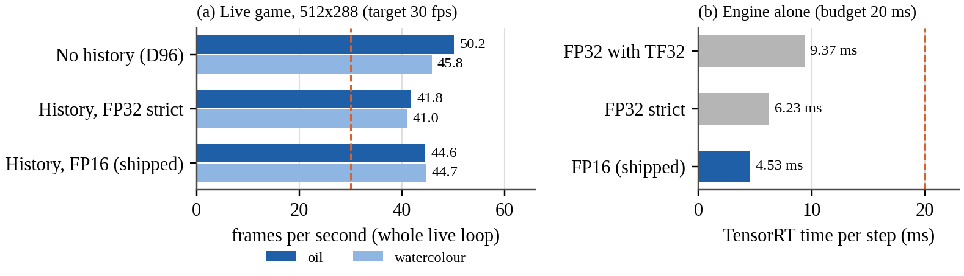
Figure 10: Frame rate of the whole live loop, and TensorRT time per step alone.

4.5 EPAM: the headline idea that did not help
EPAM (Engine-Keyed Persistent Appearance Memory) keeps a memory slot per object, keyed by the engine's entity identity. While the object is visible enough, its descriptor is blended into the slot by an exponential moving average (decay λ = 0.9); the slot is frozen while the object is out of view, deleted when it is destroyed, and cleared on a style change. The goal: an object should look the same when it reappears.
The test was clean. Model F (memory on) and its twin F0 (λ = 0, memory off) share code, data, schedule and selection rule (D78). The pass threshold, 0.0206 sharpness, was written before the run. Result: F − F0 = −0.0127 (0.8829 vs 0.8956) on 3,912 test clips: inside noise and in the wrong direction (D79). Three further measurements agree that the data offers memory nothing to recover: appearance correlation across an occlusion gap is at most 0.037 beyond 30 ticks (D73), the reappearance metric does not degrade with time unseen (D53), and anchoring the teacher's noise per object does not create a persistent look (D81). The likeliest reason is the supervision: the diffusion teacher re-invents each object's look every frame, so there is no stable appearance in the targets to remember. The lifecycle rules themselves are met and covered by 17 tests.

5. The Project Story, Milestone by Milestone
Eleven milestones, each with exit criteria fixed in advance; failures were recorded as findings.
Table 10: Milestone scorecard
Milestone | Verdict | Key decisions
M0 Repository and minimal Godot game | Complete | D22–D24
M1 Structural export | Complete | D23–D26
M2 Dataset recorder and validator | Complete | D27–D30
M3 Offline teacher and alignment gates | Complete | D31–D34, D40
M4 CNN / U-Net baseline | Passes at every dataset size | D35, D41, D46, D71
M5 StructFormer baseline | Fails: below the U-Net at 644, 10,890 and 20,790 frames | D49, D71
M6 Temporal reprojection | Passes (−11.7 %); replicated (−10.7 %) | D67, D85
M7 Structured entity awareness | Complete | D74
M8 EPAM | Criteria 1–3 met; criterion 4 (improves output) not met | D78, D79
M9 Full evaluation (ablation ladder) | Complete | D83, D85, D89
M10 ONNX → TensorRT → C++ → Godot | Passes all exit criteria | D84, D86, D96–D99

5.1 Turning points worth knowing
- The design (D1–D21). The engine is the source of truth; diffusion is an offline teacher; engine motion replaces optical flow; entity IDs are addresses; EPAM is the headline idea and is session-local; TensorRT engines are built on the target laptop; FP16 before FP8.
- A fourth gate (D32). Calibration showed that a teacher that does nothing passes the three structural gates perfectly, so the stylisation gate was added. The first teacher setting also failed on moving-camera frames until ControlNet conditioning was strengthened.
- The scene limited the style (D36–D40). The stylisation gate proved too permissive; the cause was the plain scene geometry, not the teacher. The scene was enriched, which rescued the failing configuration, and oil_impasto became the committed style.
- Measuring noise properly (D46). Three seeds showed that two runs badly understate run-to-run variance, and that M4's sharpness gate is seed-fragile. All later margins were set from measured noise.
- StructFormer refuted (D49, D71). The transformer lost to the CNN at equal size, and at 32× the data its sharpness fell instead of rising, refuting the scaling hypothesis.
- M6 first failed, then passed (D57, D67). Temporal reprojection's gain was first inside StructFormer's own seed noise; with the correctly measured margin on the larger ladder, it passed.
- A tempting fix made things worse (D60). Conditioning the teacher on its own previous painting made flicker 11× worse (378× the engine), most likely because it re-stylised already-styled frames again and again.
- A silent bug found and fixed (D66, D80). Model B's temporal fusion looked inert. The real cause: B had gone through the single-frame trainer, so the fusion never received any gradient. The trainer was fixed and guarded; once trained correctly, temporal input cut flicker on both backbones (D85).
- A TensorRT failure diagnosed (D84). Model A would not build in TensorRT. Changing one thing at a time showed that GroupNorm, exported as ONNX InstanceNormalization, triggered a compiler failure; rewriting GroupNorm as plain maths fixed it, verified to 4.26 × 10⁻⁶.
- From the test scene to the real game (D87–D95). The game itself was recorded (23,760 frames). Oil passed the gates; the original watercolour failed and a bolder watercolour passed at 0.55. Eleven failing frames were excluded instead of dropping whole sessions. The two-style model was built and scored.
- Live in the game (D96–D99). Style switching first ran without history (about 2 dB worse); the LiveStep graph then brought the scored model's history into the game. FP16 passed its pre-set tolerance and was shipped; failure injection, stability runs and the last open checks closed M10.
- Higher resolution stopped (D100–D102). A 768 × 432 dataset was pre-registered, but the teacher's look changes with resolution, and re-tuning strength could not recover the committed look, so the bulk run was stopped.

6. Limitations
- One scene, one game. Nothing here is evidence about other games or art styles.
- The teacher's flicker is the ceiling. The renderer halves it but stays about 57× above the engine.
- Single training runs on the game. Small differences between game models (such as 0.1 dB) are not claimed.
- Mild styles at low resolution. 512 × 288 and strength about 0.5, set by what passes the gates on a plain grey game.
- Scripted, not human, recording; the 11 excluded frames are the hardest views and are slightly under-represented.
- Free play is not lockstep. A physics tick can occasionally land mid-capture during free play; every equivalence check was run in lockstep.
- EPAM and structured entity use are untested where they should matter: many objects, recycled IDs and a temporally consistent teacher.

7. How to Run Everything

7.1 Commands
All Python commands run from the repository root in the dl conda environment (Python 3.10.21, PyTorch 2.13.0).
Table 11: Main commands
Purpose | Command
Run all tests | python -m pytest -q (or ./scripts/test.sh)
Score the game model on the sealed test sessions | python -m scripts.eval_game checkpoints/game_b_two_style/best.pt configs/data/game_split_v1.json oil_impasto eval/reports/game_b_two_style_test_oil.json configs/data/game_frame_exclusions_v1.json
Build the live TensorRT engines for this GPU | python -m scripts.m10_live_temporal_engines, then python -m scripts.m10_fp16_live
Play the game live | set SR_ENGINE_OIL and SR_ENGINE_WATERCOLOR to the FP16 engines in artifacts/engines/, then godot --path game_project -s res://tests/runtime/live_game.gd; keys 1 oil, 2 watercolour, 0 native
Remake the report figures and demo video | python -m scripts.make_report_figures; python -m scripts.make_demo_video

Trained weights are published as GitHub releases game-v1 (the game models) and ladder-v3 (ladder rungs A, C and E). No training command is listed here: training is only started deliberately.

7.2 Where things are in the repository
Table 12: Repository map
Folder | Contents
game_project/ | The Godot game, structural exporter, recorder, live-runtime scripts
data_pipeline/ | Recording, validation, teacher generation and the alignment gates
renderer/ | Models (U-Net, StructFormer, temporal, EPAM), losses, training
inference/ | ONNX export, TensorRT build, the C++ runtime and GDExtension
eval/ | Metrics, protocols, reports (eval/reports/) and logs (eval/logs/)
configs/ | Data splits, frame exclusions, training and teacher configurations
scripts/ | One-command entry points: evaluate, build engines, make figures
docs/ | Knowledge base and Decision Log, final report, lab report, paper, presentation, this guide
checkpoints/, artifacts/ | Model weights and built engines (not in git)

7.3 Related deliverables
- Lab report: docs/lab_report/StructRender_Lab_Report.pdf (33 pages, SRIHER format).
- Conference paper draft: docs/paper/ (IEEE format; Word, PDF and an Overleaf project).
- Presentation: docs/presentation/StructRender_Lab_Presentation.pptx (19 slides).
- Demo video: eval/reports/demo/structrender_demo.mp4 (native vs live, switching styles).
- Separate project: the Spider-Man web-swinging game at structrender.vercel.app has 16 hand-made shader themes. It does not run the StructRender model; always present it that way.

8. Glossary
Table 13: Terms used in the project
Term | Meaning
Ablation | Removing or adding one component at a time to measure its effect
Albedo | A surface's base colour without lighting
Alignment gate | A pass/fail test that a teacher painting keeps the engine's structure and is really stylised
bfloat16 | A 16-bit number format used to train faster with less memory
Confidence mask (M_{t}) | Per-pixel weight saying how far the previous frame can be trusted
ControlNet | A side network that makes a diffusion model follow a control image such as depth
Diffusion model | A generator that creates images by removing noise step by step
Disocclusion | A pixel newly revealed this frame, with no valid history
Entity ID | The engine's identity for an object; used only as an address
EPAM | Engine-Keyed Persistent Appearance Memory: a per-object memory of appearance
FiLM | Feature-wise linear modulation: a learned scale and shift per channel, from a conditioning vector
FP16 / FP32 / TF32 | Floating-point precisions: 16-bit, 32-bit, and NVIDIA's fast 32-bit mode
G-buffer | Per-pixel geometric images (depth, normals, albedo) produced while rendering
GDExtension | Godot's interface for calling native C++ code
LiveStep | The exported one-frame step of the model used in the game
LPIPS | A perceptual distance computed from deep network features
Motion vector | Where each pixel's surface was in the previous frame
ONNX | A standard file format for neural-network graphs
Pre-registration | Fixing a test's threshold before seeing its result
PSNR / SSIM | Pixel-accuracy and structural-similarity image metrics
Sharpness ratio | Output's high-frequency energy relative to the target's; guards against blur
StructFormer | The project's window-attention transformer renderer
StyleTemporalUNet | The deployed U-Net with temporal fusion and FiLM style conditioning
Teacher | The offline diffusion model that makes the training targets
TensorRT | NVIDIA's compiler that turns a network into a fast GPU engine
Warp (W) | Moving an image or features by motion vectors into the current frame

9. Viva Questions and Answers
Q. What is StructRender in one sentence?
A renderer in which the Godot engine keeps all gameplay truth and a small neural network paints each frame from the engine's structure in a learned style, live at about 45 fps.
Q. Why not just use a generative world model like GameNGen?
Those models predict pixels and hold no authoritative state, so world facts can drift. We keep the engine in charge, so the network can only change how things look, never what happens.
Q. Where do the training targets come from if no painted game frames exist?
An offline teacher: Stable Diffusion 1.5 img2img with a depth ControlNet driven by the engine's own depth. Each target must pass four alignment gates before it is used.
Q. Why four gates and not three?
The three structural gates are passed perfectly by a teacher that changes nothing (the native frame scored boundary F 0.976 and spurious 0.000). The stylisation gate rejects that passthrough.
Q. Why is the entity ID not an input channel?
It is an arbitrary label. As a number, a recycled ID would make a new object look like the old one. We use IDs only as addresses for masks and memory.
Q. What does the confidence mask do?
It marks pixels where the previous frame can be trusted, using depth and normal agreement after warping, and zeroes background, the first frame, off-screen motion and newly spawned objects. History is ignored where the mask is zero, both in training and live.
Q. Why a U-Net and not the transformer?
We tested both at equal size. The U-Net won on every image metric and was the only model above the sharpness gate; the transformer did not catch up even with 32× more data.
Q. How does one model produce two styles?
A learned 16-number style vector drives FiLM scale and shift in the decoder. The encoder never sees the style, so its features, and the frame history, carry across a live style switch.
Q. How do you know the live game shows the model you evaluated?
Every link was checked with identical inputs: export vs evaluator (2.4 × 10⁻⁶), TensorRT vs PyTorch (1.6 × 10⁻⁶), C++ motion vs engine motion (7.5 × 10⁻⁸), and the live frame vs the scored model (within 1/255).
Q. Why FP16?
It is 27 % faster than strict FP32 (4.53 vs 6.23 ms) and passed a tolerance fixed before measurement: mean PSNR change 0.044 dB, under 0.05.
Q. What happens if the renderer fails mid-game?
The native frame is shown and the game continues; 8 of 8 forced failures recovered, and 3,000 live frames had 0 fallbacks.
Q. Why is the output still flickery compared with the plain game?
The teacher paints each frame independently, so its targets flicker. The model halves the teacher's flicker, but cannot remove flicker that is in its own training targets.
Q. Did EPAM work?
No. The memory model was 0.0127 less sharp than its identical no-memory twin, inside noise. Other measurements show the targets carry no stable per-object appearance for a memory to recover; a temporally consistent teacher would be needed.
Q. What was the most surprising bug?
Model B's temporal fusion looked useless, but it had been trained by the single-frame trainer, so the fusion never received a gradient. Once trained correctly, temporal input cut flicker by 15.2 %.
Q. Why are the styles so subtle?
The game is grey and plainly lit, and stronger teacher settings start inventing edges and fail the alignment gates, so the accepted targets are mild.
Q. Why not higher resolution?
At 768 × 432 the teacher's look changes, and re-tuning could not reproduce the committed look, so the run was stopped before spending compute.
Q. What would you do next?
A temporally consistent teacher; re-test EPAM in scenes with many objects and recycled IDs; higher resolution with a matched look; and evaluation on more games and on human play.
Q. Are the Spider-Man screenshots your model's output?
No. They come from a separate browser game with 16 hand-made shader themes. StructRender has two trained styles and runs on the Godot game.

Appendix: All 102 Decisions
The Decision Log in docs/StructRender_KB.md records every design choice, deviation, result and correction, in order. Titles are reproduced here as an index.
Table 14: Decision Log index
No. | Decision
D1 | Deterministic Engine Over Pure Generative World Simulation
D2 | Godot Is the Source of Truth
D3 | StructFormer Replaces GAN-First as the Final Renderer
D4 | GAN Becomes Optional Training Supervision
D5 | One-Step DiT Is Not a Required Deliverable
D6 | Heavy Diffusion Is an Offline Teacher
D7 | Engine Motion Replaces RAFT in Production
D8 | Motion Has an Explicit Operation, Not a Raw Channel Role
D9 | Entity IDs Are Addresses, Not Continuous Features
D10 | EPAM Is the Headline Contribution
D11 | EPAM Is Session-Local
D12 | Style Change Clears EPAM in v1
D13 | No Arbitrary EPAM Eviction in the Core Benchmark
D14 | Window Attention Over Global Full-Resolution Attention
D15 | Runtime Style Encoding Is Cached
D16 | TensorRT Engine Is Built on the Target Laptop
D17 | C++ Owns the Final Runtime Orchestration
D18 | FP16 Before FP8
D19 | Train in Stages and Resume Checkpoints
D20 | Paid GPU Budget Is Reserved for High-Value Runs
D21 | Entity Token Overflow Is Resolved by Visibility Ranking, Not Arbitrary Order
D22 | M0 Logging Autoload Is Named GameLog, Not Logger (2026-09-03)
D23 | Structural-Export Render Path Is Pinned to Forward+ (2026-09-03)
D24 | Test / Instrumentation Autoloads May Ship in game_project, Guarded (2026-09-03)
D25 | Motion Vector Convention Pinned (2026-09-03)
D26 | M1 Structural Export Is Override-Shader Re-Render, Not Native G-Buffer Readback (2026-09-03)
D27 | M2 Dataset Storage Format and Schema Extensions (2026-09-03)
D28 | M2 Seed Reappearance Ladder Is a Training Fixture, Distinct from the Eval Headline Ladder (2026-09-03)
D29 | M2 Dataset Validator Acceptance Rules (2026-09-03)
D30 | M2 Loose Ends — Validator Tolerances, Native-RGB Capture Settings, --limit Mode (2026-09-03)
D31 | M3 Teacher Method, Style Scope, and Sidecar Target Storage (2026-09-05)
D32 | M3 Alignment Gates — Four, Not Three; Calibrated Thresholds (2026-09-05)
D33 | Seed Sessions Must Carry Visual Diversity; Target Cache Is Content-Addressed (2026-09-05)
D34 | M3 Review Follow-ups — Measurement Limits, Enforced Rules, Code Location (2026-09-05)
D35 | M4 Baseline — Input Channels, Sequence-Holdout Split, Pre-Fixed Overfit Thresholds (2026-09-05)
D36 | M3's Stylisation Gate Is More Permissive Than It Looked — Strengthen the Style Before M5 (2026-09-06)
D37 | Scene Geometry, Not the Teacher Pipeline, Is What Limits Style Strength (2026-09-06)
D38 | Structural Albedo Never Reached the Render — Scene Enrichment Scope (2026-09-06)
D39 | The Enriched Scene Rescues the Config That Failed — Decision 37's Diagnosis Confirmed (2026-09-06)
D40 | oil_impasto Is the Committed Style; gouache Retired (2026-09-06)
D41 | M4 Adds the Core Perceptual Loss; Detection Floors Re-measured (2026-09-06)
D42 | Overfit Gate Uses the Configured Objective; Reports Must Self-Identify (2026-09-06)
D43 | The Scene Enrichment Traded Hallucination Sensitivity for Translation Sensitivity (2026-09-06)
D44 | Pre-Commit Review — A Pre-Registered Threshold Changed Units; Two Guards Did Not Guard (2026-09-08)
D45 | M5 Export Probe — §12's Attention Risk Did Not Materialise; Four Written Rules Did Not Survive Contact (2026-09-08)
D46 | Training Run-to-Run Variance Measured — M4's Sharpness Gate Is Seed-Fragile (2026-09-08)
D47 | Ladder Rungs Are Compared at Parameter Parity; Gradient Accumulation Keeps Batch Out of the Comparison (2026-09-08)
D48 | M5 Export and TensorRT Benchmark — §12's Risk Landed on the Baseline, Not the Transformer (2026-09-08)
D49 | M5 Negative Result — StructFormer Underperforms the CNN Baseline at Parameter Parity on This Scene (2026-09-08)
D50 | M5 Review — The Ladder Letter Was Wrong and the Export Contract Reversed Itself (2026-09-08)
D51 | M5 Evidence Audit — A Generator That Could Not Reproduce Its Own Report, and Statistics Stated Beyond What Was Measured (2026-09-08)
D52 | Five Review Findings — A Report Path That Overwrote Committed Evidence, and a Mask That Only Discouraged (2026-09-08)
D53 | RCS Implemented and Measured — The Headline Metric Does Not Degrade With Time Unseen (2026-09-09)
D54 | Strict Masking Reaches TensorRT; RCS Re-measured Over Frame Windows (2026-09-10)
D55 | M6 Warp, Mask and Gate — The Validation Split Cannot Measure Reprojection (2026-09-10)
D56 | Model D Trains From Scratch — Decision 19's Staged Resume Is a Warm Restart Here (2026-09-10)
D57 | M6 Negative Result — Temporal Reprojection Does Not Separate From StructFormer Seed Noise (2026-09-10)
D58 | M6 Review — Four Flagged Deviations the Log Never Absorbed, and a Pre-Registration That Contained Its Own Subject (2026-09-10)
D59 | M6 Export Evidence — Model D Deploys, at 47 % More Latency and With Cross-Frame State (2026-09-10)
D60 | Cross-Frame Teacher Conditioning Is REFUTED — 11x Worse, Not Better (2026-09-12)
D61 | Fifteen Sessions — Viewpoint and Trajectory Diversity, Not New Scene Content (2026-09-13)
D62 | Early Stopping on Every Rung (2026-09-13)
D63 | Model B — the CNN Temporal Rung M6 Was Missing (2026-09-13)
D64 | Session-Level Split — the Project's First Independent Test Set (2026-09-13)
D65 | Adding Sessions Silently Repointed Every Historical Test (2026-09-14)
D66 | Model B's Temporal Fusion Is Inert; Model D's Is Not (2026-09-14)
D67 | M6 PASSES on Ladder v2 — the Margin Was Stale, Not the Result (2026-09-16)
D68 | The Recorder Does Not Wait on the Compositor (2026-09-20; written 2026-09-28)
D69 | Ladder v3 — 29 Sessions, and a Projection Pre-Registered Before the Result (2026-09-20; written 2026-09-28)
D70 | Product Scope — a Style Renderer, Not a Game Generator (2026-09-21)
D71 | M5 Fails at 32x the Data — the Scaling Hypothesis Is Refuted (2026-09-21)
D72 | RCS Cannot Measure EPAM — Its Claim Moves to Sharpness (2026-09-21)
D73 | The Residual Memory Probe — Information Exists, but Not at EPAM's Timescales (2026-09-21)
D74 | M7 Complete — Structured Entity Awareness (2026-09-21)
D75 | Entity-Masked Attention Degenerates to a Lookup; Model E Is a Null Result (2026-09-21)
D76 | Entity Consistency Is Keyed by Identity, Not by Slot (2026-09-22)
D77 | Entity Conditioning Sharpens — a Predicted Effect, Confirmed at 2.5 Sigma (2026-09-23)
D78 | M8 Design — EPAM Store, Model F, and a Built-In No-Memory Control (2026-09-23)
D79 | M8 Criterion 4 Not Met — EPAM Memory Does Not Improve Output (2026-09-26)
D80 | Model B Was Never Trained With History — Decision 66 Retracted in Cause (2026-09-26)
D81 | Entity-Anchored Teacher Noise Does Not Create Persistent Appearance — EPAM v2 Not Pursued (2026-09-26)
D82 | The Temporal Trainer Had No Early Stopping; GPU Memory Headroom for the Display (2026-09-26)
D83 | M9 Image-Quality Ladder on One Scoring Path (2026-09-27)
D84 | Model A's TensorRT Failure Diagnosed and Fixed — GroupNorm's InstanceNormalization (2026-09-27)
D85 | Temporal Conditioning Cuts Flicker on Both Backbones — B Works Once Trained Correctly (2026-09-27)
D86 | M10 Live Loop — C++ Runtime, GDExtension, and a Live Capture Path (2026-09-27)
D87 | A Training Dataset From the Playable Game (2026-09-27; written 2026-09-28)
D88 | Selecting the Game Teacher Style by the Alignment Gates (2026-09-28)
D89 | The Naive Raw-ID Control Matches Structured Entity Use on This Scene (2026-09-28)
D90 | Game Teacher Targets — Oil Passes, Watercolour Does Not (2026-09-29)
D91 | Model B on the Playable Game — Held-Out Results (2026-09-30)
D92 | A Bold Watercolour Passes on the Game at Strength 0.55 (2026-09-30)
D93 | Bold Watercolour Across All Game Sessions — 17/24 ALIGNED (2026-09-30)
D94 | Per-Frame Exclusion for the Two-Style Game Model; Two-Style Model B Built (2026-09-30)
D95 | Two-Style Model B on the Game — Held-Out Test Results (2026-10-02)
D96 | Live Style Switching in the Playable Game — Working, Without Frame History (2026-10-02)
D97 | Live Temporal Path — the Playable Game Now Renders With the Scored Model's History (2026-10-02)
D98 | M10 Closed — FP16 Engine, Idle Measurements, Failure Injection, Runtime Log (2026-10-02)
D99 | Last Two Open Checks Closed — Game Style Acquisition, and S7 Live (2026-10-23)
D100 | Higher-Resolution Game Dataset (768x432, schema m3.0) — Pre-Registered Before Any Data (2026-10-23)
D101 | The Teacher's Look Changes With Resolution — Decision 100 Paused Before the Full Run (2026-10-23)
D102 | Re-Tuning Strength Cannot Recover Today's Look at 768x432 — Higher Resolution Stopped Before the Bulk Run (2026-10-23)

