**Phase 3: Development Part 1**

Creating a static travel blog website involves several steps, including designing the layout, developing the HTML and CSS code, and adding engaging content. Here's a step-by-step guide to help you get started:

**Step 1: Define the Structure**

Before you start writing any code, it's essential to plan your website's structure. Here's a simple example of the structure for a travel blog website:

<!DOCTYPE html>

<html lang="en">

<head>

<meta charset="UTF-8">

<meta name="viewport" content="width=device-width, initial-scale=1.0">

<link rel="stylesheet" href="style.css">

<title>My Travel Blog</title>

</head>

<body>

<header>

<h1>Welcome to My Travel Blog</h1>

<nav>

<ul>

<li><a href="index.html">Home</a></li>

<li><a href="about.html">About</a></li>

<li><a href="contact.html">Contact</a></li>

</ul>

</nav>

</header>

<main>

<section>

<h2>Latest Posts</h2>

<!-- Add your blog post previews here -->

<a href="Spot/kk.html"><center><img src="Images/kk.jpg" alt="Kanyakumari" width="640" height="420"></center></a>

<center><h4>Kanyakumari - Thiruvalluvar statue</h4></center>

<a href="Spot/alep.html"><center><img src="Images/aleppey.jpg" alt="Alappuzha" width="640" height="420"></center></a>

<center><h4>Alappuzha - backwaters</h4></center>

<a href="Spot/pal.html"><center><img src="Images/palani.jpg" alt="Palani" width="640" height="420"></center></a>

<center><h4>Palani - temple</h4></center>

<center><img src="Images/somewhere.jpg" alt="somewhere" width="640" height="420"></center></a>

<center><h4>rainbow - spotted</h4></center>

<a href="Spot/tan.html"><center><img src="Images/tanjore.jpg" alt="Thanjavur" width="640" height="420"></center></a>

<center><h4>Thanjavur - Brihadeeswara Temple</h4></center>

<a href="Spot/mun.html"></a><center><img src="Images/munnar.jpg" alt="munnar" width="640" height="420"></center></a>

<center><h4>Munnar - sight</h4></center>

</section>

</main>

<footer>

<p>&copy; 2023 My Travel Blog</p>

</footer>

</body>

</html>

**Step 2: Create CSS Styles**

Now, you'll create the CSS file (styles.css) to style your website. Here's a basic example to get you started:

/* Reset some default styles */

body, h1, h2, h3, p {

margin: 0;

padding: 0;

}

/* Style the header */

header {

background-color: #333;

color: #fff;

text-align: center;

padding: 20px;

}

header h1 {

font-size: 36px;

}

nav ul {

list-style-type: none;

}

nav ul li {

display: inline;

margin-right: 20px;

}

nav a {

color: #fff;

text-decoration: none;

}

/* Style the main content */

main {

padding: 20px;

}

/* Style the footer */

footer {

text-align: center;

padding: 10px;

background-color: #333;

color: #fff;

}

**Step 3: Add Content**

Now, you can add your travel blog content. Create blog post cards within the "Latest Blog Posts" section. Each card can include a title, a featured image, and a brief description. Here's an example:

<!DOCTYPE html>

<html>

<head>

<title>Exploring Kanyakumari: Where the Ocean Meets the Sky</title>

</head>

<body>

<header>

<h1>Exploring Kanyakumari: Where the Ocean Meets the Sky</h1>

</header>

<article>

<h2>Introduction</h2>

<p>Kanyakumari, the southernmost tip of the Indian subcontinent, is a place of remarkable beauty and cultural significance. This coastal town, located in the state of Tamil Nadu, offers a unique and enchanting experience to travelers. Known for its stunning sunsets, historical landmarks, and diverse culture, Kanyakumari is a destination that will leave you in awe. In this blog, we will take you on a journey through this mesmerizing gem of South India.</p>

</article>

<article>

<h2>The Land of the Three Seas</h2>

<p>Kanyakumari is situated at the confluence of the Arabian Sea, the Bay of Bengal, and the Indian Ocean. This geographical phenomenon is a sight to behold, especially during sunrise and sunset when the sky is painted with hues of orange, pink, and purple. The iconic Thiruvalluvar Statue and Vivekananda Rock Memorial, both located offshore, offer breathtaking panoramic views of this spectacular natural event.</p>

</article>

<article>

<h2>Historical Significance</h2>

<p>Kanyakumari has a rich historical and cultural heritage. The town is named after the goddess Kanyakumari Amman, a form of the Hindu goddess Parvati. The Kumari Amman Temple, dedicated to this deity, is a major pilgrimage site. The vibrant and colorful ceremonies and rituals held here are a window into the town's deep-rooted traditions.</p>

<p>One of the most iconic landmarks in Kanyakumari is the Vivekananda Rock Memorial. This memorial stands on a rock island and was built in honor of Swami Vivekananda, who meditated on this very rock. It's not just a place of historical significance but also offers a tranquil space for introspection, with the gentle waves of the ocean providing a soothing soundtrack.</p>

</article>

<!-- Add more articles for other sections -->

<footer>

<p>&copy; 2023 Your Blog Name</p>

</footer>

</body>

</html>

**Step 4: Add Images**

Make sure to add captivating images to your website. You can create a folder for your images and reference them in your HTML like in the example above.

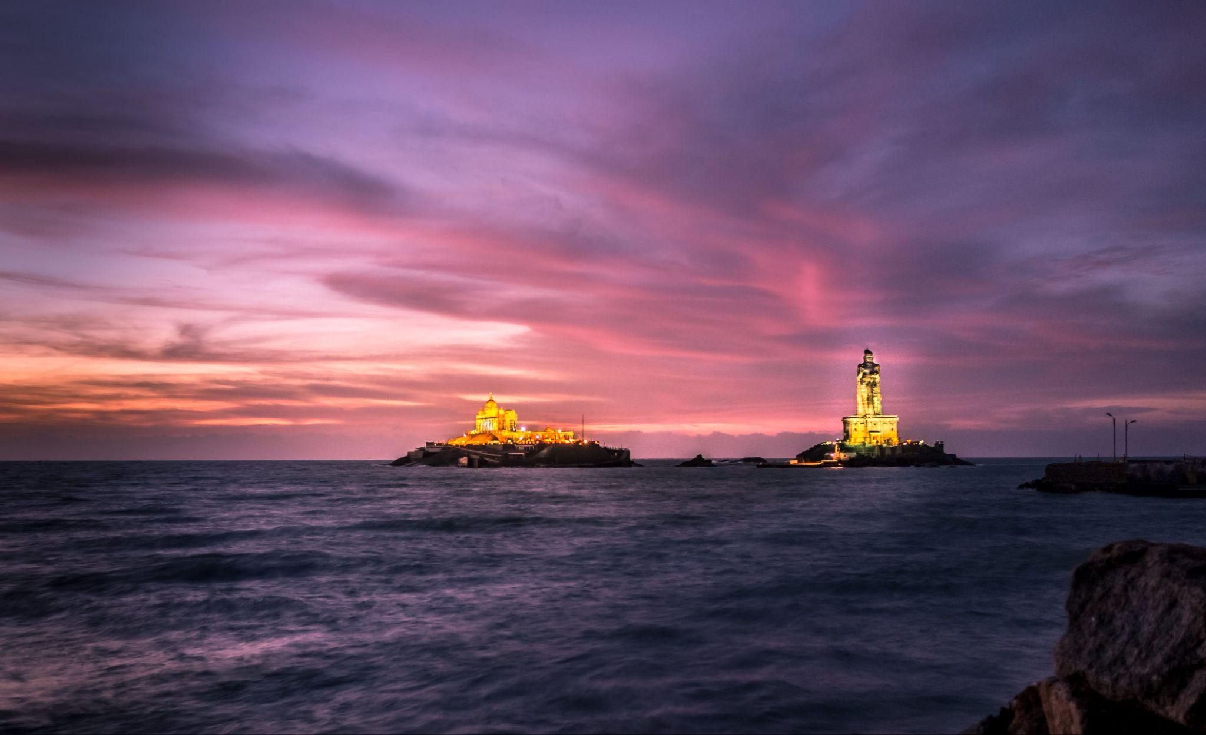

Kanyakumari - Thiruvalluvar statue

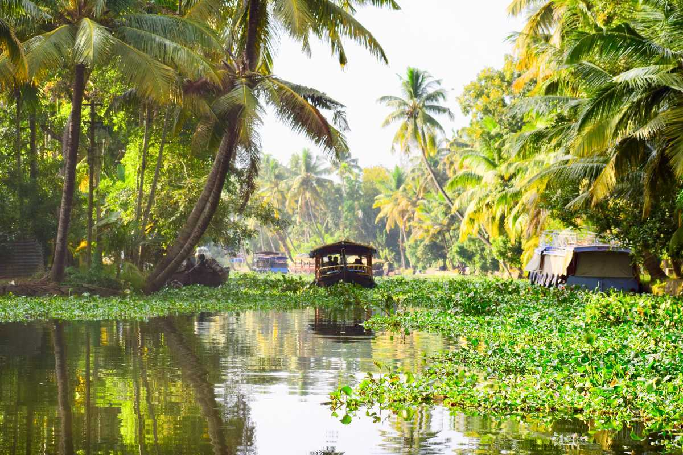

Alappuzha backwaters

**Step 5: Additional Styling and Customization**

Feel free to further customize the styles, add more sections, or include additional features like social media links or a comment section, depending on your preferences.

**Step 6: Testing**

Before launching your website, test it in different browsers and screen sizes to ensure it's responsive and looks good on all devices.

Once you've completed these steps, you'll have a basic static travel blog website. From here, you can continue to expand and enhance your website with more features and content as needed.