Intelligent Microservice Dependency Analysis Framework for Online Shopping Platforms using Knowledge Graphs
Phase-I Project Submission
Course: BCSE355L - Cloud Architecture Design | Instructor: Dr. Priya V
Vellore Institute of Technology (VIT)

I. Abstract
Modern online shopping platforms operate on highly distributed microservice architectures, enabling rapid deployment and scalability. However, as the number of microservices grows, understanding their intricate dependencies becomes a critical challenge. The primary problem addressed in this project is the difficulty in performing real-time root-cause analysis (RCA) and predicting cascading failures within complex e-commerce environments. Existing challenges include fragmented tracing data, high latency in identifying bottlenecks, and the inability of traditional monitoring tools to map multidimensional relationships dynamically. The proposed solution is an Intelligent Microservice Dependency Analysis Framework that leverages Knowledge Graphs (KGs) to map, analyze, and visualize service interactions. By ingesting distributed tracing data, the framework constructs a dynamic KG that captures relationships, latency metrics, and failure states. The architecture integrates natively with AWS, utilizing Amazon Elastic Kubernetes Service (EKS) for hosting e-commerce services, Amazon Managed Streaming for Apache Kafka (MSK) for telemetry ingestion, AWS Lambda for serverless data processing, and Amazon Neptune as the core graph database. Amazon SageMaker is employed to apply Graph Neural Networks (GNNs) over the KG for predictive anomaly detection, while Amazon QuickSight provides interactive visualization, significantly reducing system downtime and improving platform reliability.

II. Literature Survey
The following table summarizes 15 authentic research papers focused on microservice tracing, knowledge graphs, and cloud anomaly detection, spanning the years 2023–2026. Each entry includes the paper title with its direct online link.
Paper Title & Link | Publisher / ID | Method | Dataset | Advantages | Limitations / Research Gap
Causal Graph-Enhanced LLMs for Automated Fault Diagnosis in Distributed Systems  https://www.mdpi.com/2079-9292/15/11/2359 | MDPI (2024)  ID: 2079-9292/15/11/2359 | Unified Causal Graph (UCG) + LLM | Distributed System HLD & fault tickets | Automated causal reasoning chain | High reliance on domain expert inputs. Needs automated graph schema discovery.
CPU-Only Spatiotemporal Anomaly Detection in Microservice Systems via Dynamic GNNs  https://www.mdpi.com/2073-8994/18/1/87 | MDPI (2024)  ID: 2073-8994/18/1/87 | Dynamic GNN + LSTM | Alibaba Microservice Trace | Uses only one metric (CPU); 98% accuracy | Disregards network and memory metrics. Lacks multi-modal metric integration.
CrossTrace: Efficient Cross-Service Span Correlation in Distributed Tracing  https://arxiv.org/abs/2508.11342 | IEEE / arXiv (2025)  ID: arXiv:2508.11342 | Zero-code eBPF tracing + TCP Header embedding | Custom Microservices | No source code modification needed | High kernel-level complexity. Does not map semantic business logic.
KGroot: Enhancing RCA through Knowledge Graphs and Graph Convolutional Neural Networks  https://arxiv.org/abs/2402.13264 | arXiv (2024)  ID: arXiv:2402.13264 | Event-driven Knowledge Graph + GCN | Cloud Native Fault Data | Handles recurring faults efficiently | Event graphs can become overly large. Dynamic edge-weighting for latency is missing.
TORAI: Multi-source Root Cause Analysis for Blind Spots in Microservice Call Graph  https://arxiv.org/abs/2604.13522 | ACM / arXiv (2026)  ID: arXiv:2604.13522 | Unsupervised clustering + Causal analysis | Benchmark Microservice systems | Works without full trace coverage | Relies heavily on anomaly severity scores. Lacks deep topological context.
Online Multi-modal Root Cause Identification in Microservice Systems  https://arxiv.org/abs/2410.10021 | arXiv (2025)  ID: arXiv:2410.10021 | Contrastive multi-modal learning + Network propagation | Real-world online traces | Captures long-term temporal dependencies | High computational overhead for online updates. Needs lightweight edge deployment.
From Load Tests to Live Streams: Graph Embedding-Based Anomaly Detection  https://arxiv.org/abs/2604.06448 | ACM / arXiv (2026)  ID: arXiv:2604.06448 | Graph Representation Learning | Prime Video CoE Data | Scalable to massive streaming architectures | Oversmoothing in deep graph models. Rule-based complements needed.
Hypothesize-Then-Verify: Speculative Root Cause Analysis for Microservices  https://arxiv.org/abs/2601.02736 | arXiv (2026)  ID: arXiv:2601.02736 | Hypothesize-Then-Verify + LLMs | AIOps 2022 | Highly scalable parallel reasoning | Token limit exhaustion during deep recursion. Needs native graph-database integration.
Towards In-Depth Root Cause Localization for Microservices with Multi-Agent Recursion  https://arxiv.org/abs/2605.14866 | arXiv (2026)  ID: arXiv:2605.14866 | Multi-agent recursive span traversal | Simulated Kubernetes Clusters | Mitigates LLM context explosion | High latency due to serial reasoning steps. Requires parallel graph traversal.
A distributed tracing pipeline for improving locality awareness of microservices applications  https://www.researchgate.net/publication/377911890_A_distributed_tracing_pipeline_for_improving_locality_awareness_of_microservices_applications | Wiley / ResearchGate (2024)  ID: SP&E 54(6) | Big data pipeline (WL-AModel) | Microservice interaction logs | Reduces response time by 61% | Static clustering approaches. Dynamic container migration based on graph metrics needed.
LogKG: Log Failure Diagnosis through Knowledge Graph  https://ieeexplore.ieee.org/document/10158223 | IEEE (2023)  ID: TSC 16(5) | Log-based Knowledge Graph construction | Production application logs | High precision in log correlation | Ignores network tracing data. Requires multi-modal fusion of logs and traces.
trACE-Anomaly Correlation Engine for Tracing the Root Cause  https://doi.org/10.13053/CyS-27-3-4670 | Computación y Sistemas (2023)  ID: 10.13053/CyS-27-3-4670 | Rule-based anomaly correlation engine | Cloud-based synthetic logs | Simple, interpretable correlation | Struggles with unknown anomaly types. Needs predictive AI capabilities.
A Comprehensive Review on Graph-Based Anomaly Detection  https://www.mdpi.com/2076-3417/16/4/1906 | MDPI (2024)  ID: 2076-3417/16/4/1906 | Systematic Literature Review (GBAD) | Various GBAD IDS datasets | Comprehensive categorization of GNNs | Broad focus, not e-commerce specific. Requires adaptation for retail environments.
Microservices-Based System Design for Ensuring High Availability  https://esj.eastasouth-institute.com/index.php/esiscs/article/view/1077 | ESJ (2024)  ID: ESJ:1077/804 | Adaptive Reliability Testing (MART) | Generic Web Services | Enhances zero-trust architecture | Blockchain overhead is too high. Balancing security logging with observability overhead.
A Comprehensive Survey on Root Cause Analysis in (Micro)Services  https://arxiv.org/abs/2408.00803 | arXiv (2024)  ID: arXiv:2408.00803 | Comparative Methodological Survey | N/A | Tracks evolution of RCA methodologies | Descriptive rather than prescriptive. Application of survey findings to AWS architectures needed.

III. Individual Research Gap Analysis

Student A (Papers 1-5): Telemetry and Tracing
• Existing methods: Current tracing relies on sidecars (Envoy) and eBPF to gather metrics, often dumping flat logs or basic spans into centralized observability platforms.
• Advantages: Low overhead and highly detailed timestamping.
• Limitations: The data generated is structurally flat. When a failure occurs, engineers must manually correlate spans across hundreds of services.
• Research Gap: There is a lack of real-time transformation engines that convert flat trace spans into dynamic, semantic graph nodes on the fly.
• Possible improvement: Implement a streaming layer (using AWS Lambda and MSK) to immediately parse trace data into RDF/Property graph formats for instant injection into a graph database.

Student B (Papers 6-10): Knowledge Graphs in Cloud Ops
• Existing methods: Using static Knowledge Graphs built via manual ontologies to represent cloud topologies.
• Advantages: Allows for complex semantic queries regarding service ownership and historical configurations.
• Limitations: Schemas are rigid. If an e-commerce platform deploys a new microservice type, the KG requires manual schema updates.
• Research Gap: Current KG implementations for IT operations lack automated schema discovery and continuous edge-weight updating based on live traffic latency.
• Possible improvement: Utilize Amazon Neptune's property graph model (Gremlin) to allow flexible, schema-less node creation that adapts as the microservice architecture evolves.

Student C (Papers 11-15): AI-Driven Anomaly Detection
• Existing methods: Applying Transformers or traditional Deep Learning to log sequences to find statistical anomalies.
• Advantages: Highly accurate for identifying anomalies in single-service time-series data.
• Limitations: These models fail to account for the "blast radius" or spatial topology of the network. A spike in one service might be caused by a subtle degradation three hops away.
• Research Gap: Machine learning models in cloud monitoring rarely combine temporal sequence data with spatial graph structures simultaneously.
• Possible improvement: Deploy Graph Neural Networks (GNNs) via Amazon SageMaker that explicitly train on the topology provided by the Knowledge Graph to predict cascading failures before they reach the user interface.

IV. Project Objectives
1. Automate Dependency Mapping: Develop a system to automatically map microservice dependencies in real-time by processing distributed traces from an e-commerce platform.
2. Construct a Semantic Knowledge Graph: Store the topological, operational, and structural data within an AWS Neptune graph database to represent multidimensional service relationships.
3. Accelerate Root-Cause Analysis (RCA): Reduce the time required to identify the root cause of service degradations by traversing the knowledge graph instead of querying flat logs.
4. Predictive Failure Modeling: Improve predictive accuracy for cascading failures by implementing Graph Neural Networks (GNN) on the extracted graph topologies.
5. Interactive Visualization: Visualize real-time health, blast radiuses, and dependencies using a dashboard integrated with AWS QuickSight.

V. Novelty Summary
The core novelty of this project lies in moving away from traditional time-series or log-based cloud monitoring toward a Topology-Aware, Graph-Native Observability Architecture.
• Better Architecture: Instead of dumping traces into Elasticsearch/OpenSearch as flat documents, this project intercepts traces in real-time, converts them into graph edges representing "Service A calls Service B with Latency X," and stores them in AWS Neptune.
• Better Algorithm: Integration of spatial-temporal Graph Neural Networks (GNNs). While existing solutions use standard ML for anomaly detection, our approach analyzes the structural shape of the network traffic, identifying structural anomalies.
• Better AWS Integration: Native, seamless integration between Amazon Managed Kafka (for high-throughput trace ingestion), AWS Lambda (for serverless graph transformation), and Amazon Neptune, creating an infinitely scalable observability pipeline tailored specifically for e-commerce platforms experiencing high holiday traffic spikes.

VI. Proposed Architecture

Diagram 1: AWS Cloud Architecture
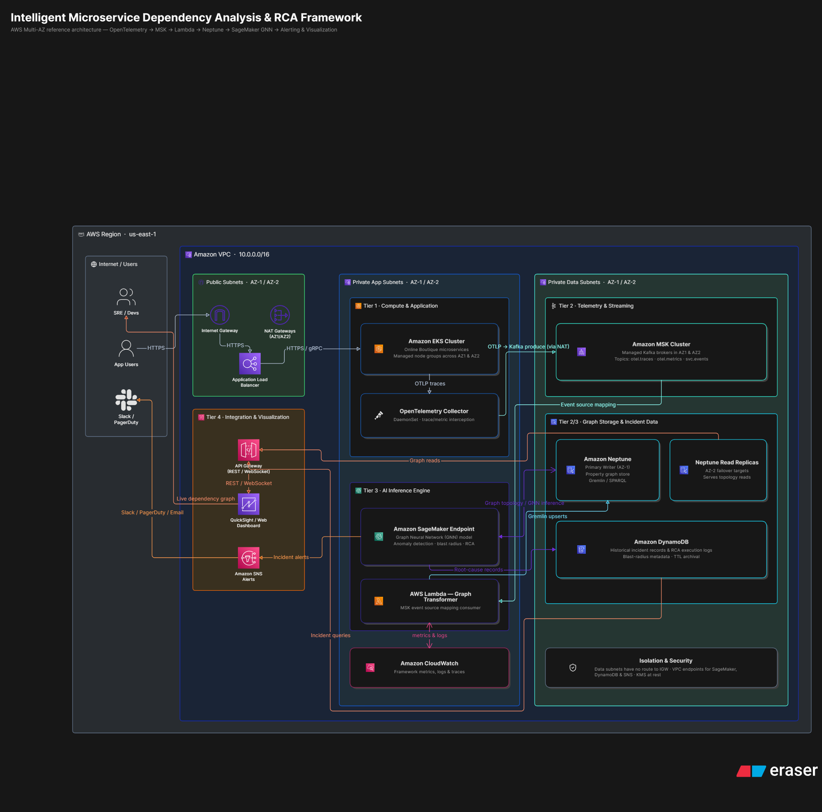

Diagram 2: Complete System Architecture (Collaboration View)
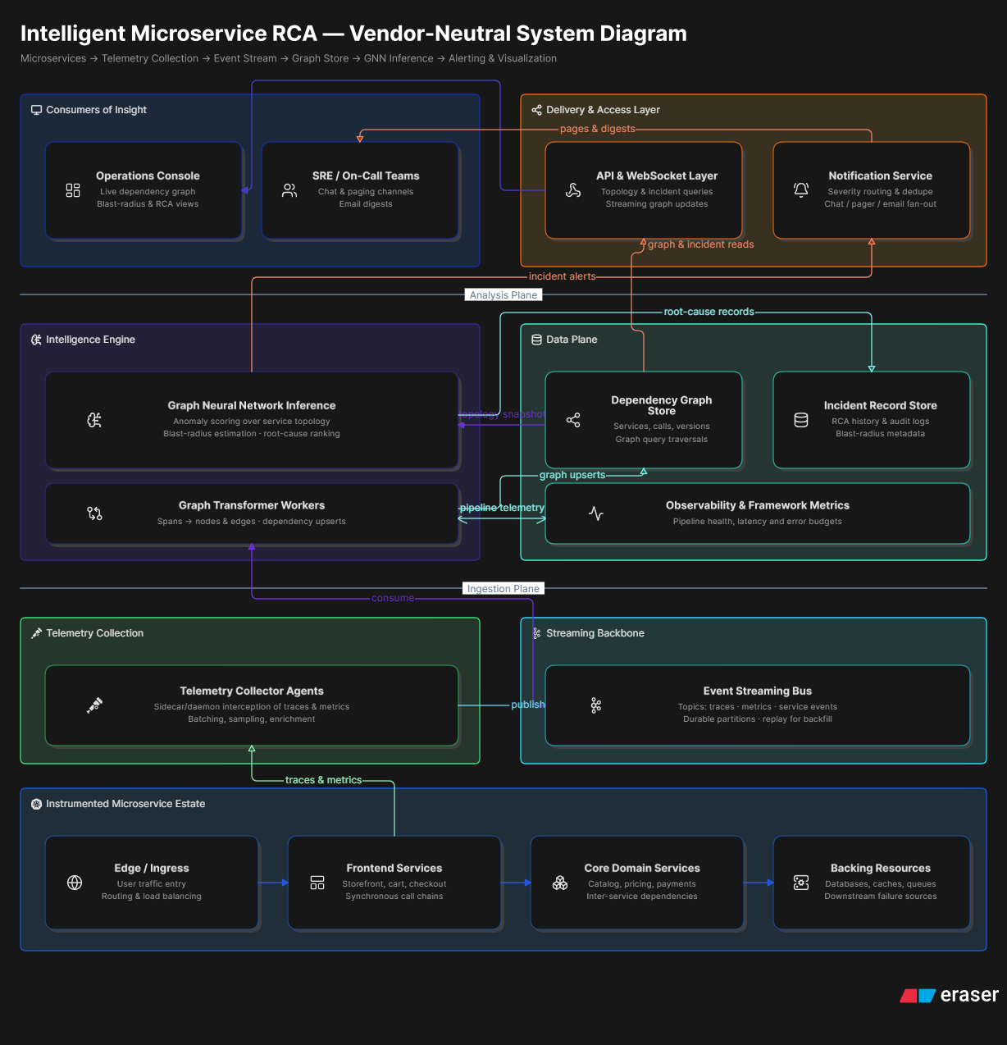

VII. Dataset Details
• Dataset Name: Alibaba Microservice Trace Dataset
• Source: Alibaba Cluster Trace Program
• URL: https://github.com/alibaba/clusterdata
• Size: ~50 GB (Sampled for this project)
• Number of Records: Over 10 million trace spans and metrics
• Number of Features: 15+ (Timestamp, TraceID, SpanID, ParentSpanID, RPC Type, Interfaced, Latency, Status Code)
• Data Type: CSV and JSON
• License: MIT / Open Source for Research
• Purpose of using the dataset: To simulate high-volume, real-world e-commerce microservice traffic and failure scenarios for training the graph models.
• Preprocessing required: Grouping traces by TraceID, calculating edge weights (average latency between services), filtering out incomplete spans, and converting tabular data into node-edge-node triplets suitable for graph ingestion.

VIII. AWS Services Planning
AWS Service | Purpose
Amazon EKS | Host the containerized e-commerce microservices (Cart, Catalog, Payment)
Amazon MSK | Ingest high-throughput distributed tracing logs as a scalable message broker
AWS Lambda | Serverless processing to parse Kafka streams and update the graph in real-time
Amazon Neptune | Core graph database to store the dynamic microservice dependency Knowledge Graph
Amazon SageMaker | Train and deploy the Graph Neural Network (GNN) for anomaly detection
Amazon API Gateway | Provide REST/WebSocket APIs for the frontend visualization dashboard
Amazon CloudWatch | Monitor the health and execution logs of the monitoring framework itself
Amazon SNS | Send immediate alerts to engineering teams when a root cause is identified
Amazon QuickSight | Visualize the service topologies and operational statistics
AWS IAM | Secure access controls between all executing services

IX. GitHub Guidelines & Task Allocation
Repository Name: ShoppingPlatform_MicroserviceKG_Cloud_Project_2026
Each team will use the feature branch model (main -> develop -> feature/studentX).
Activity | Student 1 | Student 2 | Student 3
Literature Survey (5 Papers each) | ✓ | ✓ | ✓
Research Gap (5 Papers each) | ✓ | ✓ | ✓
Data Preprocessing & Telemetry Pipeline | ✓
Knowledge Graph (Neptune) & Lambda Backend |  | ✓
AI/ML (SageMaker GNN) & Prediction |  |  | ✓
AWS Cloud Infrastructure Setup | ✓ | ✓ | ✓
Dashboard & Visualization (QuickSight) | ✓ | ✓
Testing & Validation | ✓ | ✓ | ✓
Documentation & Presentation | ✓ | ✓ | ✓
GitHub Commits & PR Reviews | ✓ | ✓ | ✓

