Lab-4  Spatio- Temporal segmentation

By

21MIA1132 -A.Kabilesh Rajaselvan



SCOPE SCHOOL VIT CHENNAI CAMPUS, VANDALUR-KELAMBAKKAM ROAD, CHENNAI-600127

DATE: 10-10-2024

STUDENTS: Students of IV year M.TECH (5 YEARS)

Submitted To: Dr. Saranyaraj D

**Objective**  
The primary goal is to analyze a provided video, extract individual frames, perform spatio-temporal segmentation, and detect scene cuts (both hard and soft transitions). This allows for a detailed understanding of motion, object tracking, and scene changes in the video.

**Problem Statement**  
In real-world applications, extracting meaningful data from video requires segmentation of objects from frames and identifying regions of motion and change over time. This system will isolate moving objects, track them, and detect both hard and soft scene transitions. The challenge lies in segmenting objects accurately under changing conditions and identifying scene cuts that aren't immediately apparent through simple pixel comparison.

**Expected Output**

1. **Extracted Frames:** A series of frames from the input video.
2. **Segmented Objects:** Segmented objects from each frame, distinguishing between the foreground (moving objects) and the background (static regions).
3. **Scene Cuts:** Marked frames where scene transitions occur, categorized as hard or soft cuts.
4. **Visual Summary:** A summary highlighting the detected scene boundaries and segmented objects in key frames.

**Methodology**

1. **Video Loading and Frame Extraction**
   * Load the provided video file.
   * Extract individual frames using a library like OpenCV or similar.

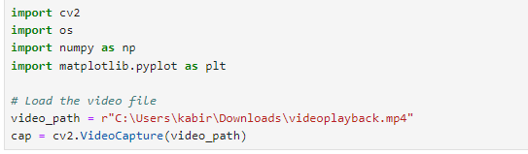

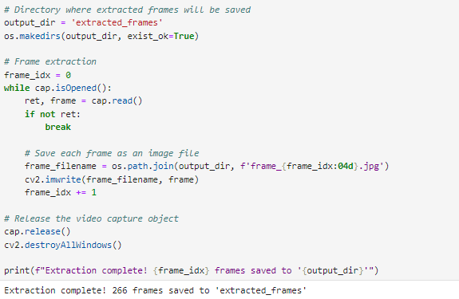

**Spatio-Temporal Segmentation**

* For each frame, apply color thresholding to segment objects based on color features.
* Detect edges using edge detection techniques like Canny Edge Detection.
* Track the segmented objects across consecutive frames to observe changes in motion and shape.
* Separate foreground (moving objects) from background by analyzing which regions remain consistent over time.

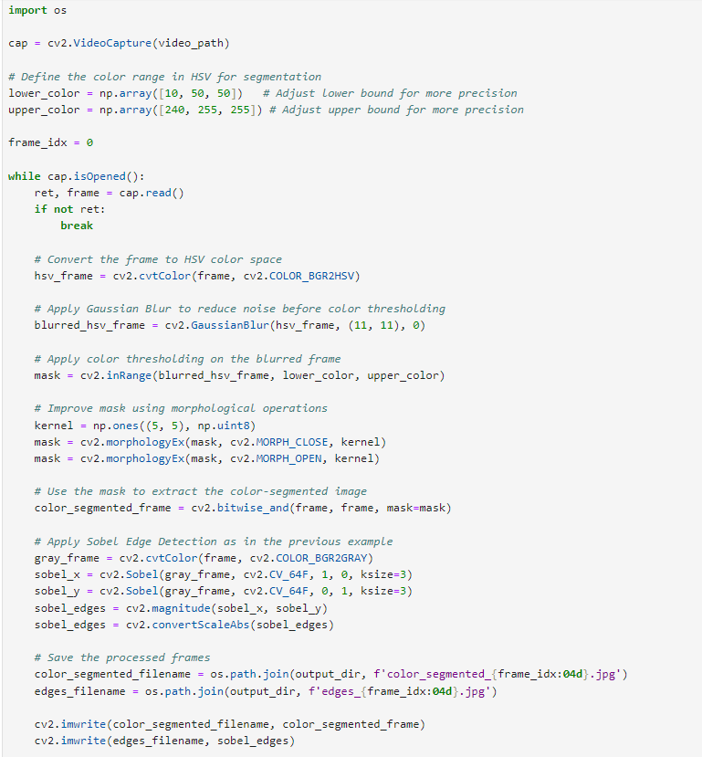



**Scene Cut Detection**

* **Hard Cuts**: Use pixel-based comparison between consecutive frames. If the pixel difference exceeds a certain threshold, a hard cut is detected.
* **Soft Cuts**: Analyze frame-to-frame intensity changes. Gradual shifts in color or brightness over several frames signal a soft transition.

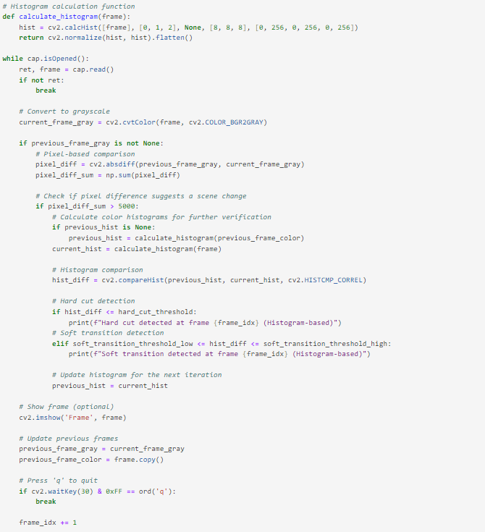

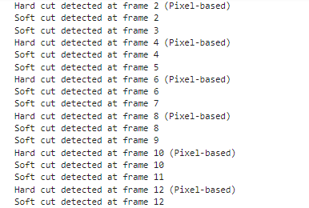

**Result Visualization**

* Display the segmented objects and the detected scene cuts visually, marking the scene transitions with bounding boxes or labels.
* Select key frames to showcase the segmentation results and scene boundaries.

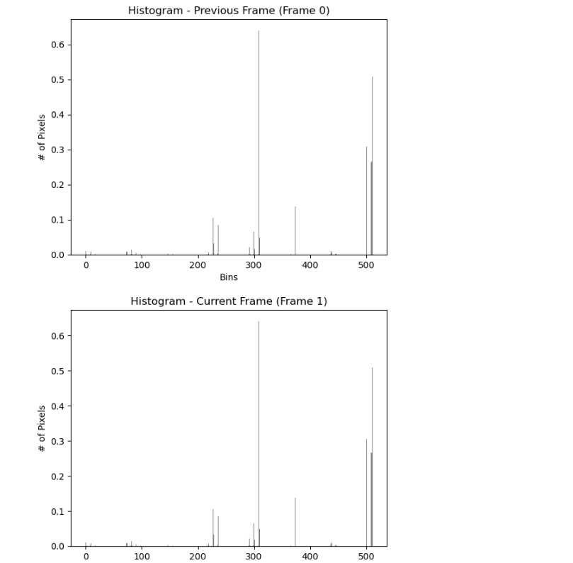

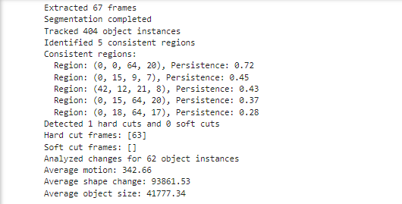

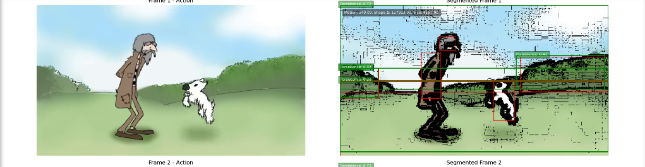



**Challenges and Observations**

1. **Object Segmentation Accuracy**: The success of spatio-temporal segmentation highly depends on the consistency of lighting and the clarity of object boundaries. For more robust segmentation, advanced techniques like watershed segmentation or machine learning-based models can be considered, similar to object detection projects involving feature extraction.
2. **Scene Cut Detection**: Hard cuts are relatively easy to detect through pixel comparison, but soft transitions require more nuanced analysis, as gradual changes can be subtle.

**Conclusion**

This task provides insight into how video analysis can be leveraged to detect scene changes and segment objects. It ties closely to real-time applications like traffic analysis or surveillance, where understanding motion and identifying key transitions are essential. The same principles are applicable to IoT projects where devices capture and analyze video data, like in your ongoing IoT work, involving video-based event detection.

By segmenting each frame and detecting scene transitions, you can create an efficient pipeline for visual analysis, which could be extended for more complex tasks, like summarizing video content or detecting abnormal events.