📚

CITY BOOKSHOP
Management System

A Java-based Bookshop Management System with JavaFX Interface

Course Title | : | Object Oriented Programming
Course Code | : | CO2125
Submission Date | : | 25/02/2026
Group | : | DCS 22/23 Devs
Lecturer | : | Ms. J. Janani

Name | Registration Number
M. Kabileshwaran | EUSL/TC/IS/2022/COM/38
M. DinushKhan | EUSL/TC/IS/2022/COM/36
W.P.V.DESHAN | EUSL/TC/IS/2022/COM/ 35
K.B.M.I.U.BASNAYAKA | EUSL/TC/IS/2022/COM/ 34
B.L.A.D.M.Liyanage | EUSL/TC/IS/2022/COM/ 37

DECLARATION

We hereby declare that this assignment is our own group work and has not been submitted previously for any academic purpose.

Signature: __________________ Date: ______________________

Signature: __________________ Date: ______________________

Signature: __________________ Date: ______________________

Signature: __________________ Date: ______________________

Signature: __________________ Date: ______________________

ACKNOWLEDGEMENT

We are grateful to our lecturer, Ms. Janani, for giving us this opportunity to build a real-world system and for her guidance throughout this project.
We used Claude (by Anthropic) as an AI assistant to help troubleshoot issues and provide guidance throughout the development of this project.
Building the City Bookshop Management System using Java was a good learning experience. We learnt a lot about Object-Oriented Programming, JavaFX, file handling, and teamwork throughout this process.

TABLE OF CONTENTS
Table of Contents
DECLARATION 2
ACKNOWLEDGEMENT 3
TABLE OF CONTENTS 4
INTRODUCTION 6
SYSTEM DEVELOPMENT 7
System Overview 7
Objectives of the System 7
Main Functionalities 7
System Design 8
Application of Object-Oriented Concepts 9
Object 9
Class 9
Abstraction 10
Encapsulation 10
Inheritance 11
Polymorphism 12
Source Code 12
UserService.java 13
LoginController.java 13
Testing and Output 14
USER MANUAL 16
System Requirements 16
Installation Guide 16
How to Use the System 17
Logging In 17
Viewing Books (All Users) 17
Searching Books (All Users) 17
Viewing Stock (All Users) 17
Adding a New Book (Manager Only) 18
Adding a Category (Manager Only) 18
Creating a New User Account (Manager Only) 18
Logging Out 18
Screenshots 18
Login Screen 19
Dashboard 20
20
Books list 21
Stock view 22
Add Book form 23
Add Category form 24
Create Account form 25
Troubleshooting 26
CONCLUSION 27
REFERENCES 28

INTRODUCTION

As part of our Object-Oriented Programming group assignment, we developed the City Bookshop Management System. The purpose of this system is to help a bookshop manage its daily operations such as tracking books, stock levels, and staff accounts in a simple and organized way.
The system was built using Java with a JavaFX graphical user interface. Data is stored using text files through Java File I/O.
The system demonstrates all six OOP concepts
- Class
- Object
- Encapsulation
- Inheritance
- Abstraction
- Polymorphism
in a practical way.
The system has two user roles.
A Cashier can view and search books and check stock levels.
A Manager has full access and can also add books, add categories, and create new staff accounts.
This project was a great learning experience for our team and helped us better understand how OOP concepts are applied in real-world application development.

SYSTEM DEVELOPMENT

System Overview

The City Bookshop Management System is a role-based desktop application that enables bookshop staff to efficiently manage books, categories, stock levels, and user accounts. The system stores all data in plain text files and provides a dark-themed JavaFX graphical interface.

Objectives of the System

- Provide a digital solution for managing bookshop inventory
- Implement role-based access for Cashier and Manager users
- Enable searching and filtering of books by title, category, and price
- Allow managers to add books, categories, and create user accounts
- Demonstrate all six OOP concepts in a practical application
- Store and retrieve data using Java File I/O without a database

Main Functionalities

Cashier Features
- Login with username and password
- View all books in the system
- Search books by title, author, category, and price range
- View current stock levels with low stock warnings

Manager Features (All Cashier Features Plus)
- Add new books to the system
- Add new book categories
- Create new user accounts (Cashier or Manager)
- Access to all management screens

System Design
The system follows the Model-View-Controller (MVC) architectural pattern, which cleanly separates business logic, user interface, and data handling. The project structure is divided into four main packages:

Package | Responsibility
model/ | Contains all OOP entity classes: User (abstract), Cashier, Manager, Book, Category
service/ | Business logic and file I/O FileHandler, UserService, BookService, CategoryService
controller/ | JavaFX controllers that connect FXML screens to service classes
view/ | FXML screen layouts designed using Scene Builder
data/ | Flat text files: users.txt, books.txt, categories.txt

All data is stored in pipe-separated text files:

File | Format
users.txt | USR001|kabil|1896|Manager
books.txt | BK001|Clean Code |Robert C. Martin|Programming|5500|20
categories.txt | CAT001|Fiction|Books that contain fictional stories

Screen List

Screen | Access
Login | All users
Dashboard | All users (role-based menu)
View Books | All users
View Stock | All users
Add New Book | Manager only
Add Category | Manager only
Create Account | Manager only

Each record is pipe-delimited (|), enabling straightforward parsing via Java's String.split() method.
The FileHandler service reads and writes these files at runtime, ensuring data is persisted across sessions.

Application of Object-Oriented Concepts

Object
An object is an instance of a class that holds state (fields) and behavior (methods).
In the system, every book managed by the application is represented as an instance of the Book class. Similarly, each user logged into the system is an instance of either Cashier or Manager.
For example, when the application loads book data from books.txt, each line is parsed and instantiated as a Book object stored in a list.
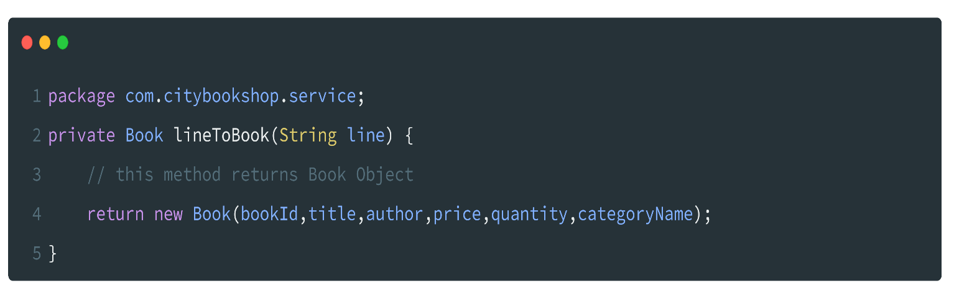

Class
A class is a blueprint that defines the structure and behavior of objects.
The system contains five primary model classes:
- User.java – Abstract base class for all users, holding common attributes such as user ID, username, and password.
- Cashier.java – Concrete class extending User, representing a cashier role.
- Manager.java – Concrete class extending User, representing a manager role with elevated privileges.
- Book.java – Encapsulates book details such as ID, title, author, category, price, and stock quantity.
- Category.java – Represents a book category with an ID, name, and description.

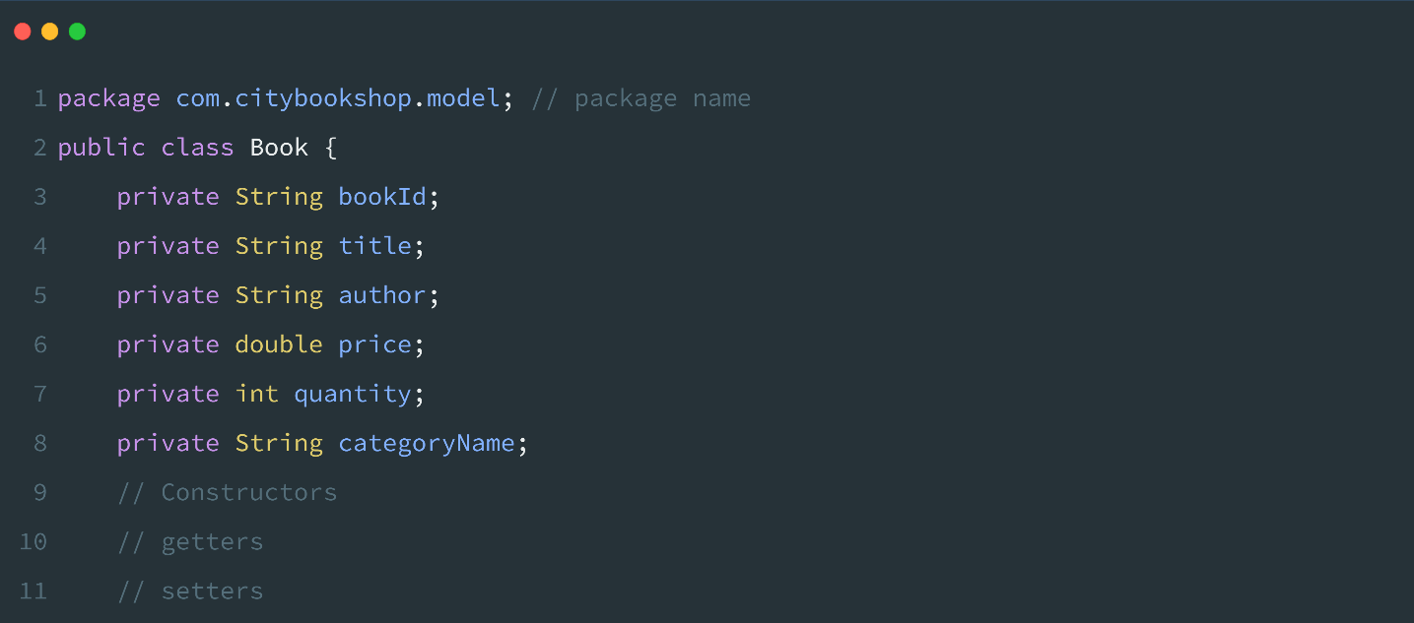

Abstraction

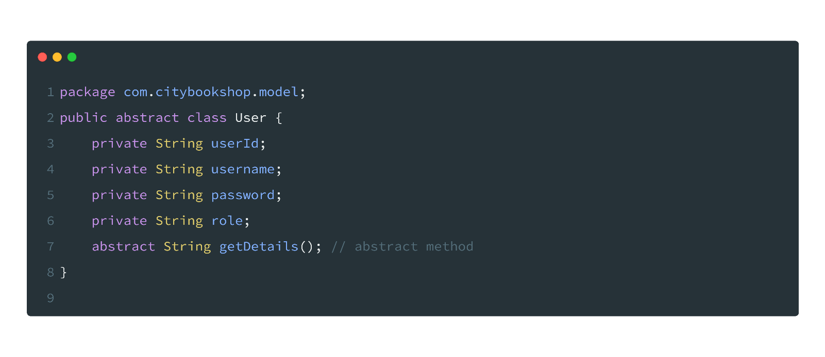
Abstraction hides implementation complexity and exposes only the relevant interface to the user. In the system, the User class is declared abstract. It defines the abstract method getDetails(), which must be implemented by every concrete subclass. This means the calling code interacts with the User type without needing to know whether the actual object is a Cashier or Manager.

Encapsulation
Encapsulation protects an object's internal state by restricting direct access to its fields and providing controlled access through getter and setter methods. In the system, all model class fields are declared private and accessed only through public getters and setters. For example, the Book class does not allow direct manipulation of its bookId or its title.
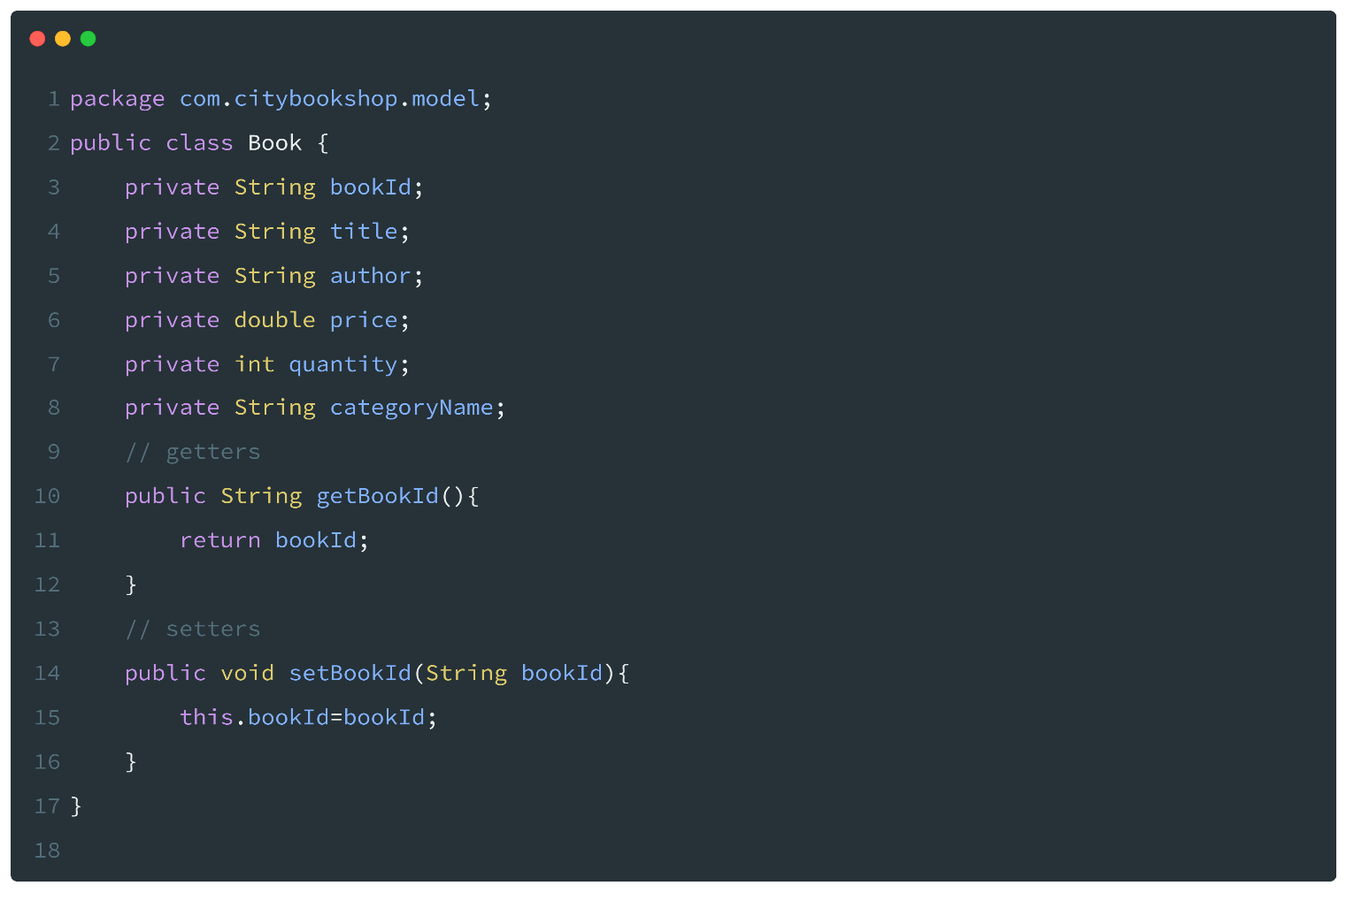

This ensures that the integrity of data is maintained and that any validation logic can be centrally enforced within the setter methods.

Inheritance
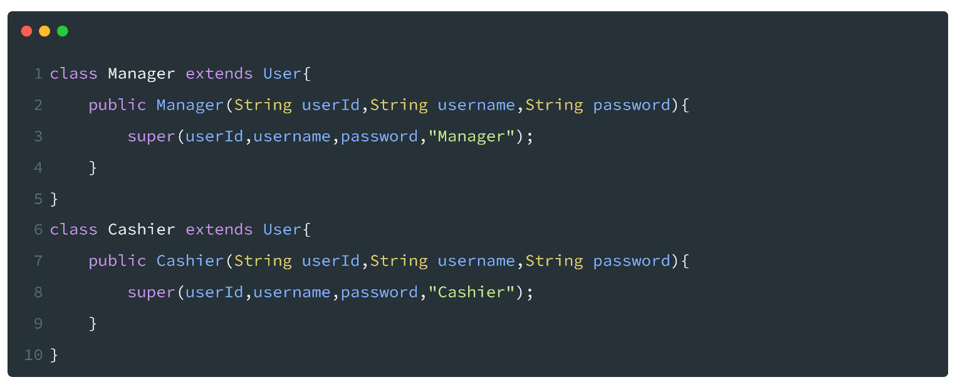
Inheritance allows a child class to inherit the fields and methods of a parent class, promoting code reuse and establishing a natural class hierarchy. In the system, both Cashier and Manager extend the abstract User class, inheriting its common fields (userId, username, password) and the requirement to implement getDetails(). This avoids code duplication across both user type classes.

Polymorphism
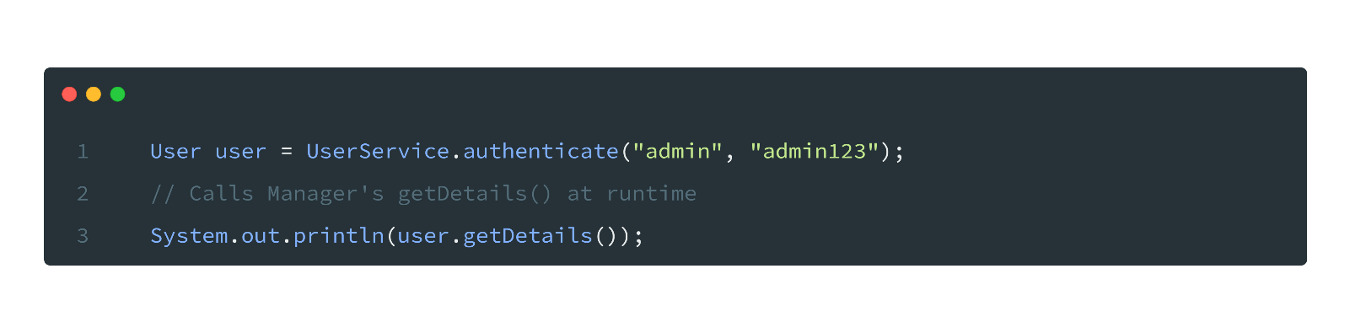
Polymorphism allows a single interface to represent different underlying data types, and enables methods to behave differently depending on the object's actual type at runtime. In the system, the overridden getDetails() method in Cashier and Manager demonstrates runtime polymorphism. A variable declared as type User can hold either a Cashier or Manager object, and calling getDetails() will invoke the correct version depending on the actual runtime type.
Polymorphism is also applied in the Dashboard controller, where the role of the logged-in user is used to dynamically render or hide menu items without requiring separate controller classes for each role.

Source Code
Below is a representative selection of the key source code components.
The complete source code is available in the project's
GitHub repository at:
source-code (https://github.com/KabileshwaranKabil/CityBookshop-JavaFX).

UserService.java

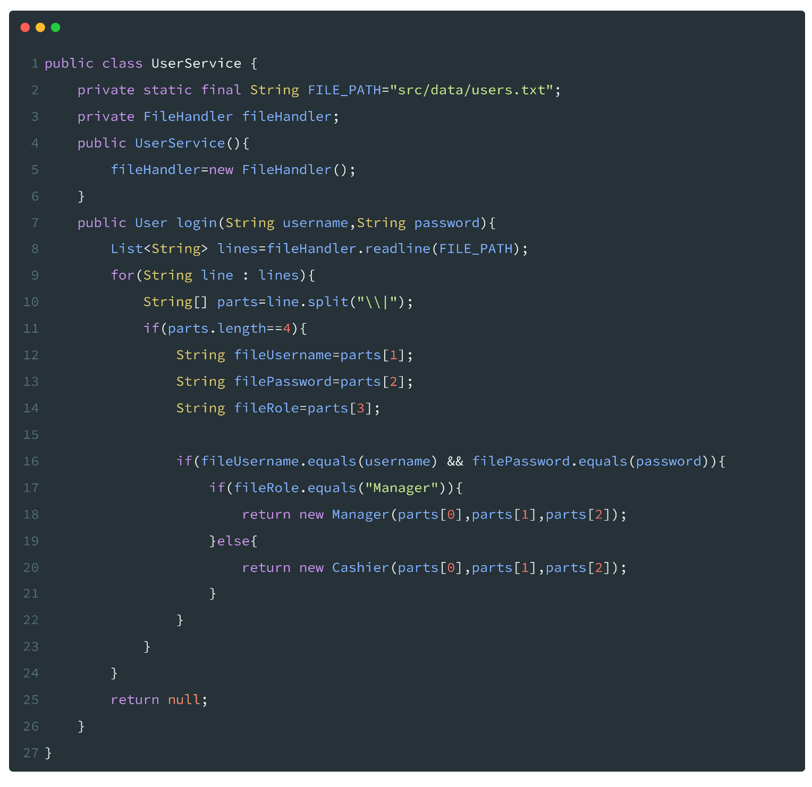
LoginController.java

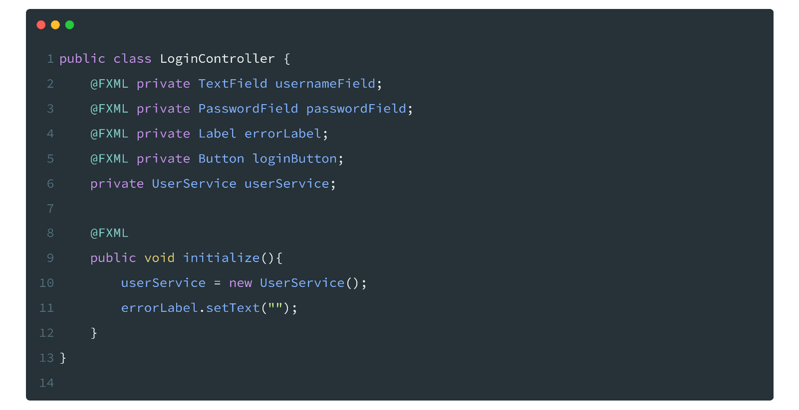

Testing and Output

The system was tested manually across all screens and user roles. The following table summarises the test cases conducted

Test Case | Input | Expected Output | Result
Valid Manager Login | kabil / 1896 | Redirect to Dashboard with full menu | Pass
Valid Cashier Login | praveen / 897 | Redirect to Dashboard with limited menu | Pass
Invalid Login | vijay / wrongpass | Error alert shown | Pass
View All Books | Click 'Books' menu | Table populated with book data | Pass
Search by Name | Enter 'Clean Code' | Matching book displayed | Pass
Search by Category | Select 'Programming' | All programming books listed | Pass
Add New Book (Manager) | Enter book details, click Save | Book saved to books.txt | Pass
Add Category (Manager) | Enter category, click Save | Category saved to categories.txt | Pass
Create Account (Manager) | Enter new user details | User saved to users.txt | Pass
Cashier Access to Add Book | Login as Cashier | Add Book menu not visible | Pass

All test cases were executed successfully and produced the expected outputs; for a complete walkthrough of the testing process, please refer to the demonstration video available on YouTube.

USER MANUAL

System Requirements
To run the City Bookshop Management System, the following hardware and software requirements must be met:
Requirement | Minimum Specification
Operating System | Windows 10 / macOS 10.14 / Ubuntu 20.04 or later
Java Version | JDK 17 or higher
JavaFX SDK | JavaFX 17 or compatible version
IDE (optional) | IntelliJ IDEA or Eclipse with JavaFX plugin

Installation Guide
Follow the steps below to set up and run the City Bookshop Management System on your local machine:

Step 1: Install Java JDK 17
Download and install Java JDK 17 or higher.

Step 2: Download JavaFX SDK
Download the JavaFX SDK and extract it to a known directory on your machine.
download here

Step 3: Clone the Repository
git clone https://github.com/KabileshwaranKabil/CityBookshop-JavaFX.git

Step 4: Open the Project in IntelliJ IDEA
- Launch IntelliJ IDEA and select File > Open.
- Navigate to the cloned folder and open it as a project.
- Add the JavaFX SDK: Go to File > Project Structure > Libraries, click +, and select the lib folder from your JavaFX SDK directory.

Step 5: Configure VM Options
In IntelliJ IDEA, go to Run > Edit Configurations and add the following VM options:
`--module-path /path/to/javafx-sdk/lib --add-modules javafx.controls,javafx.fxml`

Step 6: Run the Application
Right-click Main.java and select Run 'Main'. The application will launch showing the Login screen.

How to Use the System

Logging In
Upon launching the application, the Login screen is displayed. Enter your username and password and click the Login button. The default administrator credentials are:
Username: kabil
Password: 1896

Upon successful authentication, you will be redirected to the Dashboard. The available menu options will reflect your assigned role.

Viewing Books (All Users)
- From the Dashboard, click the Books menu item.
- A table listing all available books will be displayed, showing the book ID, title, author, category, price, and stock quantity.

Searching Books (All Users)
- Navigate to the Books screen.
- Use the search bar at the top to type a book title. Results will filter in real time.
- Use the Category dropdown to filter books by category.
- Enter a price range in the designated fields to filter by price.

Viewing Stock (All Users)
- Click the Stock menu item from the Dashboard.
- The stock screen displays current inventory levels for all books.

Adding a New Book (Manager Only)
- Click the Add Book menu item (visible to Managers only).
- Enter the book ID, title, author name, category, price, and initial stock quantity.
- Click Save. The new book will be stored in books.txt and appear in the Books list.

Adding a Category (Manager Only)
- Click the Add Category menu item.
- Enter a unique category ID, category name, and description.
- Click Save. The new category will be available for selection when adding books.

Creating a New User Account (Manager Only)
- Click the Create Account menu item.
- Enter a unique user ID, username, and password.
- Select the role (Cashier or Manager) from the dropdown.
- Click Create. The new user account will be saved and can log in immediately.

Logging Out
- Click the Logout button from the Dashboard.
- You will be returned to the Login screen.

Screenshots
Note: The following section would contain screenshots of each screen in the application. Please refer to the running application or the /docs folder in the repository for visual references of the Login screen, Dashboard, Books list, Stock view, Add Book form, Add Category form, and Create Account form.

Login Screen

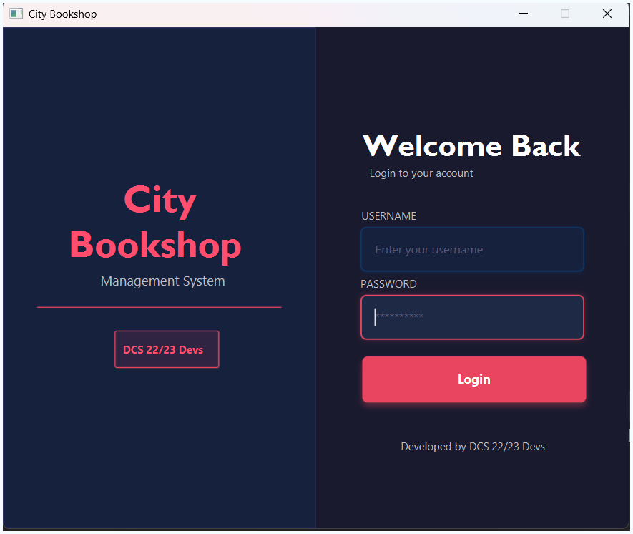

Dashboard
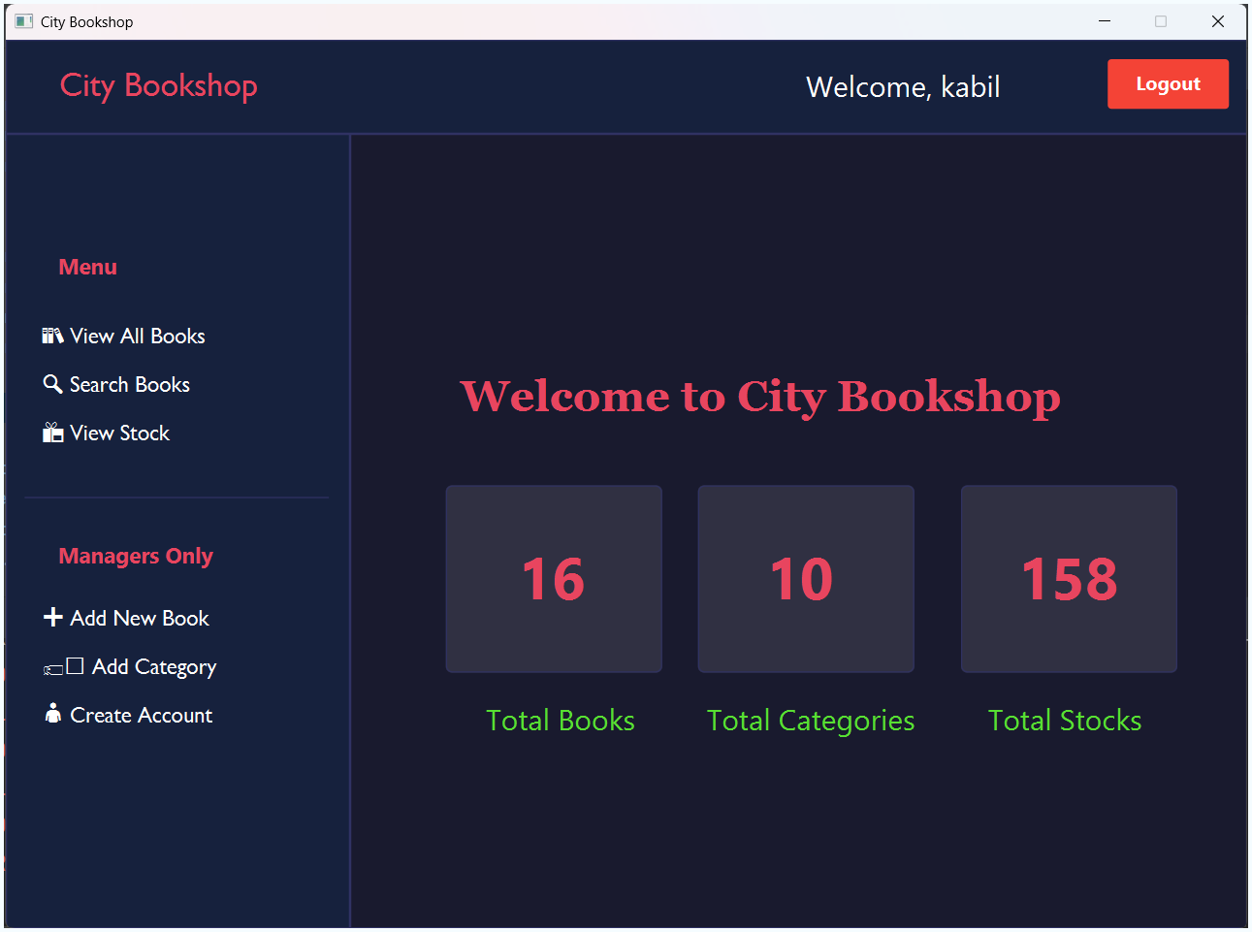

Books list
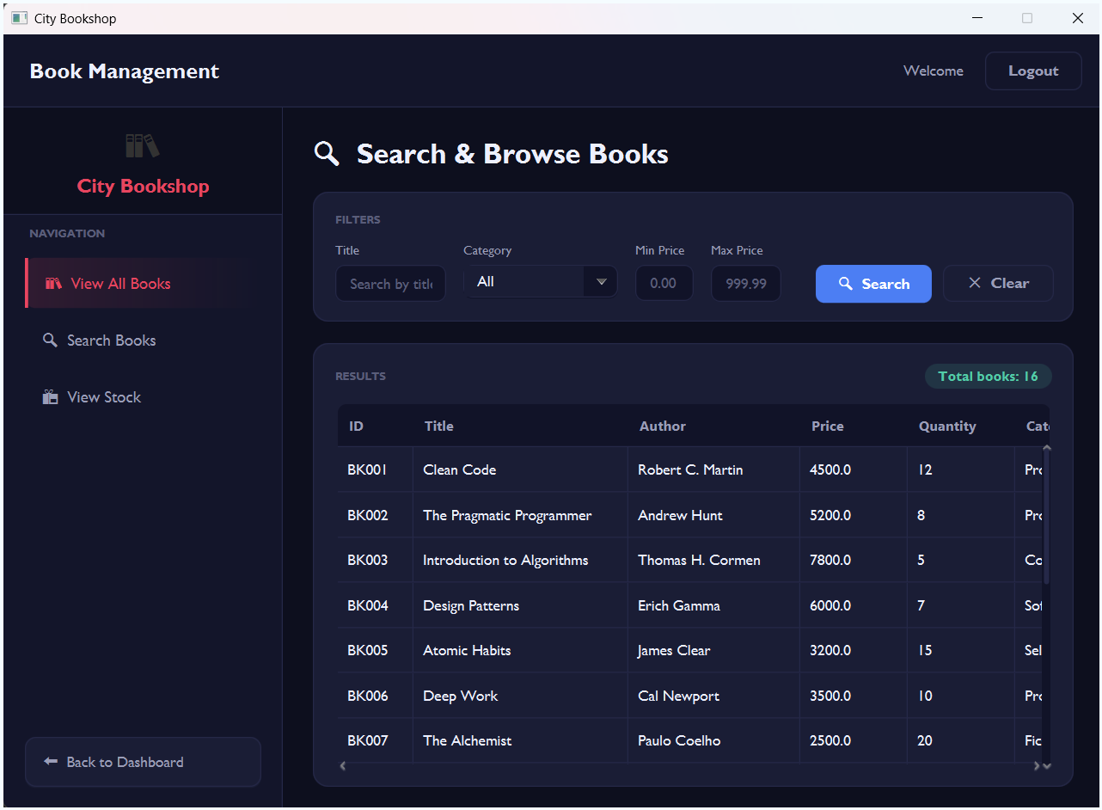

Stock view
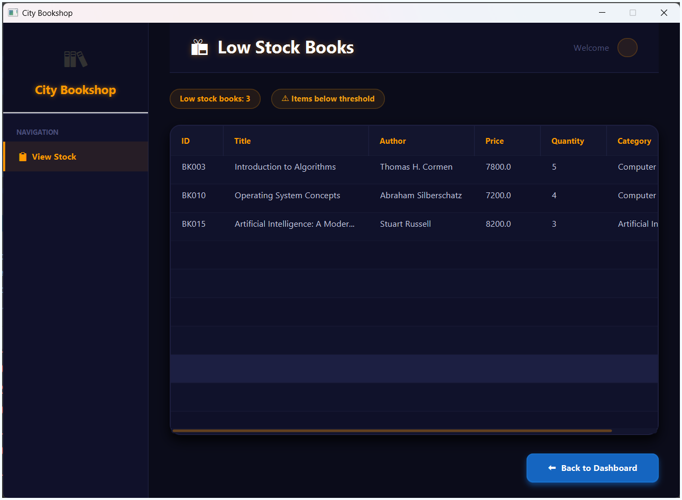

Add Book form
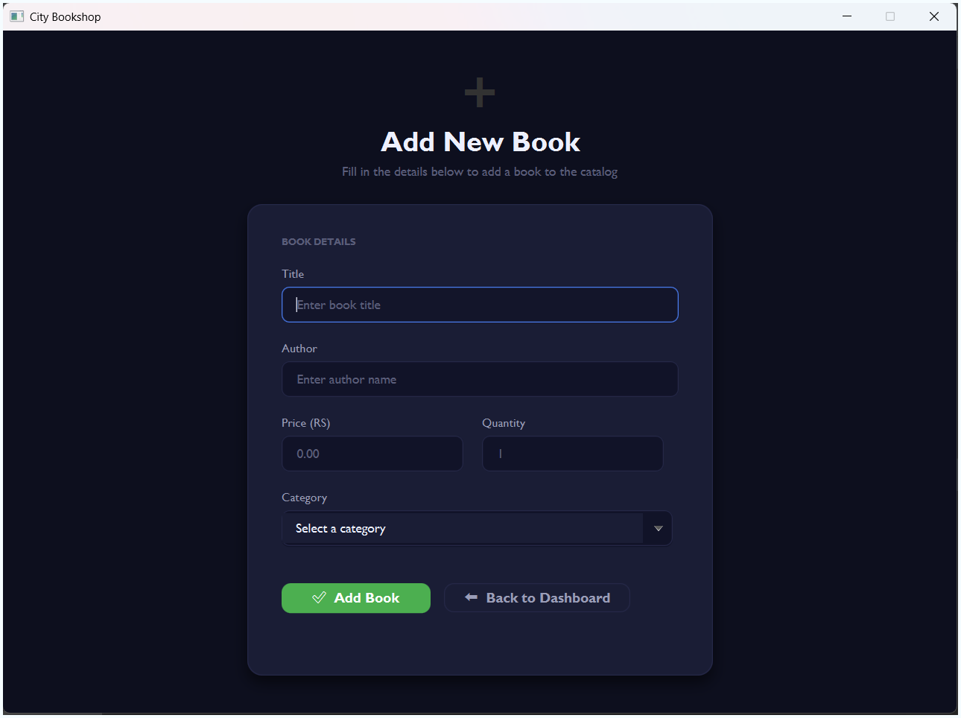

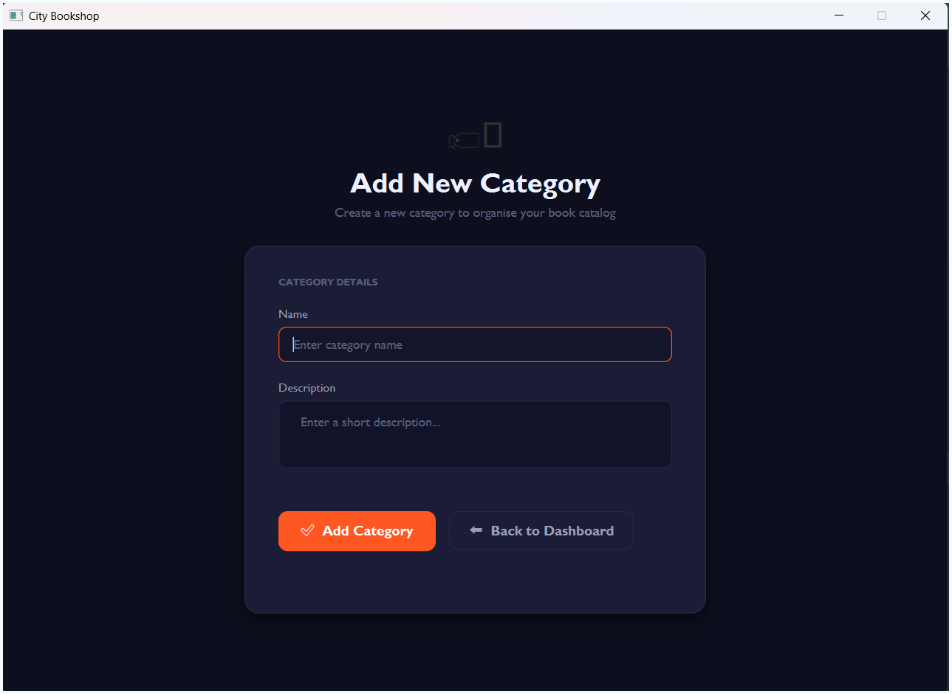
Add Category form

Create Account form
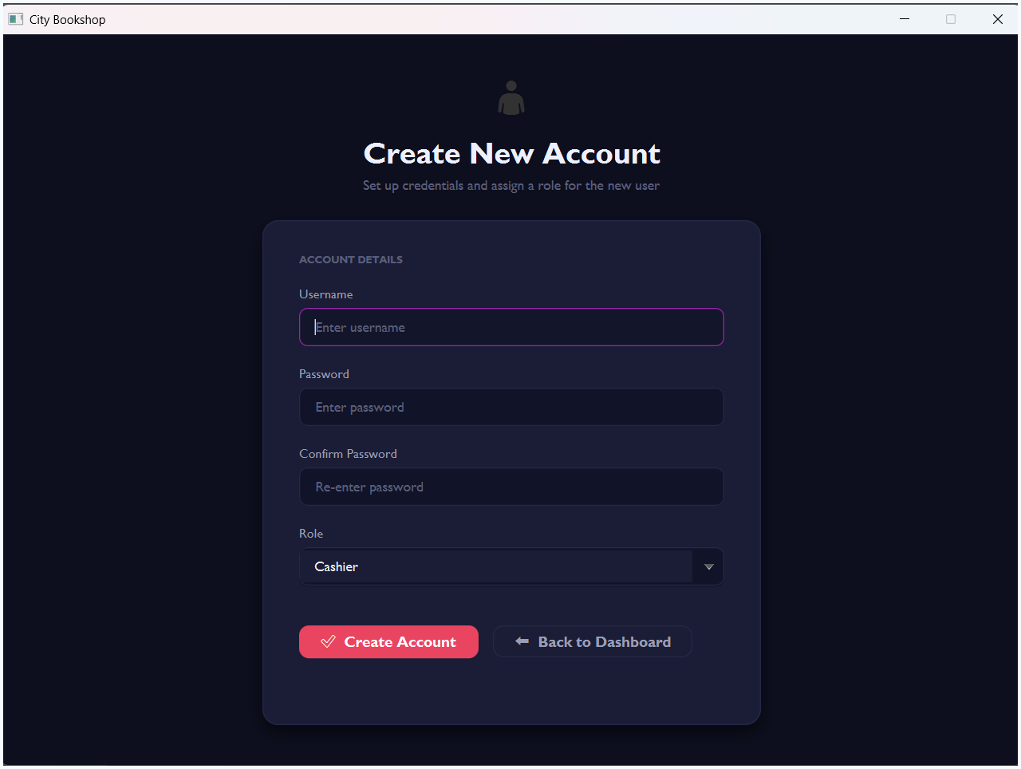

Troubleshooting

Problem | Possible Cause | Solution
Application does not launch | JavaFX not configured | Ensure VM options include --module-path and --add-modules
Login fails with correct credentials | Corrupted users.txt | Check the /data/users.txt file and verify the pipe-delimited format
Books not loading | Missing books.txt | Ensure the /data/ folder exists and contains books.txt
Changes not saving | Insufficient file permissions | Run IDE/application as administrator or adjust folder permissions
Blank screen after login | FXML file missing | Verify all .fxml files exist in the /src/.../view/ folder

CONCLUSION
The City Bookshop Management System successfully demonstrates the practical application of Object-Oriented Programming principles in the development of a real-world desktop application. By designing a system around the core OOP concepts of encapsulation, inheritance, abstraction, and polymorphism, the team was able to produce a clean, modular, and maintainable codebase.

The use of an abstract User class with Cashier and Manager subclasses allowed for a flexible and extensible role-based access control mechanism. Encapsulation ensured that the internal state of model objects was protected and accessed through well-defined interfaces. Polymorphism enabled the Dashboard to dynamically adapt its behaviour based on the logged-in user's role, without requiring duplicated code.

The JavaFX framework with FXML and Scene Builder proved effective for designing an intuitive graphical interface, while Java's file I/O capabilities provided a lightweight and portable data persistence solution without requiring an external database. The MVC architectural pattern kept the codebase well-organised and maintainable across the team.

In conclusion, this project has provided the group with valuable hands-on experience in applying OOP design principles, working collaboratively using Git version control, and developing a complete end-to-end desktop application. The lessons learned will serve as a strong foundation for future software development endeavours.

REFERENCES
JavaFX. (2023). JavaFX API Documentation. Retrieved from https://openjfx.io/javadoc/17/
Oracle Corporation. (2023). Java Object-Oriented Programming Concepts. Retrieved from https://docs.oracle.com/javase/tutorial/java/concepts/index.html
Oracle Corporation. (2023). Java File I/O (NIO.2). Retrieved from https://docs.oracle.com/javase/tutorial/essential/io/fileio.html

