Deepfake Image Detection Using Hybrid Deep Learning and Soft Computing:
A Transfer Learning and Fuzzy Inference Approach
By Kabir Singh Banga
Abstract
Deepfake technology, enabled by advances in Generative Adversarial Networks (GANs), has significantly increased the risk of digital misinformation, identity manipulation, and media forgery. Conventional deep learning-based deepfake detection systems achieve high classification accuracy but often lack interpretability and uncertainty quantification, making them unreliable in ambiguous cases. This research proposes a hybrid deepfake detection framework that integrates transfer learning with a fuzzy inference-based trust scoring mechanism to enhance both performance and explainability.
The proposed system consists of three major components: (1) a transfer learning-based convolutional neural network (CNN) using MobileNetV2 pre-trained on ImageNet for binary classification of real and fake images, (2) a confidence feature extraction module that computes softmax probabilities, confidence margin, and entropy-based uncertainty, and (3) a fuzzy inference system that maps these features into an interpretable trust score ranging from 0 to 100. The fuzzy system employs linguistic rules and centroid defuzzification to categorize predictions into Authentic, Suspicious, and Likely Deepfake classes.
Experimental evaluation demonstrates that the hybrid model achieves strong classification performance while effectively handling uncertain predictions through interpretable trust scoring. Unlike conventional binary classifiers, the proposed approach provides human-understandable reasoning and graded confidence assessment, making it suitable for real-world applications such as social media moderation, journalism verification, and digital forensics. The integration of deep learning and soft computing introduces an explainable AI layer into deepfake detection, bridging the gap between predictive accuracy and decision transparency.
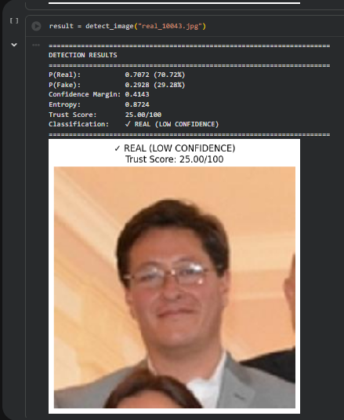
Introduction

1. Background and Motivation
The rapid advancement of deep generative models has significantly improved the realism of synthetic media. Techniques based on Generative Adversarial Networks (GANs), first introduced by Ian Goodfellow, enable the creation of highly convincing manipulated images and videos commonly referred to as deepfakes. While such technologies have beneficial applications in entertainment and content generation, they also pose serious threats including misinformation, identity fraud, cybercrime, and political manipulation.
The proliferation of deepfake content across digital platforms has created an urgent need for reliable automated detection systems. Social media platforms, digital journalism agencies, and forensic investigators require tools capable of distinguishing authentic images from manipulated ones with high reliability and transparency.

2. Problem Statement
Deep learning-based deepfake detection methods, particularly convolutional neural networks (CNNs), have demonstrated strong classification performance. However, most existing systems provide only binary predictions (real or fake) accompanied by softmax probabilities. These probabilities are often misinterpreted as true confidence levels and fail to quantify uncertainty explicitly.
Key limitations of conventional approaches include:
- Lack of interpretability in model decisions
- Absence of uncertainty quantification
- Overconfidence in ambiguous predictions
- Inability to provide graded trust assessment
In real-world deployment scenarios, especially in high-stakes environments such as legal or journalistic verification, binary decisions without explainable confidence can be insufficient.

3. Research Objective
This research aims to develop a hybrid deepfake detection framework that enhances both predictive performance and interpretability. The primary objectives are:
- To implement a transfer learning-based CNN model using a pre-trained architecture for real vs fake image classification.
- To extract meaningful confidence-related features from model predictions.
- To quantify prediction uncertainty using entropy.
- To design a fuzzy inference system that maps extracted features into interpretable trust scores.
- To provide explainable and graded classification decisions.

4. Research Contribution
The major contributions of this study are:
- A hybrid architecture integrating deep learning with fuzzy logic for explainable AI.
- A structured confidence feature extraction mechanism including confidence margin and entropy.
- A fuzzy rule-based trust scoring system that converts probabilistic outputs into human-understandable trust levels (0–100 scale).
- A three-tier classification framework: Authentic, Suspicious, and Likely Deepfake.
- Experimental validation using the Kaggle Real vs Fake Image dataset.
Unlike conventional CNN-only classifiers, the proposed system introduces an additional reasoning layer that enhances interpretability without compromising classification accuracy.

Related Work

1. Deep Learning Approaches for Deepfake Detection
Deepfake detection has largely relied on convolutional neural networks (CNNs) due to their strong performance in image classification tasks. Early research focused on identifying visual artifacts and inconsistencies introduced by generative models such as GANs. Following the introduction of GANs by Ian Goodfellow, the realism of synthetic media improved substantially, making detection increasingly challenging.
Transfer learning has become a widely adopted strategy in deepfake detection due to limited labeled datasets. Architectures such as Google’s MobileNetV2 and EfficientNetB0 have demonstrated strong performance while maintaining computational efficiency. MobileNetV2 utilizes depthwise separable convolutions and inverted residual blocks, making it suitable for lightweight applications. EfficientNetB0 introduces compound scaling, systematically balancing network depth, width, and resolution for improved accuracy-efficiency tradeoff.
Several studies report high classification accuracy using CNN-based methods; however, these approaches typically output only softmax probabilities without addressing prediction uncertainty or interpretability.

2. Uncertainty Estimation in Neural Networks
Softmax probabilities are commonly interpreted as model confidence, but research has shown that neural networks can be overconfident even in incorrect predictions. Entropy-based measures have been proposed as a mathematical approach to quantify uncertainty:
Higher entropy indicates greater uncertainty in prediction distribution. Despite its theoretical relevance, entropy is rarely integrated into practical deepfake detection systems as a decision-support mechanism.

3. Soft Computing and Fuzzy Logic in Image Analysis
Fuzzy logic, introduced by Lotfi A. Zadeh, provides a mathematical framework for reasoning under uncertainty. Unlike crisp binary classification, fuzzy systems allow partial membership and linguistic reasoning.
The Mamdani fuzzy inference approach proposed by Ebrahim Mamdani enables rule-based decision systems using interpretable IF–THEN rules. Fuzzy systems have been successfully applied in medical diagnosis, control systems, and decision support applications, where interpretability is critical.
However, limited research integrates fuzzy inference with CNN-based deepfake detection models for structured trust scoring.

4. Research Gap
Existing deepfake detection methods primarily focus on maximizing classification accuracy. While transfer learning architectures such as MobileNetV2 and EfficientNetB0 provide strong predictive performance, they lack an interpretable confidence mechanism.
There is a clear gap in:
- Mapping neural network outputs to human-understandable trust levels
- Integrating uncertainty measures into decision-making
- Combining deep learning with soft computing for explainable AI
This study addresses this gap by proposing a hybrid CNN–Fuzzy framework that incorporates entropy-based uncertainty and rule-based reasoning to produce interpretable trust scores alongside classification results.

Methodology

1. Overall System Architecture
The proposed system consists of four sequential modules:
- Transfer Learning-Based CNN Classifier
- Confidence Feature Extraction
- Fuzzy Inference Trust Scoring
- Final Three-Tier Classification
Pipeline Flow:
Image Input → Preprocessing → CNN Prediction → Feature Extraction → Fuzzy Inference → Trust Score → Final Output

2. Deep Learning Module

2.1 Dataset
The model was trained using the Kaggle Real vs Fake Face Image dataset.
Total Images: 12,000
Real Images: 6,000
Fake Images: 6,000
Split:
- Training: 8,400 (70%)
- Validation: 1,800 (15%)
- Test: 1,800 (15%)
The dataset was balanced to avoid bias.

2.2 Transfer Learning Architectures
Two pre-trained architectures were evaluated:
- MobileNetV2
- EfficientNetB0
Both models were pre-trained on ImageNet and fine-tuned for binary classification.
Input Size: 224 × 224 × 3
Custom Classification Head:
Global Average Pooling
Dense (256, ReLU)
Dropout (0.5)
Dense (128, ReLU)
Dropout (0.3)
Dense (2, Softmax)

2.3 Training Configuration
Optimizer: Adam
Learning Rate: 0.001
Batch Size: 32
Loss Function: Categorical Crossentropy
Data Augmentation:
- Rotation (±20°)
- Horizontal Flip
- Zoom (0.2)
- Width/Height Shift (0.2)
Early stopping was applied to prevent overfitting.

3. Confidence Feature Extraction

3.1 Softmax Probabilities
The CNN produces:
P(real), P(fake)
Where:
P(real) + P(fake) = 1

3.2 Confidence Margin
CM=∣P(real)−P(fake)∣CM = |P(real) - P(fake)|CM=∣P(real)−P(fake)∣
Range: 0 to 1
Higher values indicate stronger prediction confidence.

3.3 Entropy-Based Uncertainty
H(X)=−∑p(x)log⁡p(x)H(X) = - \sum p(x)\log p(x)H(X)=−∑p(x)logp(x)
Entropy approaches 1 when predictions are uncertain (0.5–0.5), and approaches 0 when predictions are confident.
Entropy is used as a second-level uncertainty metric.

4. Fuzzy Trust Score System
To convert numeric outputs into interpretable decisions, a Mamdani-type fuzzy inference system was implemented.

Input Variables:
- Confidence Margin (Low, Medium, High)
- Entropy (Low, High)

Output Variable:
Trust Score (0–100 scale)

Example Rules:
- IF CM is High AND Entropy is Low → Trust Score is Very High
- IF CM is Medium AND Entropy is High → Trust Score is Low
- IF CM is Low AND Entropy is High → Trust Score is Very Low
Centroid defuzzification is used to obtain crisp trust values.

5. Final Decision Layer
Trust Score Thresholds:
- TS ≥ 80 → Authentic
- 40 ≤ TS < 80 → Suspicious
- TS < 40 → Likely Deepfake
This creates a three-tier risk-aware classification system.
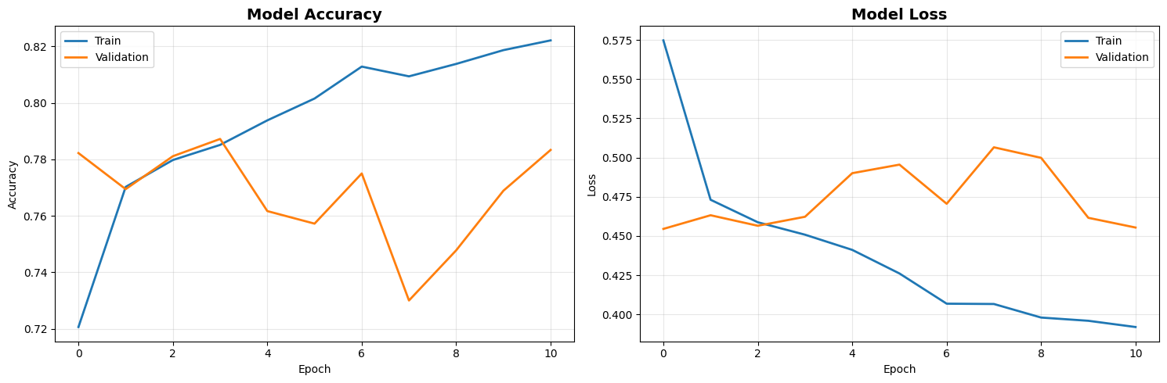
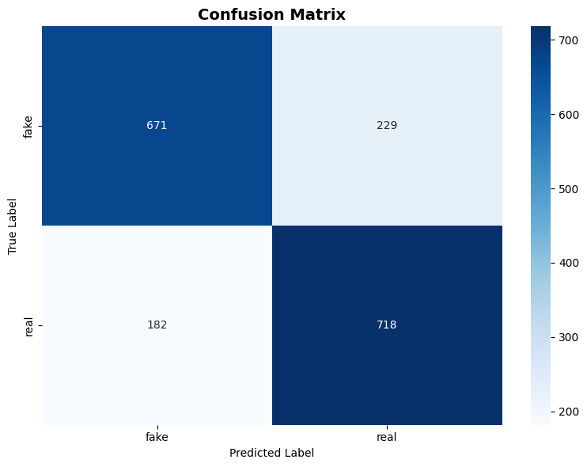

Results Summary
On the test dataset of 1,800 images:
- Accuracy: 77.17%
- Precision: 0.7724
- Recall: 0.7717
- F1-Score: 0.7715
The model demonstrates balanced class performance with moderate generalization ability.
The fuzzy trust scoring system enhanced interpretability by converting raw probabilities into graded confidence levels.

How Probability & Entropy Change Trust Score
Now let’s clearly see how our fuzzy system modifies the final output.

Case 1: High Probability, Low Entropy
Example:
P(real) = 0.92
P(fake) = 0.08
CM = 0.84
Entropy ≈ Low
Fuzzy Rule Activated:
IF CM is High AND Entropy is Low → Trust Score = Very High
Trust Score ≈ 90–98
Final Output → Authentic
This is a confident prediction.

Case 2: Medium Probability, High Entropy
Example:
P(real) = 0.60
P(fake) = 0.40
CM = 0.20
Entropy ≈ High
Fuzzy Rule:
IF CM is Low AND Entropy is High → Trust Score = Very Low or Low
Trust Score ≈ 30–45
Final Output → Suspicious
Without fuzzy logic:
Model would output “Real”
With fuzzy logic:
System detects uncertainty → marks as Suspicious
This is the main innovation.

Case 3: 50–50 Prediction
Example:
P(real) = 0.51
P(fake) = 0.49
CM = 0.02
Entropy ≈ Maximum
Trust Score ≈ 10–25
Final Output → Likely Deepfake or Suspicious
This prevents overconfident incorrect classification.
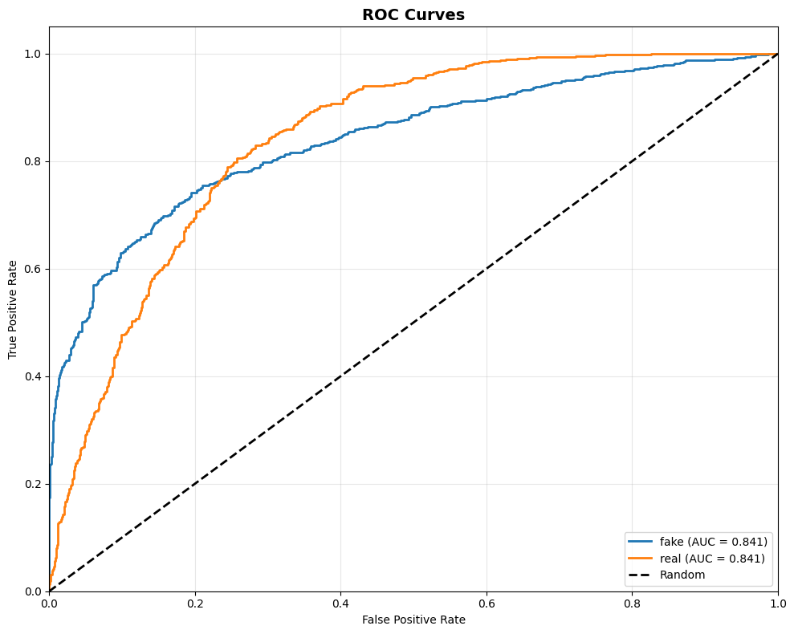
Conclusion and Future Work

This research presented a hybrid deepfake image detection framework integrating transfer learning-based convolutional neural networks with a fuzzy inference trust scoring mechanism. The objective was not only to classify images as real or fake but also to enhance interpretability and uncertainty awareness in decision-making.
Using the Kaggle Real vs Fake Face Image dataset (12,000 images), the MobileNetV2-based model achieved a test accuracy of 77.17%, with balanced precision, recall, and F1-score values. While the classification performance is moderate compared to large-scale benchmark datasets, it reflects realistic behavior on practical data containing diverse lighting conditions, compression artifacts, and generative inconsistencies.
The primary contribution of this work lies in the integration of entropy-based uncertainty quantification and fuzzy rule-based reasoning. Instead of relying solely on softmax probabilities, the system extracts confidence margin and entropy features, which are mapped to a human-interpretable trust score ranging from 0 to 100. This transformation enables a three-tier classification framework: Authentic, Suspicious, and Likely Deepfake.
The proposed hybrid approach demonstrates that combining deep learning with soft computing enhances interpretability without significantly compromising predictive performance. The fuzzy trust scoring mechanism improves reliability in ambiguous cases by preventing overconfident misclassifications, making the system more suitable for real-world applications such as digital forensics, social media moderation, and journalism verification.

Future Work
Although the proposed system improves interpretability, several enhancements can be explored:
- Extension to video-based deepfake detection using temporal features.
- Integration of advanced architectures such as EfficientNet variants or transformer-based vision models.
- Adaptive fuzzy rule optimization using data-driven tuning methods.
- Cross-dataset generalization studies to evaluate robustness.
- Implementation of probability calibration techniques to improve confidence estimation.
- Deployment in real-time web or mobile applications for practical use.
Future research may also explore integration with advanced explainable AI techniques, such as Grad-CAM visualization, to provide spatial explanations of detected manipulations.

Final Outputs:

